Matins pg. 219

Reformation Sunday

October 26,2025

Hymn: 660 Stand Up, Stand Up for Jesus
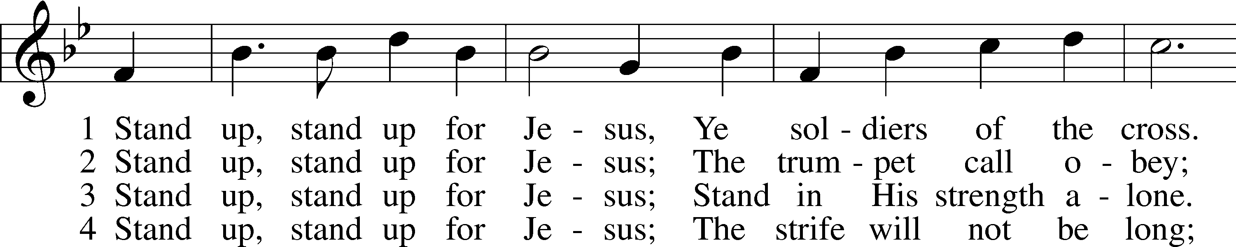
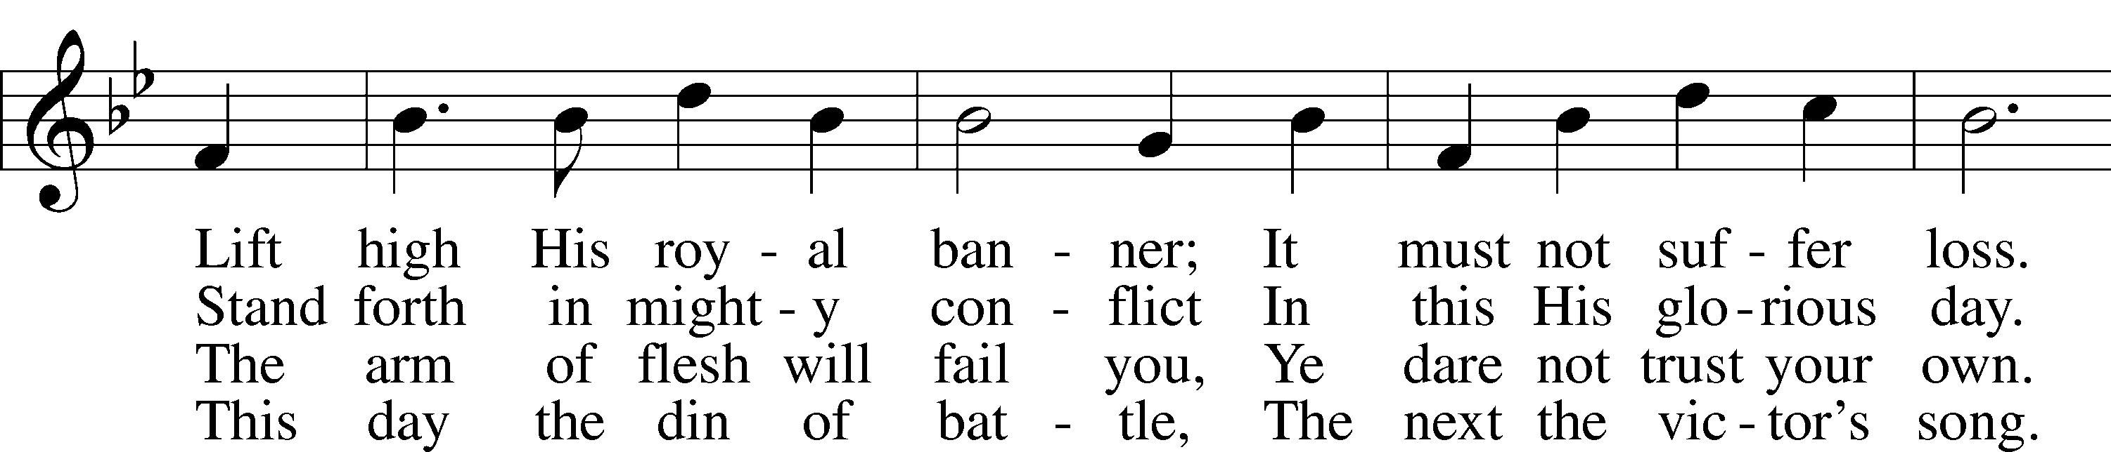
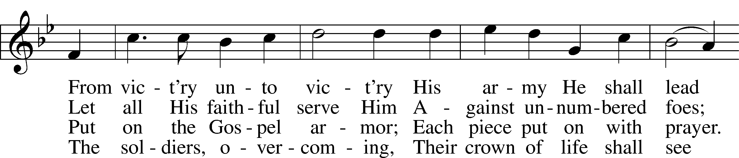
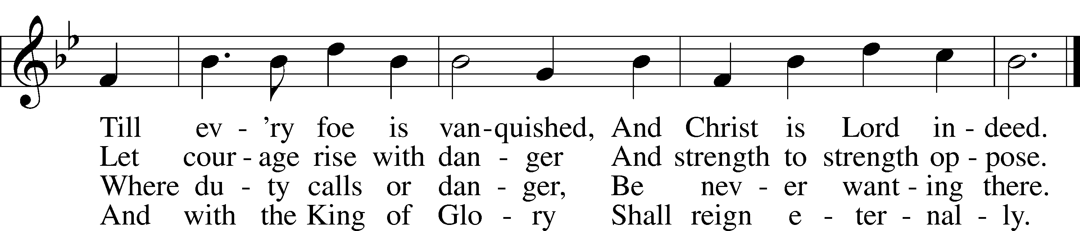

Text: George Duffield, Jr., 1818–88, alt.
Tune: George J. Webb, 1803–87
Text and tune: Public domain

Stand







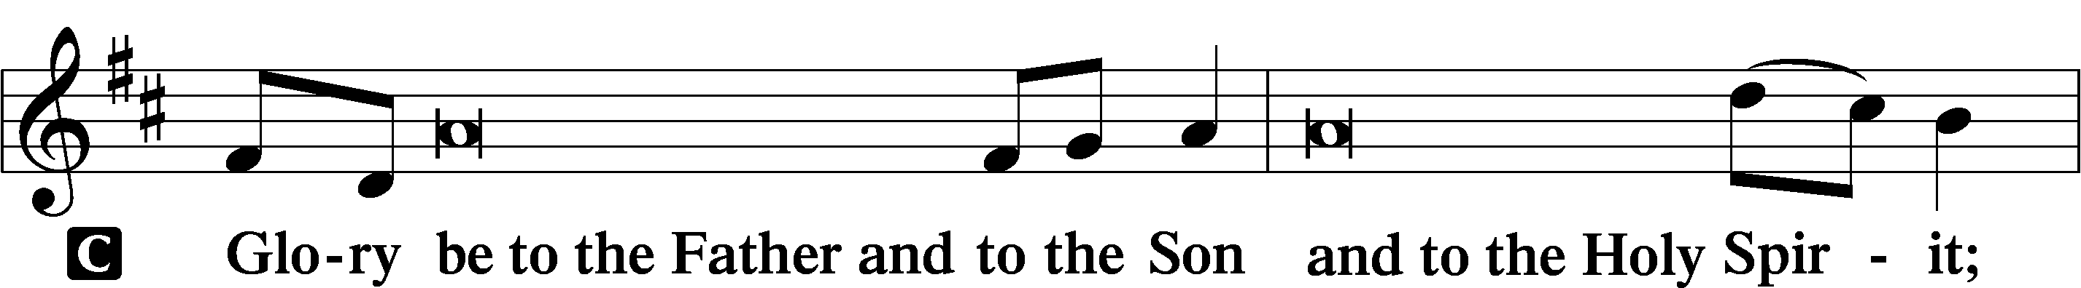
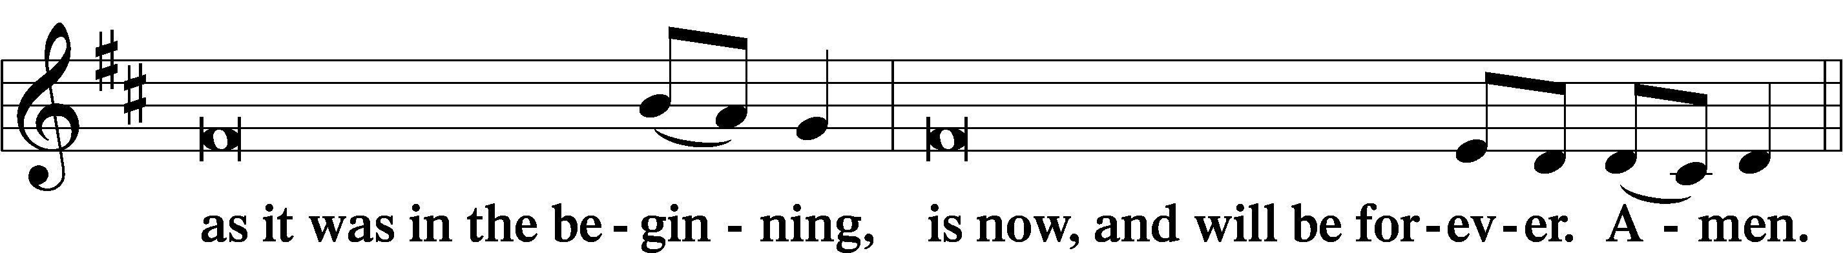
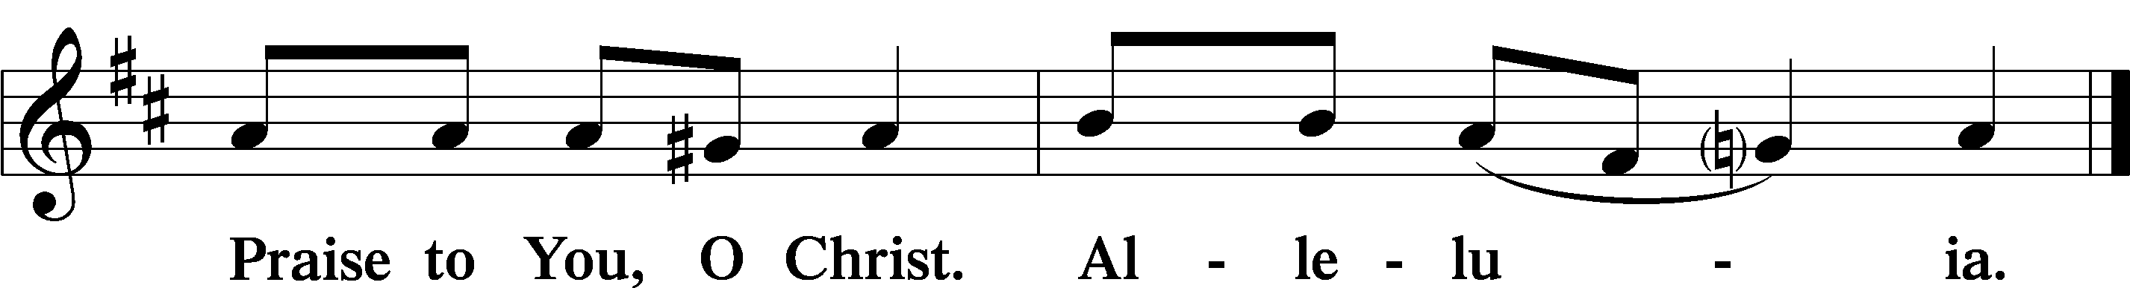

Psalmody

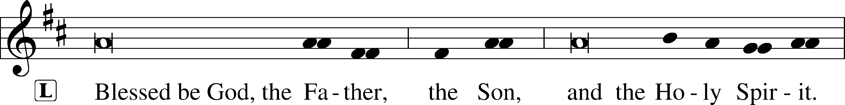


Venite LSB 220
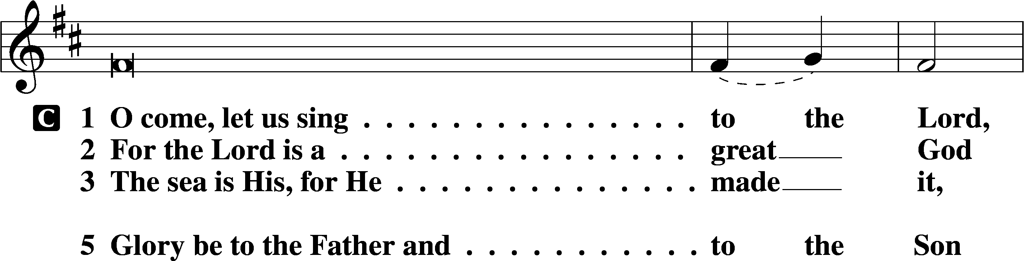
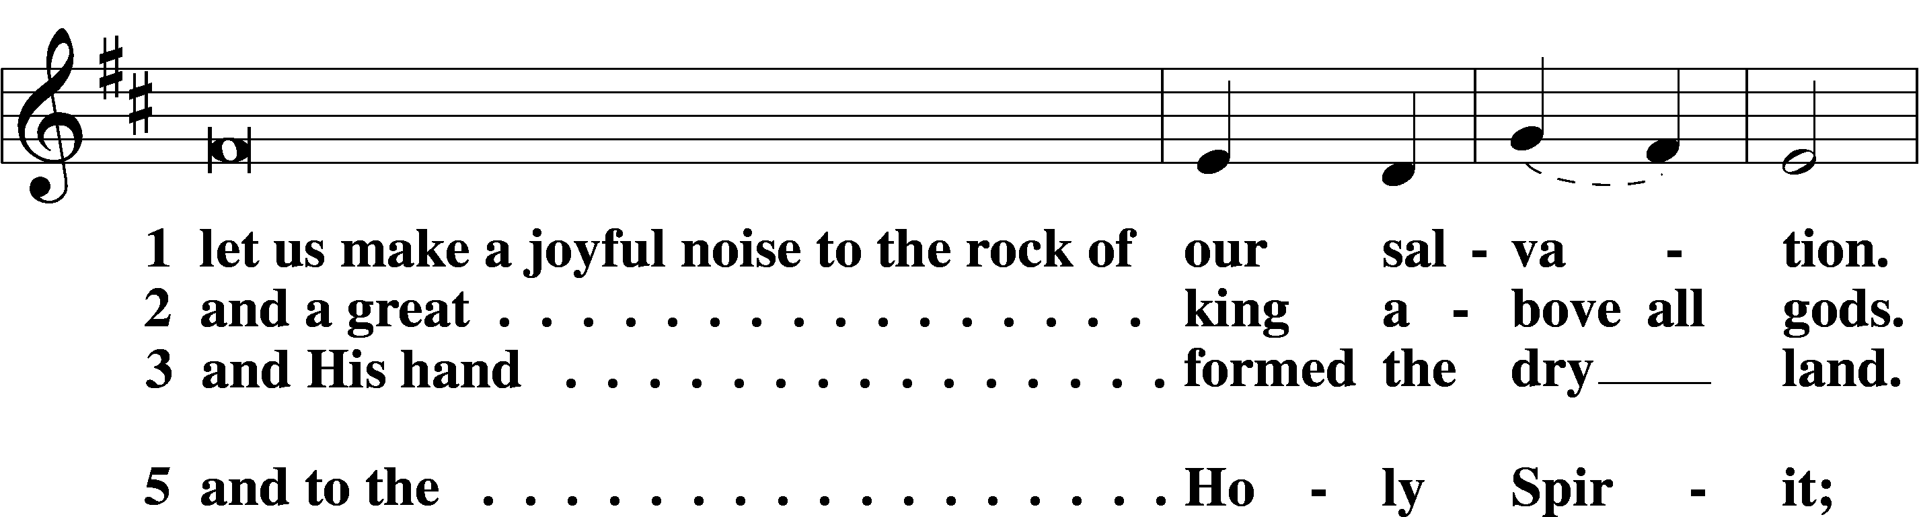
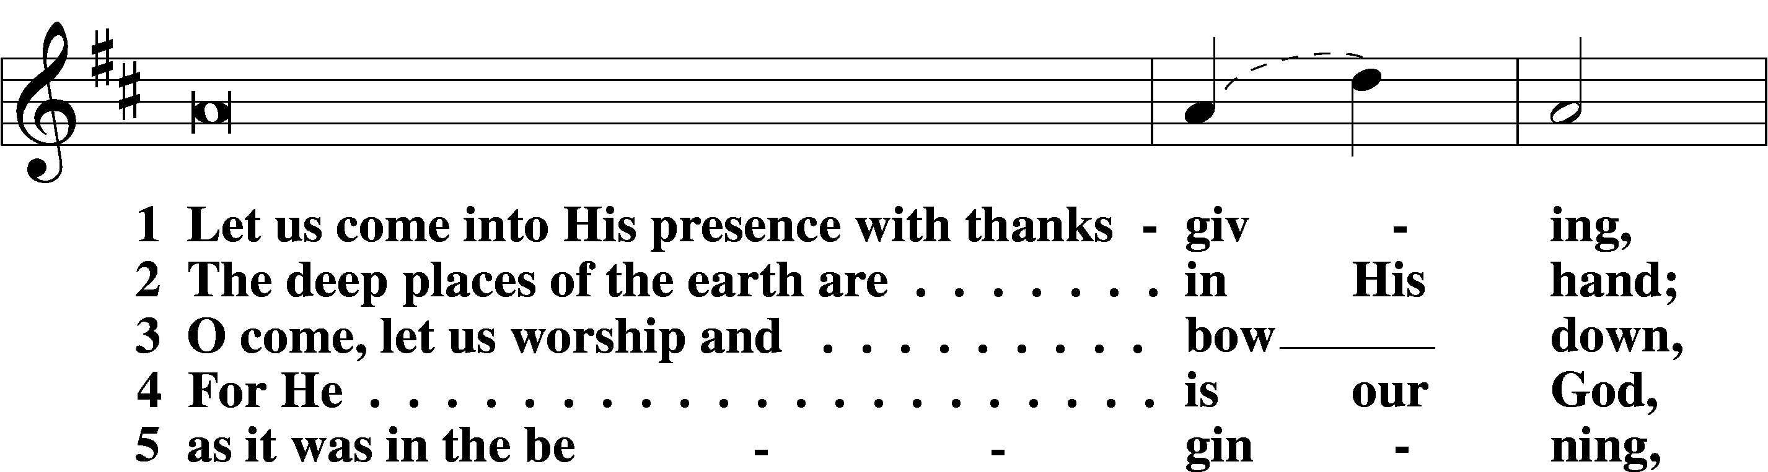
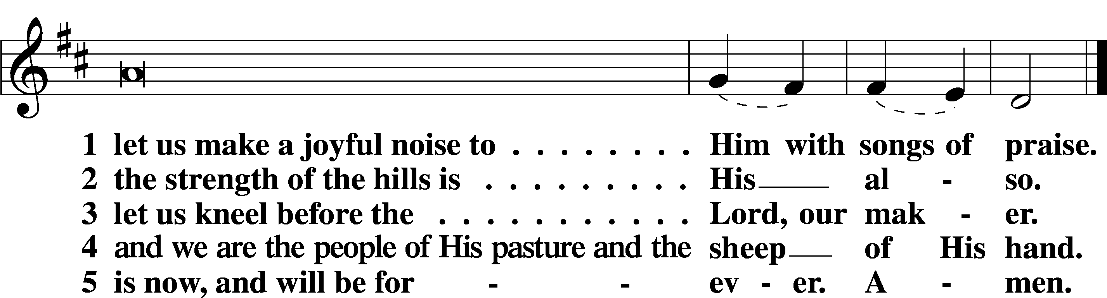

Sit

Office Hymn: 662 Onward, Christian Soldiers
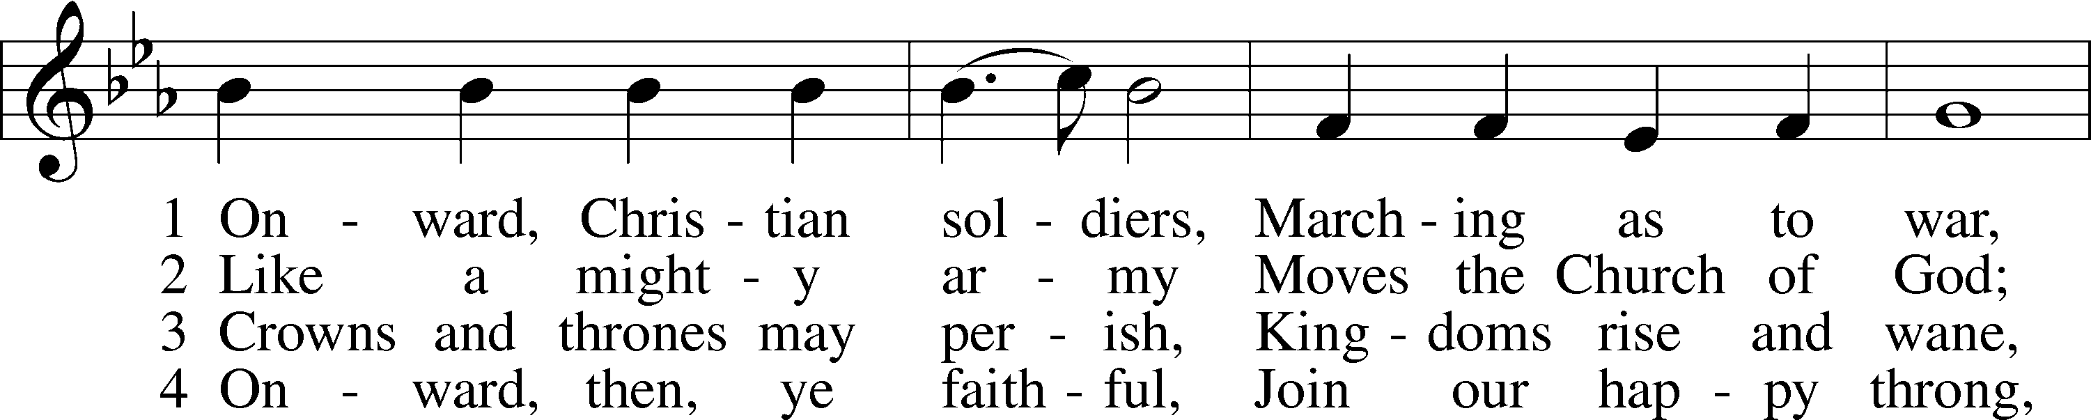
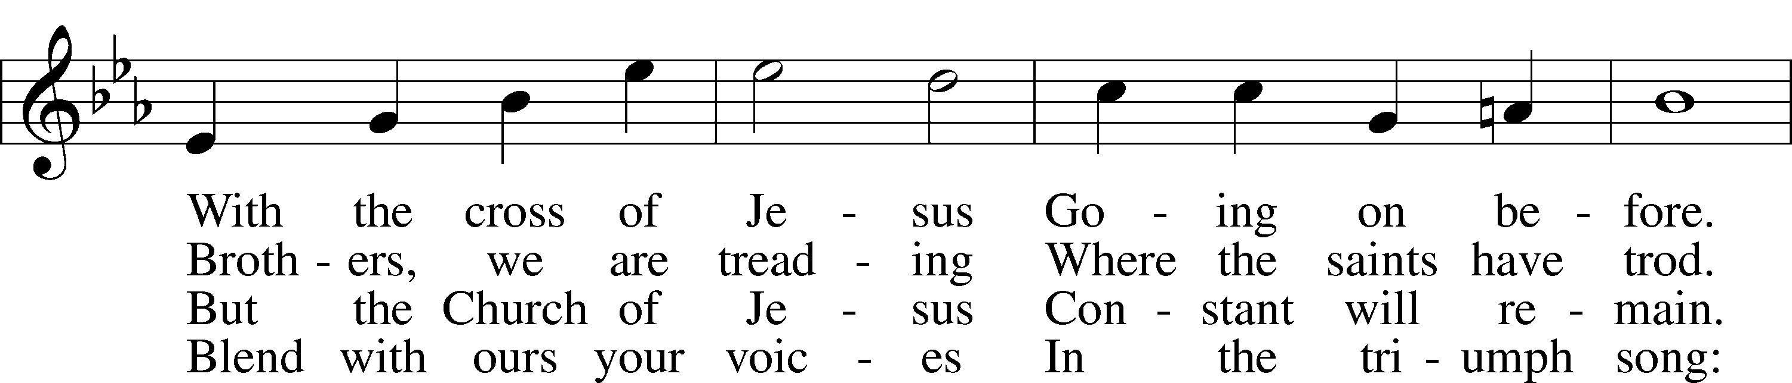
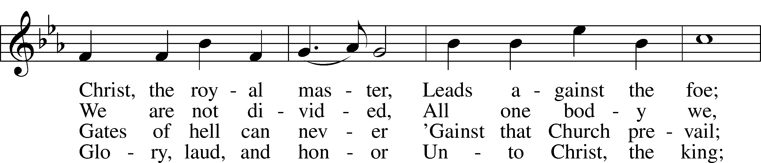
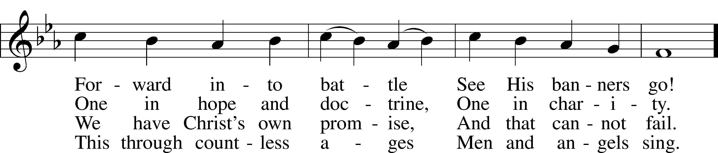
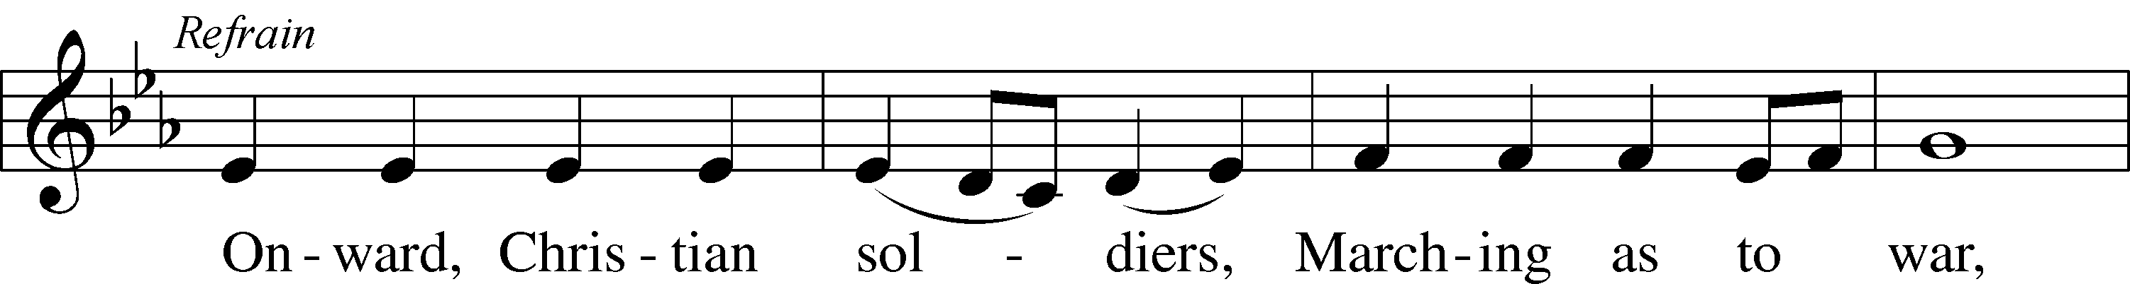
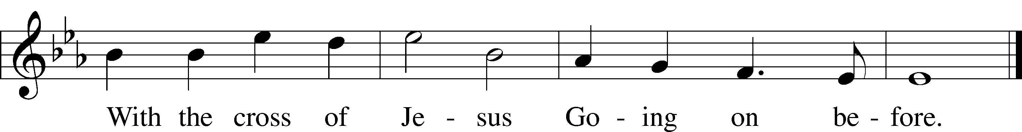

Text: Sabine Baring-Gould, 1834–1924, alt.
Tune: Arthur S. Sullivan, 1842–1900
Text and tune: Public domain

Readings

Reading Revelation 14:6–7
L A reading from Revelation, chapter 14.

The Messages of the Three Angels
6Then I saw another angel flying directly overhead, with an eternal gospel to proclaim to those who dwell on earth, to every nation and tribe and language and people. 7And he said with a loud voice, “Fear God and give him glory, because the hour of his judgment has come, and worship him who made heaven and earth, the sea and the springs of water.”

L O Lord, have mercy on us.
C Thanks be to God.

Reading Romans 3:19–28
L A reading from Romans, chapter 3.

19Now we know that whatever the law says it speaks to those who are under the law, so that every mouth may be stopped, and the whole world may be held accountable to God. 20For by works of the law no human being will be justified in his sight, since through the law comes knowledge of sin.
The Righteousness of God Through Faith
21But now the righteousness of God has been manifested apart from the law, although the Law and the Prophets bear witness to it— 22the righteousness of God through faith in Jesus Christ for all who believe. For there is no distinction: 23for all have sinned and fall short of the glory of God, 24and are justified by his grace as a gift, through the redemption that is in Christ Jesus, 25whom God put forward as a propitiation by his blood, to be received by faith. This was to show God’s righteousness, because in his divine forbearance he had passed over former sins. 26It was to show his righteousness at the present time, so that he might be just and the justifier of the one who has faith in Jesus.
27Then what becomes of our boasting? It is excluded. By what kind of law? By a law of works? No, but by the law of faith. 28For we hold that one is justified by faith apart from works of the law.

L O Lord, have mercy on us.
C Thanks be to God.

Reading John 8:31–36
L A reading from John, chapter 8.

The Truth Will Set You Free
31So Jesus said to the Jews who had believed in him, “If you abide in my word, you are truly my disciples, 32and you will know the truth, and the truth will set you free.” 33They answered him, “We are offspring of Abraham and have never been enslaved to anyone. How is it that you say, ‘You will become free’?”
34Jesus answered them, “Truly, truly, I say to you, everyone who commits sin is a slave to sin. 35The slave does not remain in the house forever; the son remains forever. 36So if the Son sets you free, you will be free indeed.”

L O Lord, have mercy on us.
C Thanks be to God.

Responsory LSB 221
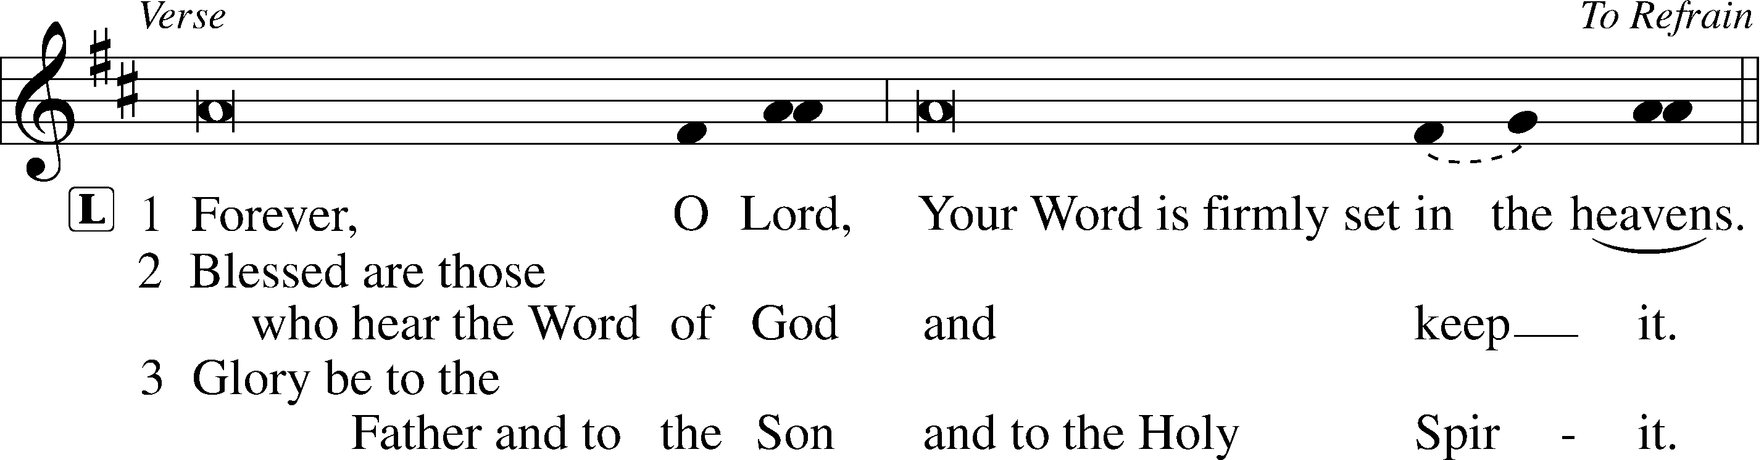
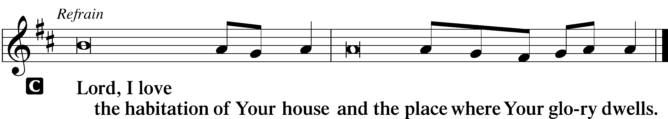

Hymn: 656 A Mighty Fortress Is Our God
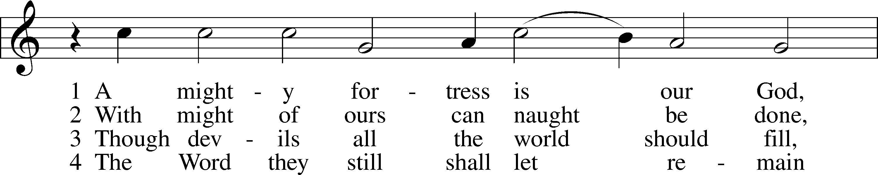
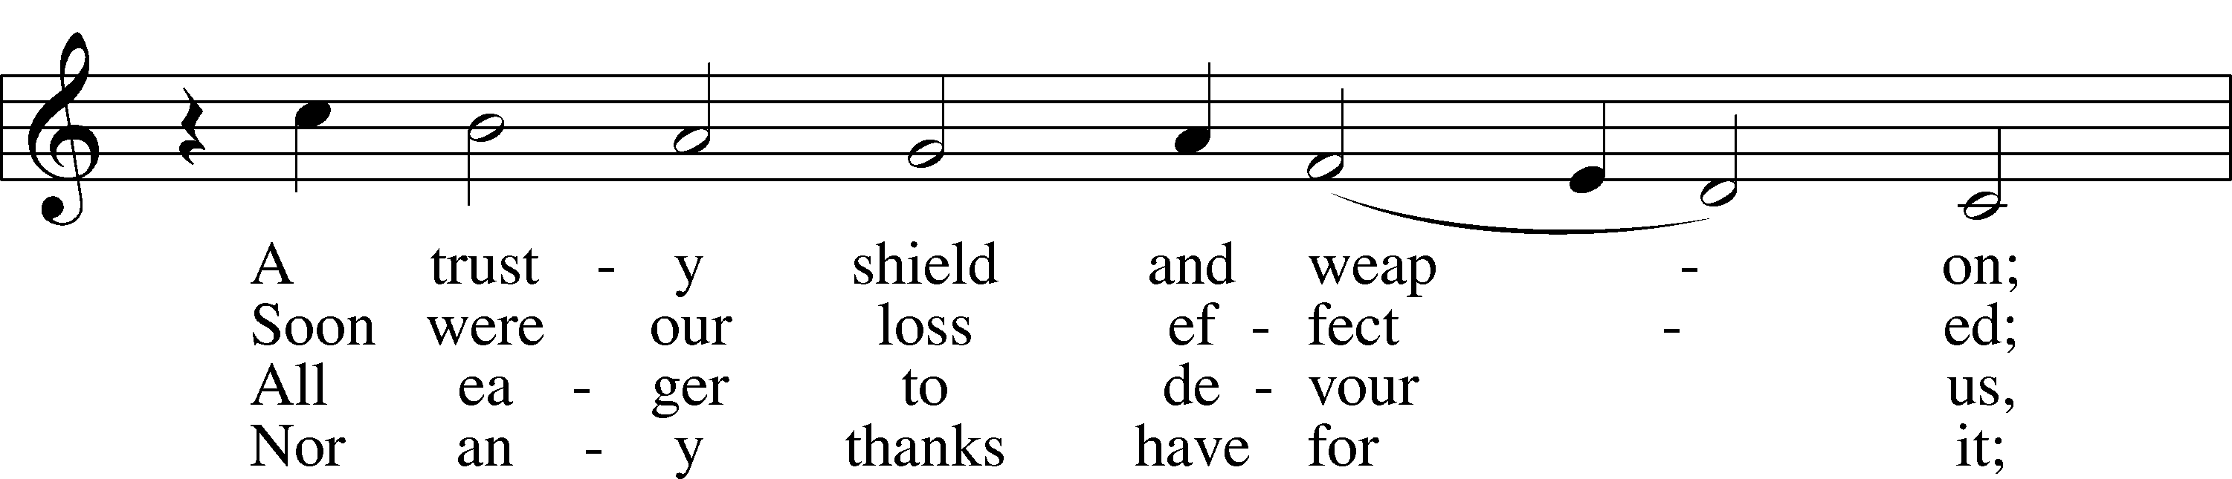
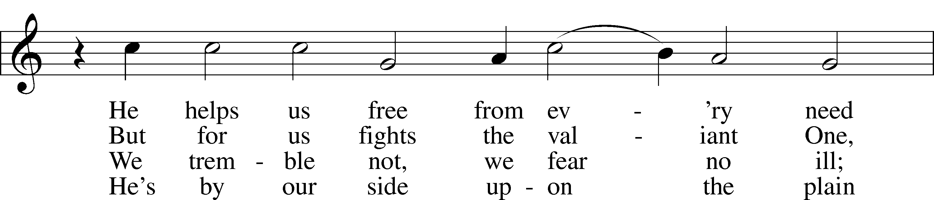
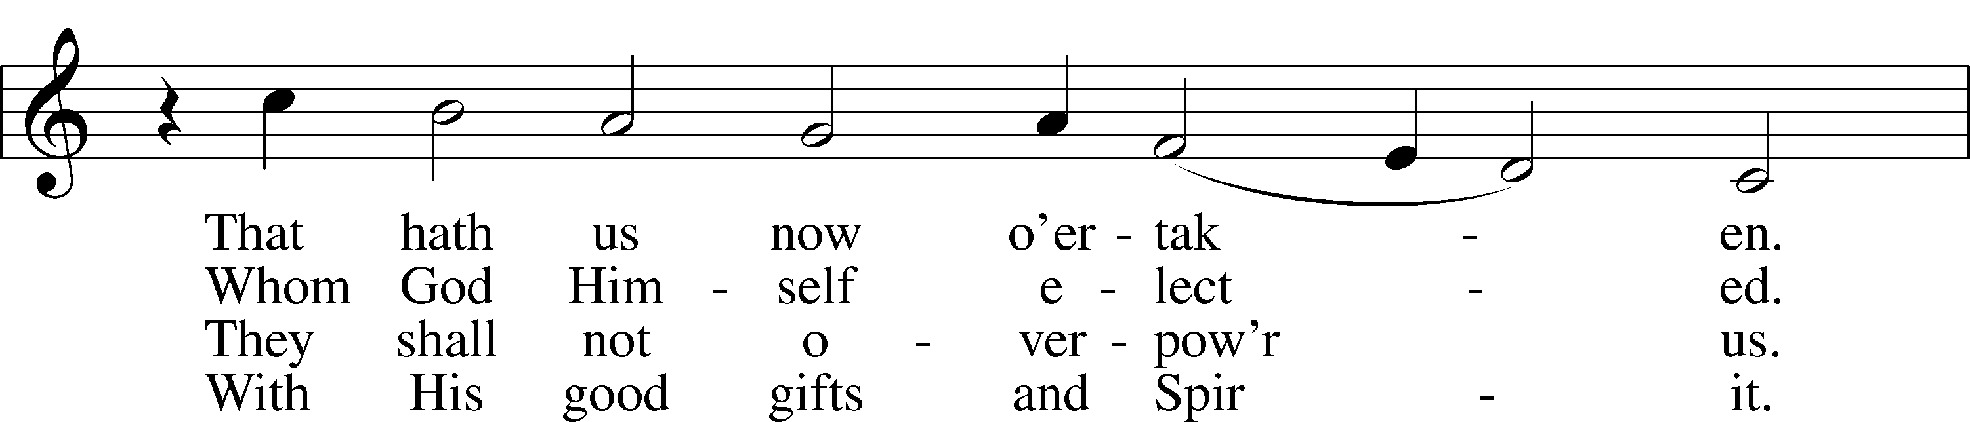
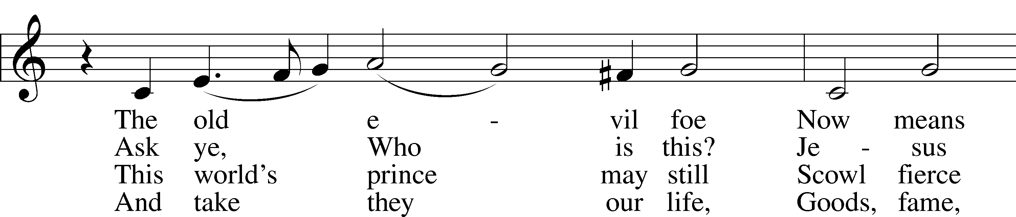
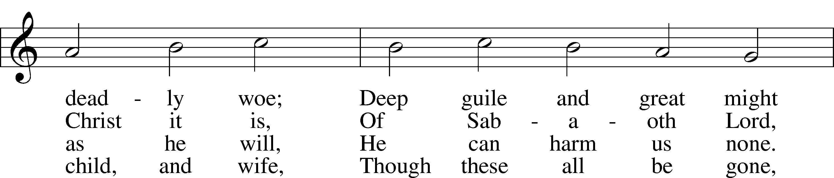
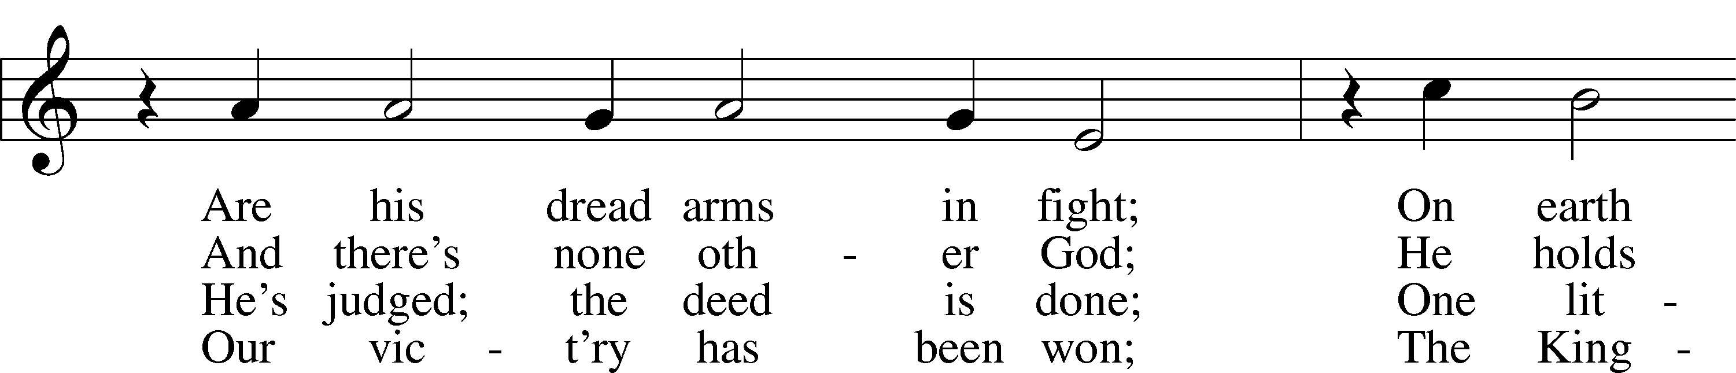
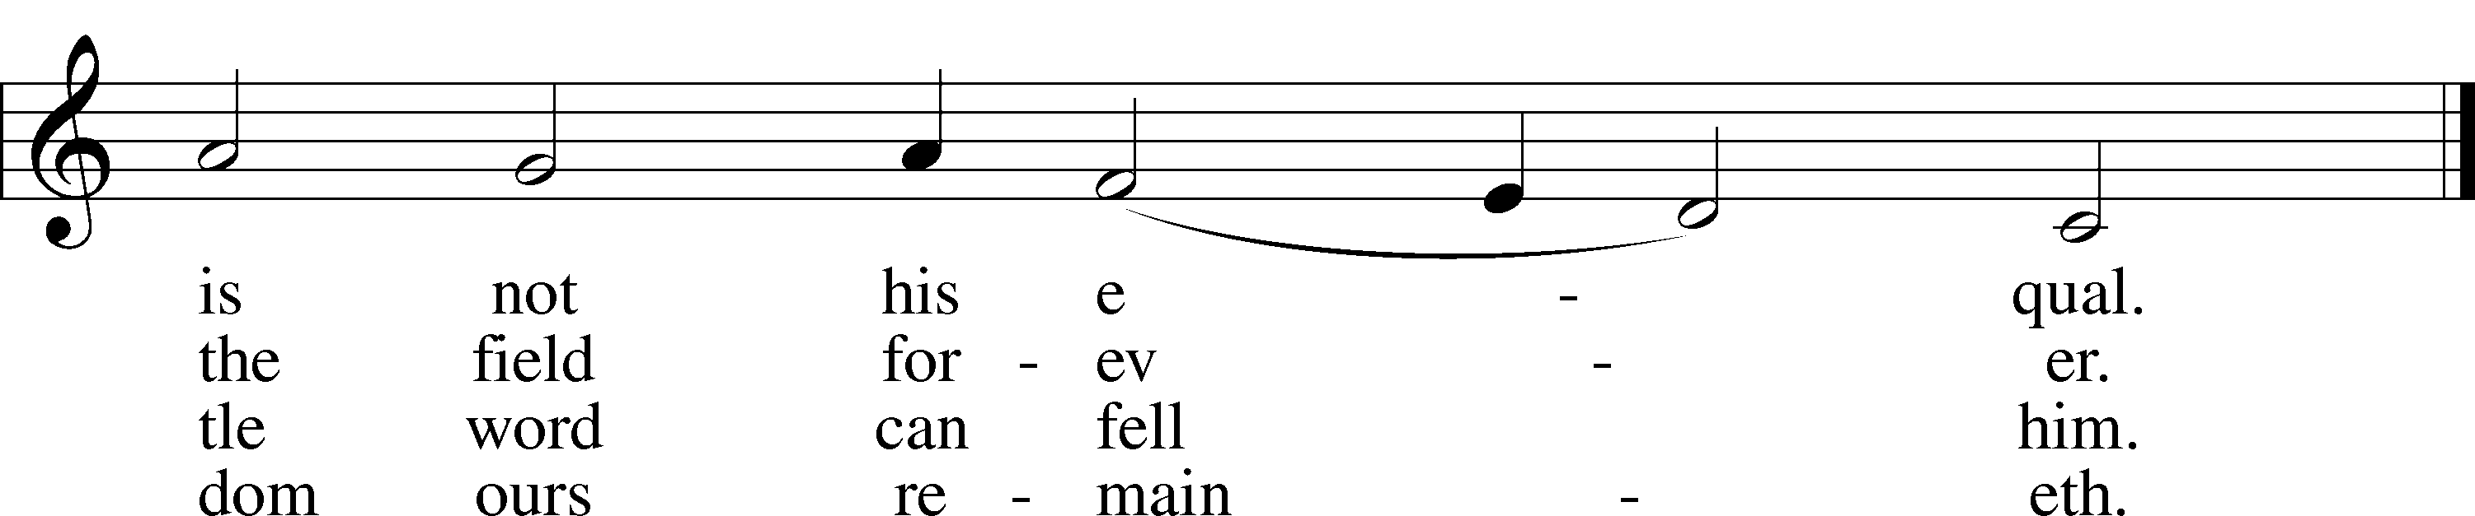

Text: tr. composite
Text and tune: Martin Luther, 1483–1546
Text and tune: Public domain

Sermon

Canticle

Stand

Te Deum LSB 223
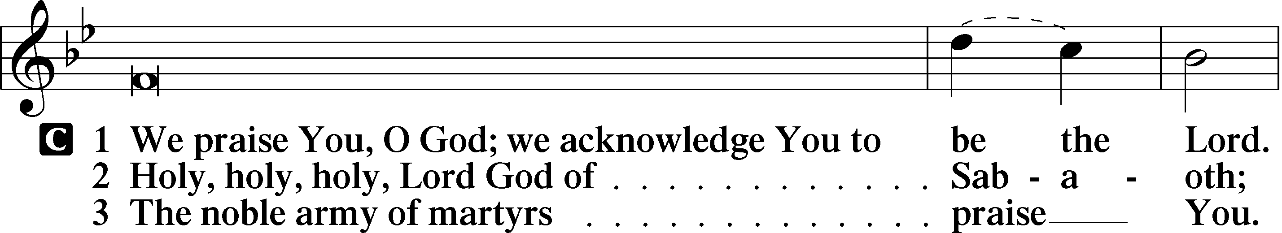
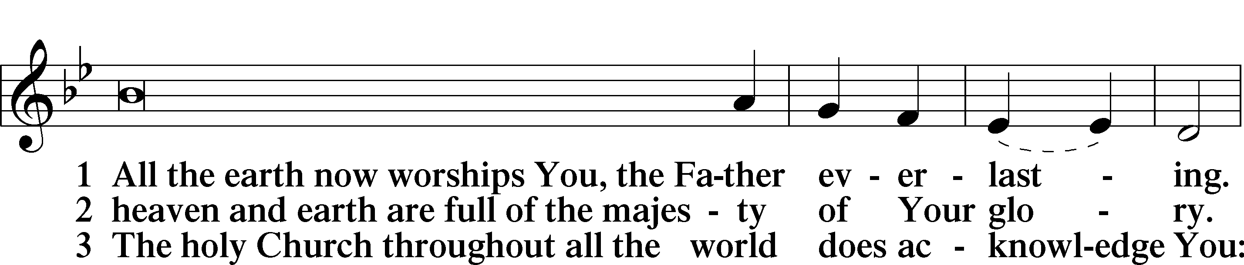
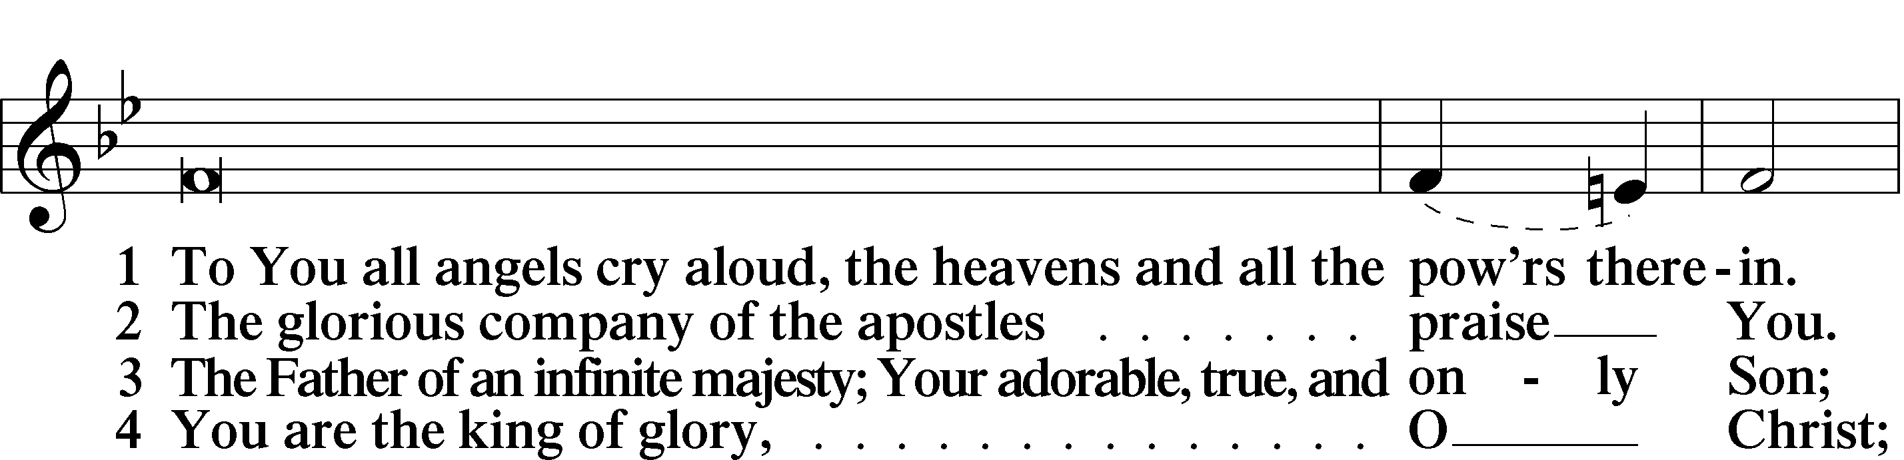
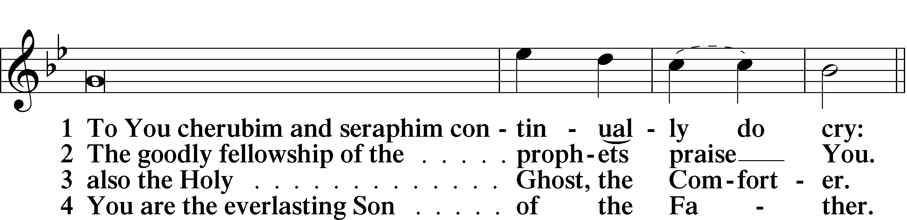
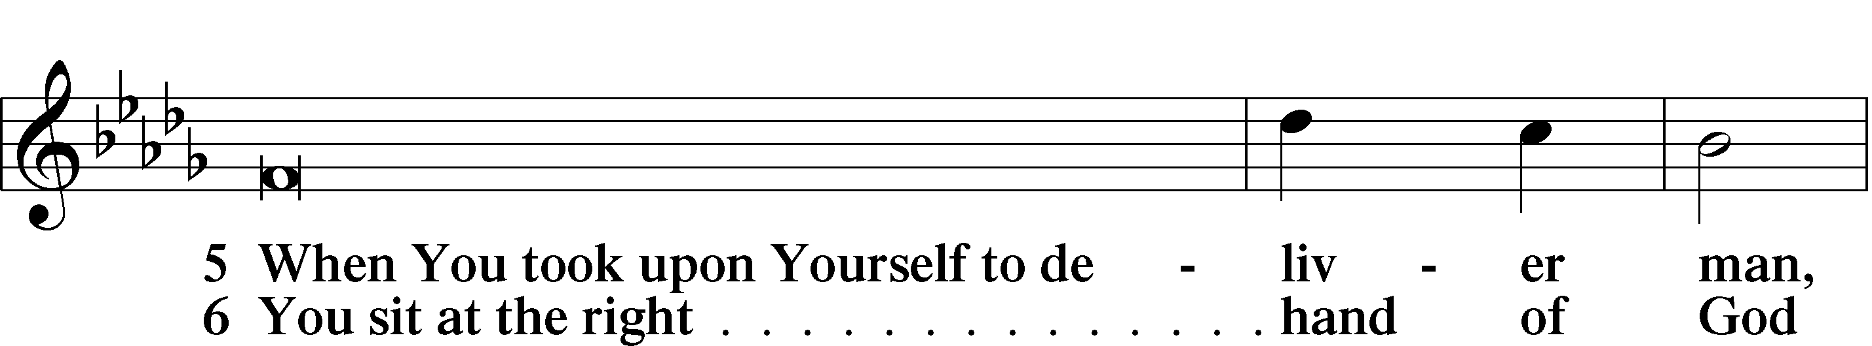
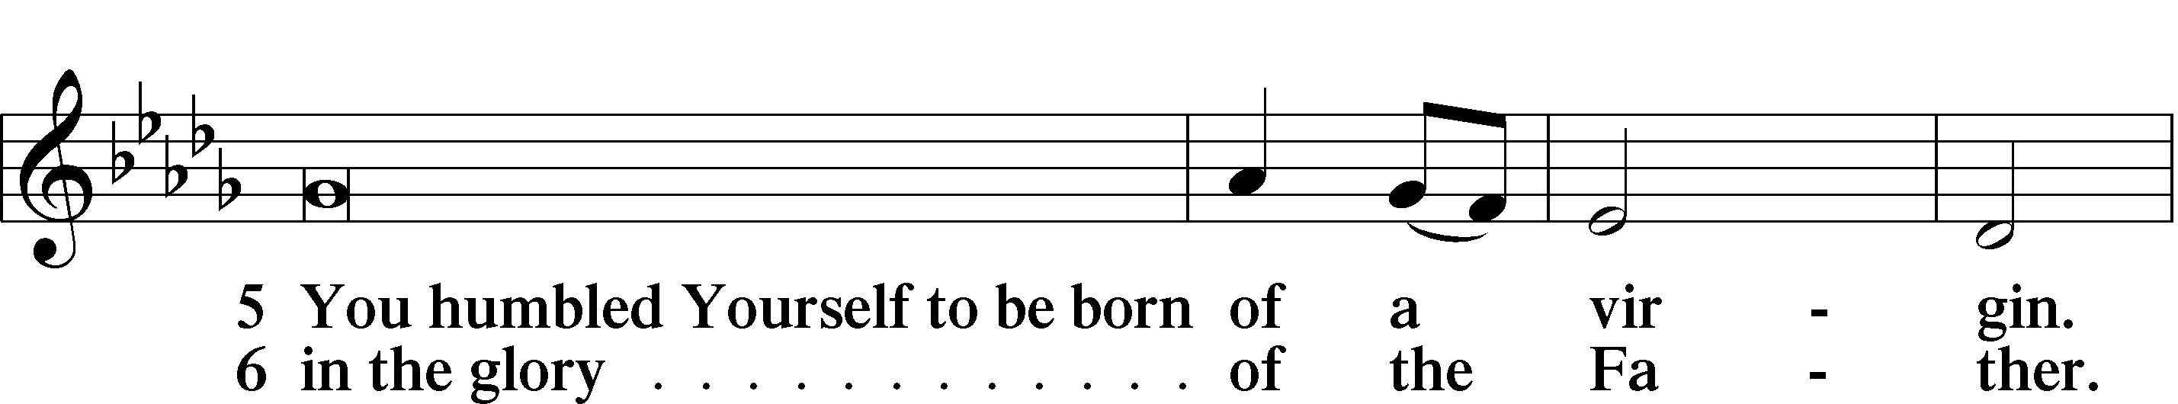
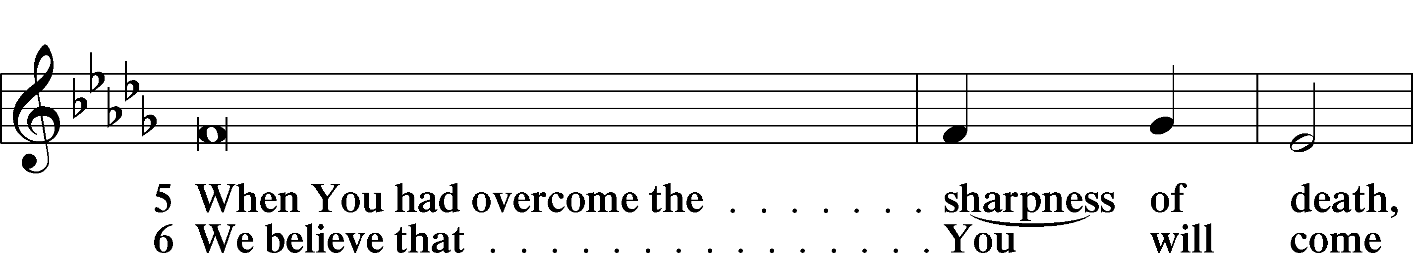
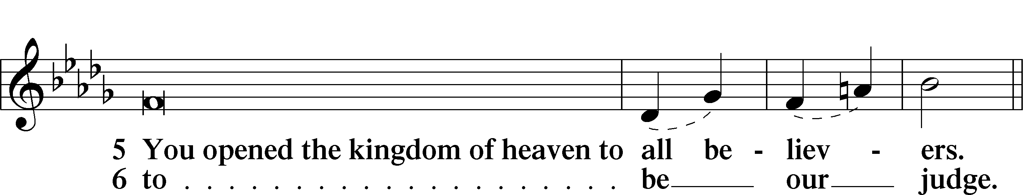
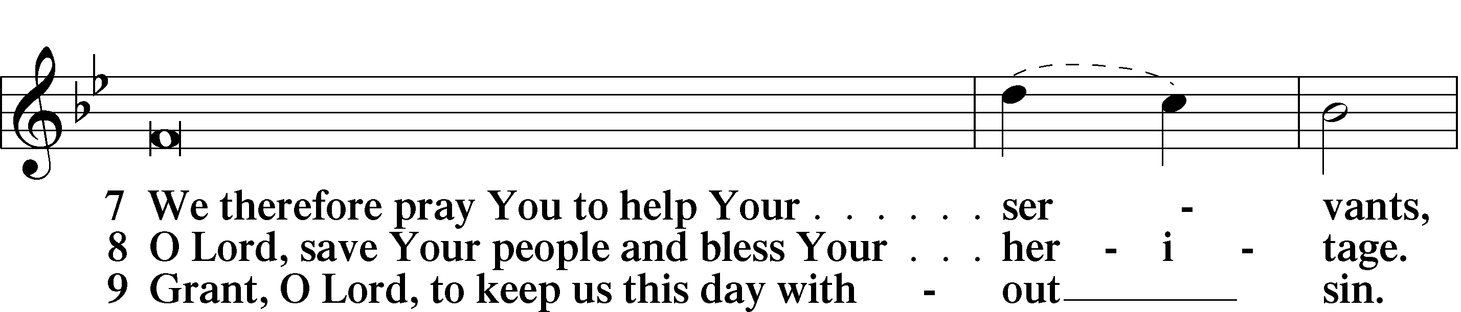
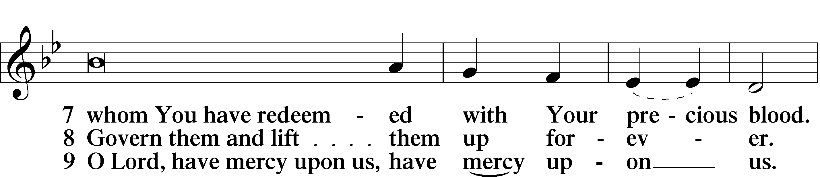
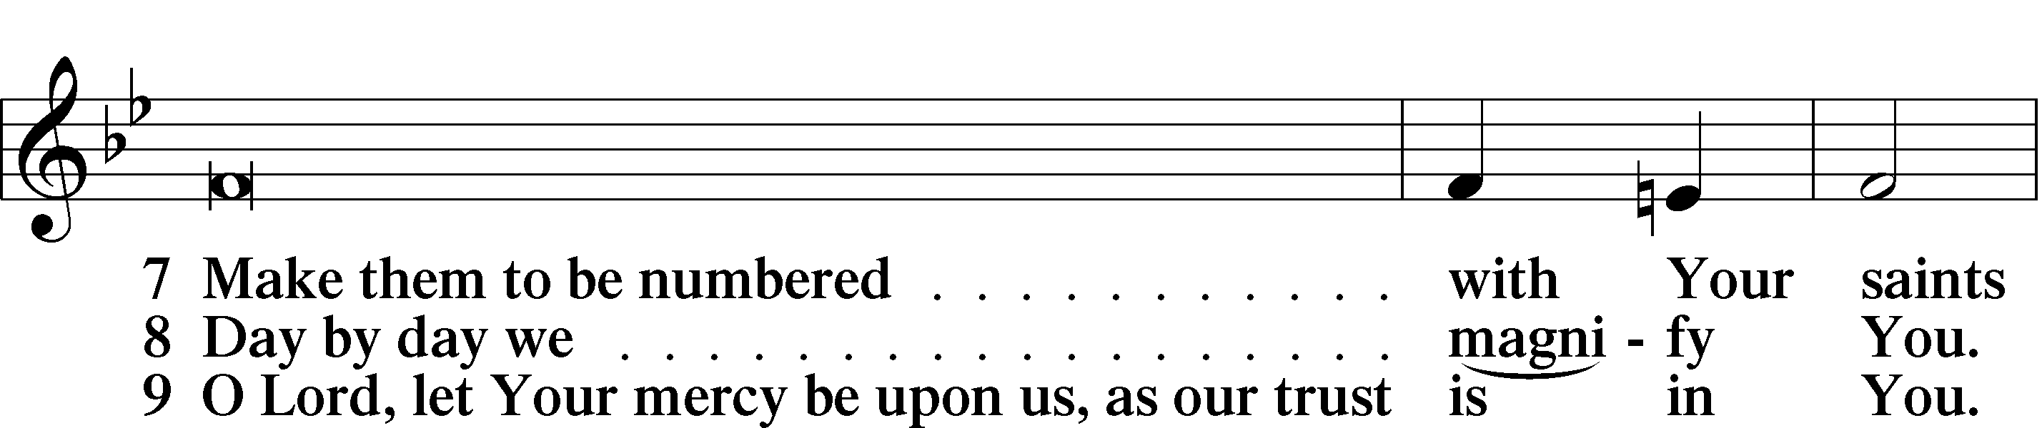
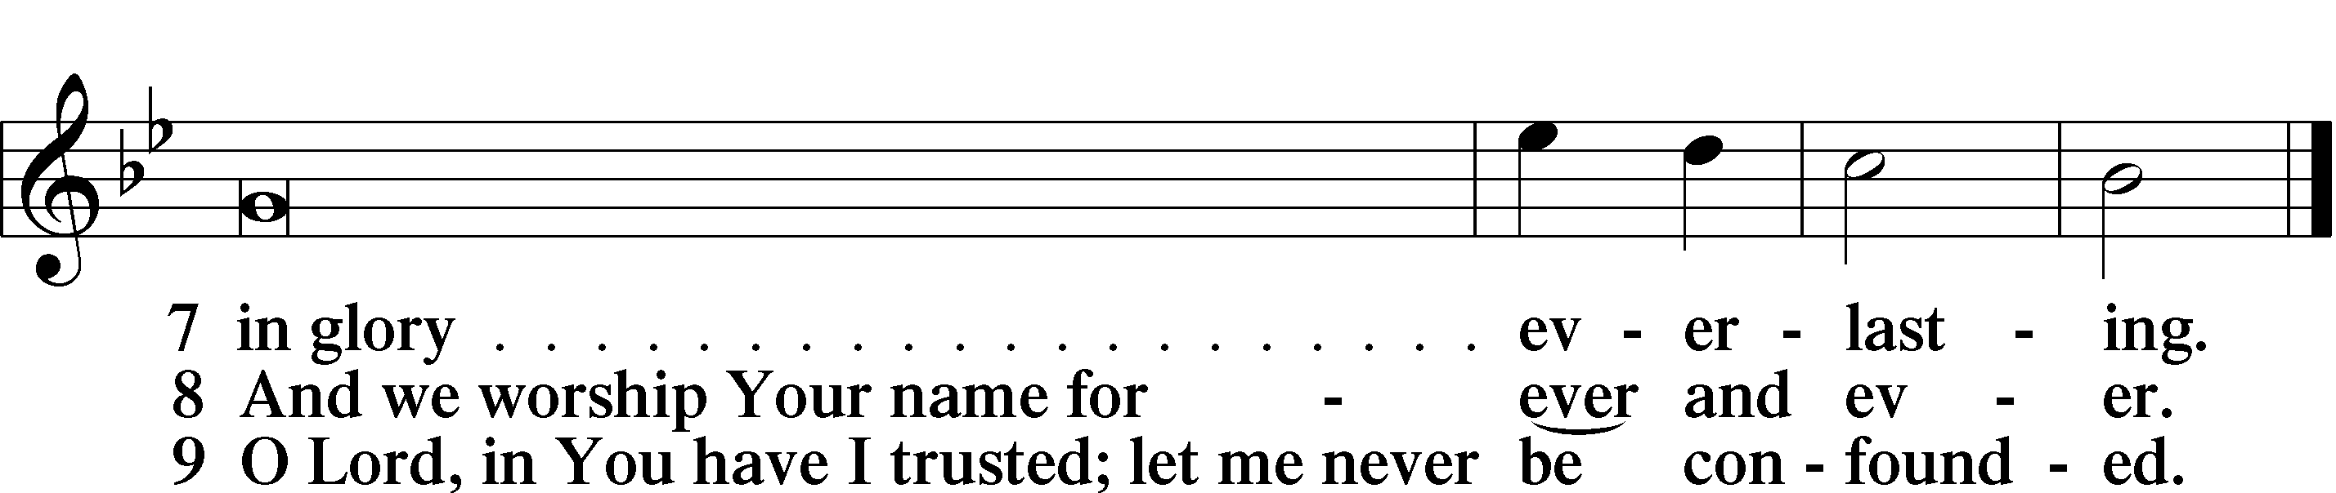

Sit

Offering

Hymn: 805 Praise God, from Whom All Blessings Flow
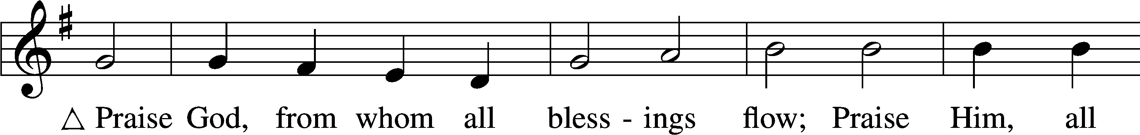
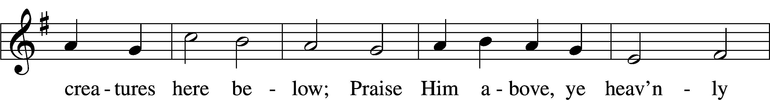
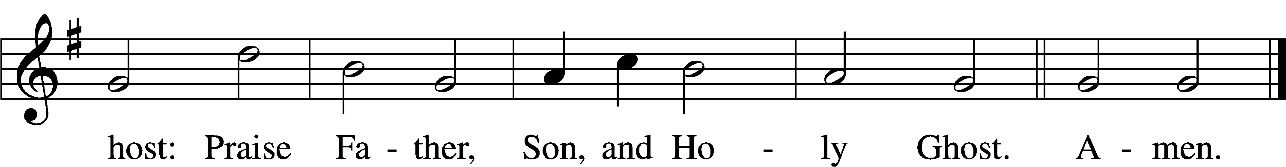

Text: Thomas Ken, 1637–1711
Tune: Trente quatre Pseaumes de David, 1551, Geneva, ed. Louis Bourgeois
Text and tune: Public domain

Prayer

Kneel/Stand

Kyrie LSB 227
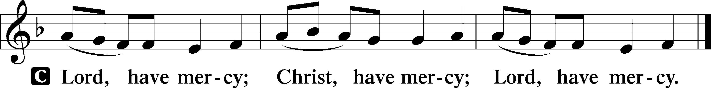

Lord’s Prayer
C Our Father who art in heaven,
hallowed be Thy name,
Thy kingdom come,
Thy will be done on earth
as it is in heaven;
give us this day our daily bread;
and forgive us our trespasses
as we forgive those
who trespass against us;
and lead us not into temptation,
but deliver us from evil.
For Thine is the kingdom
and the power and the glory
forever and ever. Amen.

Collects

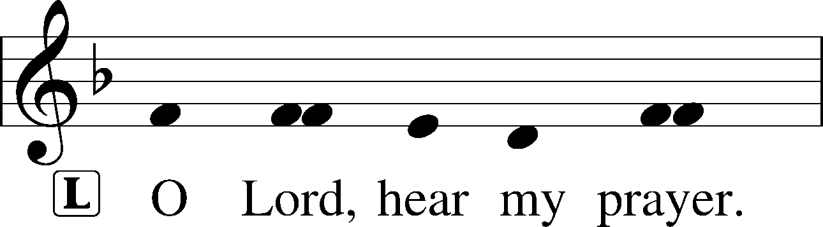
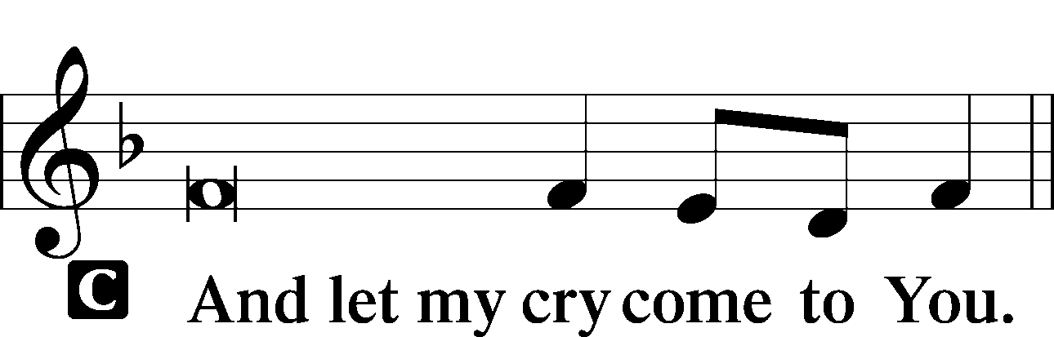

Collect of the Day
Almighty and everlasting God, You are always more ready to hear than we to pray and always ready to give more than we either desire or deserve. Pour down on us the abundance of Your mercy; forgive us those things of which our conscience is afraid; and give us those good things for which we are not worthy to ask except by the merits and mediation of Jesus Christ, Your Son, our Lord, who lives and reigns with You and the Holy Spirit, one God, now and forever.
C Amen.

Collect for Grace
L O Lord, our heavenly Father, almighty and everlasting God, You have safely brought us to the beginning of this day. Defend us in the same with Your mighty power and grant that this day we fall into no sin, neither run into any kind of danger, but that all our doings, being ordered by Your governance, may be righteous in Your sight; through Jesus Christ, Your Son, our Lord, who lives and reigns with You and the Holy Spirit, one God, now and forever.
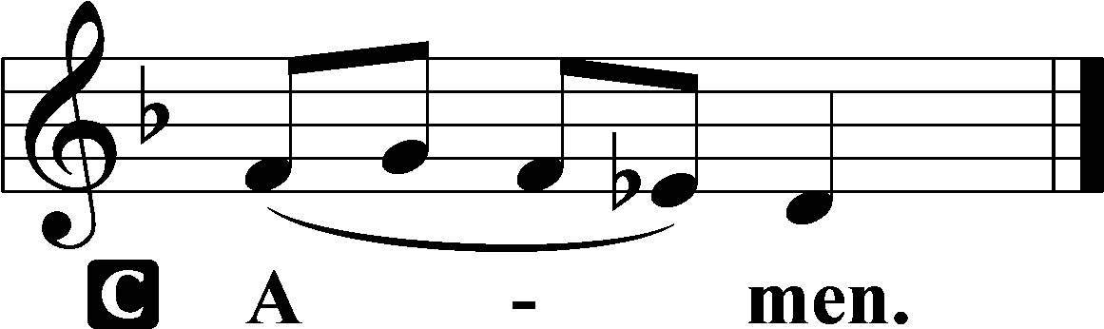

Stand

Benedicamus LSB 228
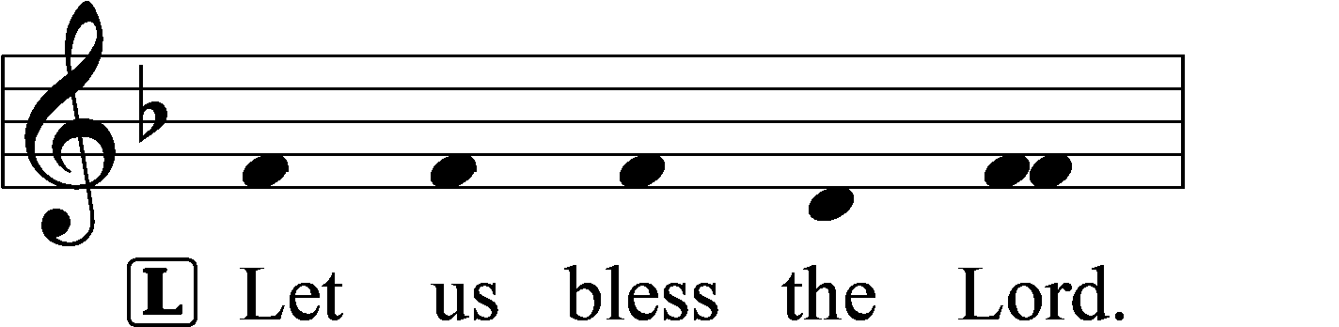
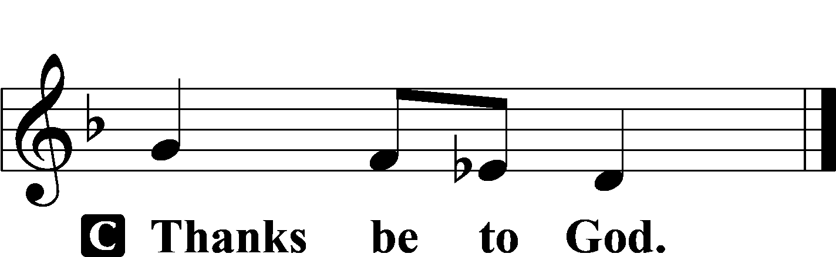

Benediction LSB 228
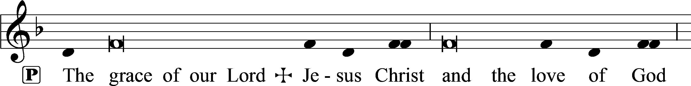
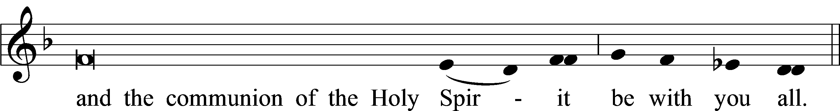


Hymn to Depart: 655 Lord, Keep Us Steadfast in Your Word
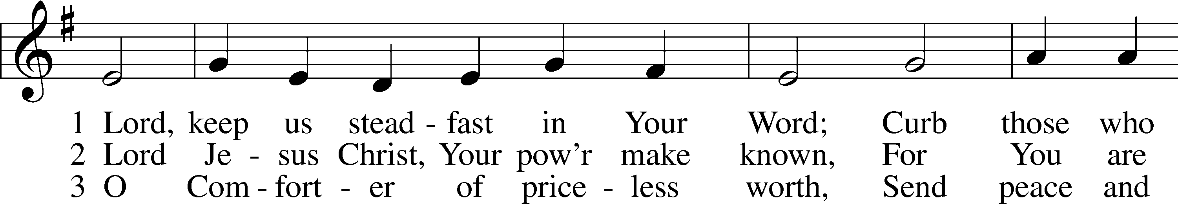
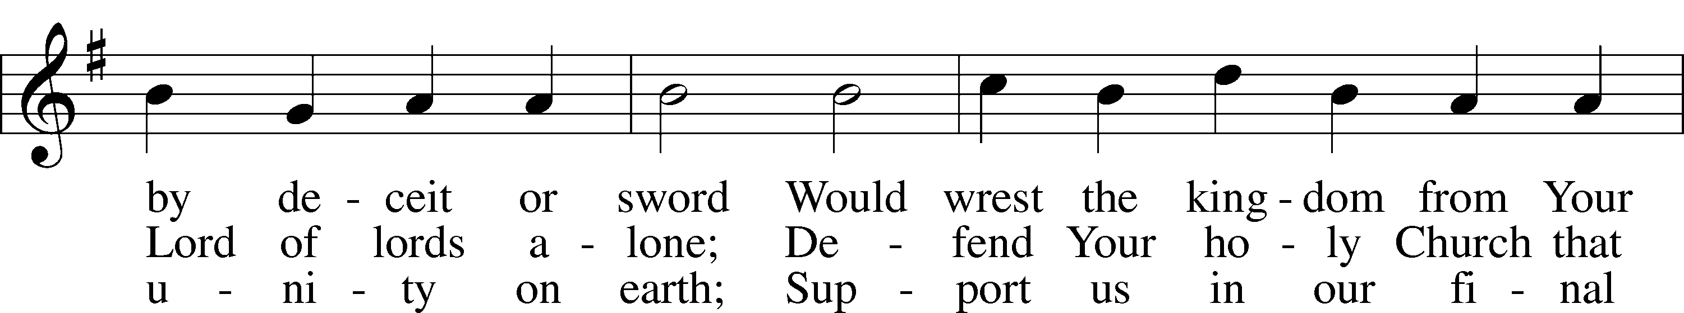
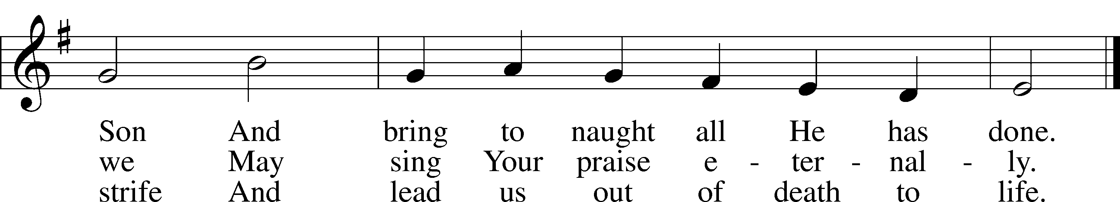

Text: Martin Luther, 1483–1546; tr. Catherine Winkworth, 1827–78, alt.
Tune: Geistliche Lieder auffs new gebessert, 1543, Wittenberg, ed. Joseph Klug
Text and tune: Public domain

Acknowledgments
Matins from Lutheran Service Book
Unless otherwise indicated, Scripture quotations are from the ESV® Bible (The Holy Bible, English Standard Version®), copyright © 2001 by Crossway, a publishing ministry of Good News Publishers. Used by permission. All rights reserved.
Created by Lutheran Service Builder © 2025 Concordia Publishing House.

Prayers Request: Those in the nursing home: Joann Jaeger, Joan Church Those Shut-in at home: Char Herman Those with ongoing health issues: Daria (Cindy Wright’s friend), Butch L. (Cindy Wright’s Brother-in-law), Melissa Miller. Sandy Hahn (Cindy Wright’s cousin’s wife) , Marlene Snyder, Shirley Hehl, Pastor Eric and Linda Stumpf, Tasha Becker(Michele Millerman’s daughter), Tom (Cindy Wright’s friend) Those who grieve: Family and Friends of Joyce Myers-Funeral is Tues. Oct. 28th 11am Recovering from surgery: Brenda Gustum (Missy Wiese’s mom) Those who lead our nation: Donald Trump, JD Vance, Tony Evers, Rod Nordby Those who serve in our military and law enforcement: Ryan Graf, Chaplain Pon Chanthaphon (Our Adopt-a-Chaplain), Rusty Weise Our Childcare Staff: Melissa Frieburg, Denise Stabenow, Holly Wilhelmi, Janica Skjerly, Cathy Anderson, Iva Gjika, Michele Millerman, Brittnie Eirckson, Mariah Ward, Sarah Setayeshi

Church Service Phone: 715-438-4200(Chippewa Falls)
715-537-4240(local)
(Stay on the line for recorded service to start)
Live Stream audio services: http://salem.listentochurch.com
Salem’s Web Page: https://www.salembarron.com/
Pastor Fred Buth: Cell phone:715-642-3050
Email: salembarronpastor@gmail.com
Office Hours: Monday-Wednesday 9-12
Attendance: 10/19-76
Coffee and Snacks: Potluck
Elder Today: Don Duncan
Reader: Don Duncan
Organist: Cindy Wright
Altar Guild: Mary Ann Thompson

Offering 10/5 $2787 General, $65 mission, $140 Building, $5 Cemetery
10/12 $1445 General Fund, $140 Mission, $100 Building, $5 Childcare, $5 Cemetery, $5 Lutheran Hour, $76.14 Schutz Oil, $15.94 SS

There is a signup sheet in the back if you would like to provide a snack for the confirmation class on a Wednesday.

Save the Date
Today – Potluck after church.

November 2nd - Daylight saving ends (set clocks back)
️

November 9th – Congregational meeting, Potluck

November 21st – Carpet cleaning

