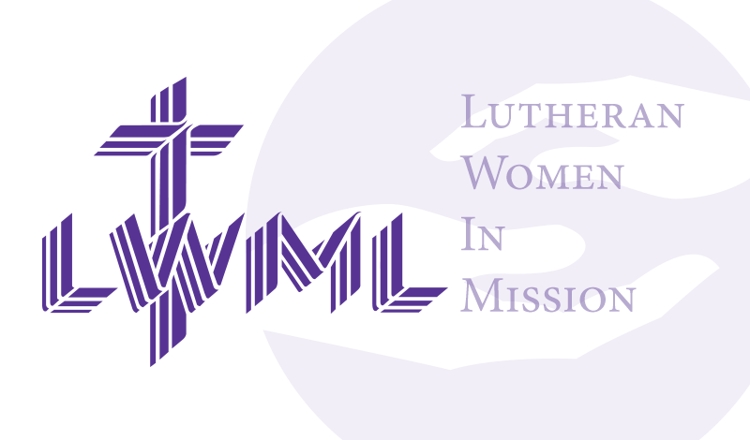

On October 4th, Salem Lutheran’s LWML hosted the Fall Rally, and it was a great day. We started with a light continental breakfast—eggs, muffins, fruit, and drinks—and 69 people joined us for the event.
Thanks to everyone's generosity, we collected 115 glasses and 36 cases, 1 box of pill bottles, 1400 stamps, and 3 boxes of magazines. We also raised $435.00 for the LWML mites. In addition to the collection at the rally, we gathered $43.00 more donations during coffee hour on LWML Sunday. A big thank you to all who contributed!
The Bible study on prayer, led by the groups from Hayward and Lampson, was a highlight of the day. We also had some helpful updates during our meeting, including news from the Yours Mine and Ours thrift shop, a report from the LWML North Wisconsin President, and a recap from a member who attended the National Conference in Omaha, Nebraska. Pastor shared an uplifting opening and closing message, and Cindy Wright played some beautiful organ music for us.
After the meeting, we worked together to pack 100 school supply kits and 100 hygiene kits for those in need. These kits will be sent to the Orphan Grain Train. Thanks to everyone who helped with this project!
We finished the day with a German luncheon, including kielbasa, German potato salad, buns, meats, cheeses, and pumpkin bars. A special thank you to Kathy Schuettpelz, Cathy Gowin, Deb Kuhrt, and Deb Lipke for all their help in the kitchen!
As a thank you, everyone left with a homemade bookmark and an information packet. Thanks to Melissa Freiberg for making those lovely bookmarks!
Our LWML team consists of Nancy Koenig, Mary Ann Thompson, Denise Stabenow, Marcia Elloitt, Jen Millerman, Linda Reibe, Sue Millerman, and Amy Dennis. If you’re interested in joining us, feel free to reach out—we’d love to have you!

