Hymn: 837 Lift High the Cross sts. ref–6
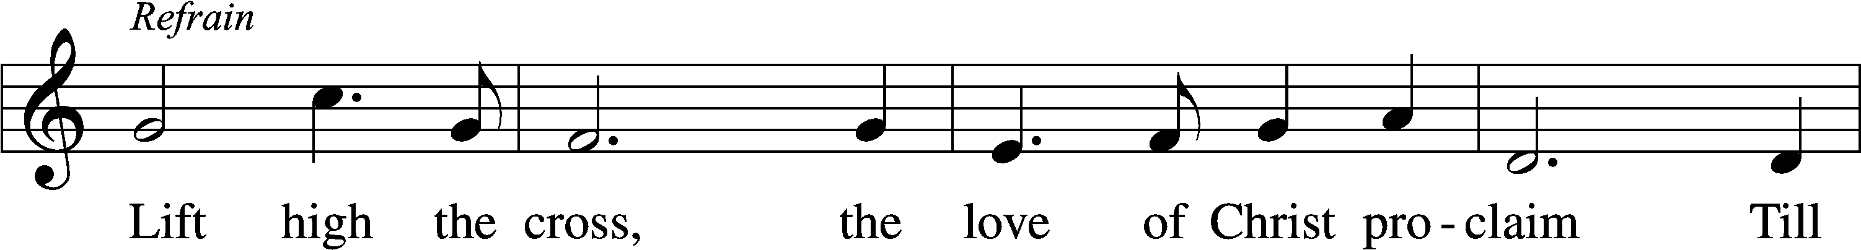
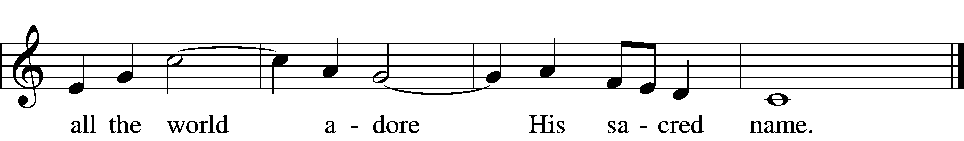
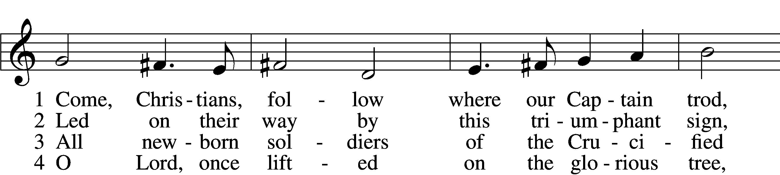
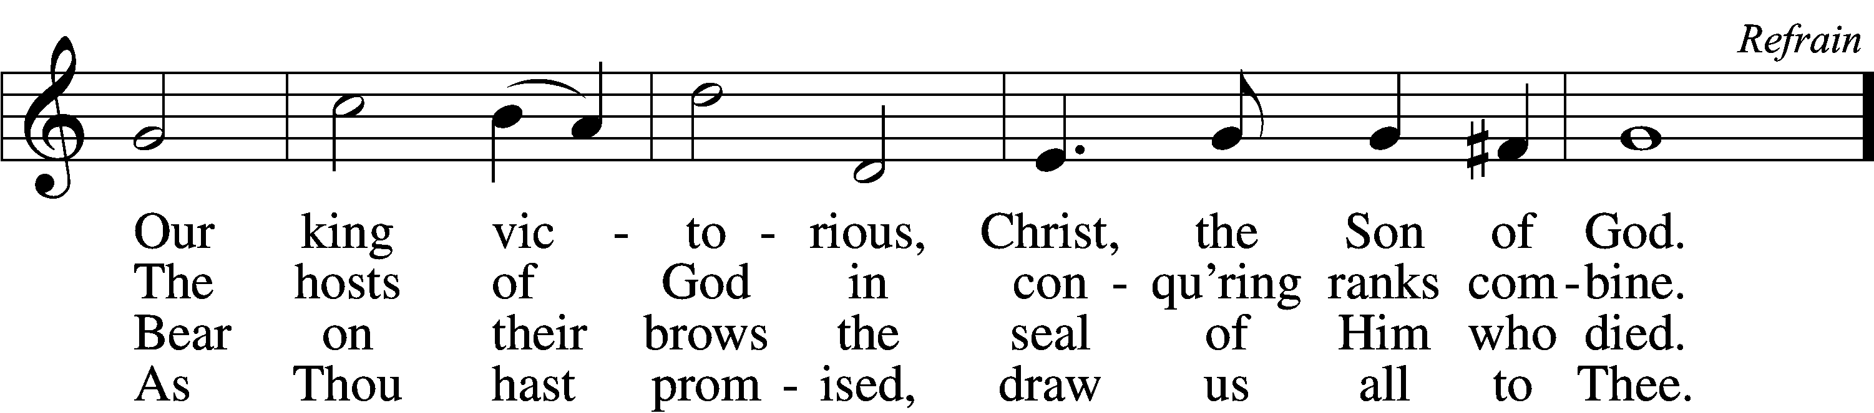

5 Let ev’ry race and ev’ry language tell
Of Him who saves our lives from death and hell. Refrain

6 So shall our song of triumph ever be:
Praise to the Crucified for victory! Refrain
Text: George W. Kitchin, 1827–1912; rev. Michael R. Newbolt, 1874–1956, alt.
Tune: Sydney H. Nicholson, 1875–1947
Text and tune: © 1974 Hope Publishing Co. Used by permission: LSB Hymn License no. 110005504

Stand

Opening Versicles

L This is the day which the Lord has made;
C let us rejoice and be glad in it.
L From the rising of the sun to its setting,
C the name of the Lord is to be praised.

L Better is one day in Your courts than a thousand elsewhere;
C I would rather be a doorkeeper in the house of my God than dwell in the tents of the wicked.
L Make me to know Your ways, O Lord.
C Teach me Your paths.
L Sanctify us in Your truth.
C Your Word is truth.

L From the rising of the sun to its setting,
C the name of the Lord is to be praised.

C Glory be to the Father and to the Son and to the Holy Spirit;
as it was in the beginning, is now, and will be forever. Amen.

Old Testament Canticle LSB 261
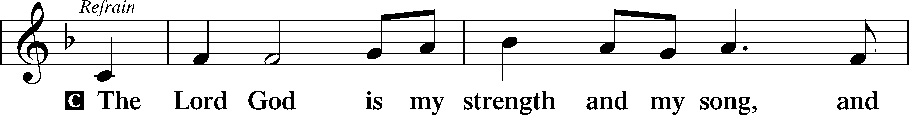
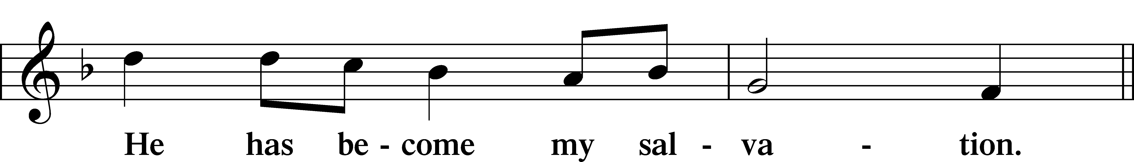
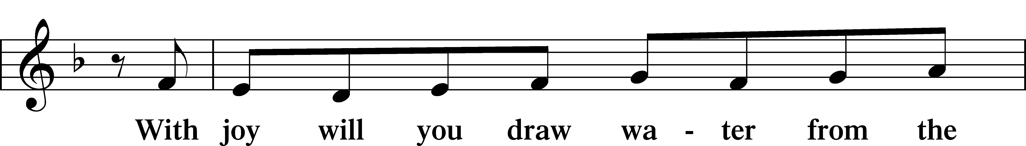
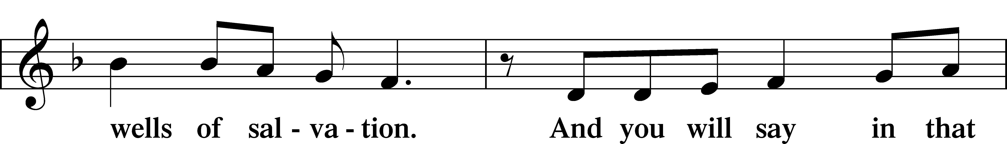
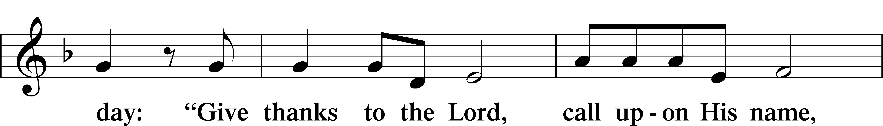
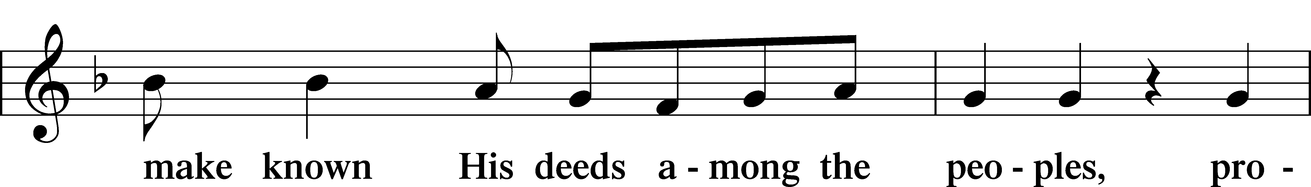
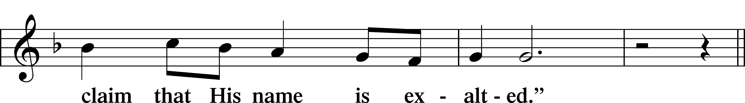
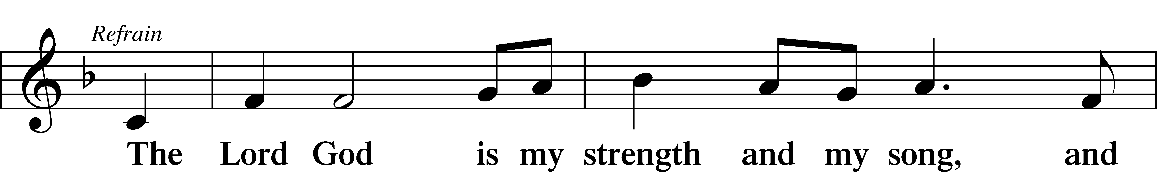
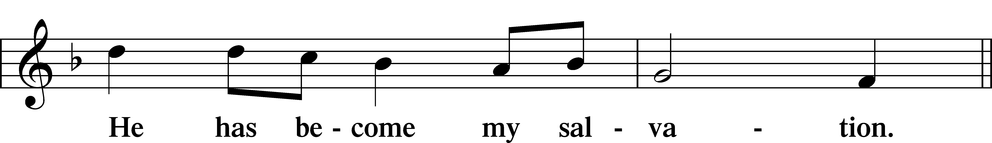
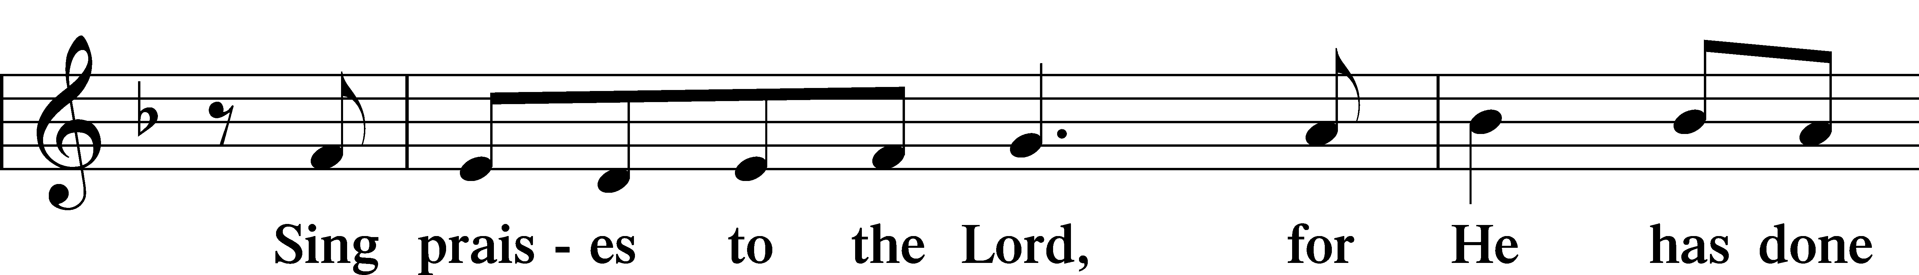
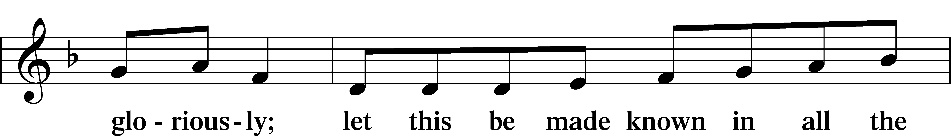
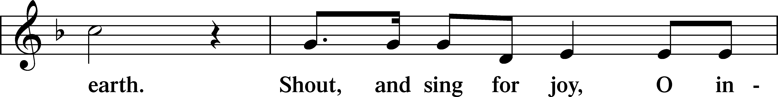
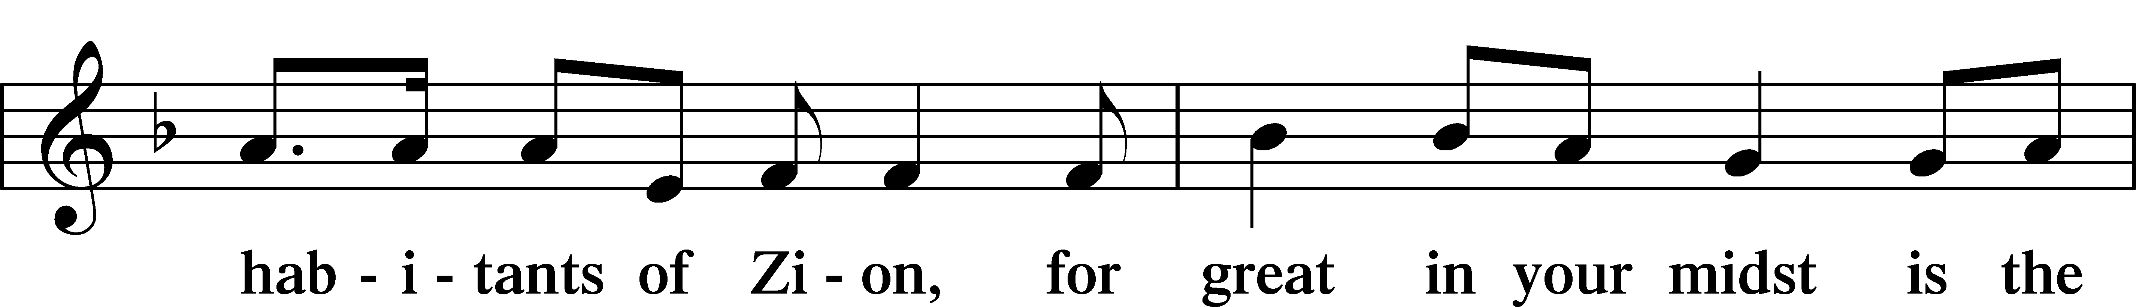
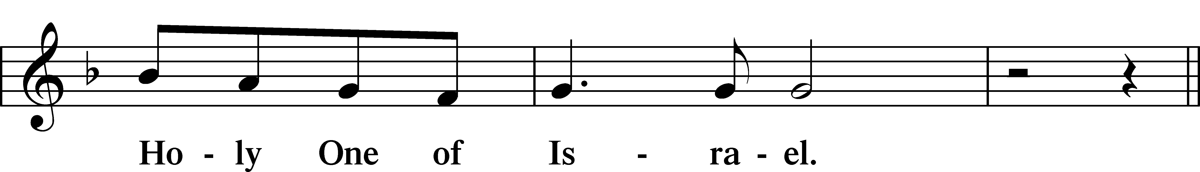
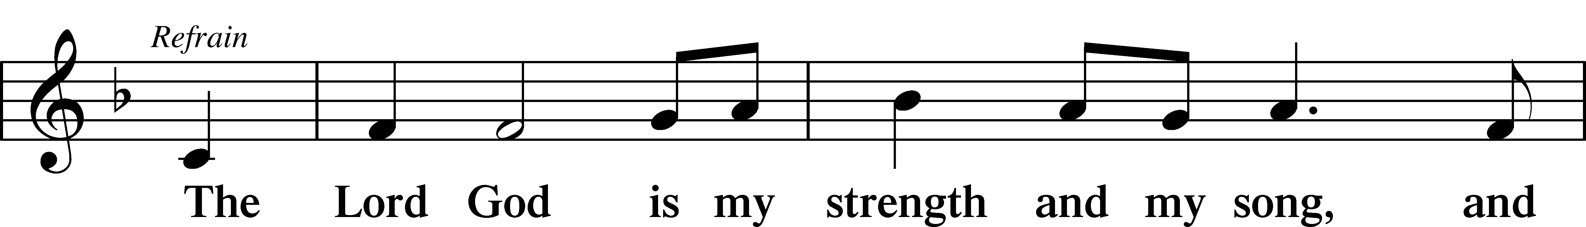
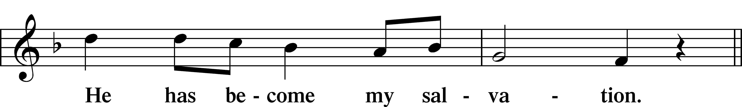
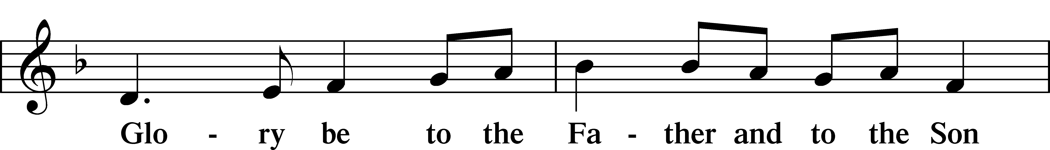
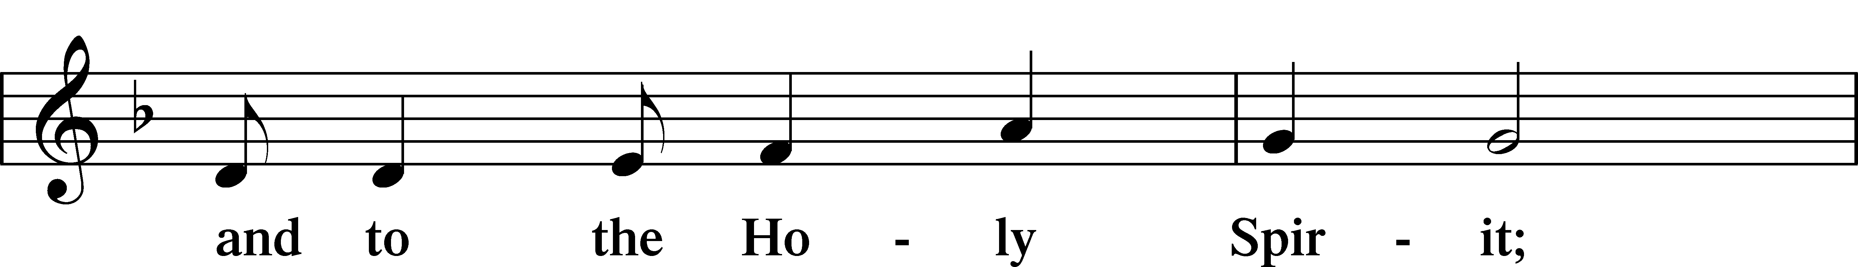
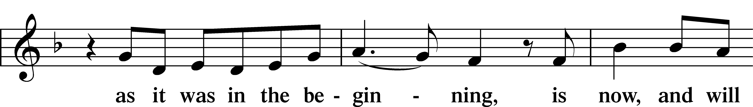
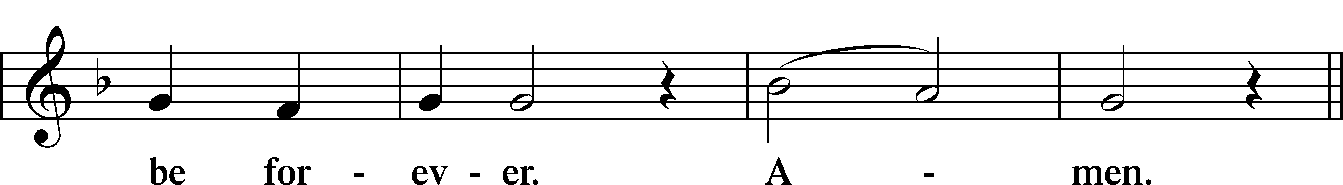
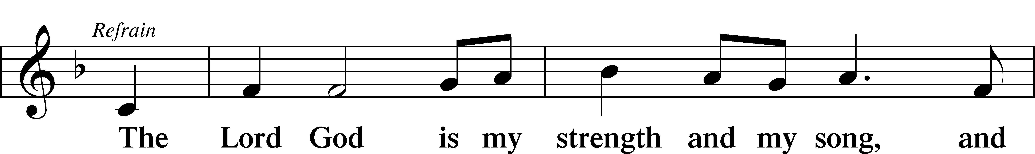
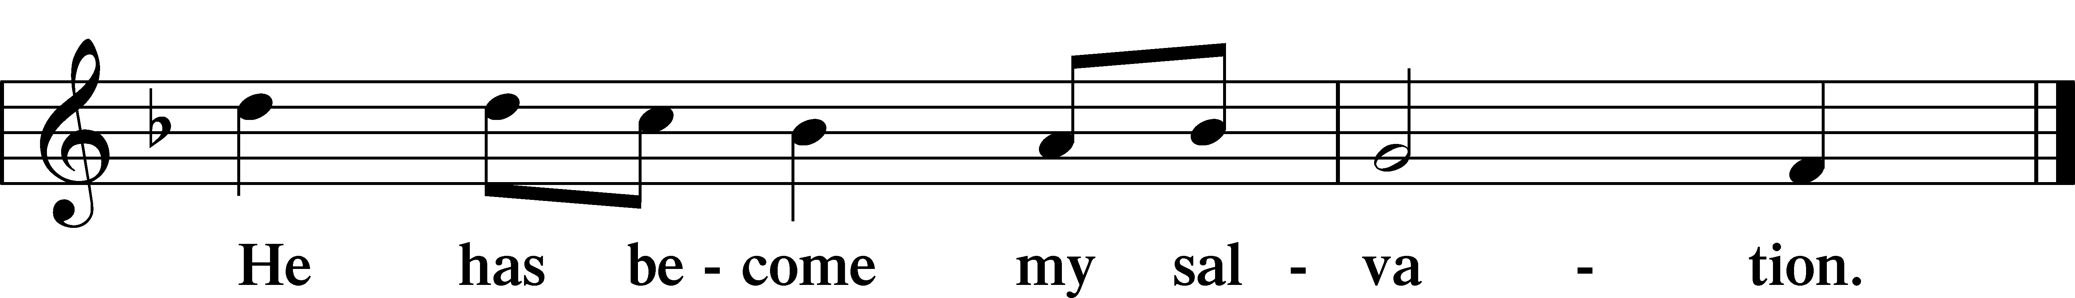

Sit

Readings From Holy Scripture

Reading Acts 8:26–40
L A reading from Acts, the eighth chapter.

Philip and the Ethiopian Eunuch
26An angel of the Lord said to Philip, “Rise and go toward the south to the road that goes down from Jerusalem to Gaza.” This is a desert place. 27And he rose and went. And there was an Ethiopian, a eunuch, a court official of Candace, queen of the Ethiopians, who was in charge of all her treasure. He had come to Jerusalem to worship 28and was returning, seated in his chariot, and he was reading the prophet Isaiah. 29And the Spirit said to Philip, “Go over and join this chariot.” 30So Philip ran to him and heard him reading Isaiah the prophet and asked, “Do you understand what you are reading?” 31And he said, “How can I, unless someone guides me?” And he invited Philip to come up and sit with him. 32Now the passage of the Scripture that he was reading was this:
“Like a sheep he was led to the slaughter
and like a lamb before its shearer is silent,
so he opens not his mouth.
33In his humiliation justice was denied him.
Who can describe his generation?
For his life is taken away from the earth.”
34And the eunuch said to Philip, “About whom, I ask you, does the prophet say this, about himself or about someone else?” 35Then Philip opened his mouth, and beginning with this Scripture he told him the good news about Jesus. 36And as they were going along the road they came to some water, and the eunuch said, “See, here is water! What prevents me from being baptized?” 38And he commanded the chariot to stop, and they both went down into the water, Philip and the eunuch, and he baptized him. 39And when they came up out of the water, the Spirit of the Lord carried Philip away, and the eunuch saw him no more, and went on his way rejoicing. 40But Philip found himself at Azotus, and as he passed through he preached the gospel to all the towns until he came to Caesarea.

L This is the Word of the Lord.
C Thanks be to God.

Psalms, hymns, or choral music may be sung between the readings.

Reading 1 John 4:1–11
Test the Spirits
1Beloved, do not believe every spirit, but test the spirits to see whether they are from God, for many false prophets have gone out into the world. 2By this you know the Spirit of God: every spirit that confesses that Jesus Christ has come in the flesh is from God, 3and every spirit that does not confess Jesus is not from God. This is the spirit of the antichrist, which you heard was coming and now is in the world already. 4Little children, you are from God and have overcome them, for he who is in you is greater than he who is in the world. 5They are from the world; therefore they speak from the world, and the world listens to them. 6We are from God. Whoever knows God listens to us; whoever is not from God does not listen to us. By this we know the Spirit of truth and the spirit of error.
God Is Love
7Beloved, let us love one another, for love is from God, and whoever loves has been born of God and knows God. 8Anyone who does not love does not know God, because God is love. 9In this the love of God was made manifest among us, that God sent his only Son into the world, so that we might live through him. 10In this is love, not that we have loved God but that he loved us and sent his Son to be the propitiation for our sins. 11Beloved, if God so loved us, we also ought to love one another.

Reading John 15:1–8
I Am the True Vine
1[Jesus said:] “I am the true vine, and my Father is the vinedresser. 2Every branch of mine that does not bear fruit he takes away, and every branch that does bear fruit he prunes, that it may bear more fruit. 3Already you are clean because of the word that I have spoken to you. 4Abide in me, and I in you. As the branch cannot bear fruit by itself, unless it abides in the vine, neither can you, unless you abide in me. 5I am the vine; you are the branches. Whoever abides in me and I in him, he it is that bears much fruit, for apart from me you can do nothing. 6If anyone does not abide in me he is thrown away like a branch and withers; and the branches are gathered, thrown into the fire, and burned. 7If you abide in me, and my words abide in you, ask whatever you wish, and it will be done for you. 8By this my Father is glorified, that you bear much fruit and so prove to be my disciples.”

Responsory

L Forever, O Lord, Your Word is firmly set in the heavens.
C Lord, I love the habitation of Your house and the place where Your glory dwells.
L Blessed are those who hear the Word of God and keep it.
C Lord, I love the habitation of Your house and the place where Your glory dwells.
L Glory be to the Father and to the Son and to the Holy Spirit.
C Lord, I love the habitation of Your house and the place where Your glory dwells.

Reading Psalm 150
Let Everything Praise the Lord
1Praise the Lord!
Praise God in his sanctuary;
praise him in his mighty heavens
2Praise him for his mighty deeds;
praise him according to his excellent greatness!
3Praise him with trumpet sound;
praise him with lute and harp!
4Praise him with tambourine and dance;
praise him with strings and pipe!
5Praise him with sounding cymbals;
praise him with loud clashing cymbals!
6Let everything that has breath praise the Lord!
Praise the Lord!

Stand

Ten Commandments
C You shall have no other gods.
You shall not misuse the name of the Lord your God.
Remember the Sabbath day by keeping it holy.
Honor your father and your mother.
You shall not murder.
You shall not commit adultery.
You shall not steal.
You shall not give false testimony against your neighbor.
You shall not covet your neighbor’s house.
You shall not covet your neighbor’s wife, or his manservant or maidservant, his ox or donkey, or anything that belongs to your neighbor.

Apostles’ Creed
C I believe in God, the Father Almighty,
maker of heaven and earth.

And in Jesus Christ, His only Son, our Lord,
who was conceived by the Holy Spirit,
born of the virgin Mary,
suffered under Pontius Pilate,
was crucified, died and was buried.
He descended into hell.
The third day He rose again from the dead.
He ascended into heaven
and sits at the right hand of God the Father Almighty.
From thence He will come to judge the living and the dead.

I believe in the Holy Spirit,
the holy Christian Church,
the communion of saints,
the forgiveness of sins,
the resurrection of the body,
and the life T everlasting. Amen.

Lord’s Prayer
C Our Father who art in heaven,
hallowed be Thy name,
Thy kingdom come,
Thy will be done on earth
as it is in heaven;
give us this day our daily bread;
and forgive us our trespasses
as we forgive those
who trespass against us;
and lead us not into temptation,
but deliver us from evil.
For Thine is the kingdom
and the power and the glory
forever and ever. Amen.

Sit

Hymn

Hymn: 596 All Christians Who Have Been Baptized
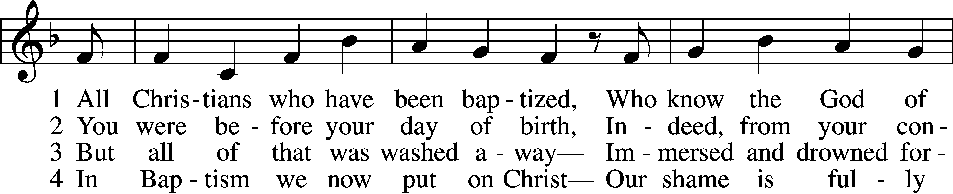
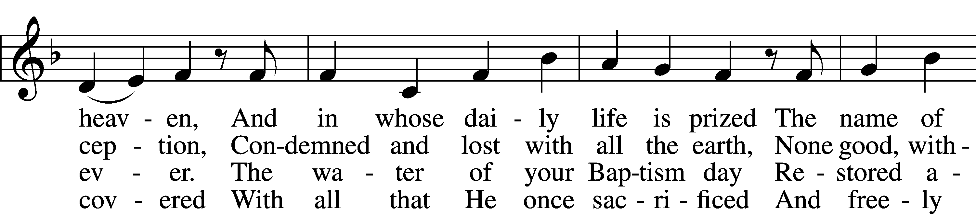
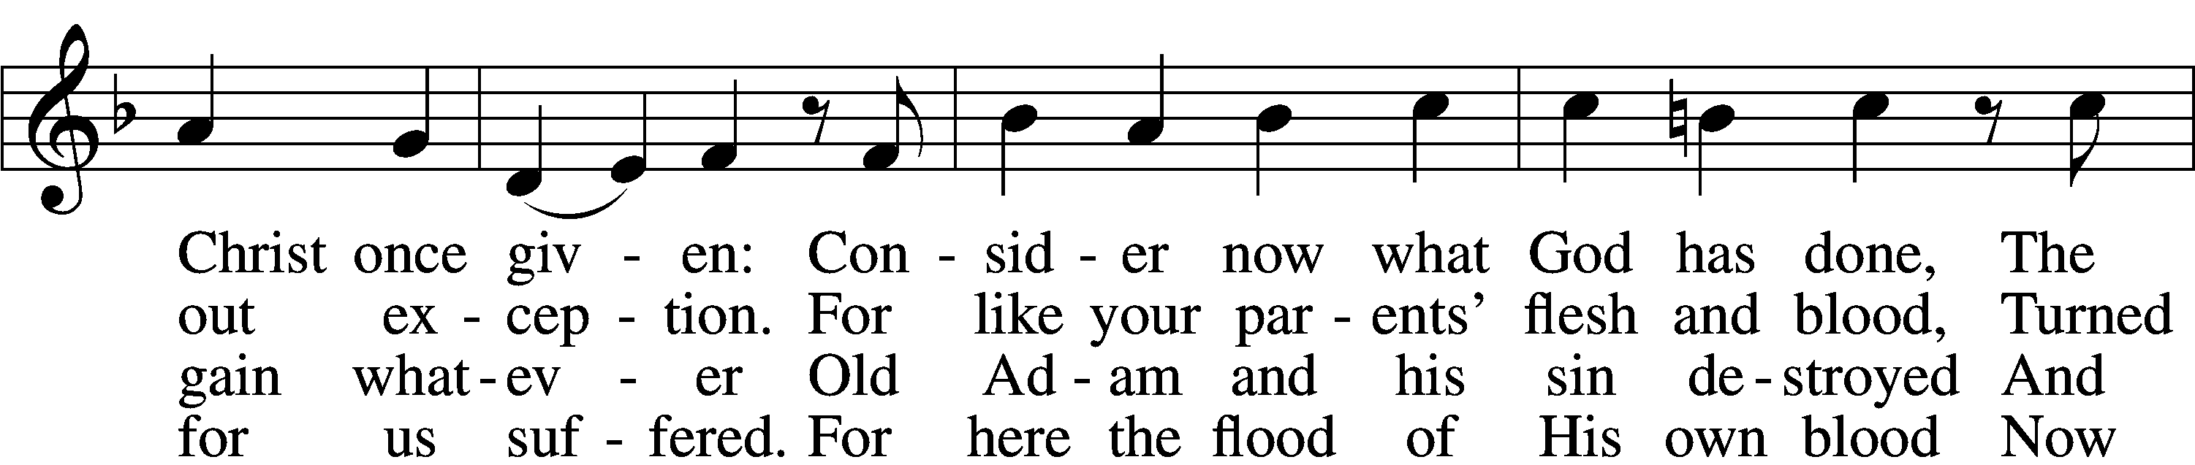
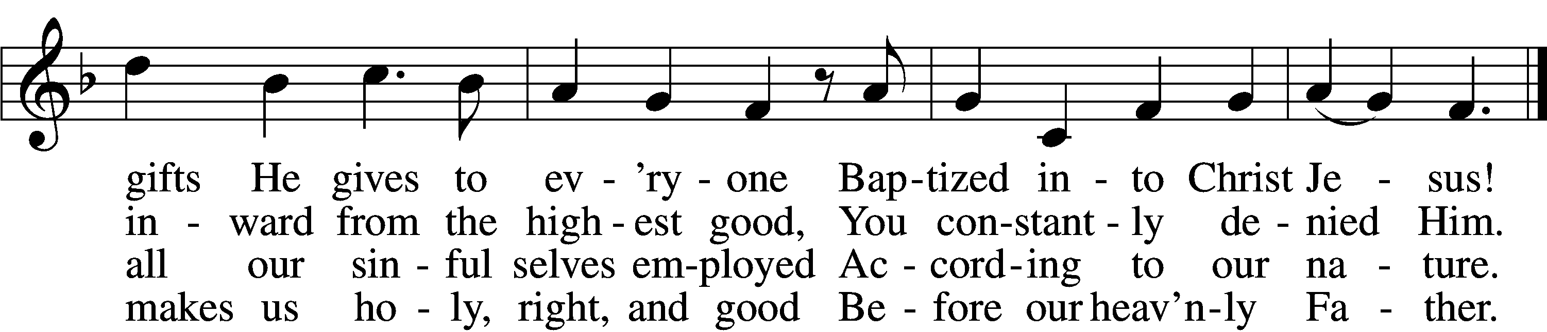

5 O Christian, firmly hold this gift
And give God thanks forever!
It gives the power to uplift
In all that you endeavor.
When nothing else revives your soul,
Your Baptism stands and makes you whole
And then in death completes you.

6 So use it well! You are made new—
In Christ a new creation!
As faithful Christians, live and do
Within your own vocation,
Until that day when you possess
His glorious robe of righteousness
Bestowed on you forever!
Text: Paul Gerhardt, 1607–76; tr. Jon D. Vieker, 1961
Tune: Etlich Cristlich lider, 1524, Wittenberg
Text: © 2004 Concordia Publishing House. Used by permission: LSB Hymn License no. 110005504
Tune: Public domain

Sermon

Hymn: 594 God’s Own Child, I Gladly Say It
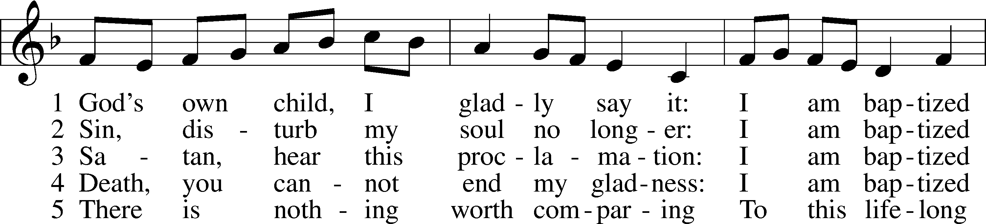
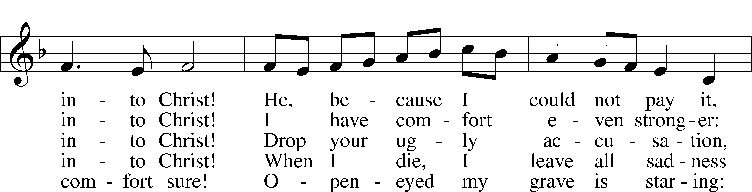
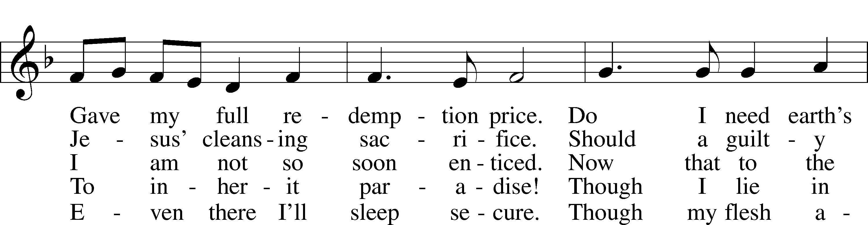
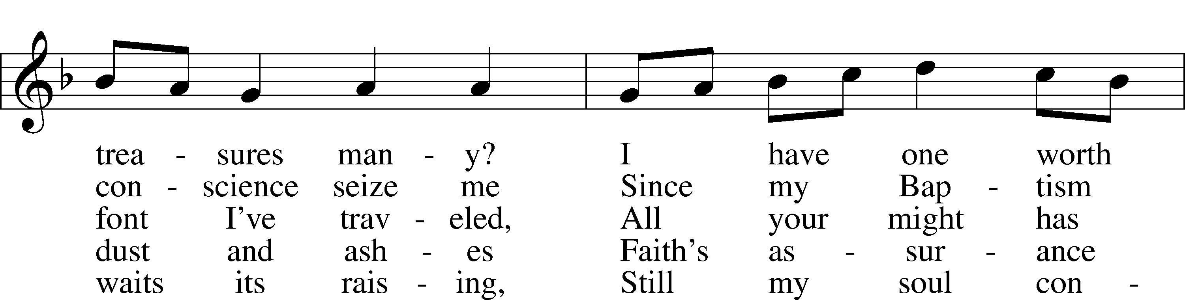
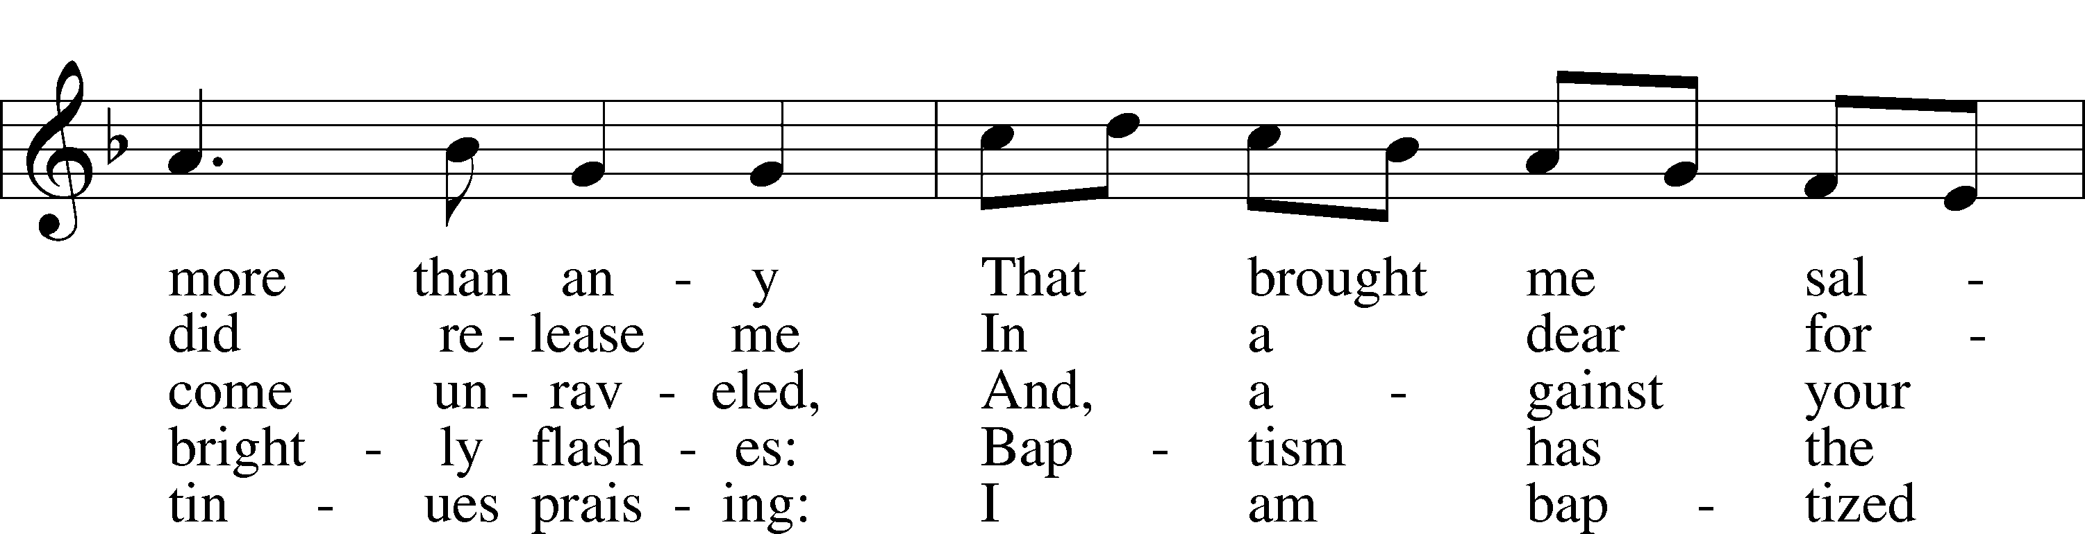
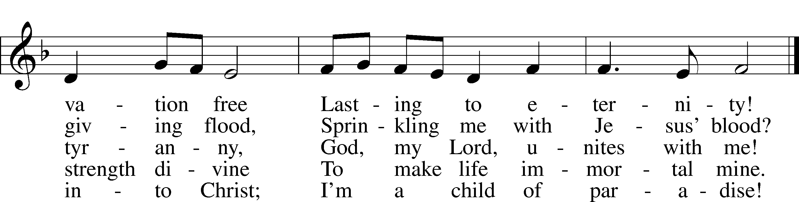
Text: Erdmann Neumeister, 1671–1756; tr. Robert E. Voelker, 1957
Tune: Johann Caspar Bachofen, 1695–1755, alt.
Text: © 1991 Robert E. Voelker. Used by permission: LSB Hymn License no. 110005504
Tune: Public domain

Offering

Stand

Prayer
L In peace let us pray to the Lord:
C Lord, have mercy.
L For the gift of divine peace and of pardon, with all our heart and with all our mind, let us pray to the Lord:
C Lord, have mercy.
L For the holy Christian Church, here and scattered throughout the world, and for the proclamation of the Gospel and the calling of all to faith, let us pray to the Lord:
C Lord, have mercy.
L For this nation, for our cities and communities, and for the common welfare of us all, let us pray to the Lord:
C Lord, have mercy.
L For seasonable weather and for the fruitfulness of the earth, let us pray to the Lord:
C Lord, have mercy.
L For those who labor, for those whose work is difficult or dangerous, and for all who travel, let us pray to the Lord:
C Lord, have mercy.
L For all those in need, for the hungry and homeless, for the widowed and orphaned, and for all those in prison, let us pray to the Lord:
C Lord, have mercy.
L For the sick and dying and for all those who care for them, let us pray to the Lord:
C Lord, have mercy.
L For . . . [additional bids for prayer may be inserted here] . . . let us pray to the Lord:
C Lord, have mercy.
L Finally, for these and for all our needs of body and soul, let us pray to the Lord:
C Lord, have mercy. Christ, have mercy. Lord, have mercy.

Collect of the Day
L O God, You make the minds of Your faithful to be of one will. Grant that we may love what You have commanded and desire what You promise, that among the many changes of this world our hearts may be fixed where true joys are found; through Jesus Christ, Your Son, our Lord, who lives and reigns with You and the Holy Spirit, one God, now and forever.
C Amen.

Collect for the Word
L Blessed Lord, You have caused all Holy Scriptures to be written for our learning. Grant that we may so hear them, read, mark, learn, and take them to heart that, by the patience and comfort of Your holy Word, we may embrace and ever hold fast the blessed hope of everlasting life; through Jesus Christ, Your Son, our Lord, who lives and reigns with You and the Holy Spirit, one God, now and forever.
C Amen.

Morning Prayer
C I thank You, my heavenly Father, through Jesus Christ, Your dear Son, that You have kept me this night from all harm and danger; and I pray that You would keep me this day also from sin and every evil, that all my doings and life may please You. For into Your hands I commend myself, my body and soul, and all things. Let Your holy angel be with me, that the evil foe may have no power over me.

New Testament Canticle LSB 266
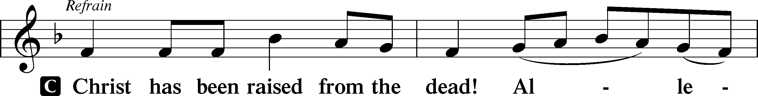
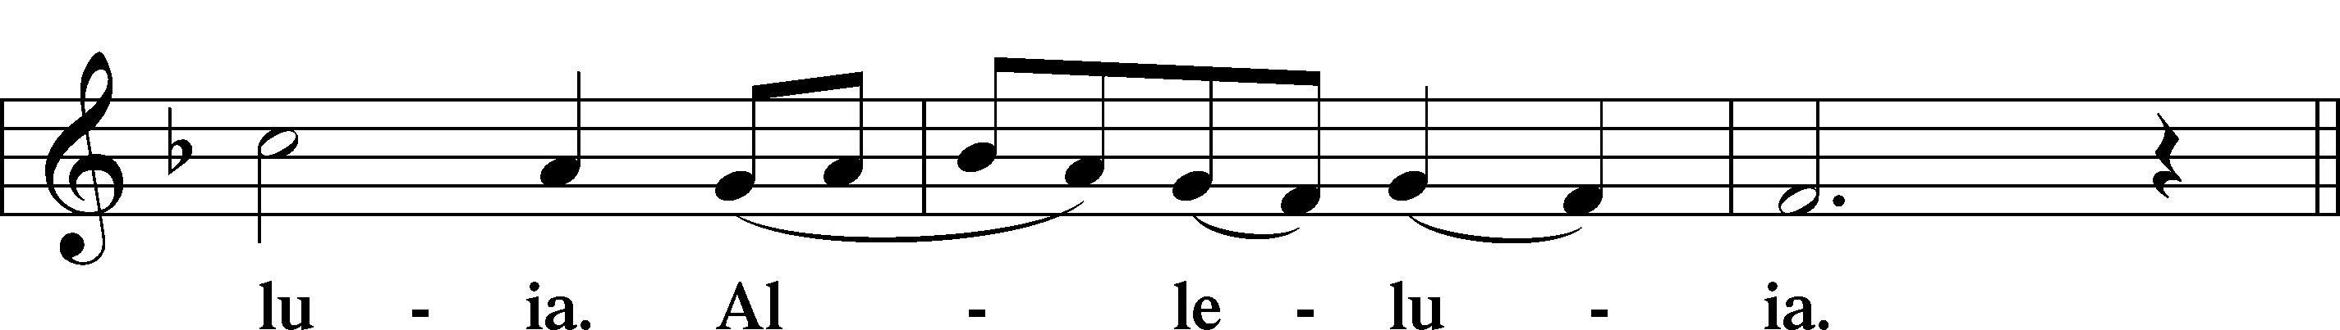
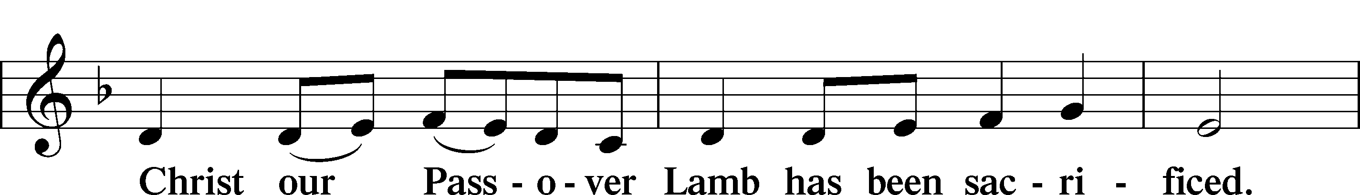
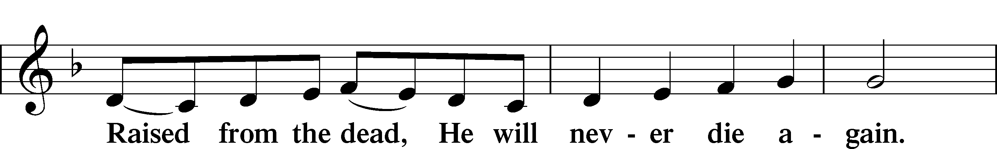
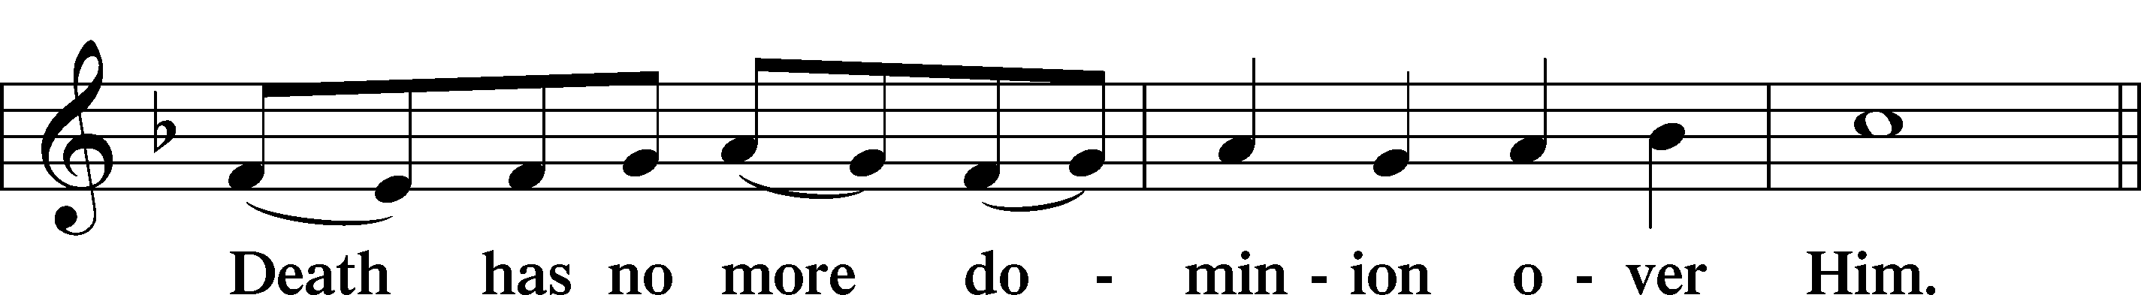
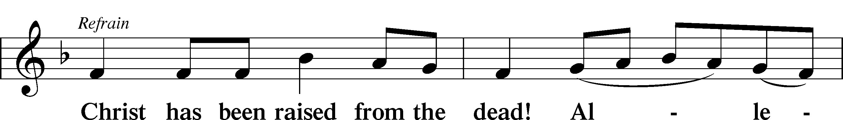
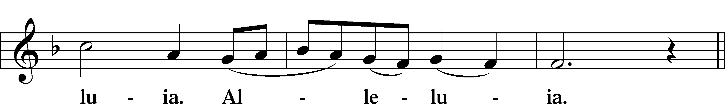
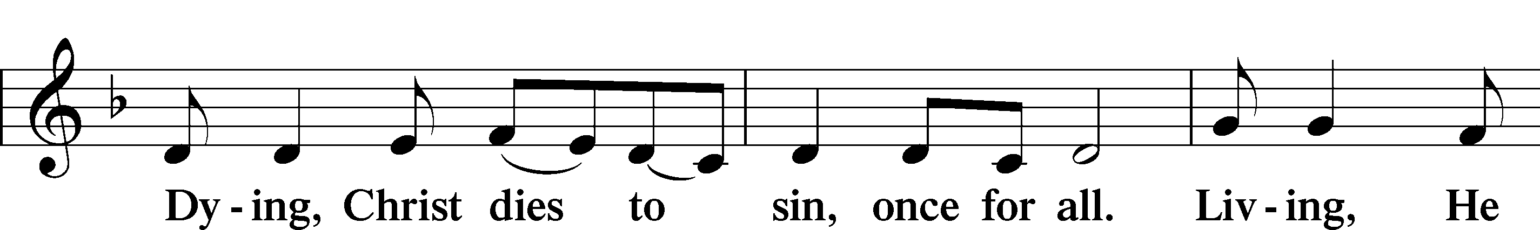
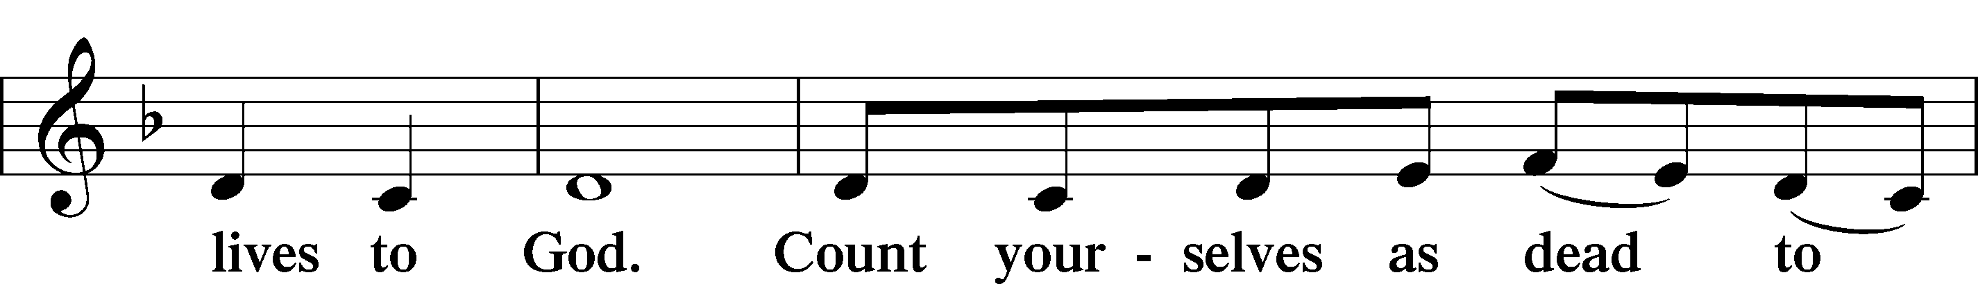
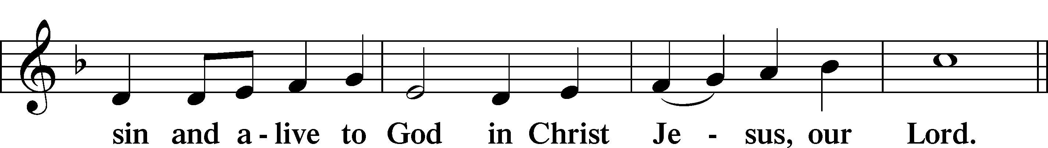
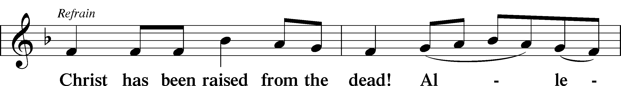
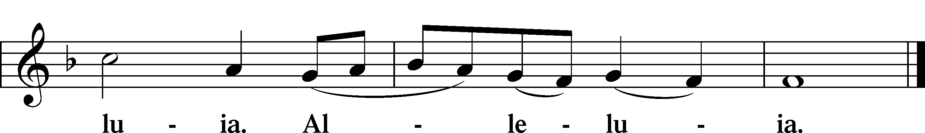

Blessing

L Let us bless the Lord.
C Thanks be to God.

L The almighty and merciful Lord, the Father, the T Son, and the Holy Spirit, bless and preserve us.
C Amen.

Hymn
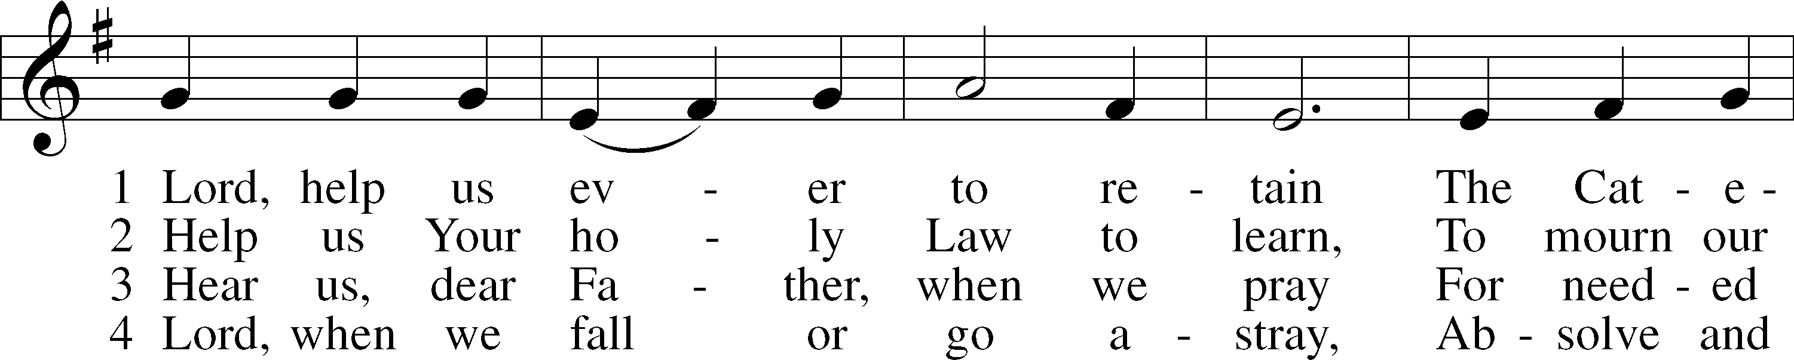
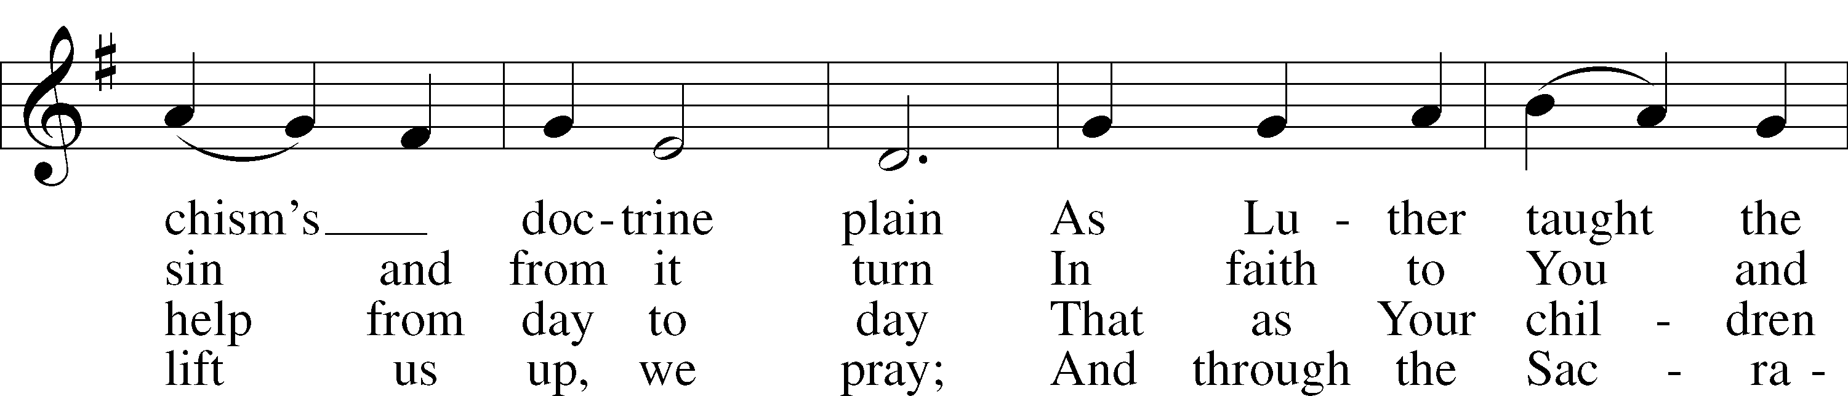
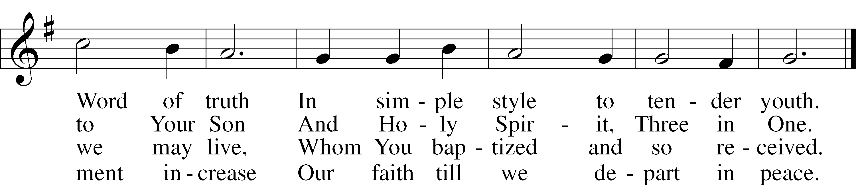
Text: Ludwig Helmbold, 1532–98; tr. Matthias Loy, 1828–1915, alt.
Tune: As hymnodus sacer, 1625, Leipzig
Text and tune: Public domain

Acknowledgments
Service of Prayer and Preaching from Lutheran Service Book
Unless otherwise indicated, Scripture quotations are from the ESV® Bible (The Holy Bible, English Standard Version®), copyright © 2001 by Crossway, a publishing ministry of Good News Publishers. Used by permission. All rights reserved.
Created by Lutheran Service Builder © 2024 Concordia Publishing House.

Church Service Phone: 888-505-1870/715-438-4200
(Stay on the line for recorded service to start)
Live Stream audio services: http://salem.listentochurch.com
Salem’s Web Page: https://www.salembarron.com/
Pastor Fred Buth: Cell phone:715-642-3050 (H)715-353-2540
Pastor’s Email: salembarronpastor@gmail.com
Office Hours: Monday-Wednesday 9-12
Office email: salembarron@gmail.com
Attendance:
Call-in line: 4/21-0 In-person: 4/21-60

Coffee and Snacks: Mark & Amy/Fred & Linda
Elder Today: Don Duncan
Altar Guild: Nancy & Marcia

May 7th – 5:00pm - Church and parsonage clean up, bring rakes, shovels if you have them. There will be supper provided after.

Sign up in the back if you would like to join the choir. They will be singing in church May 19th.

Save the Date:
Today – Annual Spring Church Meeting after service May 1st – 6pm Choir practice May 7th – 5:00 pm Parsonage and Church yard clean up May 8th – 6pm Choir practice May 12- Teacher Appreciation Brunch, Mother’s Day, Graduates recognition Sunday, Children Singing in church May 13 – 6:00 PM – Circuit Lay Leader Meeting @ St. Paul’s Cumberland
May 15th – 6pm Choir practice May 19 – Last day of Sunday School, Choir singing May 21 -4:30 pm YFM

Prayers Request:
Those in the nursing home: Joann Jaeger Those Shut-in at home: Char Herman, Joan Church, Joyce Myers, Joyce Koba Those with ongoing health issues: Harrison Fields, Jeanne Perala, Owen Metz, Jeff Bonneville, Daria (Cindy Wright’s friend), Butch L. (Cindy Wright’s Brother-in-law), Melissa Miller., Dale Bryan, Art Smith (Sue Millerman’s brother), Brenda Sellent (Denise Stabenow’s sister), Sandy Hahn (Cindy Wright’s cousin’s wife), Roger Hinrichs Recovering from surgery: Wyatt Weise, Gail Espeseth Those who lead our nation: Joe Biden, Kamala Harris, Tony Evers, Rod Nordby Those who serve in our military and law enforcement: Ryan Graf, Chaplain Pon Chanthaphon (Our Adopt-a-Chaplain), Rusty Weise Our Childcare Staff: Melissa Weinert, Denise Stabenow, Katelyn Hendren, Holly Wilhelmi, Janica Skjerly, Jacie Amundson, Emily Young, Zuri Soto, Cathy Anderson For Christ Community Lutheran School – For God’s guidance throughout the development and planning process

