Prayer and Preaching pg.260

16th Sunday after Pentecost

September 28,2025

Hymn: 506 Glory Be to God the Father
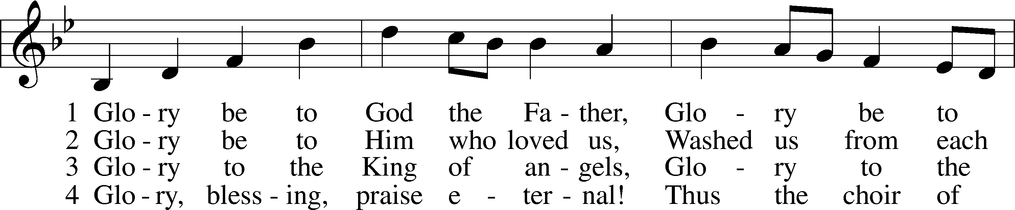
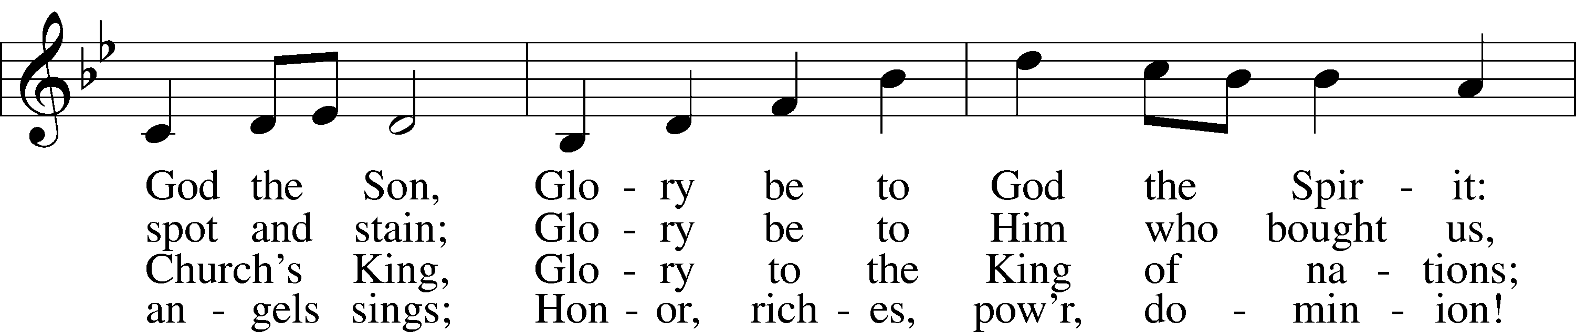
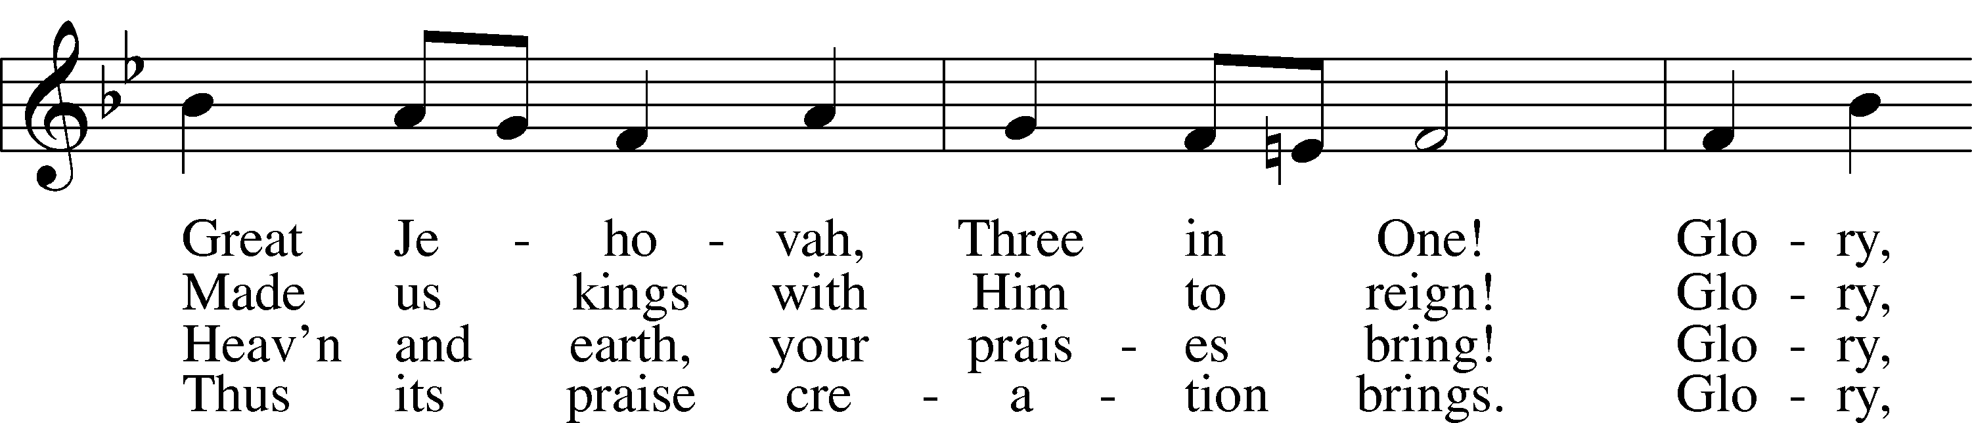
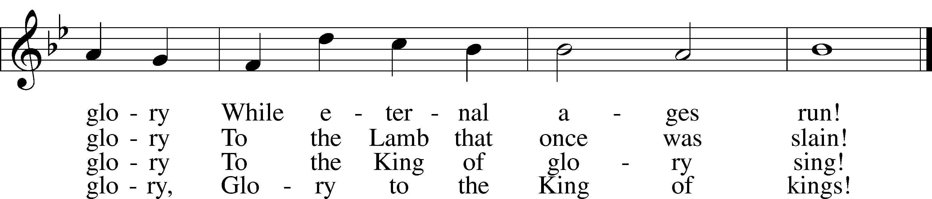

Text: Horatius Bonar, 1808–89
Tune: Walter G. Whinfield, 1865–1919
Text and tune: Public domain

Stand

Opening Versicles

L This is the day which the Lord has made;
C let us rejoice and be glad in it.
L From the rising of the sun to its setting,
C the name of the Lord is to be praised.

L Better is one day in Your courts than a thousand elsewhere;
C I would rather be a doorkeeper in the house of my God than dwell in the tents of the wicked.
L Make me to know Your ways, O Lord.
C Teach me Your paths.
L Sanctify us in Your truth.
C Your Word is truth.

L From the rising of the sun to its setting,
C the name of the Lord is to be praised.

C Glory be to the Father and to the Son and to the Holy Spirit;
as it was in the beginning, is now, and will be forever. Amen.

Old Testament Canticle LSB 261
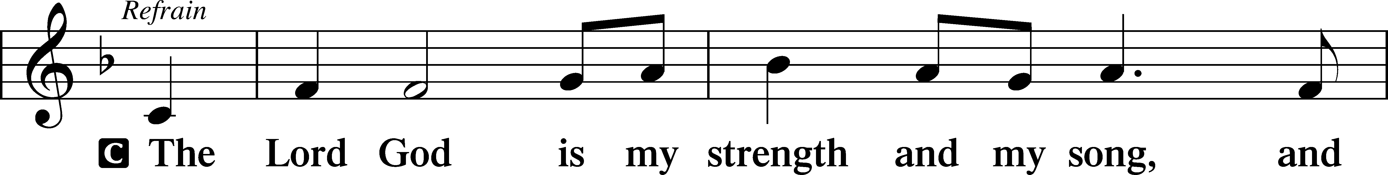
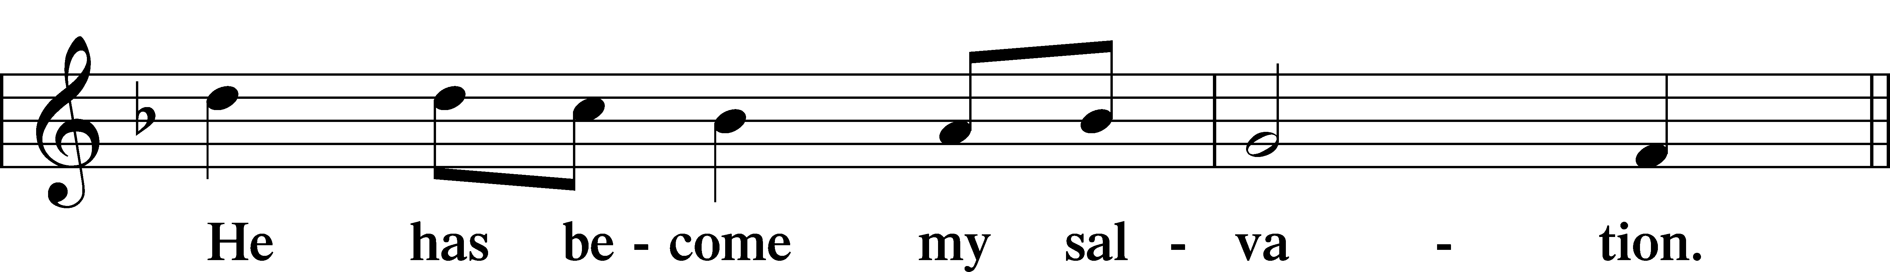


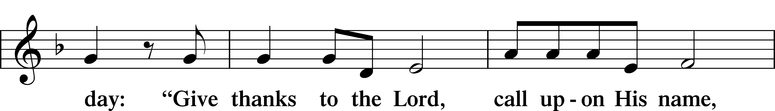
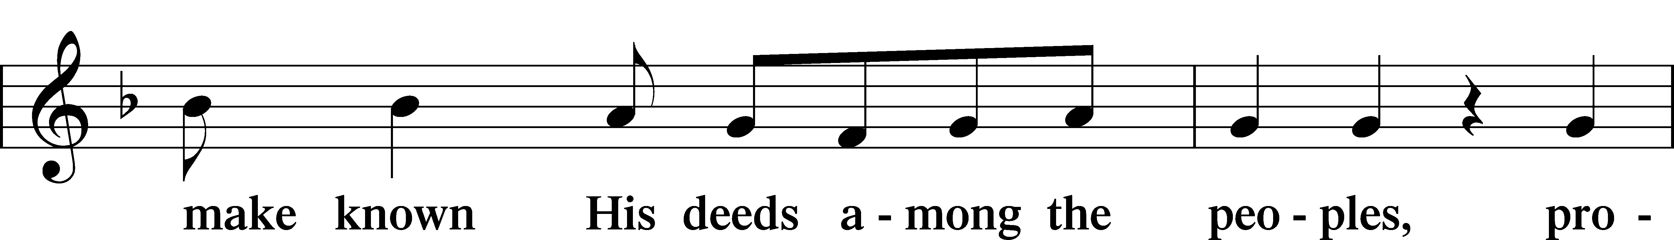

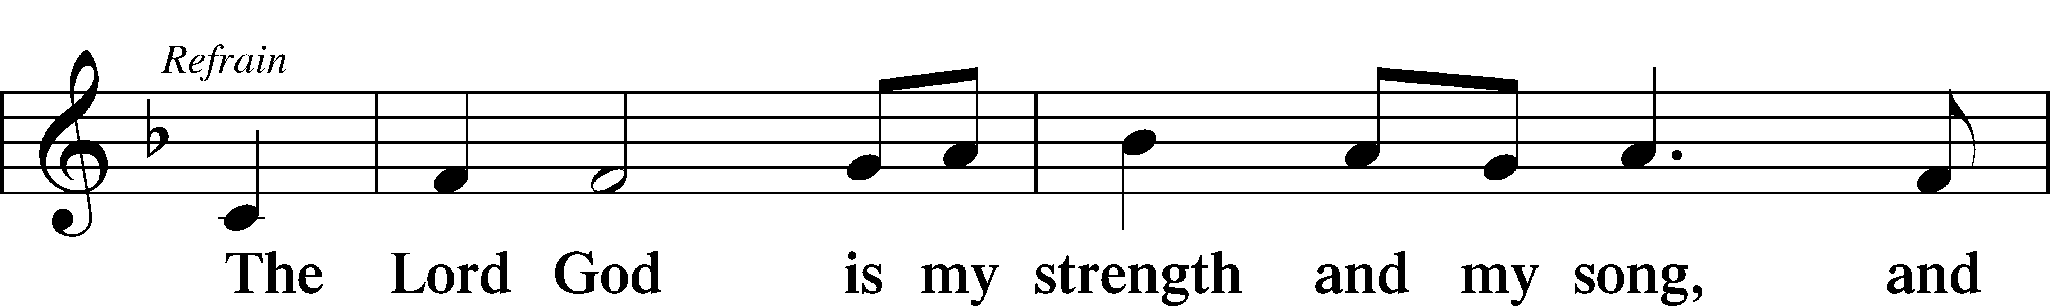
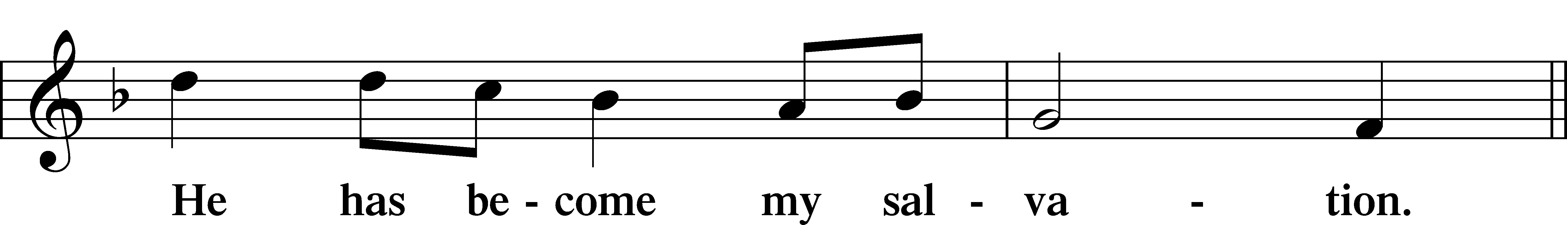




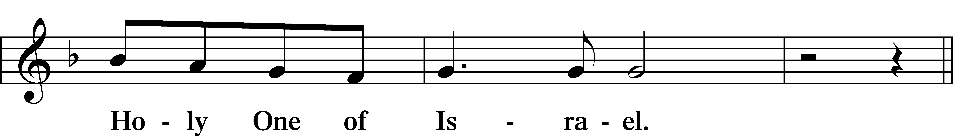
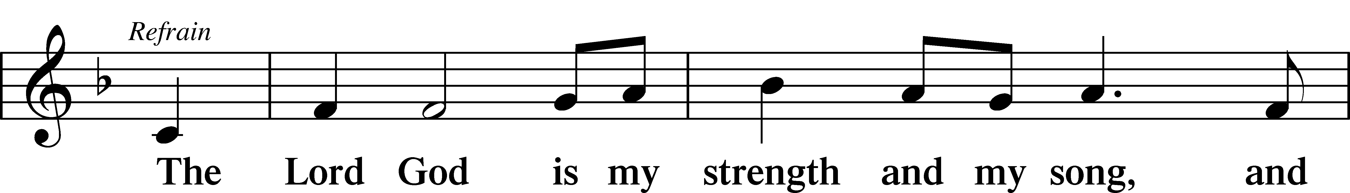
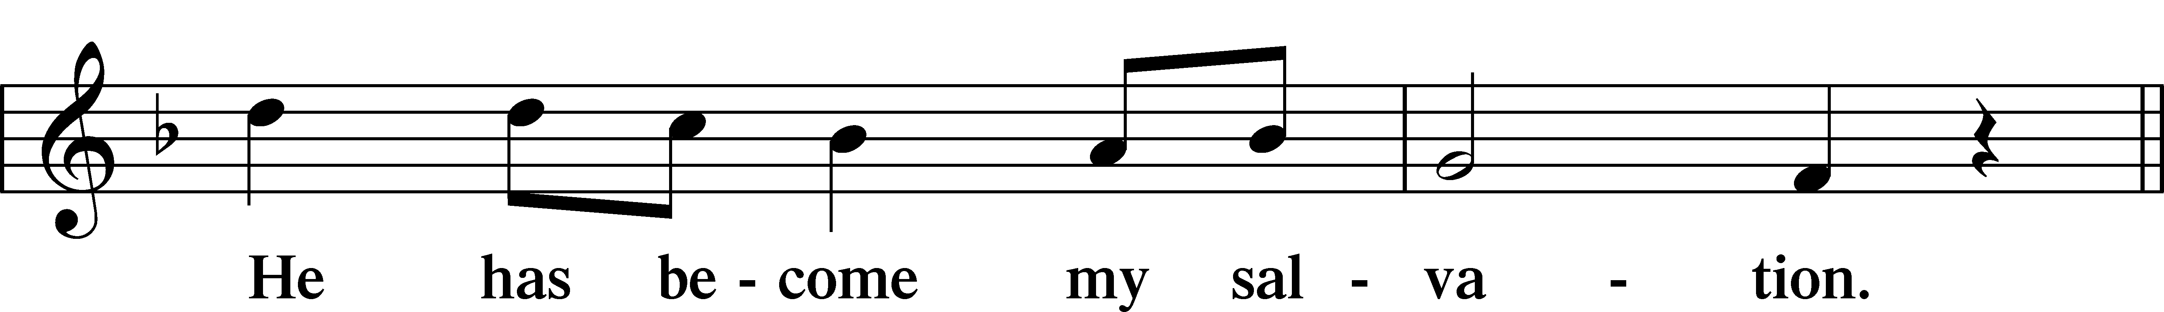




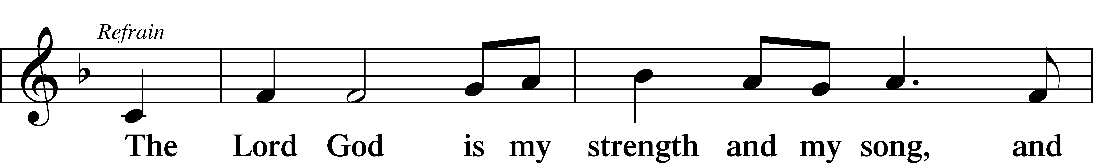


Sit

Readings From Holy Scripture

Reading Amos 6:1–7
L A reading from Amos, the sixth chapter.

Woe to Those at Ease in Zion
1“Woe to those who are at ease in Zion,
and to those who feel secure on the mountain of Samaria,
the notable men of the first of the nations,
to whom the house of Israel comes!
2Pass over to Calneh, and see,
and from there go to Hamath the great;
then go down to Gath of the Philistines.
Are you better than these kingdoms?
Or is their territory greater than your territory,
3O you who put far away the day of disaster
and bring near the seat of violence?
4“Woe to those who lie on beds of ivory
and stretch themselves out on their couches,
and eat lambs from the flock
and calves from the midst of the stall,
5who sing idle songs to the sound of the harp
and like David invent for themselves instruments of music,
6who drink wine in bowls
and anoint themselves with the finest oils,
but are not grieved over the ruin of Joseph!
7Therefore they shall now be the first of those who go into exile,
and the revelry of those who stretch themselves out shall pass away.”

L This is the Word of the Lord.
C Thanks be to God.

Reading 1 Timothy 3:1–13
Qualifications for Overseers
1The saying is trustworthy: If anyone aspires to the office of overseer, he desires a noble task. 2Therefore an overseer must be above reproach, the husband of one wife, sober-minded, self-controlled, respectable, hospitable, able to teach, 3not a drunkard, not violent but gentle, not quarrelsome, not a lover of money. 4He must manage his own household well, with all dignity keeping his children submissive, 5for if someone does not know how to manage his own household, how will he care for God’s church? 6He must not be a recent convert, or he may become puffed up with conceit and fall into the condemnation of the devil. 7Moreover, he must be well thought of by outsiders, so that he may not fall into disgrace, into a snare of the devil.
Qualifications for Deacons
8Deacons likewise must be dignified, not double-tongued, not addicted to much wine, not greedy for dishonest gain. 9They must hold the mystery of the faith with a clear conscience. 10And let them also be tested first; then let them serve as deacons if they prove themselves blameless. 11Their wives likewise must be dignified, not slanderers, but sober-minded, faithful in all things. 12Let deacons each be the husband of one wife, managing their children and their own households well. 13For those who serve well as deacons gain a good standing for themselves and also great confidence in the faith that is in Christ Jesus.

Psalms, hymns, or choral music may be sung between the readings.

Reading Luke 16:19–31
The Rich Man and Lazarus
19[Jesus said:] “There was a rich man who was clothed in purple and fine linen and who feasted sumptuously every day. 20And at his gate was laid a poor man named Lazarus, covered with sores, 21who desired to be fed with what fell from the rich man’s table. Moreover, even the dogs came and licked his sores. 22The poor man died and was carried by the angels to Abraham’s side. The rich man also died and was buried, 23and in Hades, being in torment, he lifted up his eyes and saw Abraham far off and Lazarus at his side. 24And he called out, ‘Father Abraham, have mercy on me, and send Lazarus to dip the end of his finger in water and cool my tongue, for I am in anguish in this flame.’ 25But Abraham said, ‘Child, remember that you in your lifetime received your good things, and Lazarus in like manner bad things; but now he is comforted here, and you are in anguish. 26And besides all this, between us and you a great chasm has been fixed, in order that those who would pass from here to you may not be able, and none may cross from there to us.’ 27And he said, ‘Then I beg you, father, to send him to my father’s house— 28for I have five brothers—so that he may warn them, lest they also come into this place of torment.’ 29But Abraham said, ‘They have Moses and the Prophets; let them hear them.’ 30And he said, ‘No, father Abraham, but if someone goes to them from the dead, they will repent.’ 31He said to him, ‘If they do not hear Moses and the Prophets, neither will they be convinced if someone should rise from the dead.’”

Responsory

L Forever, O Lord, Your Word is firmly set in the heavens.
C Lord, I love the habitation of Your house and the place where Your glory dwells.
L Blessed are those who hear the Word of God and keep it.
C Lord, I love the habitation of Your house and the place where Your glory dwells.
L Glory be to the Father and to the Son and to the Holy Spirit.
C Lord, I love the habitation of Your house and the place where Your glory dwells.

Stand

Ten Commandments
C You shall have no other gods.
You shall not misuse the name of the Lord your God.
Remember the Sabbath day by keeping it holy.
Honor your father and your mother.
You shall not murder.
You shall not commit adultery.
You shall not steal.
You shall not give false testimony against your neighbor.
You shall not covet your neighbor’s house.
You shall not covet your neighbor’s wife, or his manservant or maidservant, his ox or donkey, or anything that belongs to your neighbor.

Apostles’ Creed
C I believe in God, the Father Almighty,
maker of heaven and earth.

And in Jesus Christ, His only Son, our Lord,
who was conceived by the Holy Spirit,
born of the virgin Mary,
suffered under Pontius Pilate,
was crucified, died and was buried.
He descended into hell.
The third day He rose again from the dead.
He ascended into heaven
and sits at the right hand of God the Father Almighty.
From thence He will come to judge the living and the dead.

I believe in the Holy Spirit,
the holy Christian Church,
the communion of saints,
the forgiveness of sins,
the resurrection of the body,
and the life T everlasting. Amen.

Lord’s Prayer
C Our Father who art in heaven,
hallowed be Thy name,
Thy kingdom come,
Thy will be done on earth
as it is in heaven;
give us this day our daily bread;
and forgive us our trespasses
as we forgive those
who trespass against us;
and lead us not into temptation,
but deliver us from evil.
For Thine is the kingdom
and the power and the glory
forever and ever. Amen.

Sit

Hymn: 708 Lord, Thee I Love with All My Heart
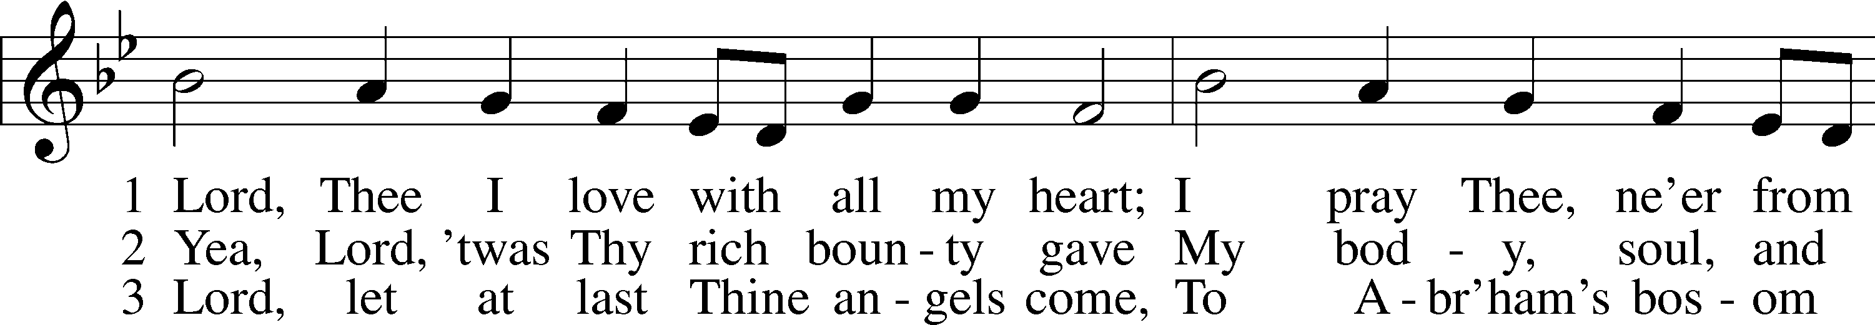
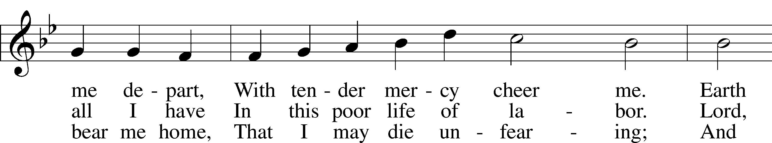
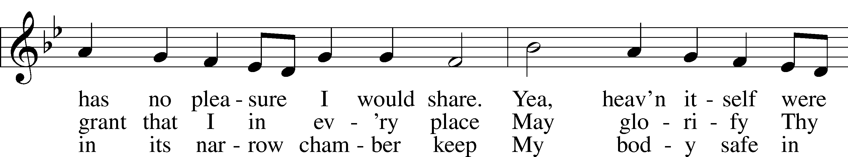
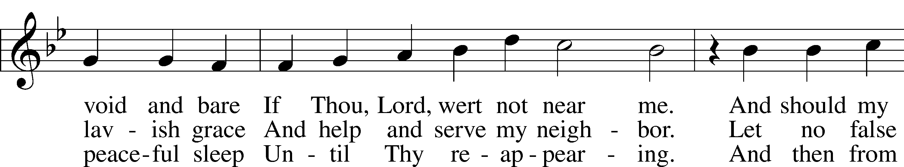
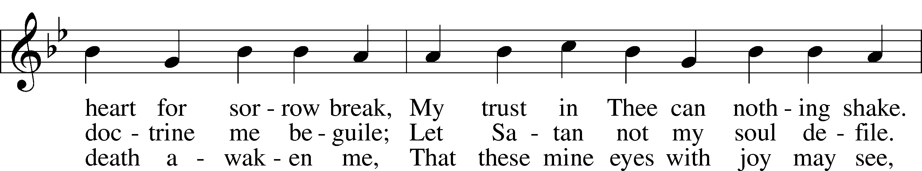
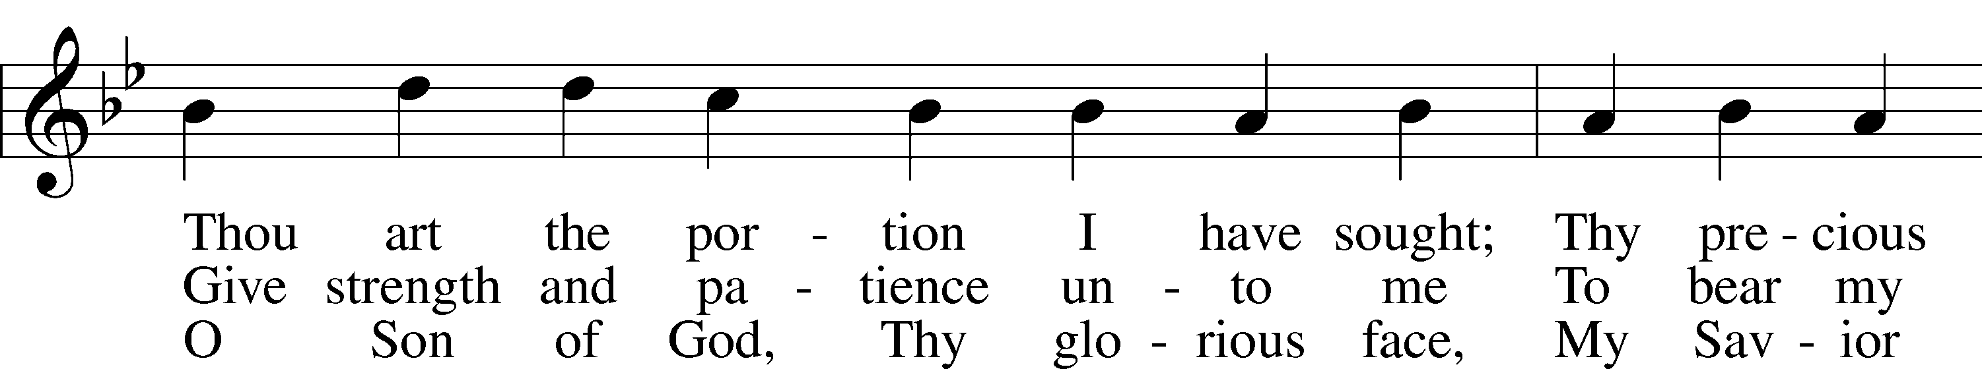
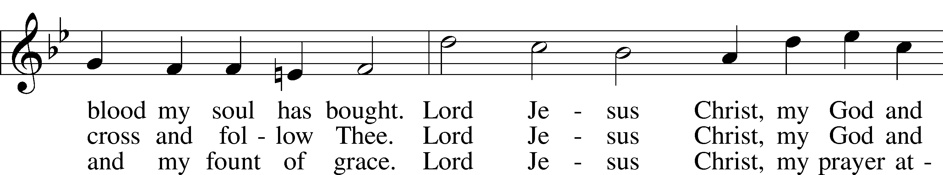
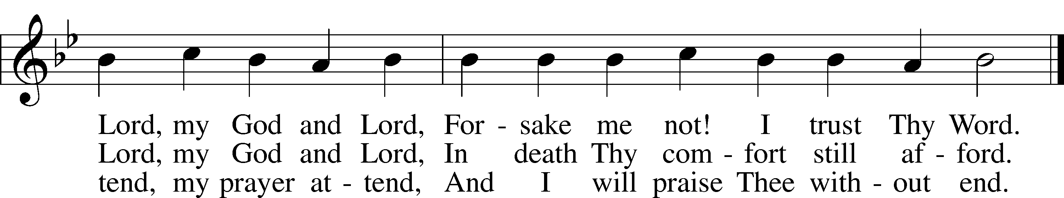

Text: Martin Schalling, 1532–1608; tr. Catherine Winkworth, 1827–78, alt.
Tune: Zwey Bücher . . . Tabulatur, 1577, Strassburg
Text and tune: Public domain

Sermon

Hymn: 850 God of Grace and God of Glory
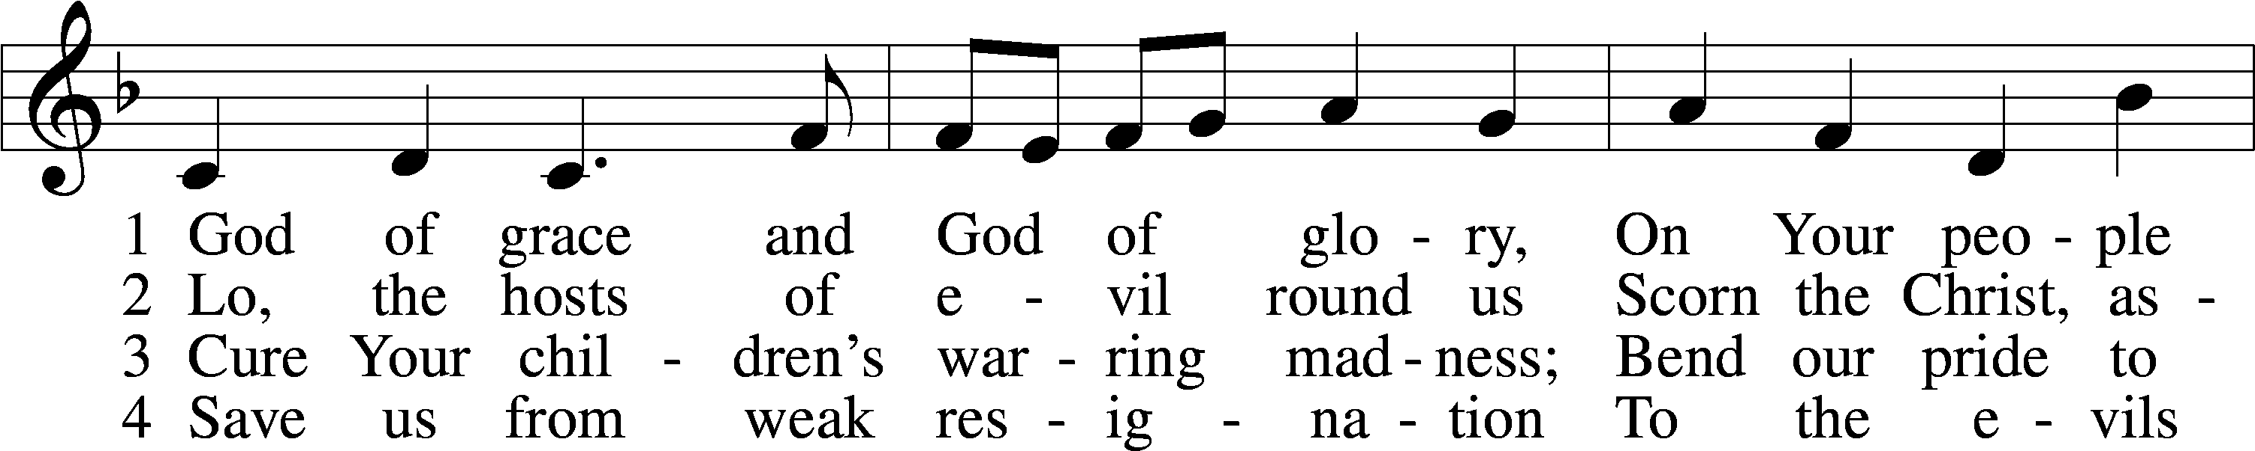
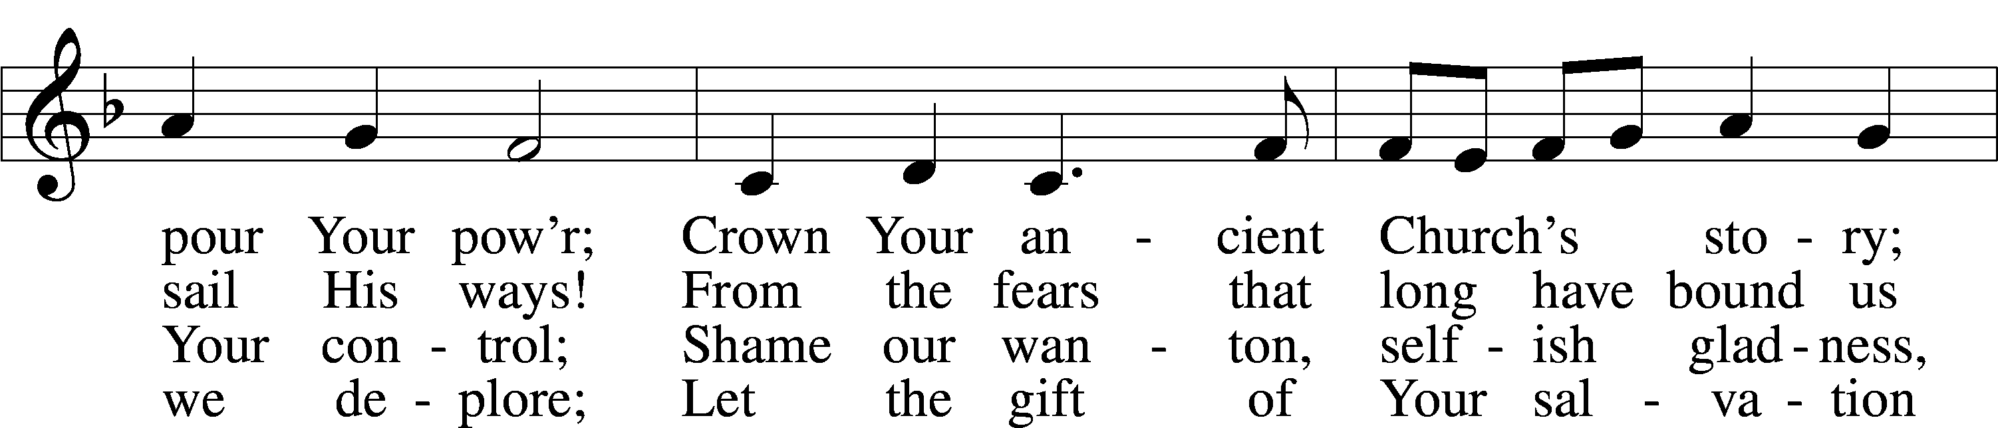
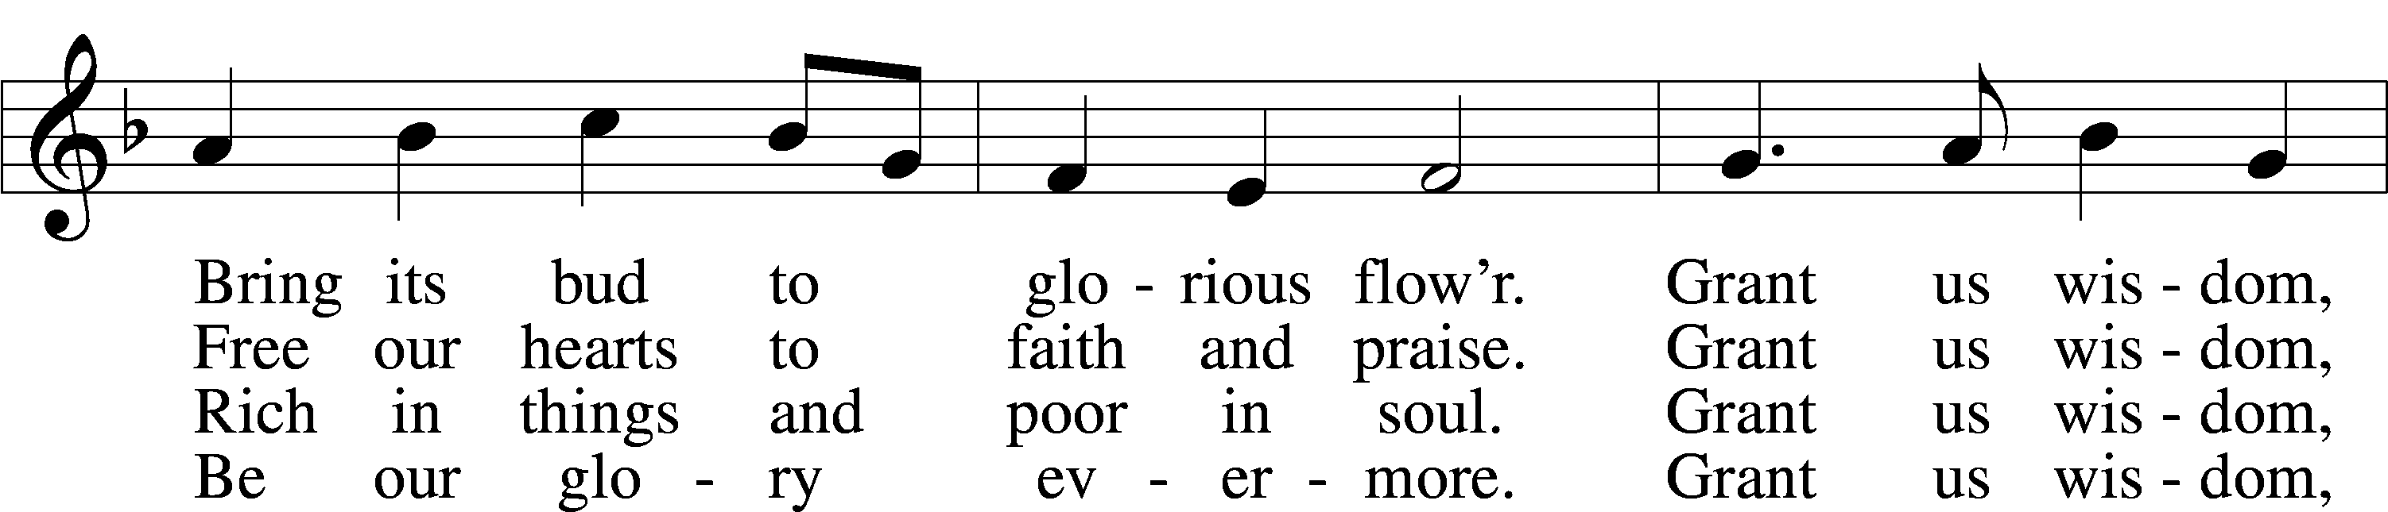
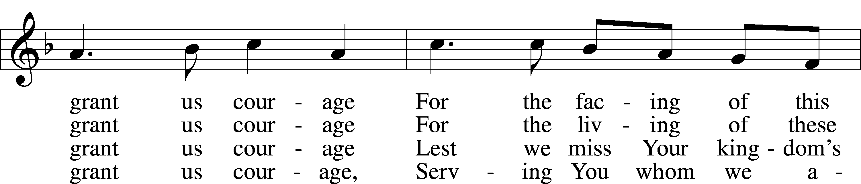
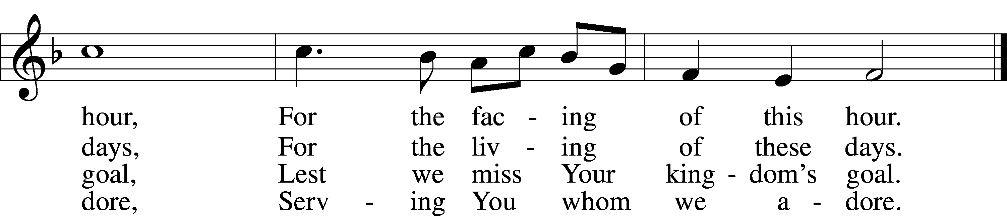

Text: Harry Emerson Fosdick, 1878–1969
Tune: John Hughes, 1873–1932
Text and tune: Public domain

Offering

Stand

Prayer
L In peace let us pray to the Lord:
C Lord, have mercy.
L For the gift of divine peace and of pardon, with all our heart and with all our mind, let us pray to the Lord:
C Lord, have mercy.
L For the holy Christian Church, here and scattered throughout the world, and for the proclamation of the Gospel and the calling of all to faith, let us pray to the Lord:
C Lord, have mercy.
L For this nation, for our cities and communities, and for the common welfare of us all, let us pray to the Lord:
C Lord, have mercy.
L For seasonable weather and for the fruitfulness of the earth, let us pray to the Lord:
C Lord, have mercy.
L For those who labor, for those whose work is difficult or dangerous, and for all who travel, let us pray to the Lord:
C Lord, have mercy.
L For all those in need, for the hungry and homeless, for the widowed and orphaned, and for all those in prison, let us pray to the Lord:
C Lord, have mercy.
L For the sick and dying and for all those who care for them, let us pray to the Lord:
C Lord, have mercy.
L For . . . [additional bids for prayer may be inserted here] . . . let us pray to the Lord:
C Lord, have mercy.
L Finally, for these and for all our needs of body and soul, let us pray to the Lord:
C Lord, have mercy. Christ, have mercy. Lord, have mercy.

Collect of the Day
L O God, You are the strength of all who trust in You, and without Your aid we can do no good thing. Grant us the help of Your grace that we may please You in both will and deed; through Jesus Christ, Your Son, our Lord, who lives and reigns with You and the Holy Spirit, one God, now and forever.
C Amen.

Collect for the Word
L Blessed Lord, You have caused all Holy Scriptures to be written for our learning. Grant that we may so hear them, read, mark, learn, and take them to heart that, by the patience and comfort of Your holy Word, we may embrace and ever hold fast the blessed hope of everlasting life; through Jesus Christ, Your Son, our Lord, who lives and reigns with You and the Holy Spirit, one God, now and forever.
C Amen.

Morning Prayer
C I thank You, my heavenly Father, through Jesus Christ, Your dear Son, that You have kept me this night from all harm and danger; and I pray that You would keep me this day also from sin and every evil, that all my doings and life may please You. For into Your hands I commend myself, my body and soul, and all things. Let Your holy angel be with me, that the evil foe may have no power over me.
Amen.

New Testament Canticle LSB 266
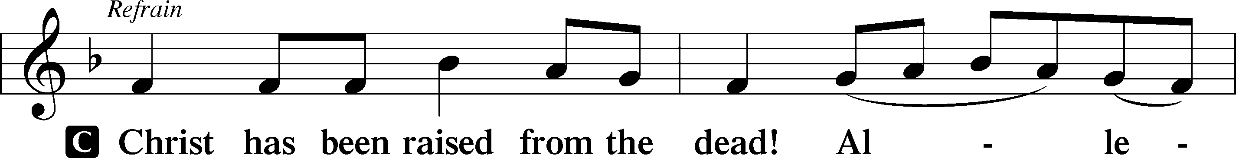

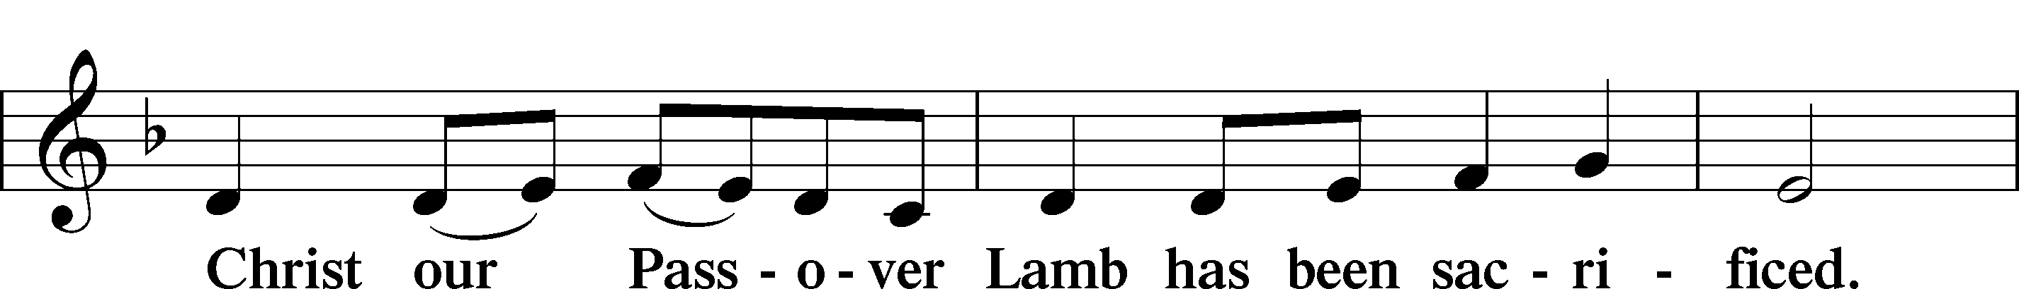
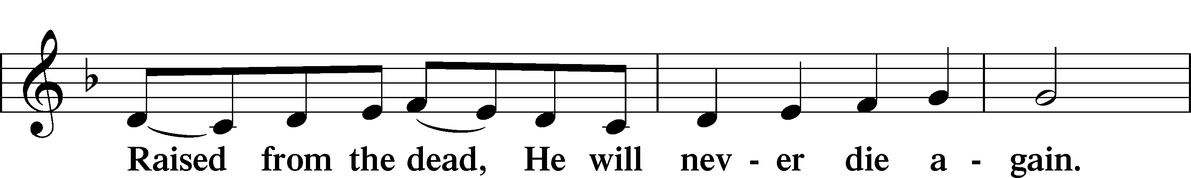
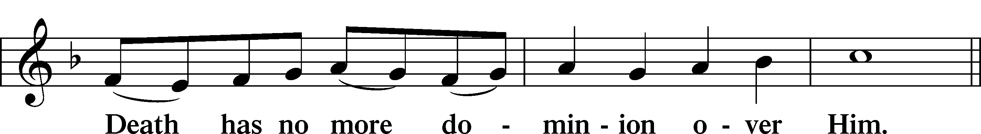
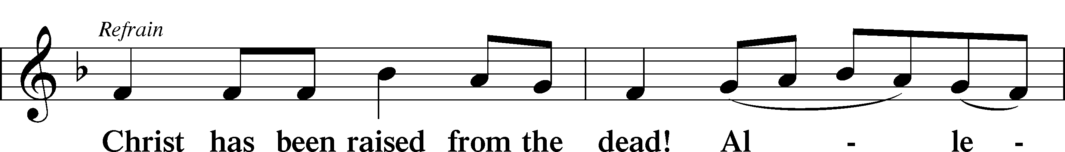

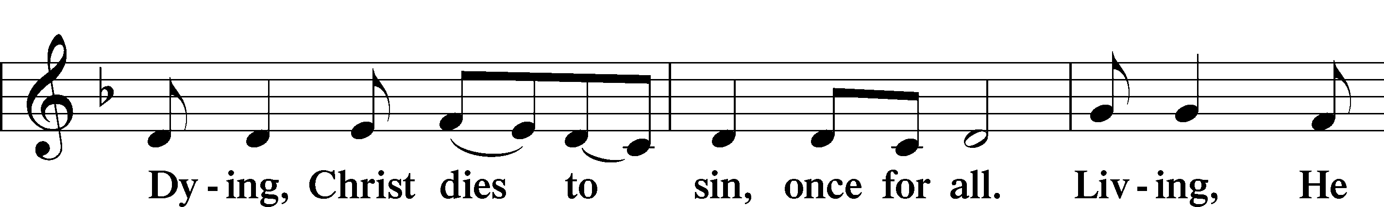
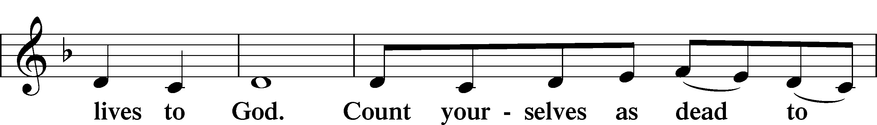
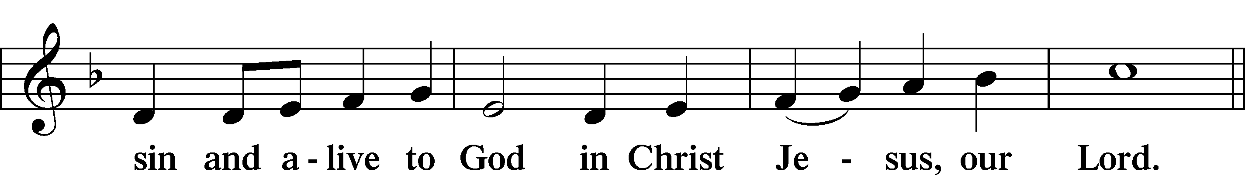
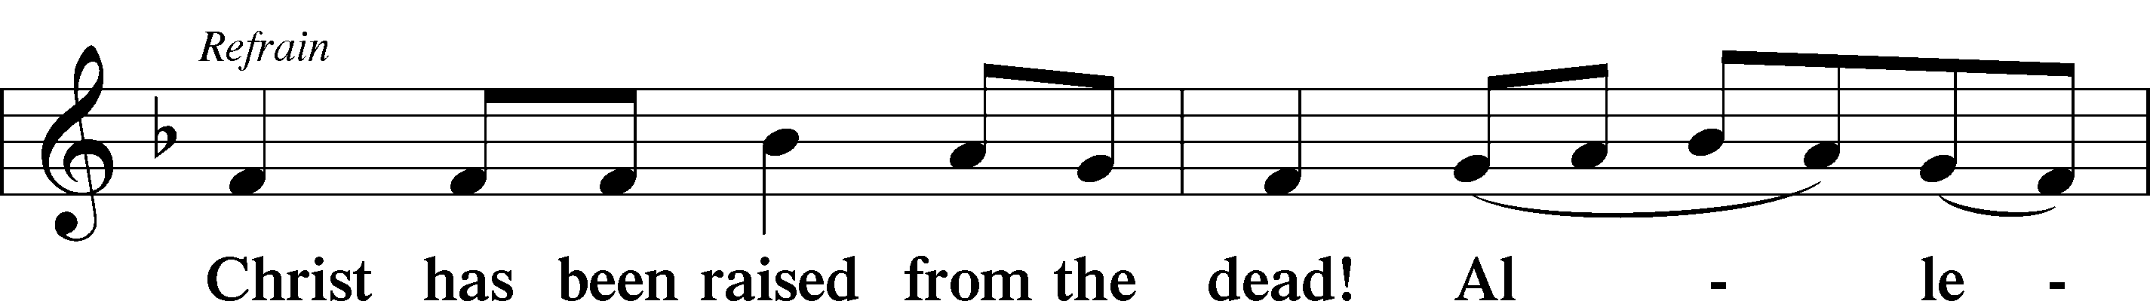
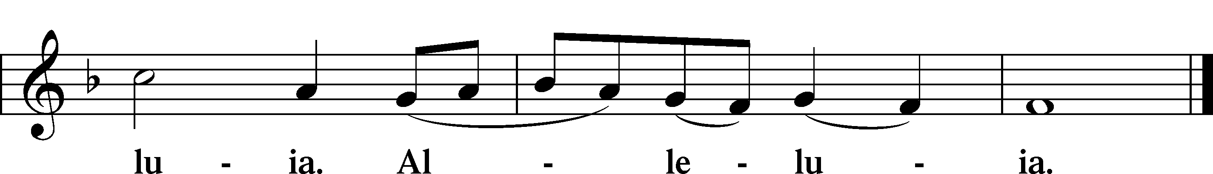

Blessing

L Let us bless the Lord.
C Thanks be to God.

L The almighty and merciful Lord, the Father, the T Son, and the Holy Spirit, bless and preserve us.
C Amen.

Hymn: 698 May We Thy Precepts, Lord, Fulfill
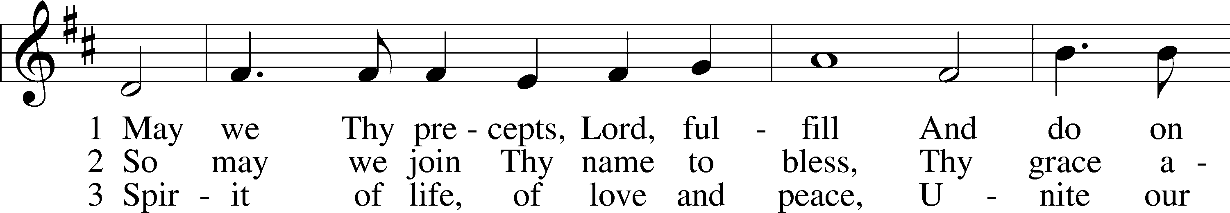
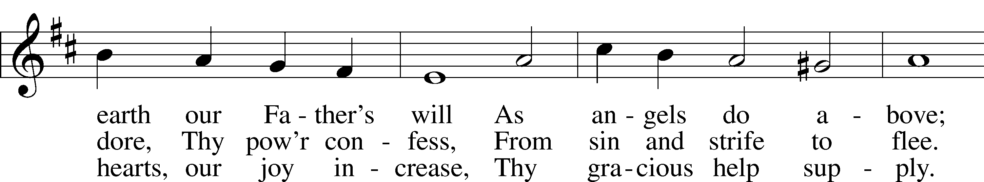
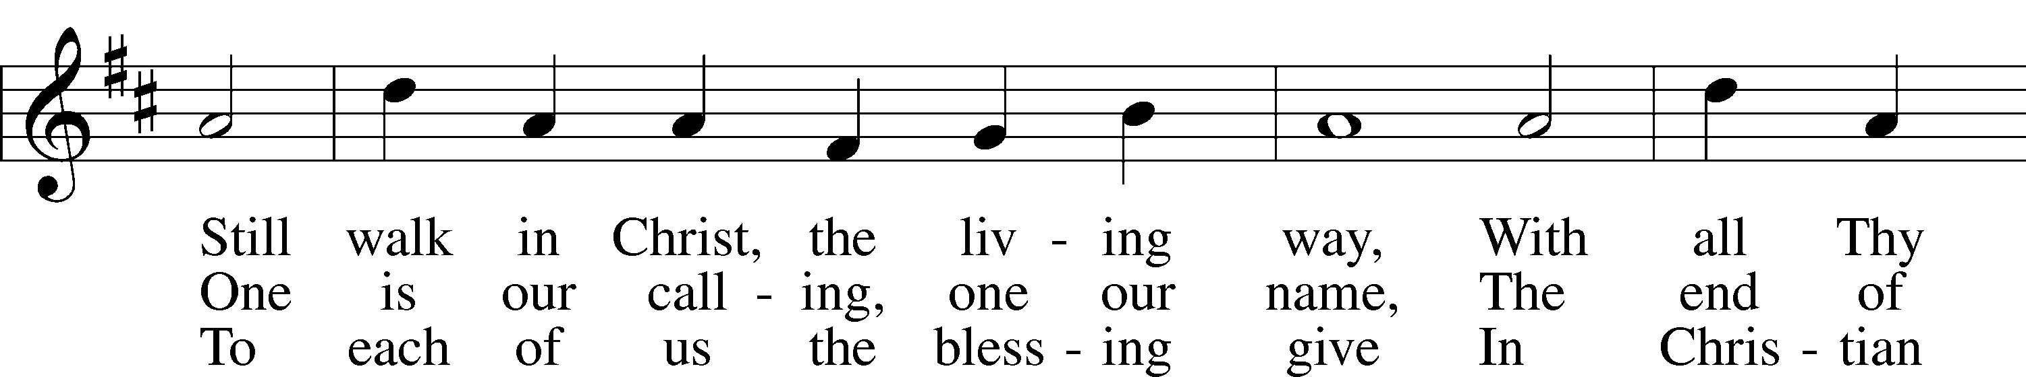
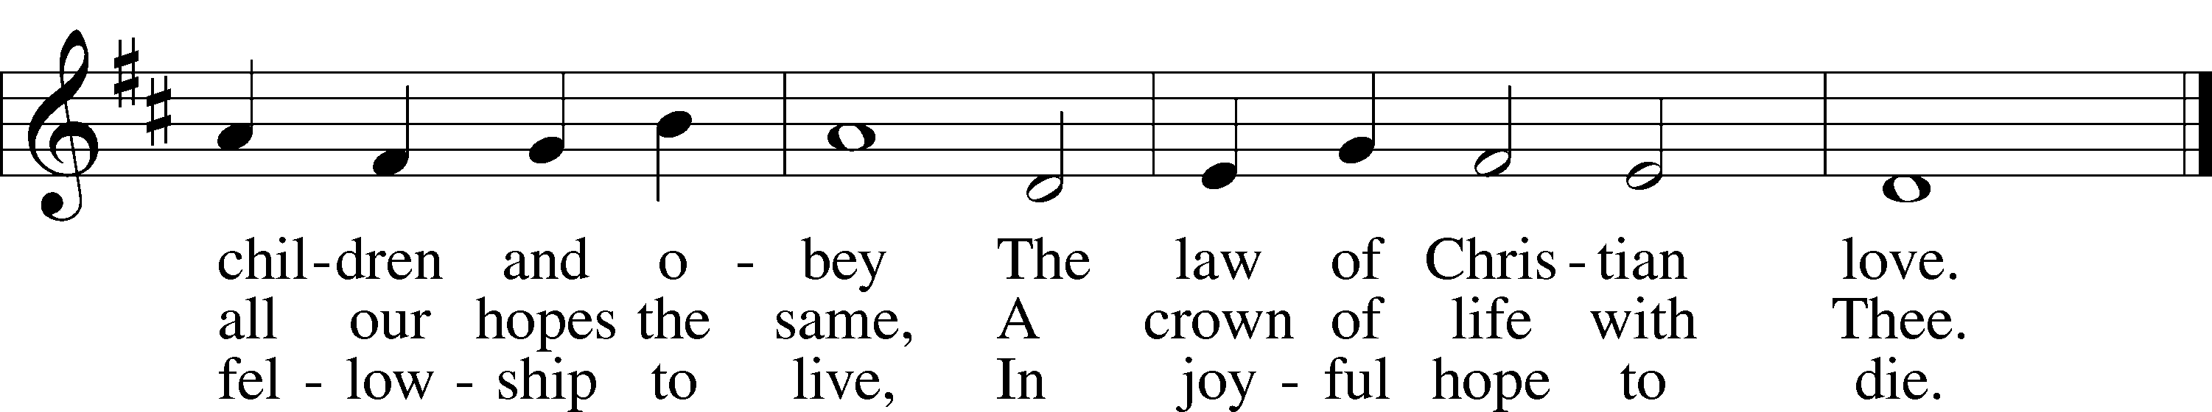

Text: Edward Osler, 1798–1863, alt.
Tune: Lowell Mason, 1792–1872
Text and tune: Public domain

Acknowledgments
Service of Prayer and Preaching from Lutheran Service Book
Unless otherwise indicated, Scripture quotations are from the ESV® Bible (The Holy Bible, English Standard Version®), copyright © 2001 by Crossway, a publishing ministry of Good News Publishers. Used by permission. All rights reserved.
Created by Lutheran Service Builder © 2025 Concordia Publishing House.

Prayers Request: Those in the nursing home: Joann Jaeger, Joan Church, Joyce Myers Those Shut-in at home: Char Herman Those with ongoing health issues: Daria (Cindy Wright’s friend), Butch L. (Cindy Wright’s Brother-in-law), Melissa Miller. Sandy Hahn (Cindy Wright’s cousin’s wife) , Marlene Snyder, Shirley Hehl, Pastor Eric and Linda Stumpf, Tasha Becker(Michele Millerman’s daughter), Tom Recovering from surgery: Brenda Gustum (Missy Wiese’s mom) Those who lead our nation: Donald Trump, JD Vance, Tony Evers, Rod Nordby Those who serve in our military and law enforcement: Ryan Graf, Chaplain Pon Chanthaphon (Our Adopt-a-Chaplain), Rusty Weise Our Childcare Staff: Melissa Frieburg, Denise Stabenow, Holly Wilhelmi, Janica Skjerly, Cathy Anderson, Iva Gjika, Michele Millerman, Brittnie Eirckson, Jayme Closs, Brooklyn Doyle, Mariah Ward, Emily Young

Announcements:
Church Service Phone: 715-438-4200(Chippewa Falls) 715-537-4240(local)
(Stay on the line for recorded service to start)
Live Stream audio services: http://salem.listentochurch.com
Salem’s Web Page: https://www.salembarron.com/
Pastor Fred Buth: Cell phone:715-642-3050 (H)715-353-2540
Email: salembarronpastor@gmail.com
Office Hours: Monday-Wednesday 9-12
Attendance: 9/21/57
Coffee and Snacks: John a & Emily Steele
Elder Today: Don Duncan
Reader: Don
Organist: Maryann Wheeler
Altar Guild: Kathy S Offering: 9/14: General fund $, Missions $, Building fund $

There is a signup sheet in the back if you would like to provide a snack for the confirmation class on a Wednesday

Oct 25th – Truck and Treat and Craft/Vendor Show (if you would like to have a trunk for this please sign up in the back)

Pray for a safe and organized move for the Berkesch Family



