Confession and Absolution

Hymn of Invocation: 905 Come, Thou Almighty King
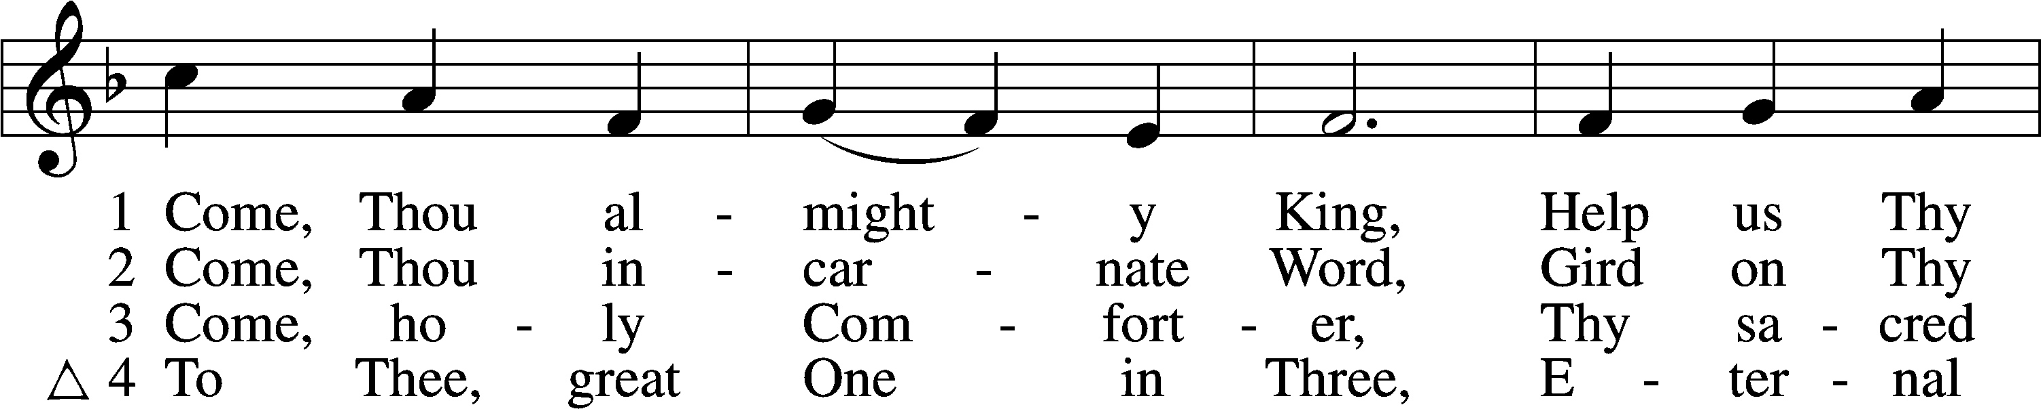
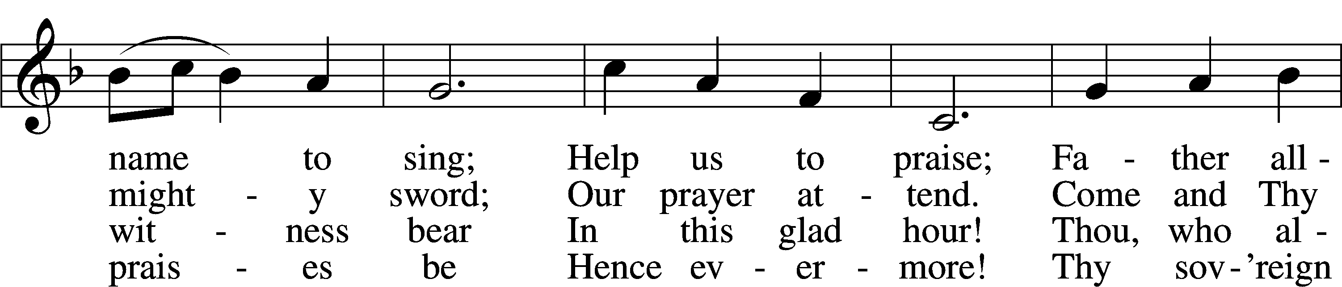
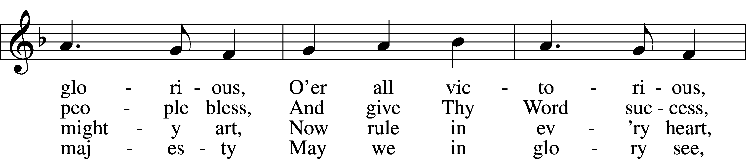
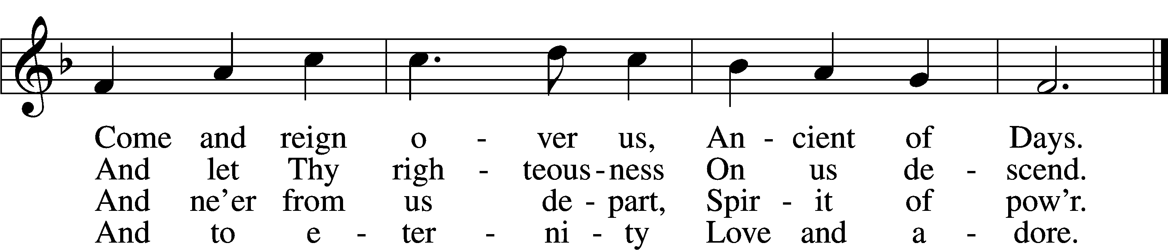
Text: English, before 1760, alt.
Tune: Felice de Giardini, 1716–96
Text and tune: Public domain

Stand

The sign of the cross may be made by all in remembrance of their Baptism.

P In the name of the Father and of the T Son and of the Holy Spirit.
C Amen.

P If we say we have no sin, we deceive ourselves, and the truth is not in us.
C But if we confess our sins, God, who is faithful and just, will forgive our sins and cleanse us from all unrighteousness.

Kneel/Stand

Silence for reflection on God’s Word and for self-examination.

P Let us then confess our sins to God our Father.
C Most merciful God, we confess that we are by nature sinful and unclean. We have sinned against You in thought, word, and deed, by what we have done and by what we have left undone. We have not loved You with our whole heart; we have not loved our neighbors as ourselves. We justly deserve Your present and eternal punishment. For the sake of Your Son, Jesus Christ, have mercy on us. Forgive us, renew us, and lead us, so that we may delight in Your will and walk in Your ways to the glory of Your holy name. Amen.

P Almighty God in His mercy has given His Son to die for you and for His sake forgives you all your sins. As a called and ordained servant of Christ, and by His authority, I therefore forgive you all your sins in the name of the Father and of the T Son and of the Holy Spirit.
C Amen.

Stand

Service of the Word

Introit Psalm 105:1–5, 8; antiphon: 1 Peter 2:2–3
Like newborn infants, long for the pure spiritual milk, that by it you may grow up to salvation—
if indeed you have tasted that the Lord is good.
Oh give thanks to the Lord; call upon his name;
make known his deeds among the peoples!
Sing to him, sing praises to him;
tell of all his wondrous works!
Glory in his holy name;
let the hearts of those who seek the Lord rejoice!
Seek the Lord and his strength;
seek his presence continually!
Remember the wondrous works that he has done,
his miracles, and the judgments he uttered.
He remembers his covenant forever,
the word that he commanded, for a thousand generations.
Glory be to the Father and to the Son
and to the Holy Spirit;
as it was in the beginning,
is now, and will be forever. Amen.
Like newborn infants, long for the pure spiritual milk, that by it you may grow up to salvation—
if indeed you have tasted that the Lord is good.

Kyrie LSB 152
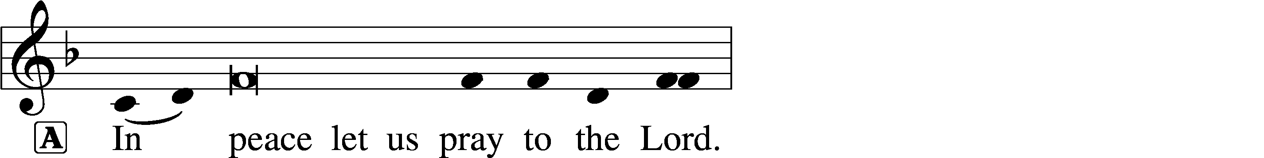
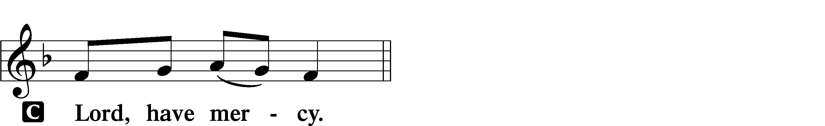

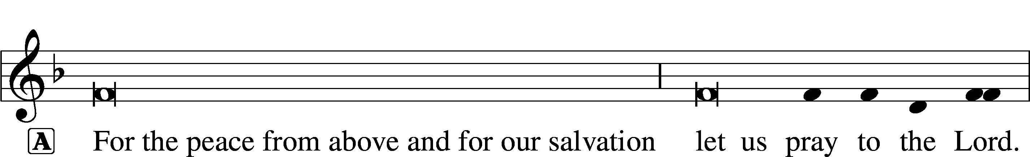
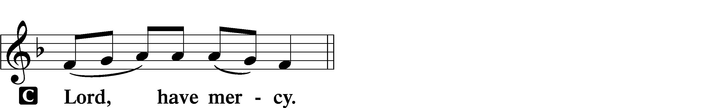

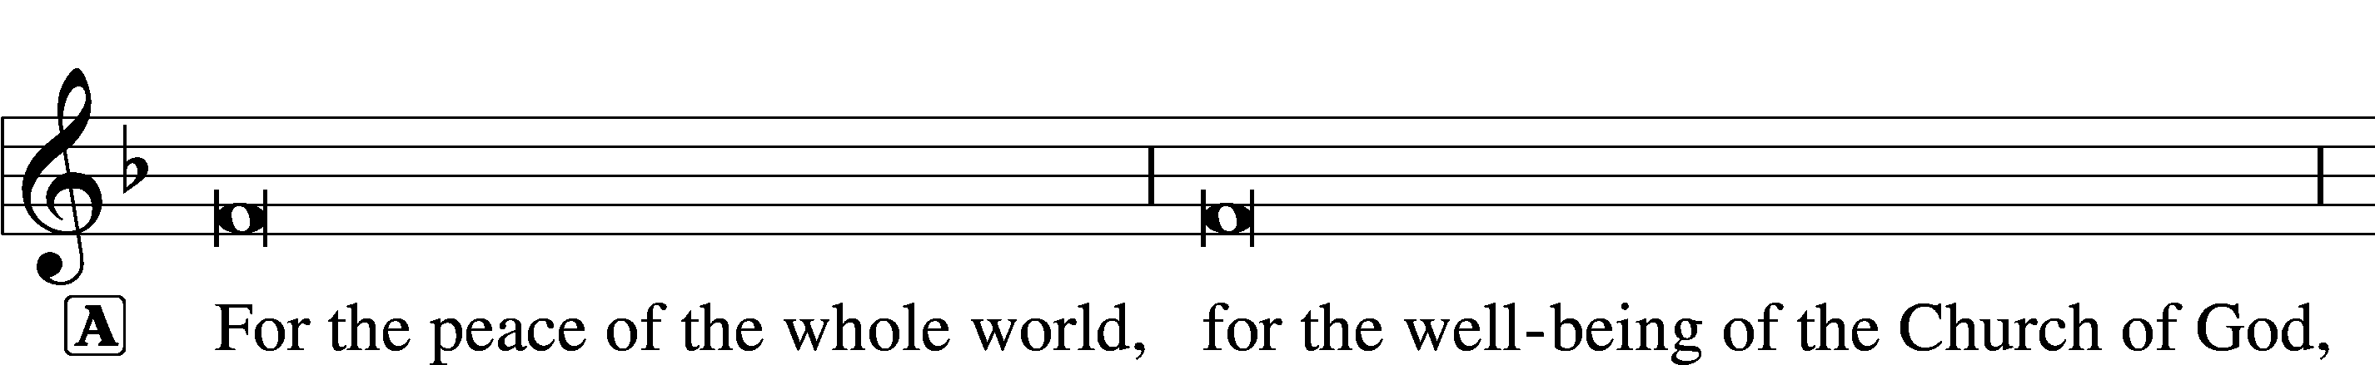
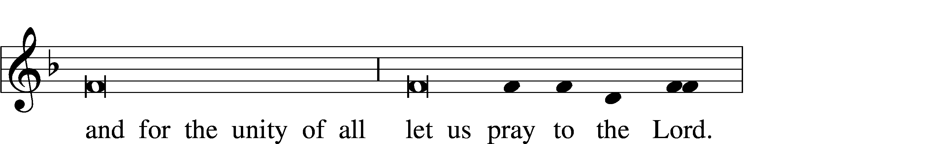
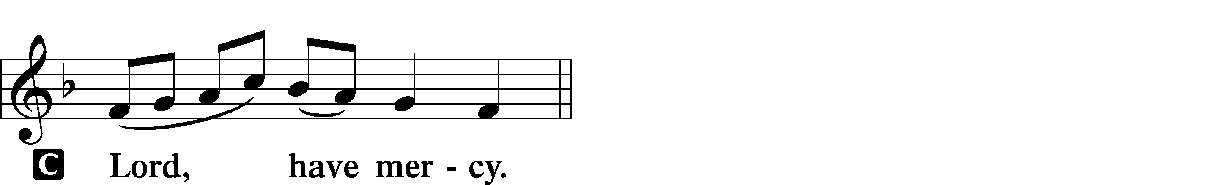

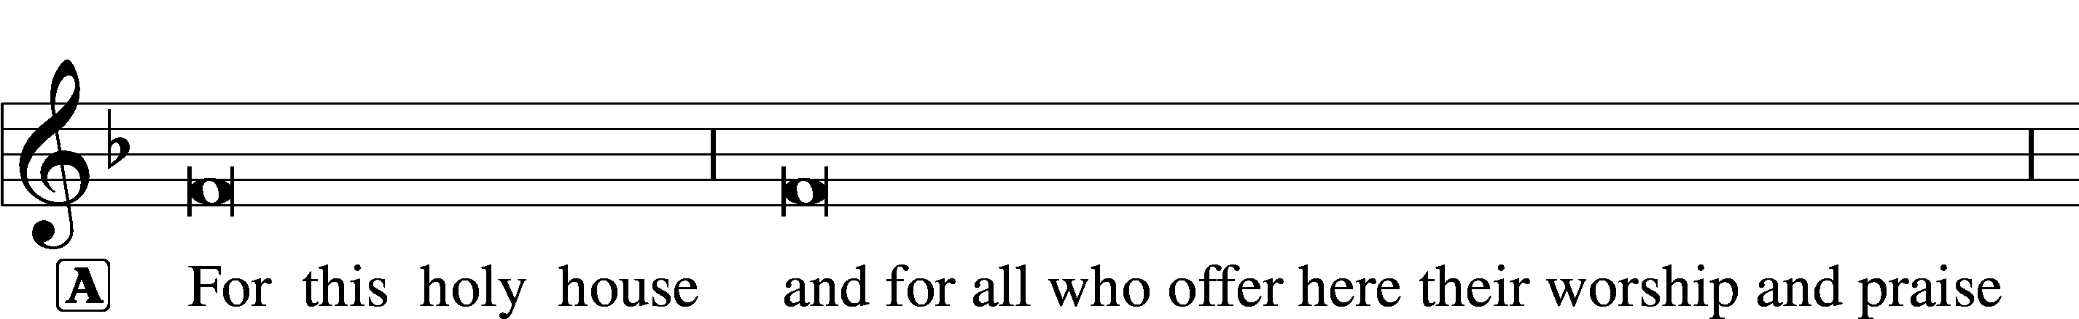
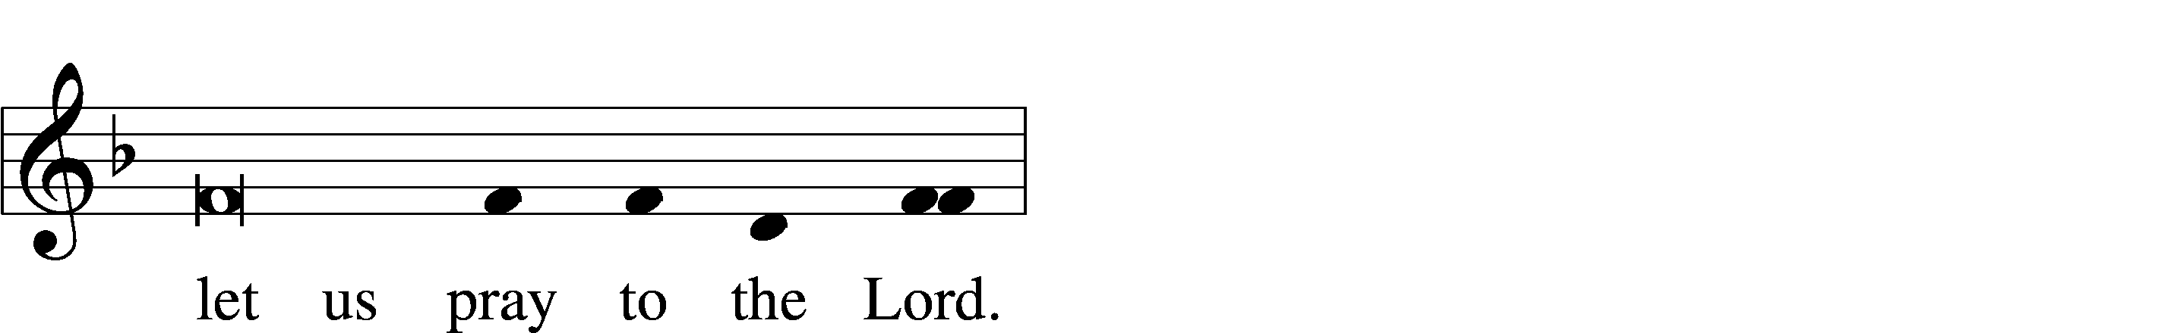
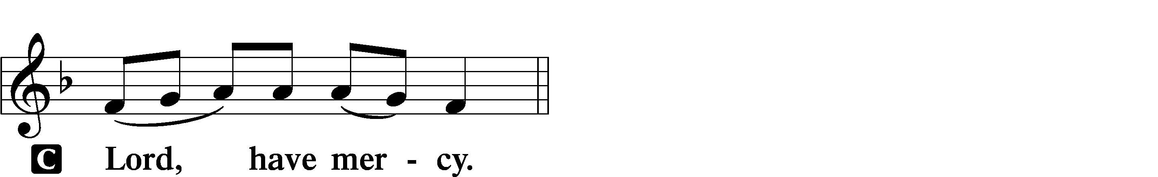

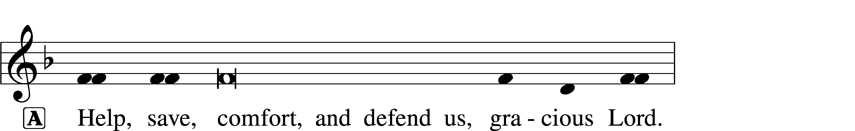

Gloria in Excelsis LSB 154
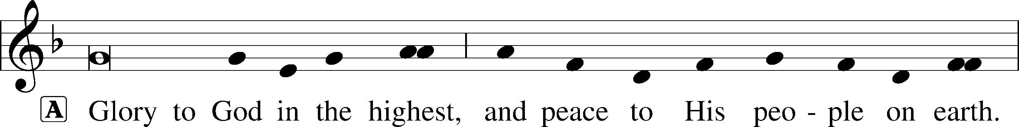
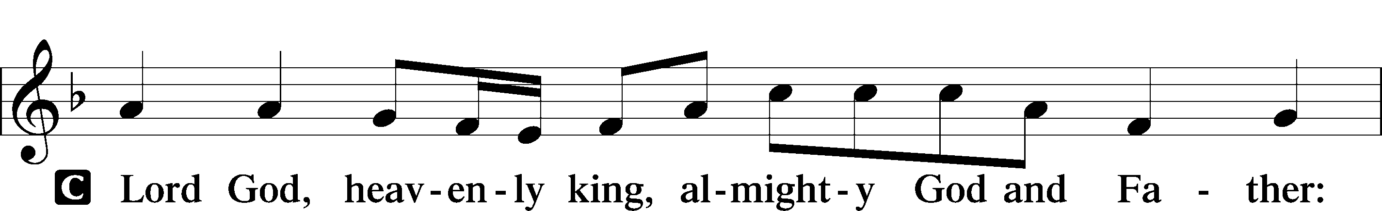
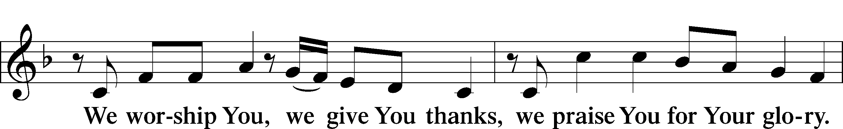
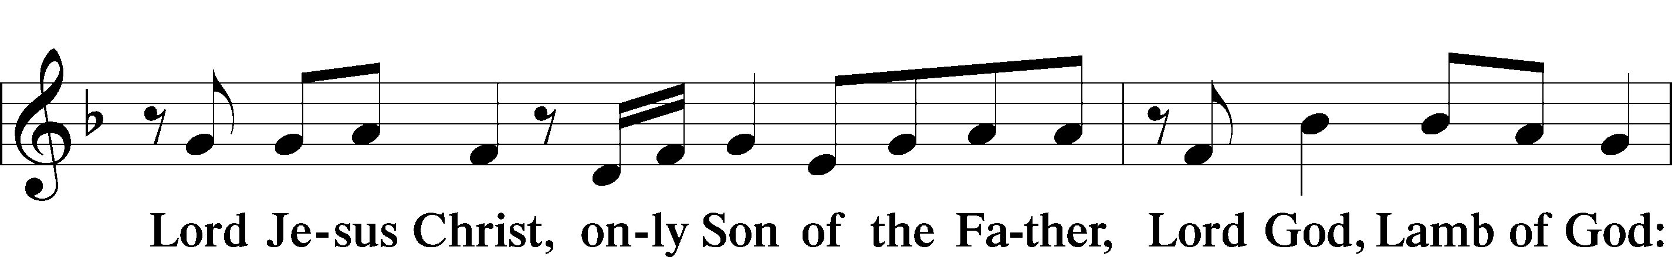
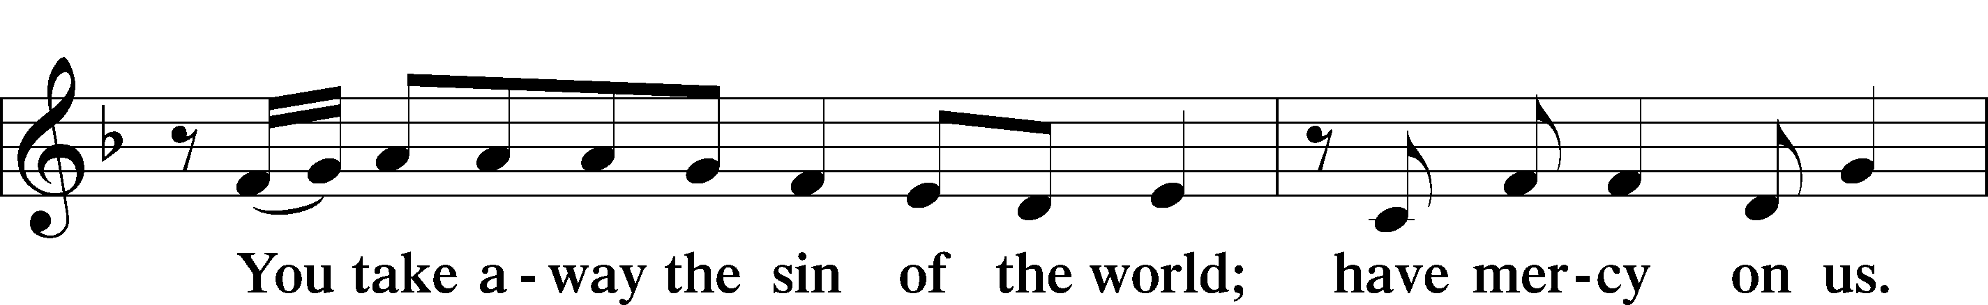
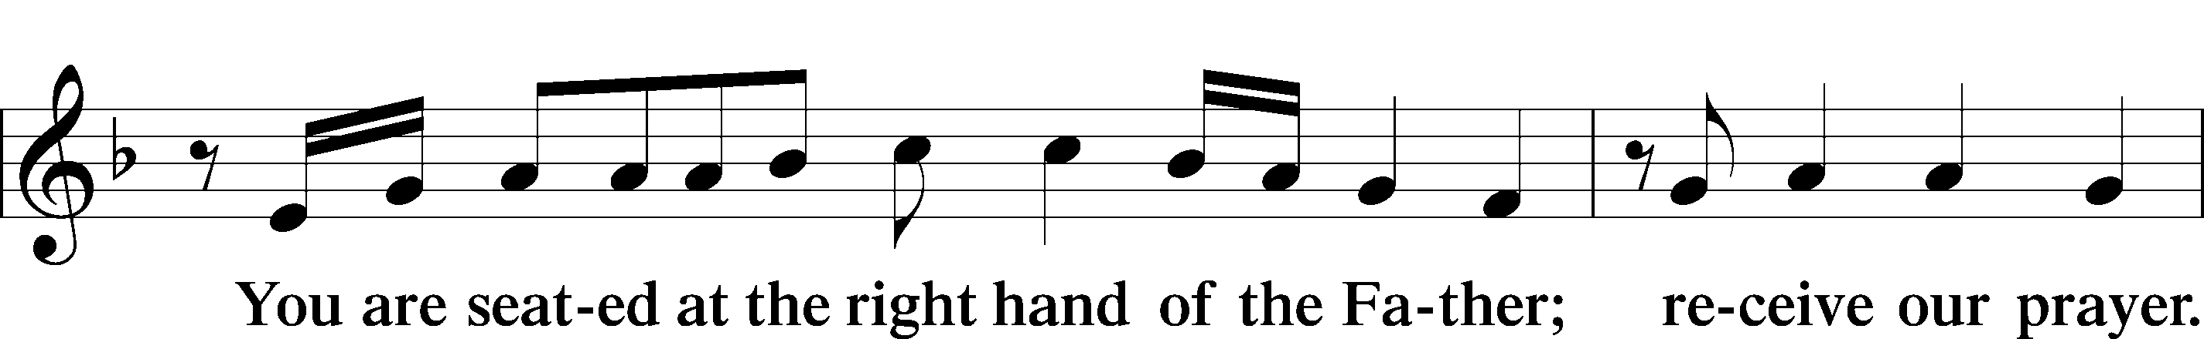
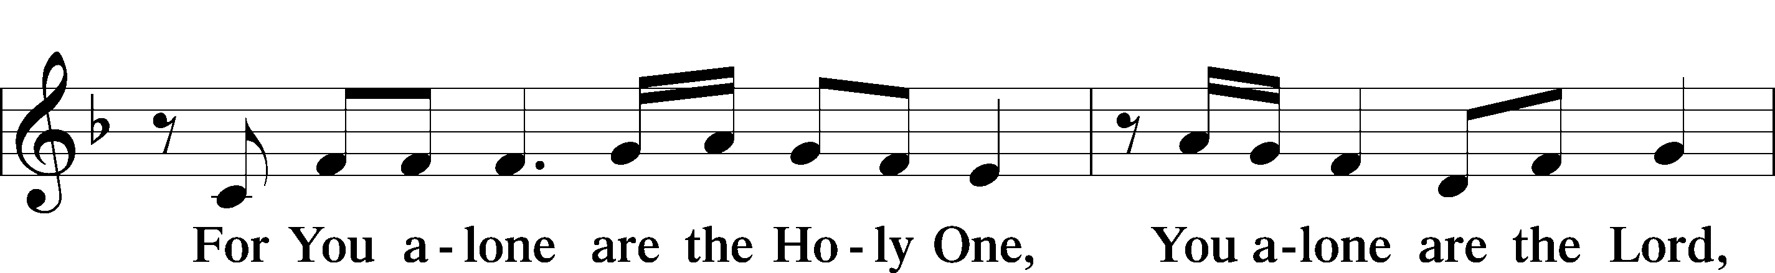
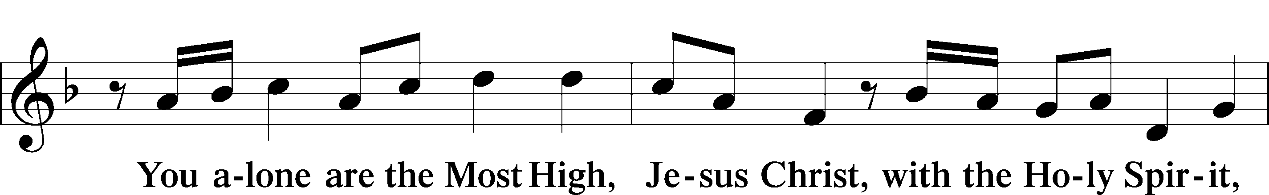
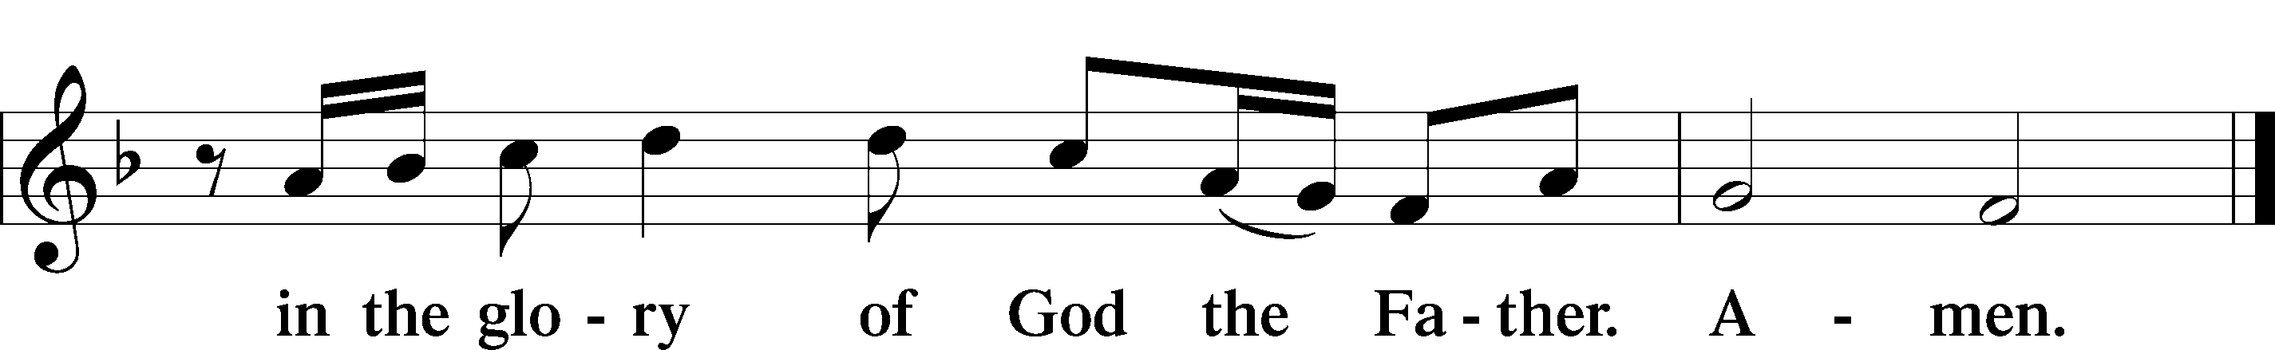

Salutation and Collect of the Day
P The Lord be with you.
C And also with you.

P Let us pray.
Almighty God, grant that we who have celebrated the Lord’s resurrection may by Your grace confess in our life and conversation that Jesus is Lord and God; through the same Jesus Christ, Your Son, who lives and reigns with You and the Holy Spirit, one God, now and forever.

C Amen.

Sit

First Reading Acts 4:32–35
They Had Everything in Common
32The full number of those who believed were of one heart and soul, and no one said that any of the things that belonged to him was his own, but they had everything in common. 33And with great power the apostles were giving their testimony to the resurrection of the Lord Jesus, and great grace was upon them all. 34There was not a needy person among them, for as many as were owners of lands or houses sold them and brought the proceeds of what was sold 35and laid it at the apostles’ feet, and it was distributed to each as any had need.

A This is the Word of the Lord.
C Thanks be to God.

Psalm Psalm 148; antiphon: v. 13
Praise the Name of the Lord
1Praise the Lord!
Praise the Lord from the heavens;
praise him in the heights!
2Praise him, all his angels;
praise him, all his hosts!
3Praise him, sun and moon,
praise him, all you shining stars!
4Praise him, you highest heavens,
and you waters above the heavens!
5Let them praise the name of the Lord!
For he commanded and they were created.
6And he established them forever and ever;
he gave a decree, and it shall not pass away.
7Praise the Lord from the earth,
you great sea creatures and all deeps,
8fire and hail, snow and mist,
stormy wind fulfilling his word!
9Mountains and all hills,
fruit trees and all cedars!
10Beasts and all livestock,
creeping things and flying birds!
11Kings of the earth and all peoples,
princes and all rulers of the earth!
12Young men and maidens together,
old men and children!
13Let them praise the name of the Lord,
for his name alone is exalted;
his majesty is above earth and heaven.
14He has raised up a horn for his people,
praise for all his saints,
for the people of Israel who are near to him. Praise the Lord!

Epistle 1 John 1:1—2:2
The Word of Life
1That which was from the beginning, which we have heard, which we have seen with our eyes, which we looked upon and have touched with our hands, concerning the word of life— 2the life was made manifest, and we have seen it, and testify to it and proclaim to you the eternal life, which was with the Father and was made manifest to us— 3that which we have seen and heard we proclaim also to you, so that you too may have fellowship with us; and indeed our fellowship is with the Father and with his Son Jesus Christ. 4And we are writing these things so that our joy may be complete.
Walking in the Light
5This is the message we have heard from him and proclaim to you, that God is light, and in him is no darkness at all. 6If we say we have fellowship with him while we walk in darkness, we lie and do not practice the truth. 7But if we walk in the light, as he is in the light, we have fellowship with one another, and the blood of Jesus his Son cleanses us from all sin. 8If we say we have no sin, we deceive ourselves, and the truth is not in us. 9If we confess our sins, he is faithful and just to forgive us our sins and to cleanse us from all unrighteousness. 10If we say we have not sinned, we make him a liar, and his word is not in us.
Christ Our Advocate
1My little children, I am writing these things to you so that you may not sin. But if anyone does sin, we have an advocate with the Father, Jesus Christ the righteous. 2He is the propitiation for our sins, and not for ours only but also for the sins of the whole world.

A This is the Word of the Lord.
C Thanks be to God.

Stand

Alleluia and Verse LSB 156
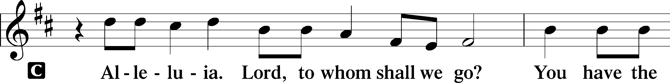
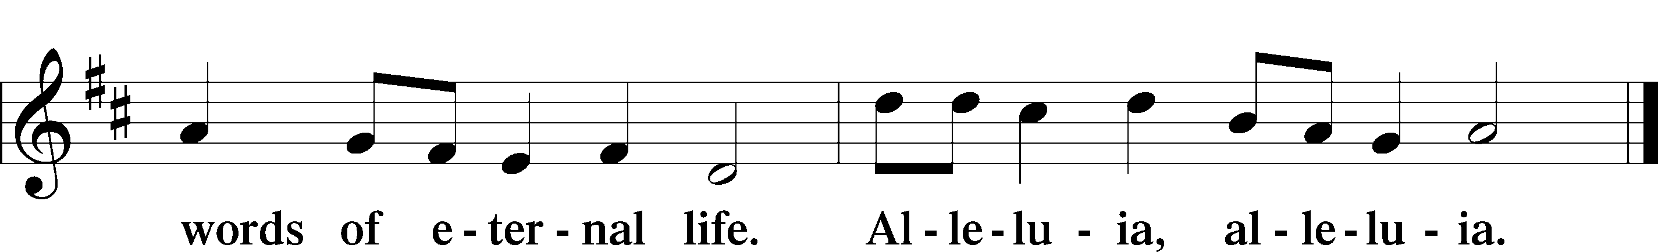

Holy Gospel John 20:19–31
P The Holy Gospel according to St. John, the twentieth chapter.
C Glory to You, O Lord.

Jesus Appears to the Disciples
19On the evening of that day, the first day of the week, the doors being locked where the disciples were for fear of the Jews, Jesus came and stood among them and said to them, “Peace be with you.” 20When he had said this, he showed them his hands and his side. Then the disciples were glad when they saw the Lord. 21Jesus said to them again, “Peace be with you. As the Father has sent me, even so I am sending you.” 22And when he had said this, he breathed on them and said to them, “Receive the Holy Spirit. 23If you forgive the sins of anyone, they are forgiven; if you withhold forgiveness from anyone, it is withheld.”
Jesus and Thomas
24Now Thomas, one of the Twelve, called the Twin, was not with them when Jesus came. 25So the other disciples told him, “We have seen the Lord.” But he said to them, “Unless I see in his hands the mark of the nails, and place my finger into the mark of the nails, and place my hand into his side, I will never believe.”
26Eight days later, his disciples were inside again, and Thomas was with them. Although the doors were locked, Jesus came and stood among them and said, “Peace be with you.” 27Then he said to Thomas, “Put your finger here, and see my hands; and put out your hand, and place it in my side. Do not disbelieve, but believe.” 28Thomas answered him, “My Lord and my God!” 29Jesus said to him, “Have you believed because you have seen me? Blessed are those who have not seen and yet have believed.”
The Purpose of This Book
30Now Jesus did many other signs in the presence of the disciples, which are not written in this book; 31but these are written so that you may believe that Jesus is the Christ, the Son of God, and that by believing you may have life in his name.

P This is the Gospel of the Lord.
C Praise to You, O Christ.

Sit

Hymn of the Day: 611 Chief of Sinners Though I Be
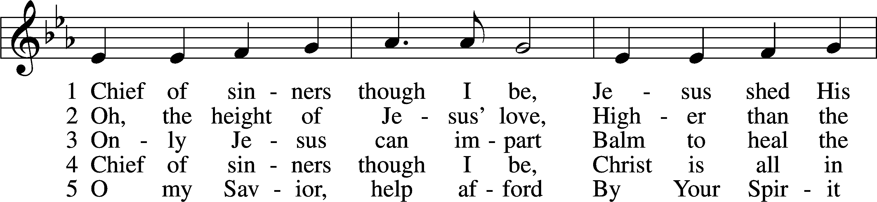
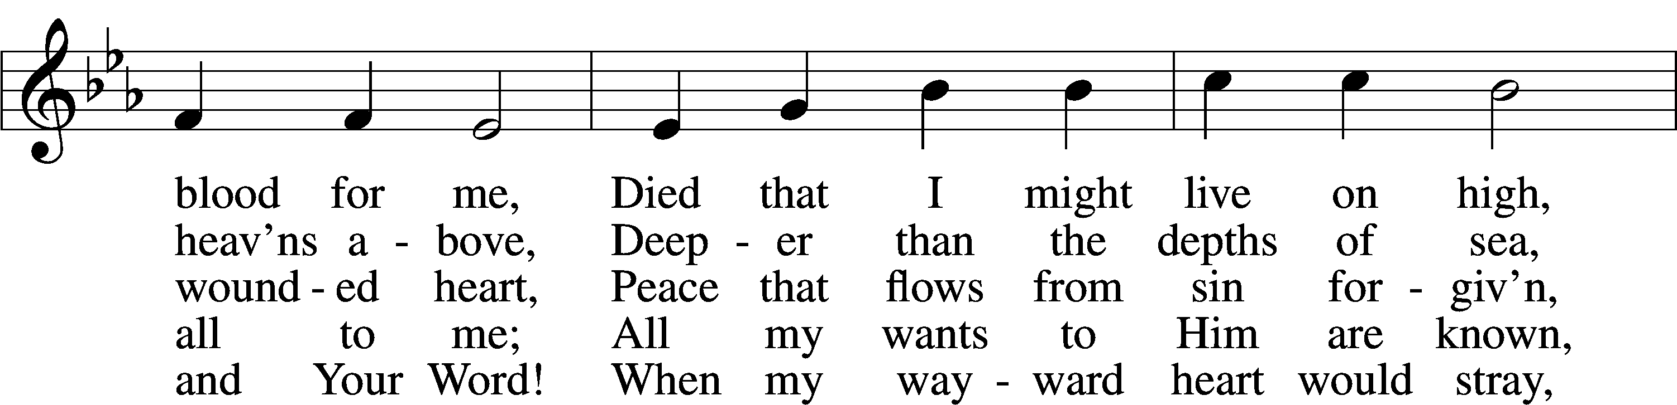
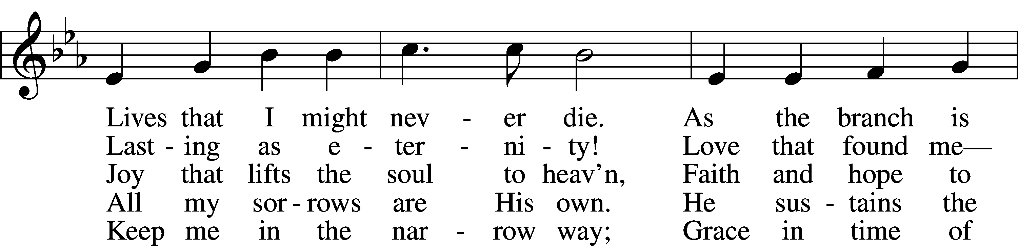
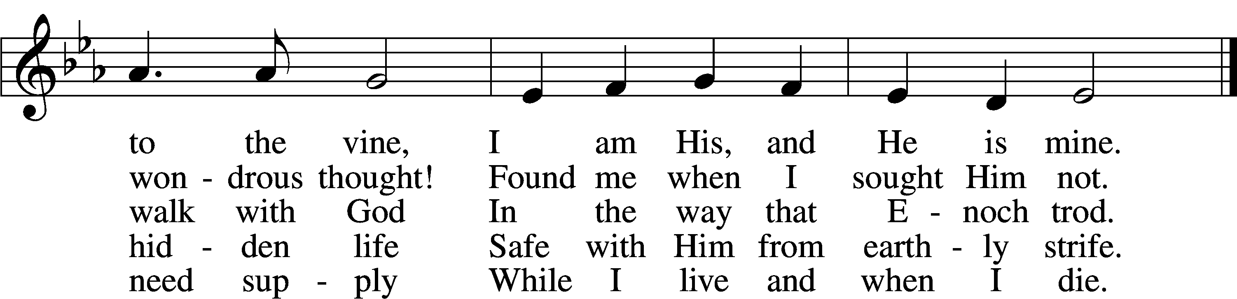
Text: William McComb, 1793–1873, alt.
Tune: Richard Redhead, 1820–1901
Text and tune: Public domain

Sermon

Stand

Nicene Creed
C I believe in one God,
the Father Almighty,
maker of heaven and earth
and of all things visible and invisible.

And in one Lord Jesus Christ,
the only-begotten Son of God,
begotten of His Father before all worlds,
God of God, Light of Light,
very God of very God,
begotten, not made,
being of one substance with the Father,
by whom all things were made;
who for us men and for our salvation came down from heaven
and was incarnate by the Holy Spirit of the virgin Mary
and was made man;
and was crucified also for us under Pontius Pilate.
He suffered and was buried.
And the third day He rose again according to the Scriptures
and ascended into heaven
and sits at the right hand of the Father.
And He will come again with glory to judge both the living and the dead,
whose kingdom will have no end.

And I believe in the Holy Spirit,
the Lord and giver of life,
who proceeds from the Father and the Son,
who with the Father and the Son together is worshiped and glorified,
who spoke by the prophets.
And I believe in one holy Christian and apostolic Church,
I acknowledge one Baptism for the remission of sins,
and I look for the resurrection of the dead
and the life T of the world to come. Amen.

Prayer of the Church

Following the prayers, the people may greet one another in the name of the Lord, saying, “Peace be with you,” as a sign of reconciliation and of the unity of the Spirit in the bond of peace (Matt. 5:22–24; Eph. 4:1–3).

Sit

Offering

Stand

Offertory LSB 159
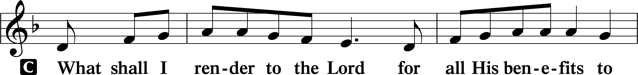
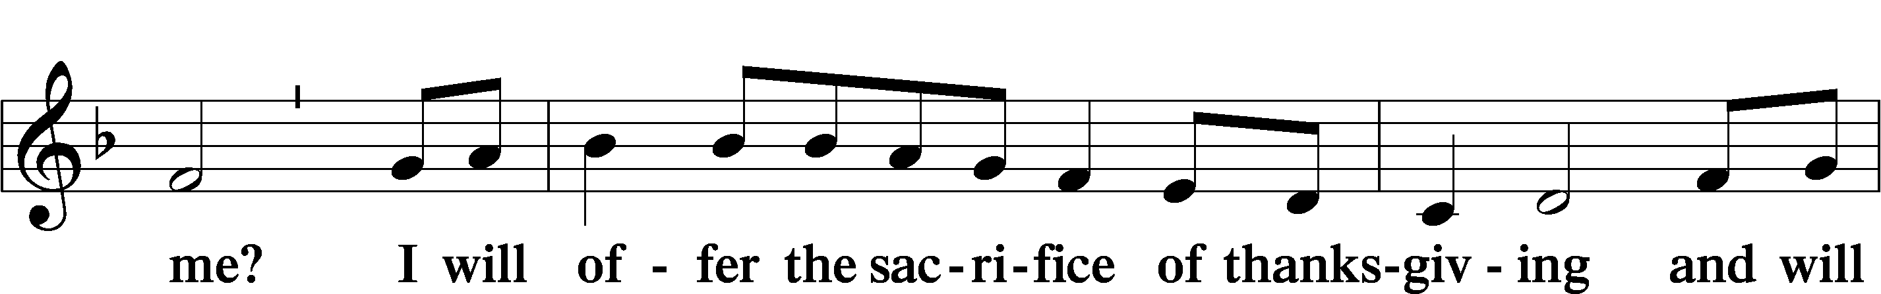
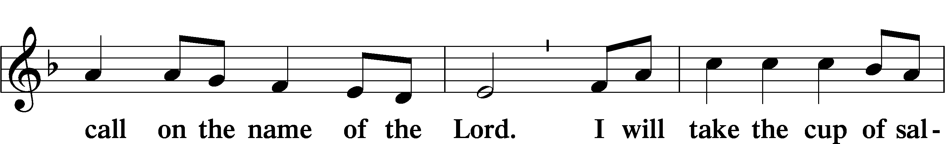
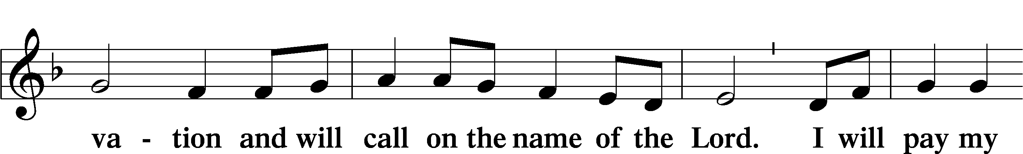
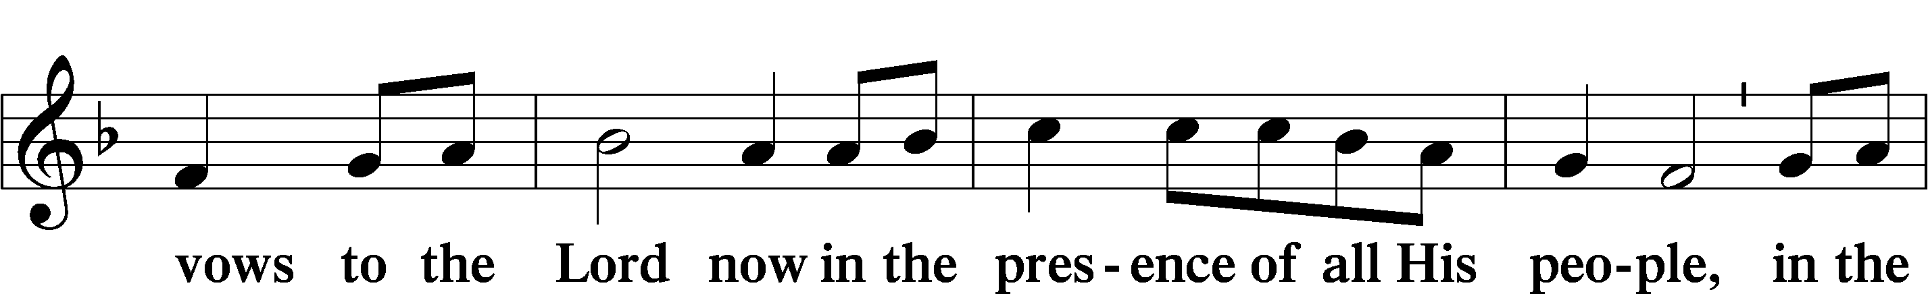
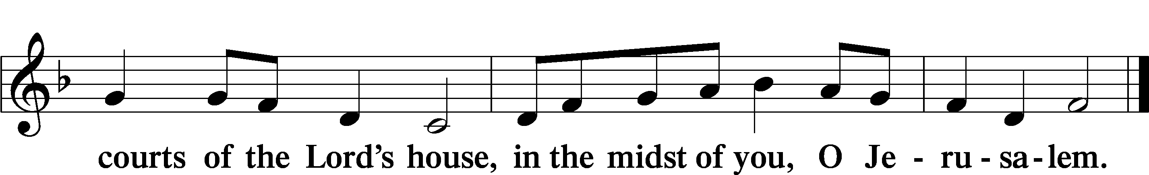

Service of the Sacrament

Preface LSB 160
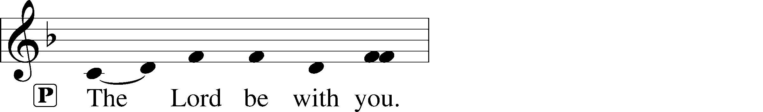
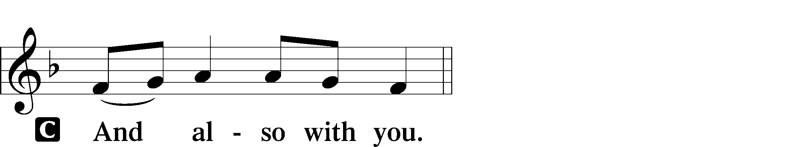
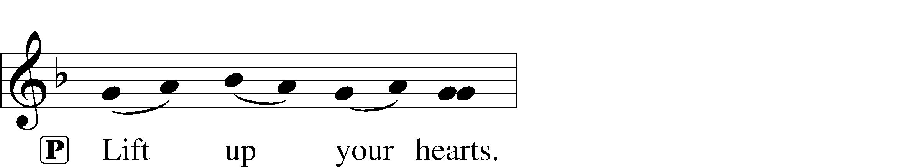
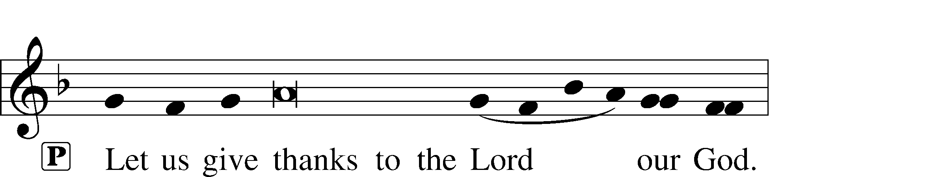
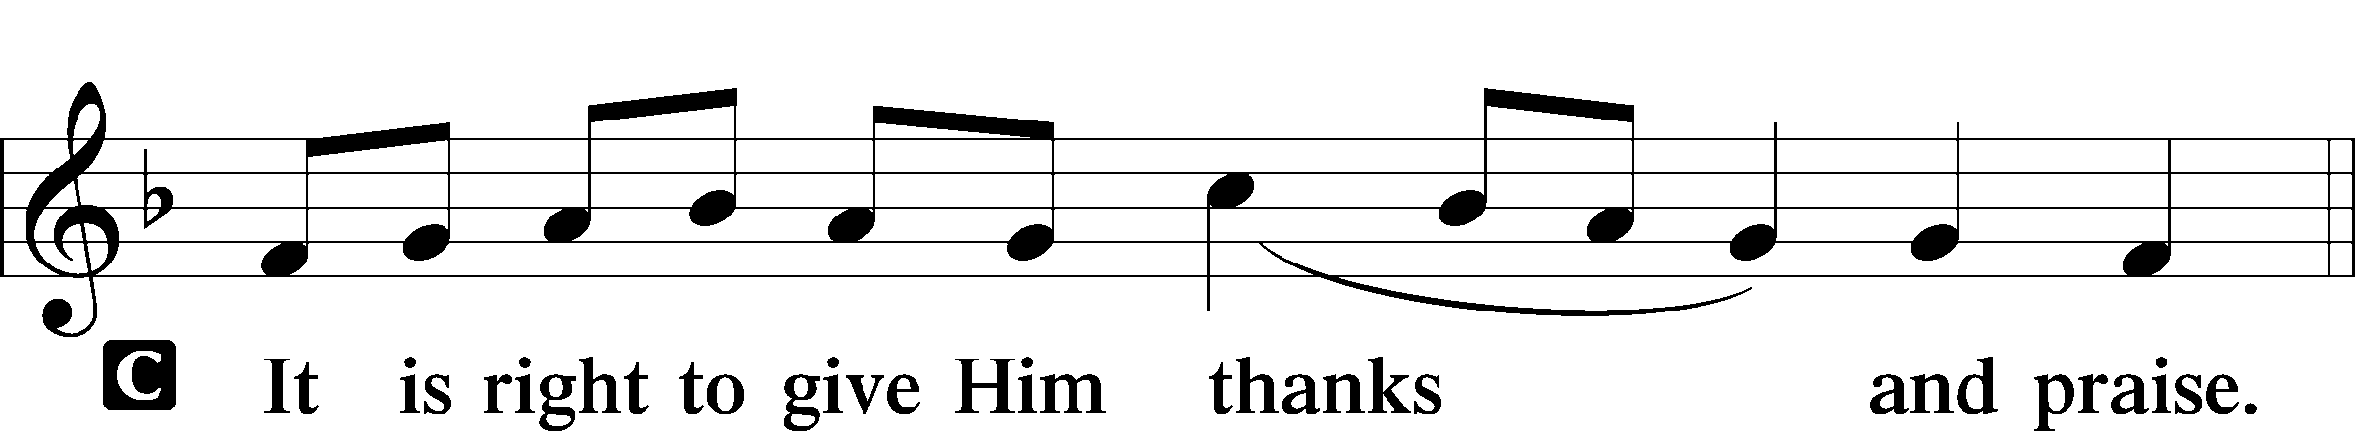

P It is truly good, right, and salutary that we should at all times and in all places give thanks to You, holy Lord, almighty Father, everlasting God. And most especially are we bound to praise You on this day for the glorious resurrection of Your Son, Jesus Christ, the very Paschal Lamb, who was sacrificed for us and bore the sins of the world. By His dying He has destroyed death, and by His rising again He has restored to us everlasting life. Therefore with Mary Magdalene, Peter and John, and with all the witnesses of the resurrection, with angels and archangels, and with all the company of heaven we laud and magnify Your glorious name, evermore praising You and saying:

Sanctus LSB 161
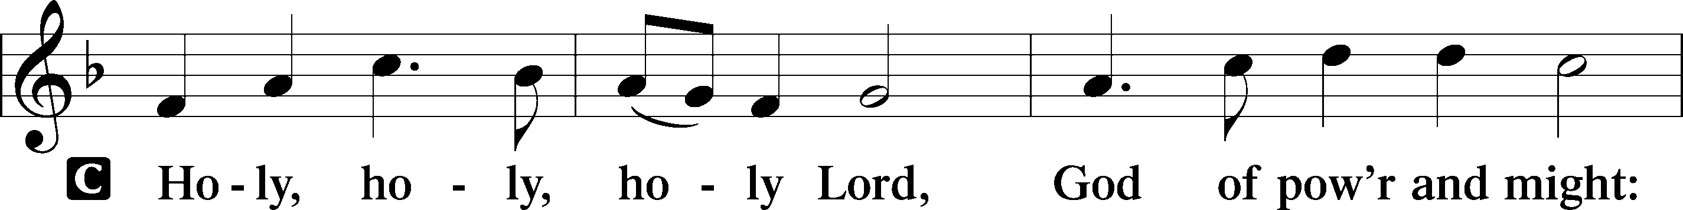
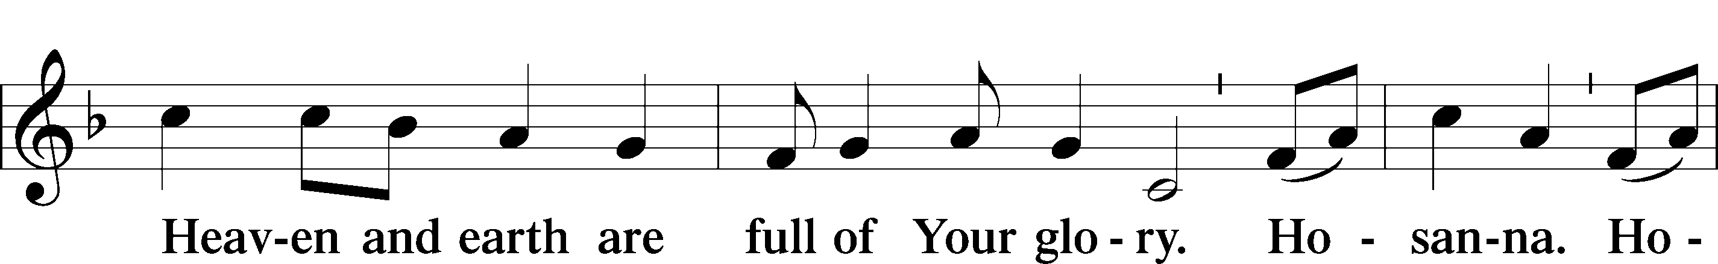
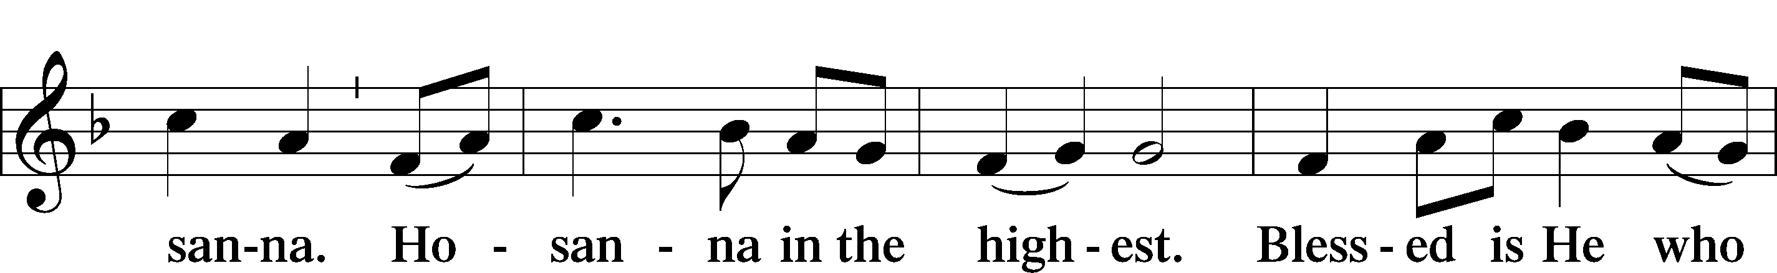
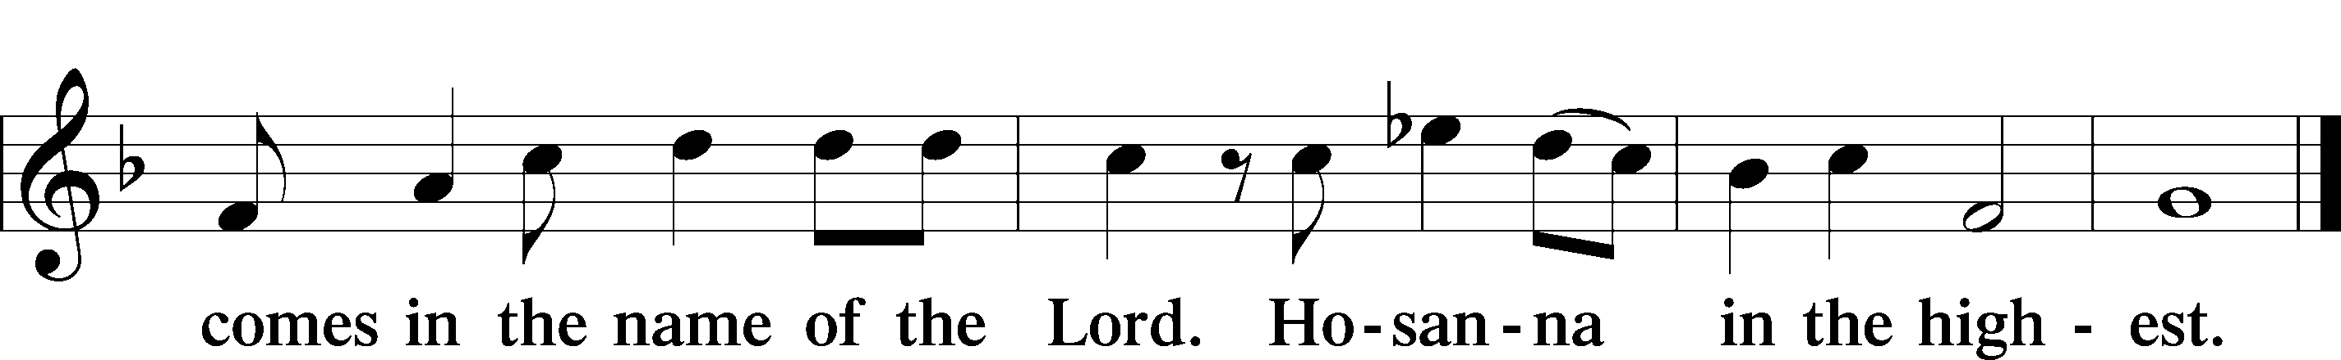

Prayer of Thanksgiving LSB 161
P Blessed are You, Lord of heaven and earth, for You have had mercy on those whom You created and sent Your only-begotten Son into our flesh to bear our sin and be our Savior. With repentant joy we receive the salvation accomplished for us by the all-availing sacrifice of His body and His blood on the cross.

Gathered in the name and the remembrance of Jesus, we beg You, O Lord, to forgive, renew, and strengthen us with Your Word and Spirit. Grant us faithfully to eat His body and drink His blood as He bids us do in His own testament. Gather us together, we pray, from the ends of the earth to celebrate with all the faithful the marriage feast of the Lamb in His kingdom, which has no end. Graciously receive our prayers; deliver and preserve us. To You alone, O Father, be all glory, honor, and worship, with the Son and the Holy Spirit, one God, now and forever.
C Amen.

The Words of Our Lord
P Our Lord Jesus Christ, on the night when He was betrayed, took bread, and when He had given thanks, He broke it and gave it to the disciples and said: “Take, eat; this is My T body, which is given for you. This do in remembrance of Me.”

In the same way also He took the cup after supper, and when He had given thanks, He gave it to them, saying: “Drink of it, all of you; this cup is the new testament in My T blood, which is shed for you for the forgiveness of sins. This do, as often as you drink it, in remembrance of Me.”

P As often as we eat this bread and drink this cup, we proclaim the Lord’s death until He comes.
C Amen. Come, Lord Jesus.

P O Lord Jesus Christ, only Son of the Father, in giving us Your body and blood to eat and to drink, You lead us to remember and confess Your holy cross and passion, Your blessed death, Your rest in the tomb, Your resurrection from the dead, Your ascension into heaven, and Your coming for the final judgment. So remember us in Your kingdom and teach us to pray:

Lord’s Prayer
C Our Father who art in heaven,
hallowed be Thy name,
Thy kingdom come,
Thy will be done on earth
as it is in heaven;
give us this day our daily bread;
and forgive us our trespasses
as we forgive those
who trespass against us;
and lead us not into temptation,
but deliver us from evil.
For Thine is the kingdom
and the power and the glory
forever and ever. Amen.

Pax Domini LSB 163
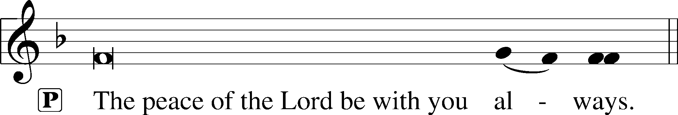

Agnus Dei LSB 163
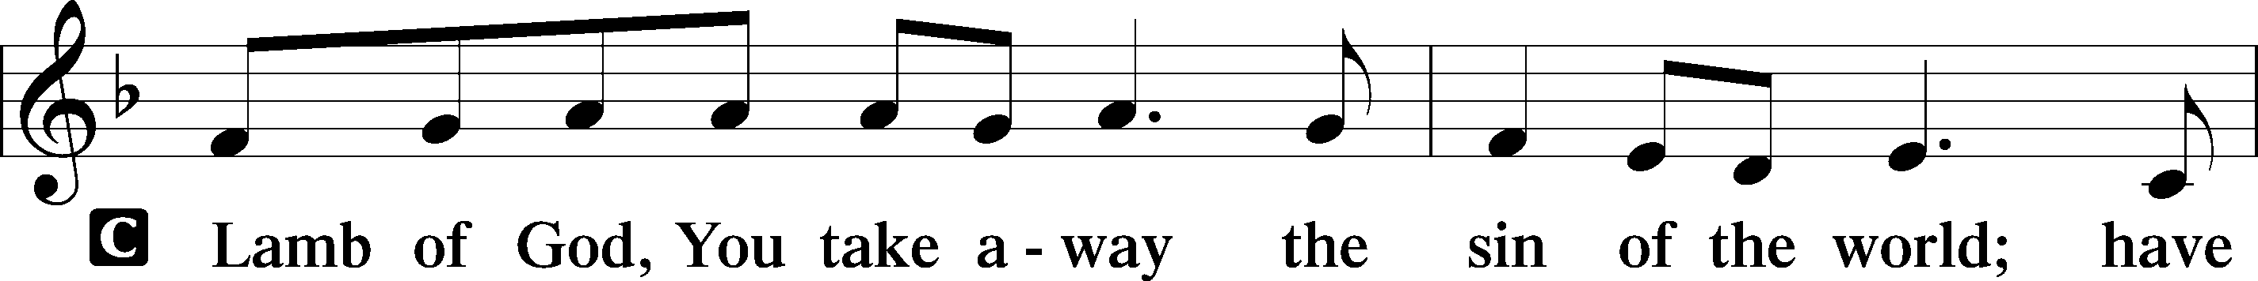
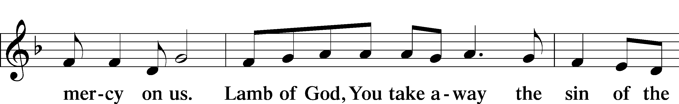
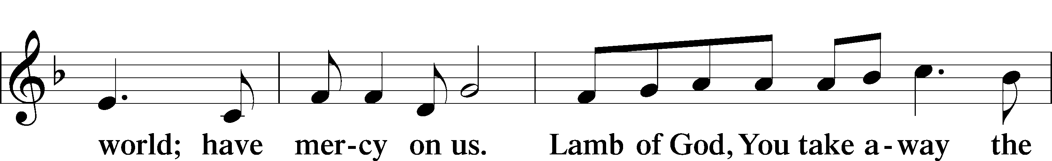
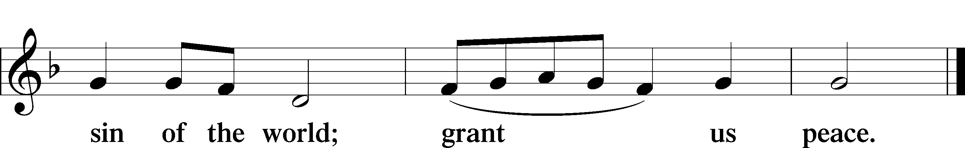

Sit

Distribution

The pastor and those who assist him receive the body and blood of Christ first and then distribute them to those who come to receive, saying:

Take, eat; this is the true body of our Lord and Savior Jesus Christ, given into death for your sins.
Amen.

Take, drink; this is the true blood of our Lord and Savior Jesus Christ, shed for the forgiveness of your sins.
Amen.

In dismissing the communicants, the following is said:

P The body and blood of our Lord Jesus Christ strengthen and preserve you in body and soul to life everlasting. Depart T in peace.
C Amen.

Distribution Hymn: 547 The Lamb
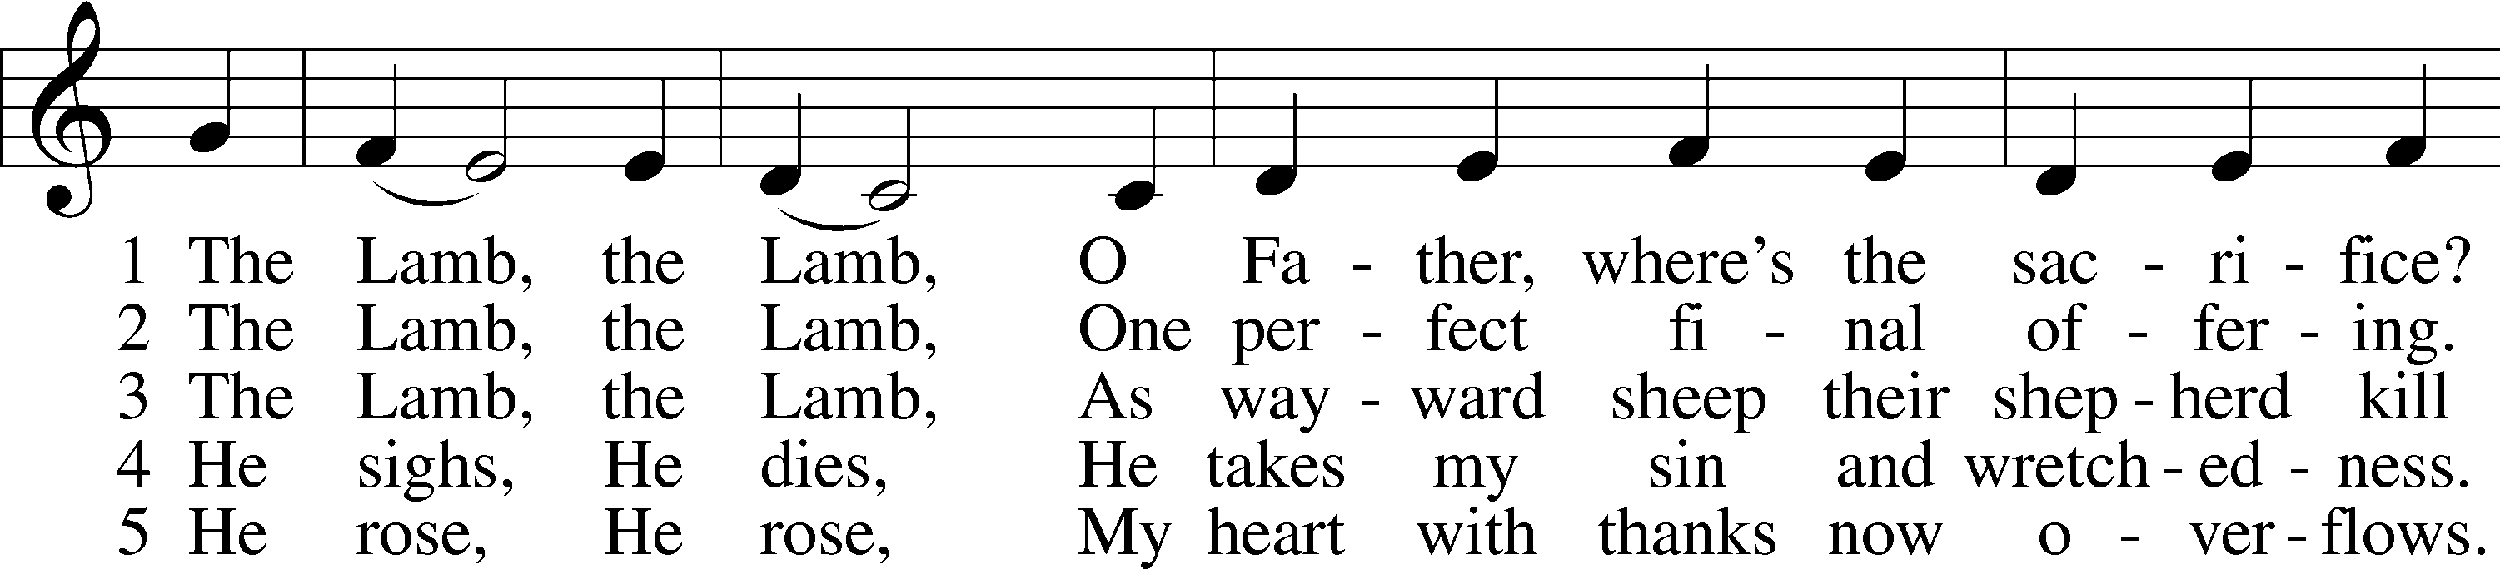
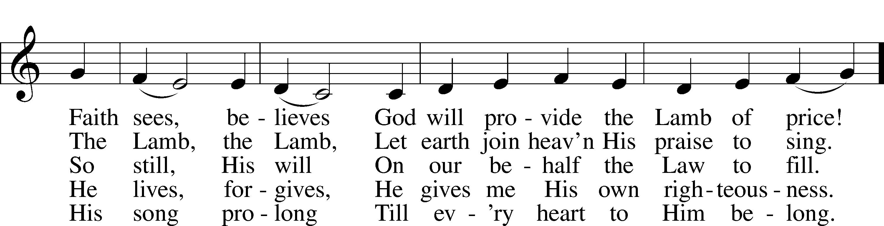
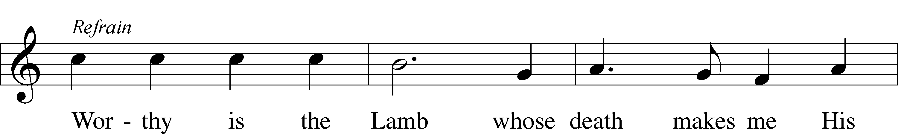
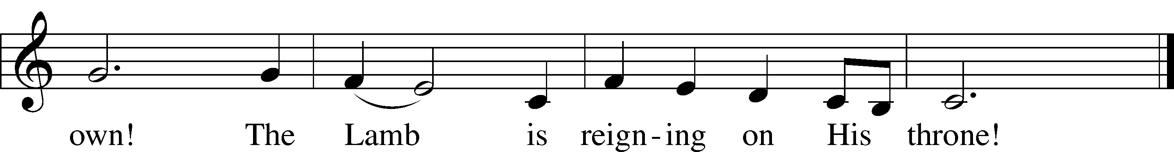
Text and tune: Gerald P. Coleman, 1953
Text and tune: © 1987 and 1997 MorningStar Music Publishers. Used by permission: LSB Hymn License no. 110005504

Distribution Hymn: 461 I Know That My Redeemer Lives
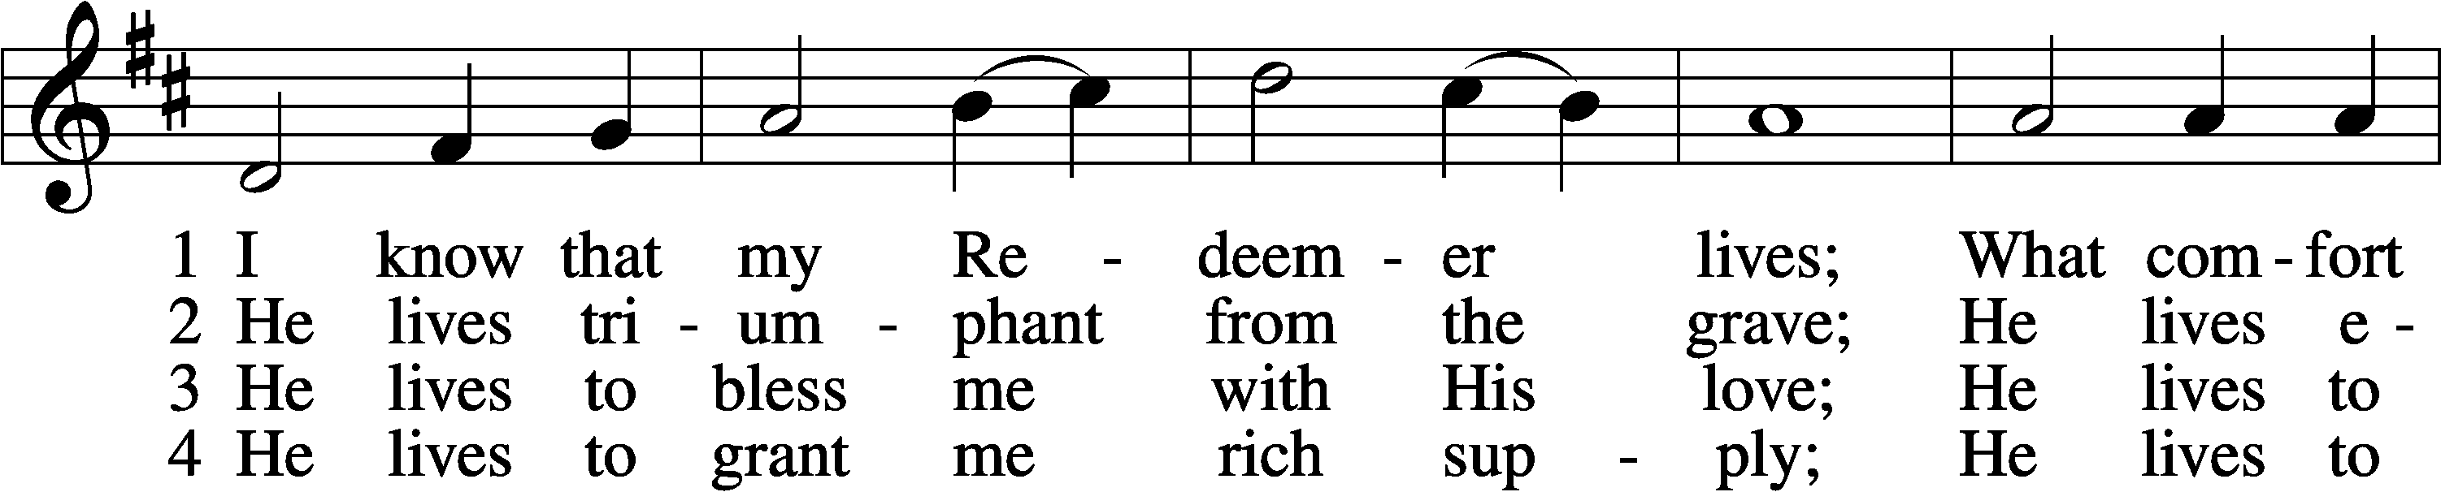
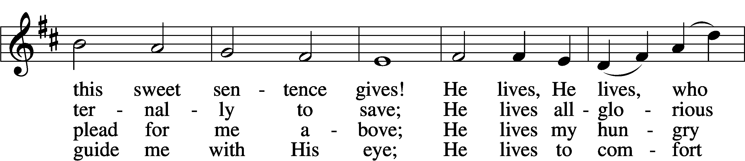
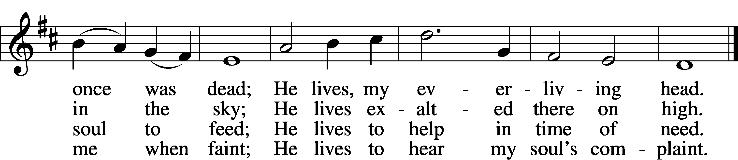

5 He lives to silence all my fears;
He lives to wipe away my tears;
He lives to calm my troubled heart;
He lives all blessings to impart.

6 He lives, my kind, wise, heav’nly friend;
He lives and loves me to the end;
He lives, and while He lives, I’ll sing;
He lives, my Prophet, Priest, and King.

7 He lives and grants me daily breath;
He lives, and I shall conquer death;
He lives my mansion to prepare;
He lives to bring me safely there.

8 He lives, all glory to His name!
He lives, my Jesus, still the same;
Oh, the sweet joy this sentence gives:
I know that my Redeemer lives!
Text: Samuel Medley, 1738–99, abr.
Tune: attr. John C. Hatton, d. 1793
Text and tune: Public domain

Stand

Thank the Lord LSB 164
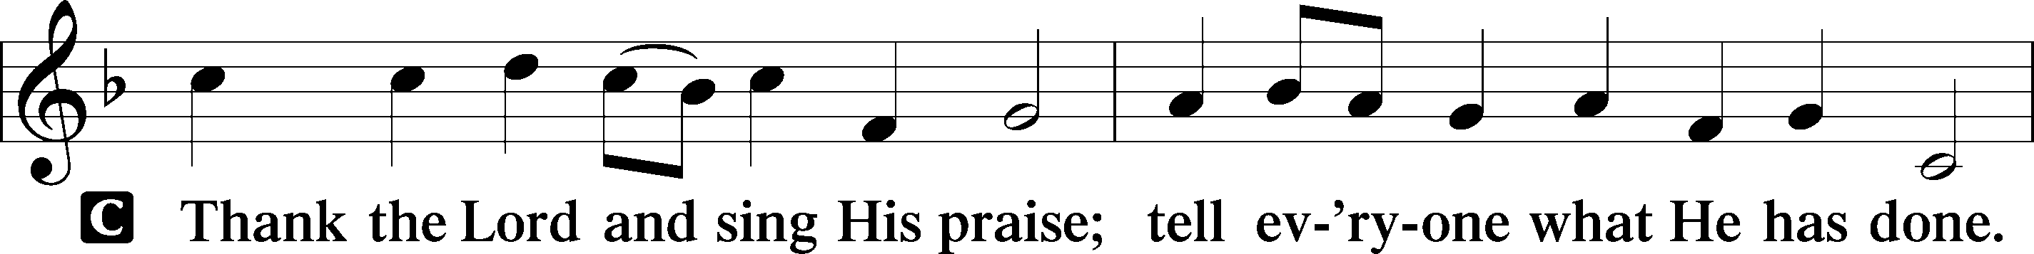
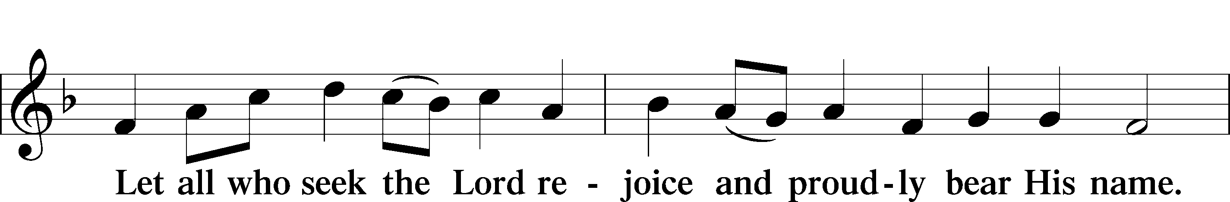
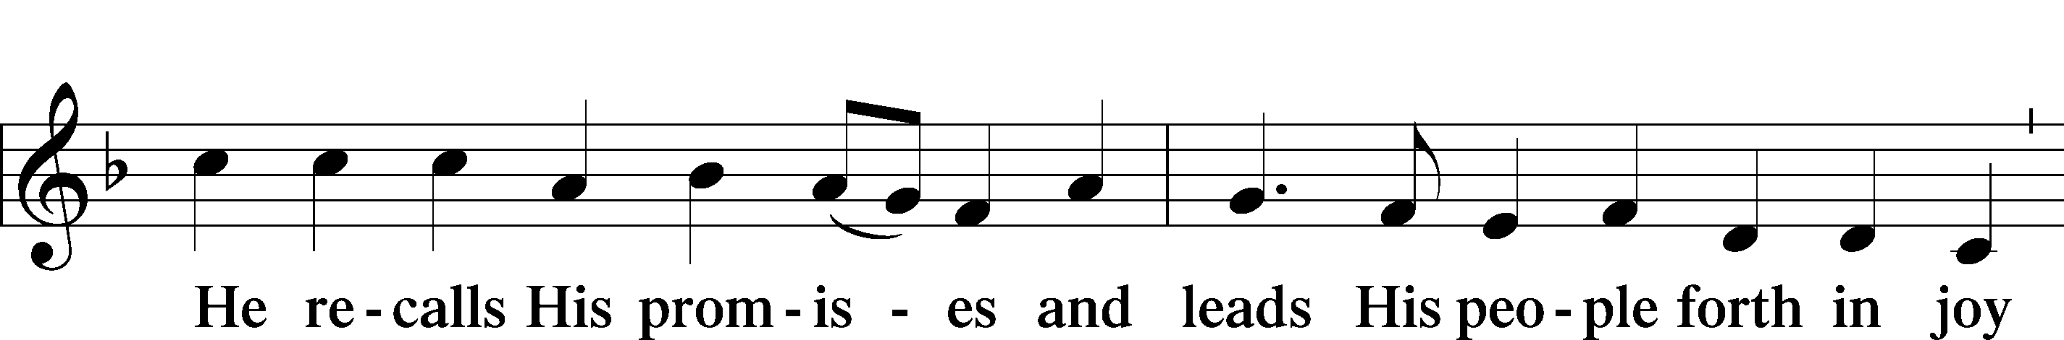
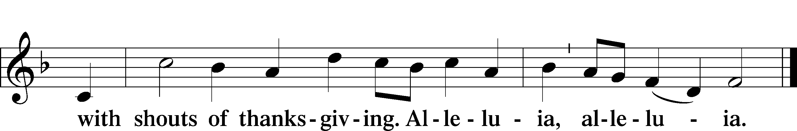

Post-Communion Collect
A Let us pray.
We give thanks to You, almighty God, that You have refreshed us through this salutary gift, and we implore You that of Your mercy You would strengthen us through the same in faith toward You and in fervent love toward one another; through Jesus Christ, Your Son, our Lord, who lives and reigns with You and the Holy Spirit, one God, now and forever.
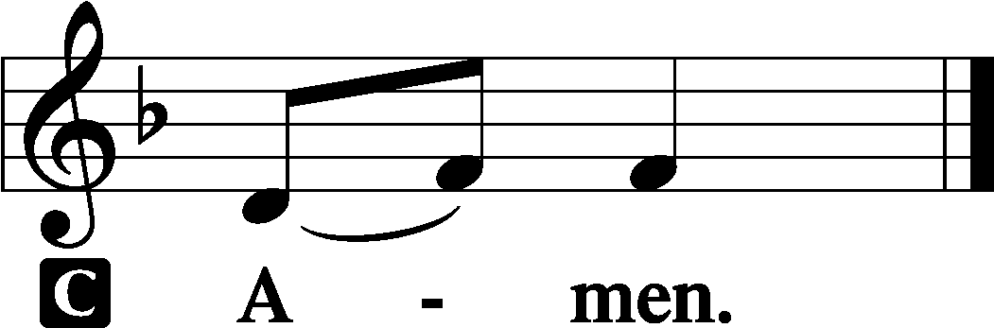

Benediction LSB 166
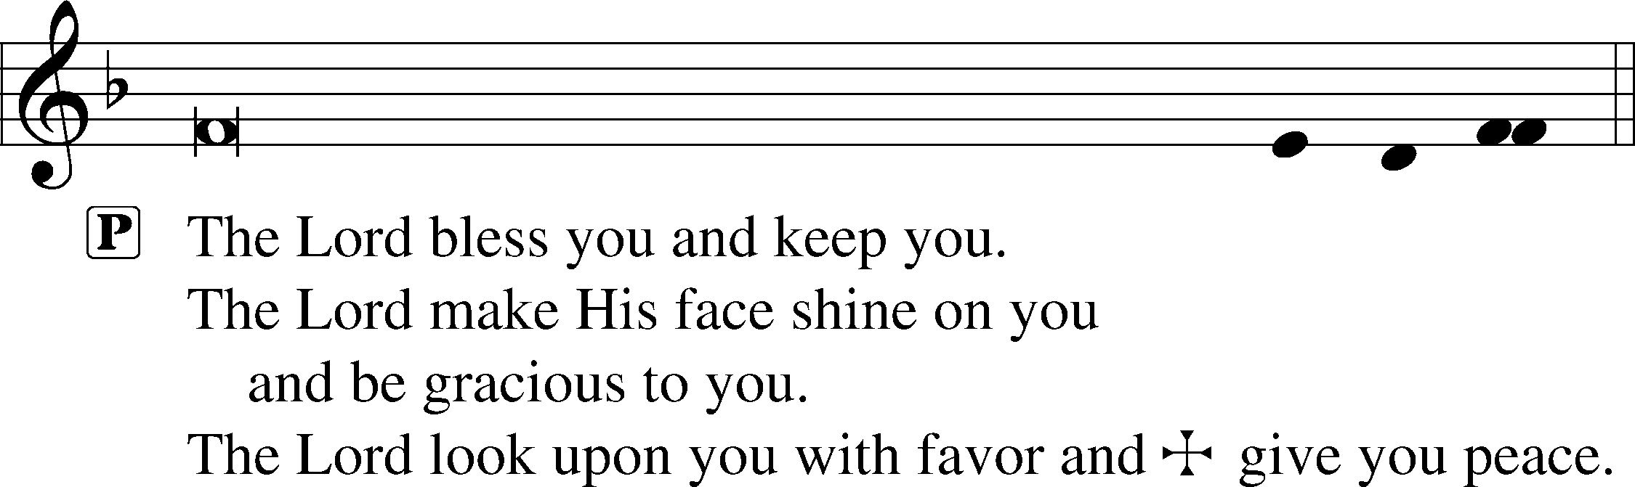

Hymn to Depart: 700 Love Divine, All Loves Excelling
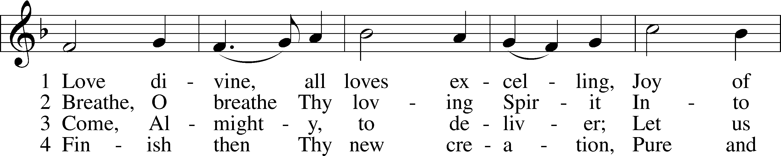
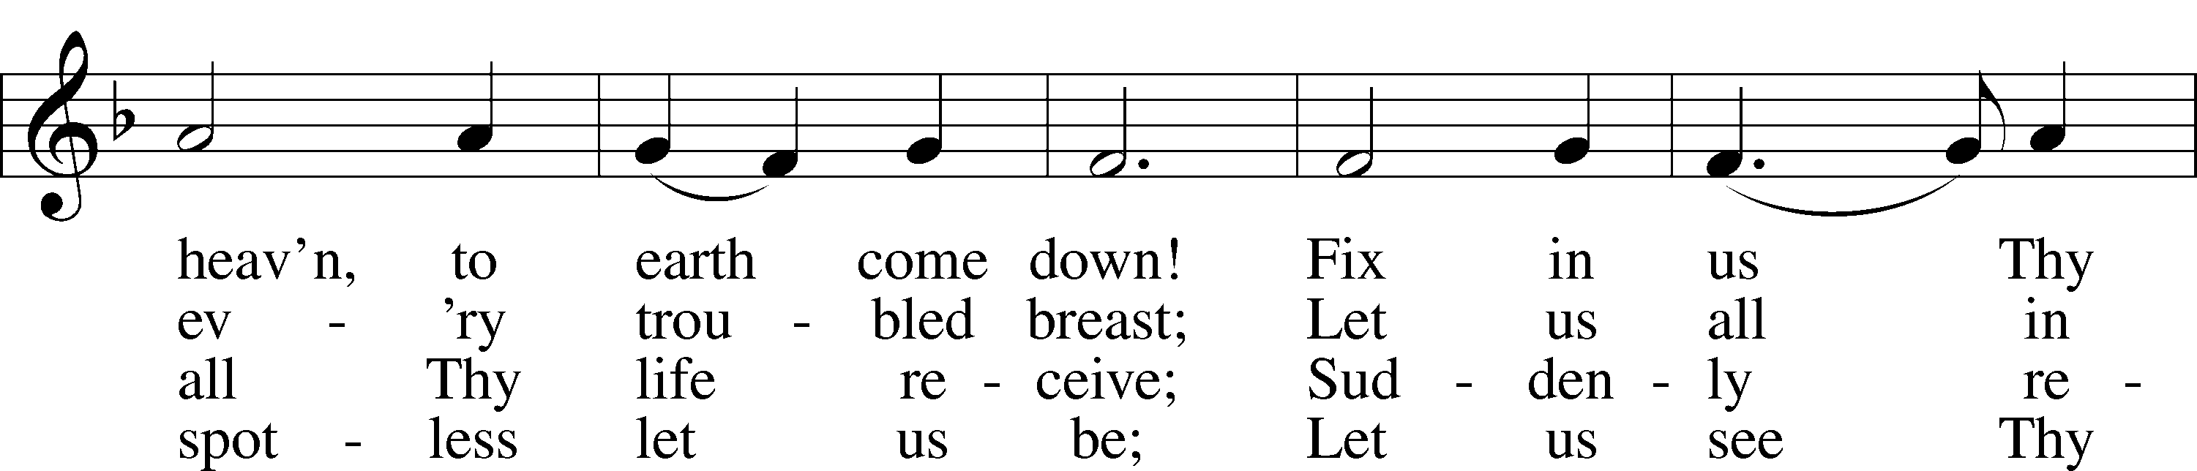
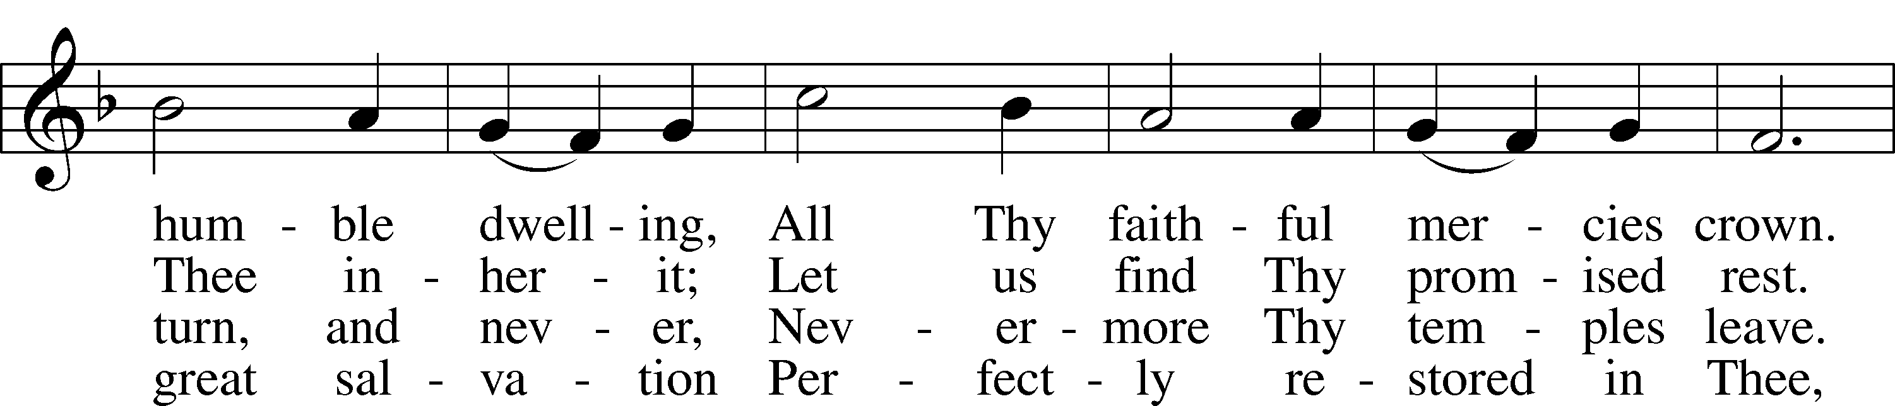
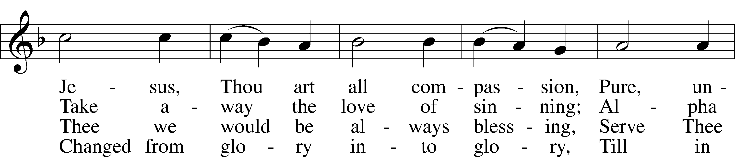
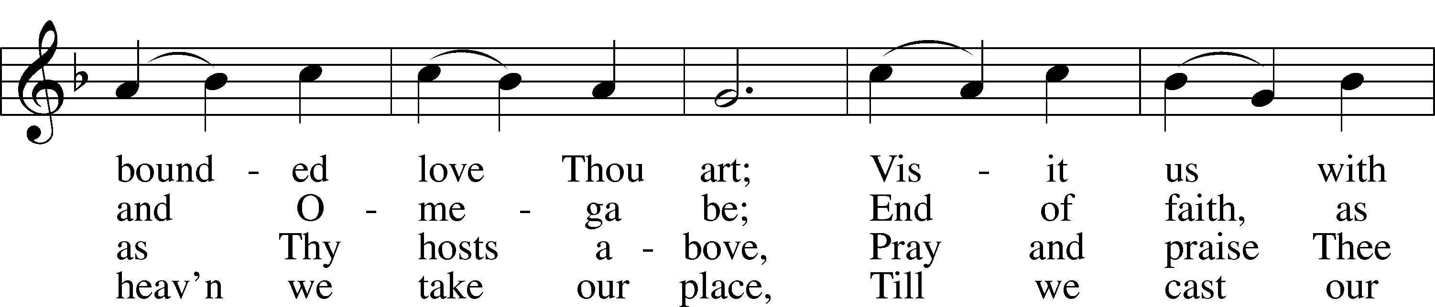
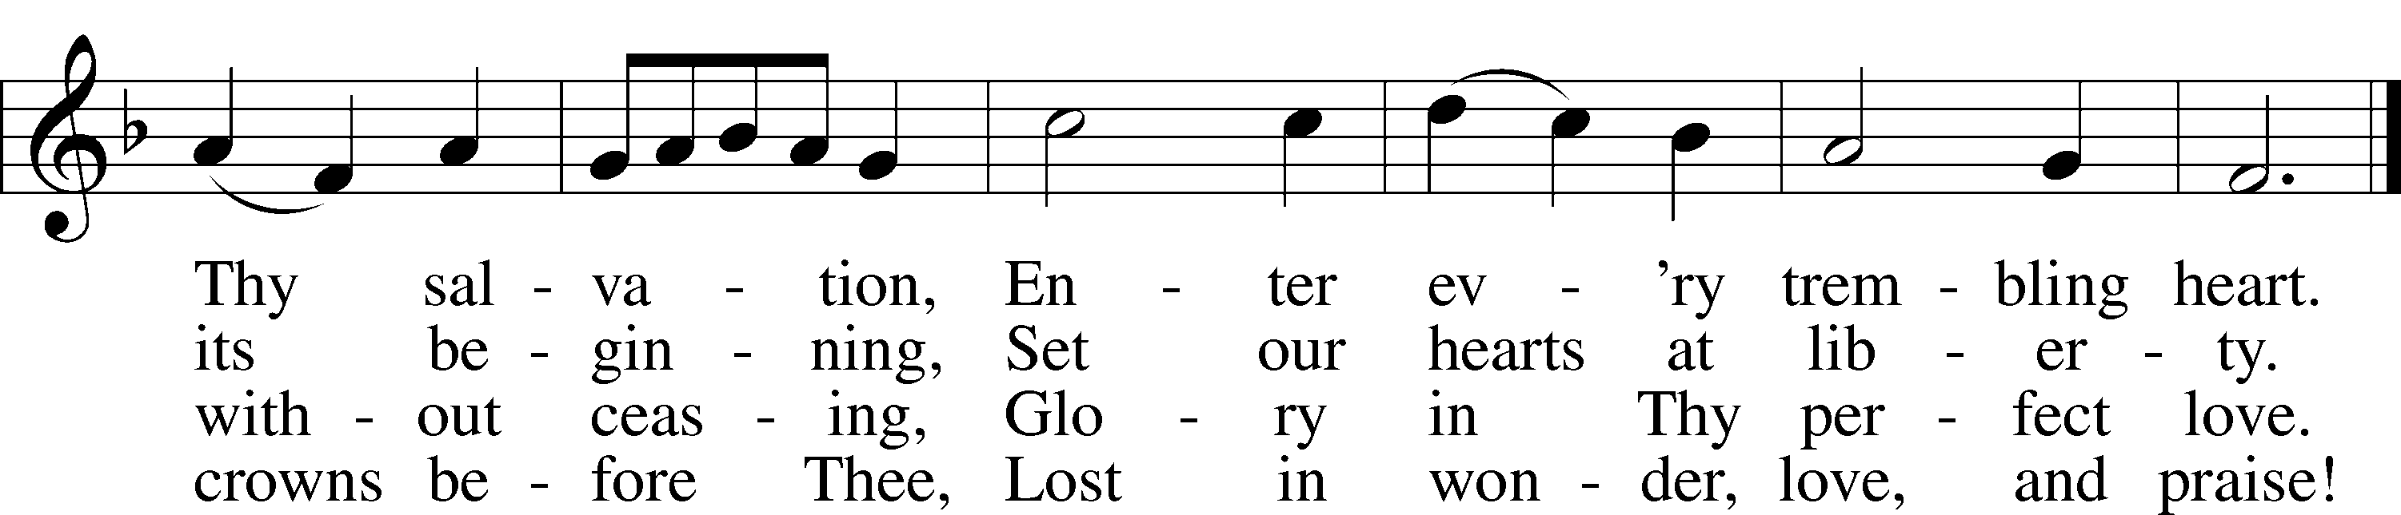
Text: Charles Wesley, 1707–88
Tune: Rowland H. Prichard, 1811–87
Text and tune: Public domain

Acknowledgments
Divine Service, Setting One from Lutheran Service Book
Unless otherwise indicated, Scripture quotations are from the ESV® Bible (The Holy Bible, English Standard Version®), copyright © 2001 by Crossway, a publishing ministry of Good News Publishers. Used by permission. All rights reserved.
Created by Lutheran Service Builder © 2024 Concordia Publishing House.

Announcements:
Church Service Phone: 888-505-1870/715-438-4200
(Stay on the line for recorded service to start)
Live Stream audio services: http://salem.listentochurch.com
Salem’s Web Page: https://www.salembarron.com/
Pastor Fred Buth: Cell phone:715-642-3050 (H)715-353-2540
Email: salembarronpastor@gmail.com
Pastor’s Office Hours: Monday-Wednesday 9-12
Attendance:
Call-in line: 3/31 – 3 In-person: 3/31 - 115

Coffee and Snacks: Trevor & Sarah Duncan
Elder Today: Paul Millerman
Altar Guild: Nancy & Marica

Schedule for the week:
Tuesday: 8:00 am Men’s Bible Study
7:00pm Coucil
Wednesday: 4:00 PM – Catechism Class
Thursday: 11:00 AM Bible Class

Looking for a Director for the VBS program, prayerfully consider this.

Save the Date:
April 7 – 10:15-11:15 – Jim and Susan Kaiser – Missionaries of LBT
April 7 – 11:30 – Chili and Cookie Contest
April 14 – 10:30 – PreCall Meeting With Pres. Lueck of the North Wisconsin District
April 15 – 6:00 PM – Circuit Lay Leader Meeting @ St. Paul’s Cumberland
Call Committee is being put together. If you are interested please contact an Elder or Sue in the office

Pastor Fred Buth will be our vacancy pastor.
He can be contacted at salembarronpastor@gmail.com or 1-715-353-2540

Pastor Nielsen’s new address is 108 Cecilia Ct. Waukesha, WI 53188 as of April 3, 2024

Communion Notices:
Please complete a communion card for our records; they are in the pew in front of you, or request one from an usher. Salem’s communion practice is that of close communion. We invite to our rail those who are members in good standing of sister Missouri Synod parishes. Visitors, please contact the pastor prior to communing. For those who prefer to use the Common Cup, we ask your assistance by holding the cup’s base as you commune.
l
Prayers Request:
Those in the nursing home: Joann Jaeger Those Shut-in at home: Char Herman, Joan Church, Joyce Myers, Joyce Koba Those with ongoing health issues: Harrison Fields, Jeanne Perala, Owen Metz, Kathy Nielsen (Pastor’s aunt), Jeff Bonneville, Daria (Cindy Wright’s friend), Butch L. (Cindy Wright’s Brother-in-law), Melissa Miller., Dale Bryan, Art Smith (Sue Millerman’s brother), Brenda Sellent (Denise Stabenow’s sister), Sandy Hahn (Cindy Wright’s cousin’s wife), Wayne Hahn (Cindy Wright’s Uncle) Recovering from surgery: Wyatt Weise, Gail Espeseth For Pastor Nielsen and family as they begin the transition to St. John’s North Prairie. Those who lead our nation: Joe Biden, Kamala Harris, Tony Evers, Rod Nordby Those who serve in our military and law enforcement: Ryan Graf, Chaplain Pon Chanthaphon (Our Adopt-a-Chaplain), Rusty Weise Our Childcare Staff: Melissa Weinert, Denise Stabenow, Katelyn Hendren, Holly Wilhelmi, Janica Skjerly, Jacie Amundson, Emily Young, Zuri Soto For Christ Community Lutheran School – For Community Support for CCLS

