Confession and Absolution

Hymn of Invocation: 790 Praise to the Lord, the Almighty
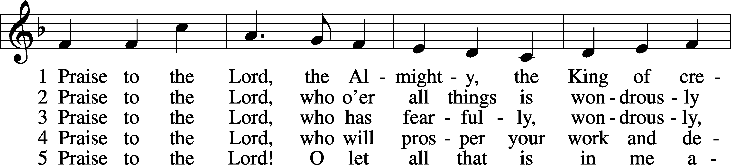
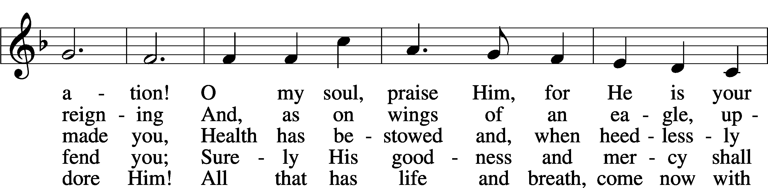
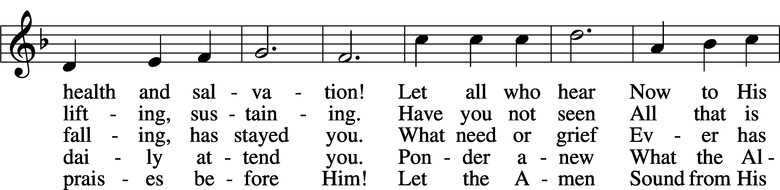
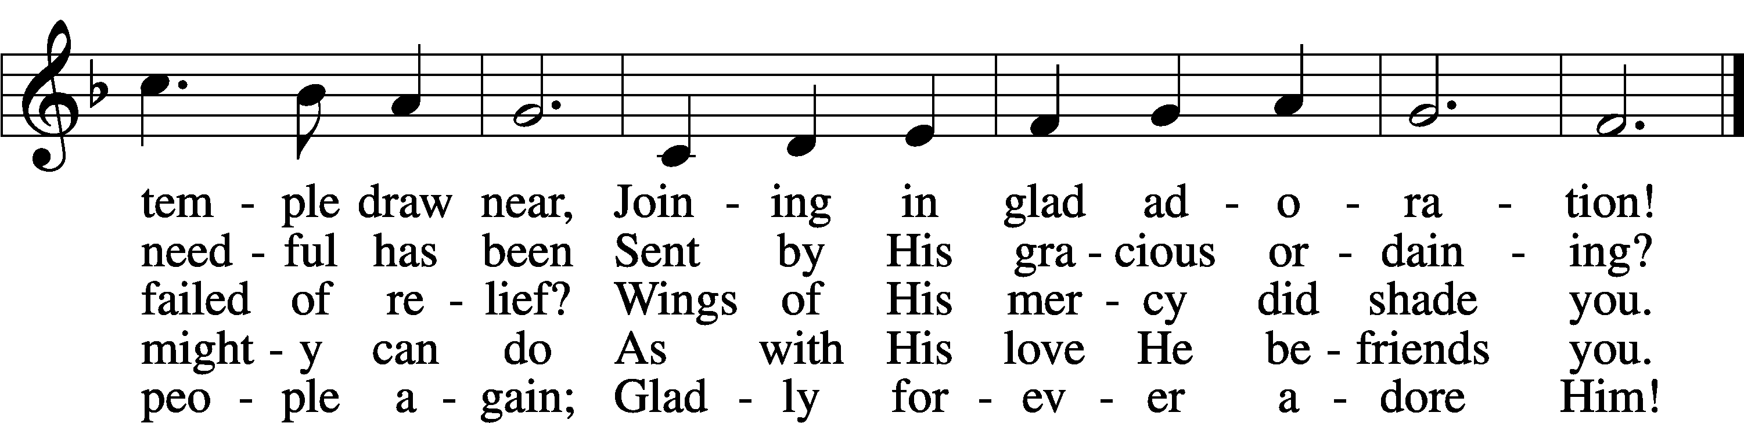
Text: Joachim Neander, 1650–80; tr. Catherine Winkworth, 1827–78, alt.
Tune: Ander Theil Des Erneuerten Gesang-Buchs, 1665, Stralsund
Text and tune: Public domain

Stand

The sign of the cross may be made by all in remembrance of their Baptism.

P In the name of the Father and of the T Son and of the Holy Spirit.
C Amen.

P Beloved in the Lord! Let us draw near with a true heart and confess our sins unto God our Father, beseeching Him in the name of our Lord Jesus Christ to grant us forgiveness.

P Our help is in the name of the Lord,
C who made heaven and earth.
P I said, I will confess my transgressions unto the Lord,
C and You forgave the iniquity of my sin.

Kneel/Stand

Silence for reflection on God’s Word and for self-examination.

P O almighty God, merciful Father,
C I, a poor, miserable sinner, confess unto You all my sins and iniquities with which I have ever offended You and justly deserved Your temporal and eternal punishment. But I am heartily sorry for them and sincerely repent of them, and I pray You of Your boundless mercy and for the sake of the holy, innocent, bitter sufferings and death of Your beloved Son, Jesus Christ, to be gracious and merciful to me, a poor, sinful being.

P Upon this your confession, I, by virtue of my office, as a called and ordained servant of the Word, announce the grace of God unto all of you, and in the stead and by the command of my Lord Jesus Christ I forgive you all your sins in the name of the Father and of the T Son and of the Holy Spirit.
C Amen.

Stand

Service of the Word

Introit Psalm 23; antiphon: John 10:14, 15b
I am the good shepherd.
I know my own and my own know me, and I lay down my life for the sheep.
The Lord is my shepherd;
I shall not want.
He makes me lie down in green pastures.
He leads me beside still waters.
He restores my soul.
He leads me in paths of righteousness for his name’s sake.
Even though I walk through the valley of the shadow of death, I will fear no evil, for you are with me;
your rod and your staff, they comfort me.
You prepare a table before me in the presence of my enemies;
you anoint my head with oil; my cup overflows.
Surely goodness and mercy shall follow me all the days of my life,
and I shall dwell in the house of the Lord forever.
Glory be to the Father and to the Son
and to the Holy Spirit;
as it was in the beginning,
is now, and will be forever. Amen.
I am the good shepherd.
I know my own and my own know me, and I lay down my life for the sheep.

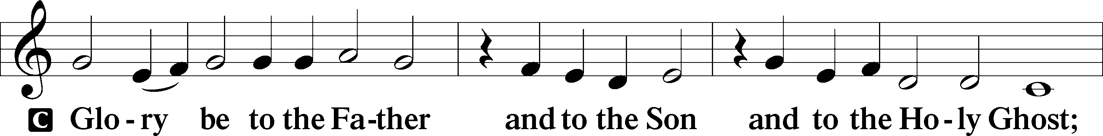
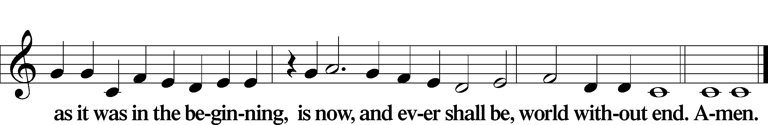

Kyrie LSB 186
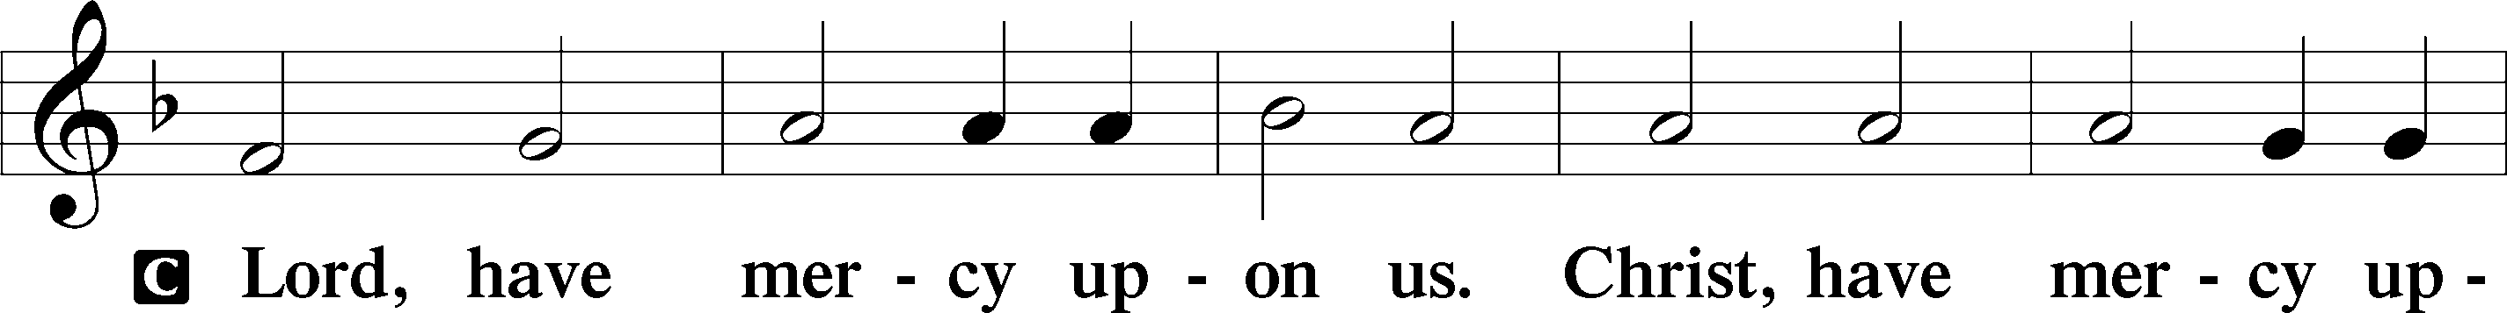
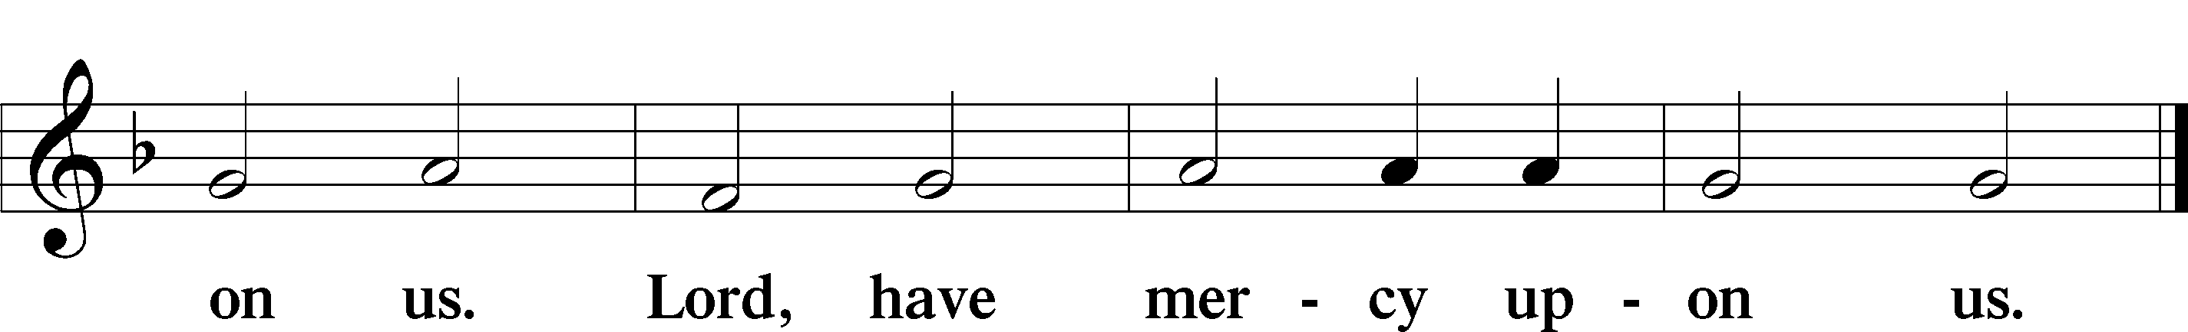

Gloria in Excelsis LSB 187
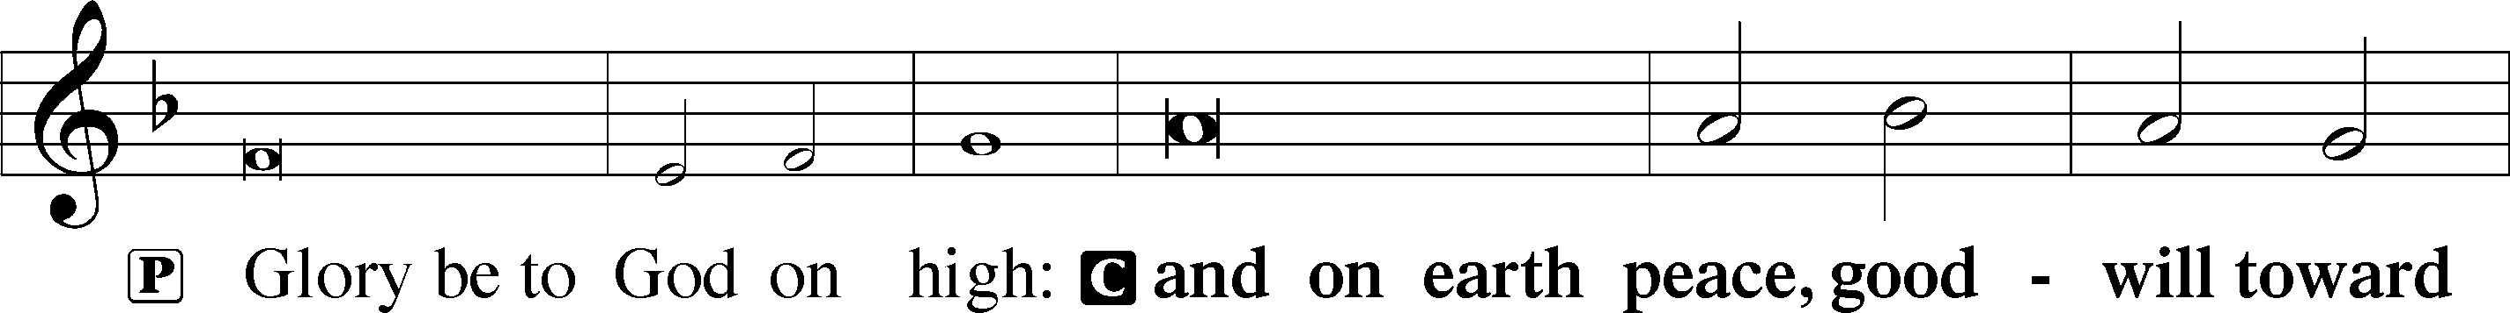
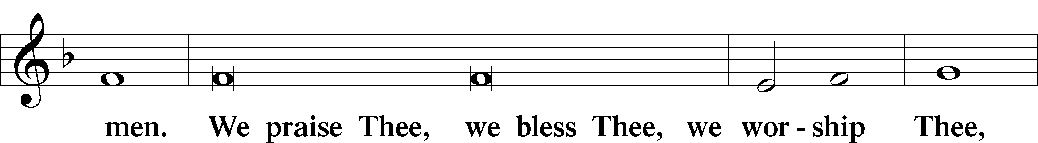
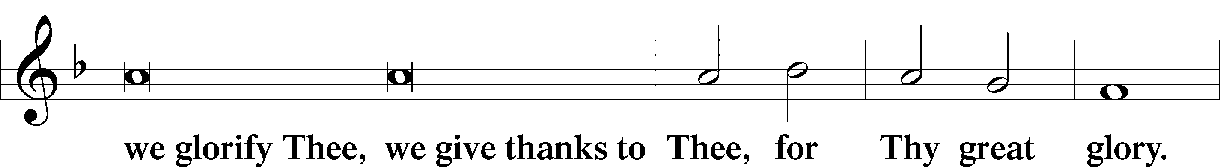
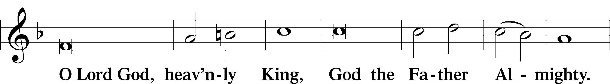
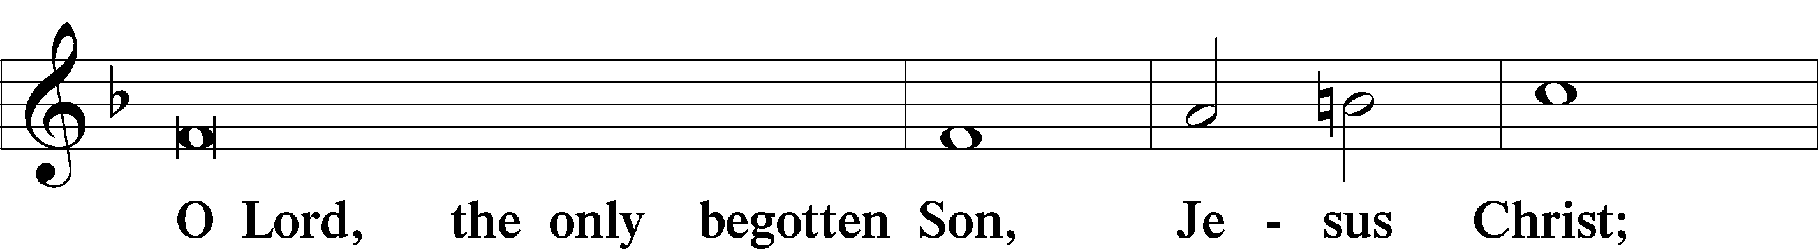
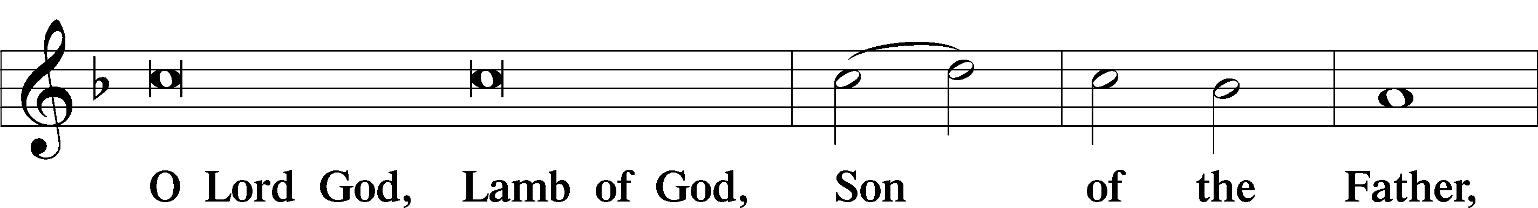
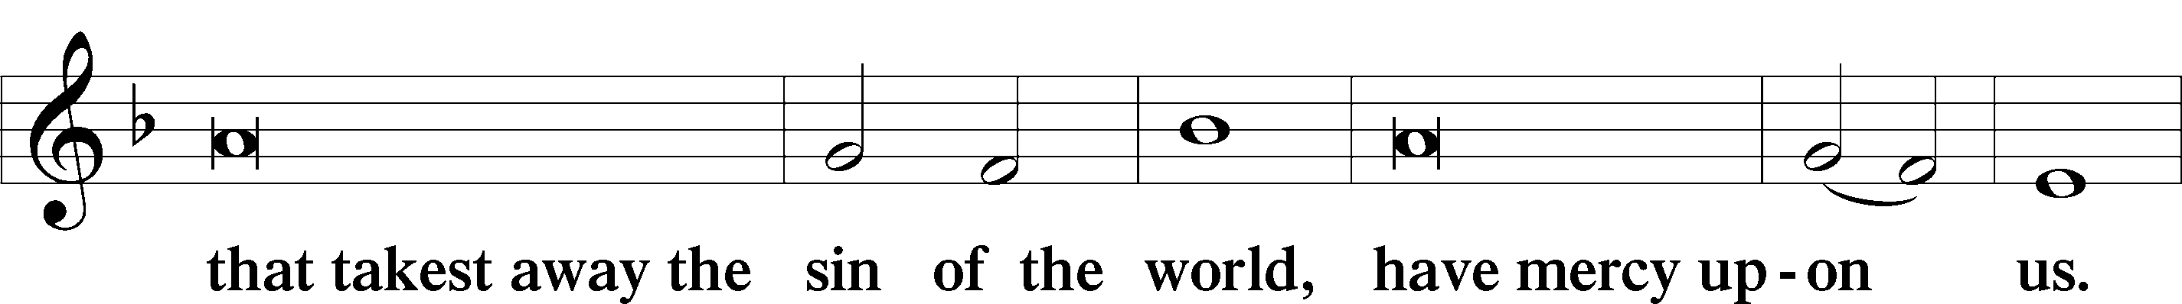
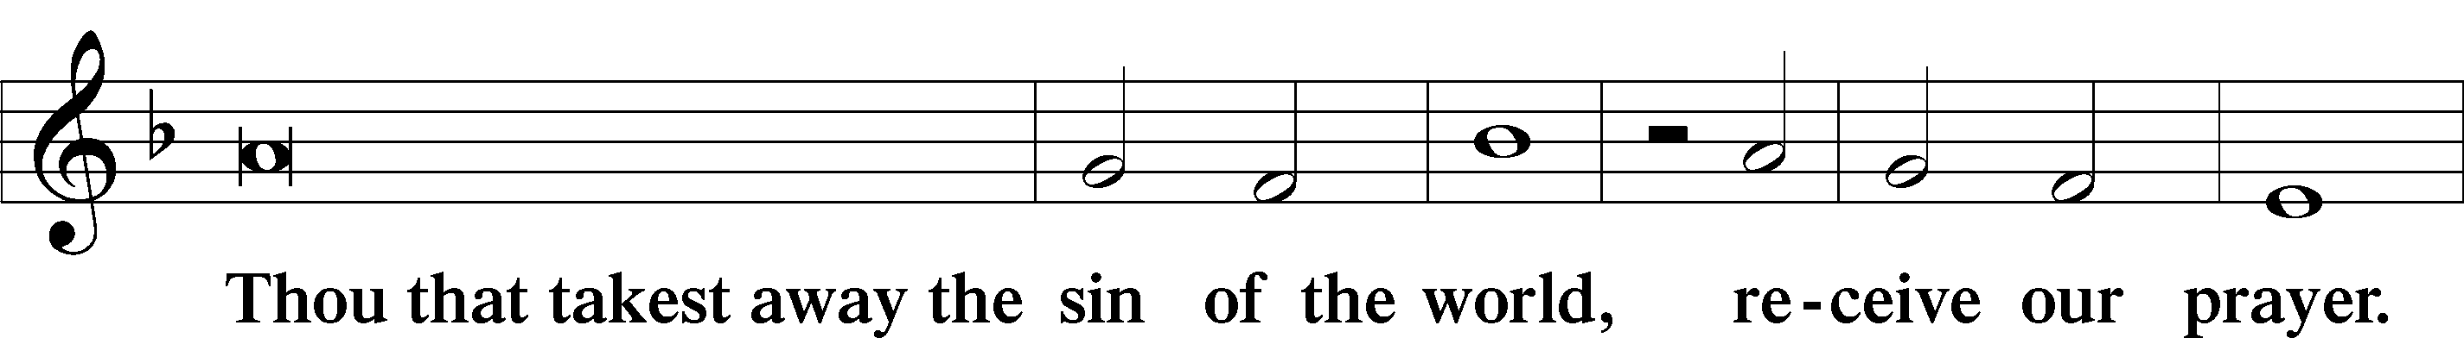
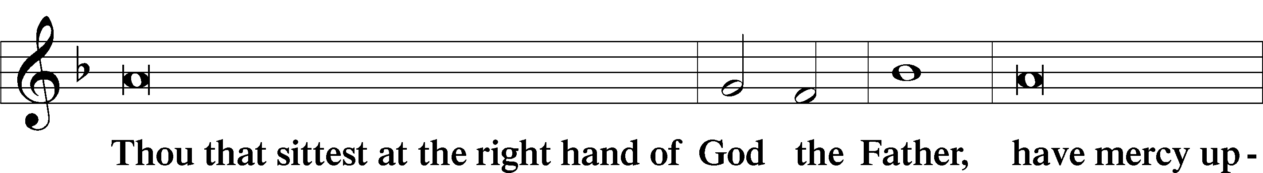
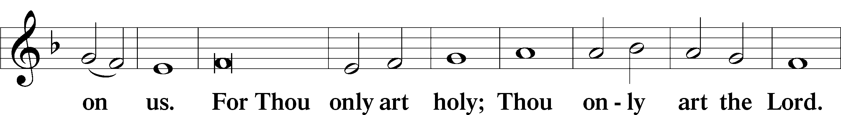
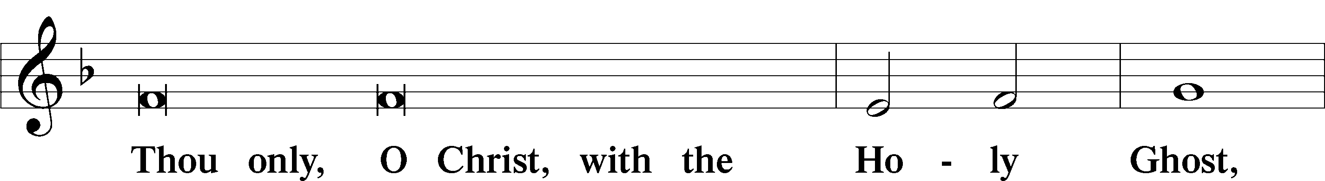
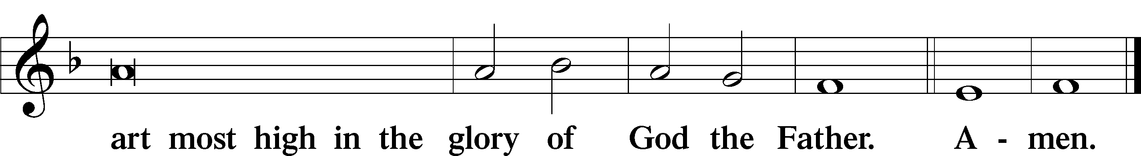

Salutation and Collect of the Day
P The Lord be with you.
C And with thy spirit.

P Let us pray.
Almighty God, merciful Father, since You have wakened from death the Shepherd of Your sheep, grant us Your Holy Spirit that when we hear the voice of our Shepherd we may know Him who calls us each by name and follow where He leads; through the same Jesus Christ, Your Son, our Lord, who lives and reigns with You and the Holy Spirit, one God, now and forever.

C Amen.

Sit

First Reading Acts 4:1–12
Peter and John Before the Council
1As they were speaking to the people, the priests and the captain of the temple and the Sadducees came upon them, 2greatly annoyed because they were teaching the people and proclaiming in Jesus the resurrection from the dead. 3And they arrested them and put them in custody until the next day, for it was already evening. 4But many of those who had heard the word believed, and the number of the men came to about five thousand.
5On the next day their rulers and elders and scribes gathered together in Jerusalem, 6with Annas the high priest and Caiaphas and John and Alexander, and all who were of the high-priestly family. 7And when they had set them in the midst, they inquired, “By what power or by what name did you do this?” 8Then Peter, filled with the Holy Spirit, said to them, “Rulers of the people and elders, 9if we are being examined today concerning a good deed done to a crippled man, by what means this man has been healed, 10let it be known to all of you and to all the people of Israel that by the name of Jesus Christ of Nazareth, whom you crucified, whom God raised from the dead—by him this man is standing before you well. 11This Jesus is the stone that was rejected by you, the builders, which has become the cornerstone. 12And there is salvation in no one else, for there is no other name under heaven given among men by which we must be saved.”

A This is the Word of the Lord.
C Thanks be to God.

Psalm Psalm 23; antiphon: v. 6
The Lord Is My Shepherd
1The Lord is my shepherd;
I shall not want.
2He makes me lie down in green pastures.
He leads me beside still waters.
3He restores my soul.
He leads me in paths of righteousness for his name’s sake.
4Even though I walk through the valley of the shadow of death,
I will fear no evil, for you are with me;
your rod and your staff, they comfort me.
5You prepare a table before me
in the presence of my enemies;
you anoint my head with oil;
my cup overflows.
6Surely goodness and mercy shall follow me
all the days of my life,
and I shall dwell in the house of the Lord forever.

Epistle 1 John 3:16–24
16By this we know love, that he laid down his life for us, and we ought to lay down our lives for the brothers. 17But if anyone has the world’s goods and sees his brother in need, yet closes his heart against him, how does God’s love abide in him? 18Little children, let us not love in word or talk but in deed and in truth.
19By this we shall know that we are of the truth and reassure our heart before him; 20for whenever our heart condemns us, God is greater than our heart, and he knows everything. 21Beloved, if our heart does not condemn us, we have confidence before God; 22and whatever we ask we receive from him, because we keep his commandments and do what pleases him. 23And this is his commandment, that we believe in the name of his Son Jesus Christ and love one another, just as he has commanded us. 24Whoever keeps his commandments abides in him, and he in them. And by this we know that he abides in us, by the Spirit whom he has given us.

A This is the Word of the Lord.
C Thanks be to God.

Stand

Alleluia LSB 190
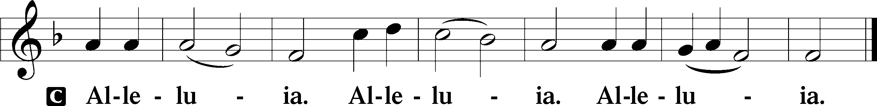

Holy Gospel John 10:11–18
P The Holy Gospel according to St. John, the tenth chapter.
C Glory be to Thee, O Lord.

11[Jesus said:] “I am the good shepherd. The good shepherd lays down his life for the sheep. 12He who is a hired hand and not a shepherd, who does not own the sheep, sees the wolf coming and leaves the sheep and flees, and the wolf snatches them and scatters them. 13He flees because he is a hired hand and cares nothing for the sheep. 14I am the good shepherd. I know my own and my own know me, 15just as the Father knows me and I know the Father; and I lay down my life for the sheep. 16And I have other sheep that are not of this fold. I must bring them also, and they will listen to my voice. So there will be one flock, one shepherd. 17For this reason the Father loves me, because I lay down my life that I may take it up again. 18No one takes it from me, but I lay it down of my own accord. I have authority to lay it down, and I have authority to take it up again. This charge I have received from my Father.”

P This is the Gospel of the Lord.
C Praise be to Thee, O Christ.

Nicene Creed
C I believe in one God,
the Father Almighty,
maker of heaven and earth
and of all things visible and invisible.

And in one Lord Jesus Christ,
the only-begotten Son of God,
begotten of His Father before all worlds,
God of God, Light of Light,
very God of very God,
begotten, not made,
being of one substance with the Father,
by whom all things were made;
who for us men and for our salvation came down from heaven
and was incarnate by the Holy Spirit of the virgin Mary
and was made man;
and was crucified also for us under Pontius Pilate.
He suffered and was buried.
And the third day He rose again according to the Scriptures
and ascended into heaven
and sits at the right hand of the Father.
And He will come again with glory to judge both the living and the dead,
whose kingdom will have no end.

And I believe in the Holy Spirit,
the Lord and giver of life,
who proceeds from the Father and the Son,
who with the Father and the Son together is worshiped and glorified,
who spoke by the prophets.
And I believe in one holy Christian and apostolic Church,
I acknowledge one Baptism for the remission of sins,
and I look for the resurrection of the dead
and the life T of the world to come. Amen.

Sit

Hymn of the Day: 709 The King of Love My Shepherd Is
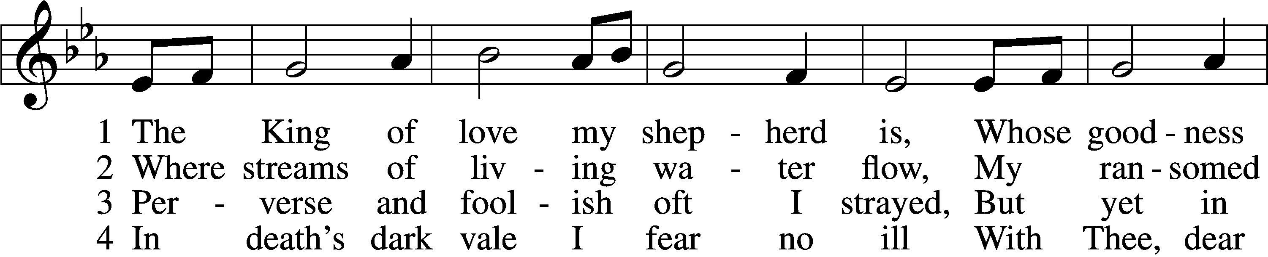
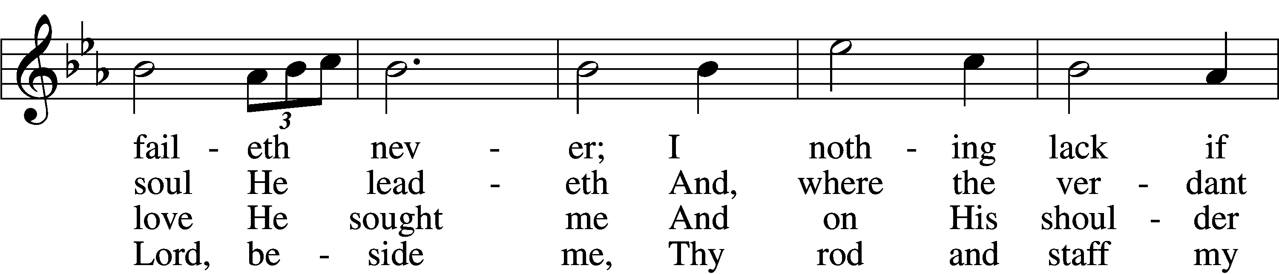
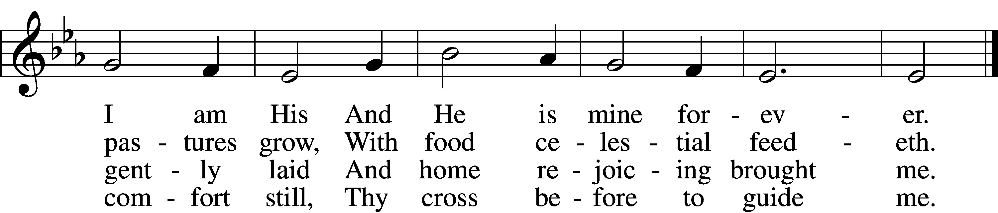

5 Thou spreadst a table in my sight;
Thine unction grace bestoweth;
And, oh, what transport of delight
From Thy pure chalice floweth!

6 And so through all the length of days
Thy goodness faileth never;
Good Shepherd, may I sing Thy praise
Within Thy house forever!
Text: Henry W. Baker, 1821–77
Tune: Irish, c. 18th cent.
Text and tune: Public domain

Sermon

P The peace of God, which passes all understanding, keep your hearts and minds in Christ Jesus.
C Amen.

Stand

Offertory LSB 192
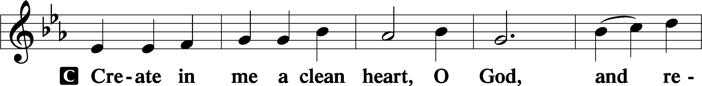
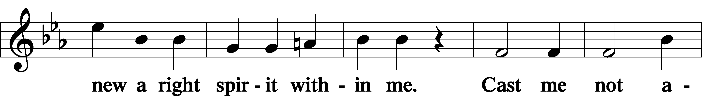
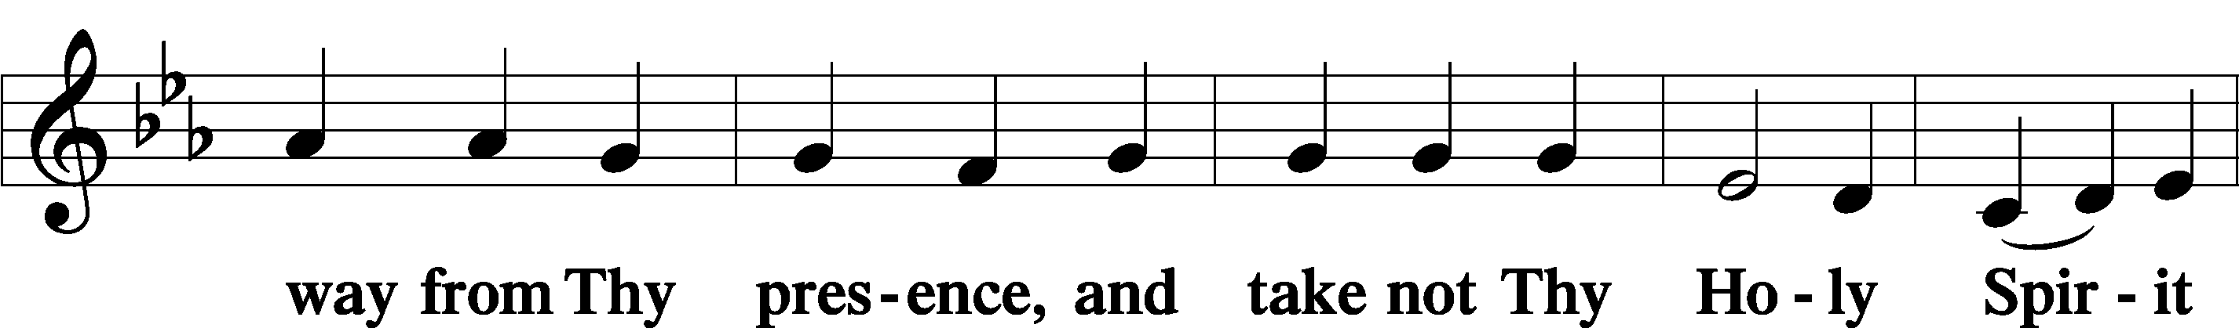
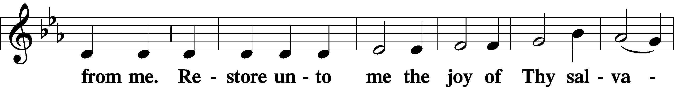
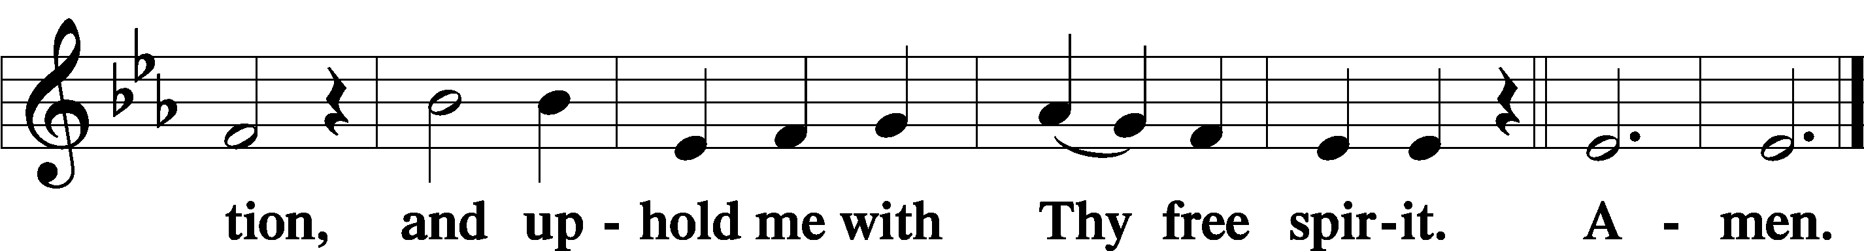

Sit

Offering

Stand

Prayer of the Church

Service of the Sacrament

Preface LSB 194
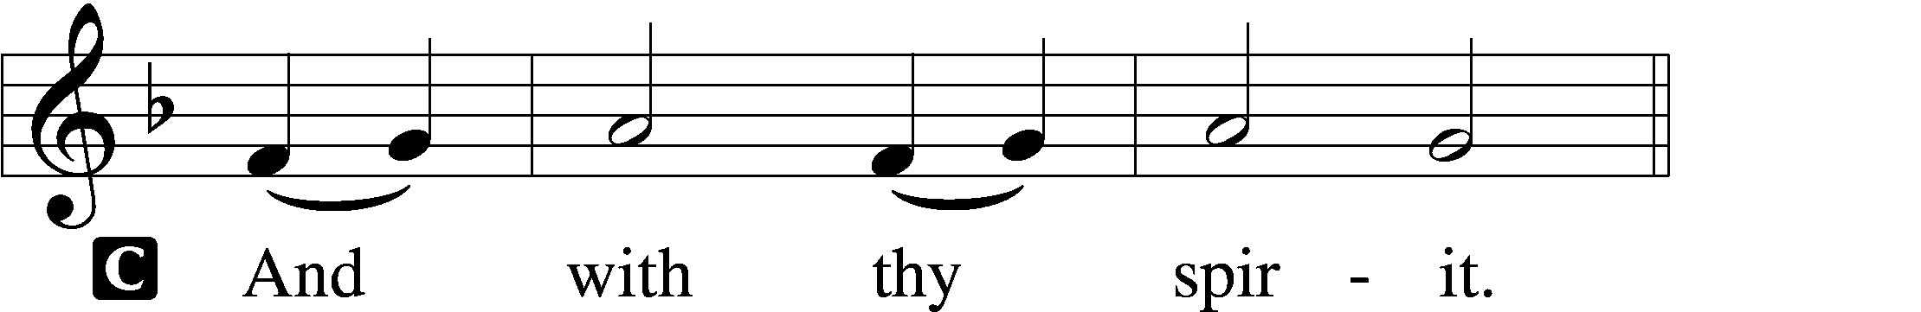

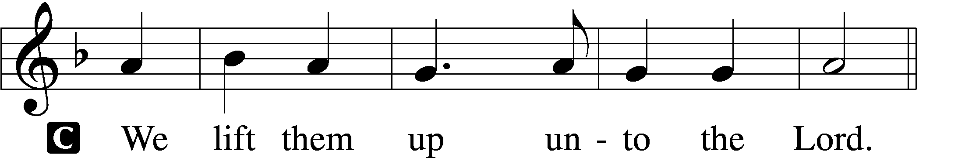

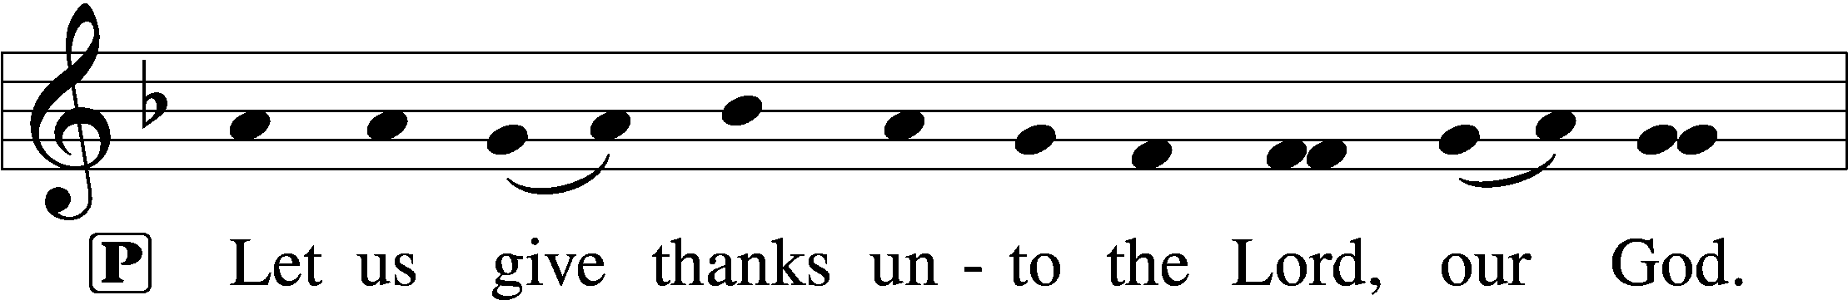
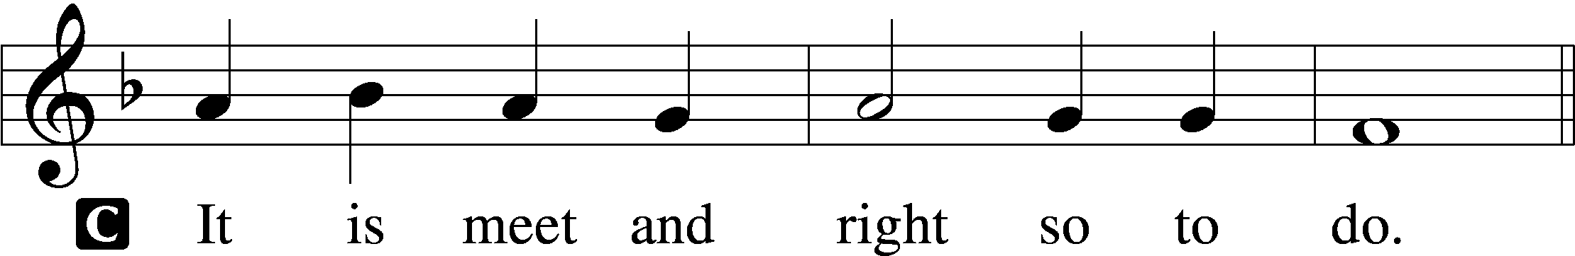

P It is truly meet, right, and salutary that we should at all times and in all places give thanks to You, holy Lord, almighty Father, everlasting God. And most especially are we bound to praise You on this day for the glorious resurrection of Your Son, Jesus Christ, the very Paschal Lamb, who was sacrificed for us and bore the sins of the world. By His dying He has destroyed death, and by His rising again He has restored to us everlasting life. Therefore with Mary Magdalene, Peter and John, and with all the witnesses of the resurrection, with angels and archangels, and with all the company of heaven we laud and magnify Your glorious name, evermore praising You and saying:

Sanctus LSB 195
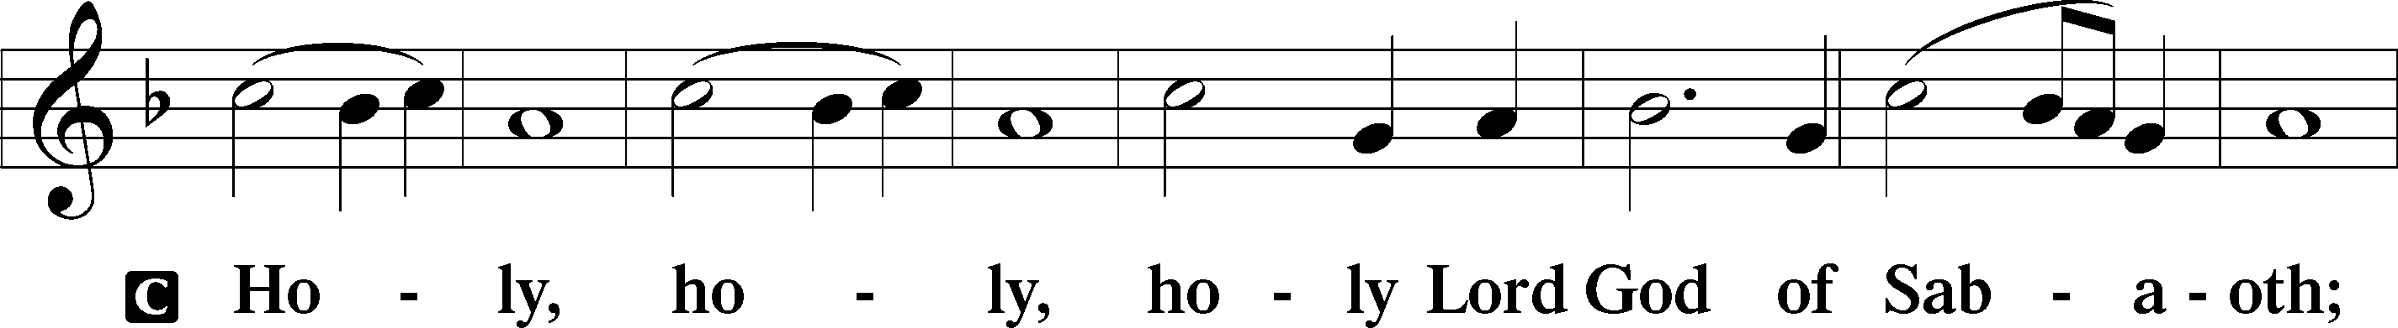
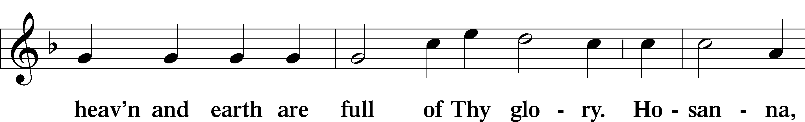
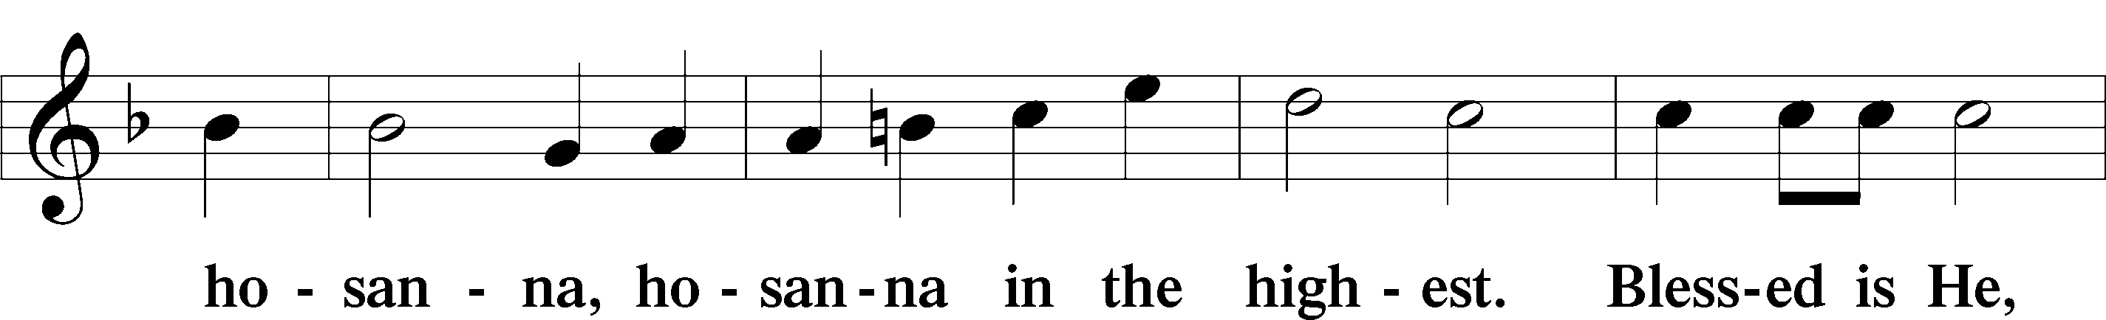
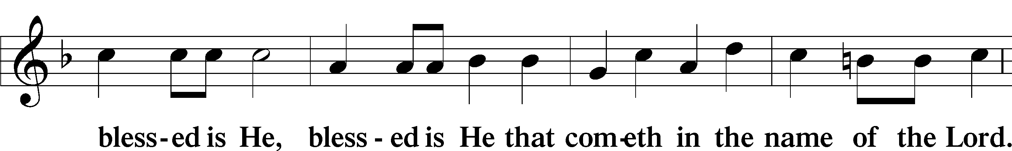
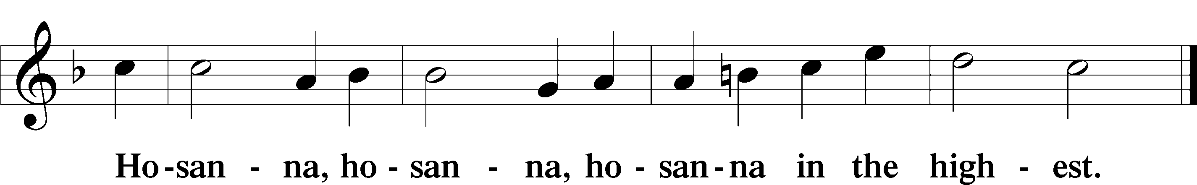

Lord’s Prayer LSB 196
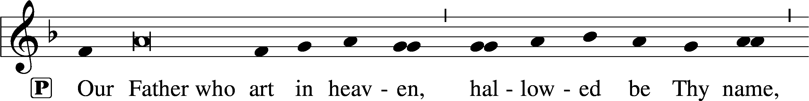
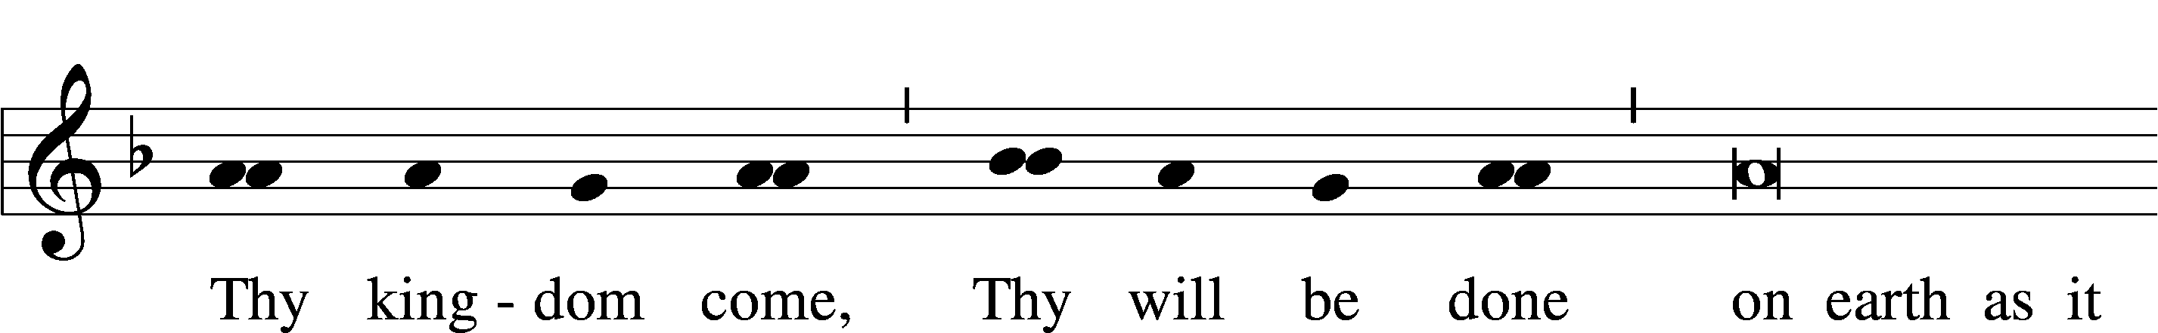
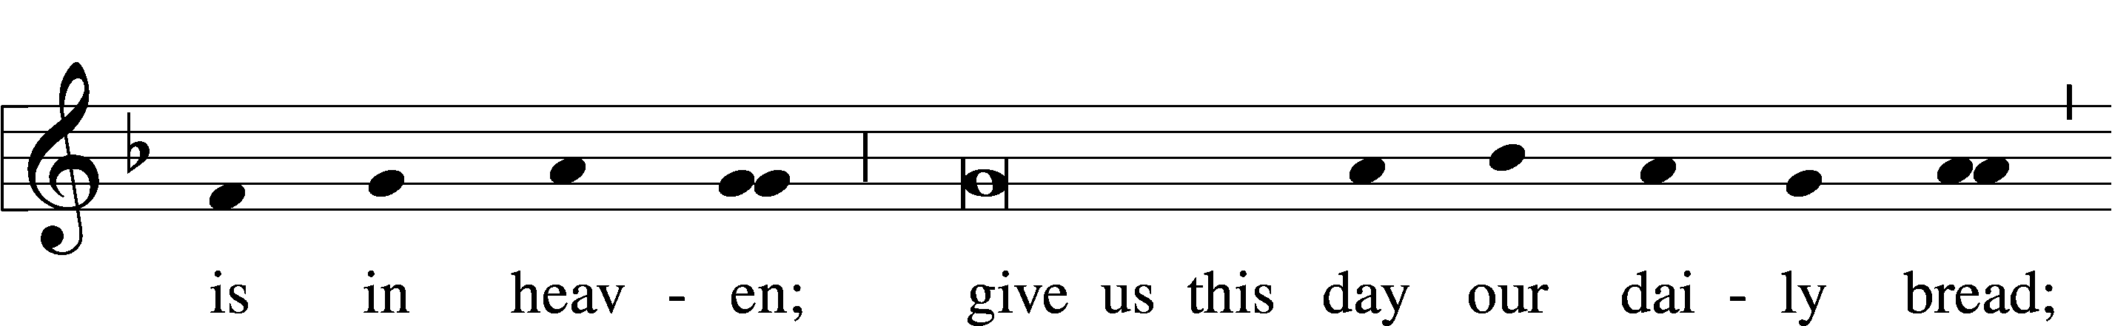
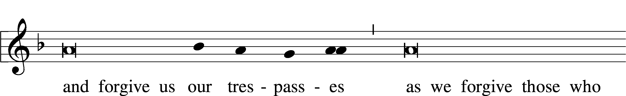
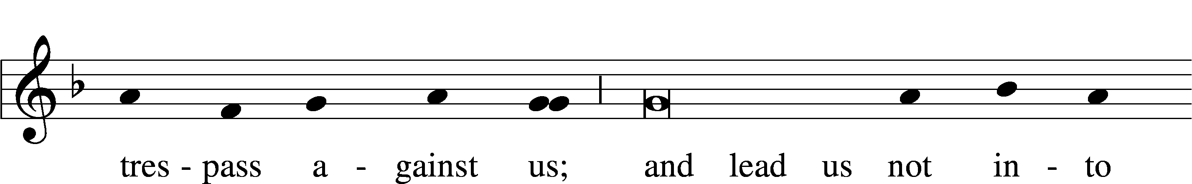
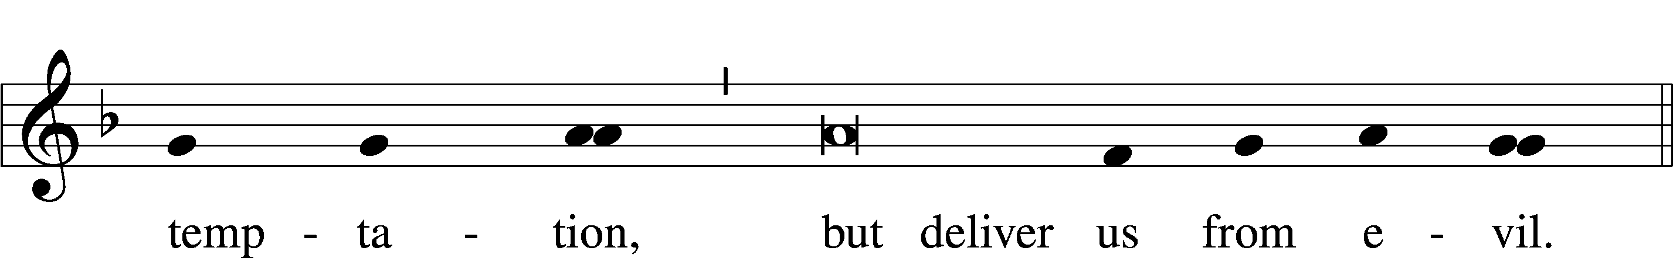

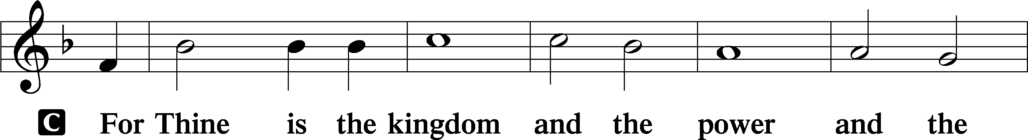
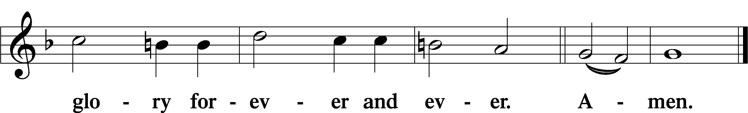

The Words of Our Lord LSB 197
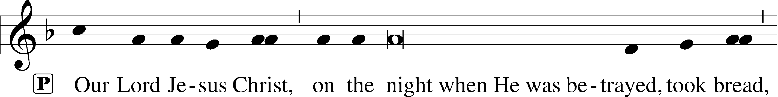
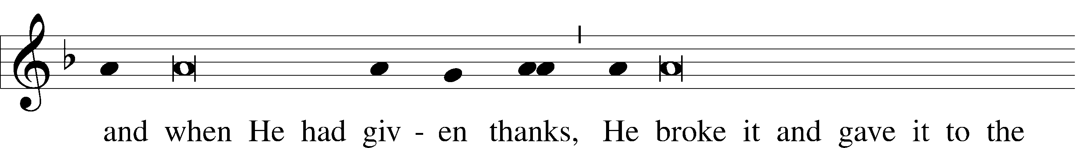
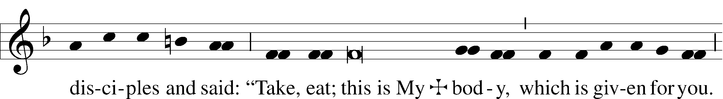
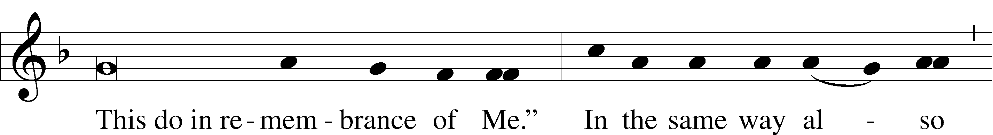
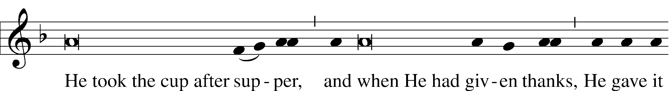
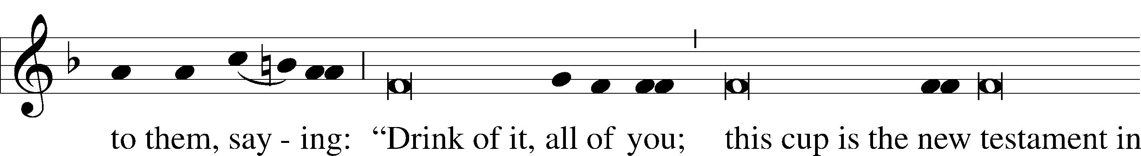
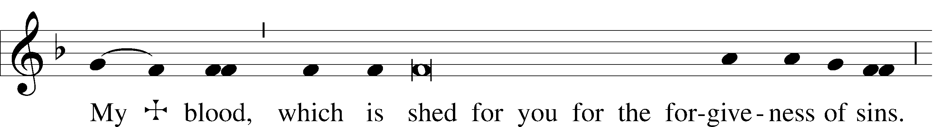
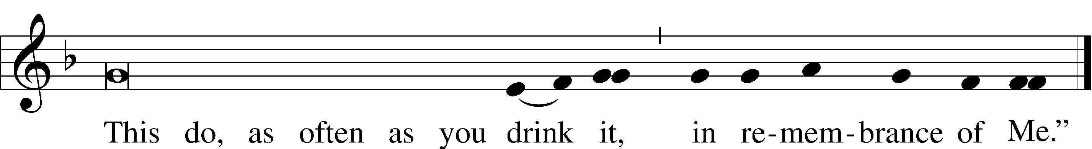

Pax Domini LSB 197
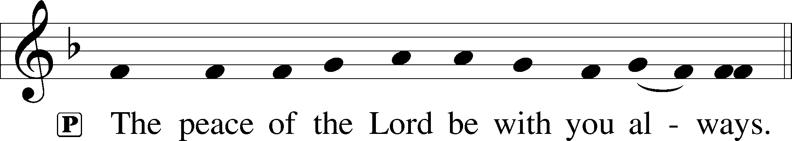

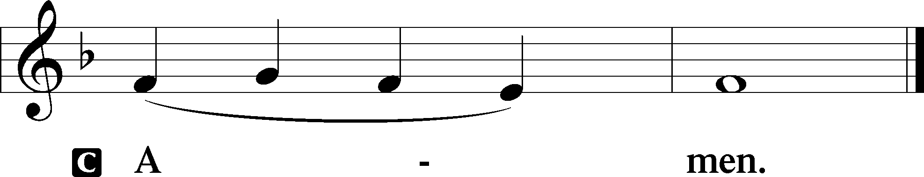

Agnus Dei LSB 198
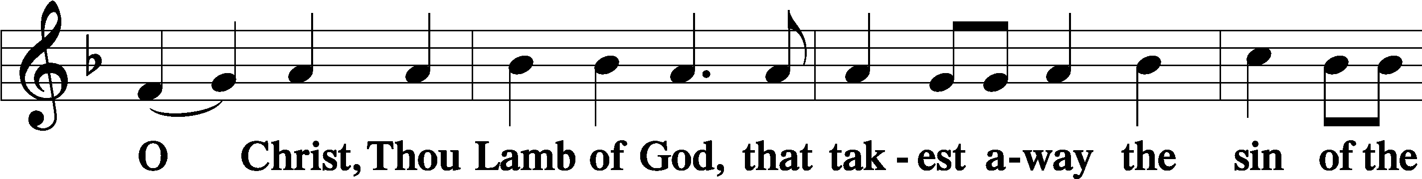
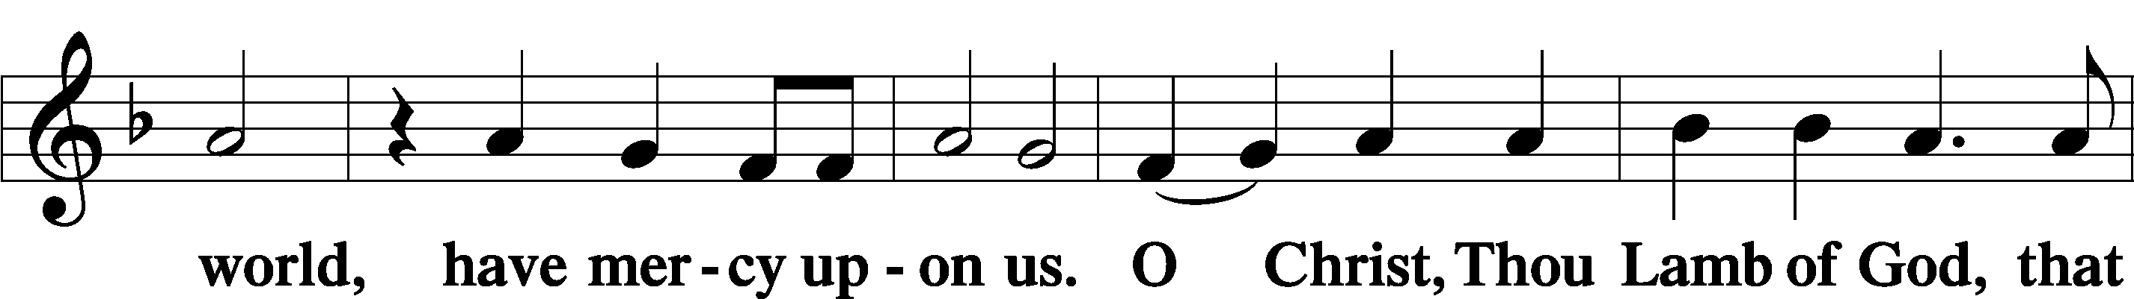
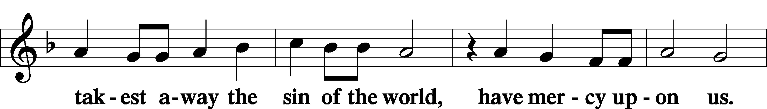
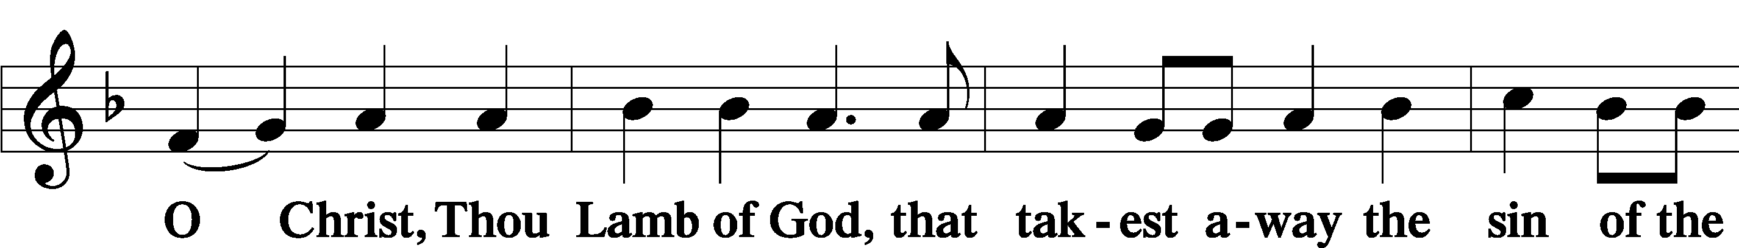
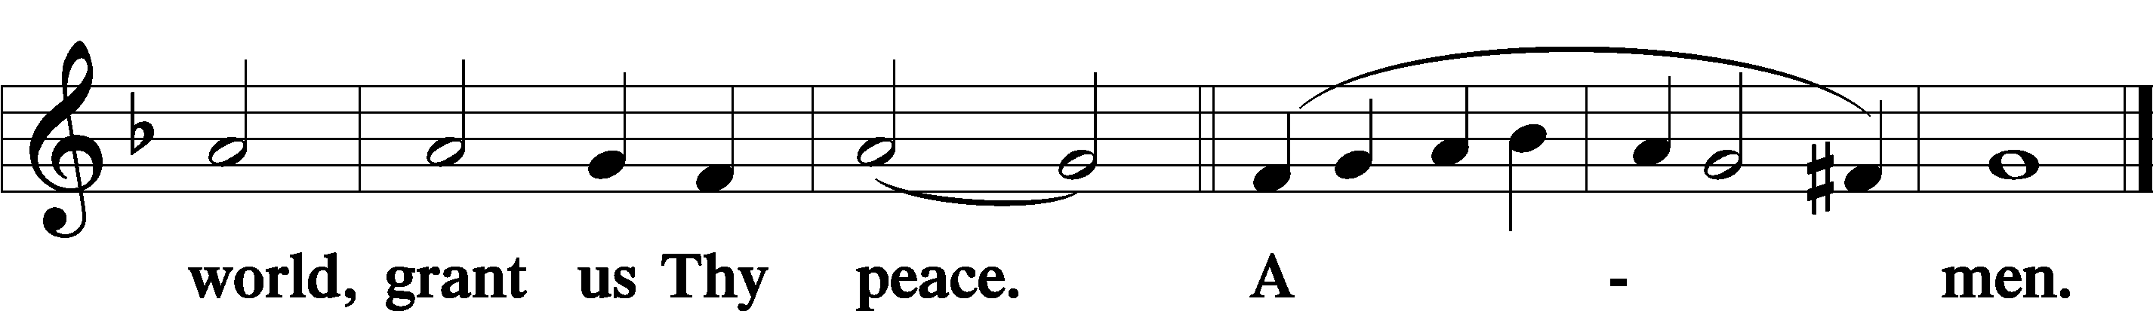

Sit

Distribution

The pastor and those who assist him receive the body and blood of Christ first and then distribute them to those who come to receive, saying:

Take, eat; this is the true body of our Lord and Savior Jesus Christ, given into death for your sins.
Amen.

Take, drink; this is the true blood of our Lord and Savior Jesus Christ, shed for the forgiveness of your sins.
Amen.

In dismissing the communicants, the following is said:

P The body and blood of our Lord Jesus Christ strengthen and preserve you in body and soul to life everlasting. Depart T in peace.
C Amen.

Distribution Hymn: 900 Jesus! Name of Wondrous Love
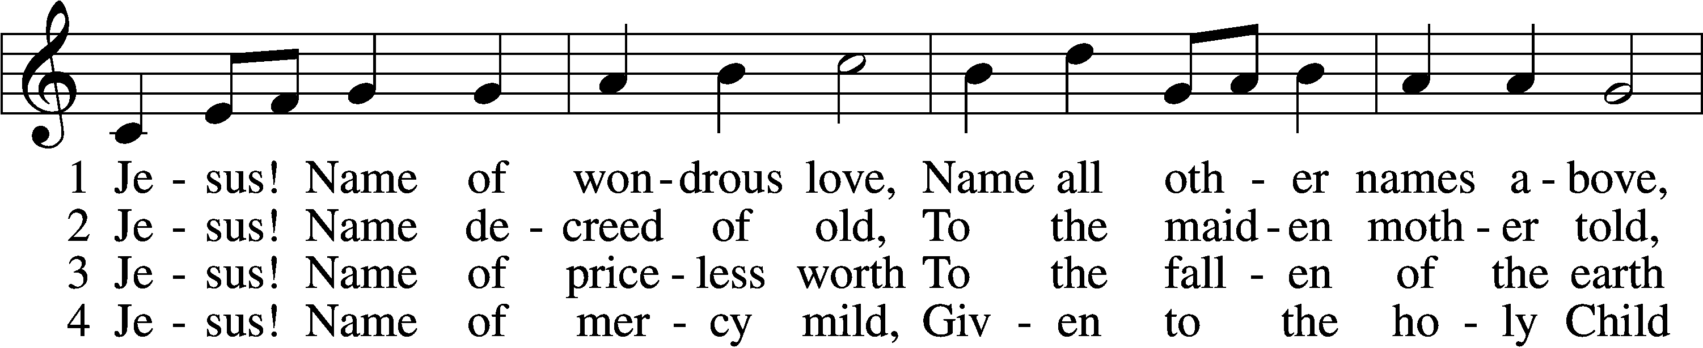
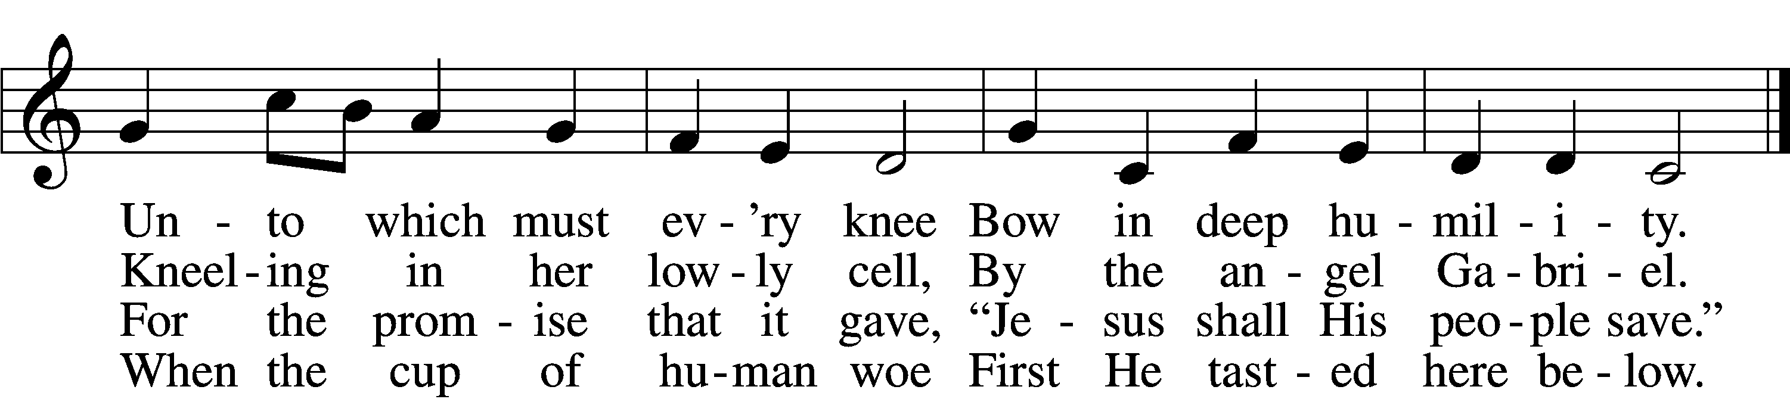

5 Jesus! Only name that’s giv’n
Under all the mighty heav’n
Whereby those to sin enslaved
Burst their fetters and are saved.

6 Jesus! Name of wondrous love,
Human name of God above;
Pleading only this, we flee
Helpless, O our God, to Thee.
Text: William W. How, 1823–97, alt.
Tune: Geist-reiches Gesang-Buch, 1704, Halle, ed. Johann A. Freylinghausen, alt.
Text and tune: Public domain

Distribution Hymn: 710 The Lord’s My Shepherd, I’ll Not Want
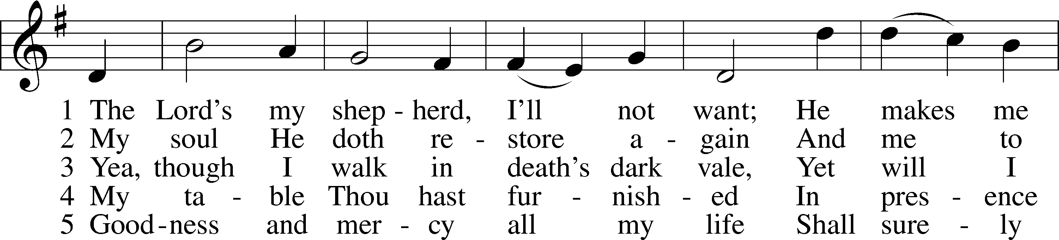
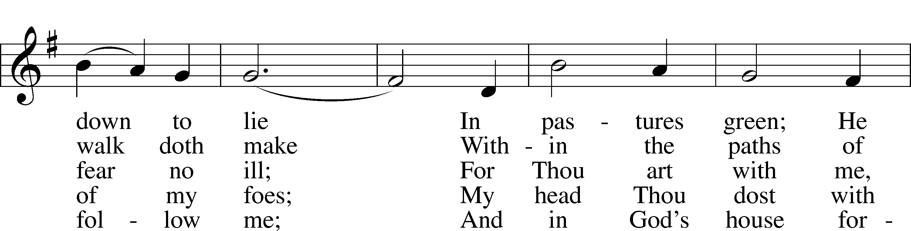
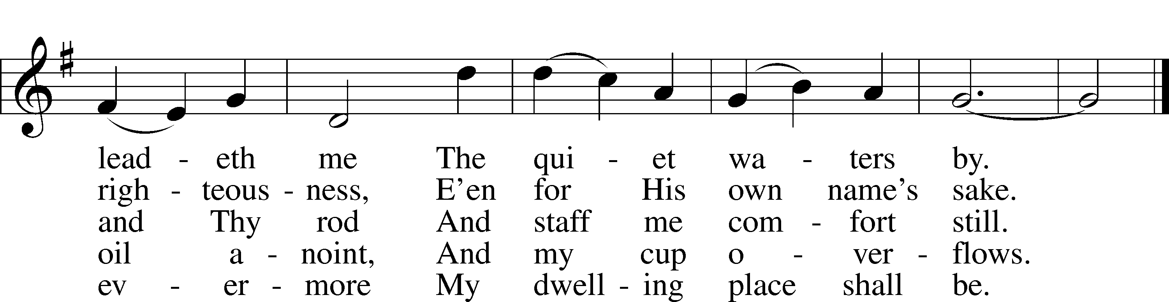
Text: The Psalms of David in Meeter, 1650, Edinburgh
Tune: William Gardiner, 1770–1853
Text and tune: Public domain

Stand

Nunc Dimittis LSB 199
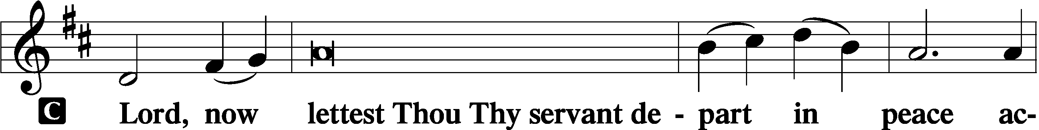

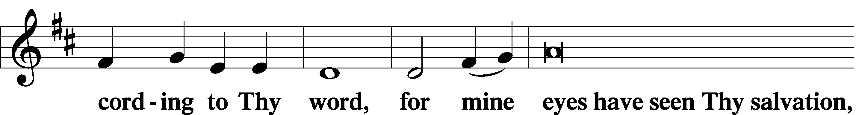

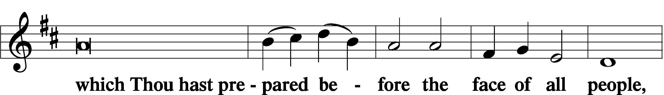

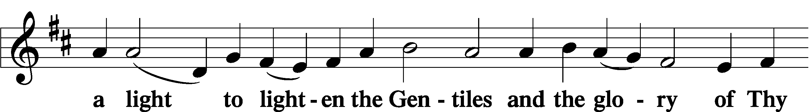

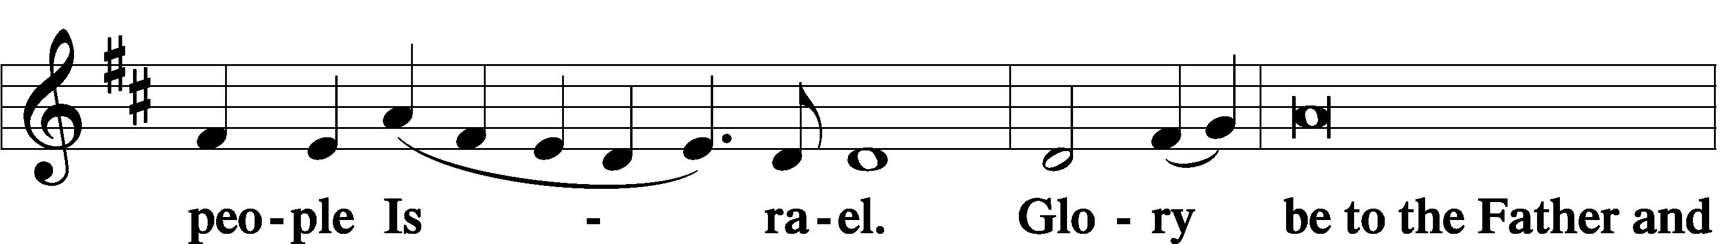

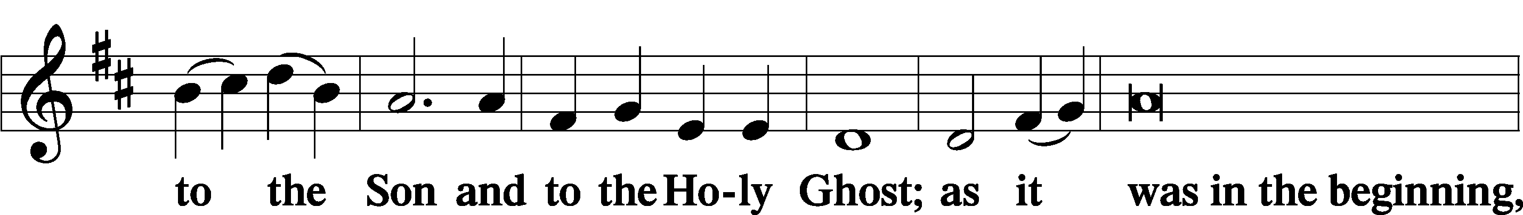

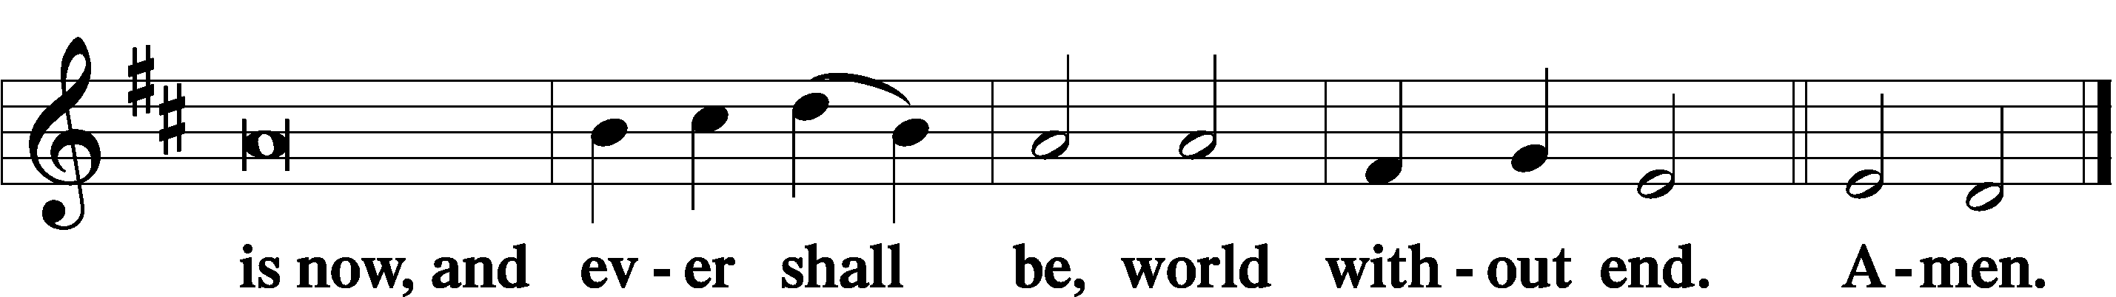

Thanksgiving LSB 200
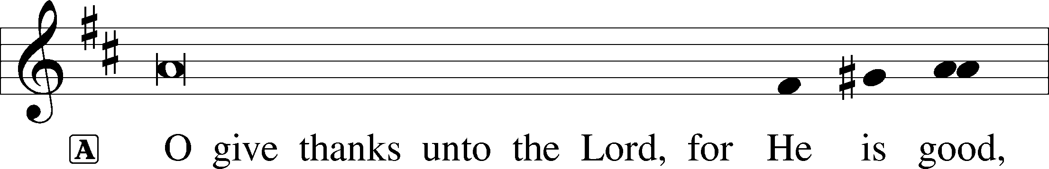

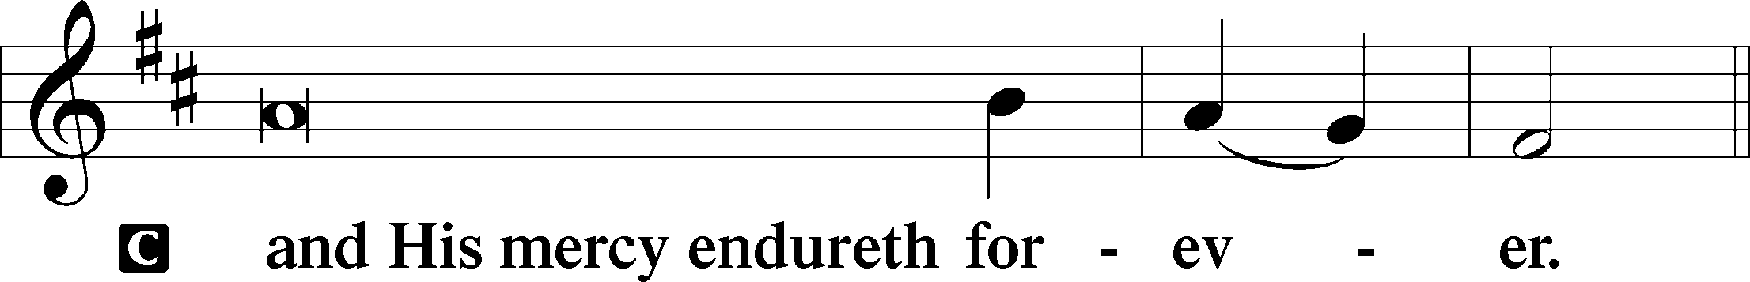

A Let us pray.
We give thanks to You, almighty God, that You have refreshed us through this salutary gift, and we implore You that of Your mercy You would strengthen us through the same in faith toward You and in fervent love toward one another; through Jesus Christ, Your Son, our Lord, who lives and reigns with You and the Holy Spirit, one God, now and forever.

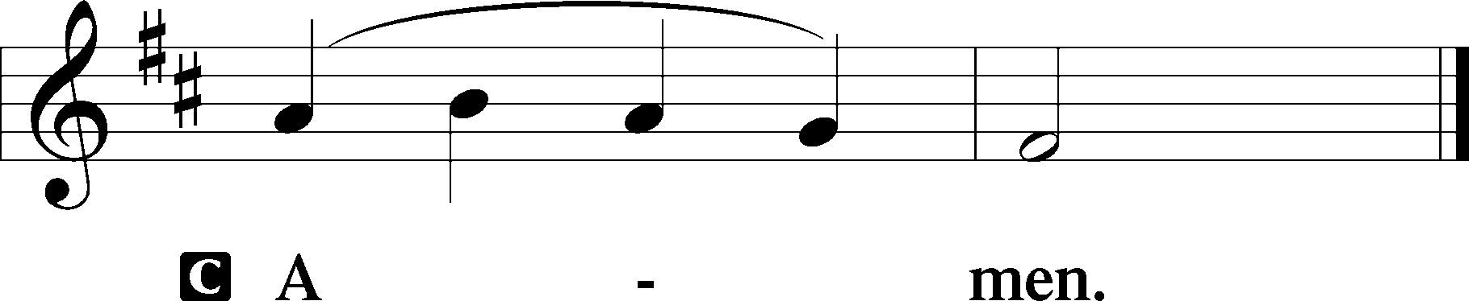

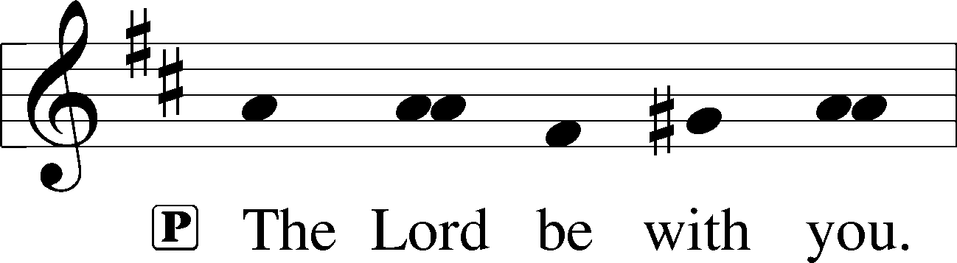

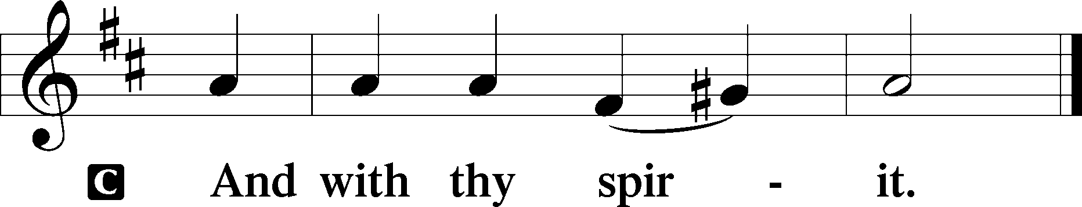

Benedicamus LSB 202
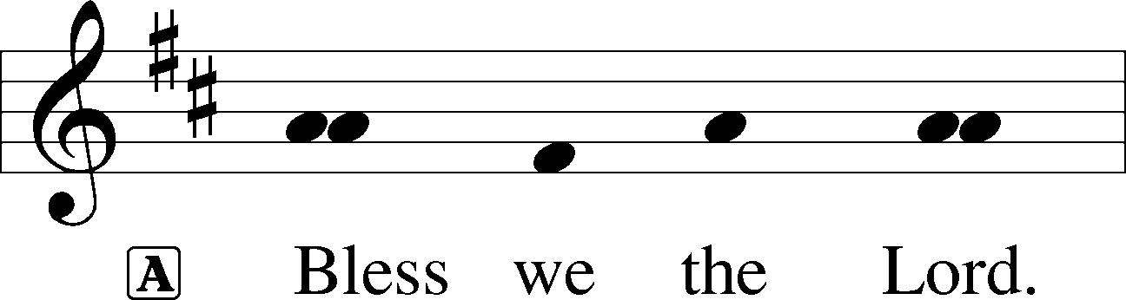

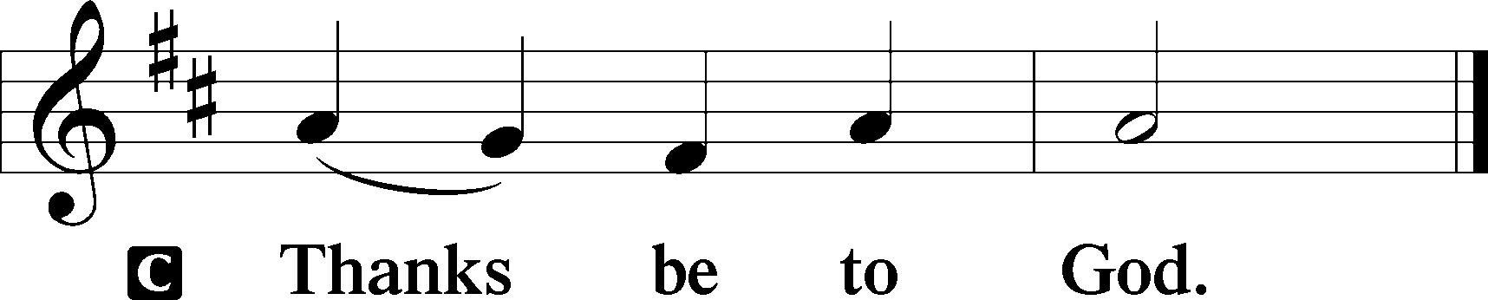

Benediction LSB 202
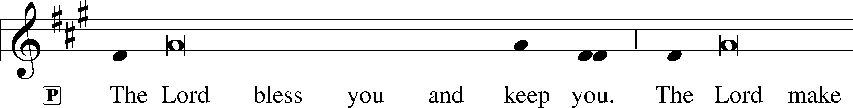
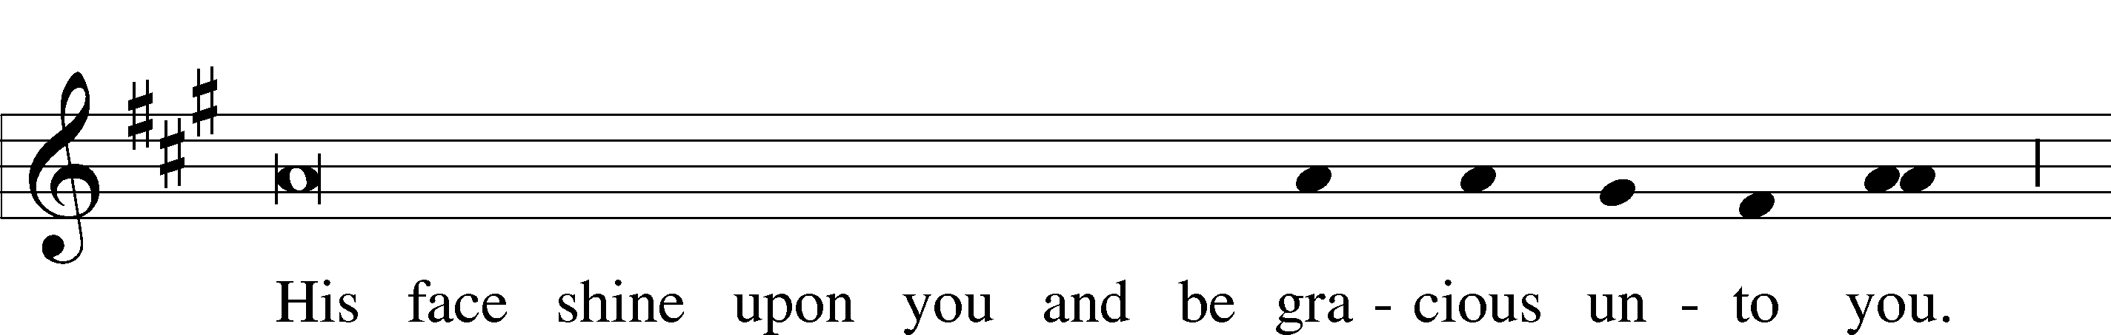
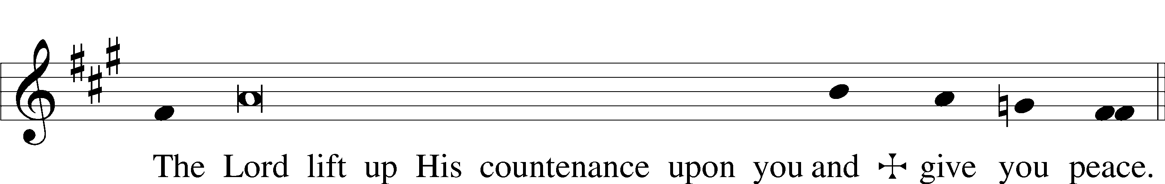

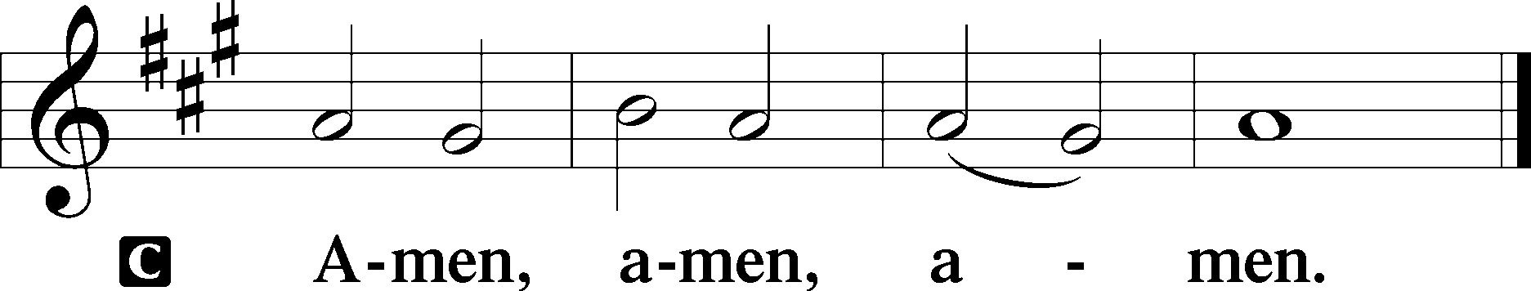

Hymn to Depart: 919 Abide, O Dearest Jesus
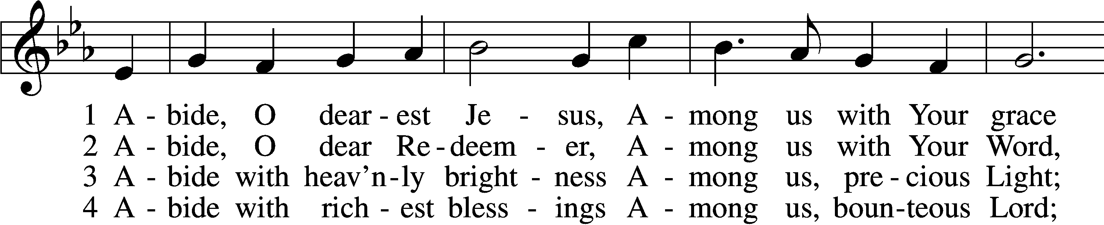
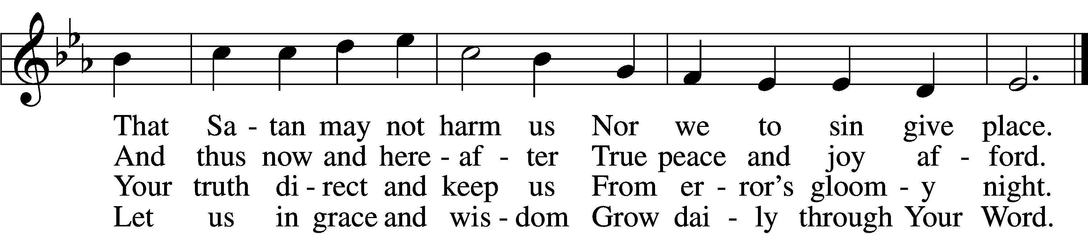

5 Abide with Your protection
Among us, Lord, our strength,
Lest world and Satan fell us
And overcome at length.

6 Abide, O faithful Savior,
Among us with Your love;
Grant steadfastness and help us
To reach our home above.
Text: tr. August Crull, 1845–1923, alt.; Josua Stegmann, 1588–1632
Tune: Melchior Vulpius, c. 1570–1615
Text and tune: Public domain

Acknowledgments
Divine Service, Setting Three from Lutheran Service Book
Unless otherwise indicated, Scripture quotations are from the ESV® Bible (The Holy Bible, English Standard Version®), copyright © 2001 by Crossway, a publishing ministry of Good News Publishers. Used by permission. All rights reserved.
Created by Lutheran Service Builder © 2024 Concordia Publishing House.

Prayer requests:
Those in the nursing home: Joann Jaeger Those Shut-in at home: Char Herman, Joan Church, Joyce Myers, Joyce Koba Those with ongoing health issues: Harrison Fields, Jeanne Perala, Owen Metz, Kathy Nielsen (Pastor’s aunt), Jeff Bonneville, Daria (Cindy Wright’s friend), Butch L. (Cindy Wright’s Brother-in-law), Melissa Miller., Dale Bryan, Art Smith (Sue Millerman’s brother), Brenda Sellent (Denise Stabenow’s sister), Sandy Hahn (Cindy Wright’s cousin’s wife), Wayne Hahn (Cindy Wright’s Uncle), Roger Hinrichs Recovering from surgery: Wyatt Weise, Gail Espeseth Those who lead our nation: Joe Biden, Kamala Harris, Tony Evers, Rod Nordby Those who serve in our military and law enforcement: Ryan Graf, Chaplain Pon Chanthaphon (Our Adopt-a-Chaplain), Rusty Weise Our Childcare Staff: Melissa Weinert, Denise Stabenow, Katelyn Hendren, Holly Wilhelmi, Janica Skjerly, Jacie Amundson, Emily Young, Zuri Soto For Christ Community Lutheran School – For God’s guidance throughout the development and planning process

Announcements:

Church Service Phone: 888-505-1870/715-438-4200
(Stay on the line for recorded service to start)
Live Stream audio services: http://salem.listentochurch.com
Salem’s Web Page: https://www.salembarron.com/
Pastor Fred Buth: Cell phone:715-642-3050 (H)715-353-2540
Pastor’s Email: salembarronpastor@gmail.com
Office Hours: Monday-Wednesday 9-12
Office email: salembarron@gmail.com
Attendance:
Call-in line: 4/14- In-person: 4/14-56

Coffee and Snacks: Marica Elliott
Elder Today: Josh Millerman
Altar Guild: Nancy & Marica

April 28th is your chance to go to the play On Golden Pond, there is a sign up in the back.

May 7th – 5:00pm - Church and parsonage clean up, bring rakes, shovels if you have them. There will be supper provided after.

Sign up in the back if you would like to join the choir. They will be singing in church May 19th.

Save the Date:
April 28 – Event: On Golden Pond, Play in Rice Lake 2pm
April 28 – Annual Spring Church Meeting after service May 1st – 6pm Choir practice May 7th – 5:00 pm Parsonage and Church yard clean up May 8th – 6pm Choir practice May 12- Teacher Appreciation Brunch, Mother’s Day, Graduates recognition Sunday, Children Singing in church May 13 – 6:00 PM – Circuit Lay Leader Meeting @ St. Paul’s Cumberland
May 15th – 6pm Choir practice May 19 – Last day of Sunday School, Choir singing May 21 -4:30 pm YFM

