

Salem Lutheran Church
Childcare and Preschool

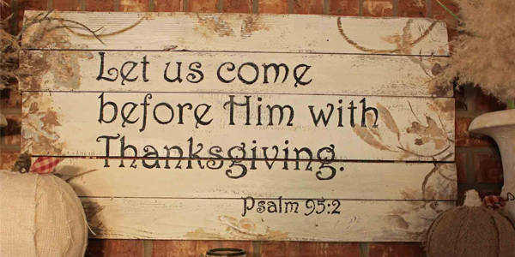

November 2025

Pastor’s Page

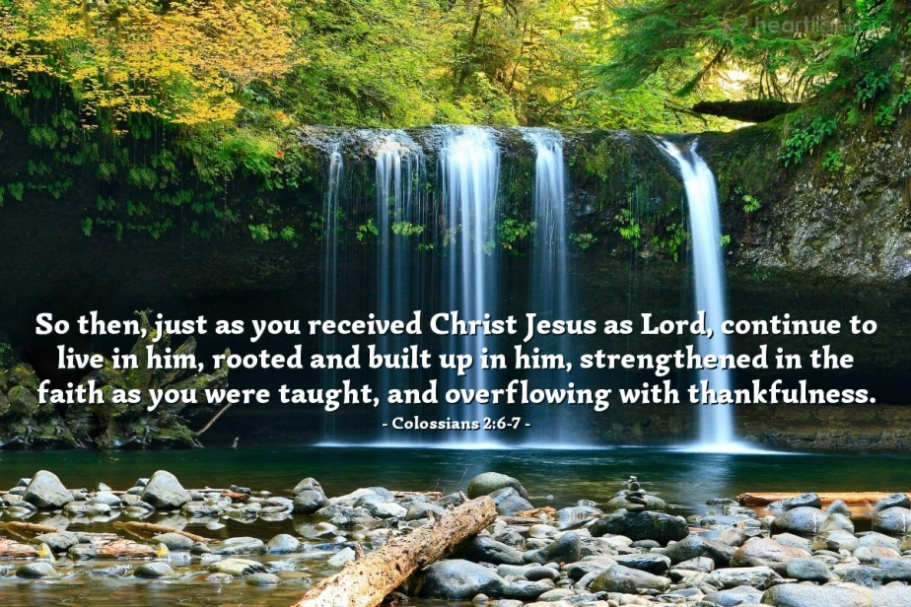
As Paul teaches us in Colossians 2: 6-7: " Therefore, as you received Christ Jesus the Lord, so walk in him, rooted and built up in him and established in the faith, just as you were taught, abounding in thanksgiving."
I am Vicar Jon Berkesch. I am now serving at Salem Barron. Thank you for welcoming me and my family! I moved from Shawano county where I taught at a Lutheran school. I moved with my wife and five boys, with one on the way! We are excited to start a new journey in life and ministry here in Barron.
Jesus has taught me to be thankful in every situation; in moving, in changing careers, and in serving God's people. I was raised by faithful parents, of whom I give thanks. I was raised in Spooner, so this feels like coming back home. Colossians shows us that we can be thankful as we were taught. That can be hard when we suffer.
If we could see all of God's grace, it would be like a vast ocean that has depths beyond imagination. We can only see our own sin washed away by God's grace. We don't see the depth of God's grace in our lives, it is too vast for us to comprehend.
Remember these verses as we give thanks this month!
And of course, I have homework for you (I was a teacher after all)! Give thanks to God, give thanks for your families, and show that to your families this month and every month! When thanksgiving comes, show your family members thankfulness because of what Jesus did for you and for them! Teach them this verse in thankfulness!
If you would like to reach out to me and connect, please do so. I would be thankful for it.
God's peace.
Vicar Jon Berkesch.
Council Meeting 10/14/25

Present: Jonathon Berkesch, President John Steele, Head Elder Don Duncan, Trustee Trevor Duncan, Secretary Emily Steele, Treasurer Mary Ann Thompson

Absent: Josh Millerman, Pastor Buth, Chris Severt

President John Steele called the meeting to order.

Jonathon Berkesch led us in a devotional and prayer.
Secretary Report: Distributed by email. No corrections or additions. A motion to approve the minutes was made by Don Duncan and seconded by Trevor Duncan. Motion carried.

Treasurer Report:
- Financial Report from September was distributed. September income was $18,686.07, expenses were $7,085.06, with a net income of $11,601.01. The General Fund balance was $50,754.96.
- A $30,000 CD will be purchased with funds from the gifts and memorials fund.
- We discussed the items purchased under the Worship line item. It includes Portals of Prayer and Lutheran Witness. The council agreed the budget should be increased to $1500 for 2026 to more accurately reflect these costs.
- The flooring bill for parsonage will be paid with the excess income from the pastor salary budget excess from earlier in 2025.
- We discussed possibly increasing the organist salaries to $90 in January to be more comparable to area salaries.
- The substitute Pastor Budget was increased to $1000. That should fund 4 Sundays substitute pastors for the year.
- A motion to accept the report was made by Trevor Duncan and seconded by Don Duncan. Motion Carried.

Elder Report: From October 6th Elders Meeting:
November Elders are as follows:
Nov 2 – Elder Stan
Nov 9 – Elder Trevor
Nov 16 – Elder Josh
Nov 23 – Elder Don
Nov 27 – Elder Paul (Thanksgiving)
Nov 30 – Josh

- No new transfers or releases.
- Jonathon Berkesch will begin doing some morning chapels at CCLS in Almena.
- Trevor Duncan will take the Elder minutes starting in January.
- The elders discussed the budget.
- Stan Koenig will be a lay delegate for the electoral circuit forum on October 9th at 6:30 PM at St. Paul’s in Cumberland.
- Jonathon Berkesch would like to do some youth events in the evenings and start doing the Bible studies, Confirmation classes, and daily devotions with the daycare workers.
- A motion was made to accept the elders’ minutes by Mary Ann Thompson and seconded by Trevor Duncan. Motion carried.
Trustee Report – Trevor Duncan:
- Air Conditioning will be installed in the sanctuary on 10/28. The wiring has already been installed and was $750 under budget.
- The cost to replace the parsonage floor was $3700 and to replace the door was $646.
- The church carpets need to be cleaned. Trevor Duncan will call and have it scheduled. We will need volunteers to move tables.
- The Parking lot and flooring in the basement needs to be updated in daycare. These are larger cost items and should be discussed at the congregational meeting.
- The building committee will have a meeting in November to discuss bathroom remodel.
- Don Duncan made a motion to accept the minutes and then seconded by Mary Ann Thompson. Motion Carried.
Board of Ed: Chris Severt Not Present
- We reviewed the proposed 2026 daycare and BOE budget. We decided to keep the allotted VBS budget in hopes that that Salem will host or co-host a VBS again this year.
Old business: None

New business:
- We decided to approve new chairs for Jonathon Berkesch and Sue Millerman at a cost of $129/each. These costs will be deducted from office supplies.
- October is Pastor appreciation month. We will get two gift cards and a basket for Pastor Buth. We will also have a potluck on October 26th.
- The Congregational Meeting will be November 9th after church with a potluck.
- We will research the usher scheduling process and may need to be update the process. Will consider adding teenagers to help with participation.
- John Steele mentioned we may want to consider adding a line to the budget for the CCLS in Almena.
- A motion was made by Trevor Duncan to adjourn the meeting and seconded by Mary Ann Thompson. Motion carried.

The meeting closed with the Lord’s Prayer.


Men’s Club Meeting
October 9, 2025

- President Tom Lipke called the meeting to order.
- Secretary report: Don gave a report from the 9/9/2025 meeting.
- Treasurer’s report: was given by Jim. Men’s club gave $200.00 to the Christian school in Almena.
- Old Business: Pancake supper 72nd year. Best year we have had. Thanks to all for help and support. Served 178 dine ins and 61 take outs. We used all the sausages, 80 lbs., 100 lbs. potatoes. Didn’t have many leftovers. Advertising was $225.00 in the paper.
- Tom will pick up weed and feed for parsonage and church yards in the spring.
- Don made a motion to adjourn, seconded by Duffy.

- Closed with the Lord’s Prayer

November 6:
Summer Hammann
November 13:
Waylon Steele




November 3 : Kayla Dennis

November 10: Andy Schuettpelz & Martin Luther

November 14: Eli Bisonette, & Jacob Duncan

November 16: Paul Millerman & Austin Stabenow

November 18: Jonathon Miller

November 25: Erin Graf (Hammann)

November 27: Mahlon Maas

November 28: Caleb Duncan



November 4: roger and ann fagerlin

November 16: rusty and Melissa weise

How to Contact Us
Pastor Berkesch – Cell: 715-416-5858
Pastor: salembarronpastor@gmail.com
Office – (715) 537-3011
Preschool – (715) 537-3011 ext.14
Mary Ann Wheeler, Parish Musician – (715) 205-1158
Church Service Phone –1 (888) 505-1870
Church Email: salembarron@gmail.com
Salem’s Web Page Is: https://www.salembarron.com/
Click on enter the following link and follow the prompts to support Salem.
https://smile.amazon.com/ch/39-6137330
November Greeters
2 – Randy & Sarah Forehand
9 – Chris & Kelly Mueller Family
16 – Mary Ann Thompson
23 – Duane & Kari Longmire
30 – Justin & Melissa Frieburg Family

November Ushers
Randy Forehand
Rick Cornelius
Christopher Mueller
Hunter Mueller
Duane Longmire
Justin Frieburg

November/December
Randy & Sarah Forehand 715-637-1300
Mary Ann Thompson 715-296-8751
Dale & Becky Bryan 715-637-8341
Rick & Judy Church 715-357-6214
James Dennis 715-418-2288
Mark & Amy Dennis 715-642-0813
Sharon Hammann 715-357-3074
Marcia Elliott 715-234-9321
Christopher & Kelly Mueller 715-418-2311
Aaron Mickelson 715-418-0234
Jim & Gwen Metcalf 715-642-0527
Hunter Mueller 715-558-6862
Chris & Jolene Severt 715-296-0339
Justin & Melissa Frieburg 715-418-9209

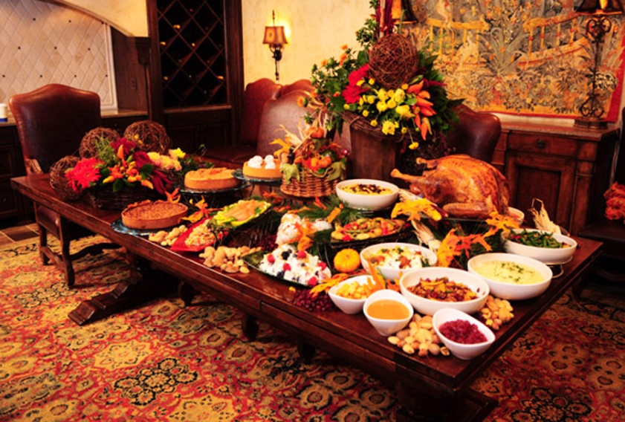

November Elders
2 – Stan Koenig
9– Trevor Duncan
16 – Josh Millerman
23 – Don Duncan
27 – Paul Millerman
30 – Josh Millerman

Coffee Schedule
2 – Amy Dennis
9 – Denise & Dwayne Sabenow
16 – Kathy S & Anne Fagerlin
23 –
30 –


November 2025

Sunday | Monday | Tuesday | Wednesday | Thursday | Friday | Saturday


1
2 White  9:00 am Communion Worship  10:00 Coffee/Snacks  10:15 am Bible Class | 3  7:00 pm Elders | 4  8:00 am Bible Class  10 am Men’s Club | 5  4-5pm Confirmation | 6 | 7 | 8
9 Green  9:00 am Worship  10:00 Coffee/Snacks  10:15 Bible Class  . | 10 | 11  8:00 am Bible Class  7:00pm Council | 12  4-5pm Confirmation | 13 | 14 | 15
16 Green  9:00 am Communion Worship  10:00 Coffee/Snacks  10:15 Bible Class  . | 17 | 18  8:00 am Bible Class | 19  4-5pm Confirmation | 20 | 21 | 22  
23 Blue  9:00 am Worship  10:00 Coffee/Snacks  10:15 am SS/Bible Class   |   24 | 25  8:00 am Bible Class   | 26    4-5pm Confirmation | 27 White    9 am Worship |   28 |   29
30

9:00 am Worship
10:00 Coffee/Snacks
10:15 am SS/Bible Class

