Prayer and Preaching pg. 260

11th Day after Pentecost

August 24, 2025

Hymn: 915 Today Your Mercy Calls Us
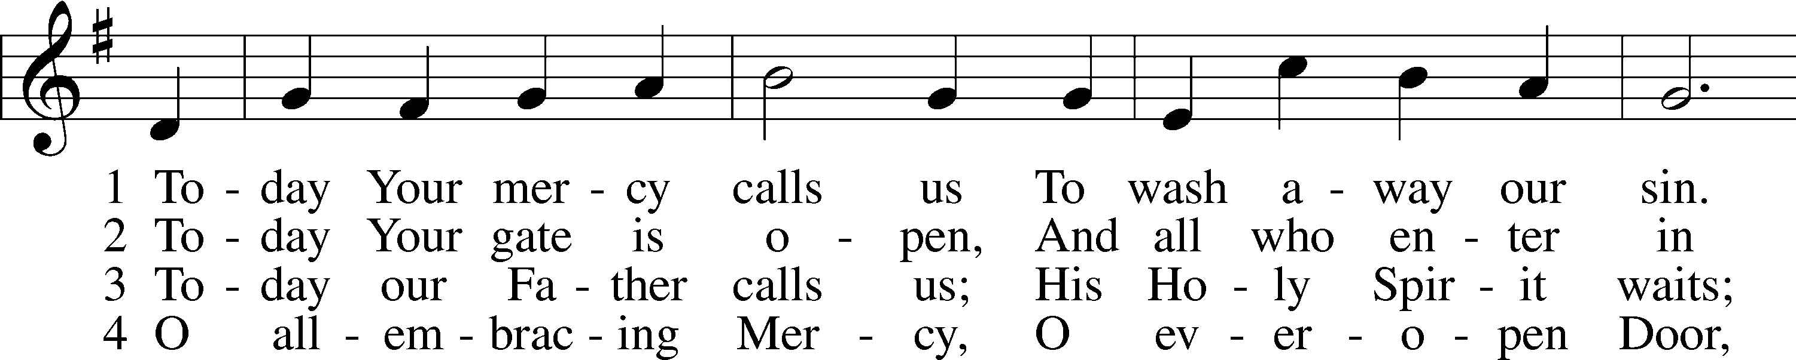
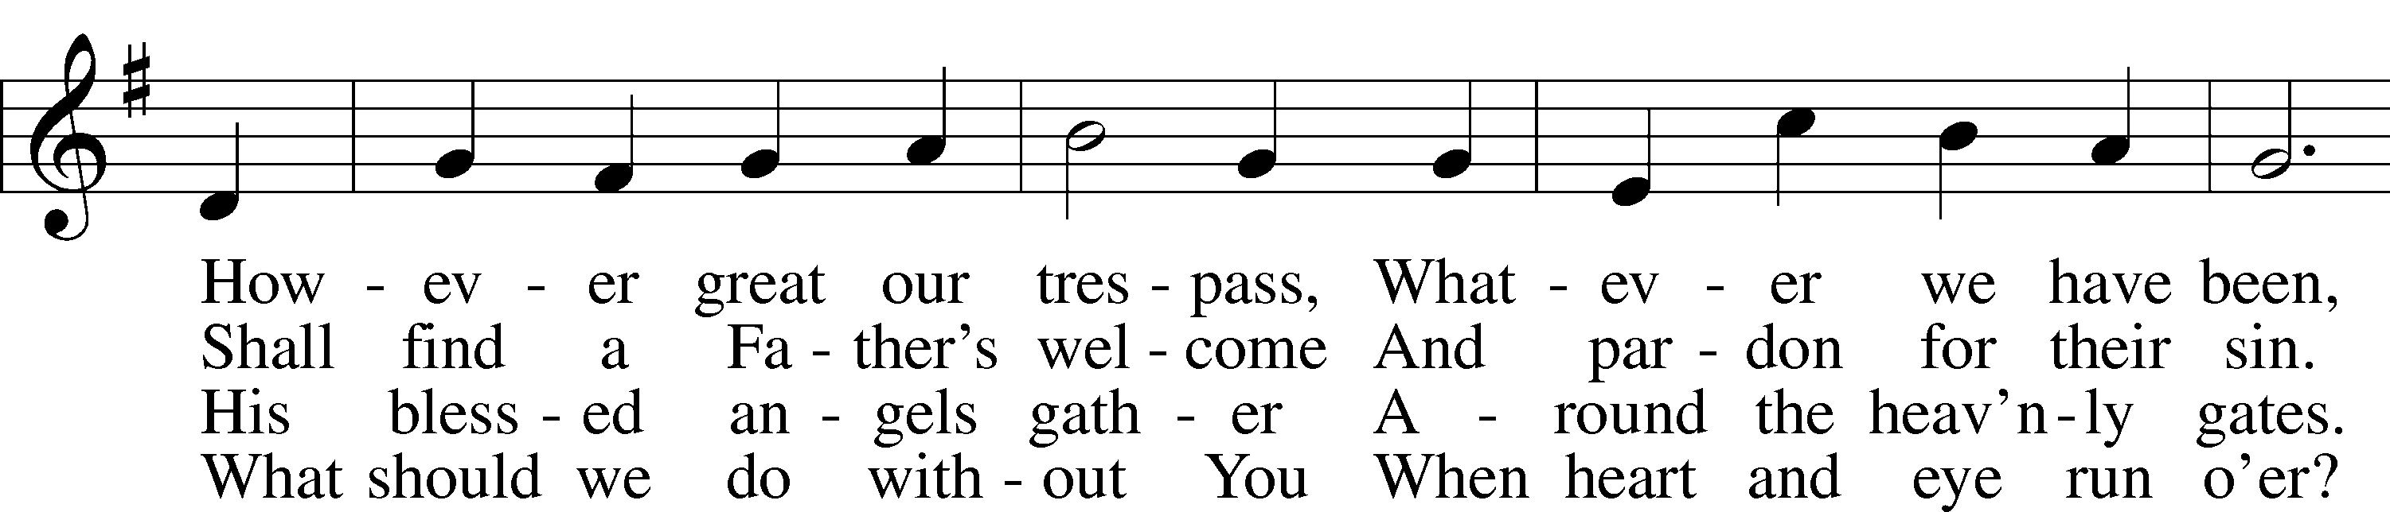
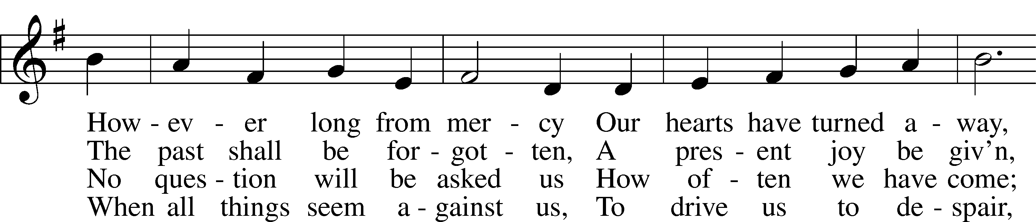
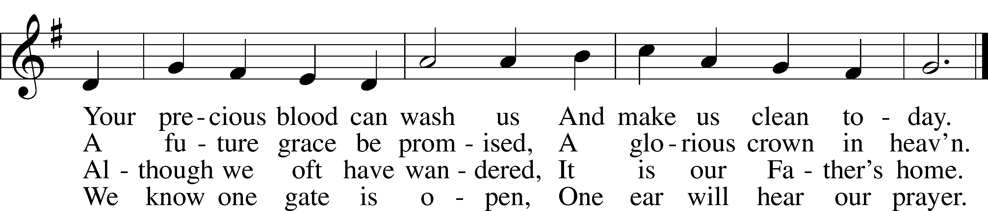

Text: Oswald Allen, 1816–78, alt.
Tune: Friedrich K. Anthes, 1812–after 1857
Text and tune: Public domain

Stand

Opening Versicles

L This is the day which the Lord has made;
C let us rejoice and be glad in it.
L From the rising of the sun to its setting,
C the name of the Lord is to be praised.

L Better is one day in Your courts than a thousand elsewhere;
C I would rather be a doorkeeper in the house of my God than dwell in the tents of the wicked.
L Make me to know Your ways, O Lord.
C Teach me Your paths.
L Sanctify us in Your truth.
C Your Word is truth.

L From the rising of the sun to its setting,
C the name of the Lord is to be praised.

C Glory be to the Father and to the Son and to the Holy Spirit;
as it was in the beginning, is now, and will be forever. Amen.

Old Testament Canticle LSB 261
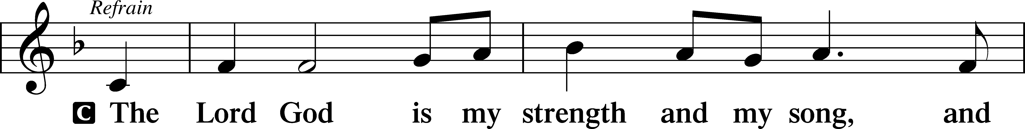
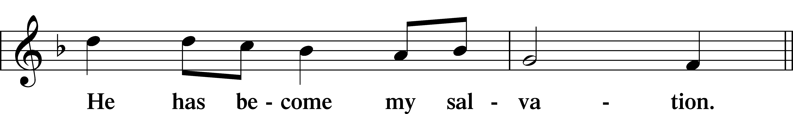
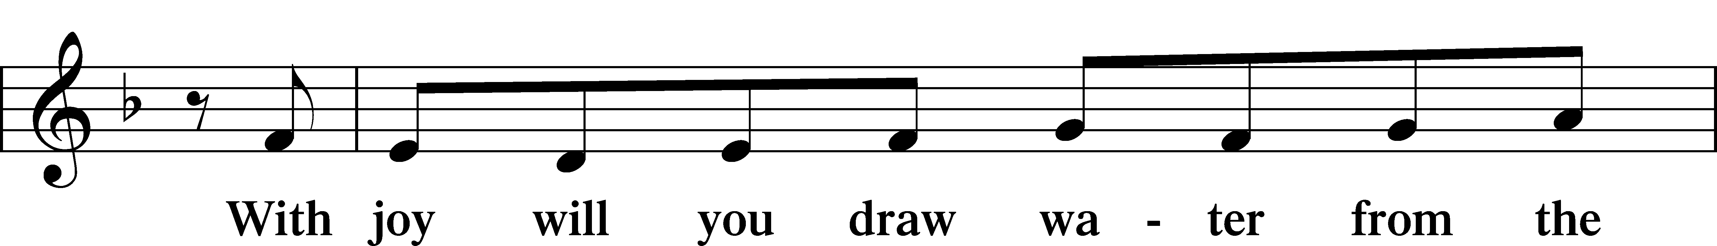
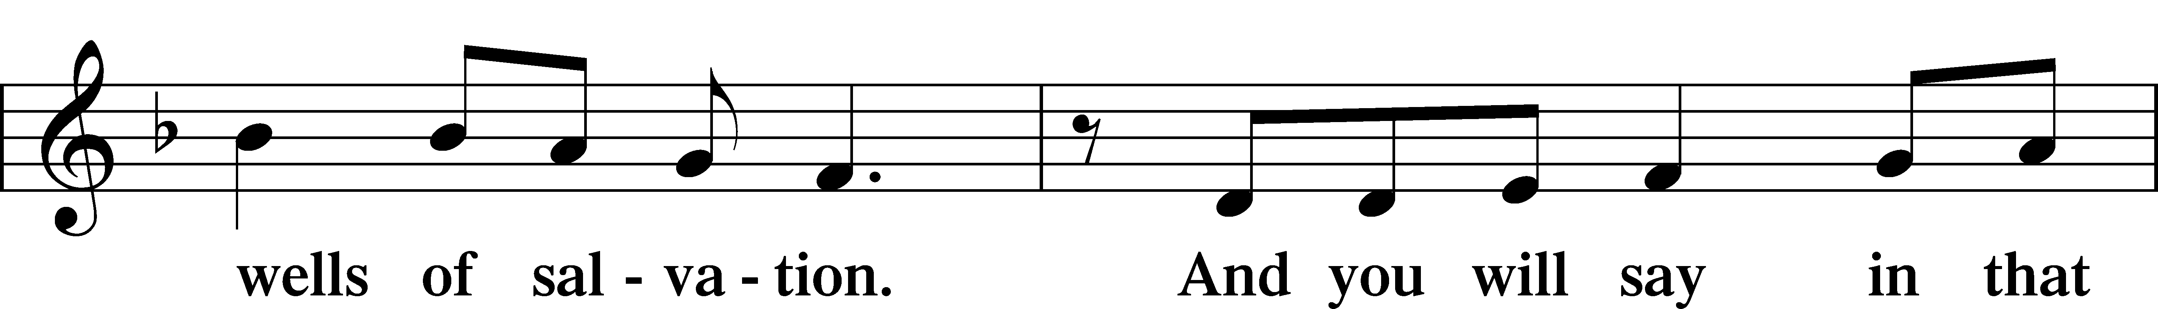
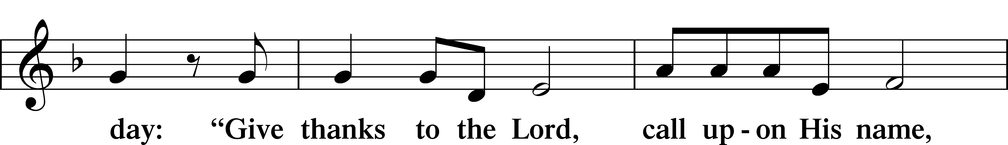
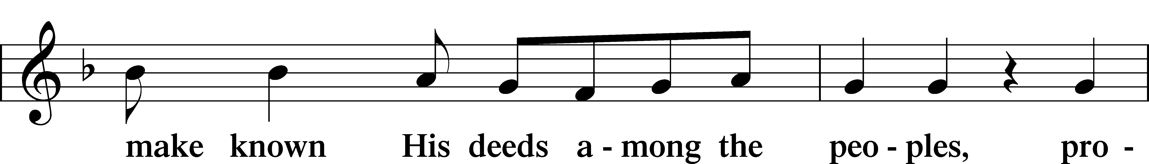
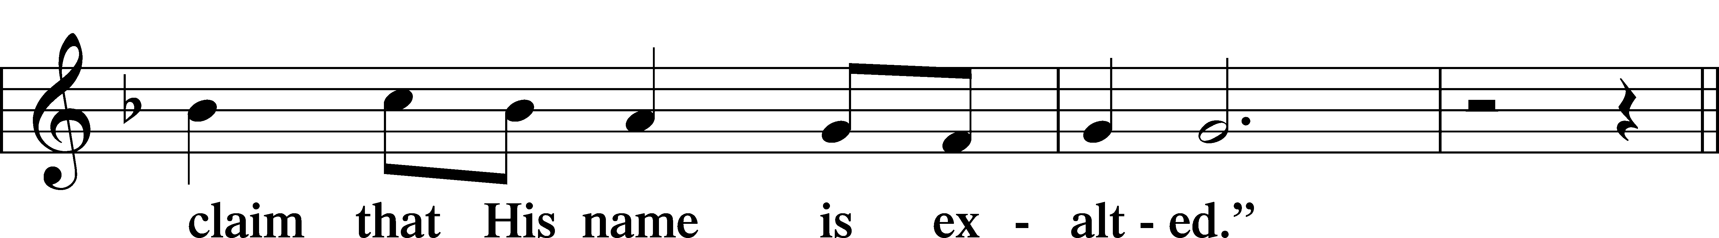
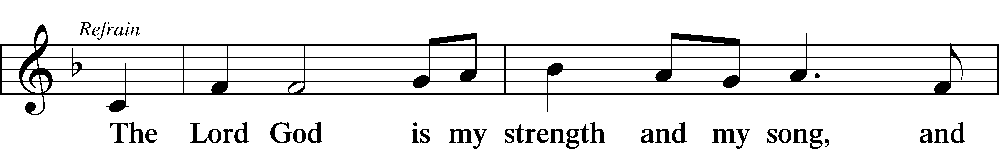
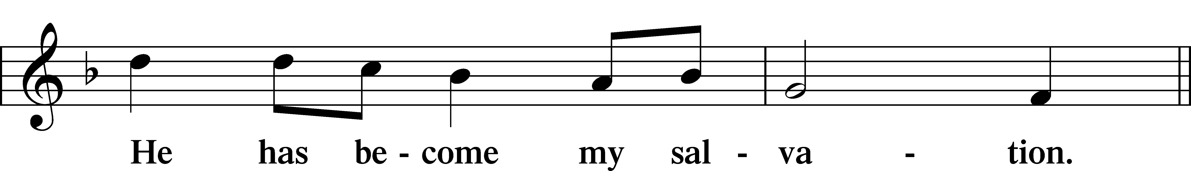
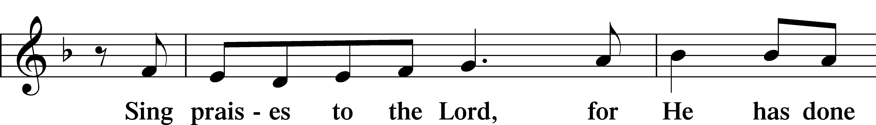
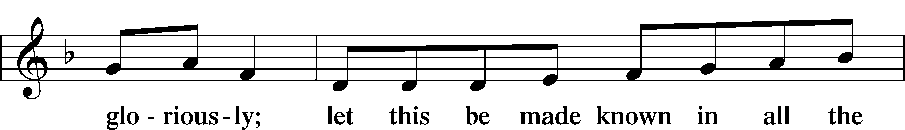
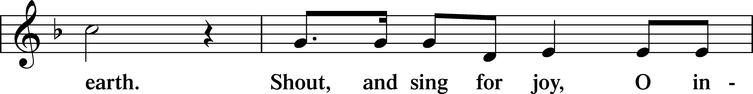
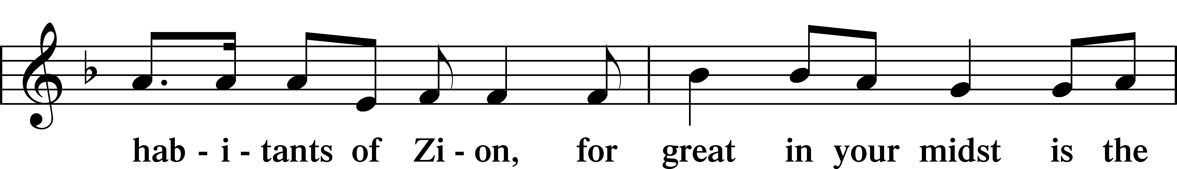
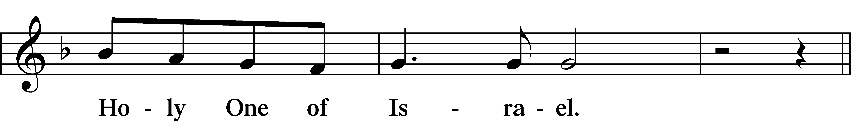
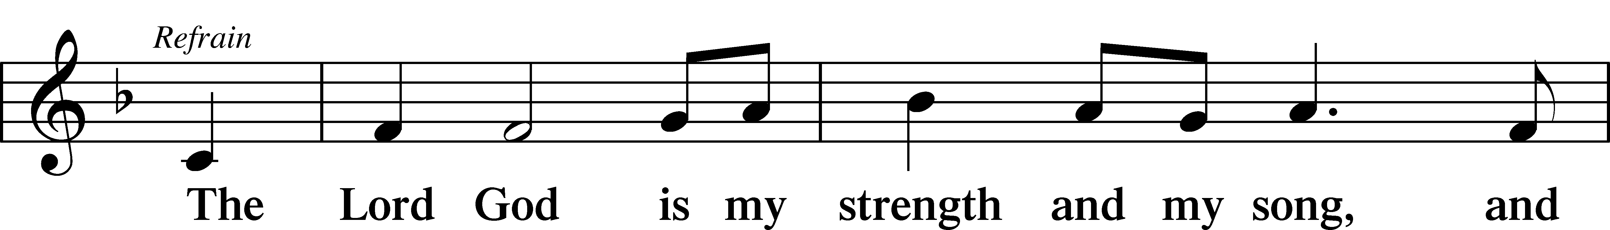
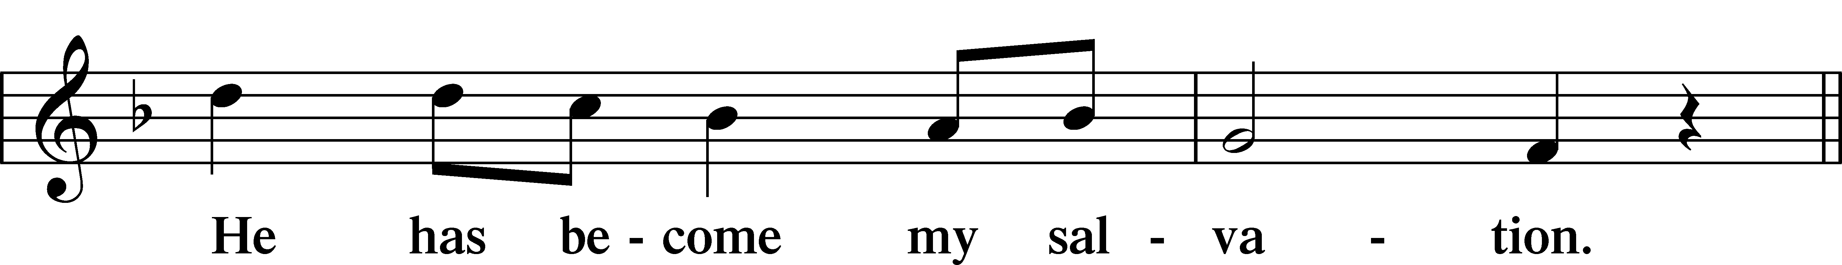
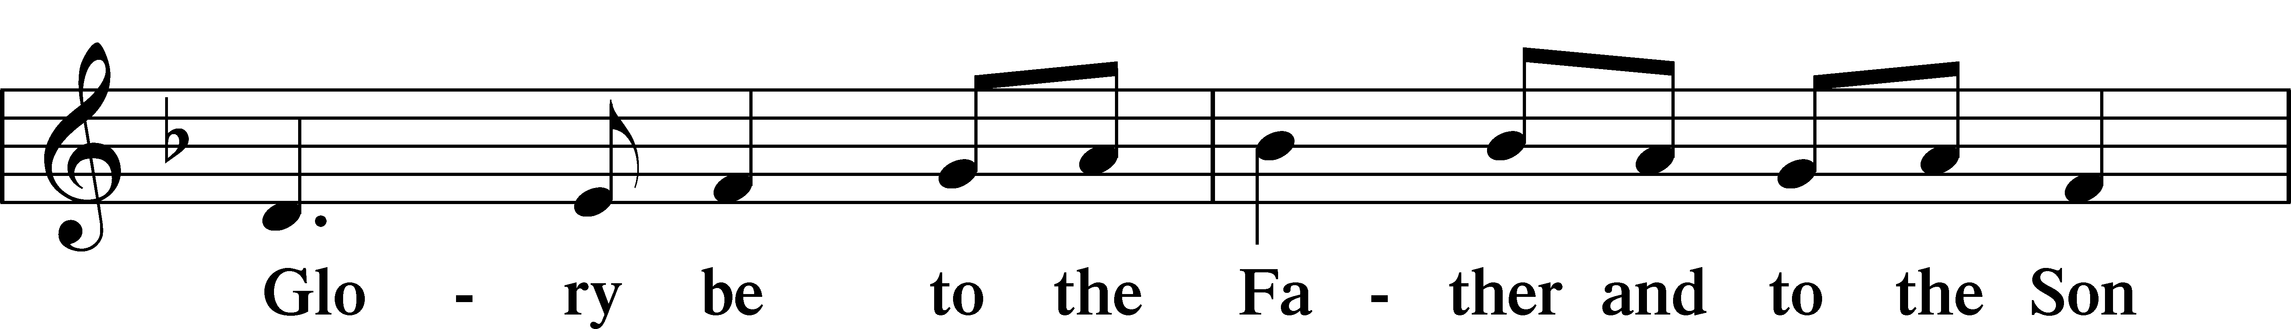
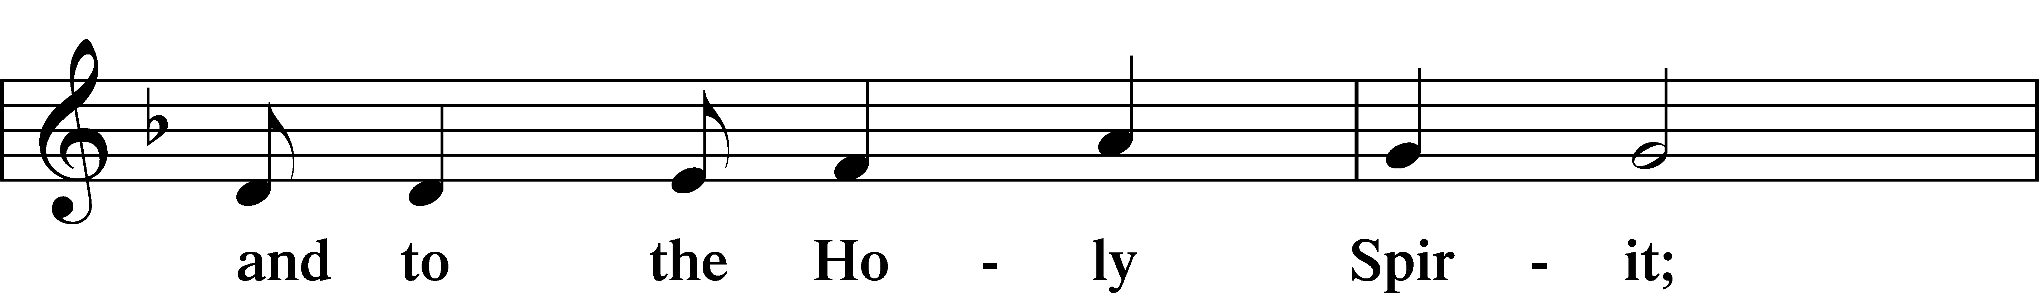
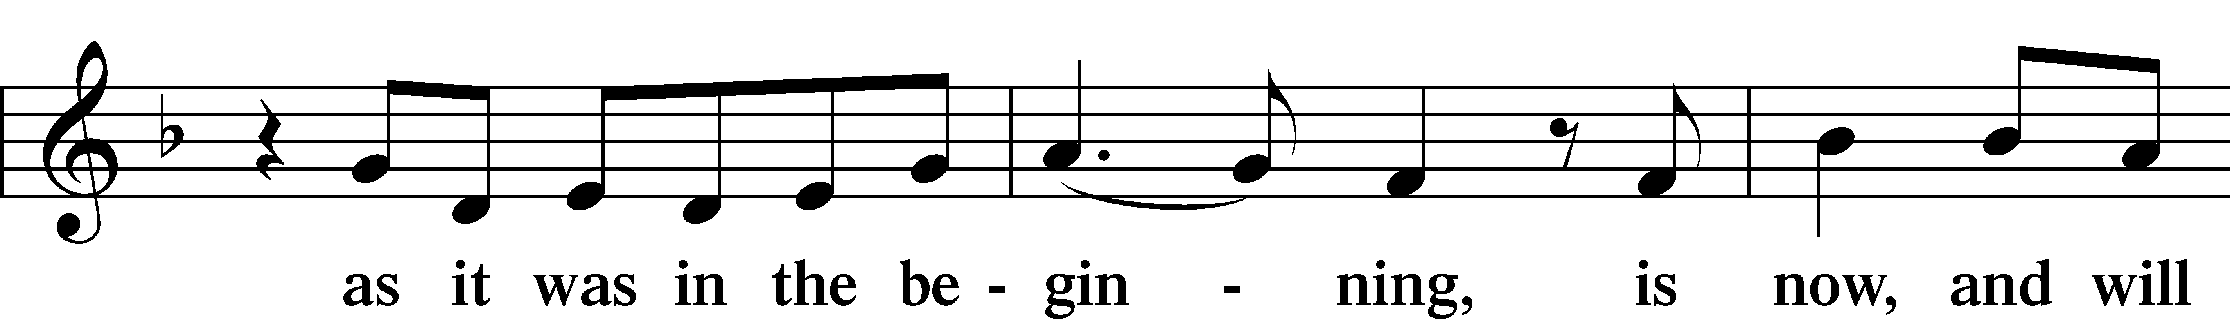
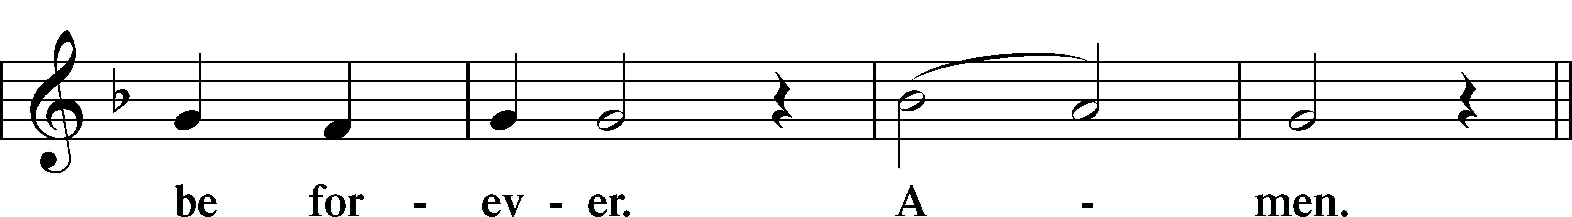
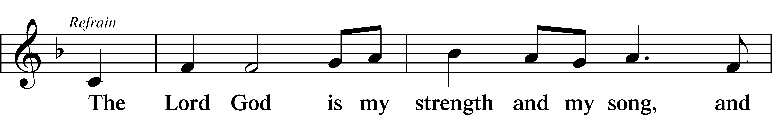
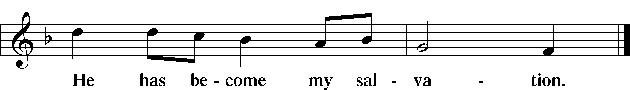

Sit

Readings From Holy Scripture

Reading Isaiah 66:18–23
L A reading from Isaiah, the sixty-sixth chapter.

18“For I know their works and their thoughts, and the time is coming to gather all nations and tongues. And they shall come and shall see my glory, 19and I will set a sign among them. And from them I will send survivors to the nations, to Tarshish, Pul, and Lud, who draw the bow, to Tubal and Javan, to the coastlands afar off, that have not heard my fame or seen my glory. And they shall declare my glory among the nations. 20And they shall bring all your brothers from all the nations as an offering to the Lord, on horses and in chariots and in litters and on mules and on dromedaries, to my holy mountain Jerusalem, says the Lord, just as the Israelites bring their grain offering in a clean vessel to the house of the Lord. 21And some of them also I will take for priests and for Levites, says the Lord.
22“For as the new heavens and the new earth
that I make
shall remain before me, says the Lord,
so shall your offspring and your name remain.
23From new moon to new moon,
and from Sabbath to Sabbath,
all flesh shall come to worship before me,
declares the Lord.”

L This is the Word of the Lord.
C Thanks be to God.

Reading Hebrews 12:4–24
4In your struggle against sin you have not yet resisted to the point of shedding your blood. 5And have you forgotten the exhortation that addresses you as sons?
“My son, do not regard lightly the discipline of the Lord,
nor be weary when reproved by him.
6For the Lord disciplines the one he loves,
and chastises every son whom he receives.”
7It is for discipline that you have to endure. God is treating you as sons. For what son is there whom his father does not discipline? 8If you are left without discipline, in which all have participated, then you are illegitimate children and not sons. 9Besides this, we have had earthly fathers who disciplined us and we respected them. Shall we not much more be subject to the Father of spirits and live? 10For they disciplined us for a short time as it seemed best to them, but he disciplines us for our good, that we may share his holiness. 11For the moment all discipline seems painful rather than pleasant, but later it yields the peaceful fruit of righteousness to those who have been trained by it.
12Therefore lift your drooping hands and strengthen your weak knees, 13and make straight paths for your feet, so that what is lame may not be put out of joint but rather be healed. 14Strive for peace with everyone, and for the holiness without which no one will see the Lord. 15See to it that no one fails to obtain the grace of God; that no “root of bitterness” springs up and causes trouble, and by it many become defiled; 16that no one is sexually immoral or unholy like Esau, who sold his birthright for a single meal. 17For you know that afterward, when he desired to inherit the blessing, he was rejected, for he found no chance to repent, though he sought it with tears.
A Kingdom That Cannot Be Shaken
18For you have not come to what may be touched, a blazing fire and darkness and gloom and a tempest 19and the sound of a trumpet and a voice whose words made the hearers beg that no further messages be spoken to them. 20For they could not endure the order that was given, “If even a beast touches the mountain, it shall be stoned.” 21Indeed, so terrifying was the sight that Moses said, “I tremble with fear.” 22But you have come to Mount Zion and to the city of the living God, the heavenly Jerusalem, and to innumerable angels in festal gathering, 23and to the assembly of the firstborn who are enrolled in heaven, and to God, the judge of all, and to the spirits of the righteous made perfect, 24and to Jesus, the mediator of a new covenant, and to the sprinkled blood that speaks a better word than the blood of Abel.

Reading Luke 13:22–30
The Narrow Door
22[Jesus] went on his way through towns and villages, teaching and journeying toward Jerusalem. 23And someone said to him, “Lord, will those who are saved be few?” And he said to them, 24“Strive to enter through the narrow door. For many, I tell you, will seek to enter and will not be able. 25When once the master of the house has risen and shut the door, and you begin to stand outside and to knock at the door, saying, ‘Lord, open to us,’ then he will answer you, ‘I do not know where you come from.’ 26Then you will begin to say, ‘We ate and drank in your presence, and you taught in our streets.’ 27But he will say, ‘I tell you, I do not know where you come from. Depart from me, all you workers of evil!’ 28In that place there will be weeping and gnashing of teeth, when you see Abraham and Isaac and Jacob and all the prophets in the kingdom of God but you yourselves cast out. 29And people will come from east and west, and from north and south, and recline at table in the kingdom of God. 30And behold, some are last who will be first, and some are first who will be last.”

Psalms, hymns, or choral music may be sung between the readings.

Responsory

L Forever, O Lord, Your Word is firmly set in the heavens.
C Lord, I love the habitation of Your house and the place where Your glory dwells.
L Blessed are those who hear the Word of God and keep it.
C Lord, I love the habitation of Your house and the place where Your glory dwells.
L Glory be to the Father and to the Son and to the Holy Spirit.
C Lord, I love the habitation of Your house and the place where Your glory dwells.

Stand

Ten Commandments
C You shall have no other gods.
You shall not misuse the name of the Lord your God.
Remember the Sabbath day by keeping it holy.
Honor your father and your mother.
You shall not murder.
You shall not commit adultery.
You shall not steal.
You shall not give false testimony against your neighbor.
You shall not covet your neighbor’s house.
You shall not covet your neighbor’s wife, or his manservant or maidservant, his ox or donkey, or anything that belongs to your neighbor.

Apostles’ Creed
C I believe in God, the Father Almighty,
maker of heaven and earth.

And in Jesus Christ, His only Son, our Lord,
who was conceived by the Holy Spirit,
born of the virgin Mary,
suffered under Pontius Pilate,
was crucified, died and was buried.
He descended into hell.
The third day He rose again from the dead.
He ascended into heaven
and sits at the right hand of God the Father Almighty.
From thence He will come to judge the living and the dead.

I believe in the Holy Spirit,
the holy Christian Church,
the communion of saints,
the forgiveness of sins,
the resurrection of the body,
and the life T everlasting. Amen.

Lord’s Prayer
C Our Father who art in heaven,
hallowed be Thy name,
Thy kingdom come,
Thy will be done on earth
as it is in heaven;
give us this day our daily bread;
and forgive us our trespasses
as we forgive those
who trespass against us;
and lead us not into temptation,
but deliver us from evil.
For Thine is the kingdom
and the power and the glory
forever and ever. Amen.

Sit

Hymn: 516 Wake, Awake, for Night Is Flying
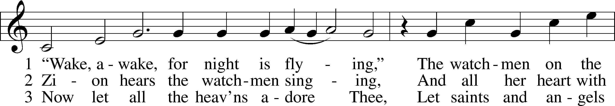
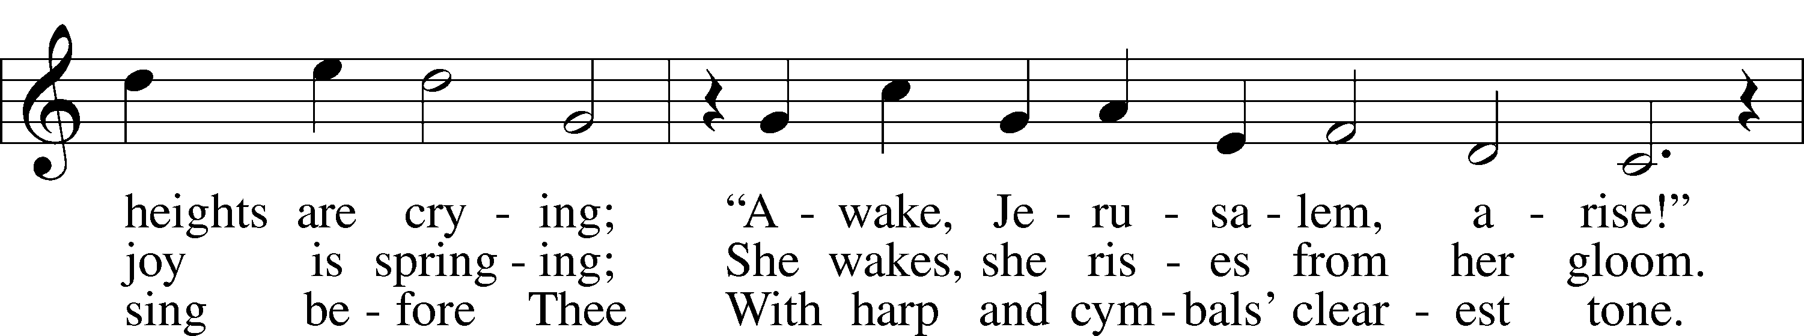
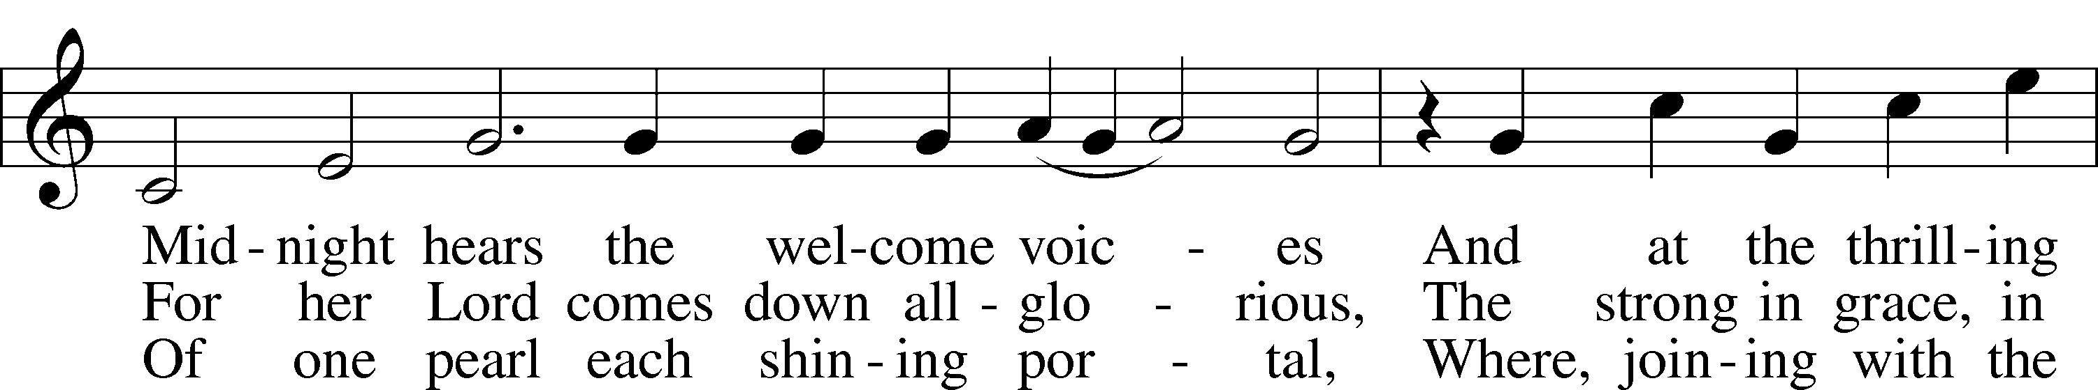
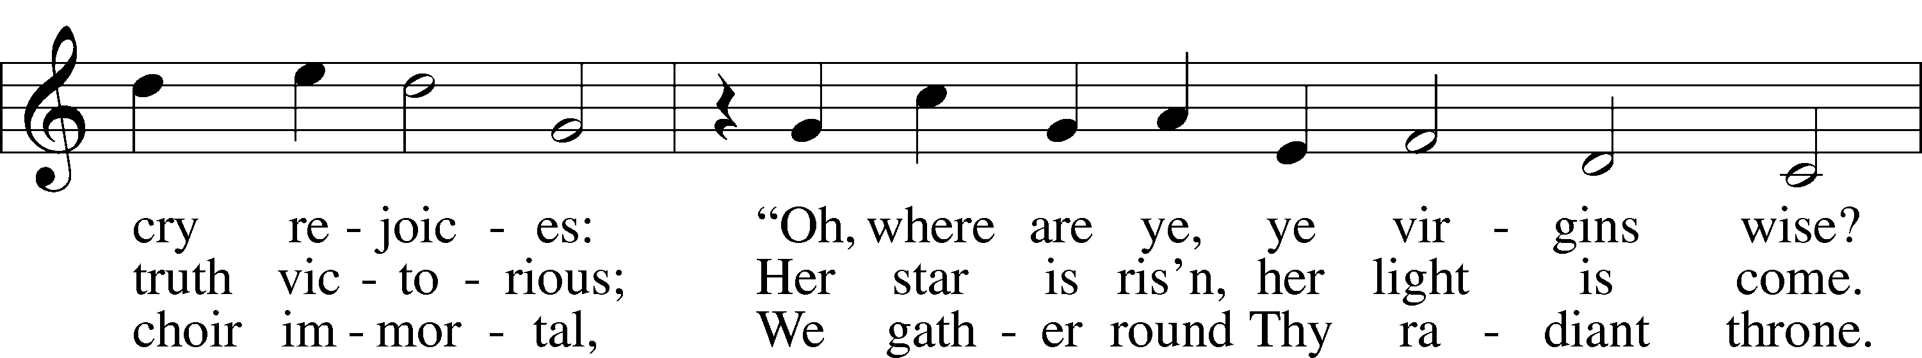
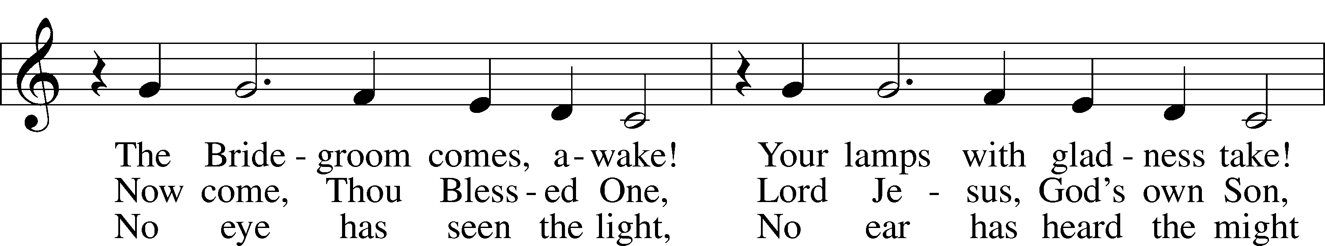
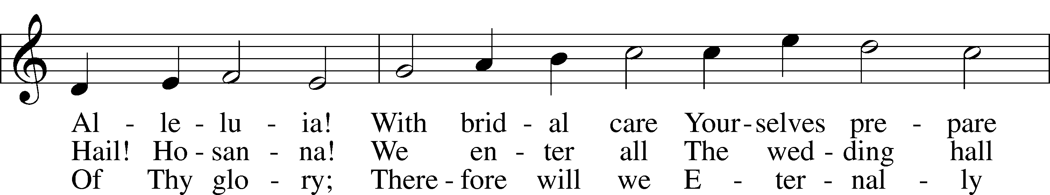
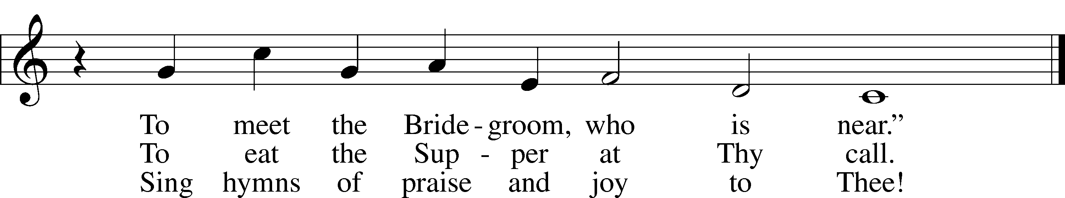

Text: tr. Catherine Winkworth, 1827–78, alt.
Text and tune: Philipp Nicolai, 1556–1608
Text and tune: Public domain

Sermon

Hymn: 505 Triune God, Be Thou Our Stay sts. –3
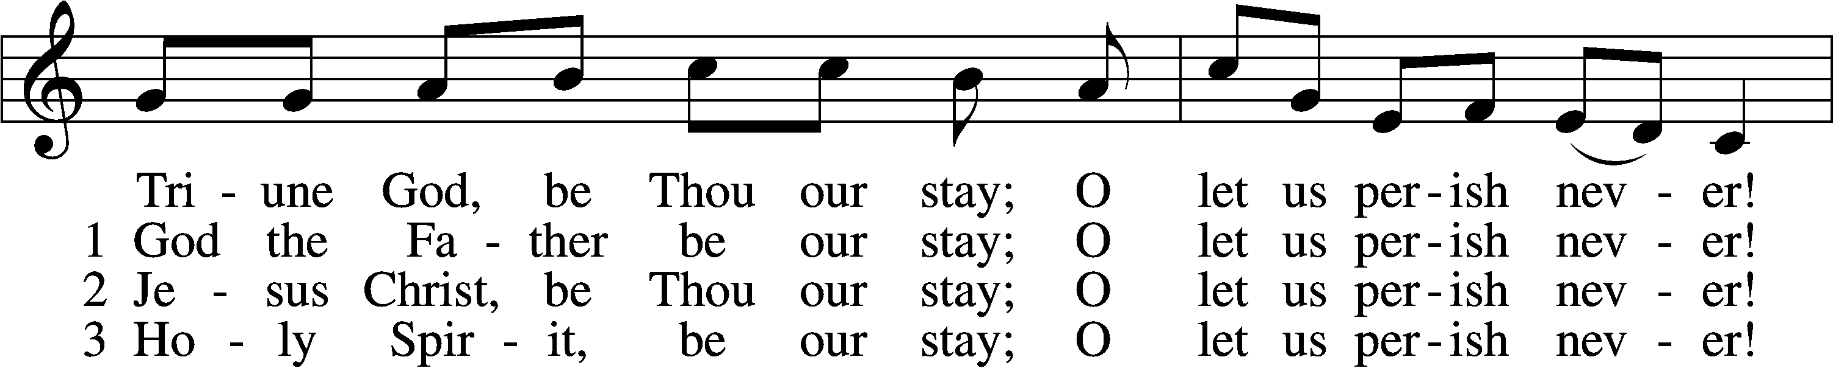
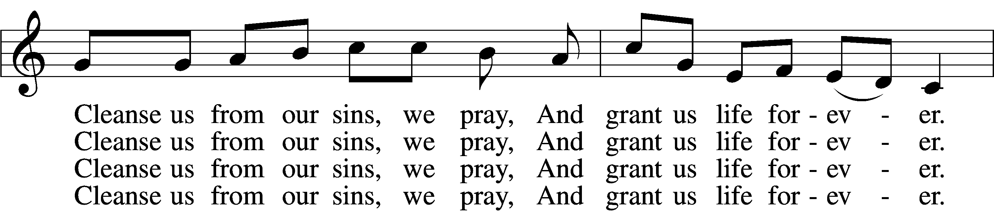
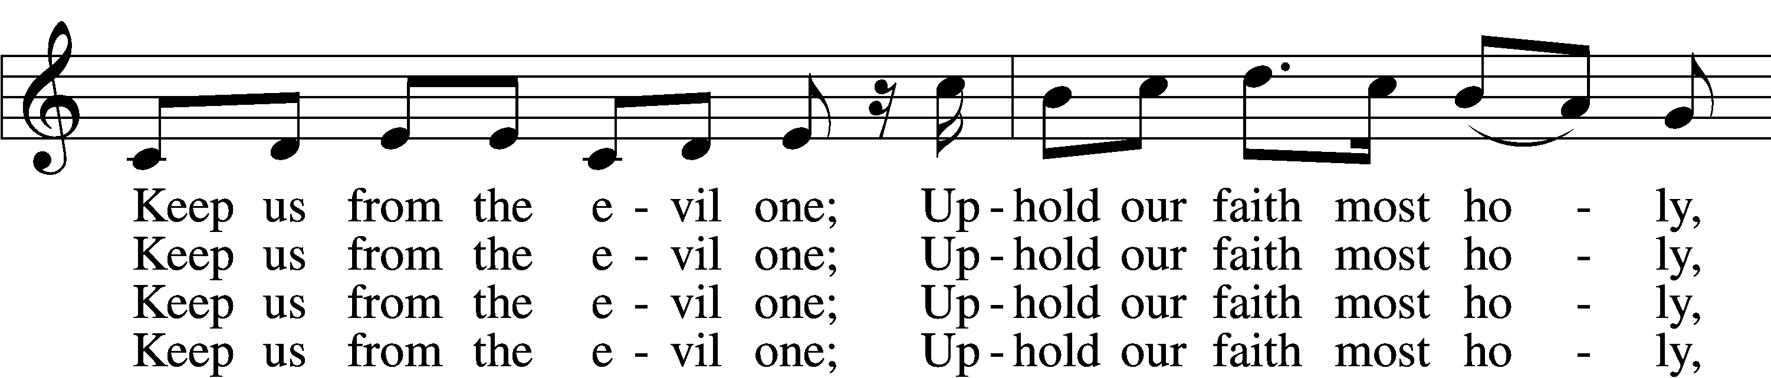
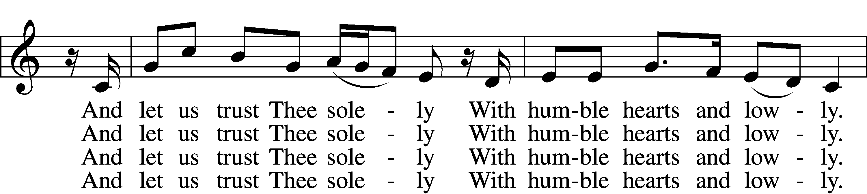
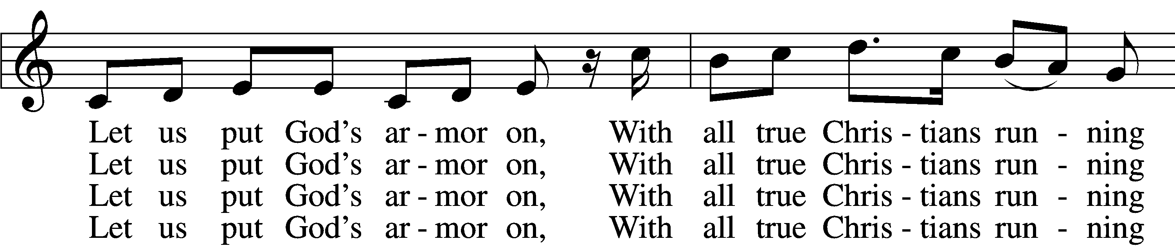
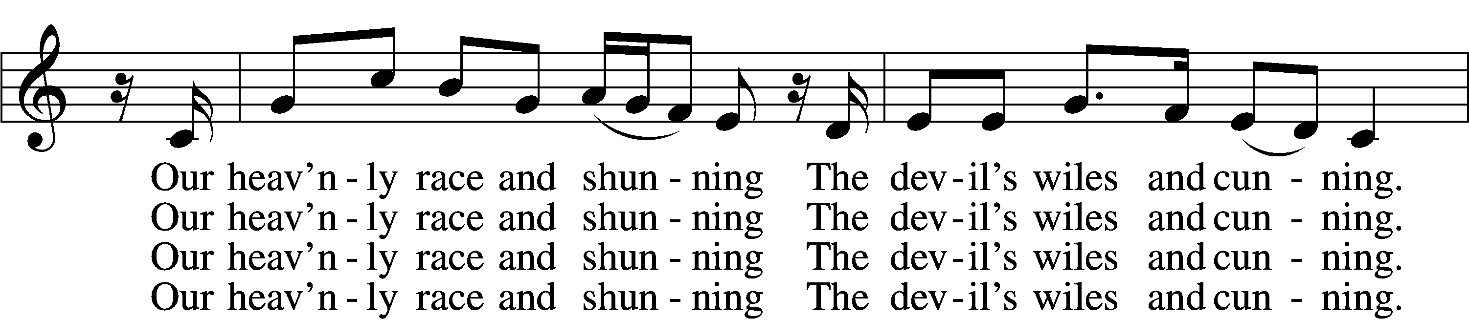
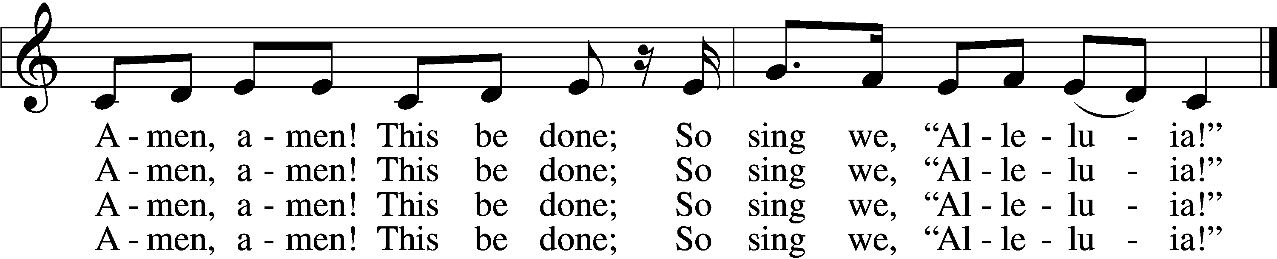

Text: Martin Luther, 1483–1546, based on 15th-cent. German litany; tr. Richard Massie, 1800–87, alt.
Tune: Geystliche gesangk Buchleyn, 1524, Wittenberg, ed. Johann Walter
Text and tune: Public domain

Offering

Stand

Prayer
L In peace let us pray to the Lord:
C Lord, have mercy.
L For the gift of divine peace and of pardon, with all our heart and with all our mind, let us pray to the Lord:
C Lord, have mercy.
L For the holy Christian Church, here and scattered throughout the world, and for the proclamation of the Gospel and the calling of all to faith, let us pray to the Lord:
C Lord, have mercy.
L For this nation, for our cities and communities, and for the common welfare of us all, let us pray to the Lord:
C Lord, have mercy.
L For seasonable weather and for the fruitfulness of the earth, let us pray to the Lord:
C Lord, have mercy.
L For those who labor, for those whose work is difficult or dangerous, and for all who travel, let us pray to the Lord:
C Lord, have mercy.
L For all those in need, for the hungry and homeless, for the widowed and orphaned, and for all those in prison, let us pray to the Lord:
C Lord, have mercy.
L For the sick and dying and for all those who care for them, let us pray to the Lord:
C Lord, have mercy.
L For . . . [additional bids for prayer may be inserted here] . . . let us pray to the Lord:
C Lord, have mercy.
L Finally, for these and for all our needs of body and soul, let us pray to the Lord:
C Lord, have mercy. Christ, have mercy. Lord, have mercy.

Collect of the Day
L Almighty God, Your Son, Jesus Christ, chose Bartholomew to be an apostle to preach the blessed Gospel. Grant that Your Church may love what he believed and preach what he taught; through Jesus Christ, our Lord, who lives and reigns with You and the Holy Spirit, one God, now and forever.
C Amen.

Collect for the Word
L Blessed Lord, You have caused all Holy Scriptures to be written for our learning. Grant that we may so hear them, read, mark, learn, and take them to heart that, by the patience and comfort of Your holy Word, we may embrace and ever hold fast the blessed hope of everlasting life; through Jesus Christ, Your Son, our Lord, who lives and reigns with You and the Holy Spirit, one God, now and forever.
C Amen.

Morning Prayer
C I thank You, my heavenly Father, through Jesus Christ, Your dear Son, that You have kept me this night from all harm and danger; and I pray that You would keep me this day also from sin and every evil, that all my doings and life may please You. For into Your hands I commend myself, my body and soul, and all things. Let Your holy angel be with me, that the evil foe may have no power over me.
Amen.

New Testament Canticle LSB 266
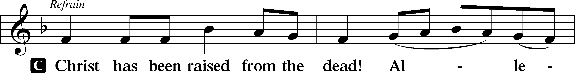
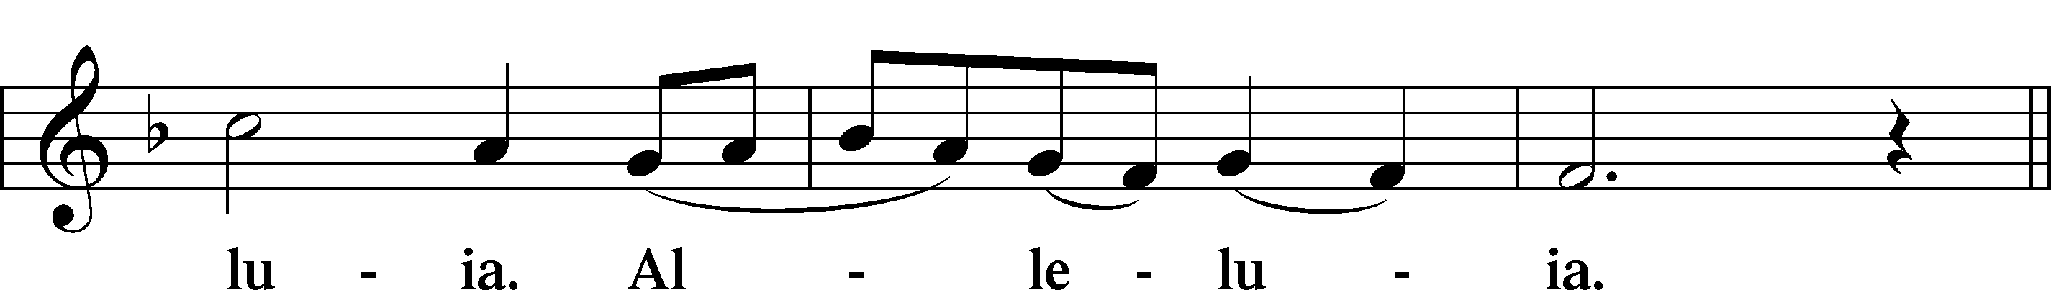
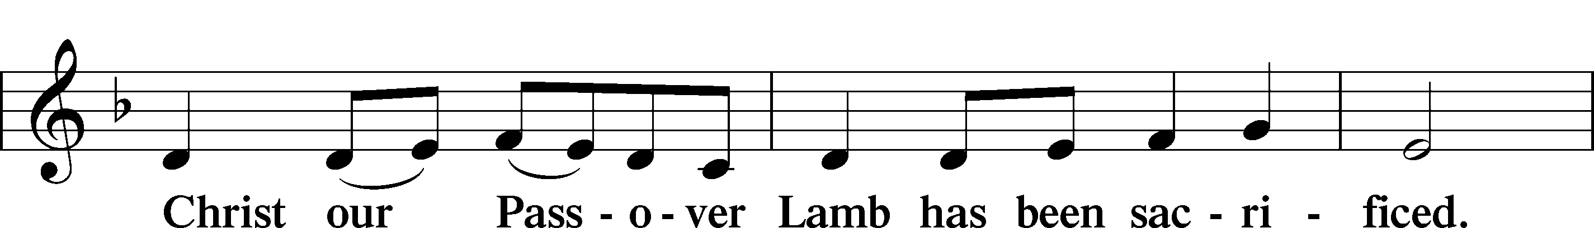
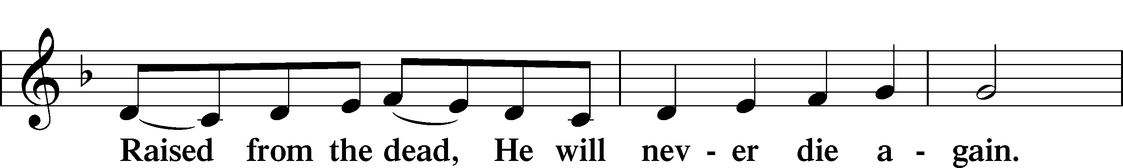
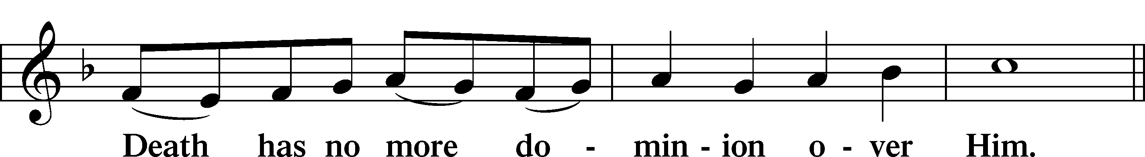
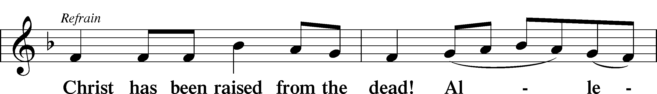
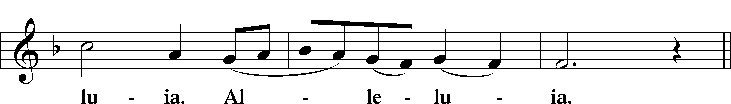
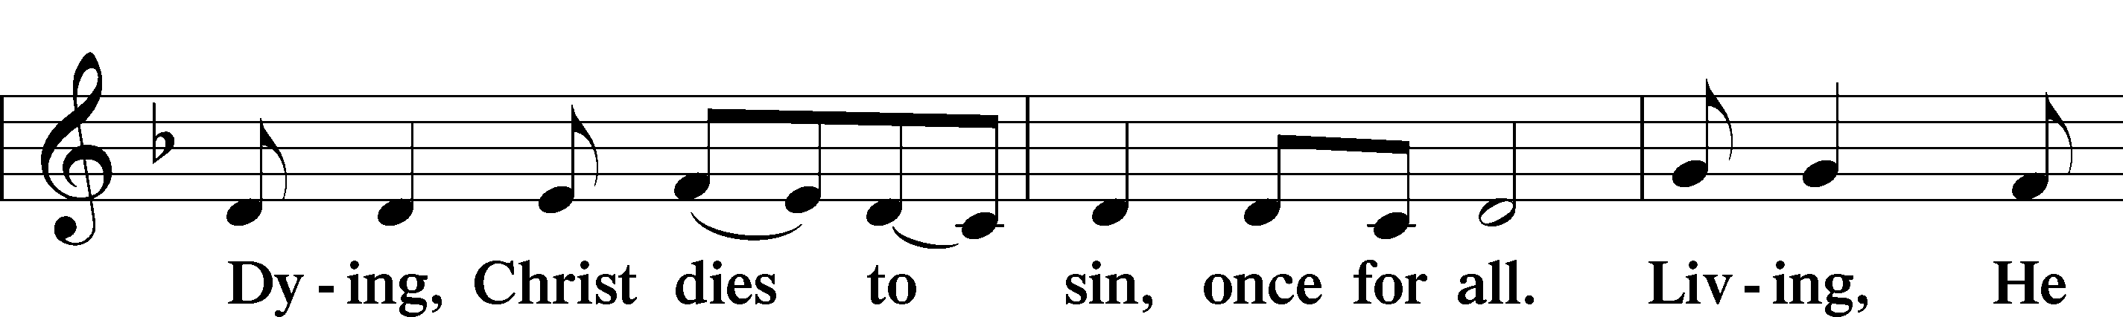
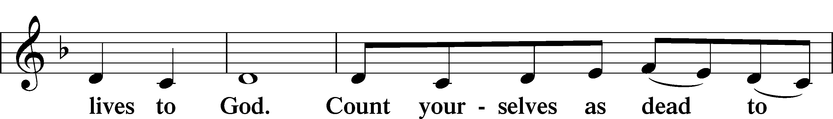
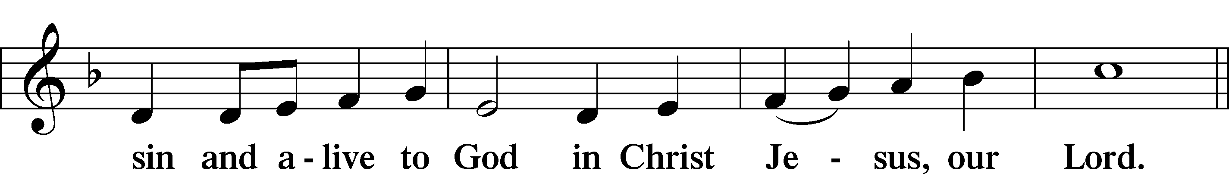
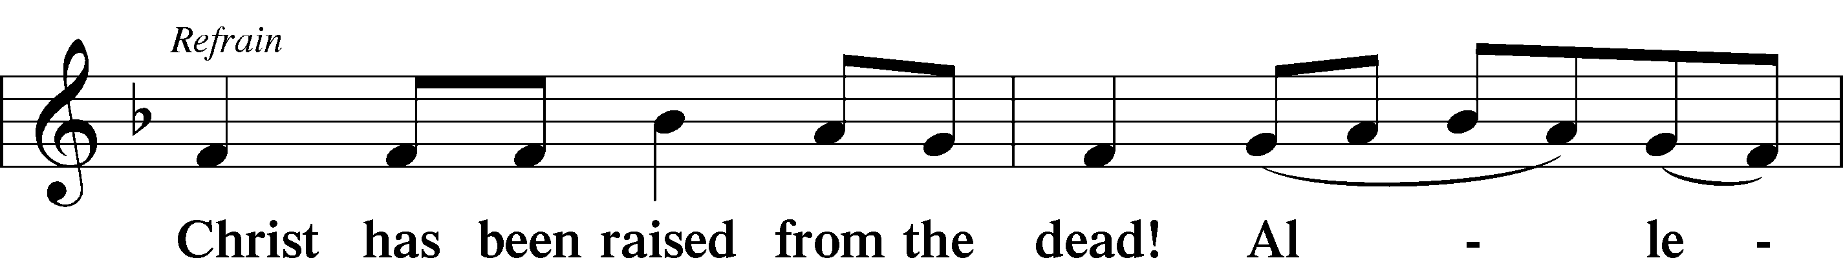
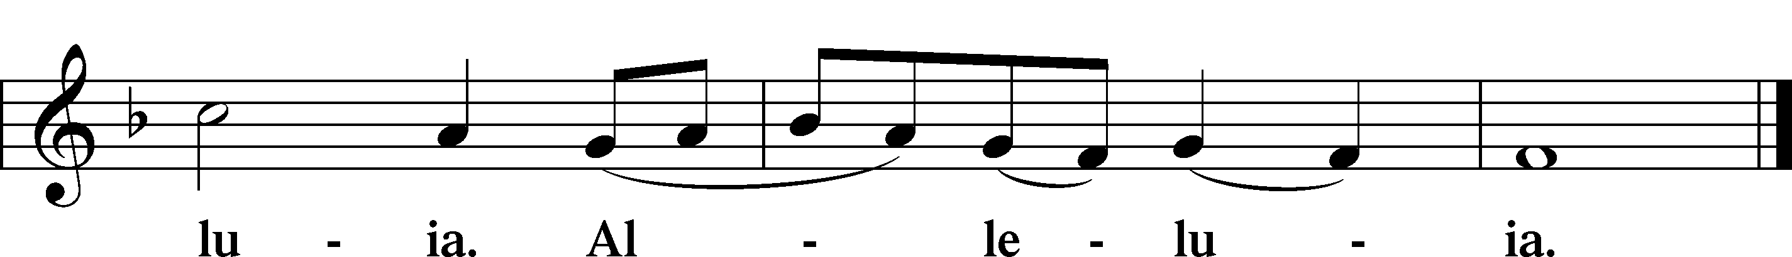

Blessing

L Let us bless the Lord.
C Thanks be to God.

L The almighty and merciful Lord, the Father, the T Son, and the Holy Spirit, bless and preserve us.
C Amen.

Hymn: 917 Savior, Again to Thy Dear Name We Raise Vs. 1-2
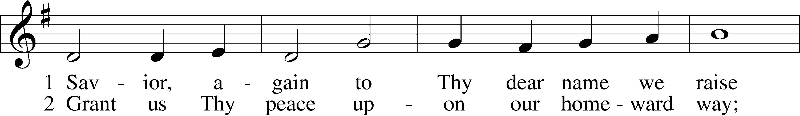
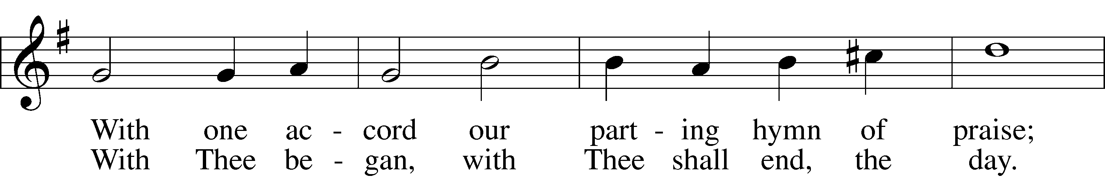
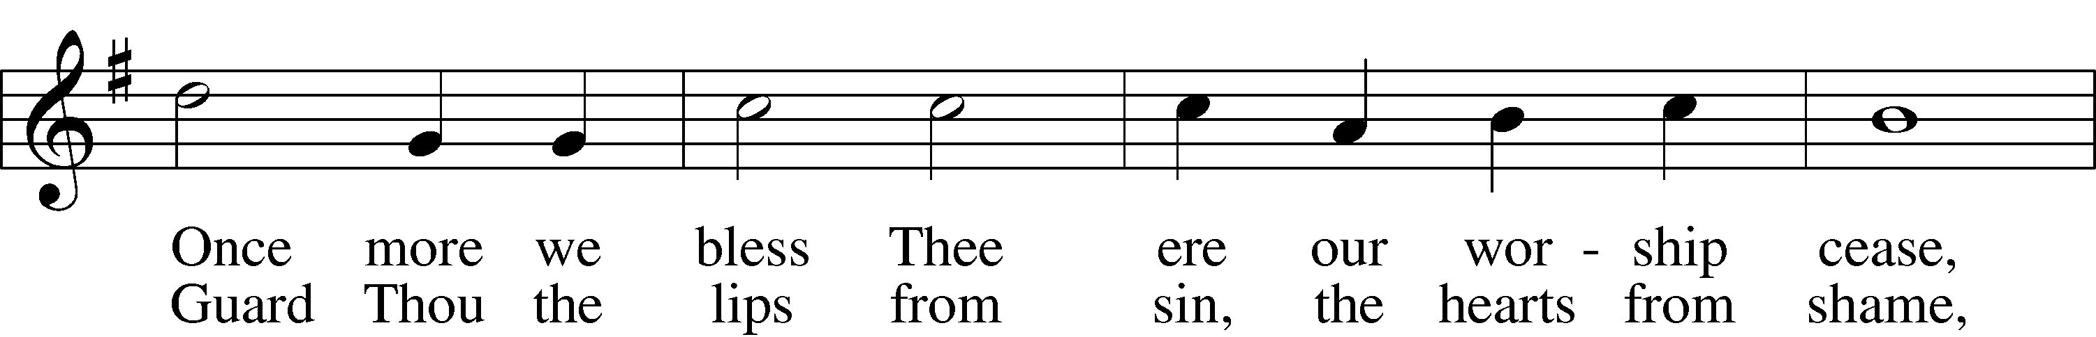
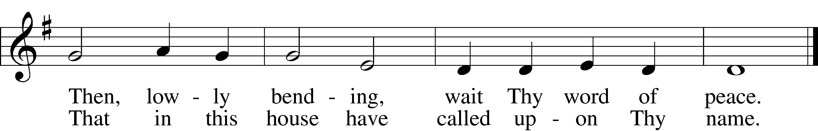
Text: John Ellerton, 1826–93
Tune: Edward J. Hopkins, 1818–1901
Text and tune: Public domain

Acknowledgments
Service of Prayer and Preaching from Lutheran Service Book
Unless otherwise indicated, Scripture quotations are from the ESV® Bible (The Holy Bible, English Standard Version®), copyright © 2001 by Crossway, a publishing ministry of Good News Publishers. Used by permission. All rights reserved.
Created by Lutheran Service Builder © 2025 Concordia Publishing House.

Prayers Request: Those in the nursing home: Joann Jaeger, Joan Church Those Shut-in at home: Char Herman, Joyce Myers Those with ongoing health issues: Daria (Cindy Wright’s friend), Butch L. (Cindy Wright’s Brother-in-law), Melissa Miller. Sandy Hahn (Cindy Wright’s cousin’s wife) , Marlene Snyder, Shirley Hehl, Pastor Eric and Linda Stumpf, Tasha Becker(Michele Millerman’s daughter) Recovering from surgery: Brenda Gustum (Missy Wiese’s mom)
Celebrating with: Aaron, Kassie and Addie Rivard at the birth of Olivia Lyn Those who lead our nation: Donald Trump, JD Vance, Tony Evers, Rod Nordby Those who serve in our military and law enforcement: Ryan Graf, Chaplain Pon Chanthaphon (Our Adopt-a-Chaplain), Rusty Weise Our Childcare Staff: Melissa Frieburg, Denise Stabenow, Holly Wilhelmi, Janica Skjerly, Cathy Anderson, Micahlee Skjerly, Iva Gjika, Michele Millerman, Brittnie Eirckson, Jayme Closs, Brooklyn Doyle, Mariah Ward(Behnke)

Church Service Phone: 715-438-4200(Chippewa Falls) 715-537-4240(local)
(Stay on the line for recorded service to start)
Live Stream audio services: http://salem.listentochurch.com
Salem’s Web Page: https://www.salembarron.com/
Pastor Fred Buth: Cell phone:715-642-3050
Email: salembarronpastor@gmail.com
Office Hours: Monday-Wednesday 9-12
Attendance: 8/17-64
Coffee and Snacks: Shirley Hehl (celebrating 90 Years!) Happy Birthday
Elder Today: Stan Koenig
Reader: Duane Longmire
Organist: Kari Longmire
Altar Guild: Nancy and Marcia Offering: 8/3: General fund $, Missions $, Building fund $ Offering: 8/3: General fund $2654, Missions $78, Building fund $140 AC $100 8/10: General fund $6949, Missions $553, Building fund $130 Schutz Oil $78.65

Position needed: Sunday School Director. Please carefully and prayerfully consider volunteering for this. The job description is on the board in the back

Today, Sunday, August 24th: Opening Vespers service for the CCLS school year. This will be held at St. Matthew in Almena at 2:00 pm.
Fall Registration open for Classical Lutheran Education christcommunityls.org
Monday, August 25th: First day of school at CCLS! August 31 – Congregational Meeting. (items: Flooring in the parsonage, old playground & creek bridge)

October 4th: LWML Fall Rally @ Salem (all women are invited) Salem is hosting the LWML Fall Rally this year. Our service project will be packing school kits and personal hygiene kits for the ORPHAN GRAIN TRAIN. If you would like to donate items, see the display in the back. We are hoping to get enough supplies to pack 200 kits

