Easter Sunday
March 31, 2024
7:00 AM

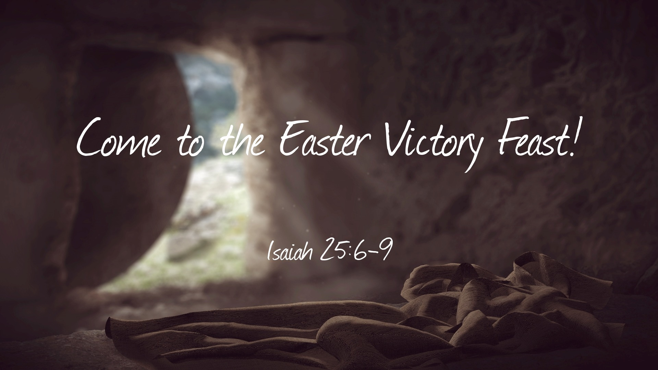

Salem Lutheran Church
1-715-537-3011
http://www.salembarron.com
rev.mike.nielsen@gmail.com

The Lord Jesus Brings Us Out of Death into Life with His God and Father in Heaven

In Adam, all people die because all people sin. The children of that first gardener have been driven out of Paradise and return to the dust whence they were taken. But now another Gardener has come, who has made His bed in the dust of the earth and who, by His rising, restores Paradise to all the children of men. With His voice of the Gospel, He calls us by name, and He opens our eyes to behold Him by faith. At His Word, we enter His tomb through Baptism into His death, so that, just as He is risen, we also “rise from the dead” (John 20:9). Come, then, “sing to the Lord, for he has triumphed gloriously” (Ex. 15:1). He has fought for us against our enemies, and in His resurrection not one enemy remains. “Fear not,” therefore, but “see the salvation of the Lord” (Ex. 14:13), which He delivers “as of first importance” by the preaching of His Gospel (1 Cor. 15:3). Thus, we are raised with Christ “in accordance with the Scriptures” (1 Cor. 15:4), and we stand firm because we “are being saved” (1 Cor. 15:1–2).

Hymn: Jesus Christ is Risen Today LSB 457
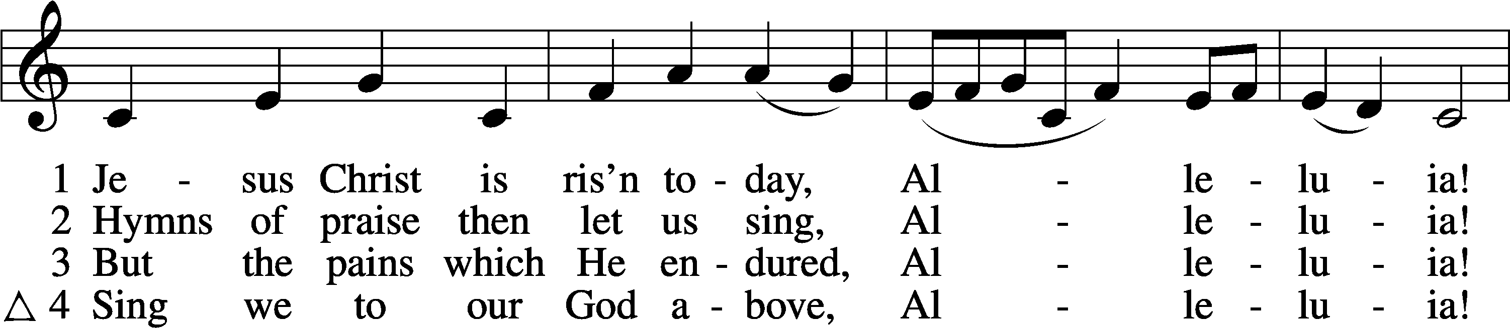
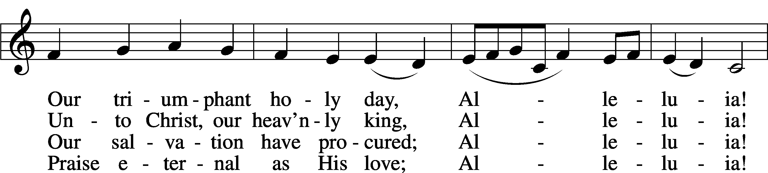
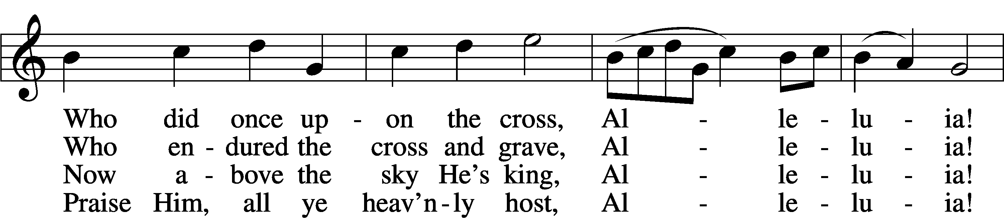
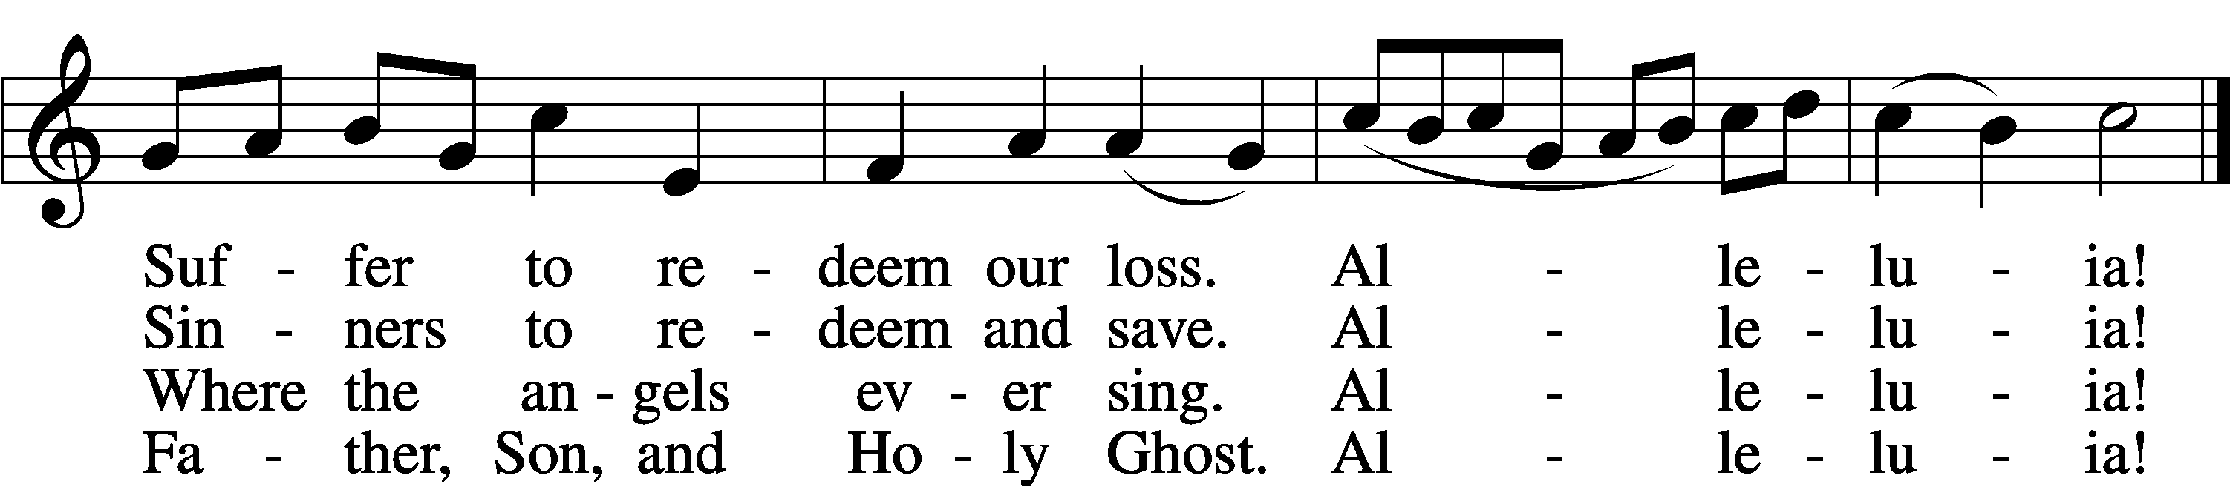
Text: tr. Lyra Davidica, 1708, London, alt.; (sts. 1–3): Latin, 14th cent.; (st. 4): Charles Wesley, 1707–88
Tune: Lyra Davidica, 1708, London
Text and tune: Public domain

Stand

Opening Versicles LSB 260
L This is the day which the Lord has made;
C let us rejoice and be glad in it.
L From the rising of the sun to its setting,
C the name of the Lord is to be praised.

L Better is one day in Your courts than a thousand elsewhere;
C I would rather be a doorkeeper in the house of my God than dwell in the tents of the wicked.
L Make me to know Your ways, O Lord.
C Teach me Your paths.
L Sanctify us in Your truth.
C Your Word is truth.

L From the rising of the sun to its setting,
C the name of the Lord is to be praised.

C Glory be to the Father and to the Son and to the Holy Spirit;
as it was in the beginning, is now, and will be forever. Amen.

Old Testament Canticle LSB 261
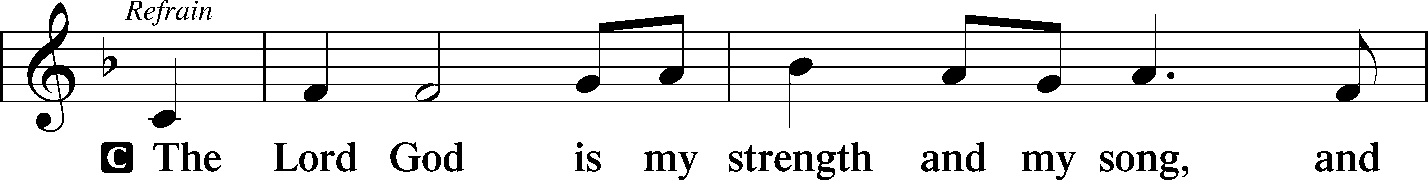
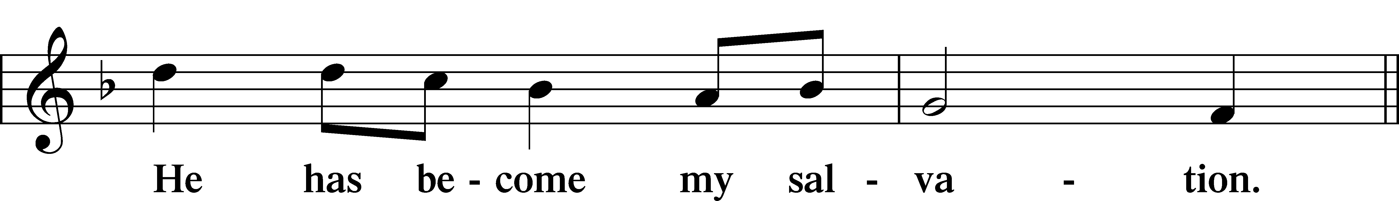
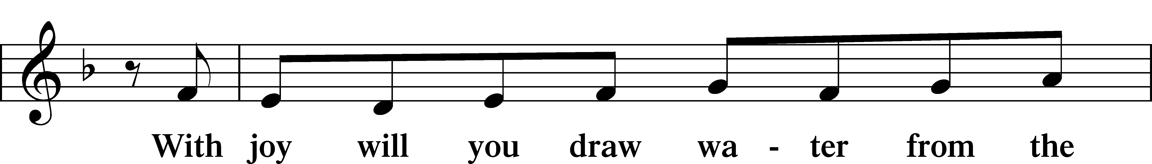
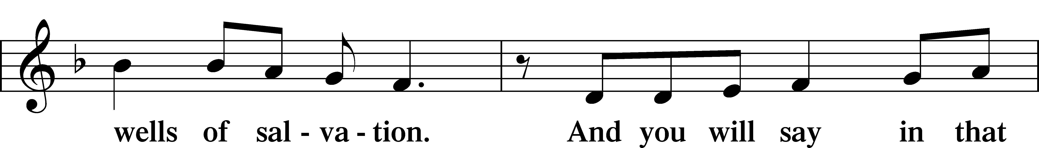
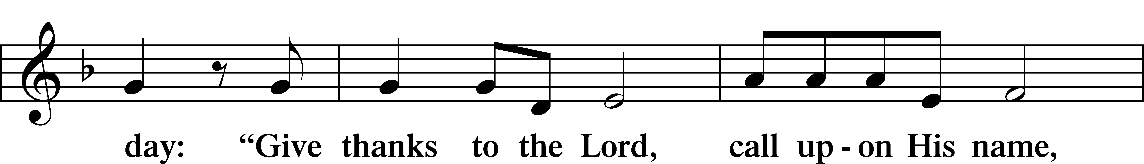
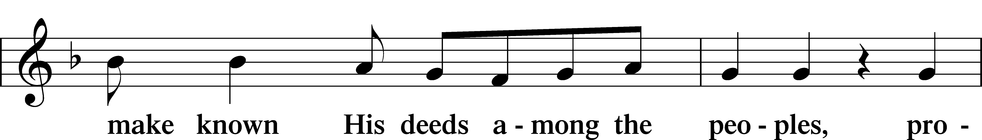
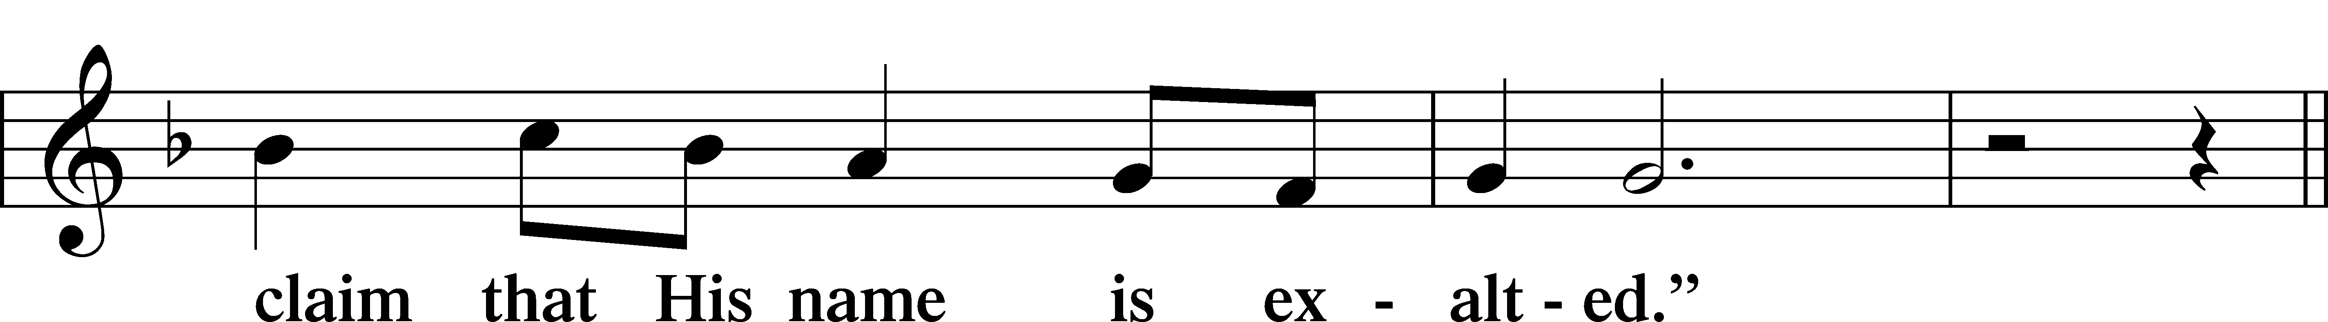
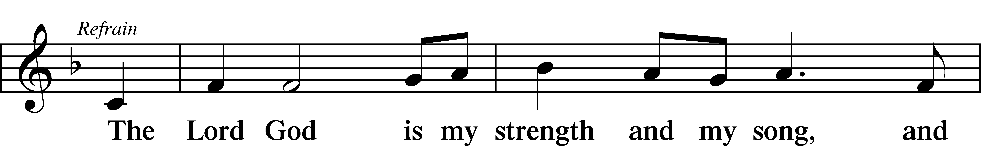
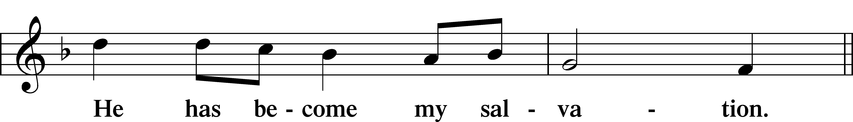
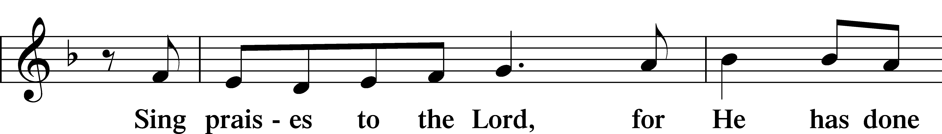
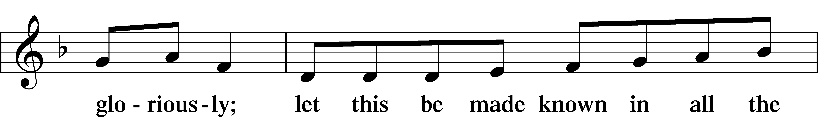
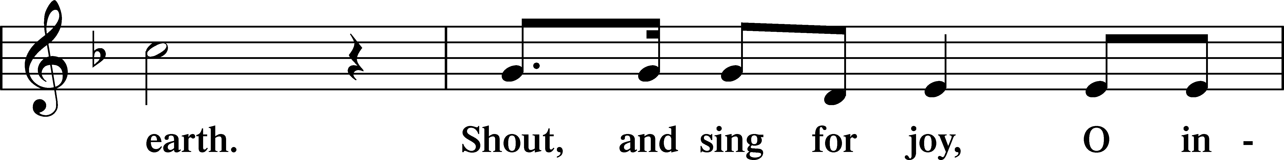
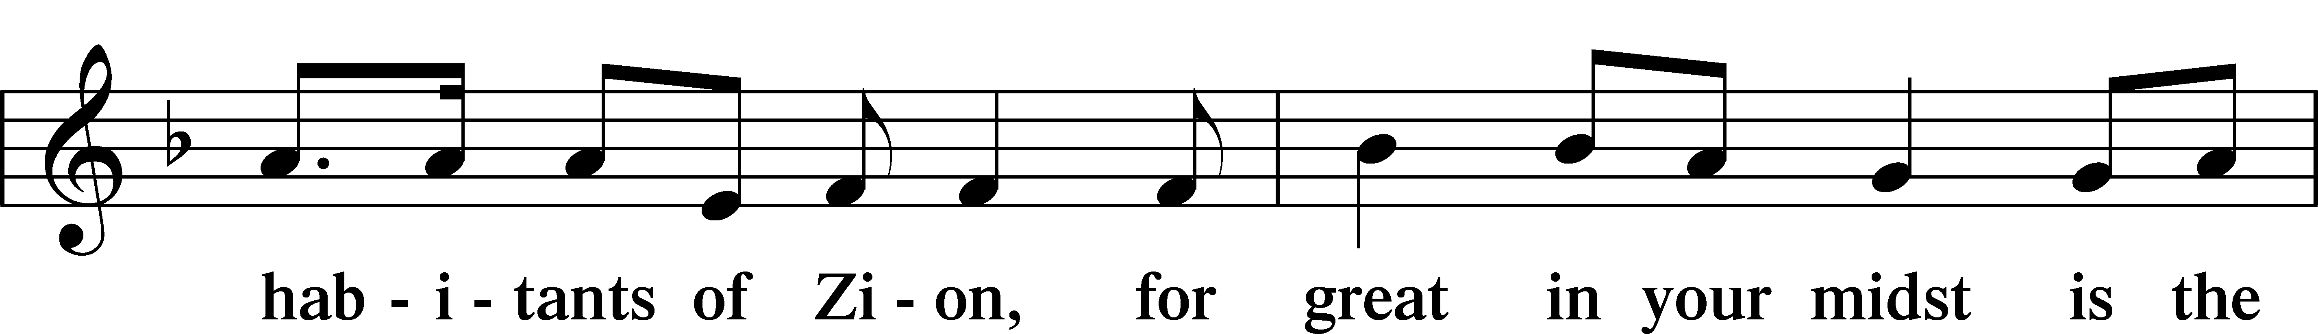
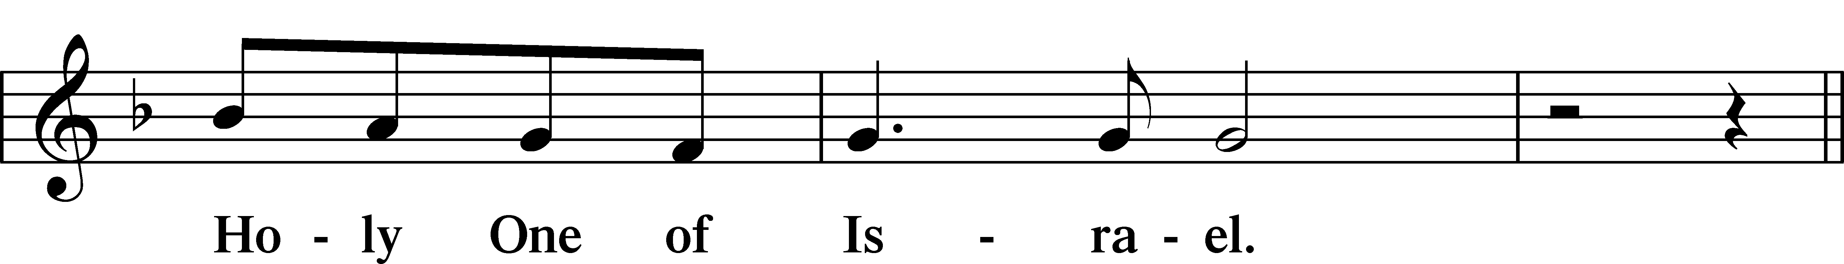
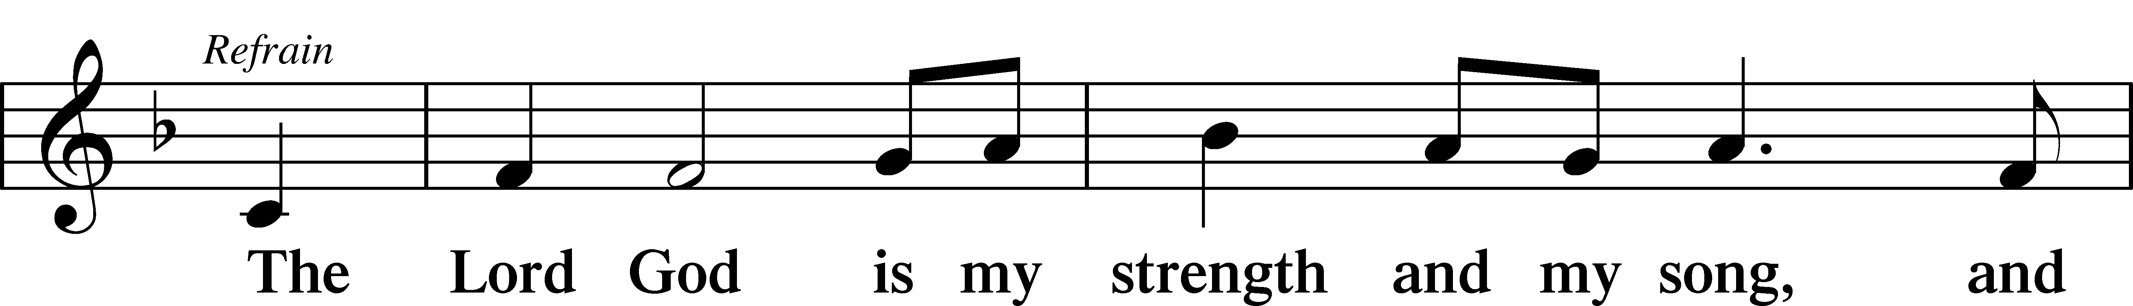
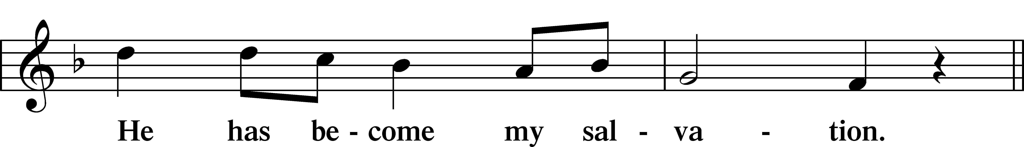
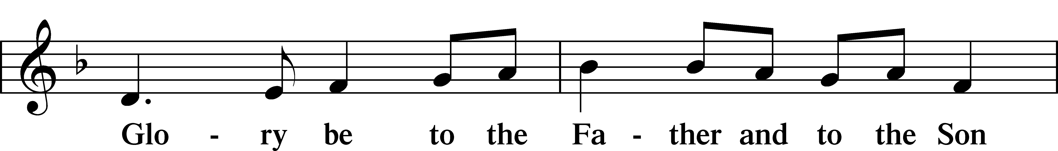
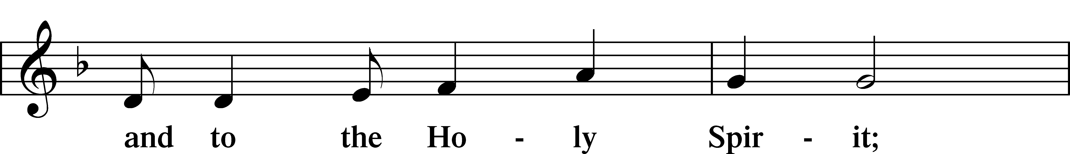
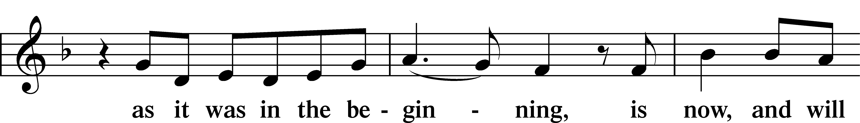
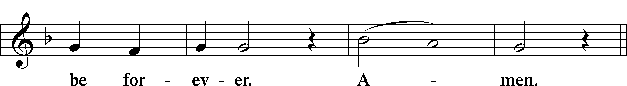
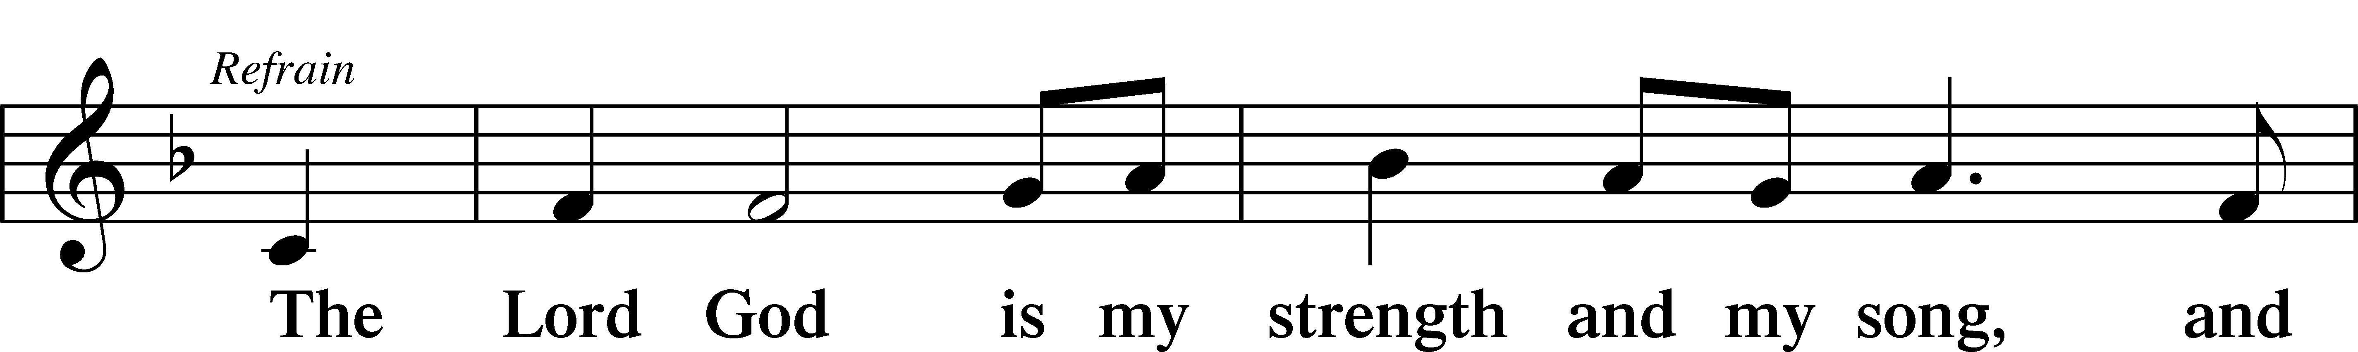
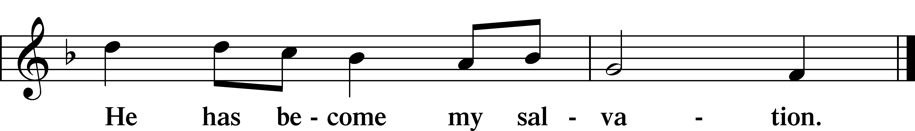

Sit

Reading Isaiah 25:6–9
L A reading from Isaiah, the twenty-fifth chapter.

6On this mountain the Lord of hosts will make for all peoples
a feast of rich food, a feast of well-aged wine,
of rich food full of marrow, of aged wine well refined.
7And he will swallow up on this mountain
the covering that is cast over all peoples,
the veil that is spread over all nations.
8He will swallow up death forever;
and the Lord God will wipe away tears from all faces,
and the reproach of his people he will take away from all the earth,
for the Lord has spoken.
9It will be said on that day,
“Behold, this is our God; we have waited for him, that he might save us.
This is the Lord; we have waited for him;
let us be glad and rejoice in his salvation.”

L This is the Word of the Lord.
C Thanks be to God.

Reading Psalm 118:15–29
15Glad songs of salvation
are in the tents of the righteous:
“The right hand of the Lord does valiantly,
16the right hand of the Lord exalts,
the right hand of the Lord does valiantly!”
17I shall not die, but I shall live,
and recount the deeds of the Lord.
18The Lord has disciplined me severely,
but he has not given me over to death.
19Open to me the gates of righteousness,
that I may enter through them
and give thanks to the Lord.
20This is the gate of the Lord;
the righteous shall enter through it.
21I thank you that you have answered me
and have become my salvation.
22The stone that the builders rejected
has become the cornerstone.
23This is the Lord’s doing;
it is marvelous in our eyes.
24This is the day that the Lord has made;
let us rejoice and be glad in it.
25Save us, we pray, O Lord!
O Lord, we pray, give us success!
26Blessèd is he who comes in the name of the Lord!
We bless you from the house of the Lord.
27The Lord is God,
and he has made his light to shine upon us.
Bind the festal sacrifice with cords,
up to the horns of the altar!
28You are my God, and I will give thanks to you;
you are my God; I will extol you.
29Oh give thanks to the Lord, for he is good;
for his steadfast love endures forever!
Reading 1 Corinthians 5:6b–8
Do you not know that a little leaven leavens the whole lump? 7Cleanse out the old leaven that you may be a new lump, as you really are unleavened. For Christ, our Passover lamb, has been sacrificed. 8Let us therefore celebrate the festival, not with the old leaven, the leaven of malice and evil, but with the unleavened bread of sincerity and truth.

A This is the Word of the Lord.
C Thanks be to God.

Reading John 20:1–18
1Now on the first day of the week Mary Magdalene came to the tomb early, while it was still dark, and saw that the stone had been taken away from the tomb. 2So she ran and went to Simon Peter and the other disciple, the one whom Jesus loved, and said to them, “They have taken the Lord out of the tomb, and we do not know where they have laid him.” 3So Peter went out with the other disciple, and they were going toward the tomb. 4Both of them were running together, but the other disciple outran Peter and reached the tomb first. 5And stooping to look in, he saw the linen cloths lying there, but he did not go in. 6Then Simon Peter came, following him, and went into the tomb. He saw the linen cloths lying there, 7and the face cloth, which had been on Jesus’ head, not lying with the linen cloths but folded up in a place by itself. 8Then the other disciple, who had reached the tomb first, also went in, and he saw and believed; 9for as yet they did not understand the Scripture, that he must rise from the dead. 10Then the disciples went back to their homes.
11But Mary stood weeping outside the tomb, and as she wept she stooped to look into the tomb. 12And she saw two angels in white, sitting where the body of Jesus had lain, one at the head and one at the feet. 13They said to her, “Woman, why are you weeping?” She said to them, “They have taken away my Lord, and I do not know where they have laid him.” 14Having said this, she turned around and saw Jesus standing, but she did not know that it was Jesus. 15Jesus said to her, “Woman, why are you weeping? Whom are you seeking?” Supposing him to be the gardener, she said to him, “Sir, if you have carried him away, tell me where you have laid him, and I will take him away.” 16Jesus said to her, “Mary.” She turned and said to him in Aramaic, “Rabboni!” (which means Teacher). 17Jesus said to her, “Do not cling to me, for I have not yet ascended to the Father; but go to my brothers and say to them, ‘I am ascending to my Father and your Father, to my God and your God.’” 18Mary Magdalene went and announced to the disciples, “I have seen the Lord”—and that he had said these things to her.

A This is the Word of the Lord.
C Thanks be to God.

Responsory
L Forever, O Lord, Your Word is firmly set in the heavens.
C Lord, I love the habitation of Your house and the place where Your glory dwells.
L Blessed are those who hear the Word of God and keep it.
C Lord, I love the habitation of Your house and the place where Your glory dwells.
L Glory be to the Father and to the Son and to the Holy Spirit.
C Lord, I love the habitation of Your house and the place where Your glory dwells.

Stand

Ten Commandments
C You shall have no other gods. You shall not misuse the name of the Lord your God.
Remember the Sabbath day by keeping it holy. Honor your father and your mother. You shall not murder. You shall not commit adultery.
You shall not steal. You shall not give false testimony against your neighbor.
You shall not covet your neighbor’s house. You shall not covet your neighbor’s wife, or his manservant or maidservant, his ox or donkey, or anything that belongs to your neighbor.

Apostles’ Creed
C I believe in God, the Father Almighty, maker of heaven and earth.

And in Jesus Christ, His only Son, our Lord, who was conceived by the Holy Spirit, born of the virgin Mary, suffered under Pontius Pilate, was crucified, died and was buried. He descended into hell. The third day He rose again from the dead. He ascended into heaven and sits at the right hand of God the Father Almighty. From thence He will come to judge the living and the dead.

I believe in the Holy Spirit, the holy Christian Church, the communion of saints, the forgiveness of sins, the resurrection of the body, and the life T everlasting. Amen.

Lord’s Prayer
C Our Father who art in heaven, hallowed be Thy name, Thy kingdom come, Thy will be done on earth as it is in heaven; give us this day our daily bread; and forgive us our trespasses as we forgive those who trespass against us; and lead us not into temptation, but deliver us from evil. For Thine is the kingdom and the power and the glory forever and ever. Amen.

Sit

Hymn: Come, You Faithful Raise the Strain LSB 487
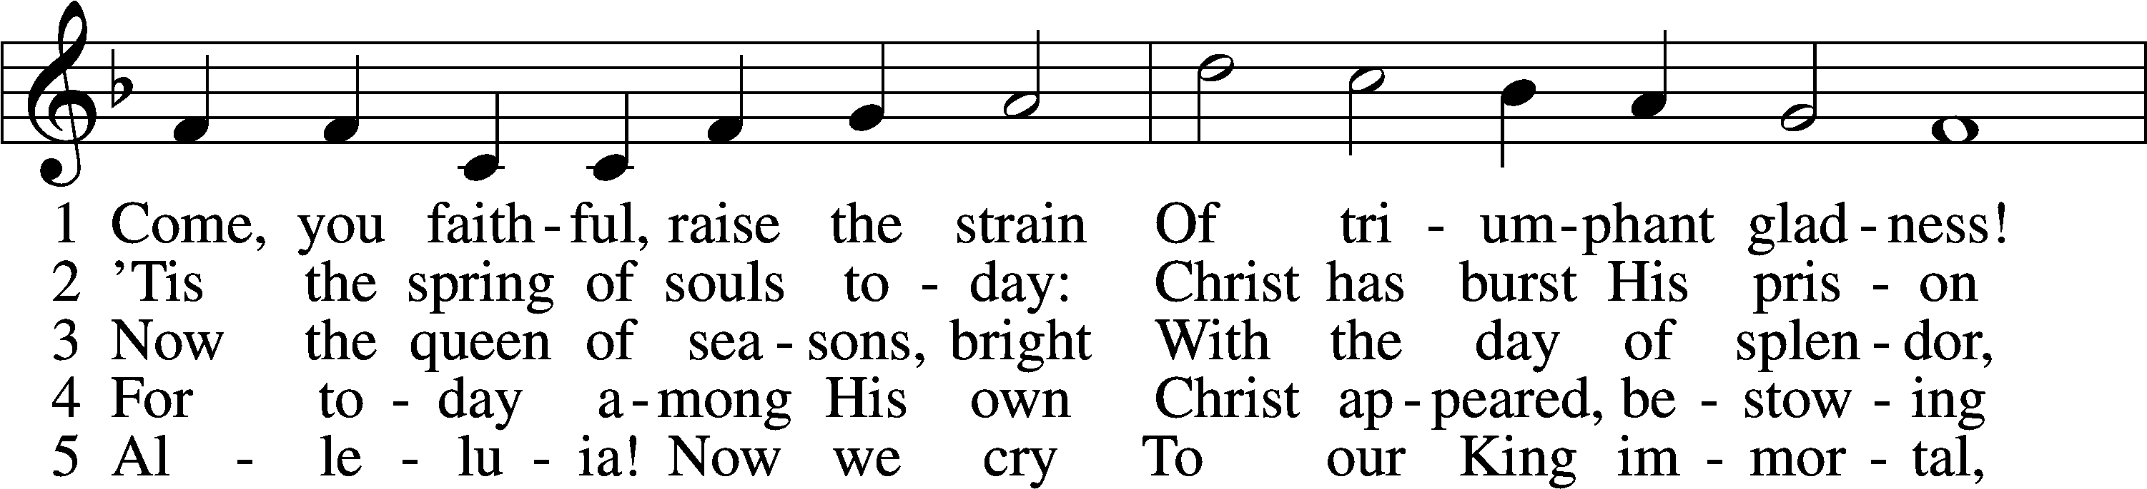
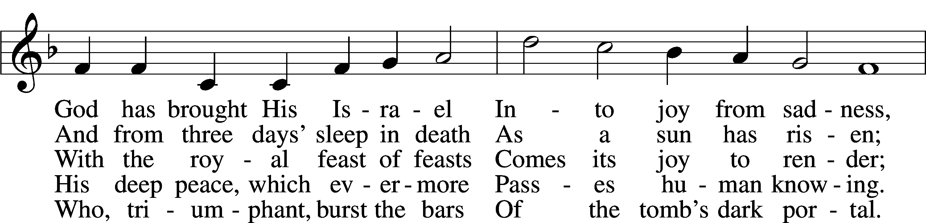
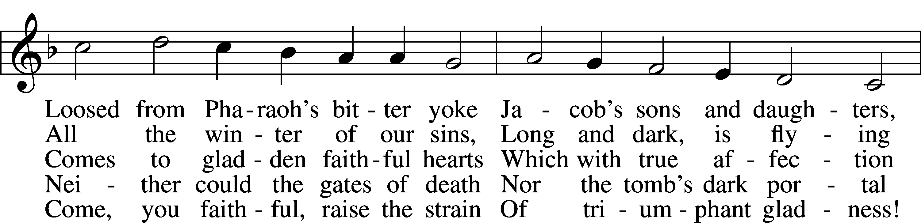
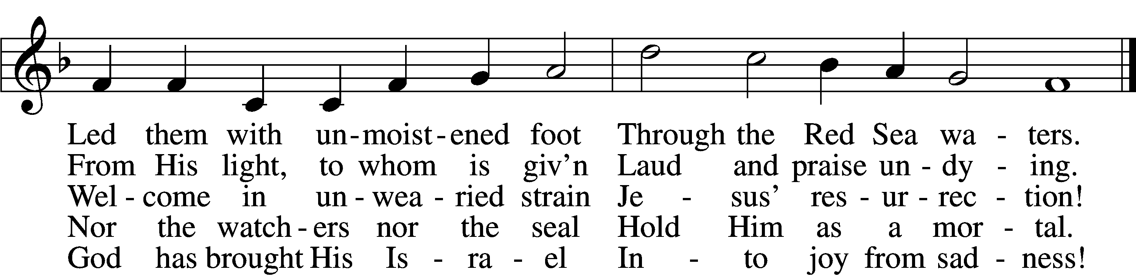
Text: John of Damascus, c. 696–c. 754; tr. John Mason Neale, 1818–66, alt.
Tune: Johann Horn, c. 1490–1547
Text and tune: Public domain

Sermon

Offering and Hymn: Good Christian Friends, Rejoice and Sing LSB 475
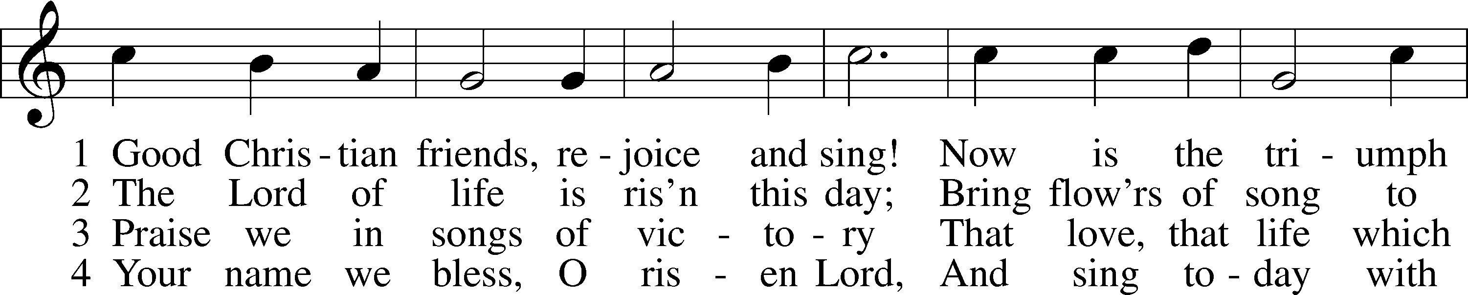
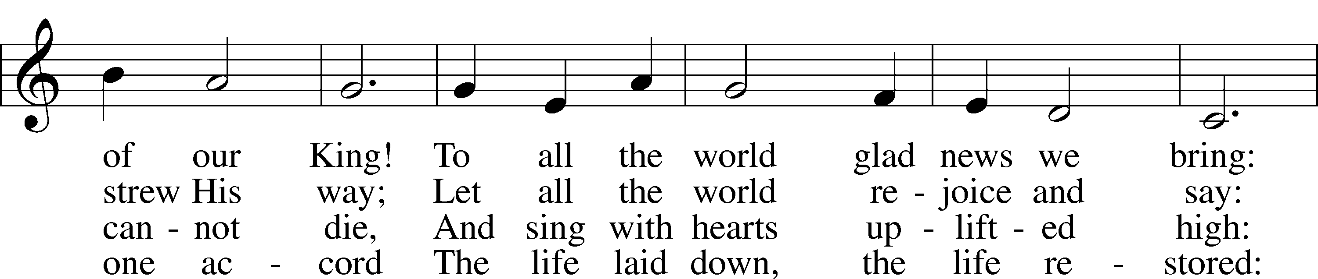
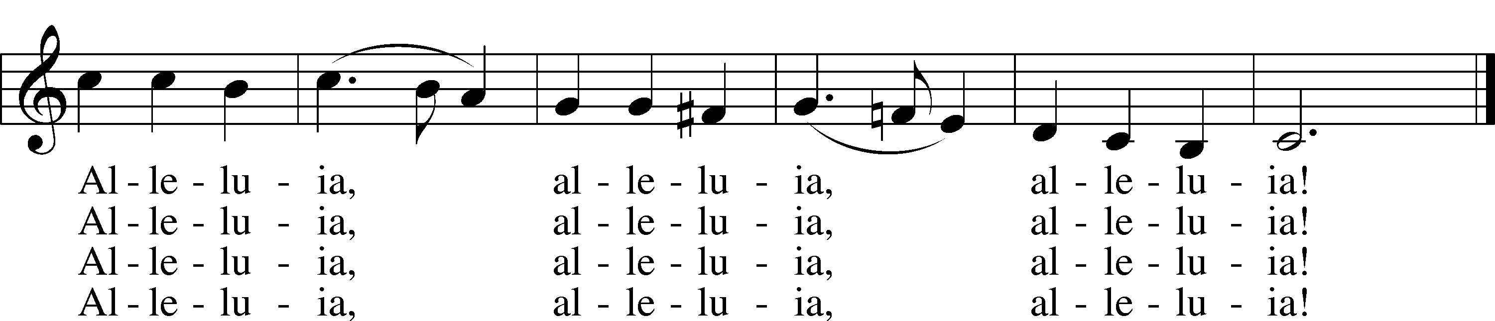
Text: Cyril A. Alington, 1872–1955, alt.
Tune: Melchior Vulpius, c. 1570–1615
Text: © 1958, renewed 1986 Hymns Ancient and Modern Ltd., admin. Hope Publishing Co. Used by permission: LSB Hymn License no. 110005504
Tune: Public domain

Stand

Prayer

Collect of the Day
L Almighty God, through Your only-begotten Son, Jesus Christ, You overcame death and opened to us the gate of everlasting life. We humbly pray that we may live before You in righteousness and purity forever; through the same Jesus Christ, our Lord, who lives and reigns with You and the Holy Spirit, one God, now and forever.
C Amen.

Collect for the Word
L Blessed Lord, You have caused all Holy Scriptures to be written for our learning. Grant that we may so hear them, read, mark, learn, and take them to heart that, by the patience and comfort of Your holy Word, we may embrace and ever hold fast the blessed hope of everlasting life; through Jesus Christ, Your Son, our Lord, who lives and reigns with You and the Holy Spirit, one God, now and forever.
C Amen.

Morning Prayer
C I thank You, my heavenly Father, through Jesus Christ, Your dear Son, that You have kept me this night from all harm and danger; and I pray that You would keep me this day also from sin and every evil, that all my doings and life may please You. For into Your hands I commend myself, my body and soul, and all things. Let Your holy angel be with me, that the evil foe may have no power over me.

New Testament Canticle LSB 266
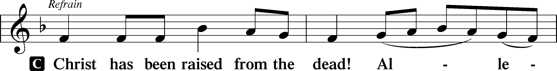
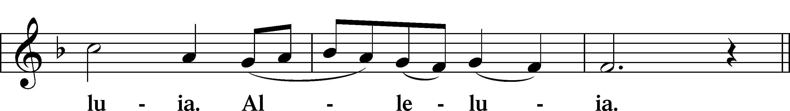
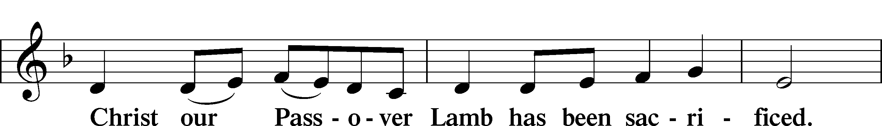
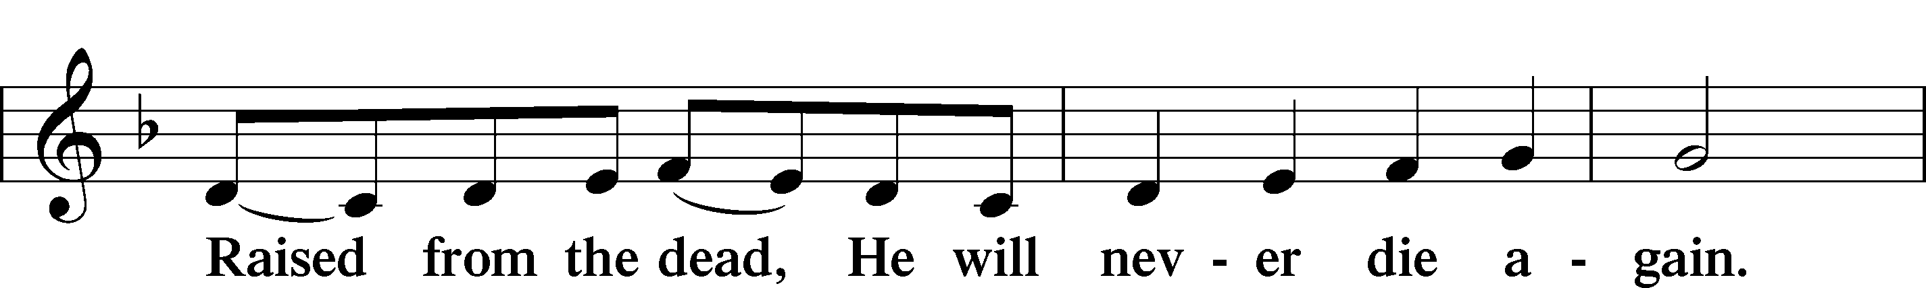
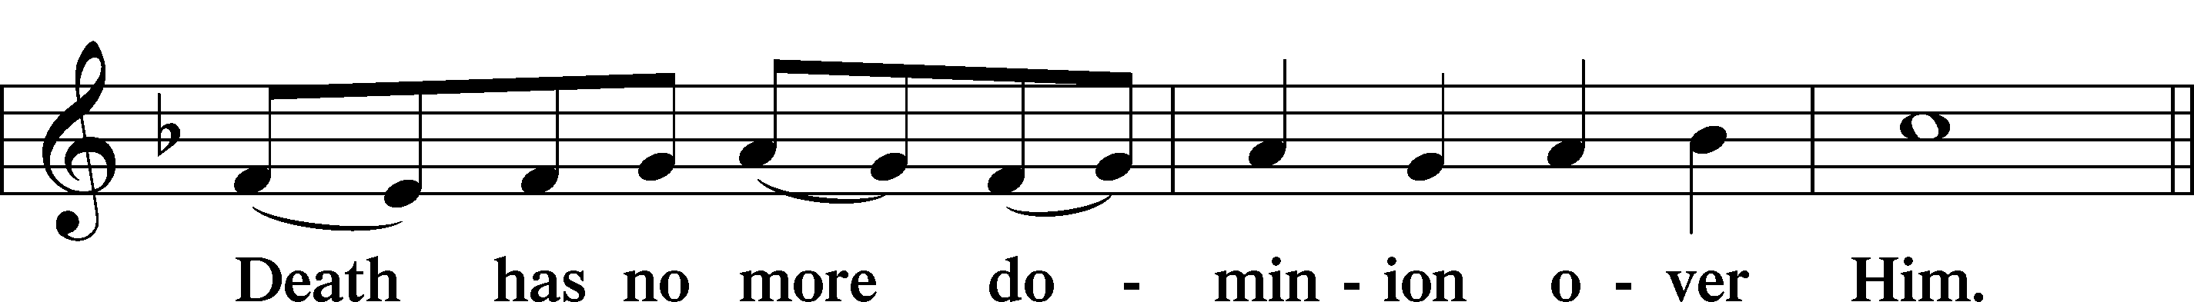
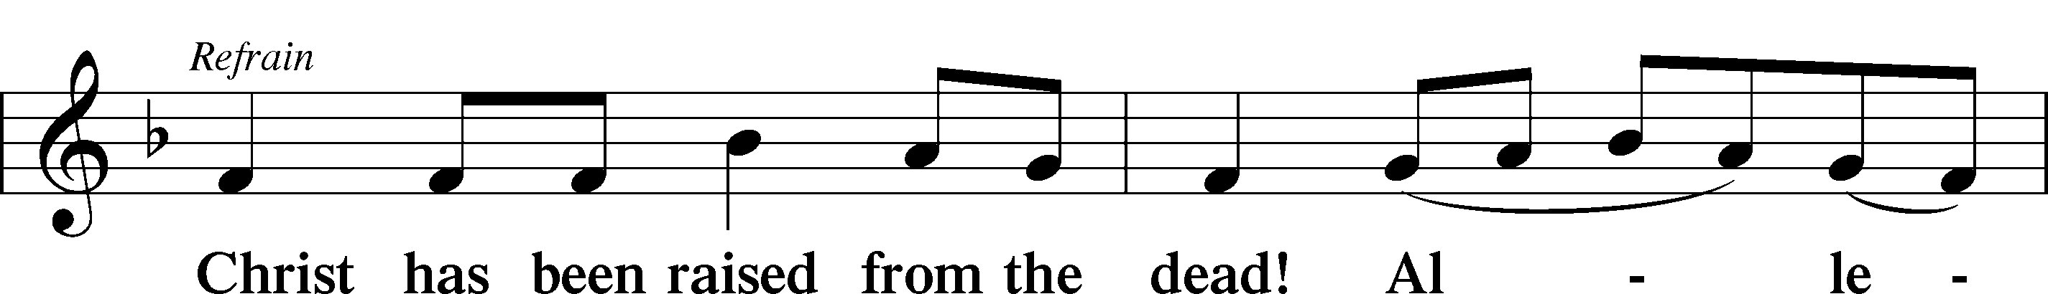
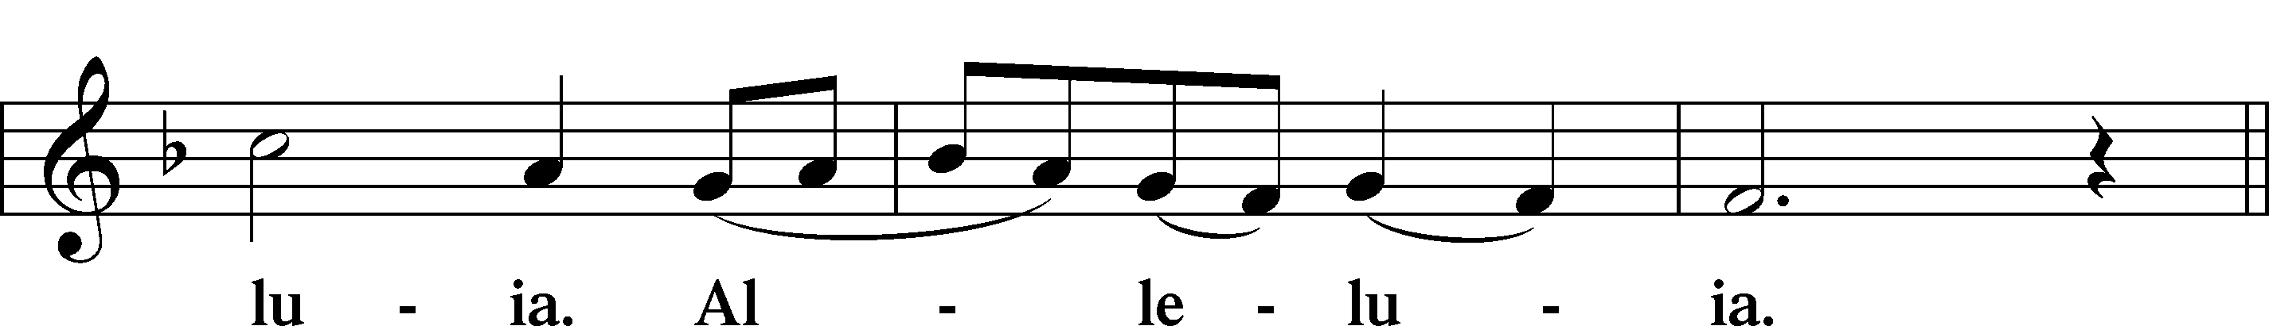
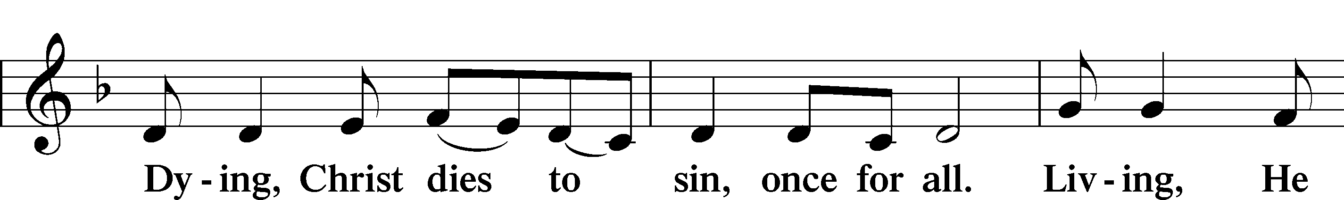
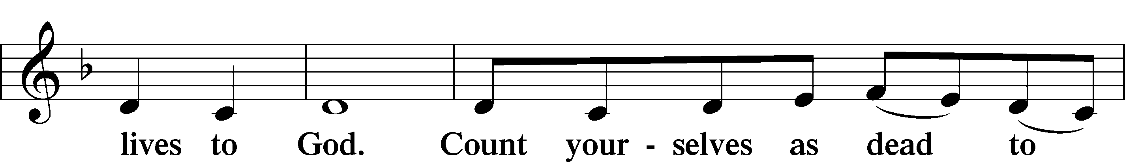
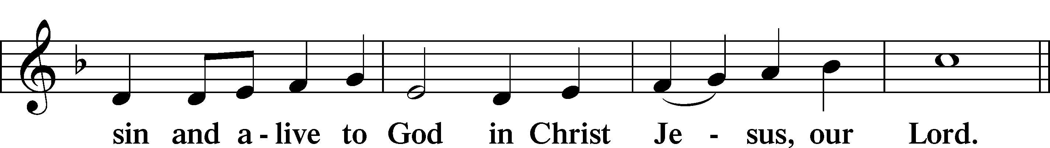
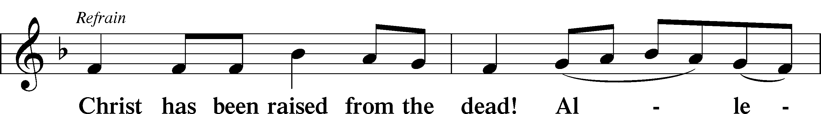
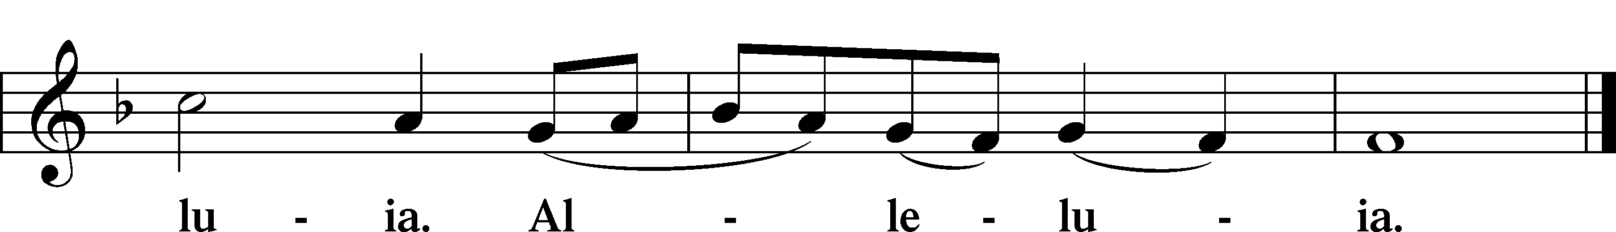

Benedicamus LSB 267
L Let us bless the Lord.
C Thanks be to God.

Benediction LSB 267
L The almighty and merciful Lord, the Father, the T Son, and the Holy Spirit, bless and preserve us.
C Amen.

Hymn: The Strife is O'er The Battle Done LSB 464
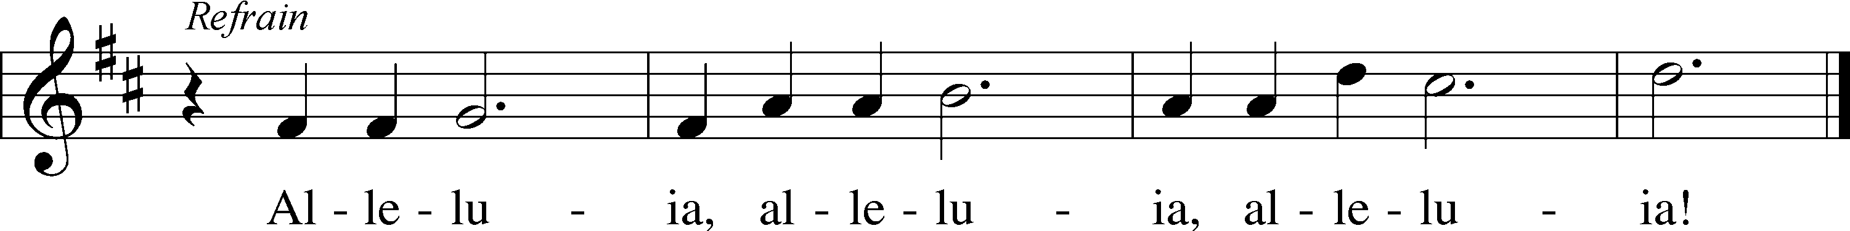
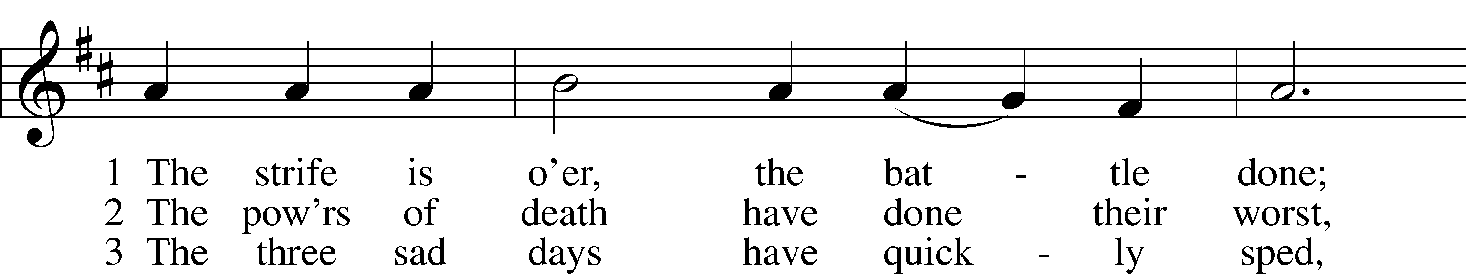
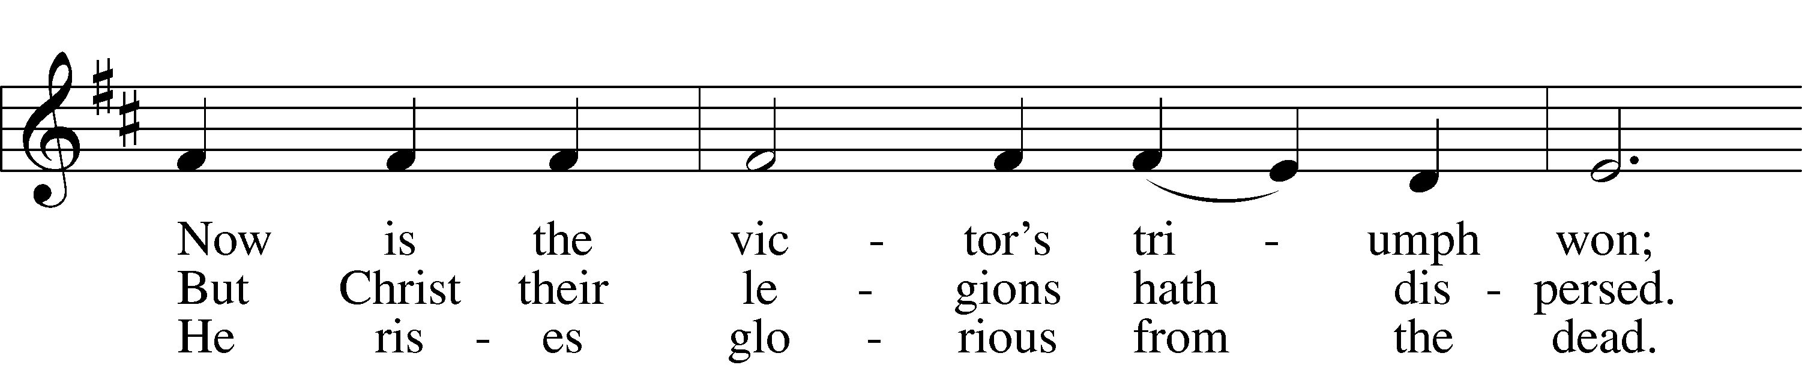
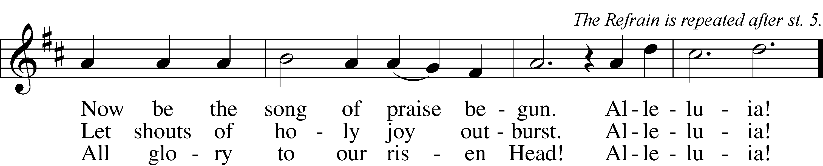

4 He broke the age-bound chains of hell;
The bars from heav’n’s high portals fell.
Let hymns of praise His triumph tell.
Alleluia!

5 Lord, by the stripes which wounded Thee,
From death’s dread sting Thy servants free
That we may live and sing to Thee.
Alleluia! Refrain
Text: Symphonia Sirenum Selectarum, 1695, Köln; tr. Francis Pott, 1832–1909, alt.
Tune: Giovanni P. da Palestrina, c. 1525–1594, adapt.
Text and tune: Public domain

Acknowledgments
Service of Prayer and Preaching from Lutheran Service Book
Unless otherwise indicated, Scripture quotations are from the ESV® Bible (The Holy Bible, English Standard Version®), copyright © 2001 by Crossway, a publishing ministry of Good News Publishers. Used by permission. All rights reserved.
Created by Lutheran Service Builder © 2024 Concordia Publishing House.

Announcements:
Church Service Phone: 888-505-1870/715-438-4200
(Stay on the line for recorded service to start)
Live Stream audio services: http://salem.listentochurch.com
Salem’s Web Page: https://www.salembarron.com/

Pastor Michael Nielsen: Cell phone: 218-280-0999
Email: rev.mike.nielsen@gmail.com
Pastor’s Office Hours: Monday-Wednesday 9-12
Attendance: 3/24 - 89

Coffee and Snacks: Men’s Club
Elder Today: Don Duncan
Altar Guild: MaryAnn Thompson and Kari Longmire

Link to Salem’s Facebook page is:
https://www.facebook.com/SalemEvangelicalLutheranChurchAndPreschool/

Schedule for the upcoming week:
Monday: 7:00 PM – Elder’s Meeting
Tuesday: 8:00 AM Men’s Bible Class
9:30 AM Men’s Club Meeting
Wednesday: 4:00 PM Catechism Class

Save the date:
April 7 – 10:15-11:15 – Jim and Susan Kaiser – Missionaries of LBT
April 7 – 11:30 – Chili and Cookie Contest
April 14 – 10:30 – PreCall Meeting With Pres. Lueck of the North Wisconsin District
April 15 – 6:00 PM – Circuit Lay Leader Meeting @ St. Paul’s Cumberland

A Call Committee is being put together. If you are interested please contact an Elder or Sue in the office.

Member information is on the table in the fellowhip hall, please look at it and update your information if needed.

Pastor Fred Buth will be our vacancy pastor.
He can be contacted at salembarronpastor@gmail.com or 1-715-353-2540

Pastor Nielsen’s new address is 108 Cecilia Ct. Waukesha, WI 53188 as of April 3, 2024

We are still looking for a Director for the VBS program, prayerfully consider this.

Prayer requests:

Those in the nursing home: Joann Jaeger
Those Shut-in at home: Char Herman, Joan Church, Joyce Myers, Joyce Koba
Those with ongoing health issues: Harrison Fields, Jeanne Perala, Owen Metz, Kathy Nielsen (Pastor’s aunt), Jeff Bonneville, Daria (Cindy Wright’s friend), Butch L. (Cindy Wright’s Brother-in-law), Melissa Miller., Dale Bryan, Art Smith (Sue Millerman’s brother), Brenda Sellent (Denise Stabenow’s sister), Sandy Hahn (Cindy Wright’s cousin’s wife), Wayne Hahn (Cindy Wright’s Uncle)
Recovering from surgery: Wyatt Weise, Gail Espeseth
For Pastor Nielsen and family as they begin the transition to St. John’s North Prairie.
For Salem and St. John’s in their transitions of ministry.
Those who lead our nation: Joe Biden, Kamala Harris, Tony Evers, Rod Nordby
Those who serve in our military and law enforcement: Ryan Graf, Chaplain Pon Chanthaphon (Our Adopt-a-Chaplain), Rusty Weise

Our Childcare Staff: Melissa Weinert, Denise Stabenow, Katelyn Hendren, Holly Wilhelmi, Janica Skjerly, Jacie Amundson, Emily Young, Zuri Soto

For Christ Community Lutheran School – For Community Support for CCLS
Families of the Week: John Ladwig, Freida Lentz, Tom and Deb Lipke, Duane and Kari Longmire, Mahlon and Barb Maas

Mission Statement
The Mission of Salem Lutheran Church is to be what God called us to be through faith in Jesus Christ, a body of believers engaged in building the Kingdom of God by discipling the Barron area with His Word and Sacrament ministry.

