Good Friday
March 29, 2024
12 Noon and 6:30 PM

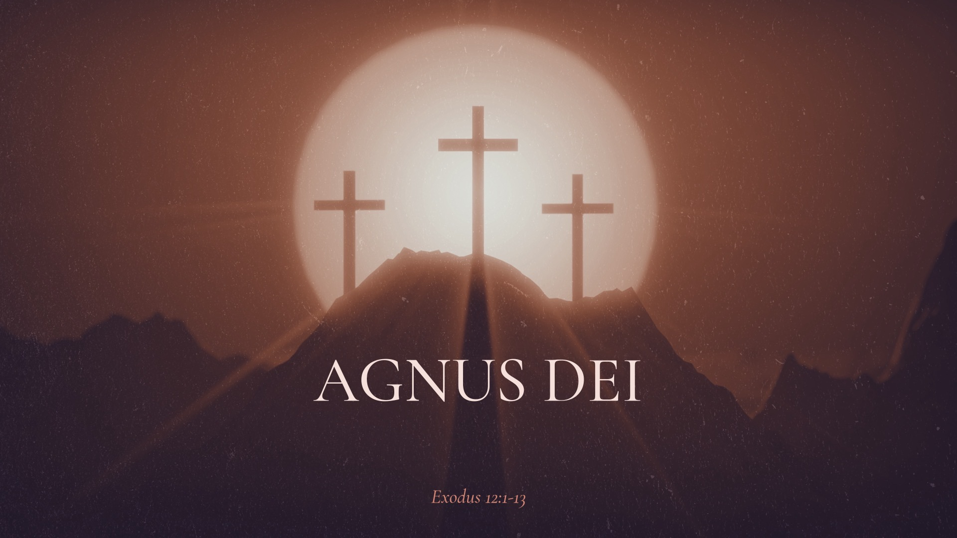

Salem Lutheran Church
1-715-537-3011
http://www.salembarron.com
rev.mike.nielsen@gmail.com

Good Friday Theme: From 1635 to 1640 a Spanish artist named Francisco de Zurbarán created a painting and called it Agnus Dei—that’s Latin for “Lamb of God.” de Zurbarán’s masterpiece points us to the wonder and awe of Jesus, the Lamb of God who takes away the sin of the world.

WORSHIP NOTES

The Order of Tenebrae is an early Christian worship service utilized in the observance of Good Friday. “Tenebrae” is Latin for “darkness” or “in the shadows,” and the service is characterized by the gradual removal of light from the sanctuary as the scriptural accounts are read, describing the death of our Lord. Tenebrae is not a funeral service for Jesus, but rather a time of repentance as we consider his love for us.

As the last candle is removed, noting the death of our Savior, a loud sound is heard. This represents that point in history when the tomb was closed. Following the silent prayer at the close of the service, worshippers will depart. We ask that there be no speaking until you have left the church grounds. We return to our homes in contemplation of the meaning of Christ's death for us and in the certain hope of the Easter victory soon to be celebrated.

As Christ’s crucifixion is commemorated on Good Friday, altar paraments, the pastor’s alb as well as the shrouds are black, symbolizing humiliation, mourning and death.

Silent Procession

Reading of the Psalm Psalm 80
P: Turn us again to yourself, O God Almighty.
C: Make your face shine upon us.
P: Only then will we be saved.
C: You brought Israel from Egypt like a grapevine.
P: You drove away the nations and transplanted them into your land.
C: You cleared the ground for your people.
P: They took root and filled the land.
C: But now, our walls are broken down.
P: The wild boar from the forest devours it, and the wild animals feed on it.
C: Make your face shine upon us.
P: Look from heaven and see our plight. Take care of this grapevine
C: Turn us again to yourself, O God Almighty.
P: Make your face shine upon us.
All: Only then will we be saved.

Hymn: How Great the Cross OAR 245
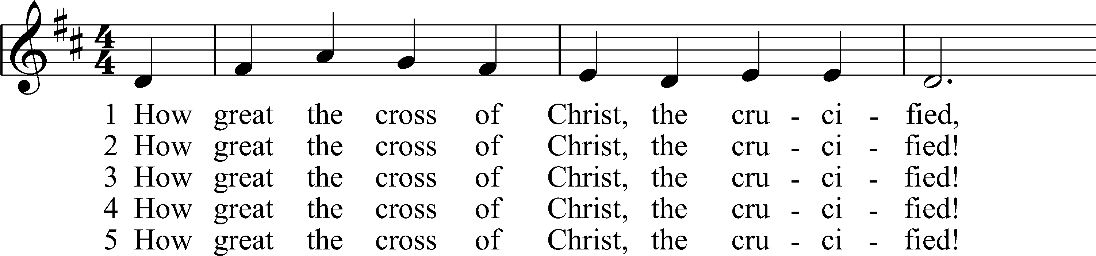
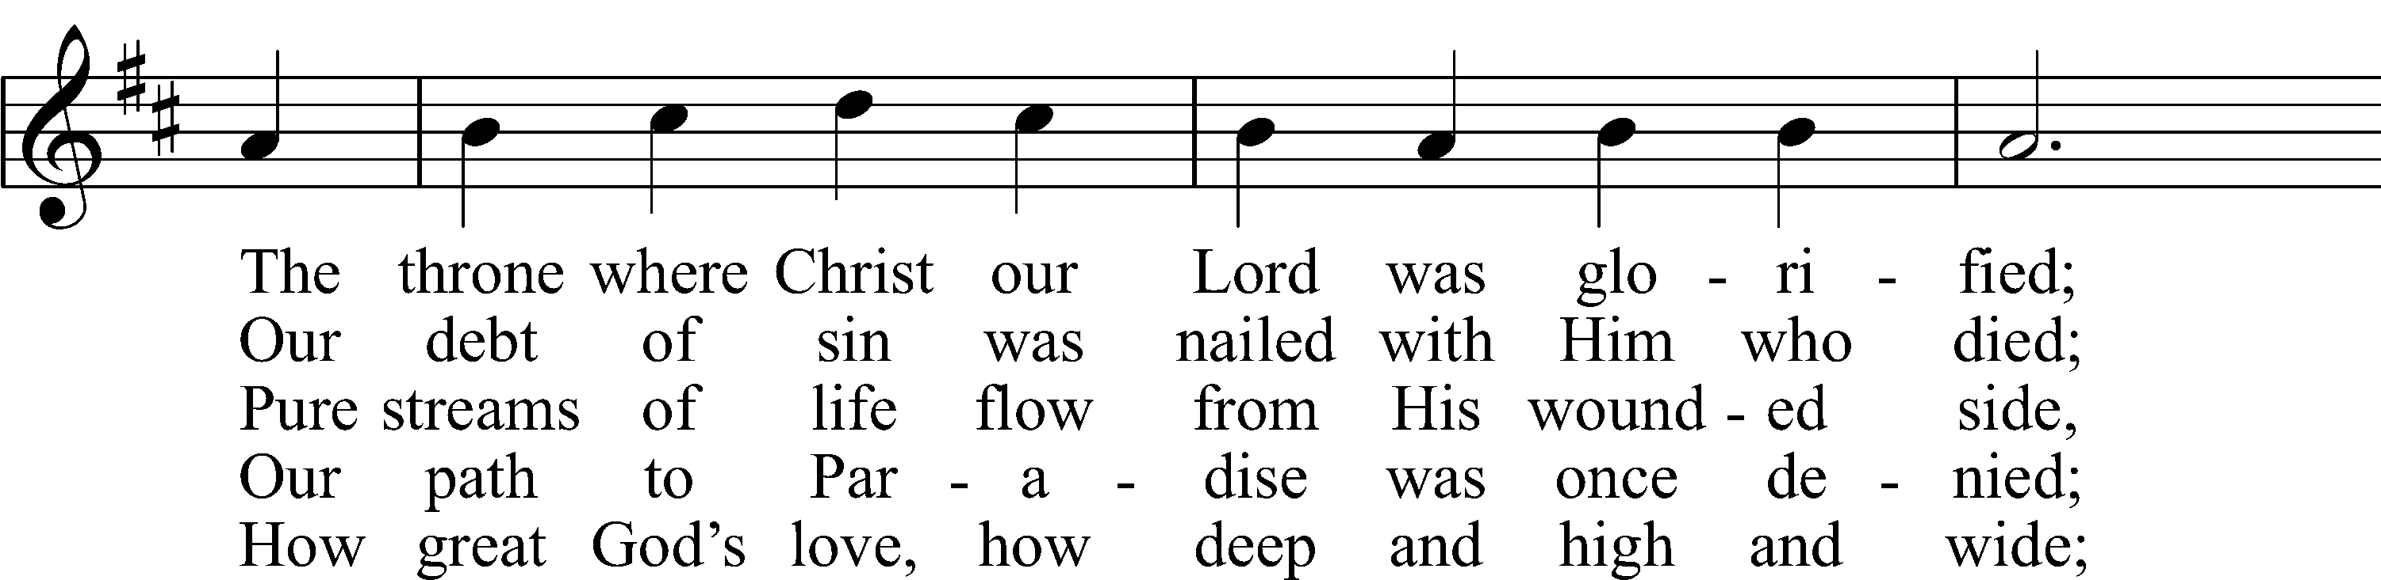
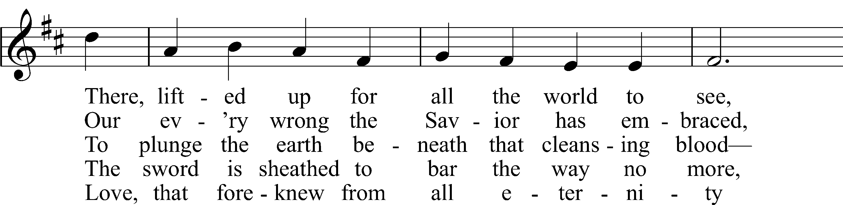
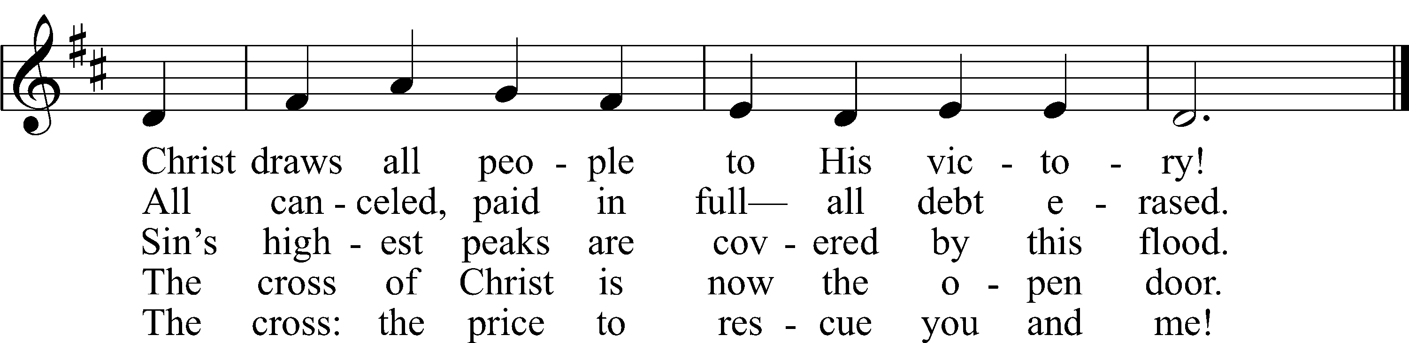
Text: Stephen P. Starke, b. 1955
Tune: Alfred M. Smith, 1879–1971
Text: © 1997 Stephen P. Starke, admin. Concordia Publishing House. Used by permission: OAR Hymn License no. 110005504
Tune: © 1990 Church of the Ascension, Atlantic City, N.J. Used by permission: OAR Hymn License no. 110005504

Salutation
P The Lord be with you.
C And also with you.

Prayer
P Almighty God, graciously behold this Your family for whom our Lord Jesus Christ was willing to be betrayed and delivered into the hands of sinful men to suffer death upon the cross; through the same Jesus Christ, Your Son, our Lord, who lives and reigns with You and the Holy Spirit, one God, now and forever.
C Amen.

Reading Exodus 12:1–13
1The Lord said to Moses and Aaron in the land of Egypt, 2“This month shall be for you the beginning of months. It shall be the first month of the year for you. 3Tell all the congregation of Israel that on the tenth day of this month every man shall take a lamb according to their fathers’ houses, a lamb for a household. 4And if the household is too small for a lamb, then he and his nearest neighbor shall take according to the number of persons; according to what each can eat you shall make your count for the lamb. 5Your lamb shall be without blemish, a male a year old. You may take it from the sheep or from the goats, 6and you shall keep it until the fourteenth day of this month, when the whole assembly of the congregation of Israel shall kill their lambs at twilight.
7“Then they shall take some of the blood and put it on the two doorposts and the lintel of the houses in which they eat it. 8They shall eat the flesh that night, roasted on the fire; with unleavened bread and bitter herbs they shall eat it. 9Do not eat any of it raw or boiled in water, but roasted, its head with its legs and its inner parts. 10And you shall let none of it remain until the morning; anything that remains until the morning you shall burn. 11In this manner you shall eat it: with your belt fastened, your sandals on your feet, and your staff in your hand. And you shall eat it in haste. It is the Lord’s Passover. 12For I will pass through the land of Egypt that night, and I will strike all the firstborn in the land of Egypt, both man and beast; and on all the gods of Egypt I will execute judgments: I am the Lord. 13The blood shall be a sign for you, on the houses where you are. And when I see the blood, I will pass over you, and no plague will befall you to destroy you, when I strike the land of Egypt.

A This is the Word of the Lord.
C Thanks be to God.

Reading 1 Corinthians 1:18–23
18For the word of the cross is folly to those who are perishing, but to us who are being saved it is the power of God. 19For it is written,
“I will destroy the wisdom of the wise,
and the discernment of the discerning I will thwart.”
20Where is the one who is wise? Where is the scribe? Where is the debater of this age? Has not God made foolish the wisdom of the world? 21For since, in the wisdom of God, the world did not know God through wisdom, it pleased God through the folly of what we preach to save those who believe. 22For Jews demand signs and Greeks seek wisdom, 23but we preach Christ crucified, a stumbling block to Jews and folly to Gentiles,

A This is the Word of the Lord.
C Thanks be to God.

Hymn: Sing, My Tongue the Glorious Battle LSB 454
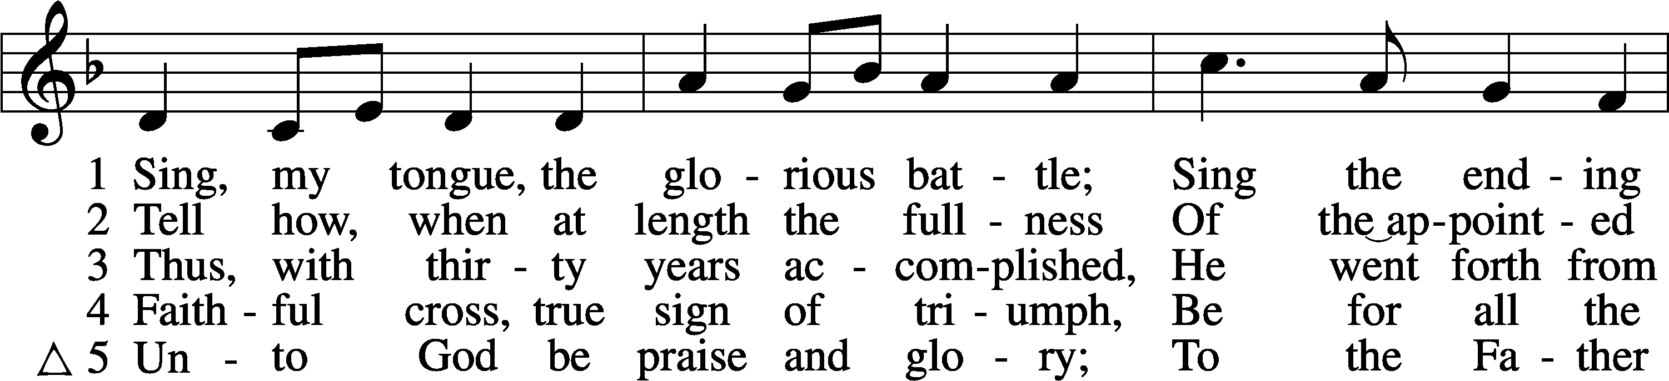
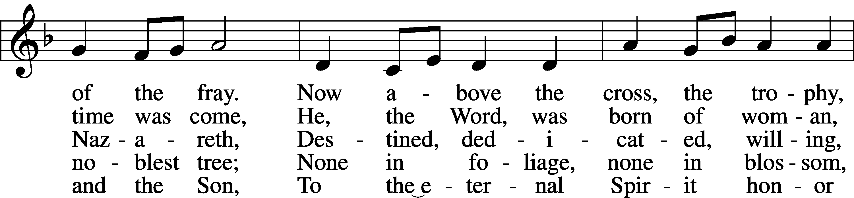
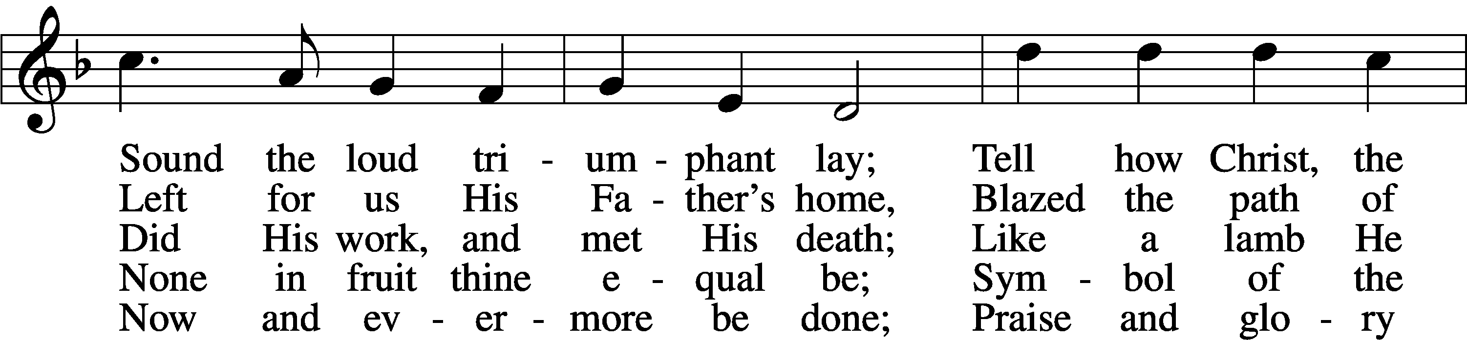
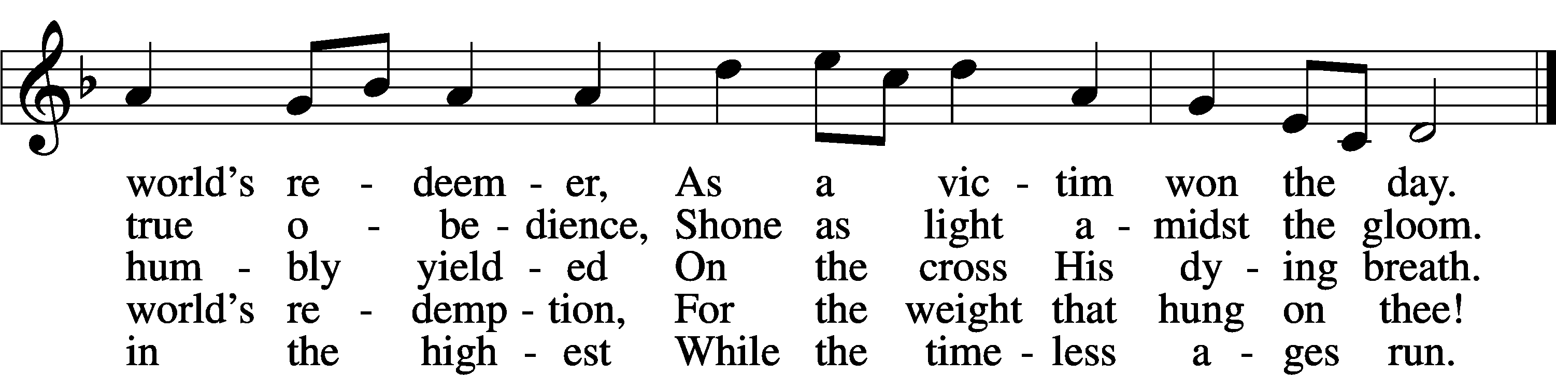
Text: Venantius Honorius Fortunatus, c. 530–609; tr. John Mason Neale, 1818–66, alt.
Tune: Carl F. Schalk, 1929
Text: Public domain
Tune: © 1967 Concordia Publishing House. Used by permission: LSB Hymn License no. 110005504

Sermon: Agnus Dei Text: Exodus 12:1-13

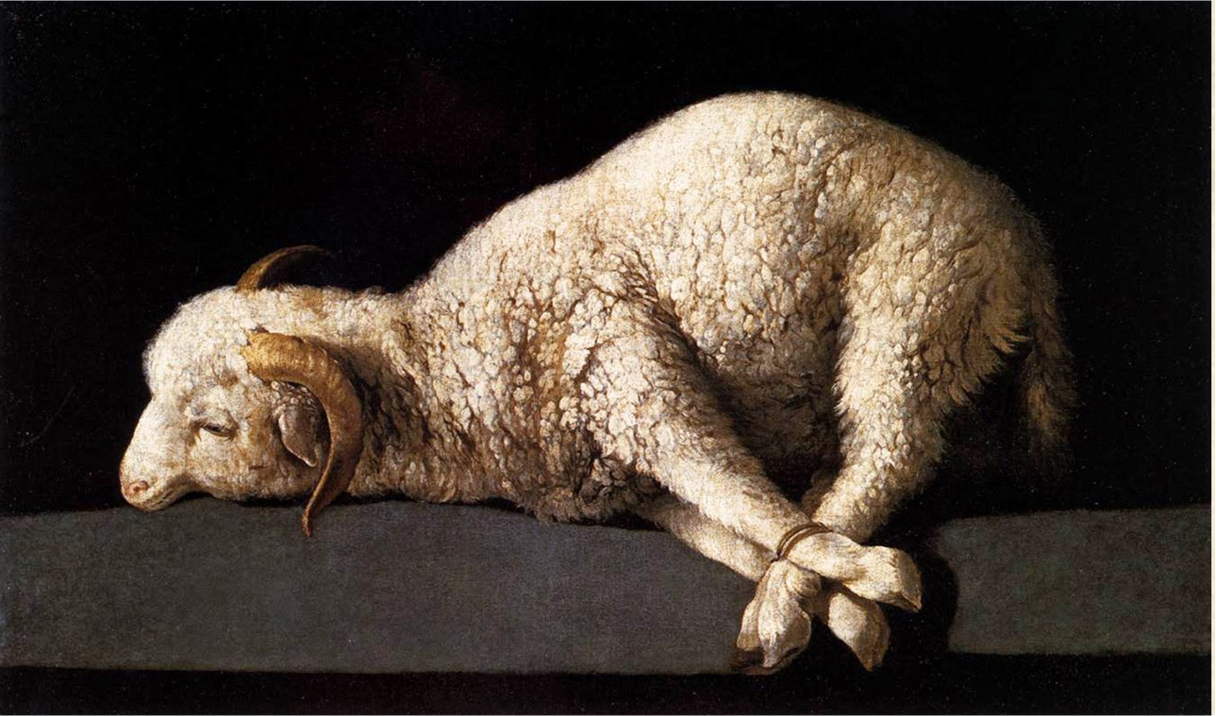

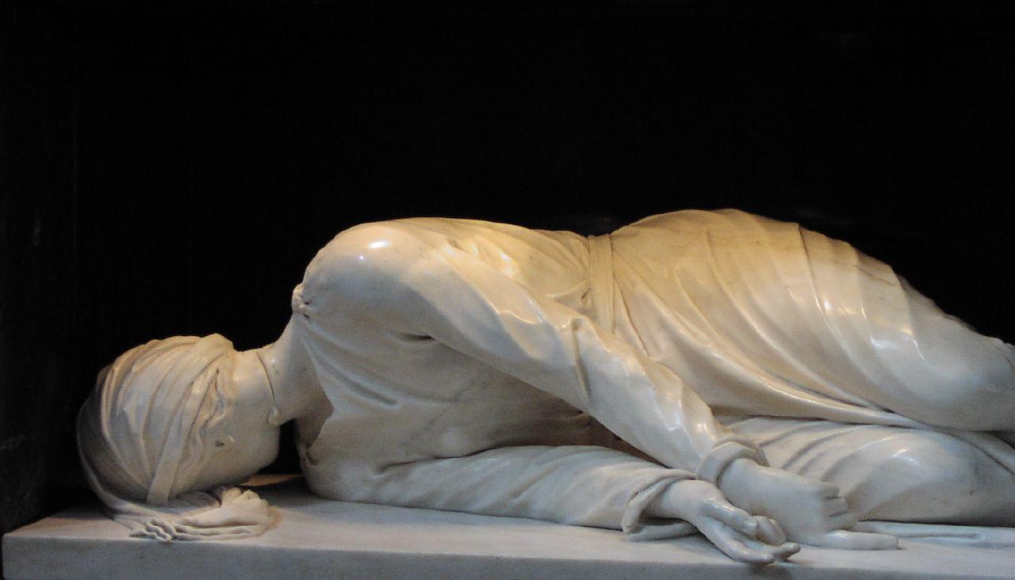

Apostles’ Creed
C I believe in God, the Father Almighty, maker of heaven and earth.

And in Jesus Christ, His only Son, our Lord, who was conceived by the Holy Spirit, born of the virgin Mary, suffered under Pontius Pilate, was crucified, died and was buried. He descended into hell. The third day He rose again from the dead. He ascended into heaven and sits at the right hand of God the Father Almighty. From thence He will come to judge the living and the dead.

I believe in the Holy Spirit, the holy Christian Church, the communion of saints, the forgiveness of sins, the resurrection of the body, and the life T everlasting. Amen.

Prayer
A Let us pray for the whole Christian Church, that our Lord God would defend her against all the assaults and temptations of the adversary and keep her perpetually on the true foundation, Jesus Christ:
P Almighty and everlasting God, since You have revealed Your glory to all nations in Jesus Christ and in the Word of His truth, keep, we ask You, in safety the works of Your mercy so that Your Church, spread throughout all the nations, may be defended against the adversary and may serve You in true faith and persevere in the confession of Your name; through Jesus Christ, our Lord.
C Amen.

A Let us pray for all the ministers of the Word, for all vocations in the Church, and for all the people of God:
P Almighty and everlasting God, by whose Spirit the whole body of the Church is governed and sanctified, receive the supplications and prayers which we offer before You for all Your servants in Your holy Church that every member of the same may truly serve You according to Your calling; through Jesus Christ, our Lord.
C Amen.

A Let us pray for our catechumens, that our Lord God would open their hearts and the door of His mercy that, having received the remission of all their sins by the washing of regeneration, they may be mindful of their Baptism and evermore be found in Christ Jesus, our Lord:
P Almighty God and Father, because You always grant growth to Your Church, increase the faith and understanding of our catechumens that, rejoicing in their new birth by the water of Holy Baptism, they may forever continue in the family of those whom You adopt as Your sons and daughters; through Jesus Christ, our Lord.
C Amen.

A Let us pray for all in authority that we may lead a quiet and peaceable life in all godliness and honesty:
P O merciful Father in heaven, because You hold in Your hand all the might of man and because You have ordained, for the punishment of evildoers and for the praise of those who do well, all the powers that exist in all the nations of the world, we humbly pray You graciously to regard Your servants, especially [name], our President; the Congress of the United States; [name], our Governor; and all those who make, administer, and judge our laws; that all who receive the sword as Your ministers may bear it according to Your Word; through Jesus Christ, our Lord.
C Amen.

A Let us pray our Lord God Almighty that He would deliver the world from all error, take away disease, ward off famine, set free those in bondage, and grant health to the sick and a safe journey to all who travel:
P Almighty and everlasting God, the consolation of the sorrowful and the strength of the weak, may the prayers of those who in any tribulation or distress cry to You graciously come before You, so that in all their necessities they may rejoice in Your manifold help and comfort; through Jesus Christ, our Lord.
C Amen.

A Let us pray for all who are outside the Church, that our Lord God would be pleased to deliver them from their error, call them to faith in the true and living God and His only Son, Jesus Christ, our Lord, and gather them into His family, the Church:
P Almighty and everlasting God, because You seek not the death but the life of all, hear our prayers for all who have no right knowledge of You, free them from their error, and for the glory of Your name bring them into the fellowship of Your holy Church; through Jesus Christ, our Lord.
C Amen.

A Let us pray for peace, that we may come to the knowledge of God’s holy Word and walk before Him as is fitting for Christians:
P Almighty and everlasting God, King of Glory, and Lord of heaven and earth, by whose Spirit all things are governed, by whose providence all things are ordered, the God of peace and the author of all concord, grant us, we implore You, Your heavenly peace and concord that we may serve You in true fear, to the praise and glory of Your name; through Jesus Christ, our Lord.
C Amen.

A Let us pray for our enemies, that God would remember them in mercy and graciously grant them such things as are both needful for them and profitable for their salvation:
P O almighty, everlasting God, through Your only Son, our blessed Lord, You have commanded us to love our enemies, to do good to those who hate us, and to pray for those who persecute us. We therefore earnestly implore You that by Your gracious visitation all our enemies may be led to true repentance and may have the same love and be of one accord and one mind and heart with us and with Your whole Christian Church; through Jesus Christ, our Lord.
C Amen.

A Let us pray for the fruits of the earth, that God would send down His blessing upon them and graciously dispose our hearts to enjoy them according to His own good will:
P O Lord, Father Almighty, by Your Word You created and You continue to bless and uphold all things. We pray You so to reveal to us Your Word, our Lord Jesus Christ that, through His dwelling in our hearts, we may by Your grace be made ready to receive Your blessing on all the fruits of the earth and whatsoever pertains to our bodily need; through Jesus Christ, our Lord.
C Amen.

The Tenebrae Sequence

Hymn: Jesus I Will Ponder Now LSB 440
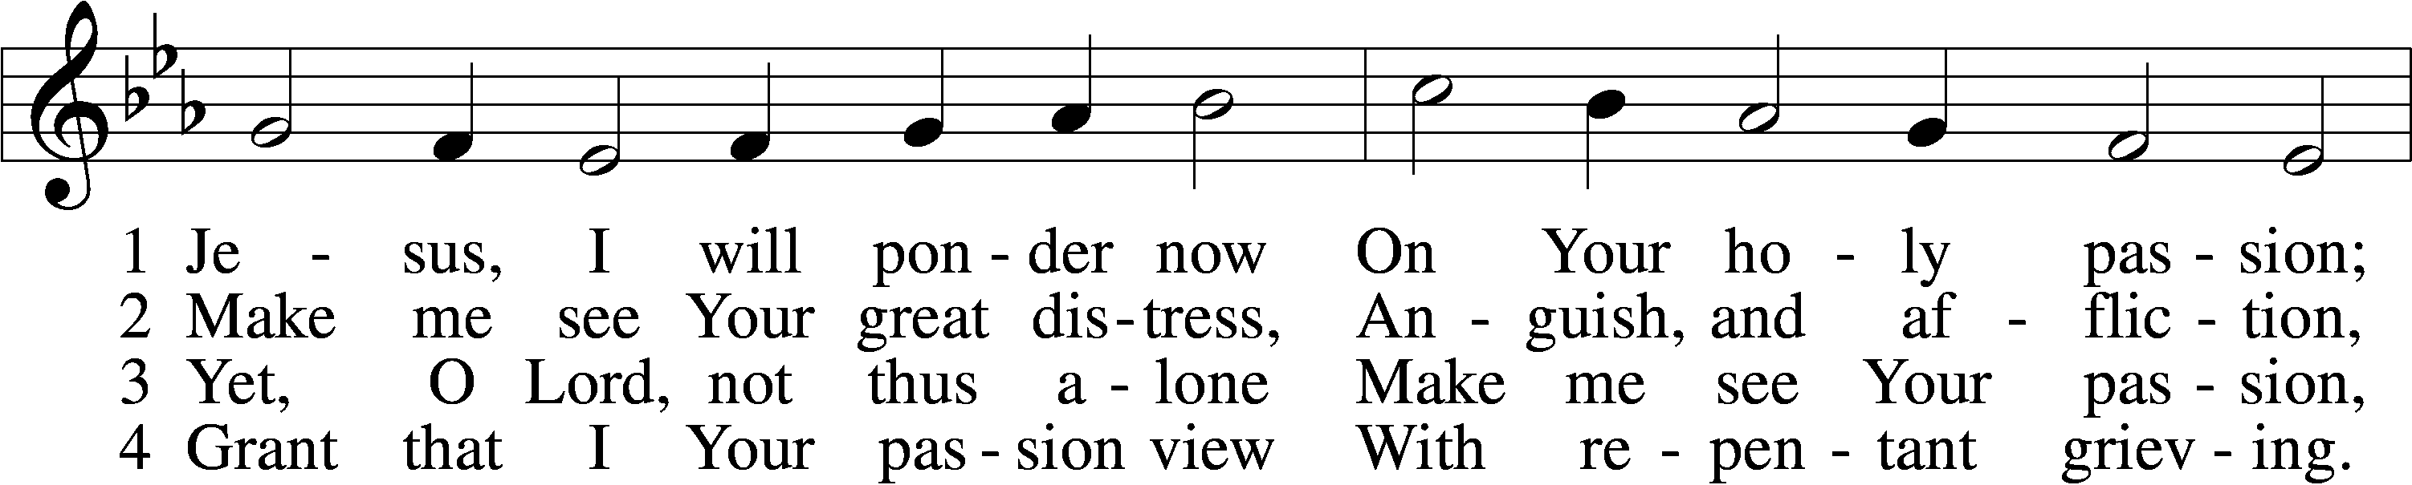
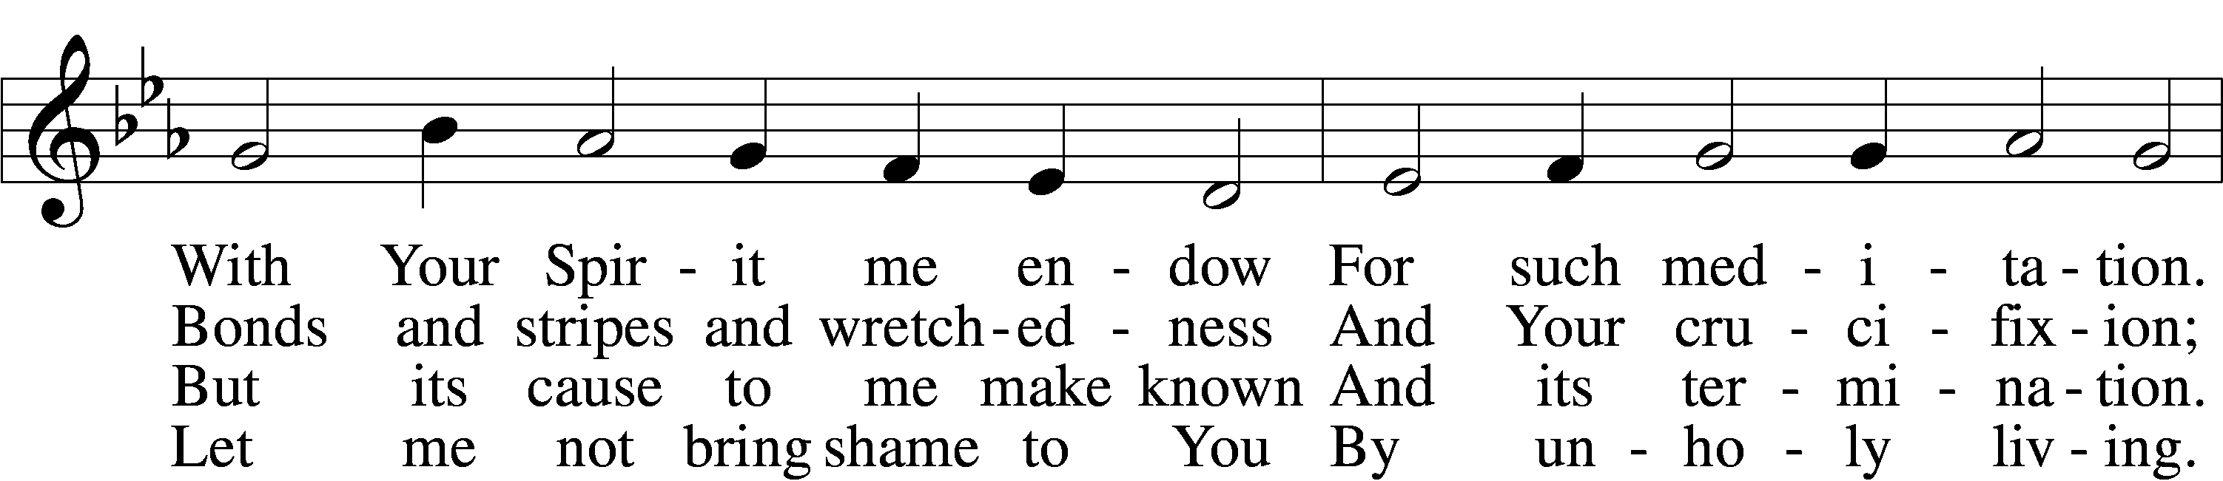
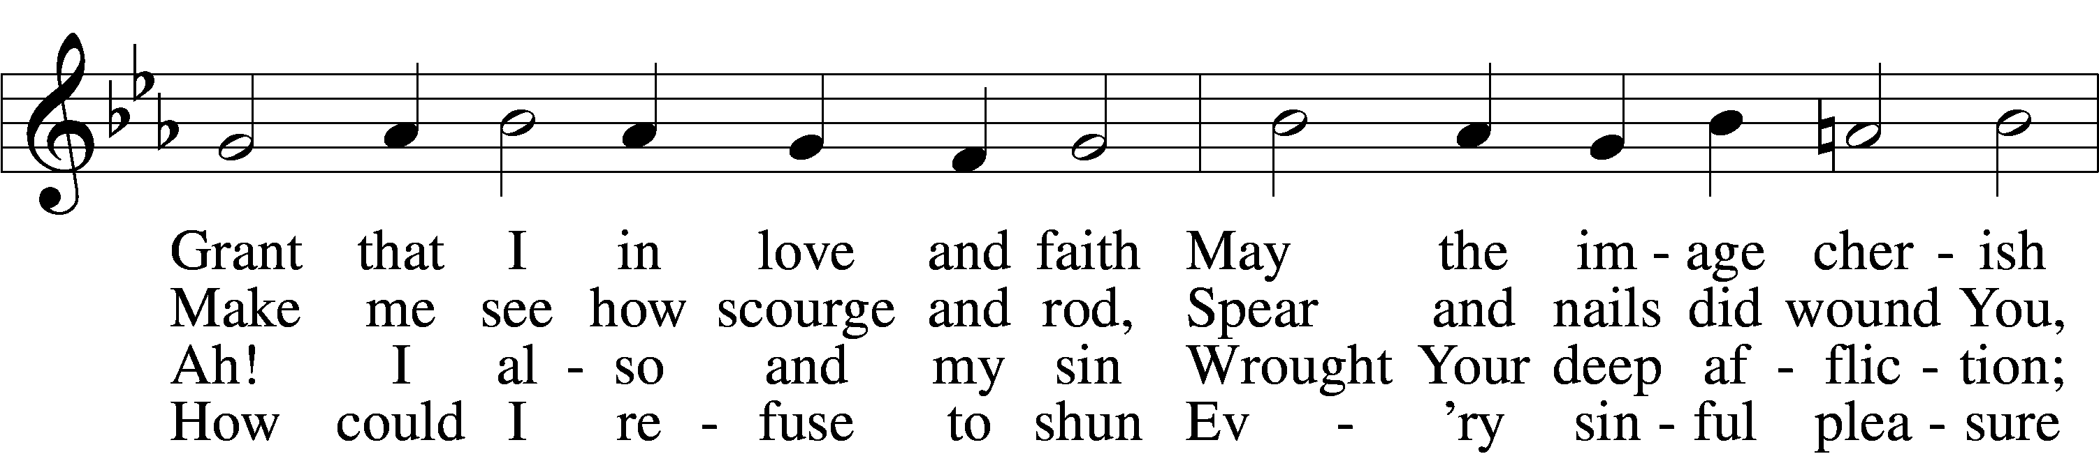
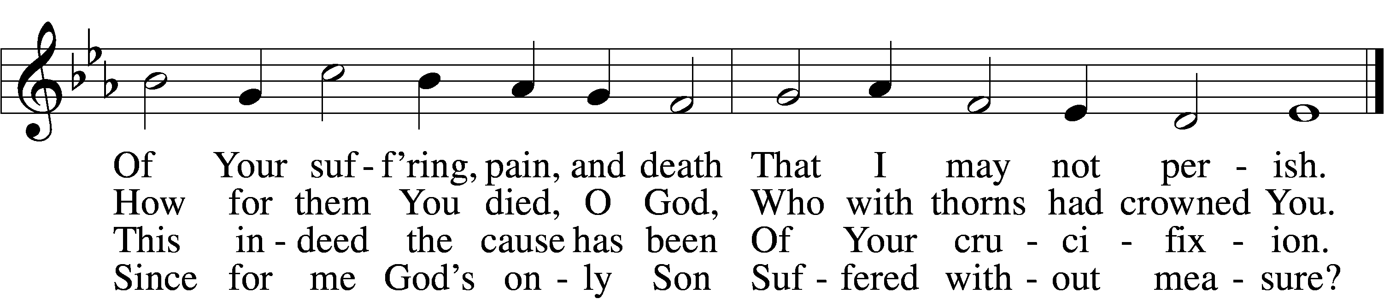

5 If my sins give me alarm
And my conscience grieve me,
Let Your cross my fear disarm;
Peace of conscience give me.
Help me see forgiveness won
By Your holy passion.
If for me He slays His Son,
God must have compassion!

6 Graciously my faith renew;
Help me bear my crosses,
Learning humbleness from You,
Peace mid pain and losses.
May I give You love for love!
Hear me, O my Savior,
That I may in heav’n above
Sing Your praise forever.
Text: Sigismund von Birken, 1626–81; tr. August Crull, 1845–1923, alt.
Tune: Melchior Vulpius, c. 1570–1615
Text and tune: Public domain

The First Word: The Word of Forgiveness Luke 23:33–38
33And when they came to the place that is called The Skull, there they crucified him, and the criminals, one on his right and one on his left. 34And Jesus said, “Father, forgive them, for they know not what they do.” And they cast lots to divide his garments. 35And the people stood by, watching, but the rulers scoffed at him, saying, “He saved others; let him save himself, if he is the Christ of God, his Chosen One!” 36The soldiers also mocked him, coming up and offering him sour wine 37and saying, “If you are the King of the Jews, save yourself!” 38There was also an inscription over him, “This is the King of the Jews.”

Hymn: 447 Jesus, in Your Dying Woes sts. 1–3
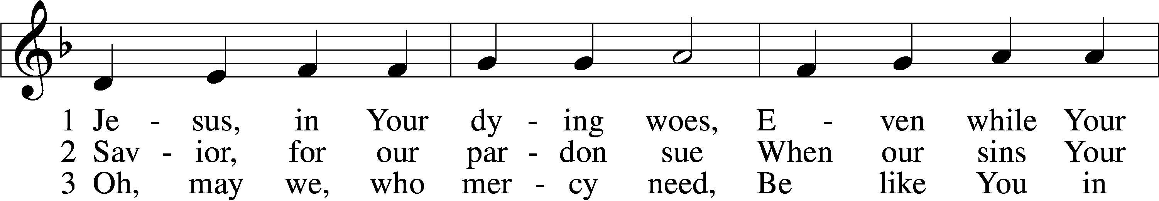
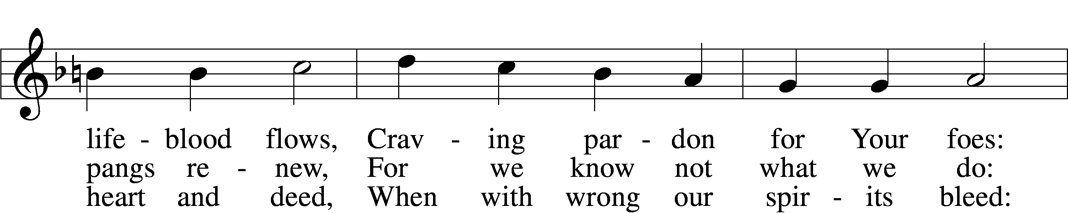
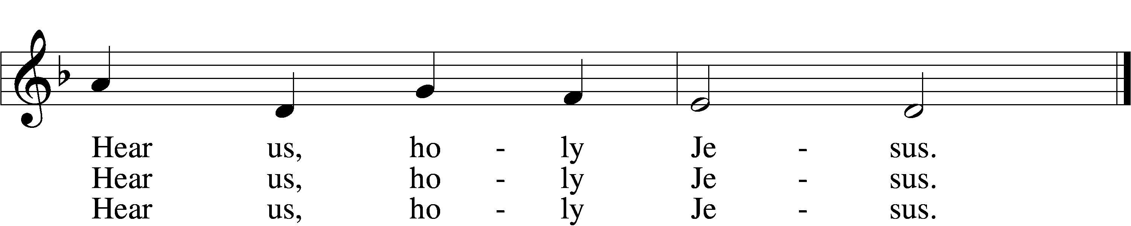
Text: Thomas B. Pollock, 1836–96, alt.
Tune: Bernhard Schumacher, 1886–1978
Text: Public domain
Tune: © 1941 Concordia Publishing House. Used by permission: LSB Hymn License no. 110005504

The First Candle is Extinguished 6:30 PM Only

The Second Word: The Word of Promise Luke 23:39–43
39One of the criminals who were hanged railed at him, saying, “Are you not the Christ? Save yourself and us!” 40But the other rebuked him, saying, “Do you not fear God, since you are under the same sentence of condemnation? 41And we indeed justly, for we are receiving the due reward of our deeds; but this man has done nothing wrong.” 42And he said, “Jesus, remember me when you come into your kingdom.” 43And he said to him, “Truly, I say to you, today you will be with me in Paradise.”

Hymn: 456 Were You There sts. 1–2
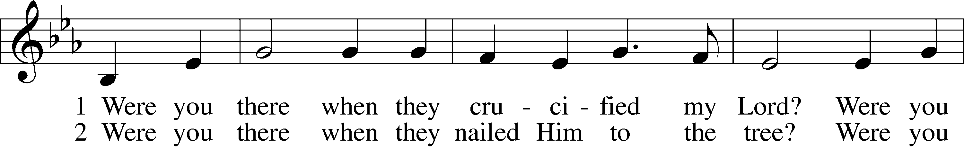
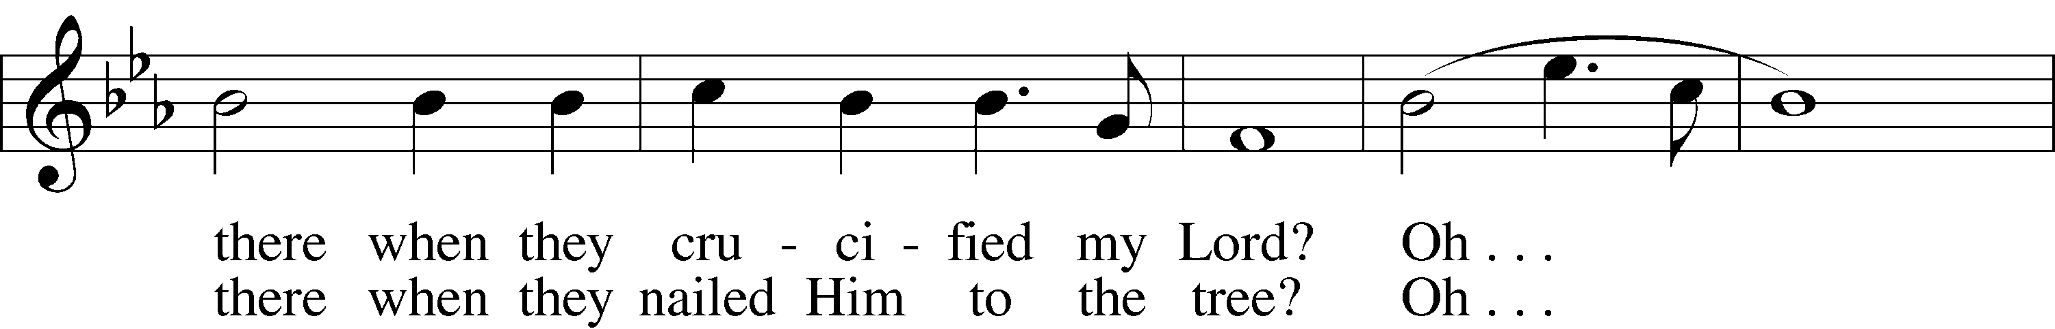
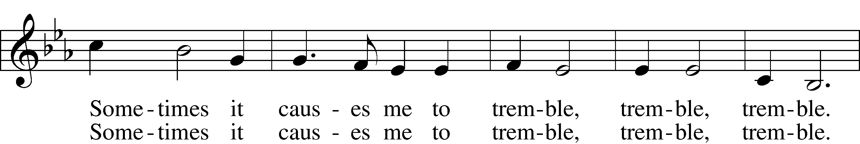
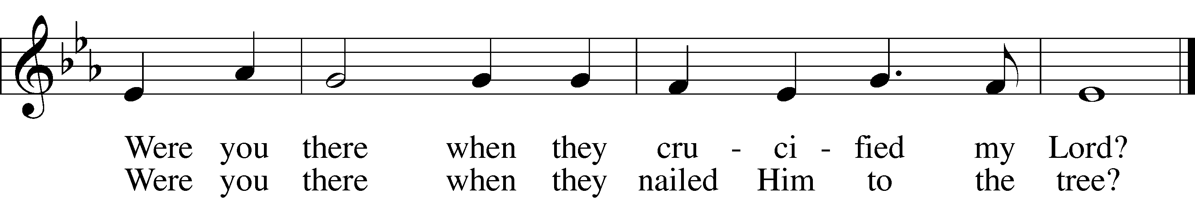
Text and tune: African American spiritual, 19th cent., alt.
Text and tune: Public domain

The Second Candle is Extinguished 6:30 PM Only

Reading John 19:25–27
25but standing by the cross of Jesus were his mother and his mother’s sister, Mary the wife of Clopas, and Mary Magdalene. 26When Jesus saw his mother and the disciple whom he loved standing nearby, he said to his mother, “Woman, behold, your son!” 27Then he said to the disciple, “Behold, your mother!” And from that hour the disciple took her to his own home.

Hymn: 450 O Sacred Head, Now Wounded sts. 1–4
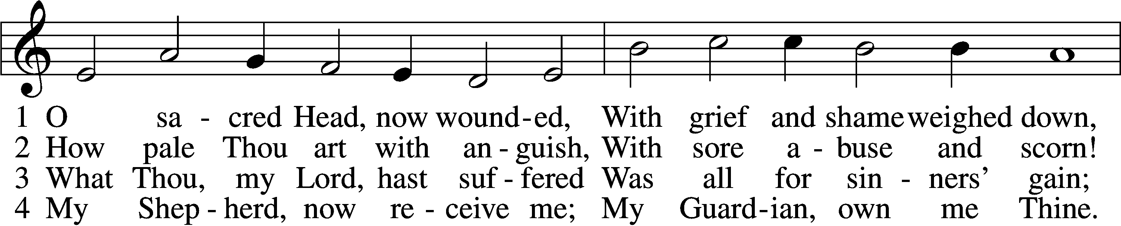
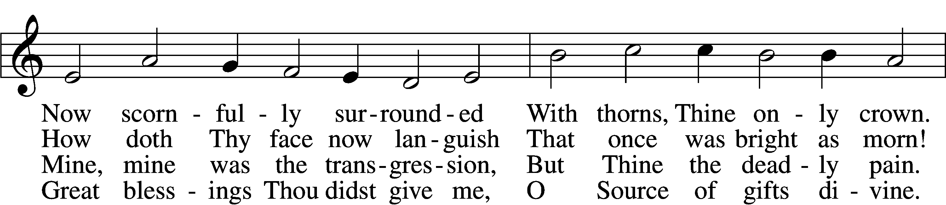
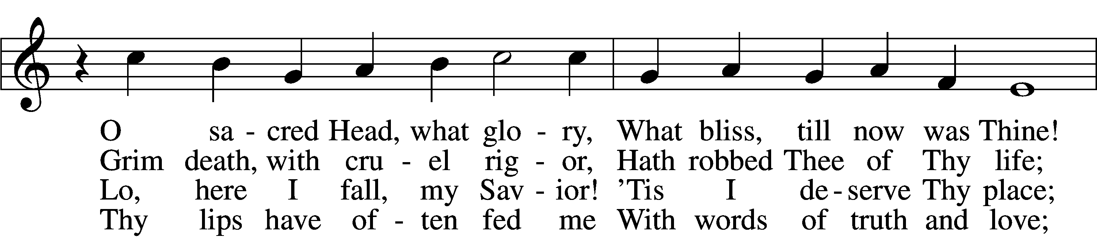
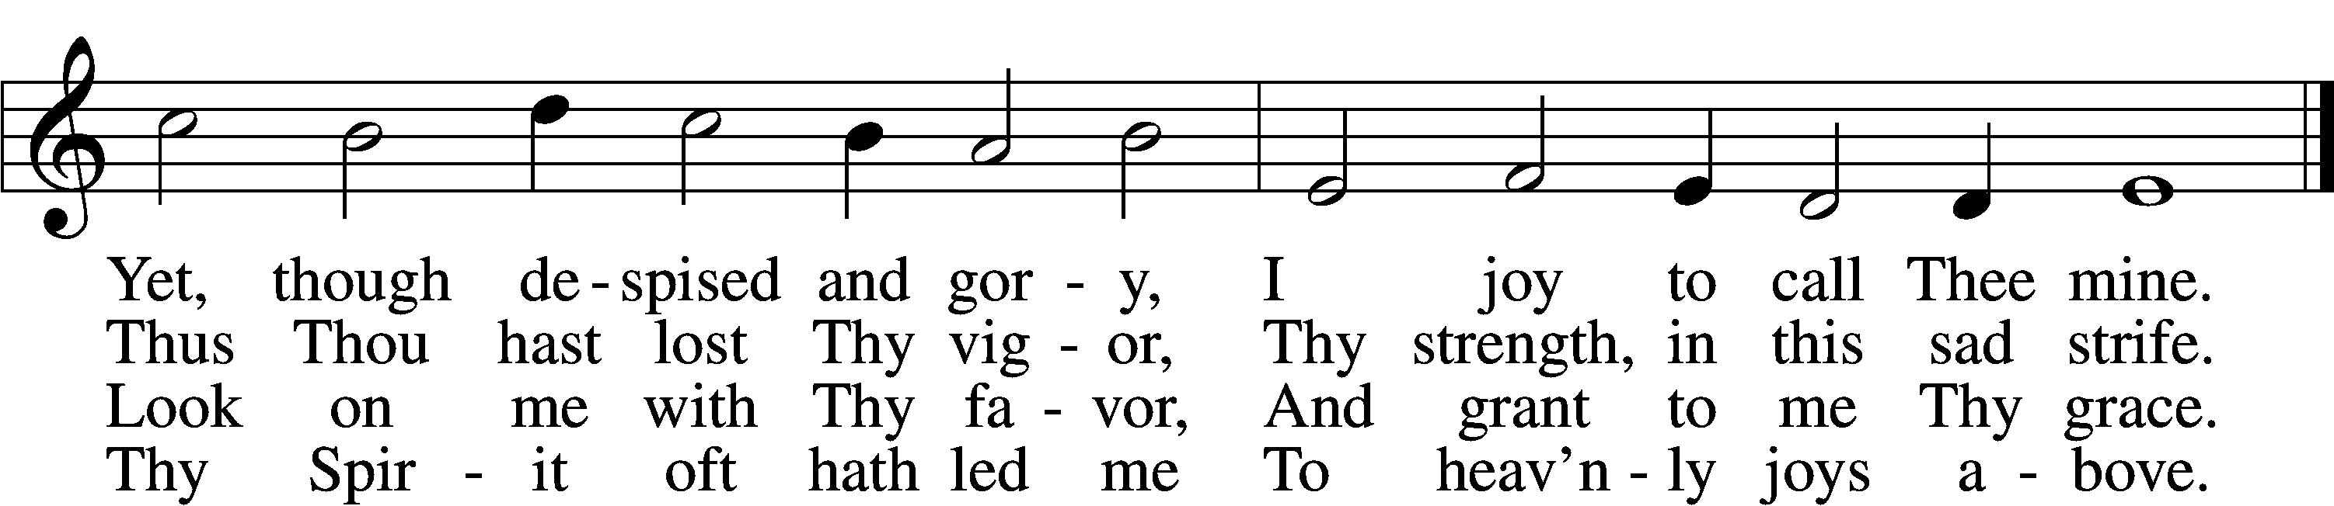
Text: attr. Bernard of Clairvaux, 1091–1153; German version, Paul Gerhardt, 1607–76; tr. The Lutheran Hymnal, 1941, alt.
Tune: Hans Leo Hassler, 1564–1612
Text: © 1941 Concordia Publishing House. Used by permission: LSB Hymn License no. 110005504
Tune: Public domain

The Third Candle is Extinguished 6:30 PM Only

The Fourth Word: The Word of Forgiveness Mark 15:25–35
25And it was the third hour when they crucified him. 26And the inscription of the charge against him read, “The King of the Jews.” 27And with him they crucified two robbers, one on his right and one on his left. 29And those who passed by derided him, wagging their heads and saying, “Aha! You who would destroy the temple and rebuild it in three days, 30save yourself, and come down from the cross!” 31So also the chief priests with the scribes mocked him to one another, saying, “He saved others; he cannot save himself. 32Let the Christ, the King of Israel, come down now from the cross that we may see and believe.” Those who were crucified with him also reviled him.
The Death of Jesus
33And when the sixth hour had come, there was darkness over the whole land until the ninth hour. 34And at the ninth hour Jesus cried with a loud voice, “Eloi, Eloi, lema sabachthani?” which means, “My God, my God, why have you forsaken me?” 35And some of the bystanders hearing it said, “Behold, he is calling Elijah.”

Hymn: 450 O Sacred Head, Now Wounded LSB 450
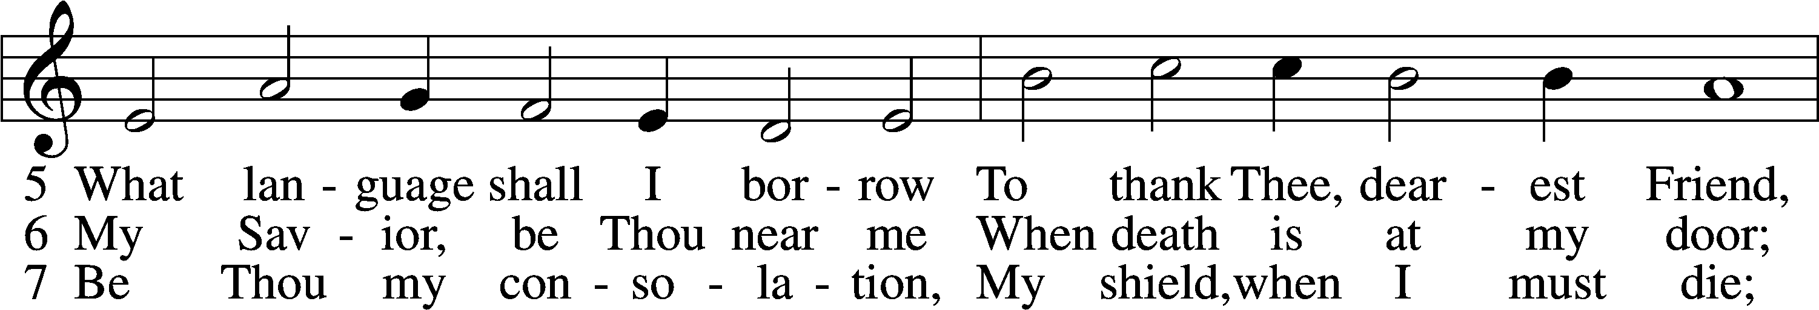
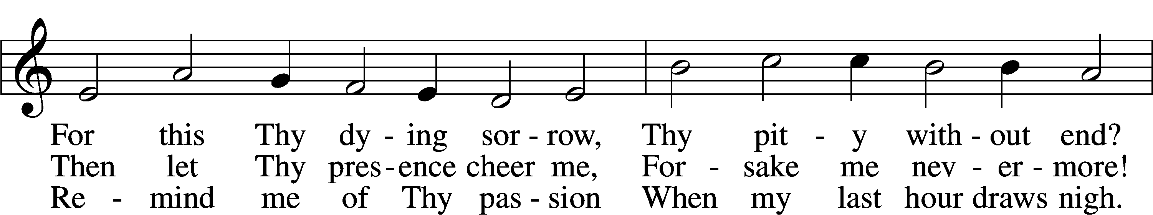
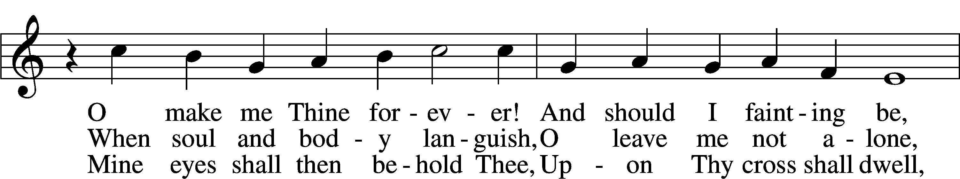
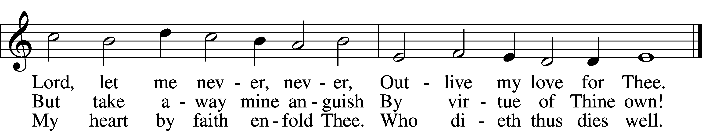
Text: attr. Bernard of Clairvaux, 1091–1153; German version, Paul Gerhardt, 1607–76; tr. The Lutheran Hymnal, 1941, alt.
Tune: Hans Leo Hassler, 1564–1612
Text: © 1941 Concordia Publishing House. Used by permission: LSB Hymn License no. 110005504
Tune: Public domain

The Fourth Candle is Extinguished

The Fifth Word: The Word of Suffering John 19:28–29
The Death of Jesus
28After this, Jesus, knowing that all was now finished, said (to fulfill the Scripture), “I thirst.” 29A jar full of sour wine stood there, so they put a sponge full of the sour wine on a hyssop branch and held it to his mouth.

Hymn: 451 Stricken, Smitten, and Afflicted
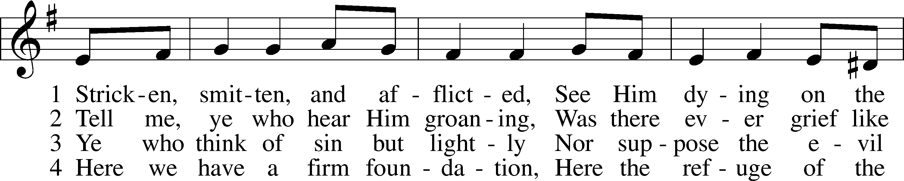
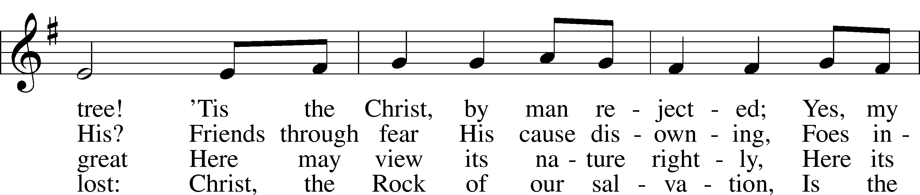
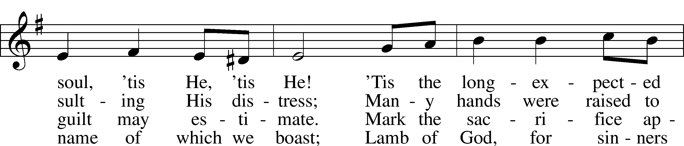
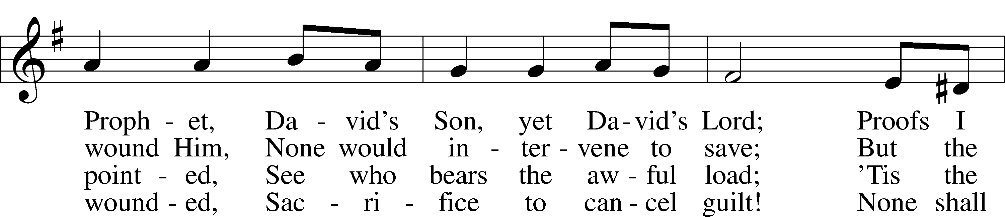
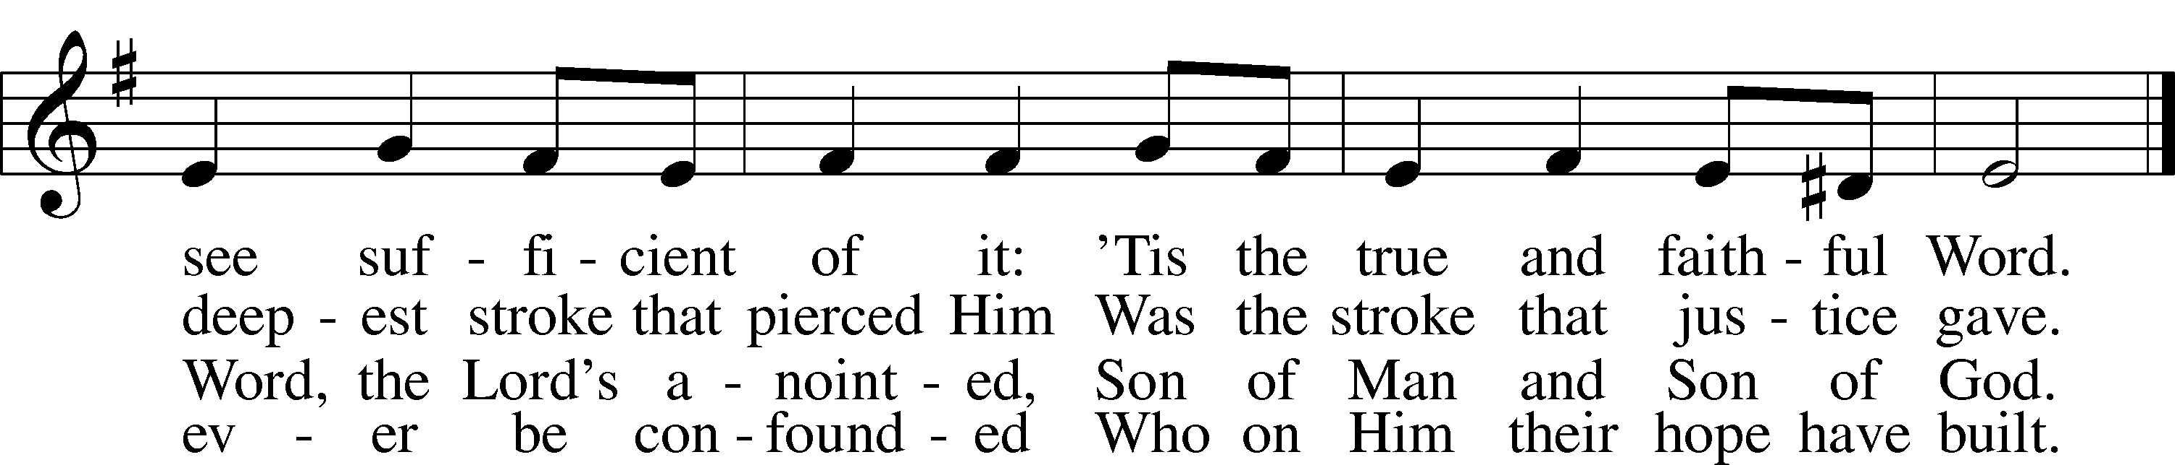
Text: Thomas Kelly, 1769–1855, alt.
Tune: Geistliche Volkslieder, 1850, Paderborn
Text and tune: Public domain

The Fifth Candle is Extinguished 6:30 PM Only

The Sixth Word: The Word of Victory John 19:30
30When Jesus had received the sour wine, he said, “It is finished,” and he bowed his head and gave up his spirit.

Hymn: 452 O Perfect Life of Love
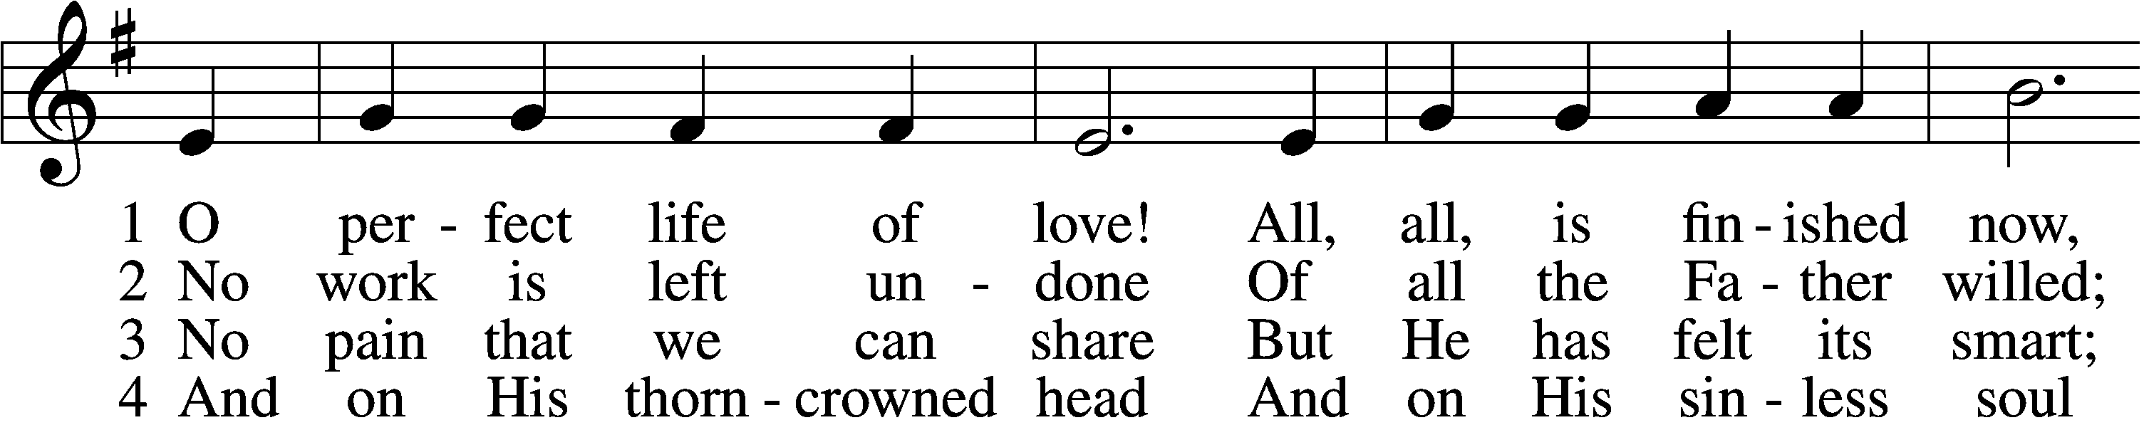
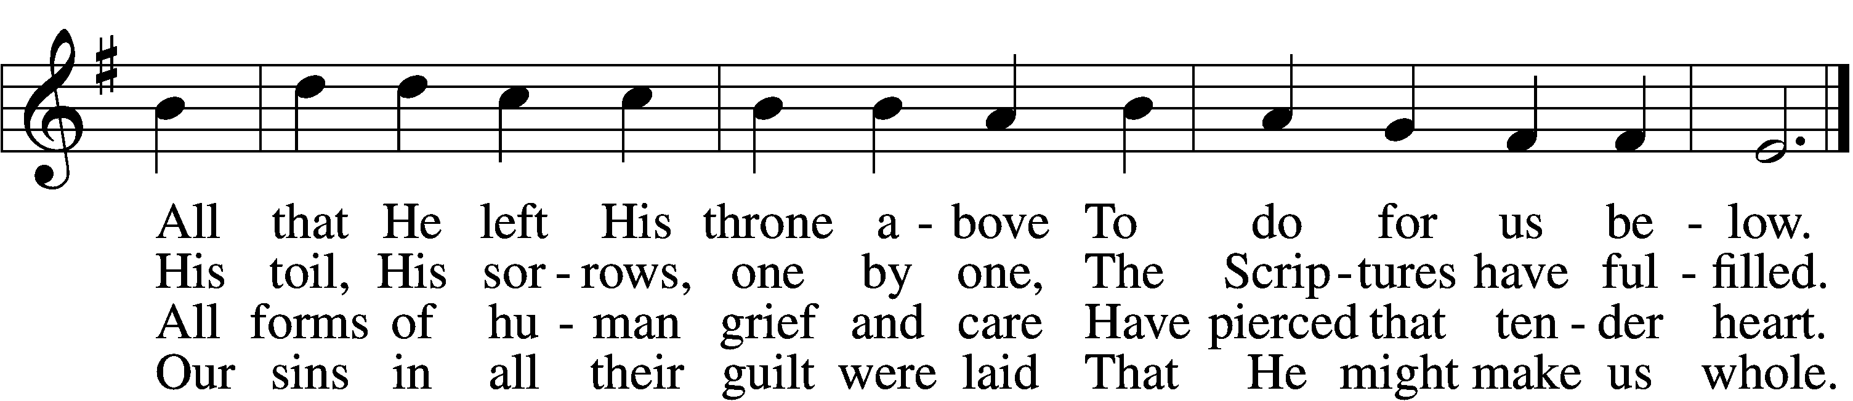

5 In perfect love He dies;
For me He dies, for me.
O all-atoning Sacrifice,
I cling by faith to Thee.

6 In ev’ry time of need,
Before the judgment throne,
Thy work, O Lamb of God, I’ll plead,
Thy merits, not mine own.

7 Yet work, O Lord, in me
As Thou for me hast wrought;
And let my love the answer be
To grace Thy love has brought.
Text: Henry W. Baker, 1821–77, alt.
Tune: William Daman, c. 1540–1591
Text and tune: Public domain

The Sixth Candle is Extinguished

The Seventh Word: The Word of Trust Luke 23:44–47
The Death of Jesus
44It was now about the sixth hour, and there was darkness over the whole land until the ninth hour, 45while the sun’s light failed. And the curtain of the temple was torn in two. 46Then Jesus, calling out with a loud voice, said, “Father, into your hands I commit my spirit!” And having said this he breathed his last. 47Now when the centurion saw what had taken place, he praised God, saying, “Certainly this man was innocent!”

Hymn: 453 Upon the Cross Extended
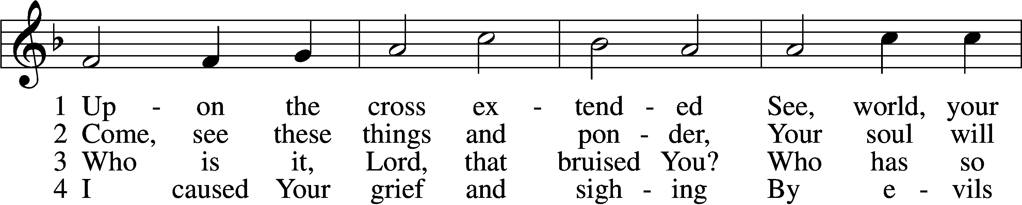
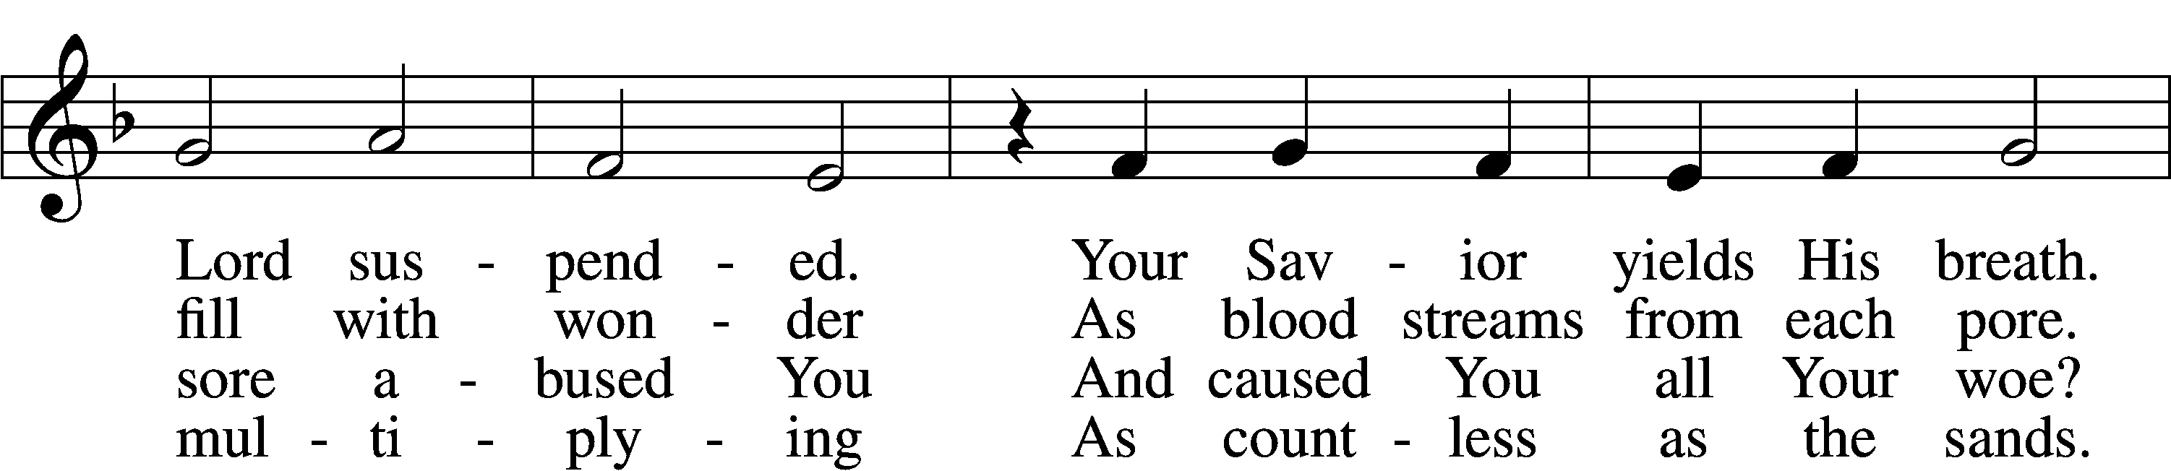
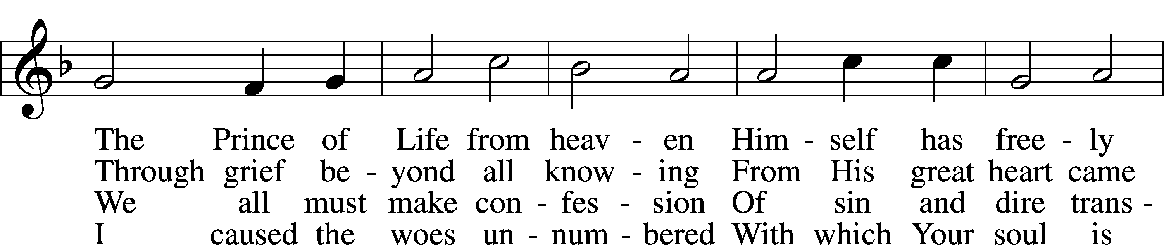
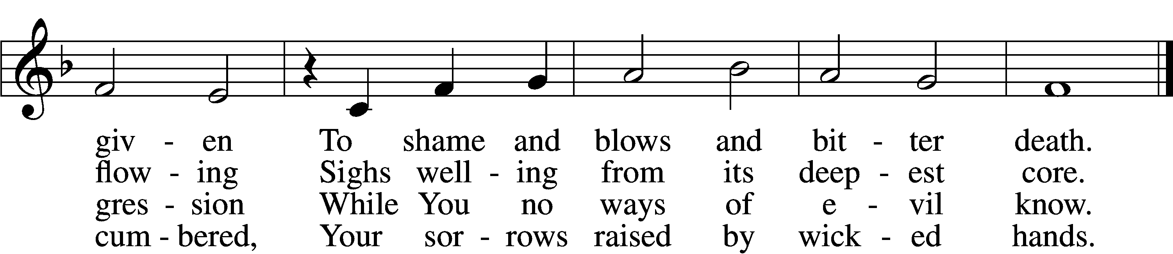

5 Your soul in griefs unbounded,
Your head with thorns surrounded,
You died to ransom me.
The cross for me enduring,
The crown for me securing,
You healed my wounds and set me free.

6 Your cords of love, my Savior,
Bind me to You forever,
I am no longer mine.
To You I gladly tender
All that my life can render
And all I have to You resign.

7 Your cross I place before me;
Its saving pow’r restore me,
Sustain me in the test.
It will, when life is ending,
Be guiding and attending
My way to Your eternal rest.
Text: Paul Gerhardt, 1607–76; tr. John Kelly, 1833–90, alt.
Tune: Heinrich Isaac, c. 1450–1517
Text and tune: Public domain

Lord’s Prayer (Spoken Softly) LSB 162
P Lord, remember us in Your kingdom and teach us to pray:
C Our Father who art in heaven,
hallowed be Thy name,
Thy kingdom come,
Thy will be done on earth
as it is in heaven;
give us this day our daily bread;
and forgive us our trespasses
as we forgive those
who trespass against us;
and lead us not into temptation,
but deliver us from evil.
For Thine is the kingdom
and the power and the glory
forever and ever. Amen.

Symbolic Removal of the 7th Candle 6:30 PM

The Removal of the Candle Symbols that our Savior hung on the cross for three-God-forsaken-hours before he died for the sins of the world.

The Shutting of the Tomb 6:30 PM

The Return of the 7th Candle 6:30 PM

The Return of the Candle Symbolizes that our Savior is still the light of the world even as he rests in the tomb.

The Silent Recessional

Please stand to face the cross as it passes by. Silently follow the Cross out of the Sanctuary as we solemnly wait for the joy of Easter.

Acknowledgments
Unless otherwise indicated, Scripture quotations are from the ESV® Bible (The Holy Bible, English Standard Version®), copyright © 2001 by Crossway, a publishing ministry of Good News Publishers. Used by permission. All rights reserved.
Created by Lutheran Service Builder © 2024 Concordia Publishing House.

