Easter Sunday
March 31, 2024
9:00 AM

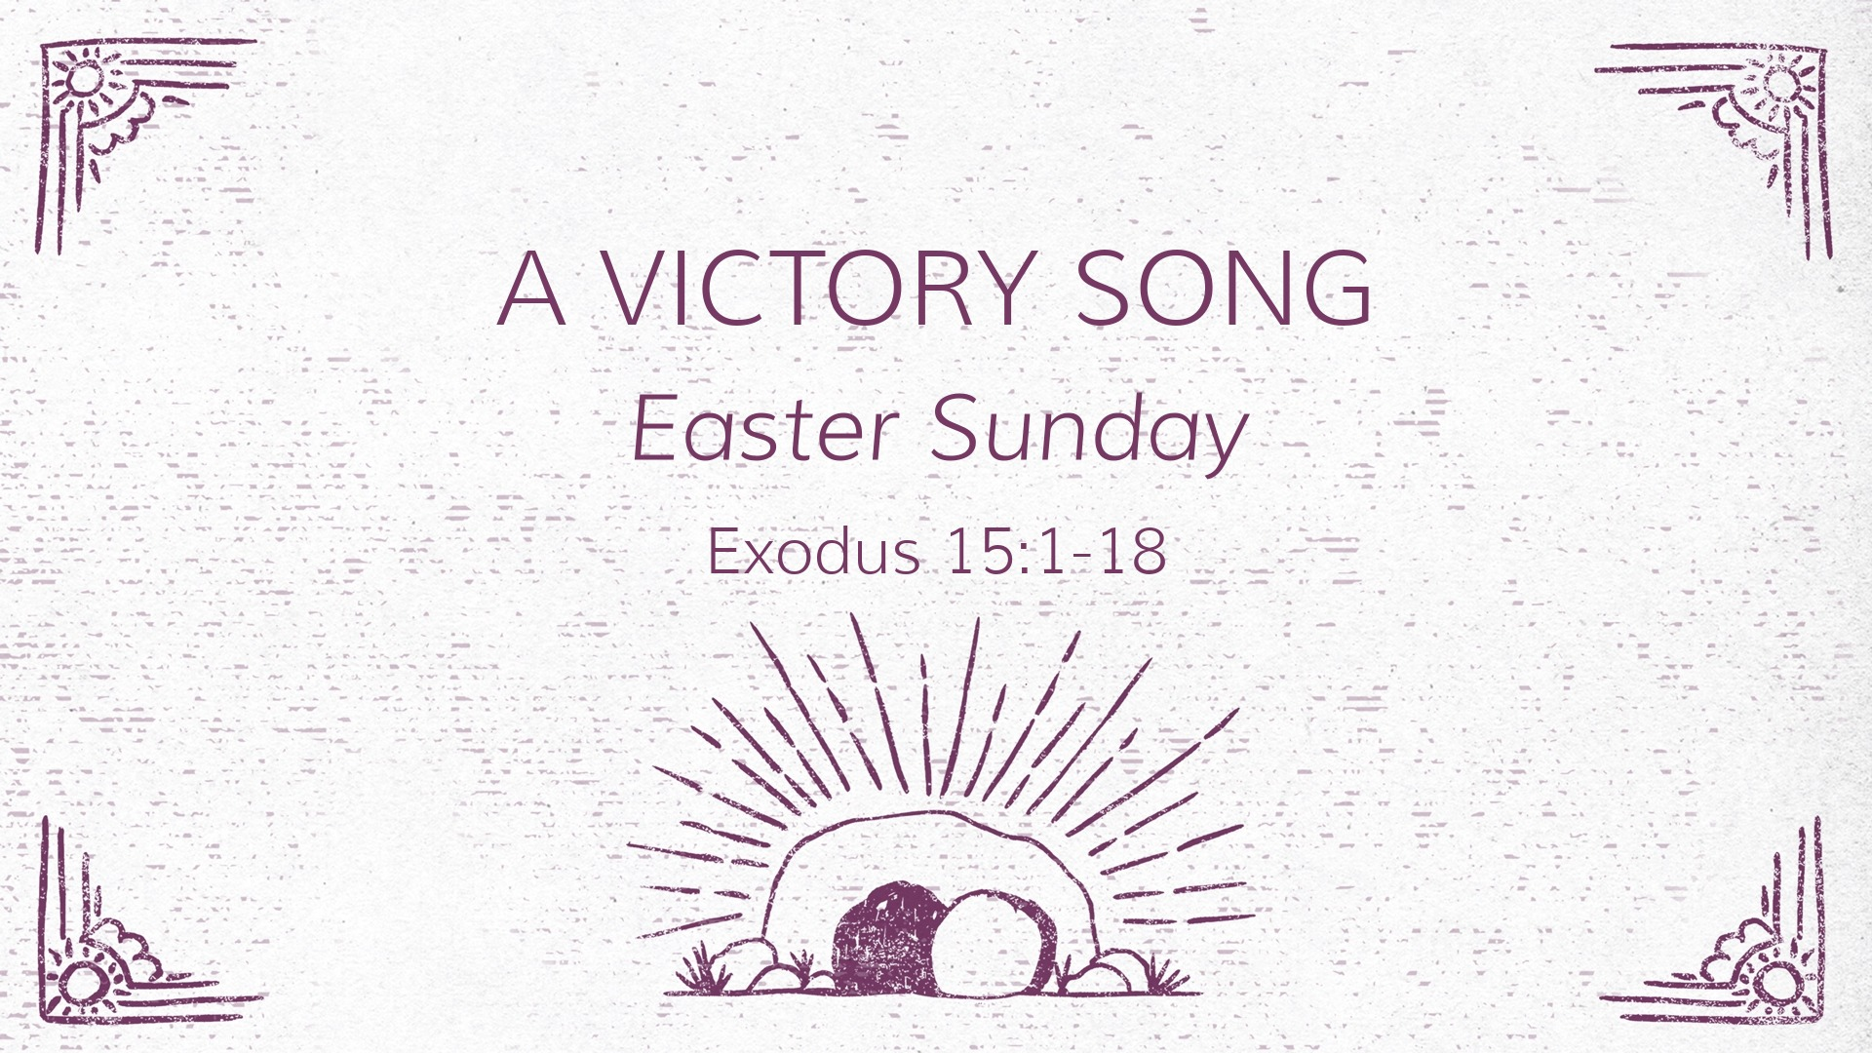

Salem Lutheran Church
1-715-537-3011
http://www.salembarron.com
rev.mike.nielsen@gmail.com

The Lord Jesus Brings Us Out of Death into Life with His God and Father in Heaven

In Adam, all people die because all people sin. The children of that first gardener have been driven out of Paradise and return to the dust whence they were taken. But now another Gardener has come, who has made His bed in the dust of the earth and who, by His rising, restores Paradise to all the children of men. With His voice of the Gospel, He calls us by name, and He opens our eyes to behold Him by faith. At His Word, we enter His tomb through Baptism into His death, so that, just as He is risen, we also “rise from the dead” (John 20:9). Come, then, “sing to the Lord, for he has triumphed gloriously” (Ex. 15:1). He has fought for us against our enemies, and in His resurrection not one enemy remains. “Fear not,” therefore, but “see the salvation of the Lord” (Ex. 14:13), which He delivers “as of first importance” by the preaching of His Gospel (1 Cor. 15:3). Thus, we are raised with Christ “in accordance with the Scriptures” (1 Cor. 15:4), and we stand firm because we “are being saved” (1 Cor. 15:1–2).

Confession and Absolution

Processional Hymn: Jesus Christ is Risen Today LSB 457
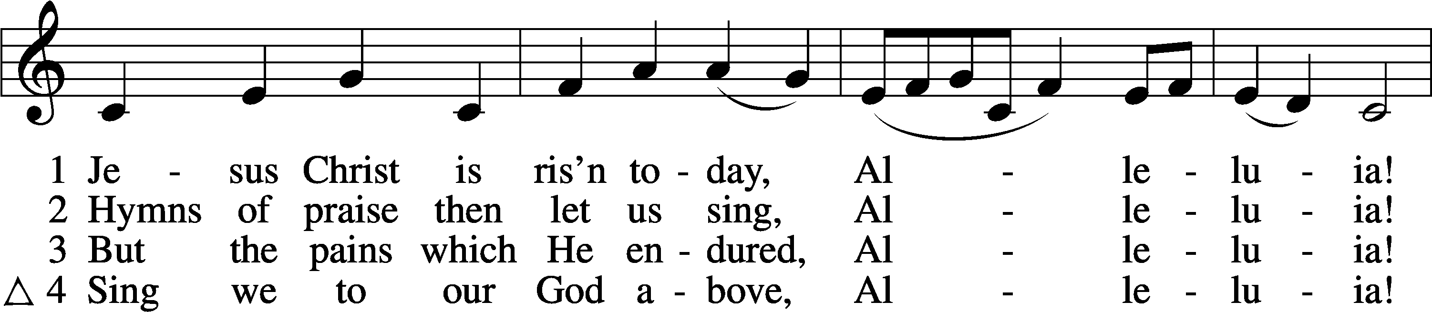
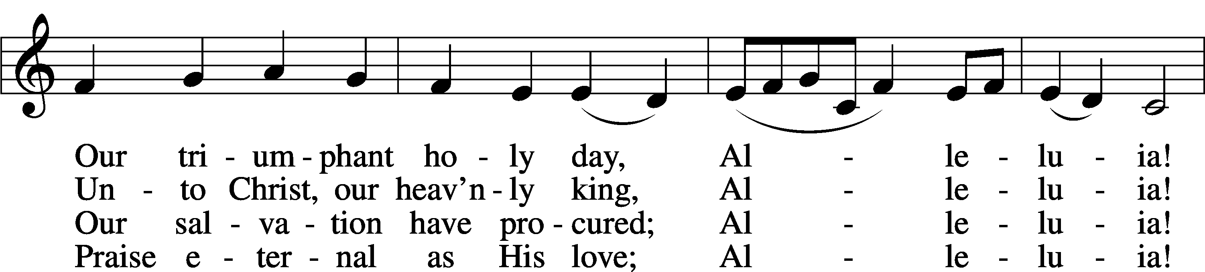
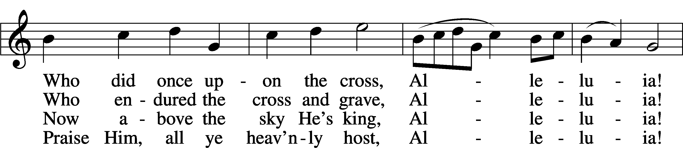
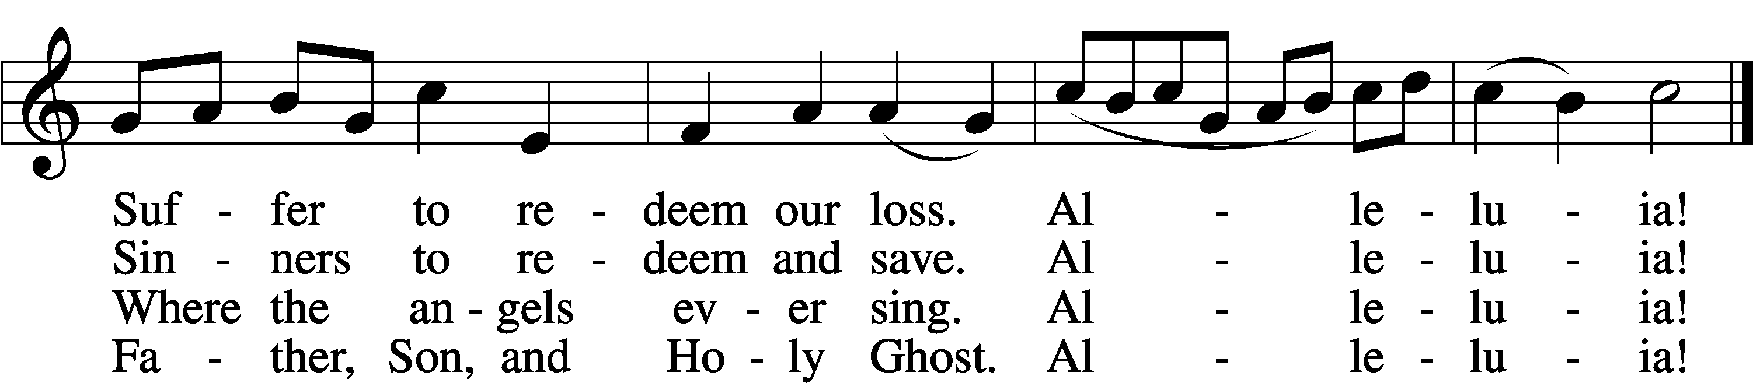
Text: tr. Lyra Davidica, 1708, London, alt.; (sts. 1–3): Latin, 14th cent.; (st. 4): Charles Wesley, 1707–88
Tune: Lyra Davidica, 1708, London
Text and tune: Public domain

Invocation
P In the name of the Father and of the T Son and of the Holy Spirit.
C Amen.

Exhortation LSB 151
P If we say we have no sin, we deceive ourselves, and the truth is not in us.
C But if we confess our sins, God, who is faithful and just, will forgive our sins and cleanse us from all unrighteousness.

Silence for reflection on God’s Word and for self-examination.

Confession of Sins LSB 151
P Let us then confess our sins to God our Father.
C Most merciful God, we confess that we are by nature sinful and unclean. We have sinned against You in thought, word, and deed, by what we have done and by what we have left undone. We have not loved You with our whole heart; we have not loved our neighbors as ourselves. We justly deserve Your present and eternal punishment. For the sake of Your Son, Jesus Christ, have mercy on us. Forgive us, renew us, and lead us, so that we may delight in Your will and walk in Your ways to the glory of Your holy name. Amen.

Absolution LSB 151
P Almighty God in His mercy has given His Son to die for you and for His sake forgives you all your sins. As a called and ordained servant of Christ, and by His authority, I therefore forgive you all your sins in the name of the Father and of the T Son and of the Holy Spirit.
C Amen.

Service of the Word

Introit Exodus 15:2a, 6, 13, 17–18; antiphon: v. 1b
I will sing to the Lord, for he has triumphed | gloriously;*
the horse and his rider he has thrown in- | to the sea.
The Lord is my strength | and my song,*
and he has become my sal- | vation.
Your right hand, O Lord, glorious | in power,*
your right hand, O Lord, shatters the | enemy.
You have led in your steadfast love the people whom you | have redeemed;*
you have guided them by your strength to your ho- | ly abode.
You will bring them in and plant them on your own | mountain,*
the place, O Lord, which you have made for | your abode,
the sanctuary, O Lord, which your hands have es- | tablished.*
The Lord will reign forever and | ever.
Glory be to the Father and | to the Son*
and to the Holy | Spirit;
as it was in the be- | ginning,*
is now, and will be forever. | Amen.
I will sing to the Lord, for he has triumphed | gloriously;*
the horse and his rider he has thrown in- | to the sea.
Kyrie LSB 152
A In peace let us pray to the Lord.
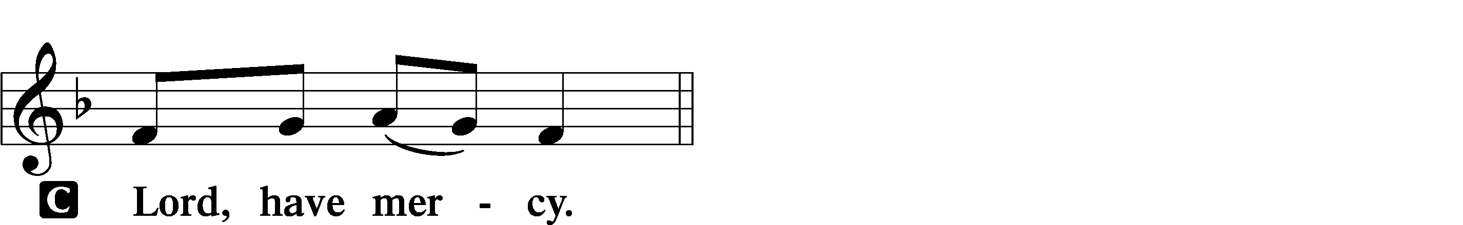

A For the peace from above and for our salvation let us pray to the Lord.
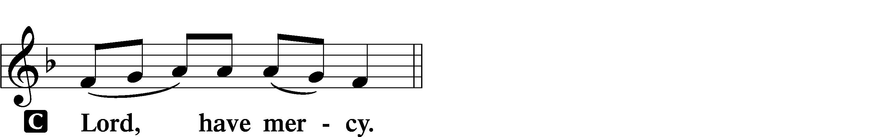

A For the peace of the whole world, for the well-being of the Church of God, and for the unity of all let us pray to the Lord.
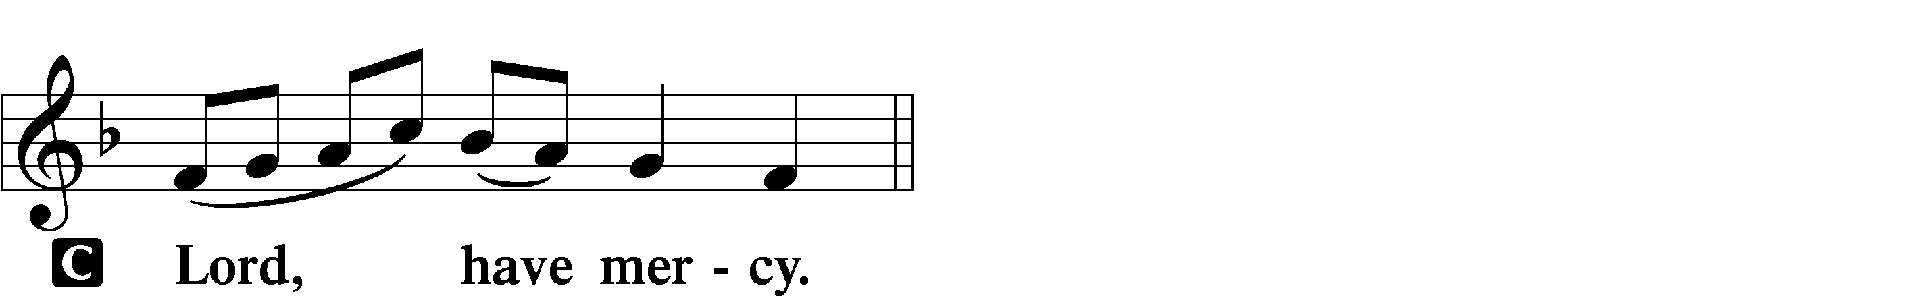

A For this holy house and for all who offer here their worship and praise let us pray to the Lord.
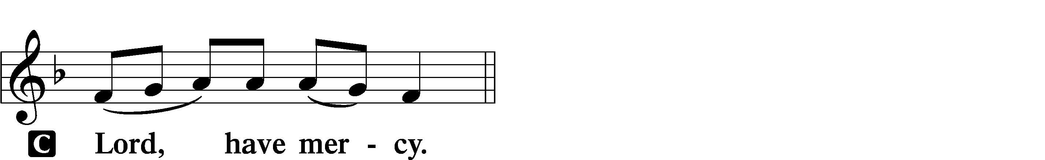

A Help, save, comfort, and defend us, gracious Lord.

This Is the Feast LSB 155
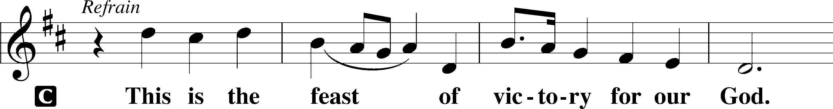
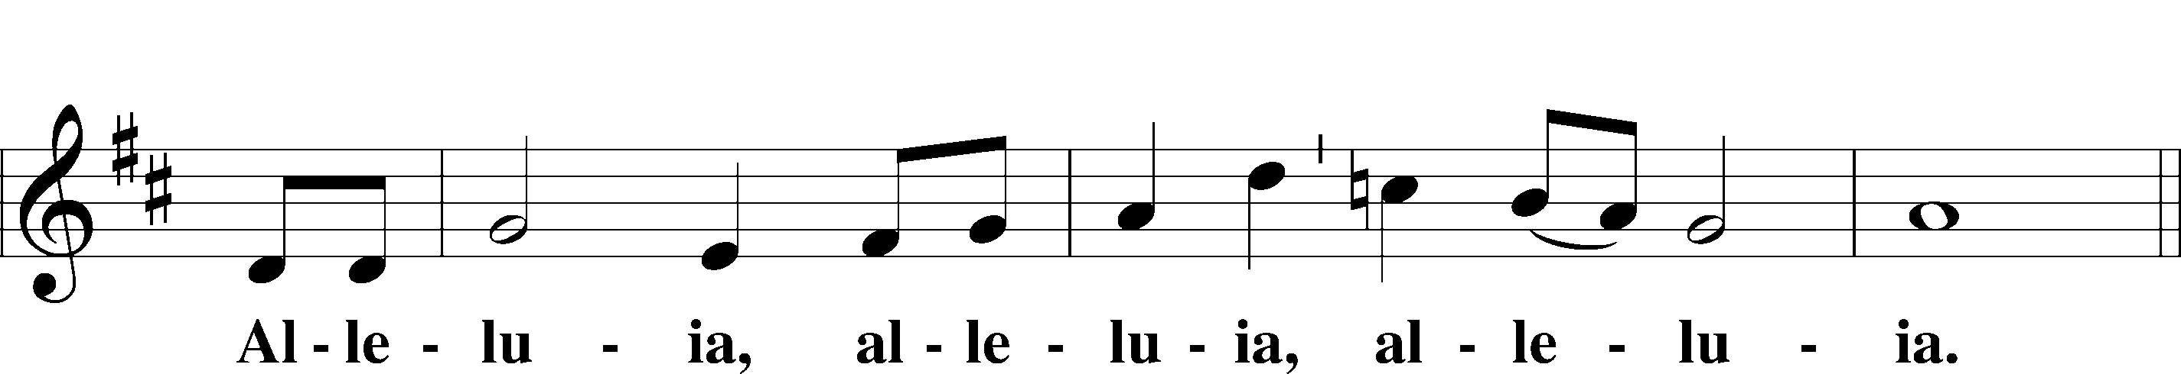
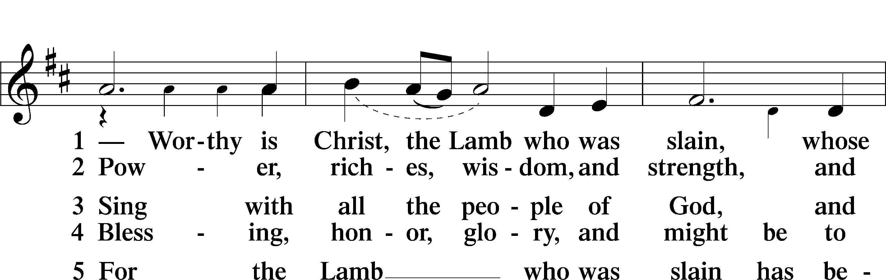
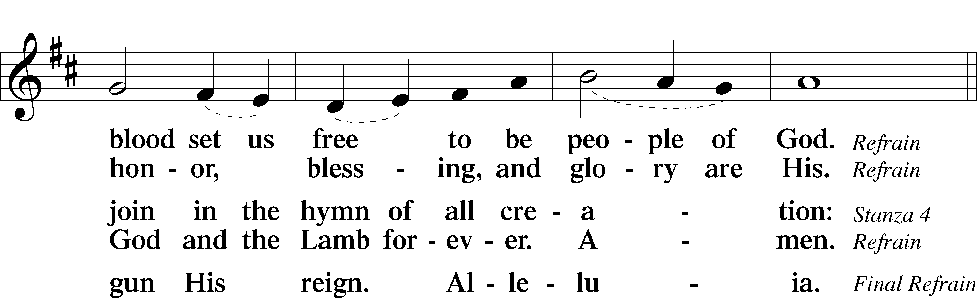
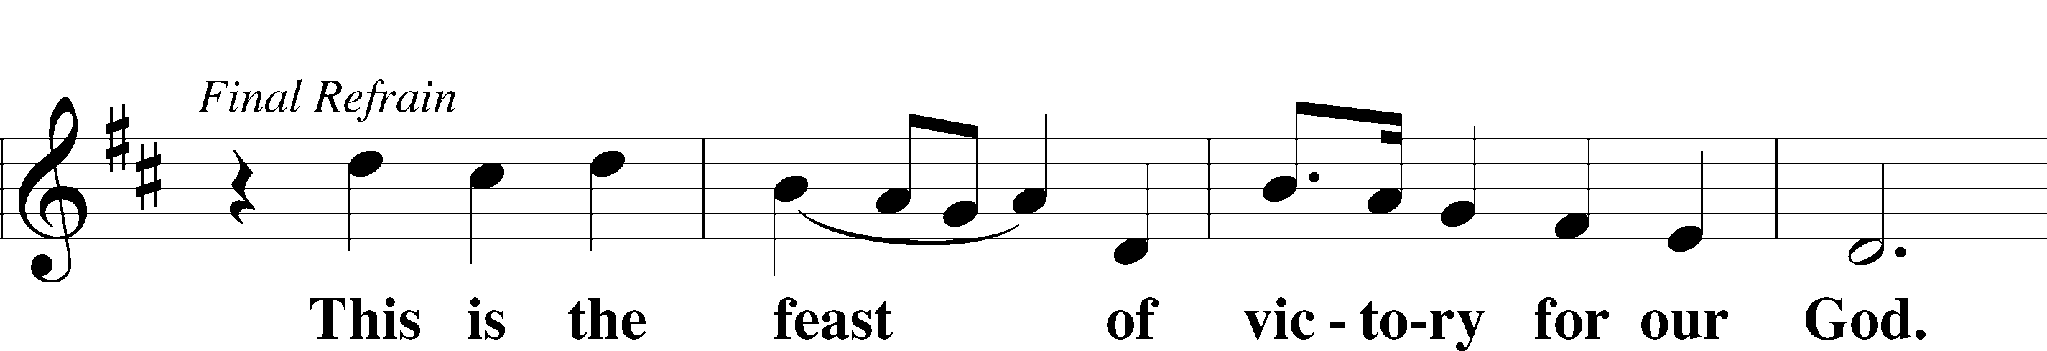
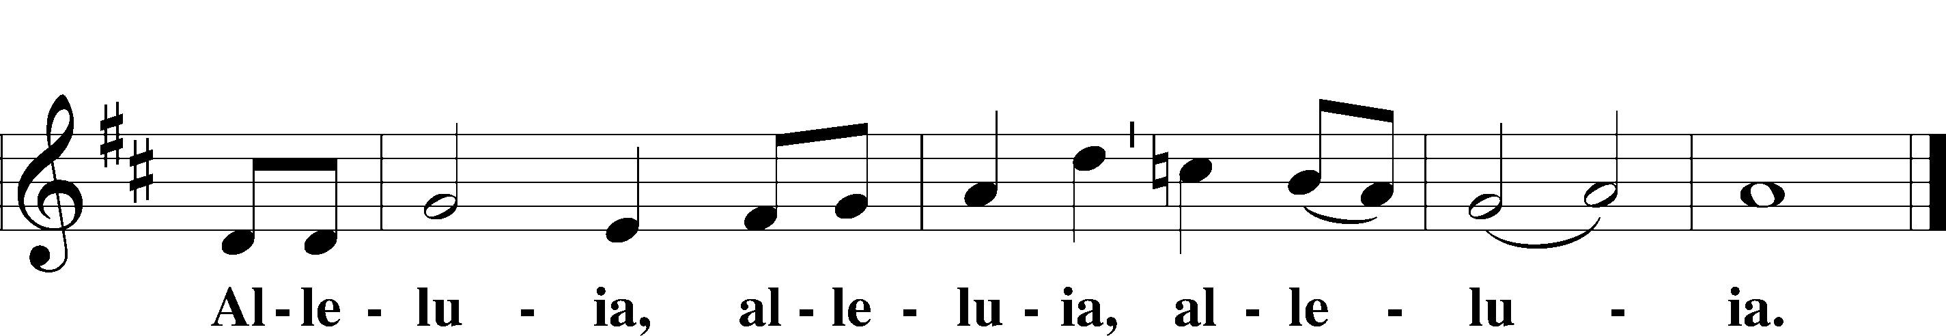

Salutation and Collect of the Day
P The Lord be with you.
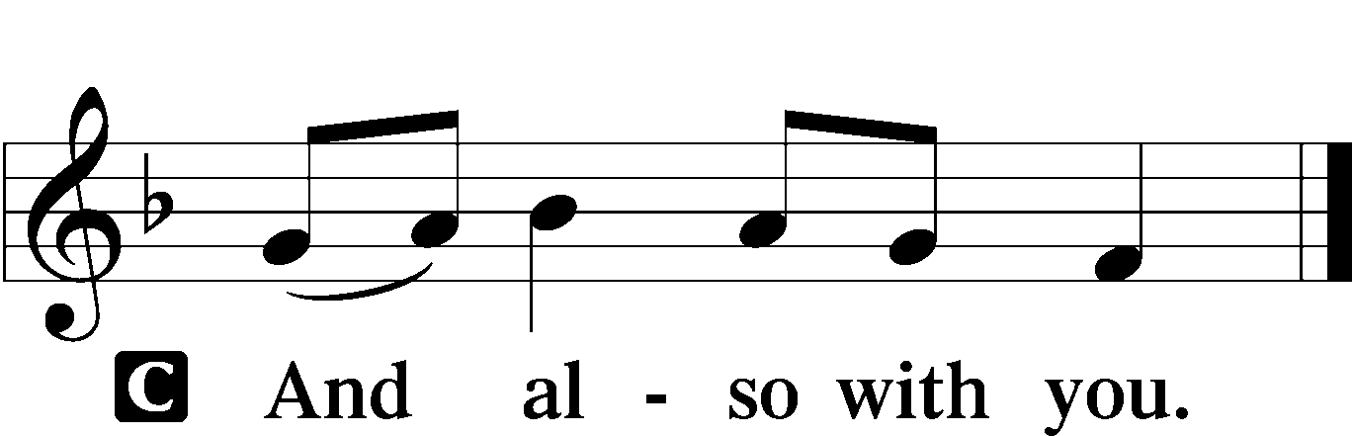

P Let us pray.
Almighty God the Father, through Your only-begotten Son, Jesus Christ, You have overcome death and opened the gate of everlasting life to us. Grant that we, who celebrate with joy the day of our Lord’s resurrection, may be raised from the death of sin by Your life-giving Spirit; through Jesus Christ, our Lord, who lives and reigns with You and the Holy Spirit, one God, now and forever.

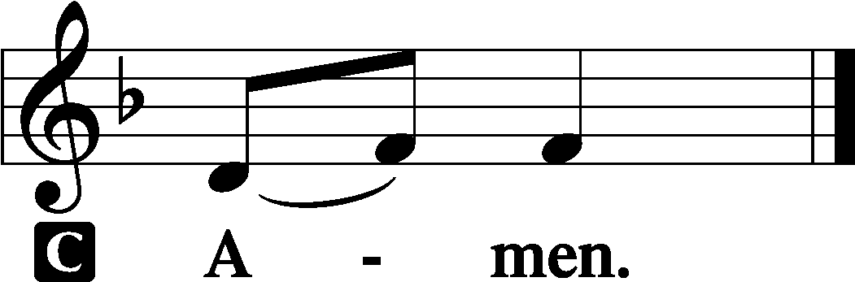

Sit

Old Testament Reading Exodus 15:1–18
1Then Moses and the people of Israel sang this song to the Lord, saying,
“I will sing to the Lord, for he has triumphed gloriously; the horse and his rider he has thrown into the sea. 2The Lord is my strength and my song, and he has become my salvation; this is my God, and I will praise him, my father’s God, and I will exalt him. 3The Lord is a man of war; the Lord is his name. 4“Pharaoh’s chariots and his host he cast into the sea, and his chosen officers were sunk in the Red Sea. 5The floods covered them; they went down into the depths like a stone.
6Your right hand, O Lord, glorious in power, your right hand, O Lord, shatters the enemy. 7In the greatness of your majesty you overthrow your adversaries; you send out your fury; it consumes them like stubble.
8At the blast of your nostrils the waters piled up; the floods stood up in a heap;
the deeps congealed in the heart of the sea.
9The enemy said, ‘I will pursue, I will overtake, I will divide the spoil, my desire shall have its fill of them. I will draw my sword; my hand shall destroy them.’
10You blew with your wind; the sea covered them; they sank like lead in the mighty waters. 11“Who is like you, O Lord, among the gods? Who is like you, majestic in holiness, awesome in glorious deeds, doing wonders?
12You stretched out your right hand; the earth swallowed them.
13“You have led in your steadfast love the people whom you have redeemed; you have guided them by your strength to your holy abode.
14The peoples have heard; they tremble; pangs have seized the inhabitants of Philistia.
15Now are the chiefs of Edom dismayed; trembling seizes the leaders of Moab; all the inhabitants of Canaan have melted away.
16Terror and dread fall upon them; because of the greatness of your arm, they are still as a stone, till your people, O Lord, pass by, till the people pass by whom you have purchased. 17You will bring them in and plant them on your own mountain, the place, O Lord, which you have made for your abode, the sanctuary, O Lord, which your hands have established. 18The Lord will reign forever and ever.”

A This is the Word of the Lord.
C Thanks be to God.

Hymn: Now All the Vault of Heaven Resounds LSB 465 sts. 1–2
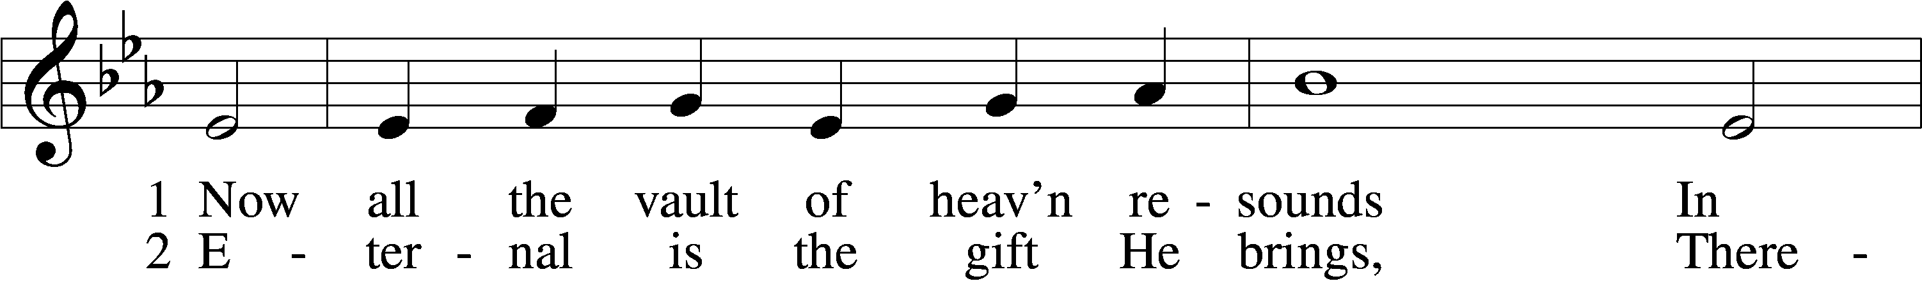
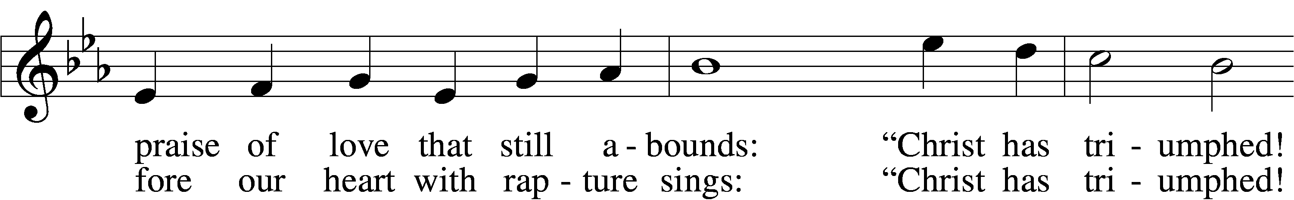
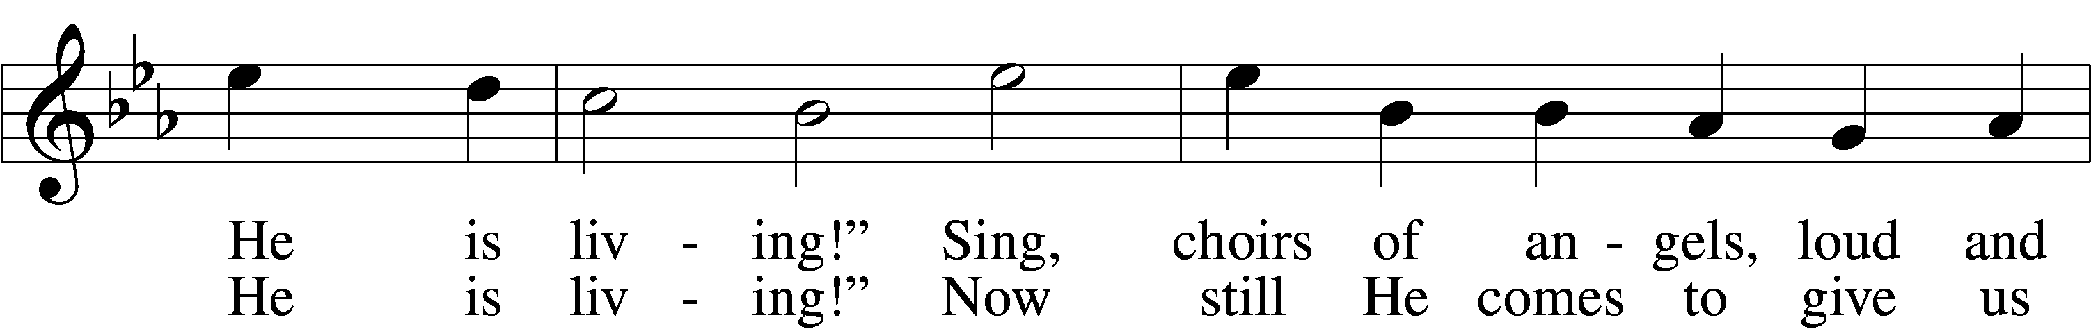
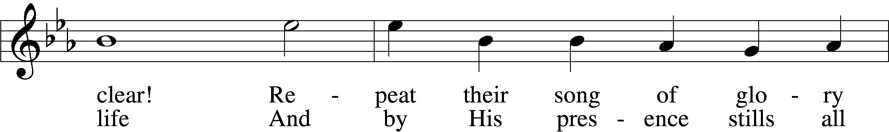
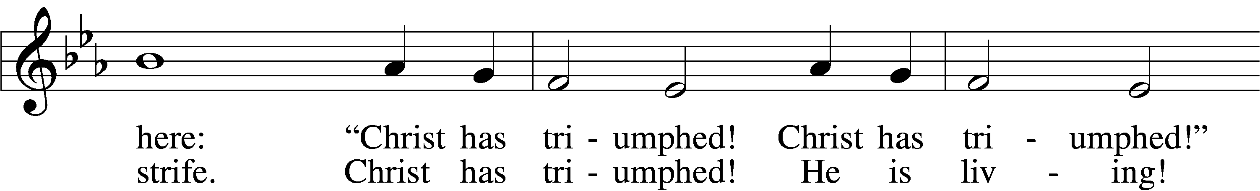
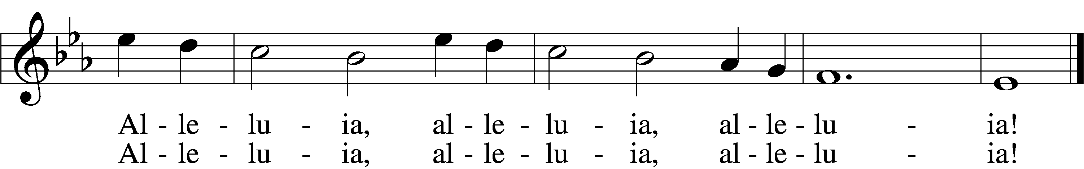
Text: Paul Z. Strodach, 1876–1947, alt.
Tune: Geistliche Kirchengesäng, 1623, Köln
Text: © 1958 Augsburg Publishing House. Used by permission: LSB Hymn License no. 110005504
Tune: Public domain

Epistle 1 Corinthians 15:1–11
1Now I would remind you, brothers, of the gospel I preached to you, which you received, in which you stand, 2and by which you are being saved, if you hold fast to the word I preached to you—unless you believed in vain.
3For I delivered to you as of first importance what I also received: that Christ died for our sins in accordance with the Scriptures, 4that he was buried, that he was raised on the third day in accordance with the Scriptures, 5and that he appeared to Cephas, then to the twelve. 6Then he appeared to more than five hundred brothers at one time, most of whom are still alive, though some have fallen asleep. 7Then he appeared to James, then to all the apostles. 8Last of all, as to one untimely born, he appeared also to me. 9For I am the least of the apostles, unworthy to be called an apostle, because I persecuted the church of God. 10But by the grace of God I am what I am, and his grace toward me was not in vain. On the contrary, I worked harder than any of them, though it was not I, but the grace of God that is with me. 11Whether then it was I or they, so we preach and so you believed.

A This is the Word of the Lord.
C Thanks be to God.

Stand

Gospel Procession Hymn: Now All the Vault of Heaven Resounds LSB 465 sts. 3–4
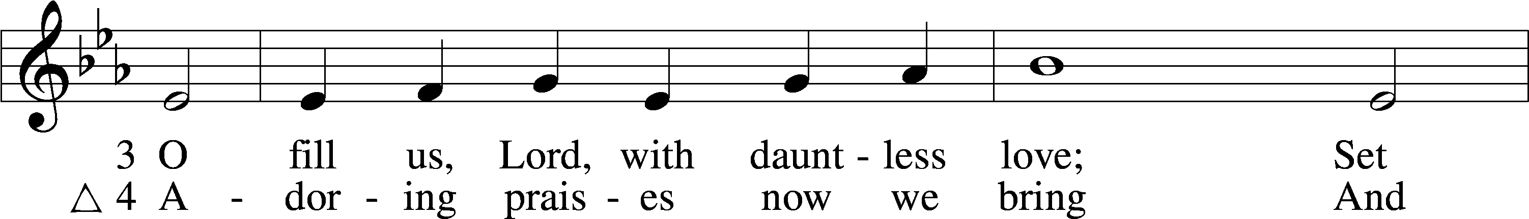
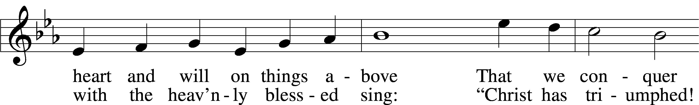
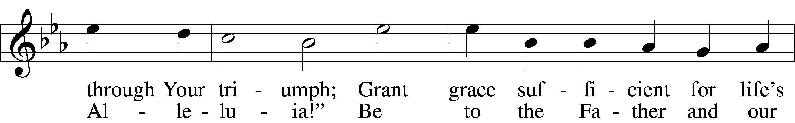
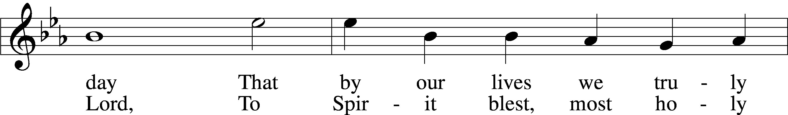
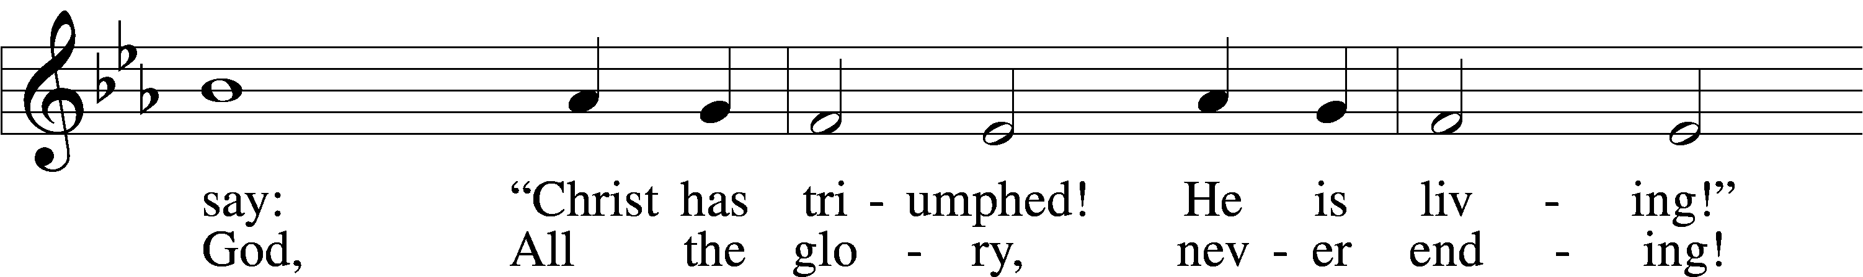
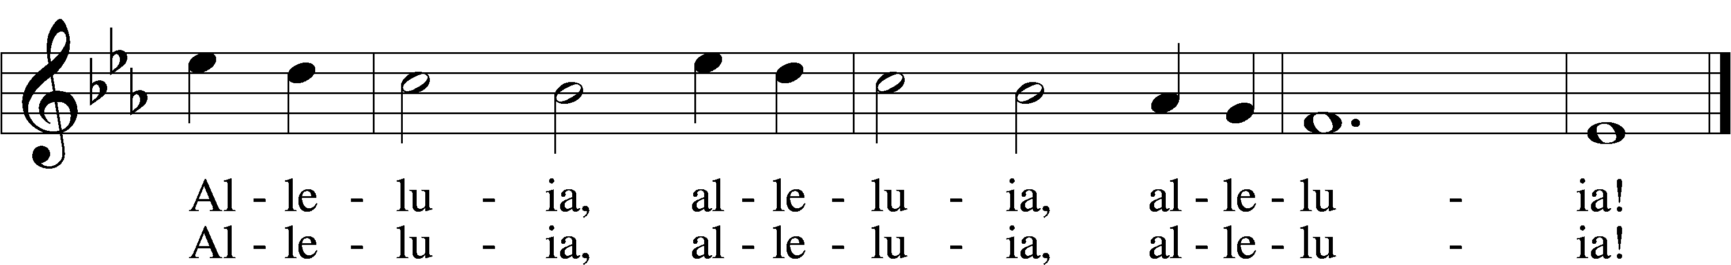
Text: Paul Z. Strodach, 1876–1947, alt.
Tune: Geistliche Kirchengesäng, 1623, Köln
Text: © 1958 Augsburg Publishing House. Used by permission: LSB Hymn License no. 110005504
Tune: Public domain

Holy Gospel Mark 16:1–8
P The Holy Gospel according to St. Mark, the sixteenth chapter.

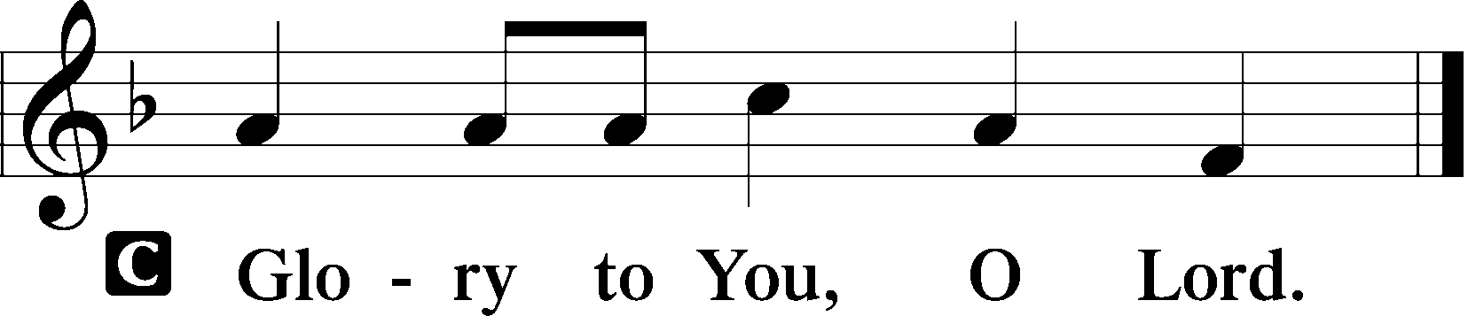

1When the Sabbath was past, Mary Magdalene and Mary the mother of James and Salome bought spices, so that they might go and anoint him. 2And very early on the first day of the week, when the sun had risen, they went to the tomb. 3And they were saying to one another, “Who will roll away the stone for us from the entrance of the tomb?” 4And looking up, they saw that the stone had been rolled back—it was very large. 5And entering the tomb, they saw a young man sitting on the right side, dressed in a white robe, and they were alarmed. 6And he said to them, “Do not be alarmed. You seek Jesus of Nazareth, who was crucified. He has risen; he is not here. See the place where they laid him. 7But go, tell his disciples and Peter that he is going before you to Galilee. There you will see him, just as he told you.” 8And they went out and fled from the tomb, for trembling and astonishment had seized them, and they said nothing to anyone, for they were afraid.

P This is the Gospel of the Lord.

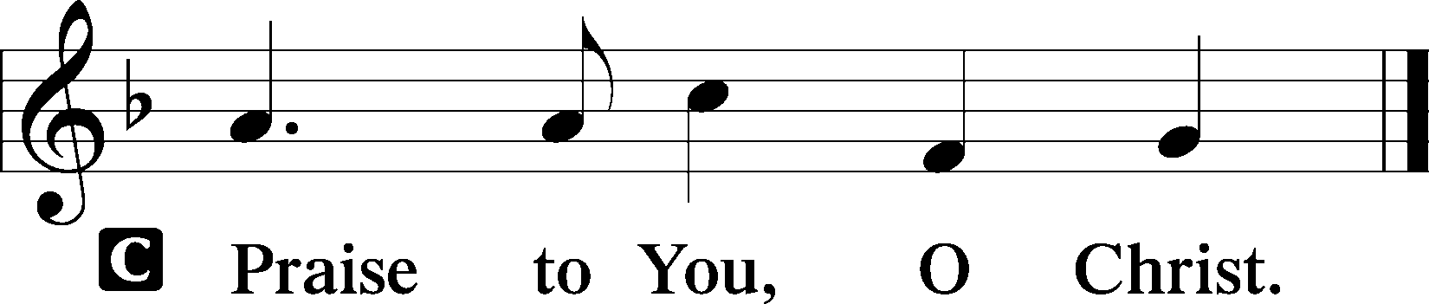
Sit
Hymn of the Day: Jesus Sound the Trumpets
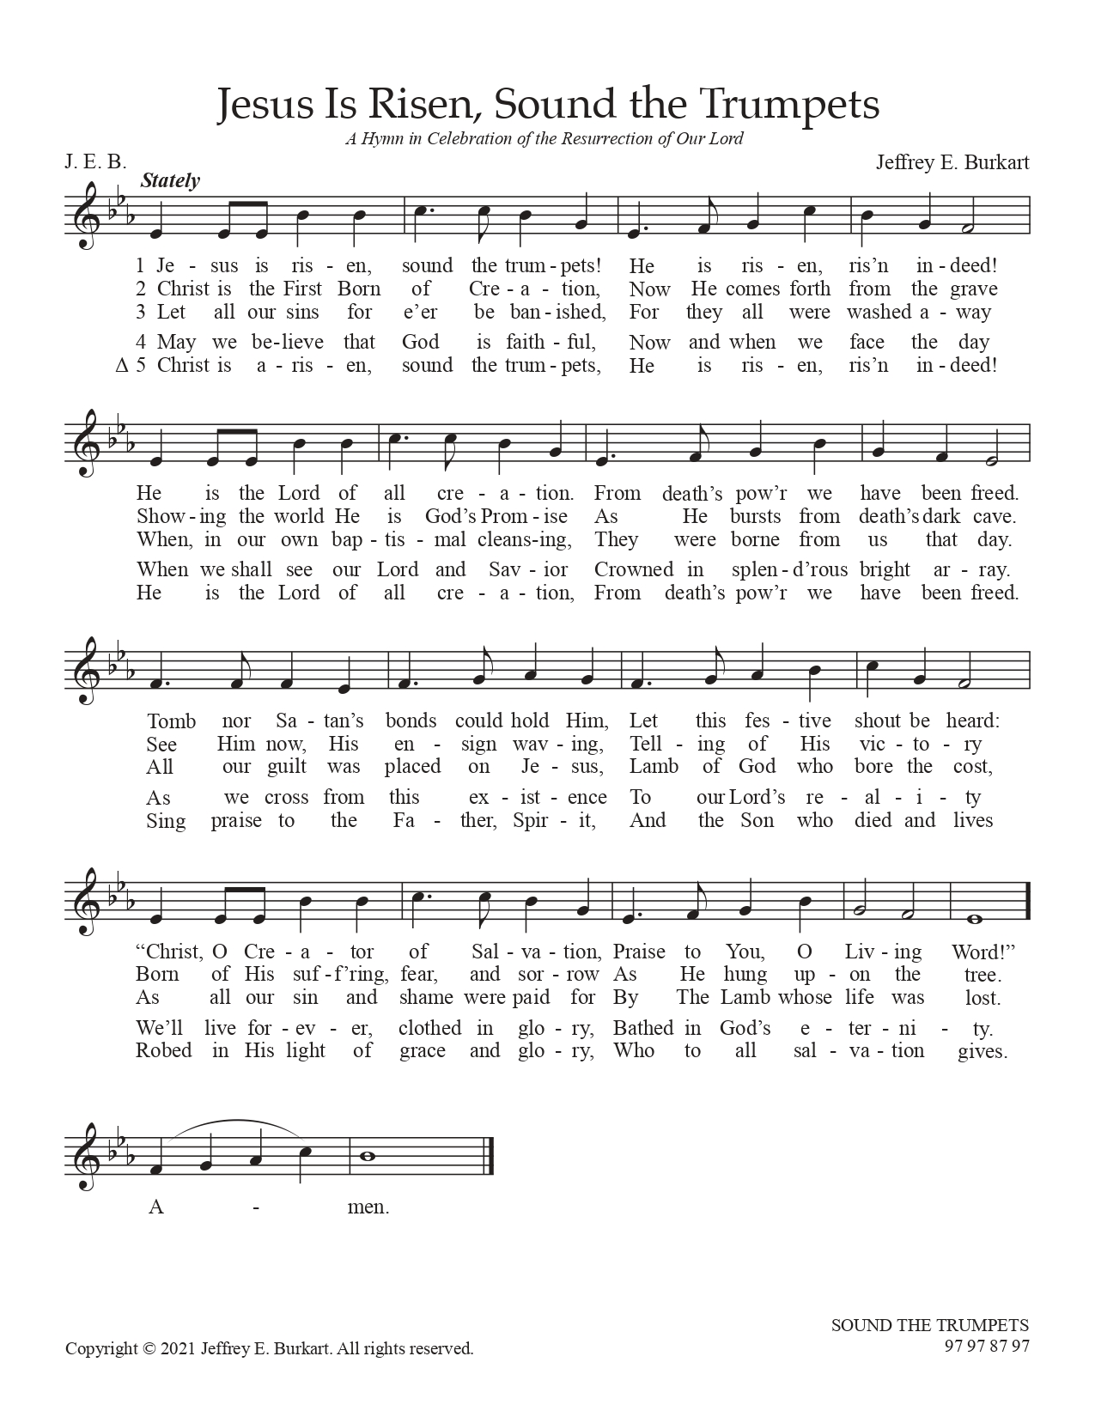
Used by the author’s permission.
Sermon

Stand

Nicene Creed
C I believe in one God,
the Father Almighty,
maker of heaven and earth
and of all things visible and invisible.

And in one Lord Jesus Christ,
the only-begotten Son of God,
begotten of His Father before all worlds,
God of God, Light of Light,
very God of very God,
begotten, not made,
being of one substance with the Father,
by whom all things were made;
who for us men and for our salvation came down from heaven
and was incarnate by the Holy Spirit of the virgin Mary
and was made man;
and was crucified also for us under Pontius Pilate.
He suffered and was buried.
And the third day He rose again according to the Scriptures
and ascended into heaven
and sits at the right hand of the Father.
And He will come again with glory to judge both the living and the dead,
whose kingdom will have no end.

And I believe in the Holy Spirit,
the Lord and giver of life,
who proceeds from the Father and the Son,
who with the Father and the Son together is worshiped and glorified,
who spoke by the prophets.
And I believe in one holy Christian and apostolic Church,
I acknowledge one Baptism for the remission of sins,
and I look for the resurrection of the dead
and the life T of the world to come. Amen.

Reception of New Members

Prayer of the Church

Sit

Offering and Hymn: Christ Has Arisen, Alleluia LSB 466
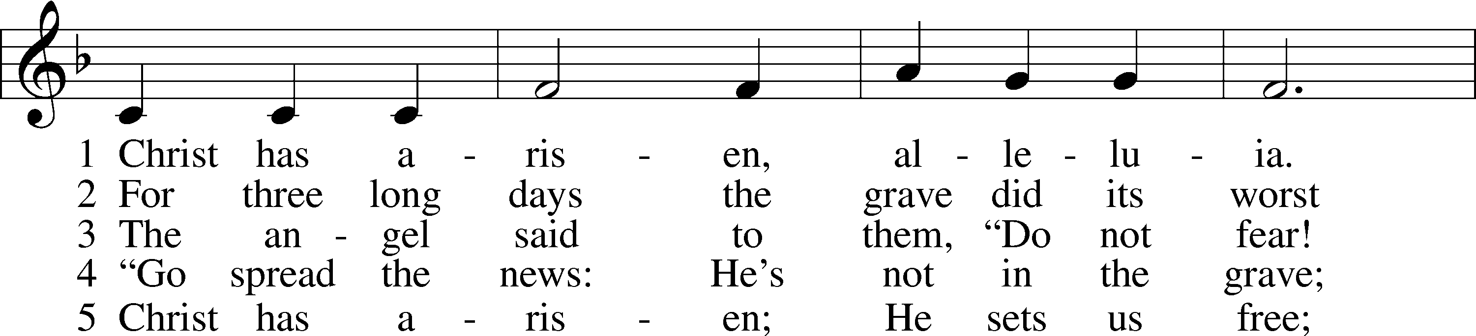
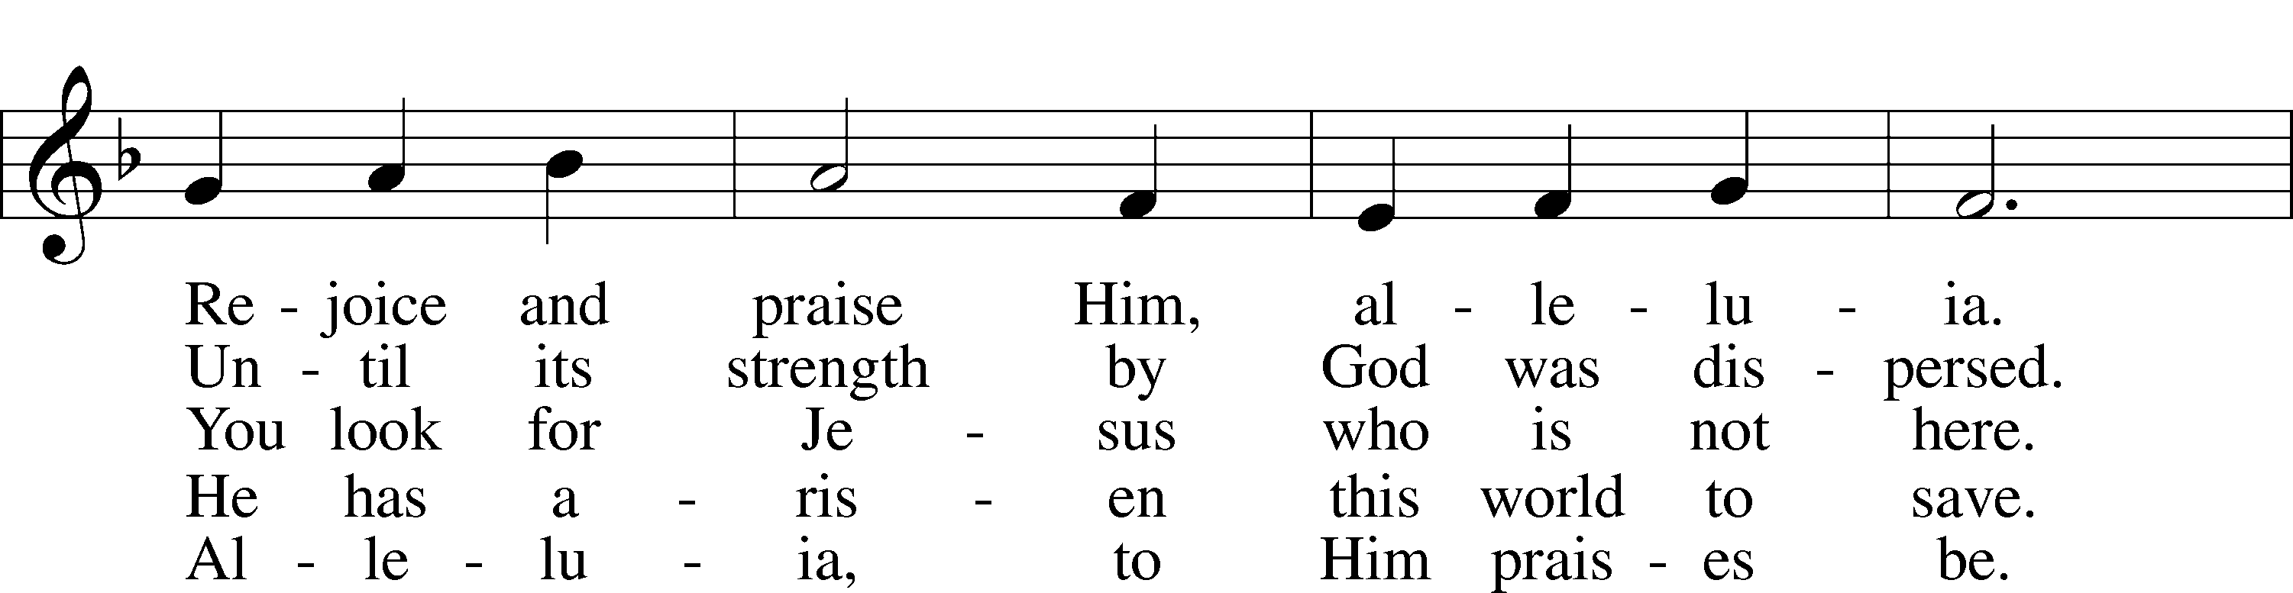
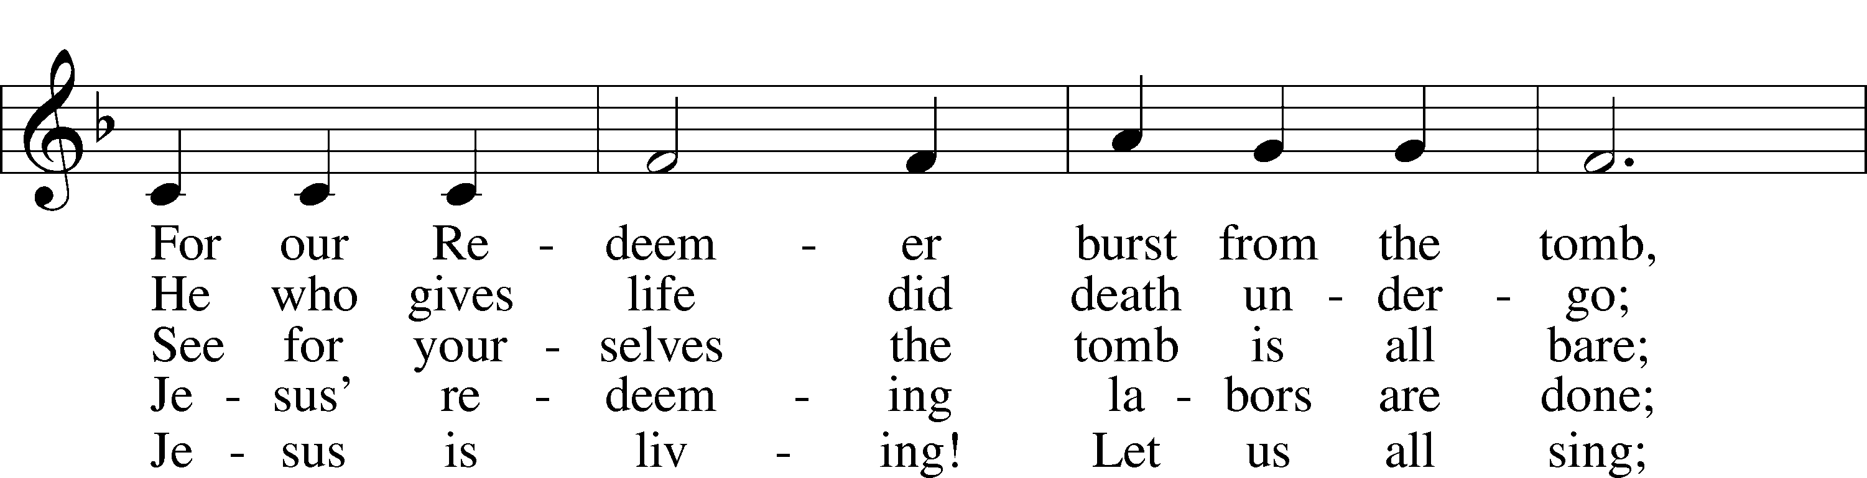
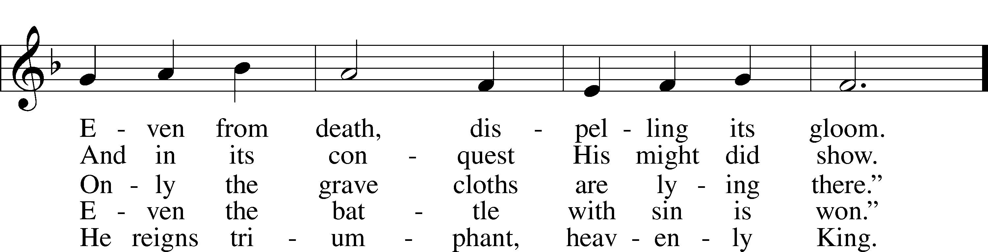
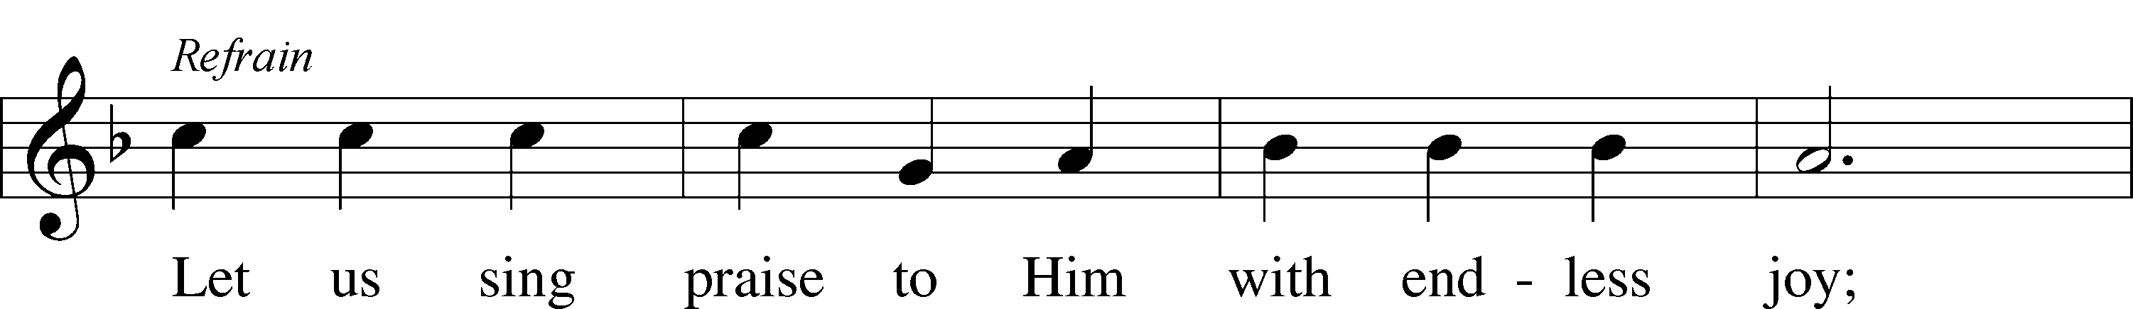
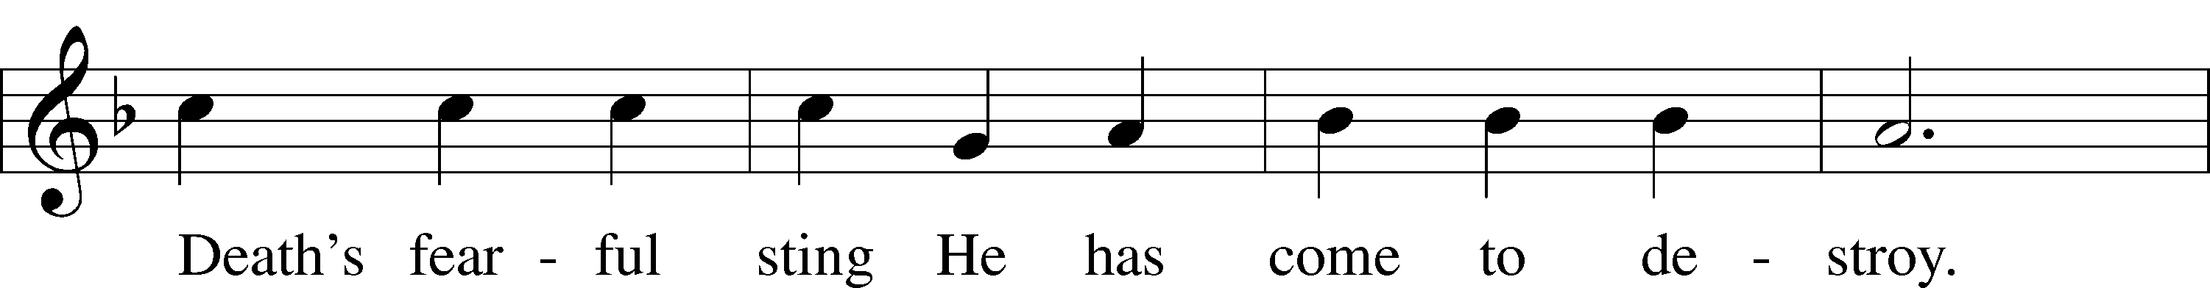
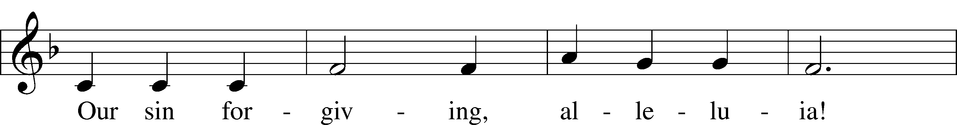
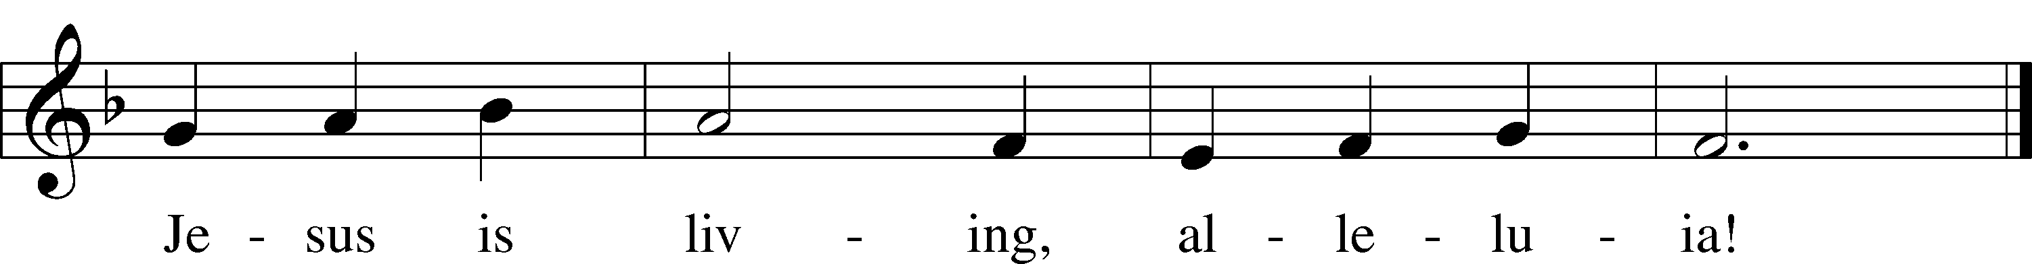
Text: Bernard Kyamanywa, 1938; tr. Howard S. Olson, 1922–2010
Tune: Tanzanian
Text: © 1977 Howard S. Olson. Used by permission: LSB Hymn License no. 110005504
Tune: Public domain

Stand

Service of the Sacrament
Please complete a communion card for our records; they are in the pew in front of you, or request one from an usher. Salem’s communion practice is that of close communion. We invite to our rail those who are members in good standing of sister Missouri Synod parishes. Visitors, please contact the pastor prior to communing. For those who prefer to use the Common Cup, we ask your assistance by holding the cup’s base as you commune.

Preface LSB 160
P The Lord be with you.
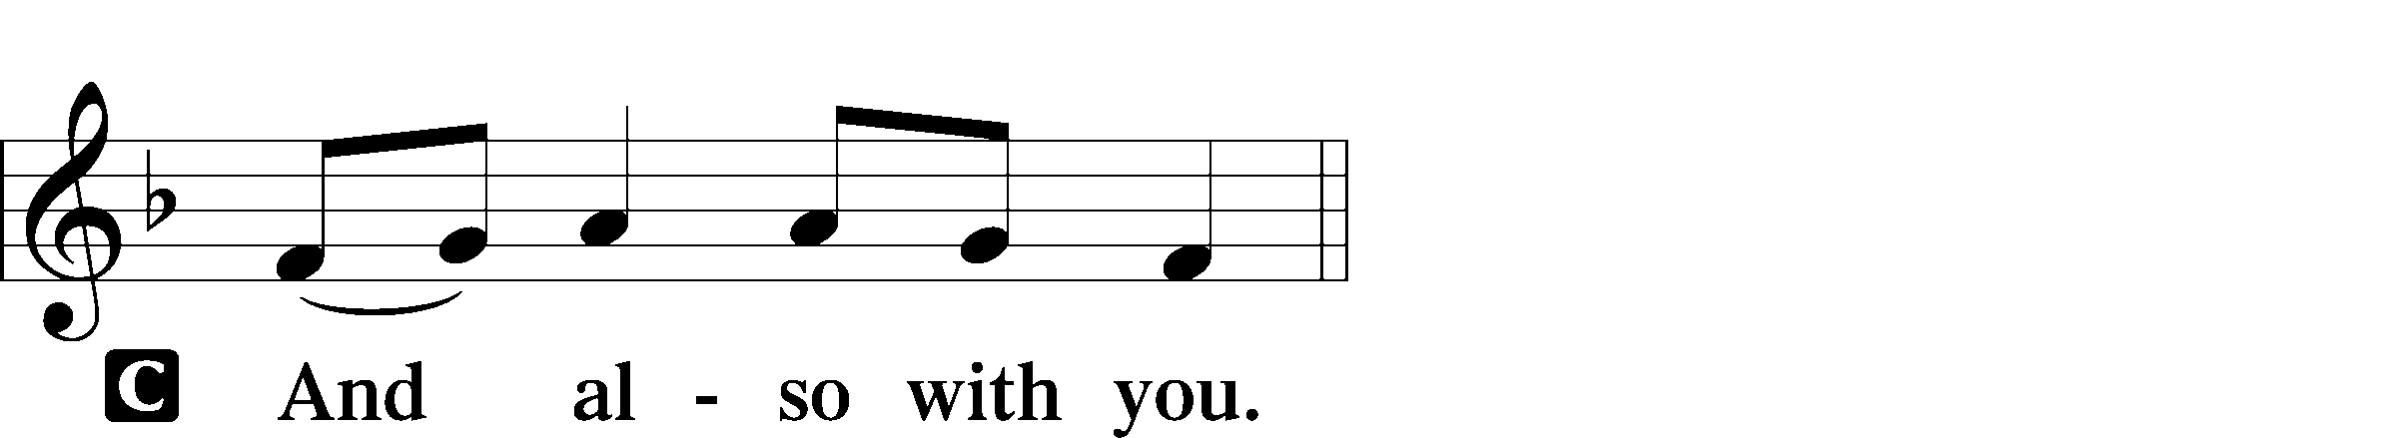

P Lift up your hearts.

P Let us give thanks to the Lord our God.
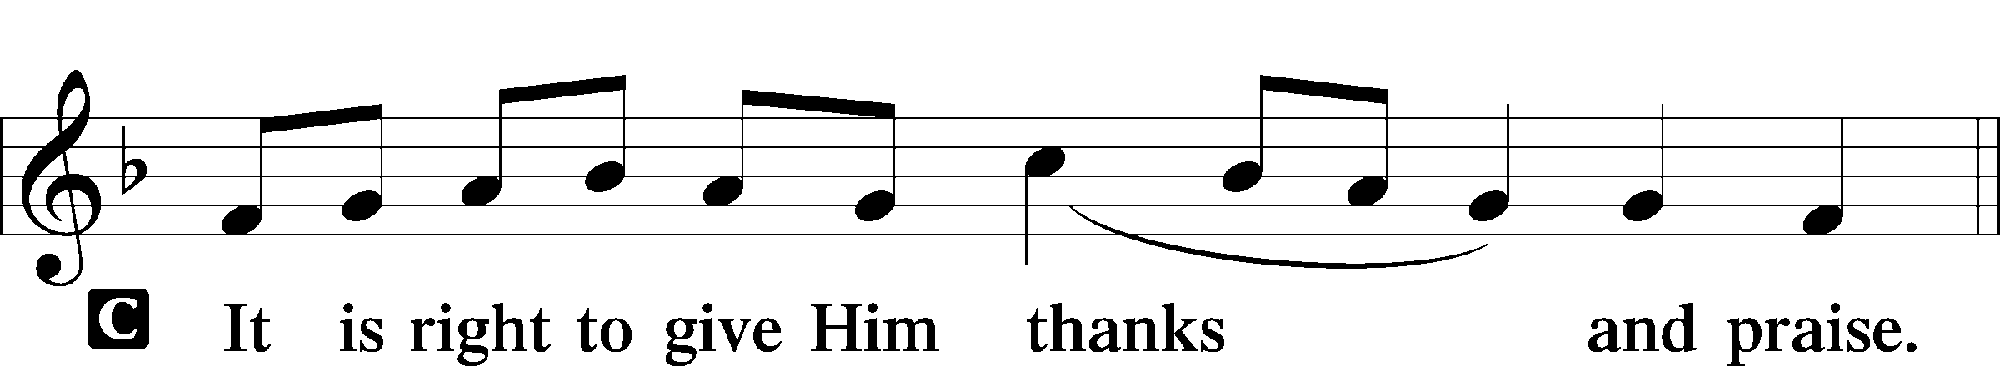

P It is truly good, right, and salutary that we should at all times and in all places give thanks to You, holy Lord, almighty Father, everlasting God. And most especially are we bound to praise You on this day for the glorious resurrection of Your Son, Jesus Christ, the very Paschal Lamb, who was sacrificed for us and bore the sins of the world. By His dying He has destroyed death, and by His rising again He has restored to us everlasting life. Therefore with Mary Magdalene, Peter and John, and with all the witnesses of the resurrection, with angels and archangels, and with all the company of heaven we laud and magnify Your glorious name, evermore praising You and saying:

Sanctus LSB 161
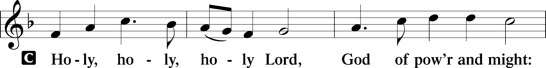
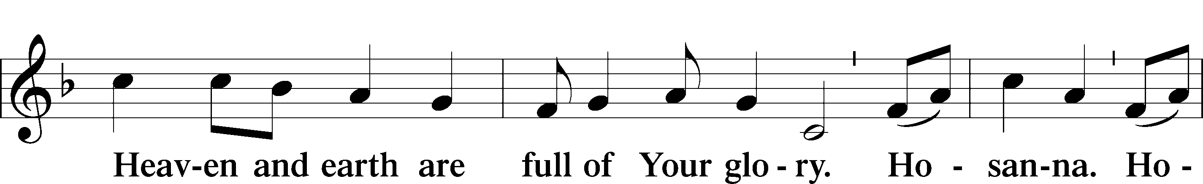
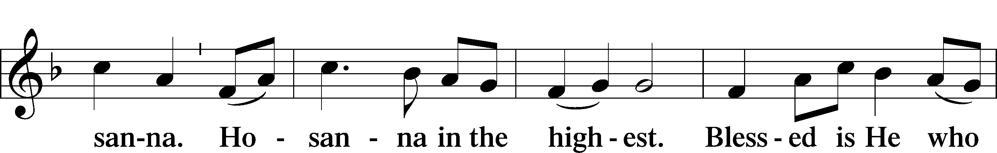
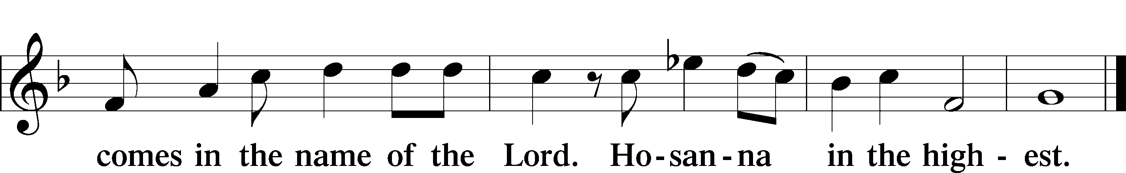

Prayer of Thanksgiving LSB 161
P Blessed are You, Lord of heaven and earth, for You have had mercy on those whom You created and sent Your only-begotten Son into our flesh to bear our sin and be our Savior. With repentant joy we receive the salvation accomplished for us by the all-availing sacrifice of His body and His blood on the cross.

Gathered in the name and the remembrance of Jesus, we beg You, O Lord, to forgive, renew, and strengthen us with Your Word and Spirit. Grant us faithfully to eat His body and drink His blood as He bids us do in His own testament. Gather us together, we pray, from the ends of the earth to celebrate with all the faithful the marriage feast of the Lamb in His kingdom, which has no end. Graciously receive our prayers; deliver and preserve us. To You alone, O Father, be all glory, honor, and worship, with the Son and the Holy Spirit, one God, now and forever.
C Amen.

Lord’s Prayer LSB 162
P Lord, remember us in Your kingdom and teach us to pray:
C Our Father who art in heaven,
hallowed be Thy name,
Thy kingdom come,
Thy will be done on earth
as it is in heaven;
give us this day our daily bread;
and forgive us our trespasses
as we forgive those
who trespass against us;
and lead us not into temptation,
but deliver us from evil.
For Thine is the kingdom
and the power and the glory
forever and ever. Amen.

The Words of Our Lord
P Our Lord Jesus Christ, on the night when He was betrayed, took bread, and when He had given thanks, He broke it and gave it to the disciples and said: “Take, eat; this is My T body, which is given for you. This do in remembrance of Me.”

In the same way also He took the cup after supper, and when He had given thanks, He gave it to them, saying: “Drink of it, all of you; this cup is the new testament in My T blood, which is shed for you for the forgiveness of sins. This do, as often as you drink it, in remembrance of Me.”

Pax Domini LSB 163
P The peace of the Lord be with you always.

Agnus Dei LSB 163
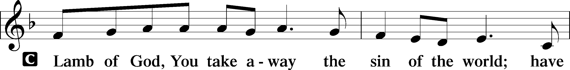
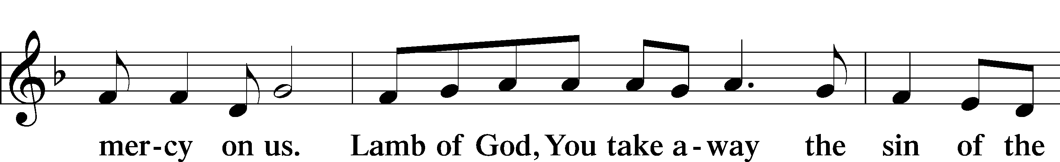
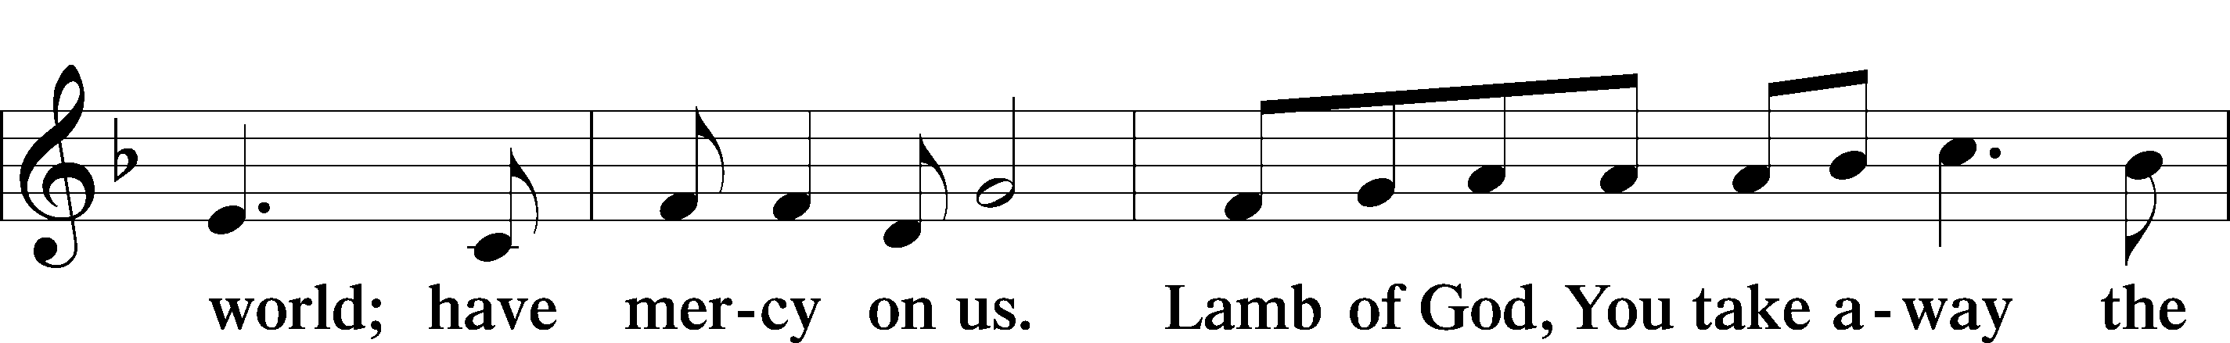
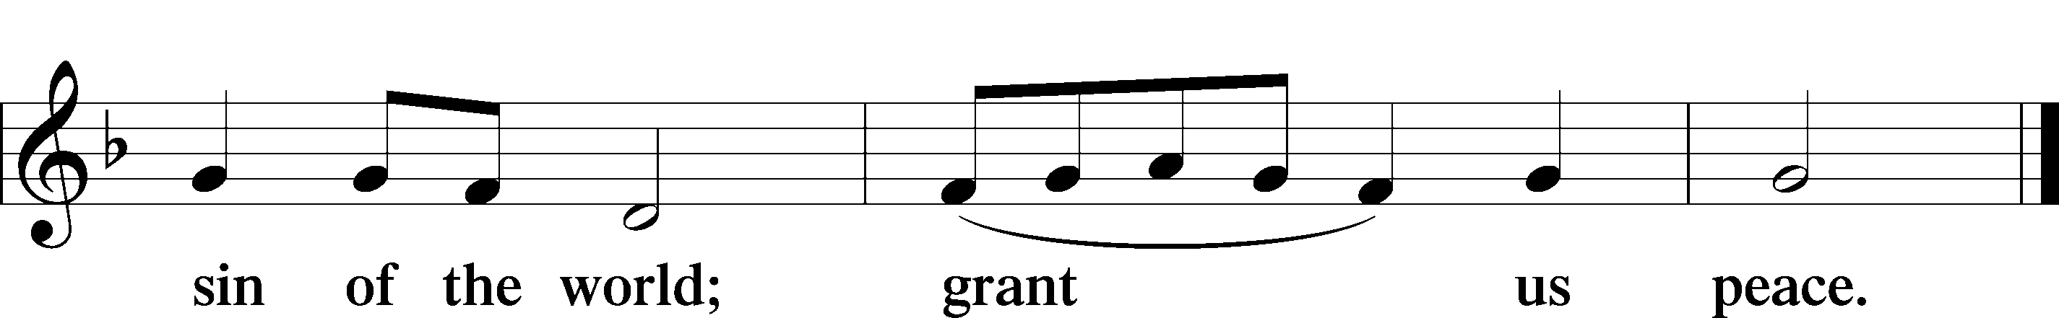

Sit

Distribution

Distribution Hymn: Alleluia, Alleluia, Give Thanks OAR 215
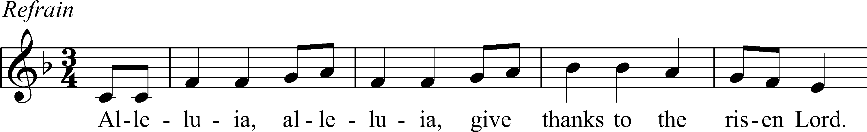
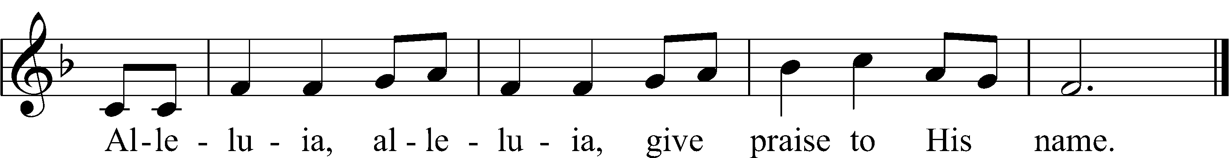
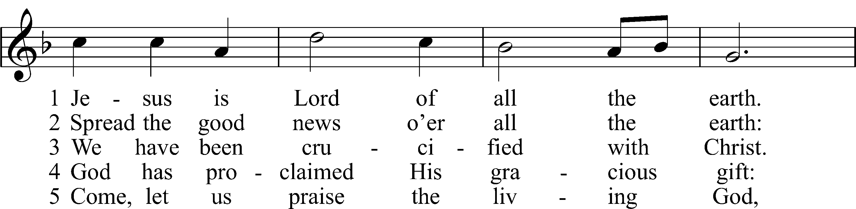
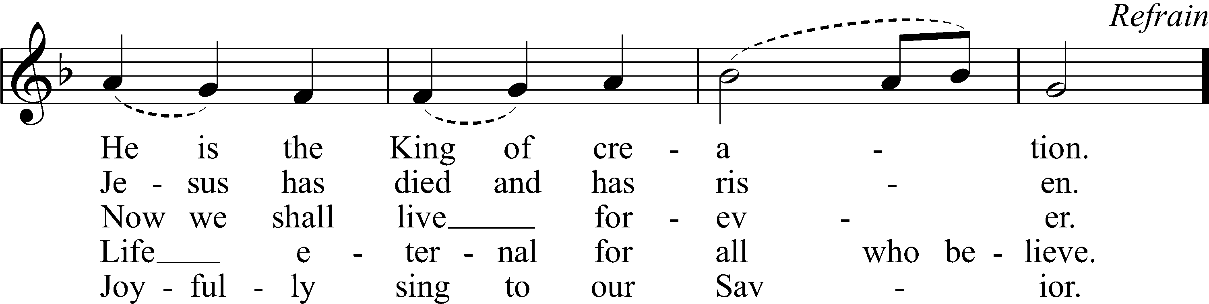
Text: Donald Fishel, b. 1950
Tune: Donald Fishel, b. 1950
Text and tune: © 1973 International Liturgy Publications. Used by permission: OAR Hymn License no. 110005504

Distribution Hymn: At the Lamb's High Feast We Sing LSB 633
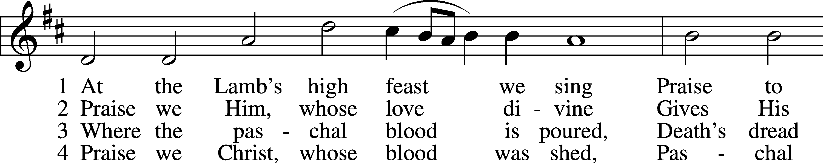
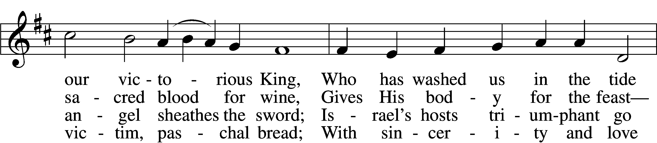
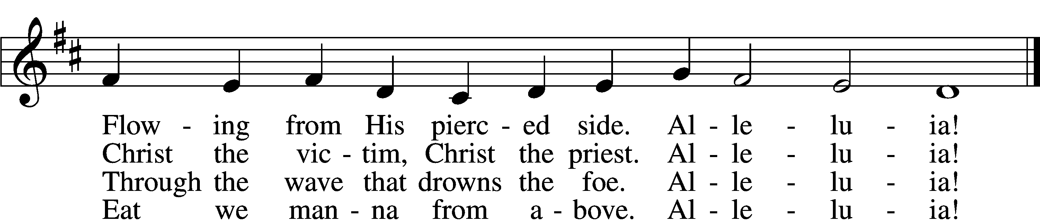

5 Mighty Victim from the sky,
Hell’s fierce pow’rs beneath You lie;
You have conquered in the fight,
You have brought us life and light.
Alleluia!

6 Now no more can death appall,
Now no more the grave enthrall;
You have opened paradise,
And Your saints in You shall rise.
Alleluia!

7 Easter triumph, Easter joy!
This alone can sin destroy;
From sin’s pow’r, Lord, set us free,
Newborn souls in You to be.
Alleluia!

D 8 Father, who the crown shall give,
Savior, by whose death we live,
Spirit, guide through all our days:
Three in One, Your name we praise.
Alleluia!
Text: Latin, c. 5th–10th cent.; tr. Robert Campbell, 1814–68, alt.
Tune: Kirchengeseng, 1566, Ivancice
Text and tune: Public domain

Hymn: He's Risen, He's Risen LSB 480
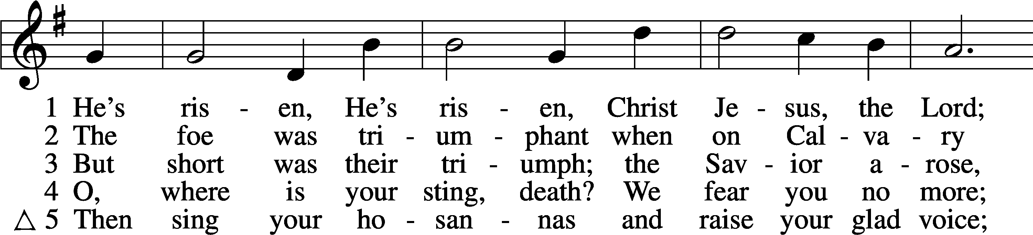
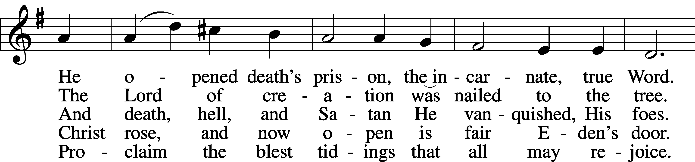
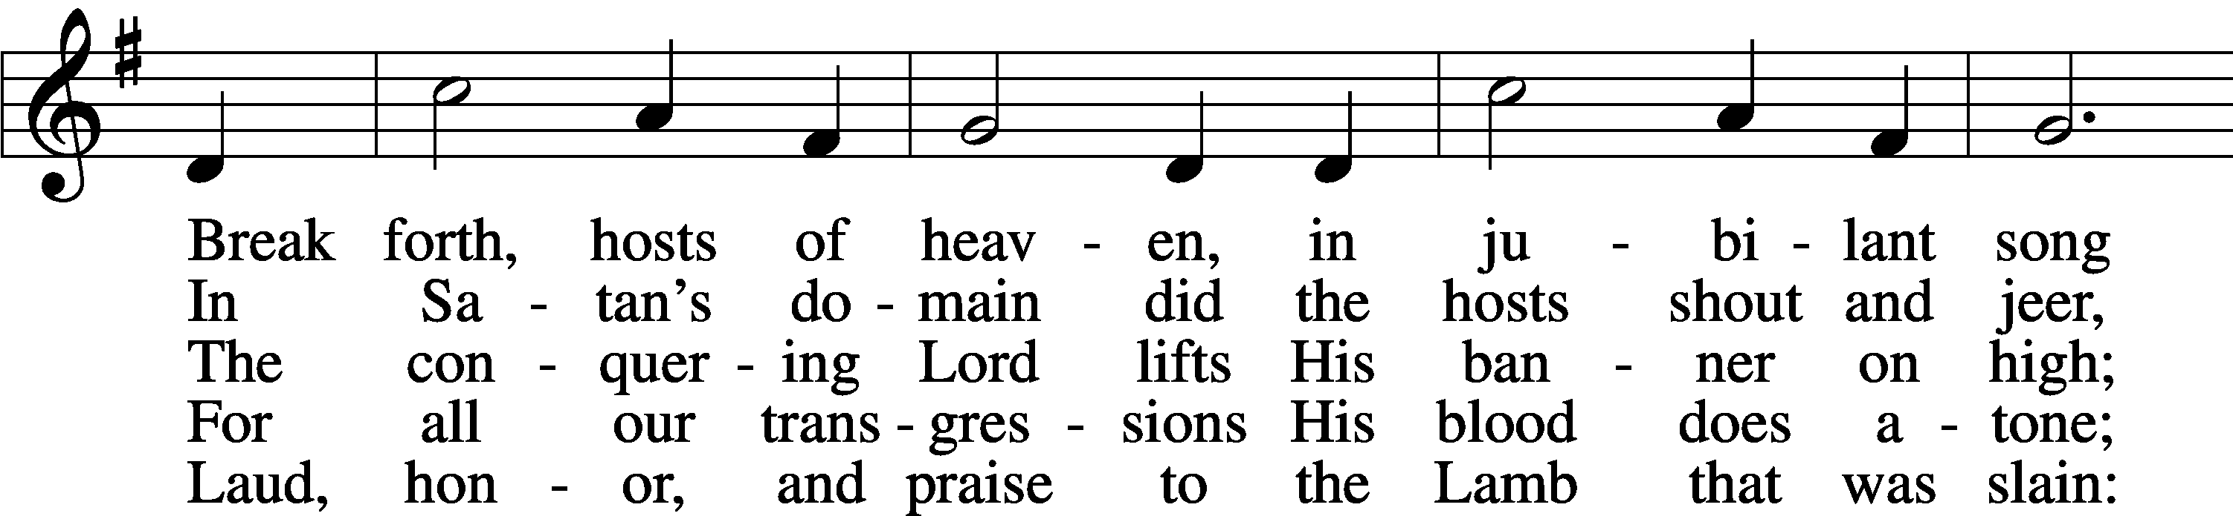
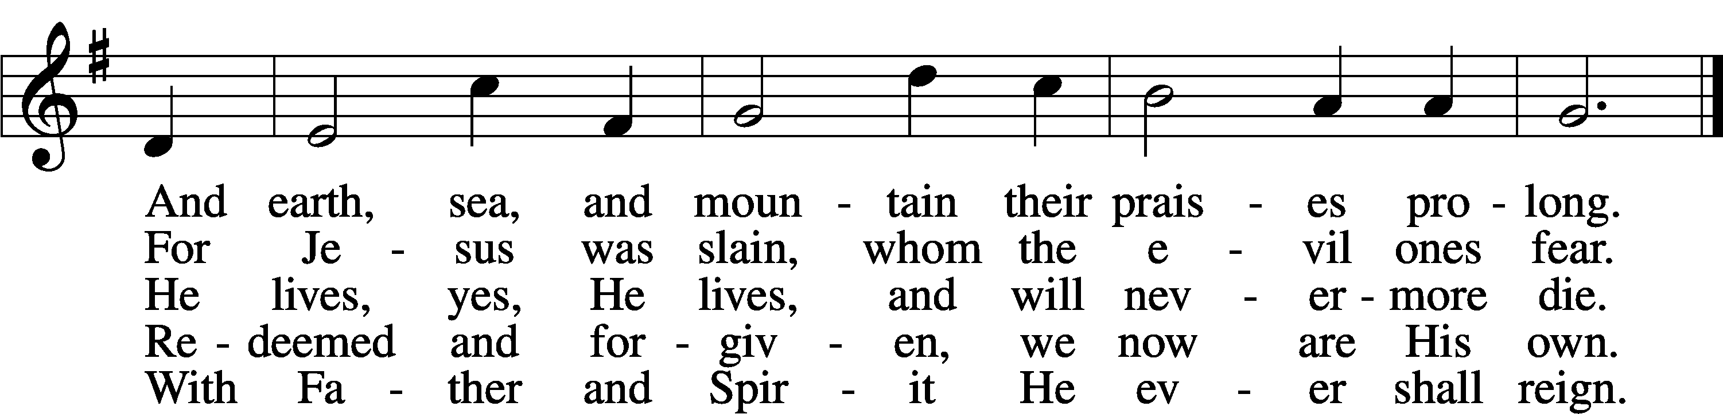
Text: C. F. W. Walther, 1811–87, abr.; tr. Anna M. Meyer, 1867–1941, alt.
Tune: C. F. W. Walther, 1811–87
Text: © 1941 Concordia Publishing House. Used by permission: LSB Hymn License no. 110005504
Tune: Public domain

Stand

Thank the Lord LSB 164
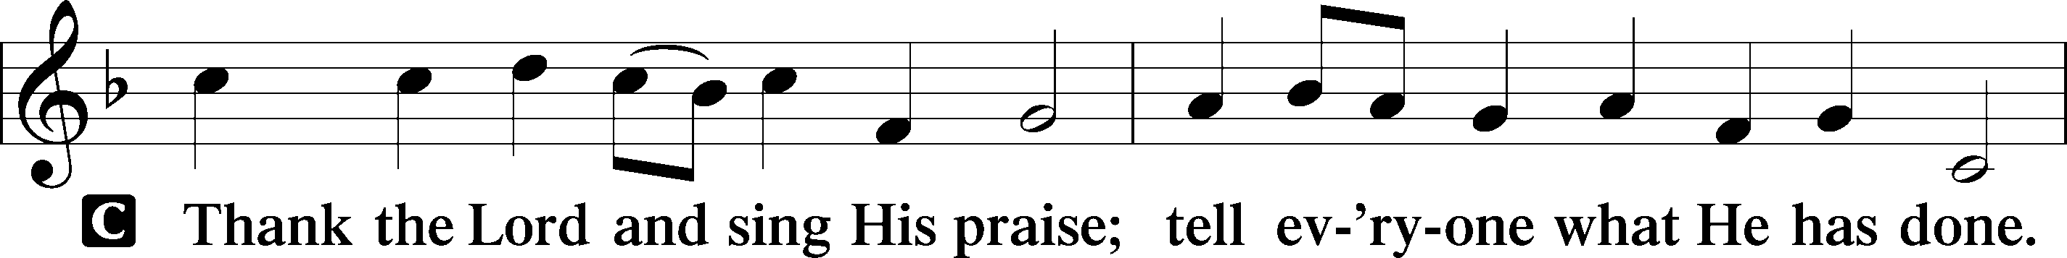
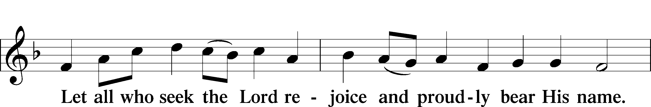
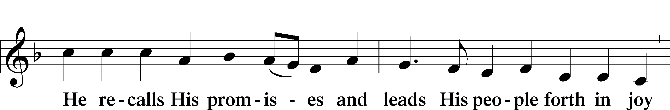
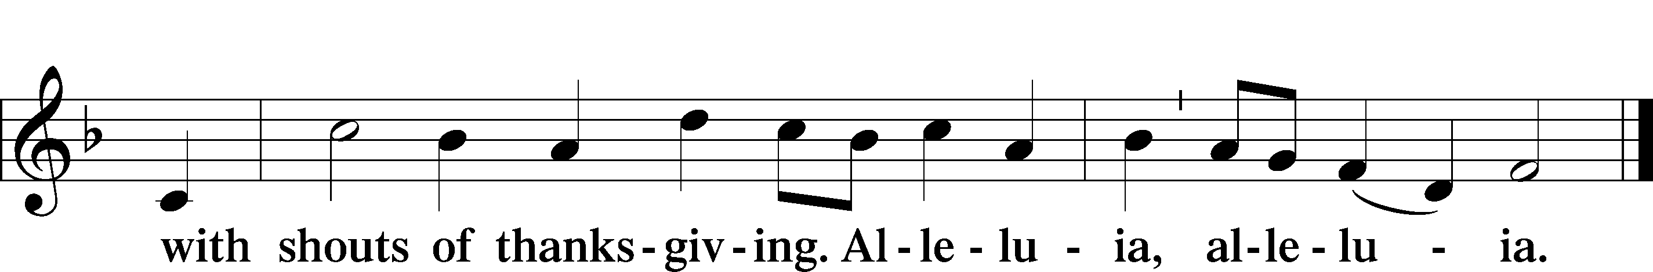

Post-Communion Collect
A Let us pray.
We give thanks to You, almighty God, that You have refreshed us through this salutary gift, and we implore You that of Your mercy You would strengthen us through the same in faith toward You and in fervent love toward one another; through Jesus Christ, Your Son, our Lord, who lives and reigns with You and the Holy Spirit, one God, now and forever.

Benediction LSB 166
P The Lord bless you and keep you.
The Lord make His face shine on you and be gracious to you.
The Lord look upon you with favor and T give you peace.

Hymn to Depart: I Know That My Redeemer Lives LSB 461
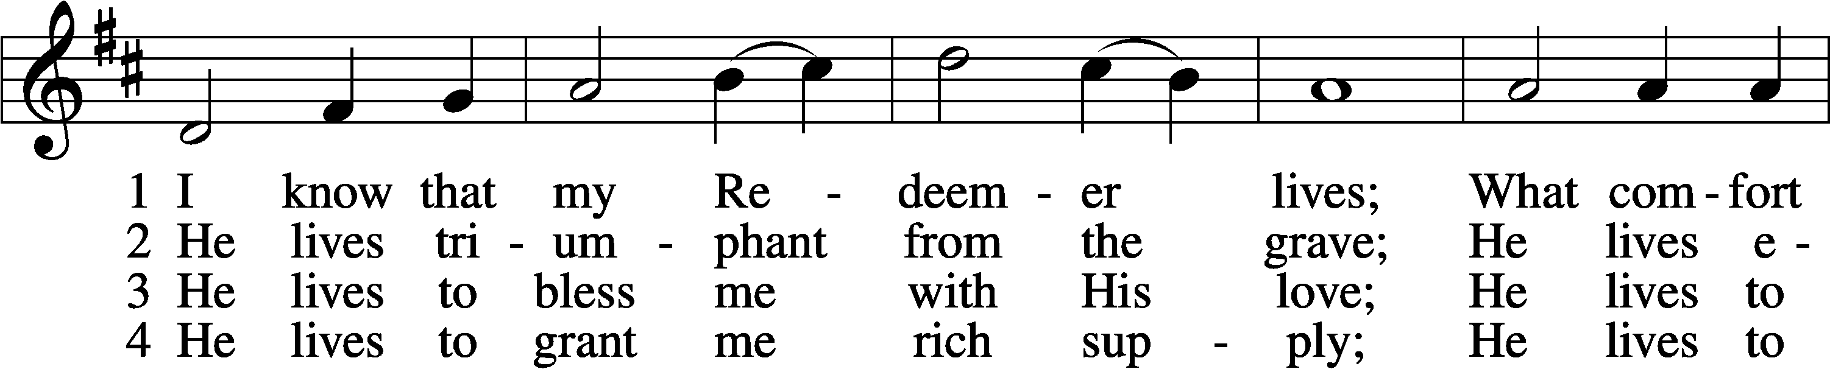
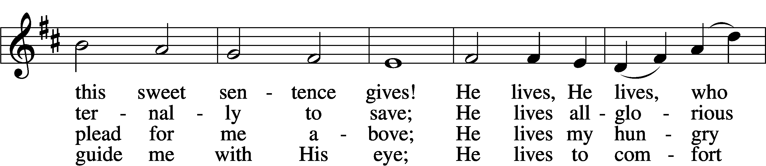
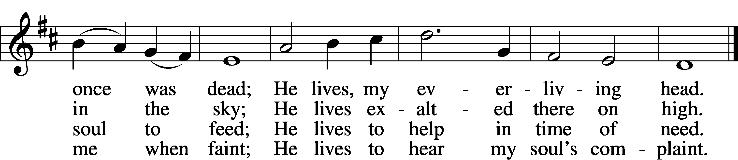

5 He lives to silence all my fears;
He lives to wipe away my tears;
He lives to calm my troubled heart;
He lives all blessings to impart.

6 He lives, my kind, wise, heav’nly friend;
He lives and loves me to the end;
He lives, and while He lives, I’ll sing;
He lives, my Prophet, Priest, and King.

7 He lives and grants me daily breath;
He lives, and I shall conquer death;
He lives my mansion to prepare;
He lives to bring me safely there.

8 He lives, all glory to His name!
He lives, my Jesus, still the same;
Oh, the sweet joy this sentence gives:
I know that my Redeemer lives!
Text: Samuel Medley, 1738–99, abr.
Tune: attr. John C. Hatton, d. 1793
Text and tune: Public domain

Acknowledgments
Divine Service, Setting One from Lutheran Service Book
Unless otherwise indicated, Scripture quotations are from the ESV® Bible (The Holy Bible, English Standard Version®), copyright © 2001 by Crossway, a publishing ministry of Good News Publishers. Used by permission. All rights reserved.
Created by Lutheran Service Builder © 2024 Concordia Publishing House.

Announcements:
Church Service Phone: 888-505-1870/715-438-4200
(Stay on the line for recorded service to start)
Live Stream audio services: http://salem.listentochurch.com
Salem’s Web Page: https://www.salembarron.com/

Pastor Michael Nielsen: Cell phone: 218-280-0999
Email: rev.mike.nielsen@gmail.com
Pastor’s Office Hours: Monday-Wednesday 9-12
Attendance: 3/24 - 89

Coffee and Snacks: YFM
Elder Today: Stan Koenig
Altar Guild: MaryAnn Thompson and Kari Longmire

Link to Salem’s Facebook page is:
https://www.facebook.com/SalemEvangelicalLutheranChurchAndPreschool/

Schedule for the upcoming week:
Monday: 7:00 PM – Elder’s Meeting
Tuesday: 8:00 AM Men’s Bible Class
9:30 AM – Men’s Club Meeting
Wednesday: 4:00 PM Catechism Class

Save the date:
April 7 – 10:15-11:15 – Jim and Susan Kaiser – Missionaries of LBT
April 7 – 11:30 – Chili and Cookie Contest
April 14 – 10:30 – PreCall Meeting With Pres. Lueck of the North Wisconsin District
April 15 – 6:00 PM – Circuit Lay Leader Meeting @ St. Paul’s Cumberland

A Call Committee is being put together. If you are interested please contact an Elder or Sue in the office.

Member information is on the table in the fellowhip hall, please look at it and update your information if needed.

Pastor Fred Buth will be our vacancy pastor.
He can be contacted at salembarronpastor@gmail.com or 1-715-353-2540

Pastor Nielsen’s new address is 108 Cecilia Ct. Waukesha, WI 53188 as of April 3, 2024

We are still looking for a Director for the VBS program, prayerfully consider this.

Prayer requests:

Those in the nursing home: Joann Jaeger
Those Shut-in at home: Char Herman, Joan Church, Joyce Myers, Joyce Koba
Those with ongoing health issues: Harrison Fields, Jeanne Perala, Owen Metz, Kathy Nielsen (Pastor’s aunt), Jeff Bonneville, Daria (Cindy Wright’s friend), Butch L. (Cindy Wright’s Brother-in-law), Melissa Miller., Dale Bryan, Art Smith (Sue Millerman’s brother), Brenda Sellent (Denise Stabenow’s sister), Sandy Hahn (Cindy Wright’s cousin’s wife), Wayne Hahn (Cindy Wright’s Uncle)
Recovering from surgery: Wyatt Weise, Gail Espeseth
For Pastor Nielsen and family as they begin the transition to St. John’s North Prairie.
For Salem and St. John’s in their transitions of ministry.
Those who lead our nation: Joe Biden, Kamala Harris, Tony Evers, Rod Nordby
Those who serve in our military and law enforcement: Ryan Graf, Chaplain Pon Chanthaphon (Our Adopt-a-Chaplain), Rusty Weise

Our Childcare Staff: Melissa Weinert, Denise Stabenow, Katelyn Hendren, Holly Wilhelmi, Janica Skjerly, Jacie Amundson, Emily Young, Zuri Soto

For Christ Community Lutheran School – For Community Support for CCLS
Families of the Week: John Ladwig, Freida Lentz, Tom and Deb Lipke, Duane and Kari Longmire, Mahlon and Barb Maas

Mission Statement
The Mission of Salem Lutheran Church is to be what God called us to be through faith in Jesus Christ, a body of believers engaged in building the Kingdom of God by discipling the Barron area with His Word and Sacrament ministry.

