Palm Sunday
March 24, 2024
9:00 AM

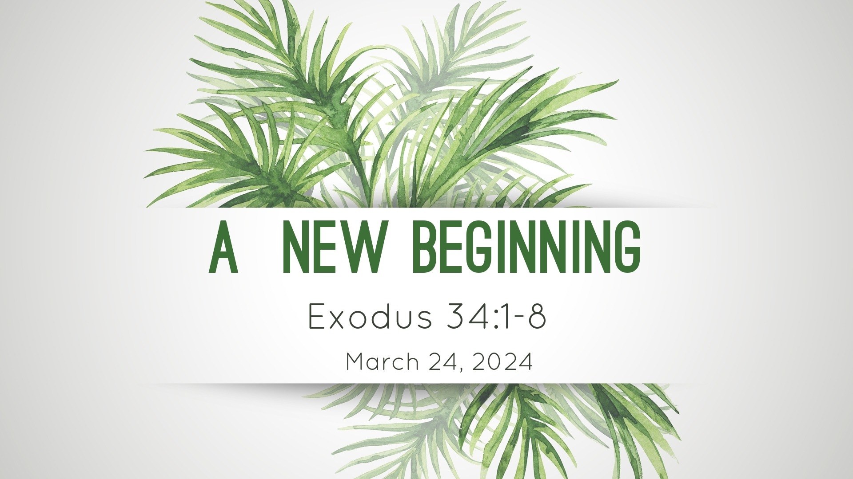

Salem Lutheran Church
1-715-537-3011
http://www.salembarron.com
rev.mike.nielsen@gmail.com

Theme of the Day: Our past is behind us. God’s grace is before us. A new beginning awaits us. That’s the message for Israel in Exodus 34. And that’s God’s message for us as well on this Palm Sunday weekend!

Procession of Palms

If the procession begins outside the nave, the congregation gathers around the processional cross. If the congregation is already seated in the nave, it now stands and faces the processional cross at the entrance to the nave.

Greeting
P The grace of our Lord T Jesus Christ and the love of God and the communion of the Holy Spirit be with you all.
C Amen.

P Blessed is He who comes in the name of the Lord.
C Hosanna to the Son of David.

Collect
P Let us pray.
Most merciful God, as the people of Jerusalem, with palms in their hands, gathered to greet Your dearly beloved Son when He came into His Holy City, grant that we may ever hail Him as our King and, when He comes again, may go forth to meet Him with trusting and steadfast hearts and follow Him in the way that leads to eternal life; through the same Jesus Christ, our Lord, who lives and reigns with You and the Holy Spirit, one God, now and forever.
C Amen.

Sunday School Children Sing

Holy Gospel John 12:12–19
P The Holy Gospel according to St. John, the twelfth chapter.
C Glory to You, O Lord.

P 12The next day the large crowd that had come to the feast heard that Jesus was coming to Jerusalem. 13So they took branches of palm trees and went out to meet him, crying out, “Hosanna! Blessed is he who comes in the name of the Lord, even the King of Israel!” 14And Jesus found a young donkey and sat on it, just as it is written,
15“Fear not, daughter of Zion;
behold, your king is coming,
sitting on a donkey’s colt!”
16His disciples did not understand these things at first, but when Jesus was glorified, then they remembered that these things had been written about him and had been done to him. 17The crowd that had been with him when he called Lazarus out of the tomb and raised him from the dead continued to bear witness. 18The reason why the crowd went to meet him was that they heard he had done this sign. 19So the Pharisees said to one another, “You see that you are gaining nothing. Look, the world has gone after him.”

P This is the Gospel of the Lord.
C Praise to You, O Christ.

P Let us go forth in peace,
C in the name of the Lord.

442 All Glory, Laud, and Honor
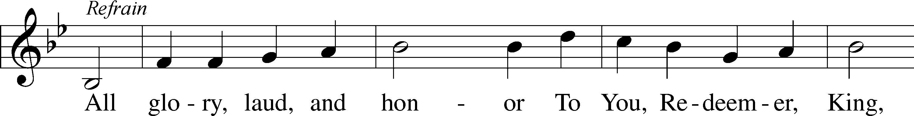
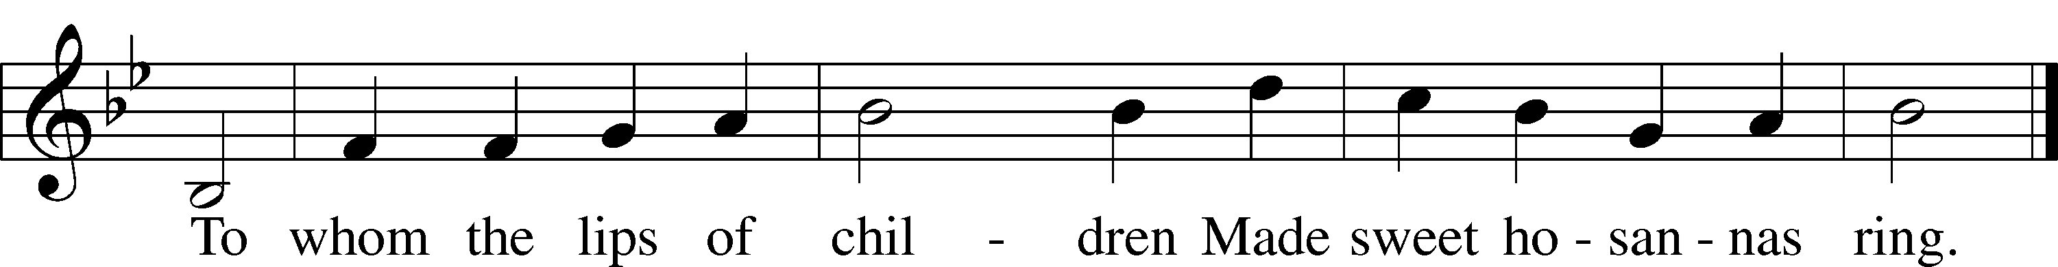
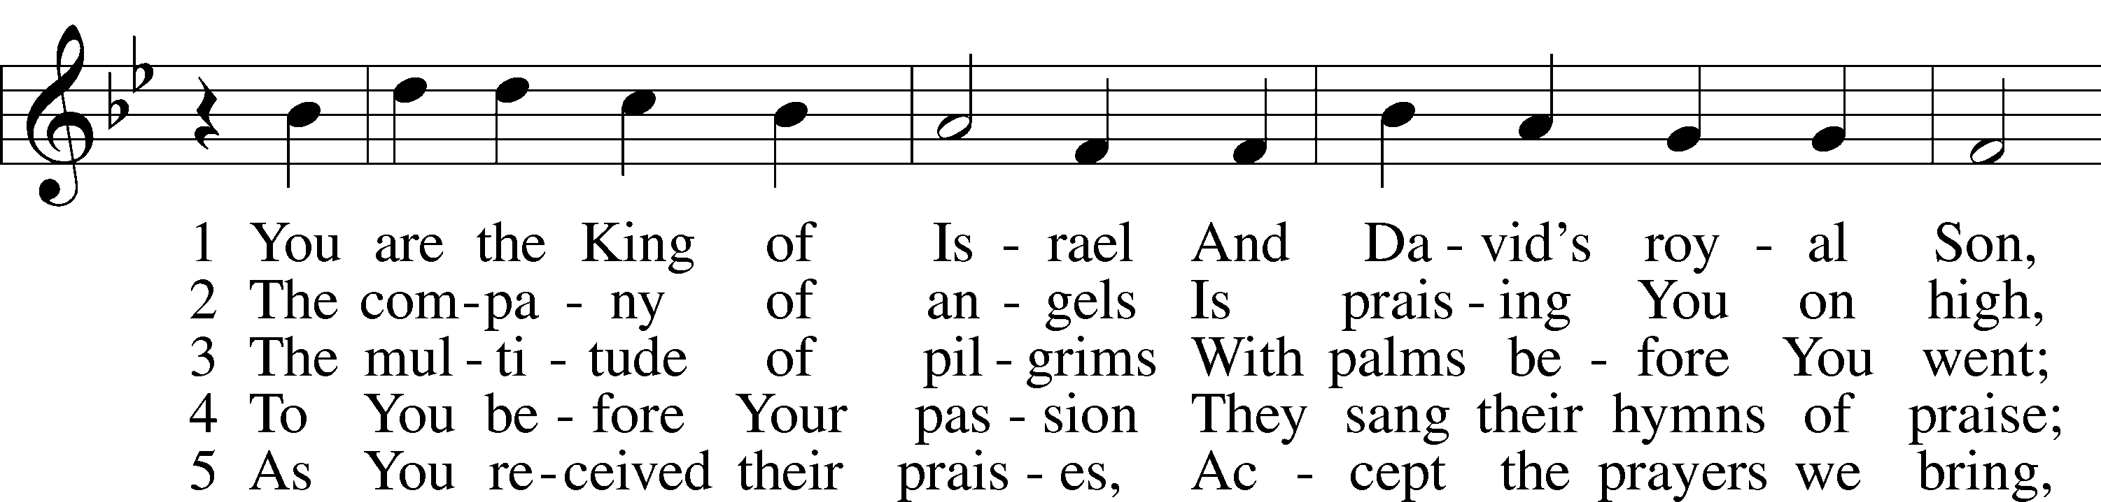
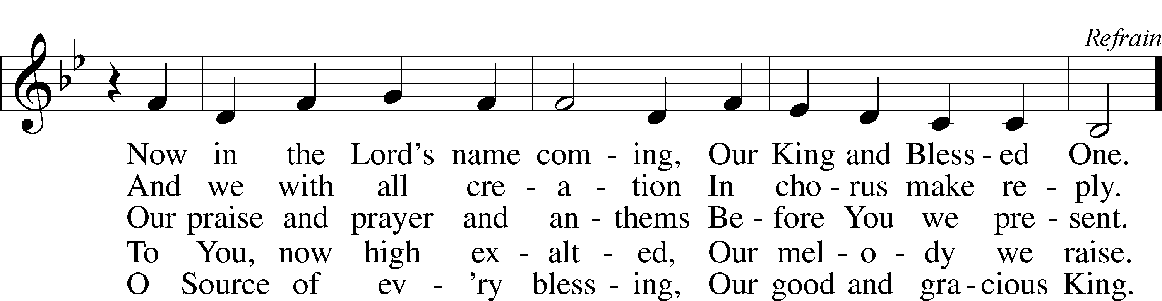
Text: Theodulf of Orléans, c. 762–821; tr. John Mason Neale, 1818–66, alt.
Tune: Melchior Teschner, 1584–1635, alt.
Text and tune: Public domain

When all have arrived at their places, the procession concludes with the following:

P Blessed is He who comes in the name of the Lord.
C Hosanna in the highest.

A time of silence may be observed to highlight the contrast between Jesus’ triumphal entry and His passion.

Collect of the Day
P Let us pray.
Almighty and everlasting God, You sent Your Son, our Savior Jesus Christ, to take upon Himself our flesh and to suffer death upon the cross. Mercifully grant that we may follow the example of His great humility and patience and be made partakers of His resurrection; through the same Jesus Christ, our Lord, who lives and reigns with You and the Holy Spirit, one God, now and forever.
C Amen.

Confession and Absolution

Stand

The sign of the cross may be made by all in remembrance of their Baptism.

Invocation
P In the name of the Father and of the T Son and of the Holy Spirit.
C Amen.

Exhortation LSB 203
P Our help is in the name of the Lord,
C who made heaven and earth.

P If You, O Lord, kept a record of sins, O Lord, who could stand?
C But with You there is forgiveness; therefore You are feared.

P Since we are gathered to hear God’s Word, call upon Him in prayer and praise, and receive the body and blood of our Lord Jesus Christ in the fellowship of this altar, let us first consider our unworthiness and confess before God and one another that we have sinned in thought, word, and deed, and that we cannot free ourselves from our sinful condition. Together as His people let us take refuge in the infinite mercy of God, our heavenly Father, seeking His grace for the sake of Christ, and saying: God, be merciful to me, a sinner.

Confession of Sins LSB 203
C Almighty God, have mercy upon us, forgive us our sins, and lead us to everlasting life. Amen.

Absolution LSB 203
P Almighty God in His mercy has given His Son to die for you and for His sake forgives you all your sins. As a called and ordained servant of Christ, and by His authority, I therefore forgive you all your sins in the name of the Father and of the T Son and of the Holy Spirit.
C Amen.
Service of the Word

Hymn: Hosanna, Loud Hosanna LSB 443
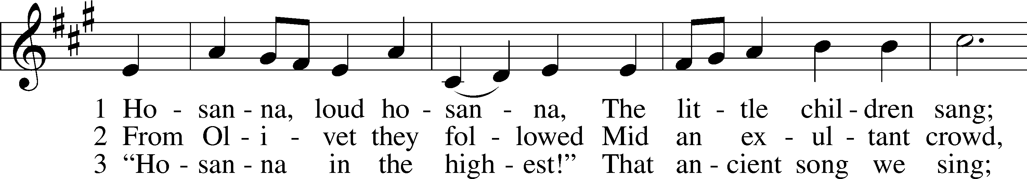
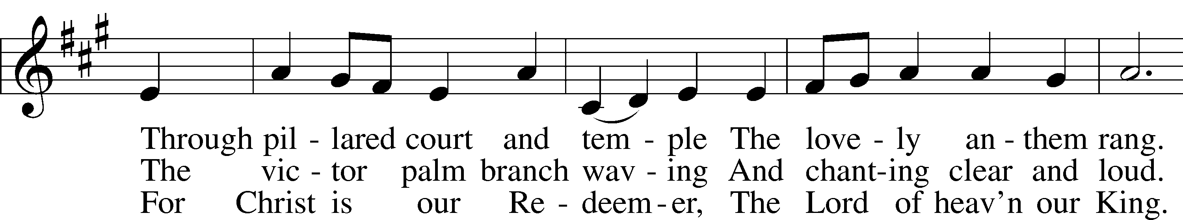
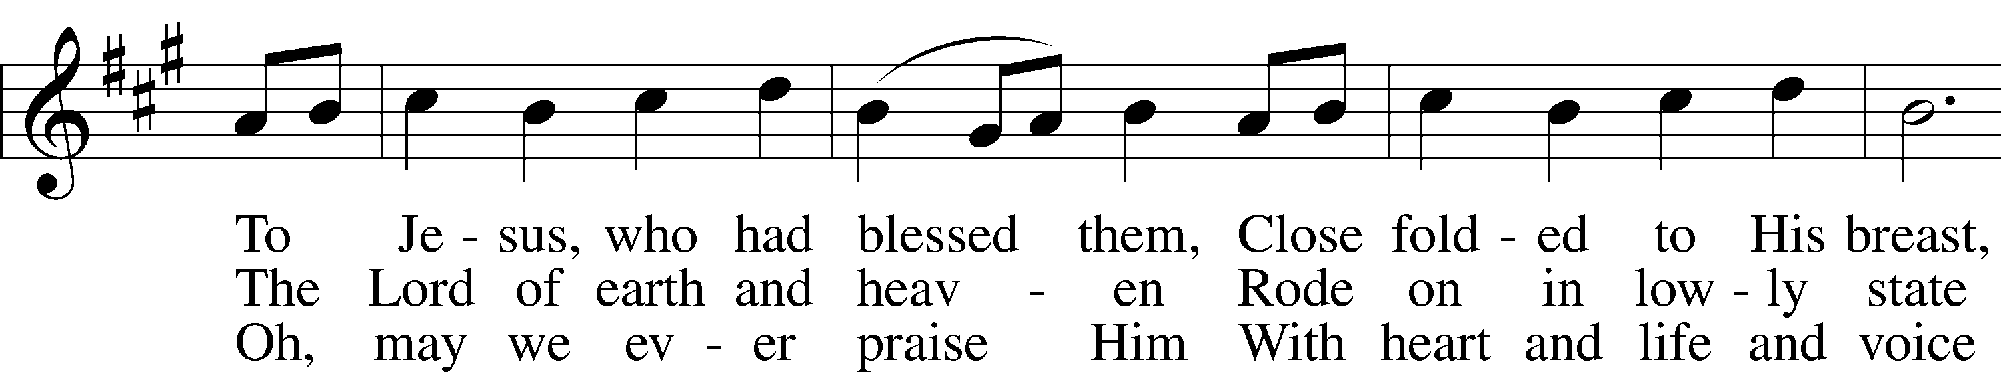
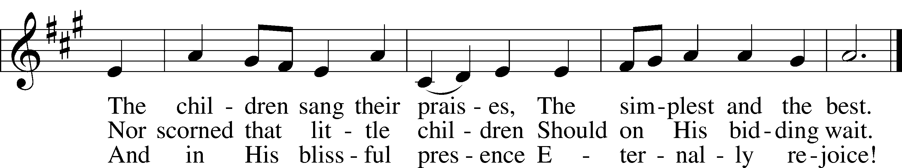
Text: Jeannette Threlfall, 1821–80, alt.
Tune: Gesangbuch der Herzogl. Hofkapelle, 1784, Württemberg
Text and tune: Public domain
Service of the Word

Introit Psalm 24:7–10; antiphon: Psalm 118:26
Blessèd is he who comes in the name | of the Lord!*
We bless you from the house | of the Lord.
Lift up your heads, O gates! And be lifted up, O | ancient doors,*
that the King of glory | may come in.
Who is this King of | glory?*
The Lord, strong and mighty, the Lord, mighty in | battle!
Lift up your heads, O gates! And lift them up, O | ancient doors,*
that the King of glory | may come in.
Who is this King of | glory?*
The Lord of hosts, he is the King of | glory!
Blessèd is he who comes in the name | of the Lord!*
We bless you from the house | of the Lord.

Kyrie LSB 204
C Lord, have mercy; Christ, have mercy; Lord, have mercy.

Salutation and Collect of the Day
P The Lord be with you.
C And also with you.

P Let us pray.
Almighty God, grant that in the midst of our failures and weaknesses we may be restored through the passion and intercession of Your only-begotten Son, who lives and reigns with You and the Holy Spirit, one God, now and forever.
C Amen.

Sit

Old Testament Reading Exodus 34:1–8
1The Lord said to Moses, “Cut for yourself two tablets of stone like the first, and I will write on the tablets the words that were on the first tablets, which you broke. 2Be ready by the morning, and come up in the morning to Mount Sinai, and present yourself there to me on the top of the mountain. 3No one shall come up with you, and let no one be seen throughout all the mountain. Let no flocks or herds graze opposite that mountain.” 4So Moses cut two tablets of stone like the first. And he rose early in the morning and went up on Mount Sinai, as the Lord had commanded him, and took in his hand two tablets of stone. 5The Lord descended in the cloud and stood with him there, and proclaimed the name of the Lord. 6The Lord passed before him and proclaimed, “The Lord, the Lord, a God merciful and gracious, slow to anger, and abounding in steadfast love and faithfulness, 7keeping steadfast love for thousands, forgiving iniquity and transgression and sin, but who will by no means clear the guilty, visiting the iniquity of the fathers on the children and the children’s children, to the third and the fourth generation.” 8And Moses quickly bowed his head toward the earth and worshiped.

A This is the Word of the Lord.
C Thanks be to God.

Psalm
[During our sermon series on Exodus we are using psalms that celebrate Israel’s deliverance from Egypt. Today we use selected verses from Psalms 8 and 135.]
Psalm 8 and 135
P: Praise the LORD! Praise the name of the LORD!
C: Praise the LORD, for the LORD is good.
P: Celebrate his lovely name with music.
C: For the LORD has chosen Jacob for himself.
P: Israel for his own special treasure.
C: He destroyed the firstborn in each Egyptian home—
P: Both people and animals.
C: He performed miraculous signs and wonders in Egypt.
P: Against Pharaoh and all his people.
C: O LORD, our Lord!
All: How majestic is your name in all the earth!

Epistle 2 Corinthians 5:14—6:2
14For the love of Christ controls us, because we have concluded this: that one has died for all, therefore all have died; 15and he died for all, that those who live might no longer live for themselves but for him who for their sake died and was raised.
16From now on, therefore, we regard no one according to the flesh. Even though we once regarded Christ according to the flesh, we regard him thus no longer. 17Therefore, if anyone is in Christ, he is a new creation. The old has passed away; behold, the new has come. 18All this is from God, who through Christ reconciled us to himself and gave us the ministry of reconciliation; 19that is, in Christ God was reconciling the world to himself, not counting their trespasses against them, and entrusting to us the message of reconciliation. 20Therefore, we are ambassadors for Christ, God making his appeal through us. We implore you on behalf of Christ, be reconciled to God. 21For our sake he made him to be sin who knew no sin, so that in him we might become the righteousness of God.
1Working together with him, then, we appeal to you not to receive the grace of God in vain. 2For he says,
“In a favorable time I listened to you,
and in a day of salvation I have helped you.”
Behold, now is the favorable time; behold, now is the day of salvation.

A This is the Word of the Lord.
C Thanks be to God.

Stand

Holy Gospel Matthew 21:1–11
P The Holy Gospel according to St. Matthew, the twenty-first chapter.
C Glory to You, O Lord.

1Now when they drew near to Jerusalem and came to Bethphage, to the Mount of Olives, then Jesus sent two disciples, 2saying to them, “Go into the village in front of you, and immediately you will find a donkey tied, and a colt with her. Untie them and bring them to me. 3If anyone says anything to you, you shall say, ‘The Lord needs them,’ and he will send them at once.” 4This took place to fulfill what was spoken by the prophet, saying,
5“Say to the daughter of Zion,
‘Behold, your king is coming to you,
humble, and mounted on a donkey,
and on a colt, the foal of a beast of burden.’”
6The disciples went and did as Jesus had directed them. 7They brought the donkey and the colt and put on them their cloaks, and he sat on them. 8Most of the crowd spread their cloaks on the road, and others cut branches from the trees and spread them on the road. 9And the crowds that went before him and that followed him were shouting, “Hosanna to the Son of David! Blessed is he who comes in the name of the Lord! Hosanna in the highest!” 10And when he entered Jerusalem, the whole city was stirred up, saying, “Who is this?” 11And the crowds said, “This is the prophet Jesus, from Nazareth of Galilee.”

P This is the Gospel of the Lord.
C Praise to You, O Christ.

Nicene Creed
C I believe in one God,
the Father Almighty,
maker of heaven and earth
and of all things visible and invisible.

And in one Lord Jesus Christ,
the only-begotten Son of God,
begotten of His Father before all worlds,
God of God, Light of Light,
very God of very God,
begotten, not made,
being of one substance with the Father,
by whom all things were made;
who for us men and for our salvation came down from heaven
and was incarnate by the Holy Spirit of the virgin Mary
and was made man;
and was crucified also for us under Pontius Pilate.
He suffered and was buried.
And the third day He rose again according to the Scriptures
and ascended into heaven
and sits at the right hand of the Father.
And He will come again with glory to judge both the living and the dead,
whose kingdom will have no end.

And I believe in the Holy Spirit,
the Lord and giver of life,
who proceeds from the Father and the Son,
who with the Father and the Son together is worshiped and glorified,
who spoke by the prophets.
And I believe in one holy Christian and apostolic Church,
I acknowledge one Baptism for the remission of sins,
and I look for the resurrection of the dead
and the life T of the world to come. Amen.

Sit

Hymn of the Day: No Tramp of Soldiers' Marching Feet LSB 444
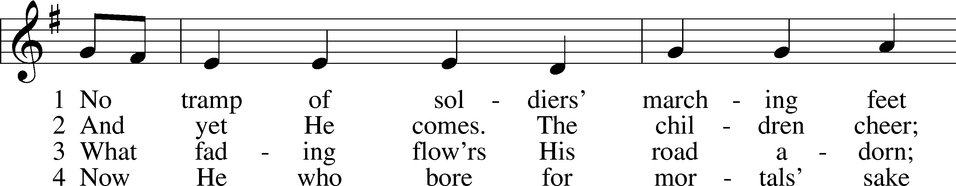
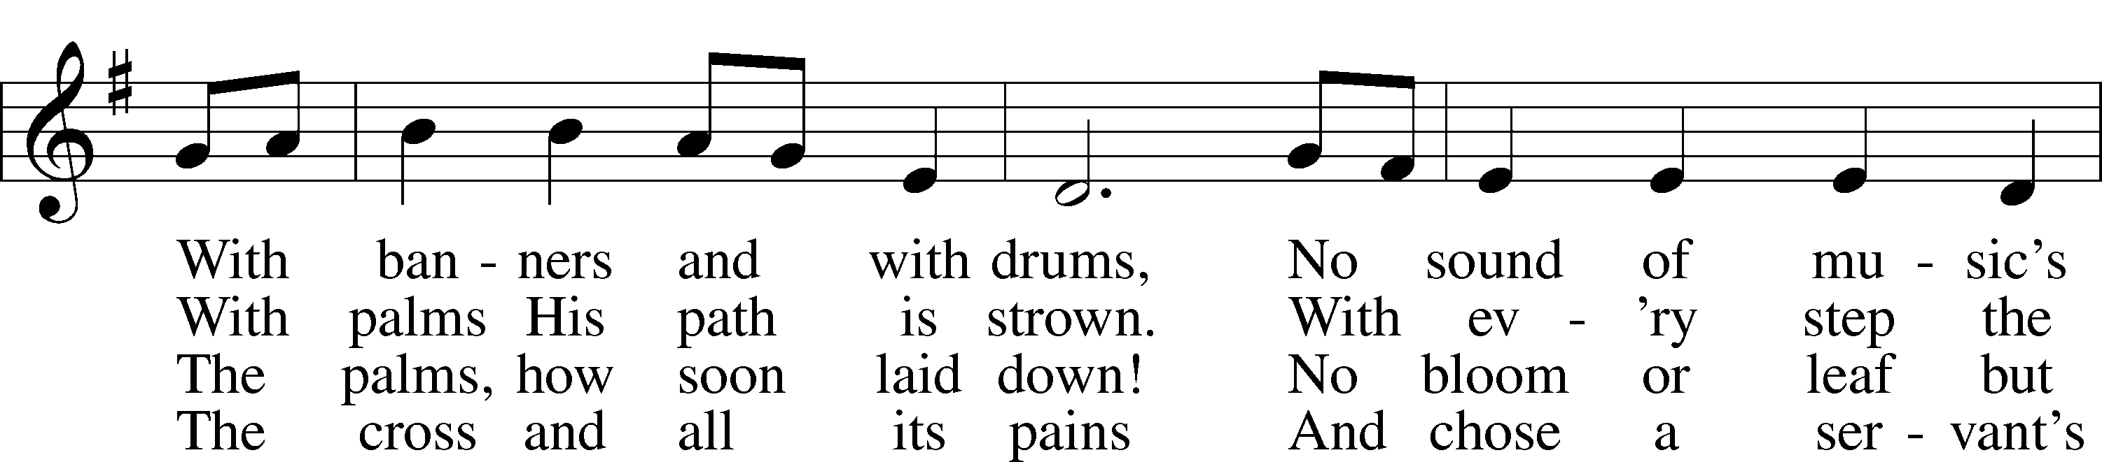
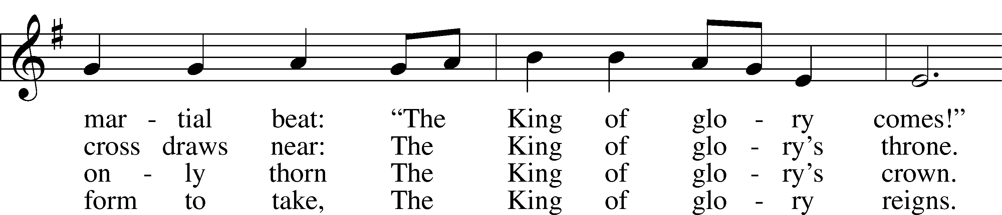
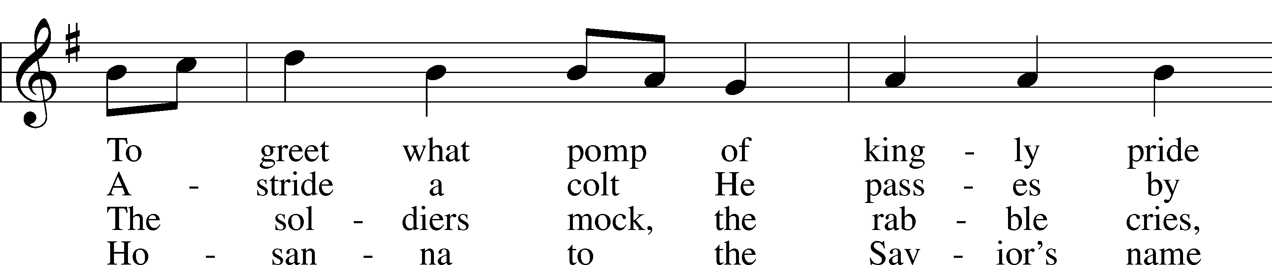
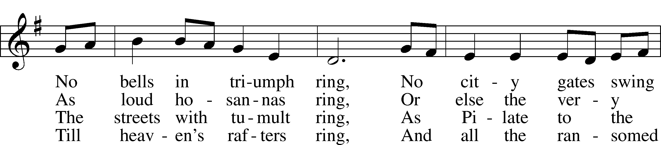
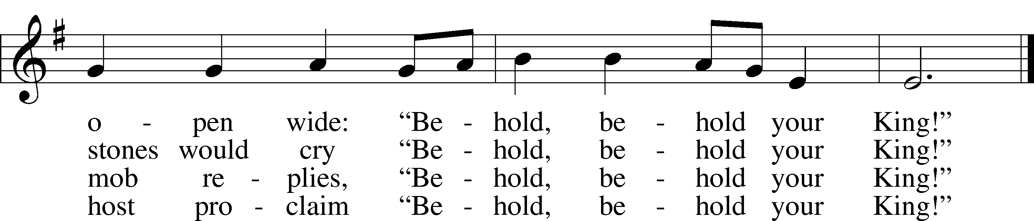
Text: Timothy Dudley-Smith, 1926
Tune: English; adapt. and harm. Ralph Vaughan Williams, 1872–1958, alt.
Text: © 1984 Hope Publishing Co. Used by permission: LSB Hymn License no. 110005504
Tune: Public domain

Sermon

Confirmation

The pastor addresses the catechumens.

P Beloved in the Lord, our Lord Jesus Christ said to His apostles: “All authority has been given to Me in heaven and on earth. Therefore go and make disciples of all nations, baptizing them in the name of the Father and of the Son and of the Holy Spirit, teaching them to observe all things that I have commanded you; and lo, I am with you always, even to the end of the age.” You have been baptized and catechized in the Christian faith according to our Lord’s bidding. Jesus said, “Whoever confesses Me before men, I will also confess before My Father who is in heaven. But whoever denies Me before men, I will also deny before My Father who is in heaven.” Lift up your hearts, therefore, to the God of all grace and joyfully give answer to what I now ask you in the name of the Lord.

P Do you this day in the presence of God and of this congregation acknowledge the gifts that God gave you in your Baptism?
R Yes, I do.

P Do you renounce the devil?
R Yes, I renounce him.

P Do you renounce all his works?
R Yes, I renounce them.

P Do you renounce all his ways?
R Yes, I renounce them.

P Do you believe in God, the Father Almighty?
R Yes, I believe in God, the Father Almighty, maker of heaven and earth.

P Do you believe in Jesus Christ, His only Son, our Lord?
R Yes, I believe in Jesus Christ, His only Son, our Lord, who was conceived by the Holy Spirit, born of the virgin Mary, suffered under Pontius Pilate, was crucified, died and was buried. He descended into hell. The third day He rose again from the dead. He ascended into heaven and sits at the right hand of God the Father Almighty. From thence He will come to judge the living and the dead.

P Do you believe in the Holy Spirit?
R Yes, I believe in the Holy Spirit, the holy Christian Church, the communion of saints, the forgiveness of sins, the resurrection of the body, and the life everlasting.

P Do you hold all the prophetic and apostolic Scriptures to be the inspired Word of God?
R I do.

P Do you confess the doctrine of the Evangelical Lutheran Church, drawn from the Scriptures, as you have learned to know it from the Small Catechism, to be faithful and true?
R I do.

P Do you intend to hear the Word of God and receive the Lord’s Supper faithfully?
R I do, by the grace of God.

P Do you intend to live according to the Word of God, and in faith, word, and deed to remain true to God, Father, Son, and Holy Spirit, even to death?
R I do, by the grace of God.

P Do you intend to continue steadfast in this confession and Church and to suffer all, even death, rather than fall away from it?
R I do, by the grace of God.

P We rejoice with thankful hearts that you have been baptized and have received the teaching of the Lord. You have confessed the faith and been absolved of your sins. As you continue to hear the Lord’s Word and receive His blessed Sacrament, He who has begun a good work in you will bring it to completion at the day of Jesus Christ.
C Amen.

The catechumens kneel to receive the confirmation blessing. The pastor places his hands on the head of each catechumen and makes the sign of the cross on the forehead while saying:

P [Name], the almighty God and Father of our Lord Jesus Christ, who has given you the new birth of water and of the Spirit and has forgiven you all your sins, strengthen you with His grace to life T everlasting.
R Amen.

The pastor may read a text of Holy Scripture as a remembrance of confirmation. After all the catechumens have received the blessing, one or both of the following collects are prayed.

Stand

P Let us pray.
Lord God, heavenly Father, we thank and praise You for Your great goodness in bringing these Your sons and daughters to the knowledge of Your Son, our Savior, Jesus Christ, and enabling them both with the heart to believe and with the mouth to confess His saving name. Grant that, bringing forth the fruits of faith, they may continue steadfast and victorious to the day when all who have fought the good fight of faith shall receive the crown of righteousness; through Jesus Christ, Your Son, our Lord, who lives and reigns with You and the Holy Spirit, one God, now and forever.
C Amen.

P Almighty and most merciful Father, in the waters of Holy Baptism You have united Your children in the suffering and death of Your Son Jesus Christ, cleansing them by His blood. Renew in them the gift of Your Holy Spirit, that they may live in daily contrition and repentance with a faith that ever clings to their Savior. Deliver them from the power of Satan and preserve them from false and dangerous doctrines, that they may remain faithful in hearing Christ’s Word and receiving His body and blood. By the Lord’s Supper strengthen them to believe that no one can make satisfaction for sin but Christ alone. Enable them to find joy and comfort only in Him, learning from this Sacrament to love You and their neighbor and to bear the cross with patience and joy until the day of the resurrection of their bodies to life immortal; through Jesus Christ, Your Son, our Lord, who lives and reigns with You and the Holy Spirit, one God, now and forever.
C Amen.

P Peace T be with you.
C Amen.

Prayer of the Church

Sit
Offering and Hymn
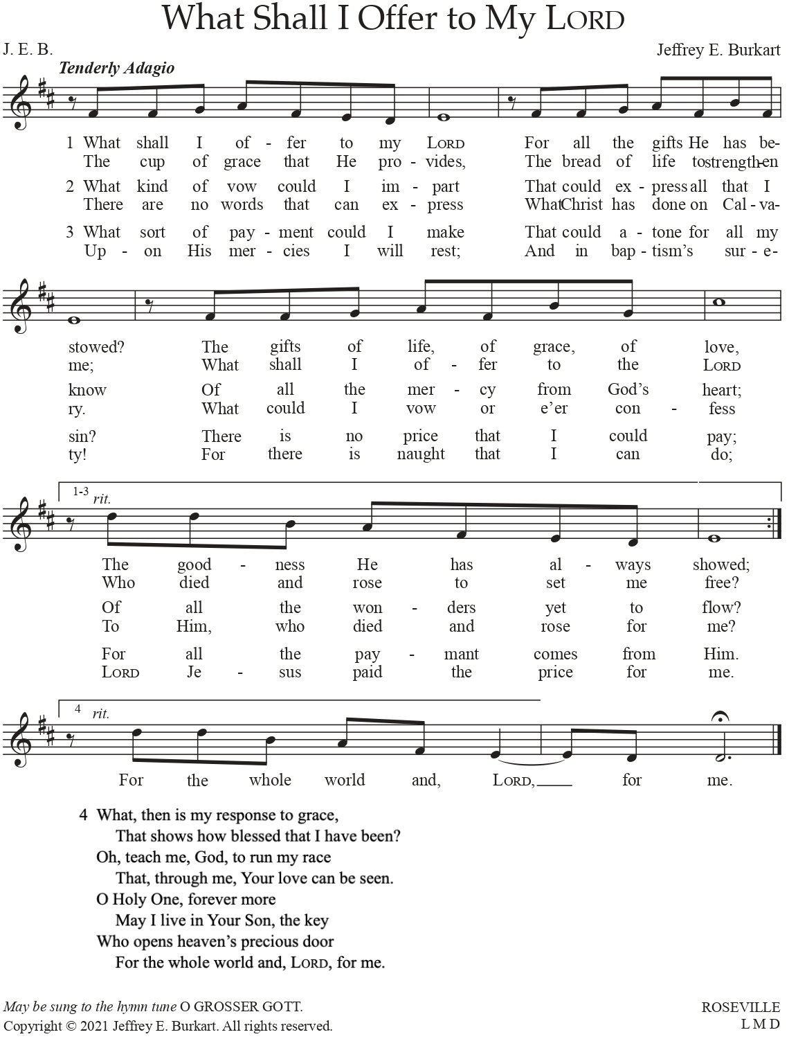
Used by permission of the Author: Dr. Jeffrey E. Burkhart

Service of the Sacrament
Please complete a communion card for our records; they are in the pew in front of you, or request one from an usher. Salem’s communion practice is that of close communion. We invite to our rail those who are members in good standing of sister Missouri Synod parishes. Visitors, please contact the pastor prior to communing. For those who prefer to use the Common Cup, we ask your assistance by holding the cup’s base as you commune.

Stand

Preface LSB 208
P The Lord be with you.
C And also with you.

P Lift up your hearts.
C We lift them to the Lord.

P Let us give thanks to the Lord our God.
C It is right to give Him thanks and praise.

P It is truly good, right, and salutary that we should at all times and in all places give thanks to You, O Lord, holy Father, almighty and everlasting God, for the countless blessings You so freely bestow on us and all creation. Above all, we give thanks for Your boundless love shown to us when You sent Your only-begotten Son, Jesus Christ, into our flesh and laid on Him our sin, giving Him into death that we might not die eternally. Because He is now risen from the dead and lives and reigns to all eternity, all who believe in Him will overcome sin and death and will rise again to new life. Therefore with angels and archangels and with all the company of heaven we laud and magnify Your glorious name, evermore praising You and saying:

Sanctus LSB 208
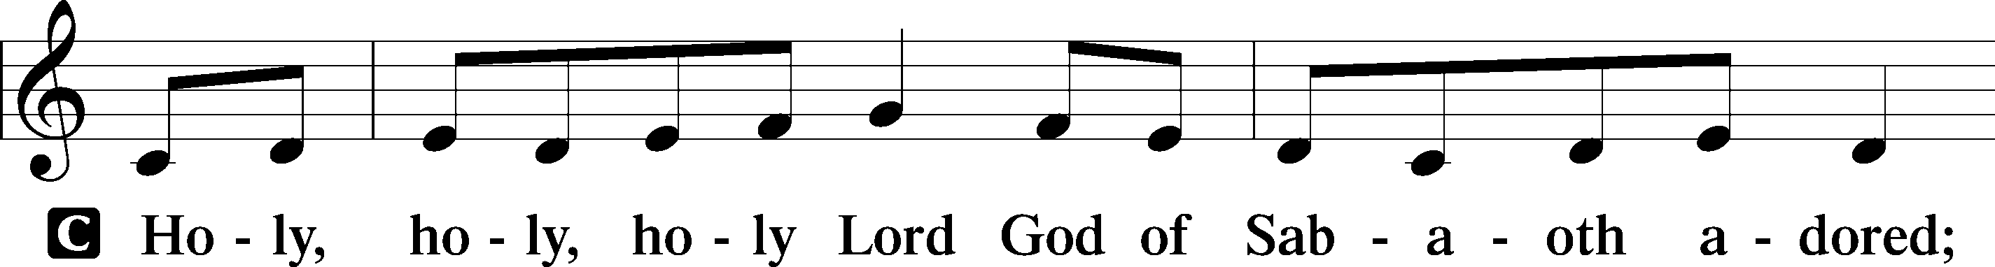
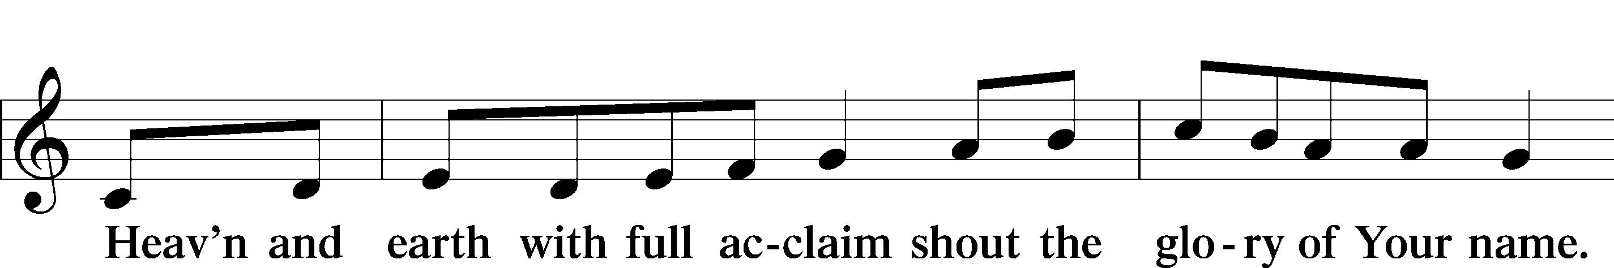
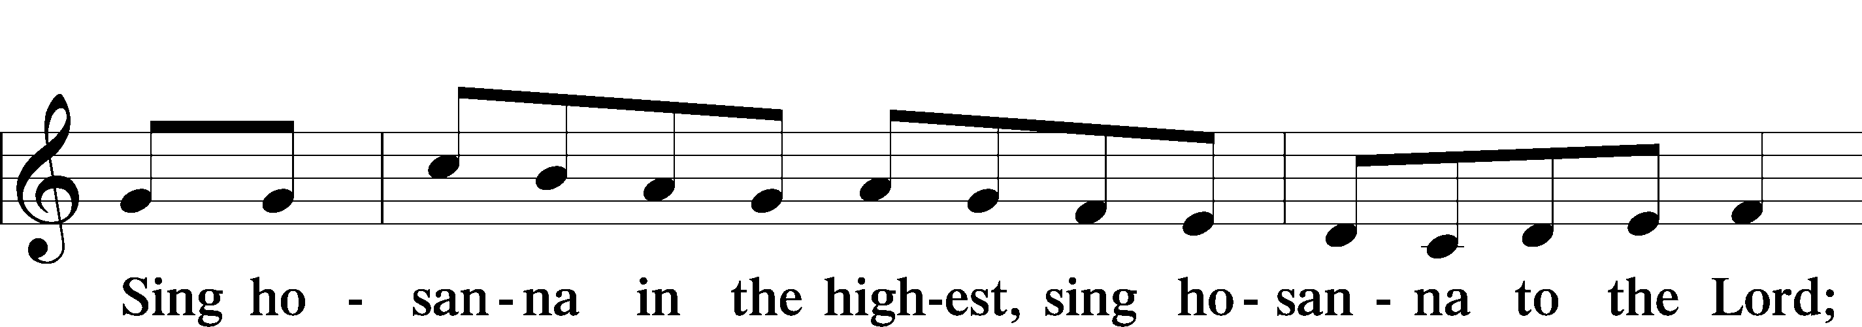
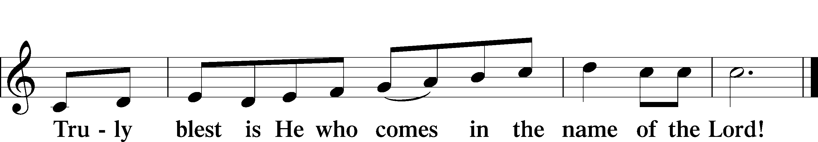
Text: Stephen P. Starke

Prayer of Thanksgiving
P Blessed are You, O Lord our God, king of all creation, for You have had mercy on us and given Your only-begotten Son that whoever believes in Him should not perish but have eternal life.

At Your command, Abraham prepared to offer his son Isaac as a sacrifice on the mountain; yet, in mercy You provided a ram as a substitute. We give You thanks that on Calvary You spared not Your only Son but sent Him to offer His life as a ransom for many.

As we eat and drink His body and blood, grant us, like Abraham our father, to trust in Your promise now fulfilled in Christ, the Lamb of God, who takes away the sin of the world.

Hear us as we pray in His name and as He has taught us:

Lord’s Prayer
C Our Father who art in heaven, hallowed be Thy name, Thy kingdom come, Thy will be done on earth as it is in heaven; give us this day our daily bread; and forgive us our trespasses as we forgive those who trespass against us; and lead us not into temptation, but deliver us from evil. For Thine is the kingdom and the power and the glory forever and ever. Amen.

The Words of Our Lord
P Our Lord Jesus Christ, on the night when He was betrayed, took bread, and when He had given thanks, He broke it and gave it to the disciples and said: “Take, eat; this is My T body, which is given for you. This do in remembrance of Me.”

In the same way also He took the cup after supper, and when He had given thanks, He gave it to them, saying: “Drink of it, all of you; this cup is the new testament in My T blood, which is shed for you for the forgiveness of sins. This do, as often as you drink it, in remembrance of Me.”

Pax Domini
P The peace of the Lord be with you always.
C Amen.

Agnus Dei LSB 210
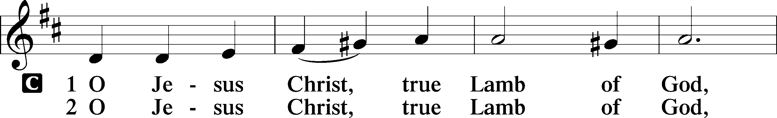
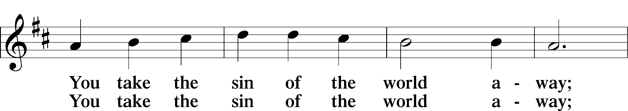
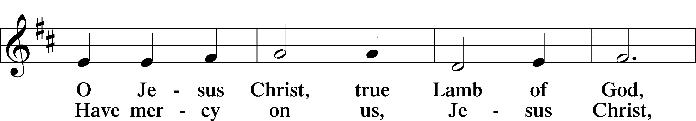
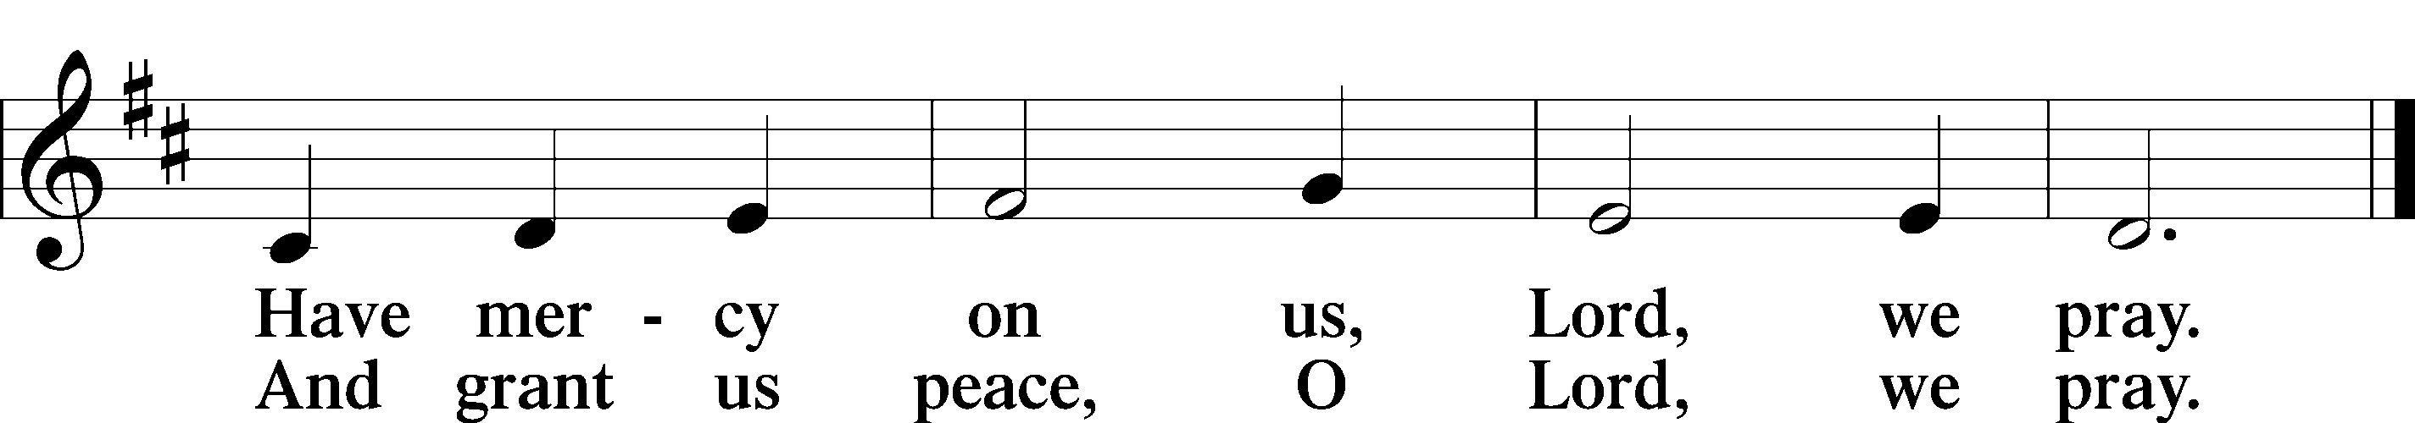
Text: Stephen P. Starke

Sit

Distribution

Distribution Hymn: When I Behold Jesus Christ LSB 542
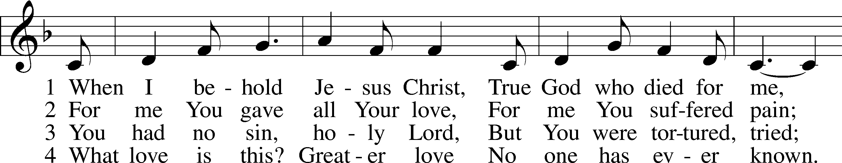
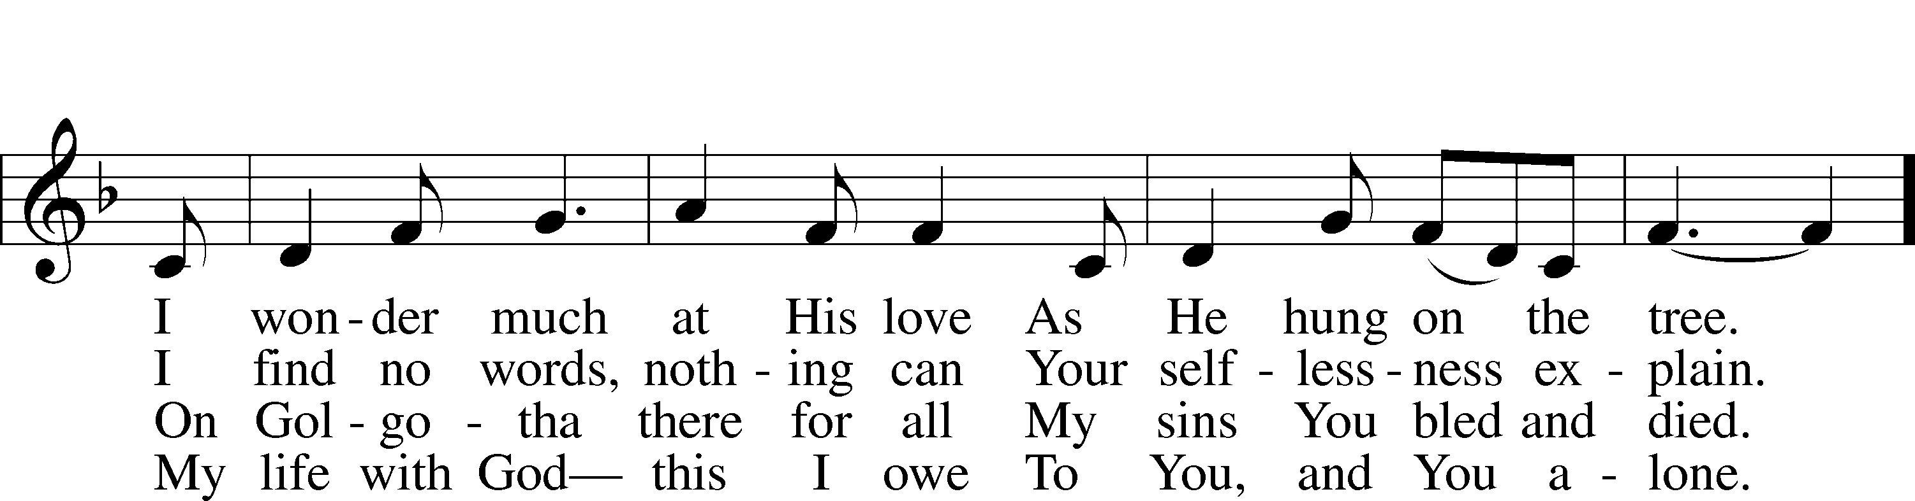
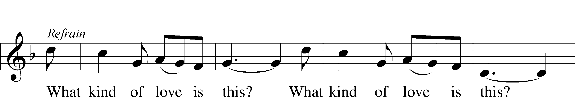
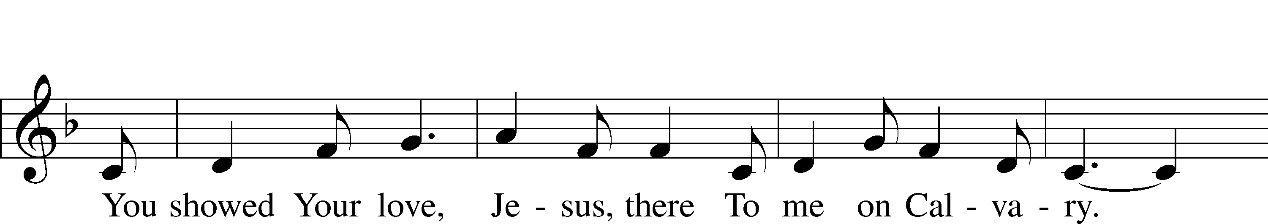
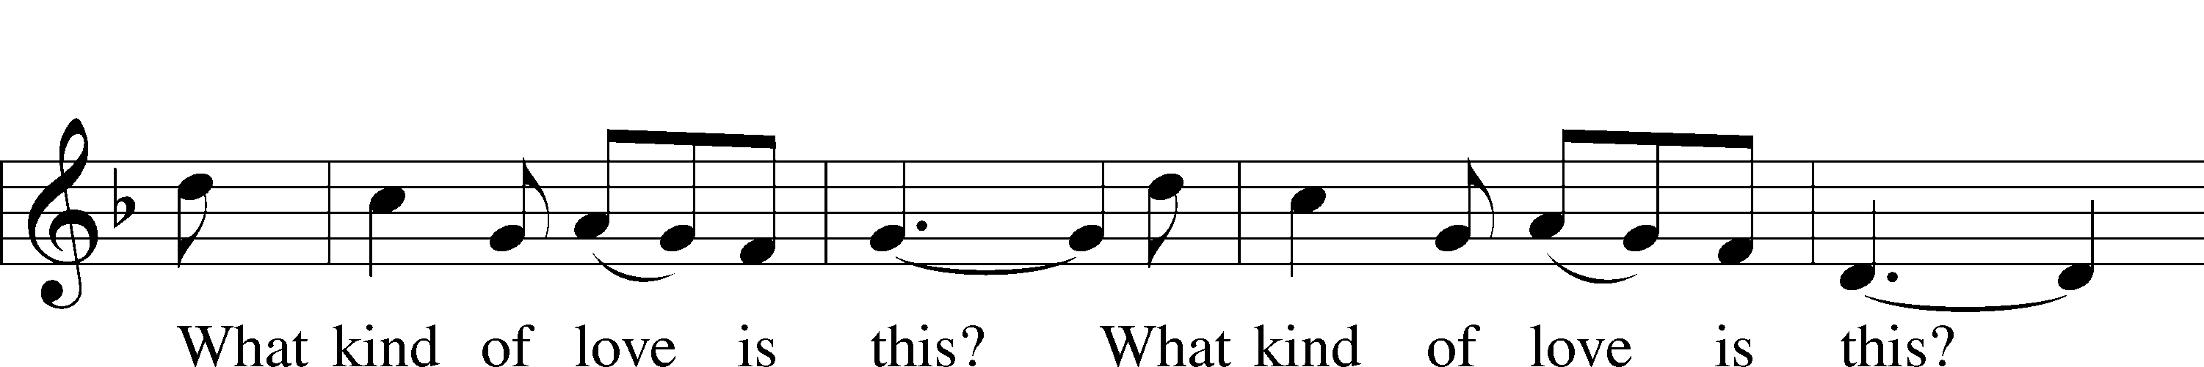
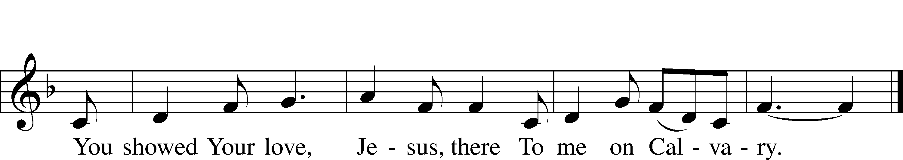
Text (sts. 1, ref, 2–3): tr. Hartmut Schoenherr, with Jim and Aurelia Keefer; (st. 4): Joseph Herl, 1959
Text (sts. 1, ref, 2–3) and tune: Almaz Belhu
Text (st. 4): © 1998 Concordia Publishing House. Used by permission: LSB Hymn License no. 110005504
Text (sts. 1, ref, 2–3) and tune: © 1970 Ethiopian Evangelical Church Mekane Yesus. Used by permission: LSB Hymn License no. 110005504

Distribution Hymn: The Lamb LSB 547 sts. 1, ref, 2–4
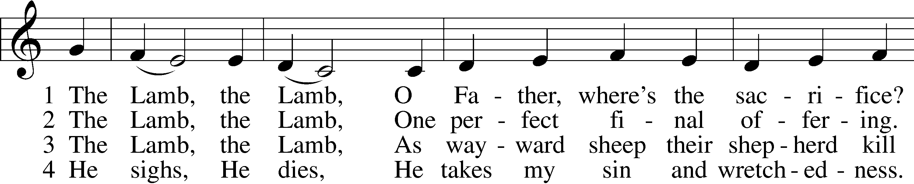
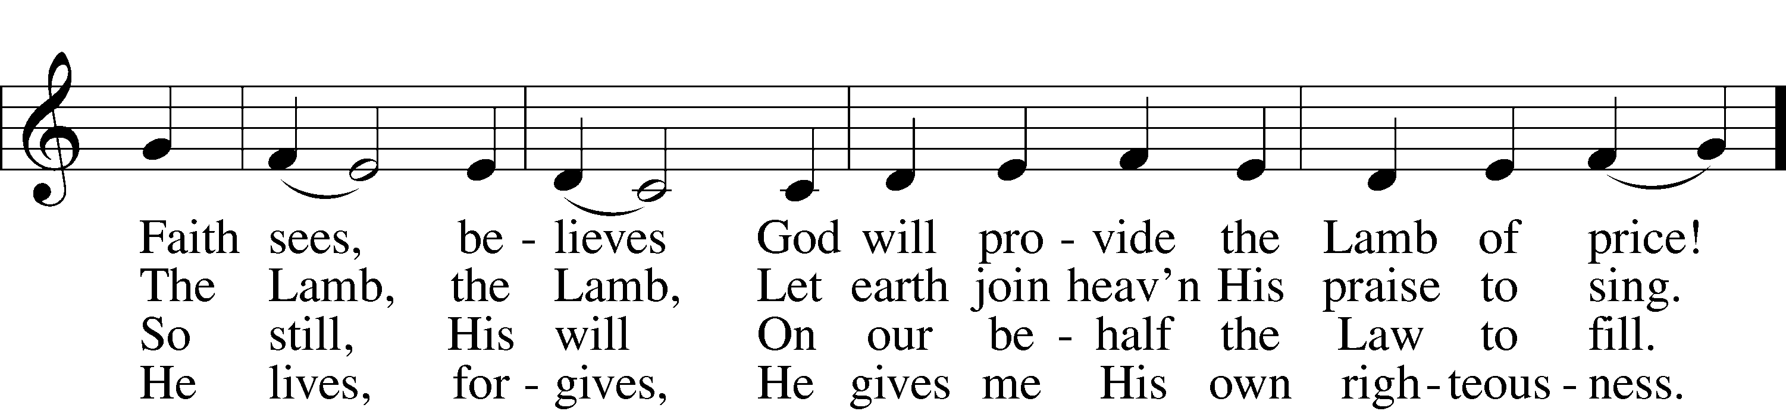
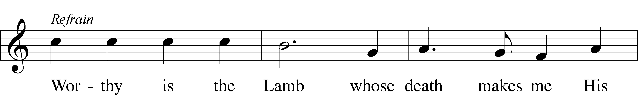
Text and tune: Gerald P. Coleman, 1953
Text and tune: © 1987 and 1997 MorningStar Music Publishers. Used by permission: LSB Hymn License no. 110005504

Stand

Nunc Dimittis LSB 211
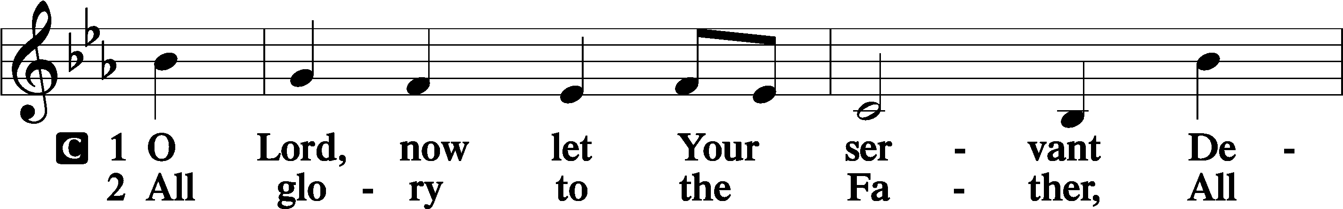
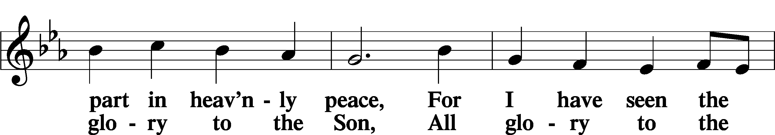
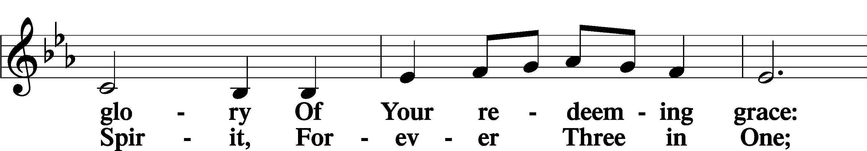
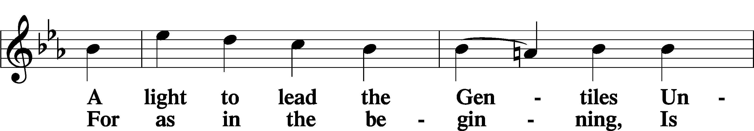
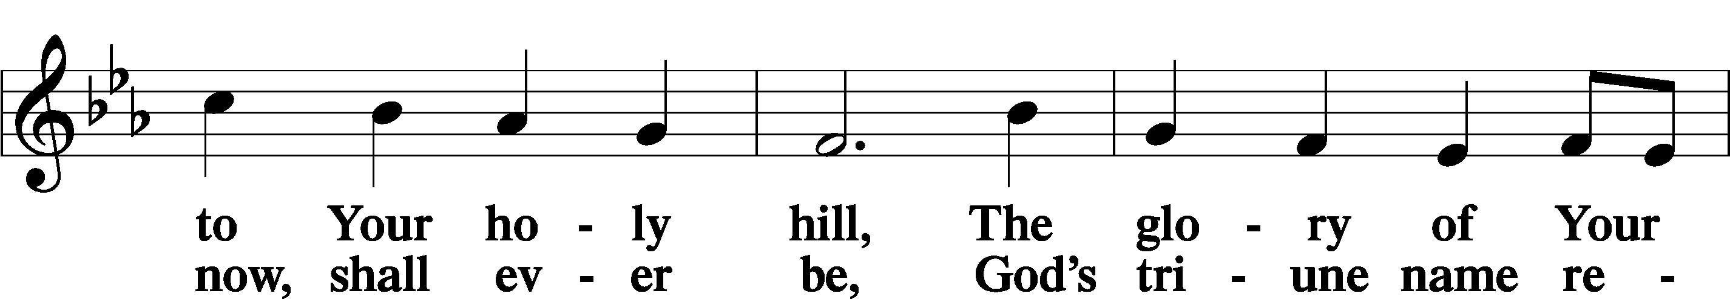
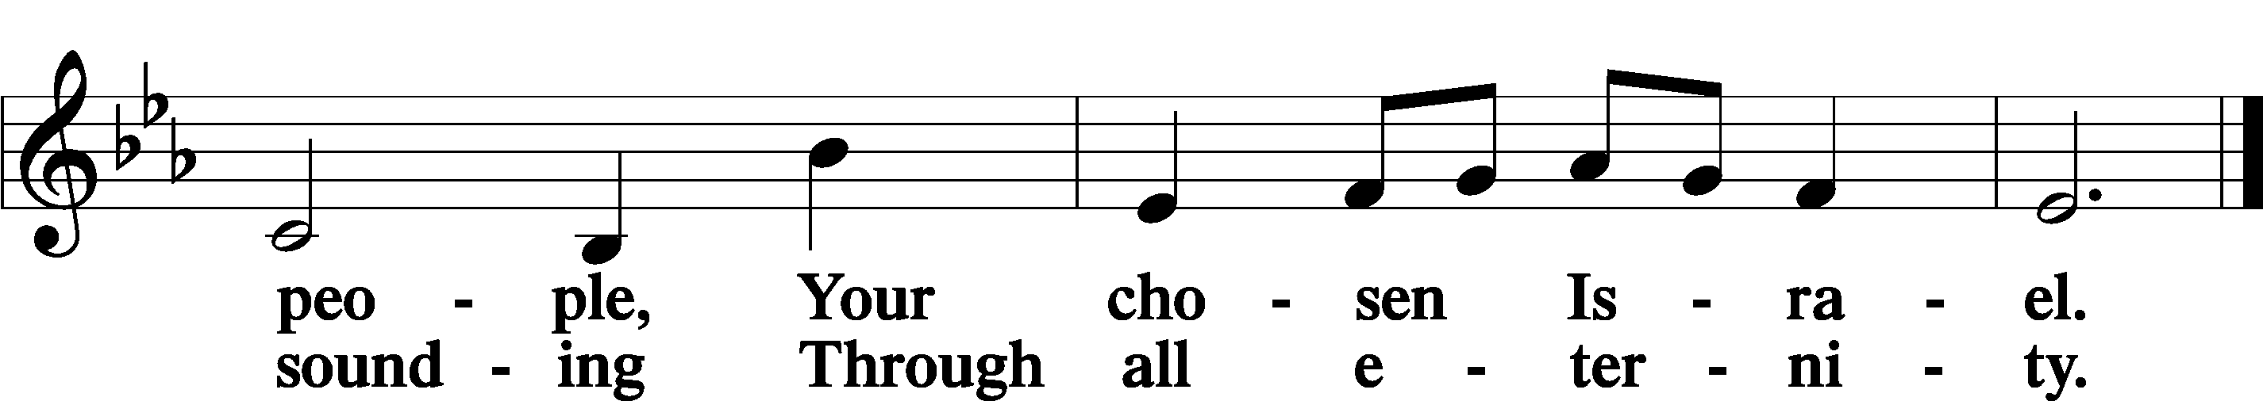

Post-Communion Collect
A Let us pray.
We give thanks to You, almighty God, that You have refreshed us through this salutary gift, and we implore You that of Your mercy You would strengthen us through the same in faith toward You and in fervent love toward one another; through Jesus Christ, Your Son, our Lord, who lives and reigns with You and the Holy Spirit, one God, now and forever.
C Amen.

Benedicamus LSB 212
A Let us bless the Lord.
C Thanks be to God.

Benediction
P The Lord bless you and keep you.
The Lord make His face shine on you and be gracious to you.
The Lord look upon you with favor and T give you peace.
C Amen.

Hymn to Depart: Ride On, Ride On In Majesty LSB 441
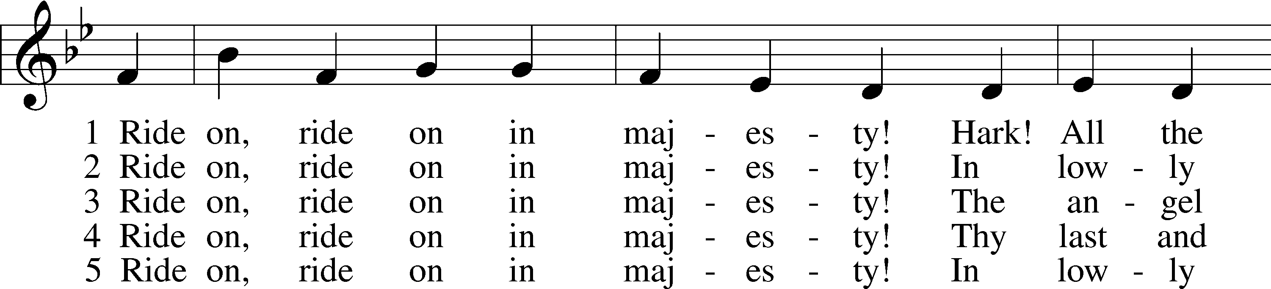
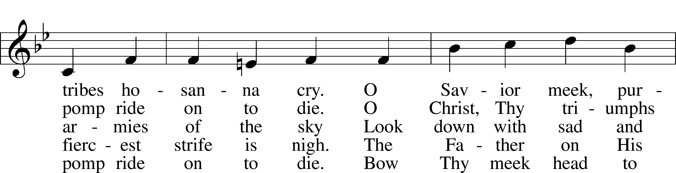
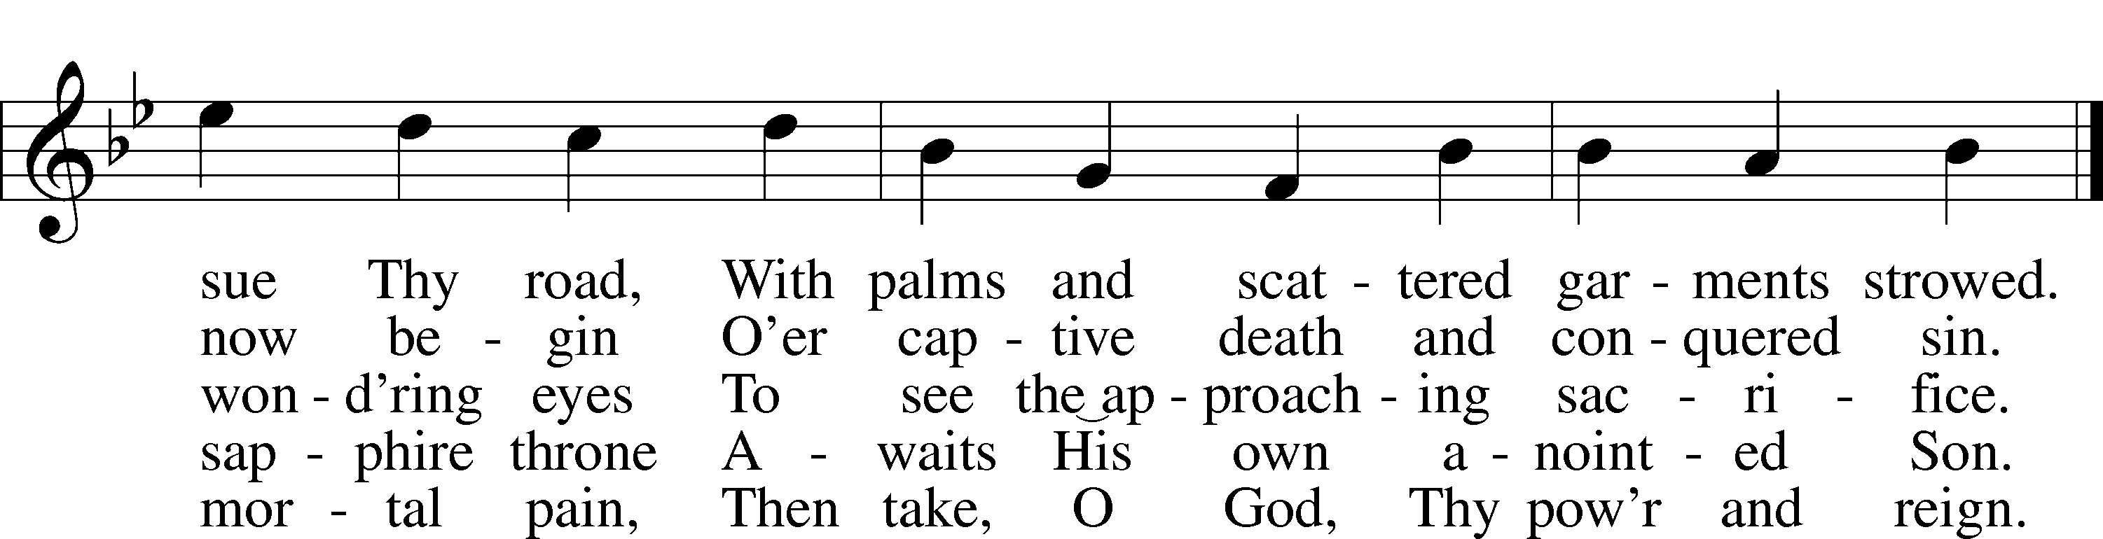
Text: Henry H. Milman, 1791–1868, alt.
Tune: Musicalisch Hand-Buch der Geistlichen Melodien, 1690, Hamburg, alt.
Text and tune: Public domain

Acknowledgments
Divine Service, Setting Four from Lutheran Service Book
Unless otherwise indicated, Scripture quotations are from the ESV® Bible (The Holy Bible, English Standard Version®), copyright © 2001 by Crossway, a publishing ministry of Good News Publishers. Used by permission. All rights reserved.
Created by Lutheran Service Builder © 2024 Concordia Publishing House.

Announcements:
Church Service Phone: 888-505-1870/715-438-4200
(Stay on the line for recorded service to start)
Live Stream audio services: http://salem.listentochurch.com
Salem’s Web Page: https://www.salembarron.com/

Pastor Michael Nielsen: Cell phone: 218-280-0999
Email: rev.mike.nielsen@gmail.com
Pastor’s Office Hours: Monday-Wednesday 9-12
Attendance: Call-in line:3/6- 0 3/10 – 3; In person: 3/6 18/17- , 3/10 - 53

Coffee and Snacks: YFM
Elder Today: Don Duncan
Altar Guild: MaryAnn Thompson and Kari Longmire

Link to Salem’s Facebook page is:
https://www.facebook.com/SalemEvangelicalLutheranChurchAndPreschool/

Schedule for the upcoming week:
Tuesday: 8:00 AM Men’s Bible Class
Thursday: 12 Noon – Maundy Thursday Service
6:30 PM – Maundy Thursday Service
Friday: 12 Noon – Good Friday Service
6:30 PM – Good Friday Service
Saturday: Easter Egg Hunt 10-12 Noon
Sunday: 7:00 AM Easter Sonrise Service
8:00 AM – Easter Brunch
9:00 AM – Easter Divine Service

The new office email address is salembarron@gmail.com

Save the date: Next Sunday is Pastor’s last service
April 7 – 10:15-11:15 – Jim and Susan Kaiser – Missionaries of LBT
April 7 – 11:30 – Chili and Cookie Contest
April 14 – 10:30 – PreCall Meeting With Pres. Lueck of the North Wisconsin District
April 15 – 6:00 PM – Circuit Lay Leader Meeting @ St. Paul’s Cumberland

A Call Committee is being put together. If you are interested please contact an Elder or Sue in the office.

Member information is on the table in the fellowhip hall, please look at it and update your information if needed.

Helpers are still needed for for the Easter Egg Hunt this coming Saturday. For more information contact a YFM Member.

Looking for some volunteers: Sunday Morning Live Video. Pastor will train you. Someone to take over the Church Website.

We are still looking for a Director for the VBS program, prayerfully consider this.

Prayer requests:

Those in the nursing home: Joann Jaeger
Those Shut-in at home: Char Herman, Joan Church, Joyce Myers, Joyce Koba
Those with ongoing health issues: Harrison Fields, Jeanne Perala, Owen Metz, Kathy Nielsen (Pastor’s aunt), Jeff Bonneville, Daria (Cindy Wright’s friend), Butch L. (Cindy Wright’s Brother-in-law), Melissa Miller., Dale Bryan, Art Smith (Sue Millerman’s brother), Brenda Sellent (Denise Stabenow’s sister), Sandy Hahn (Cindy Wright’s cousin’s wife), Wayne Hahn (Cindy Wright’s Uncle)
Recovering from surgery: Wyatt Weise, Gail Espeseth
For Pastor Nielsen and family as they begin the transition to St. John’s North Prairie.
For Salem and St. John’s in their transitions of ministry.
Those who lead our nation: Joe Biden, Kamala Harris, Tony Evers, Rod Nordby
Those who serve in our military and law enforcement: Ryan Graf, Chaplain Pon Chanthaphon (Our Adopt-a-Chaplain), Rusty Weise

Our Childcare Staff: Melissa Weinert, Denise Stabenow, Katelyn Hendren, Holly Wilhelmi, Janica Skjerly, Jacie Amundson, Emily Young

For Christ Community Lutheran School – For Community Support for CCLS
Families of the Week: Jeff Kolba, Joyce Kolba, Ethan and Chloe Kobernick (Madison), Bradley and Carol Kuchera, Michael and Debra Kuhrt

Mission Statement
The Mission of Salem Lutheran Church is to be what God called us to be through faith in Jesus Christ, a body of believers engaged in building the Kingdom of God by discipling the Barron area with His Word and Sacrament ministry.

