Maundy Thursday
March 28, 2024
12 Noon and 6:30 PM

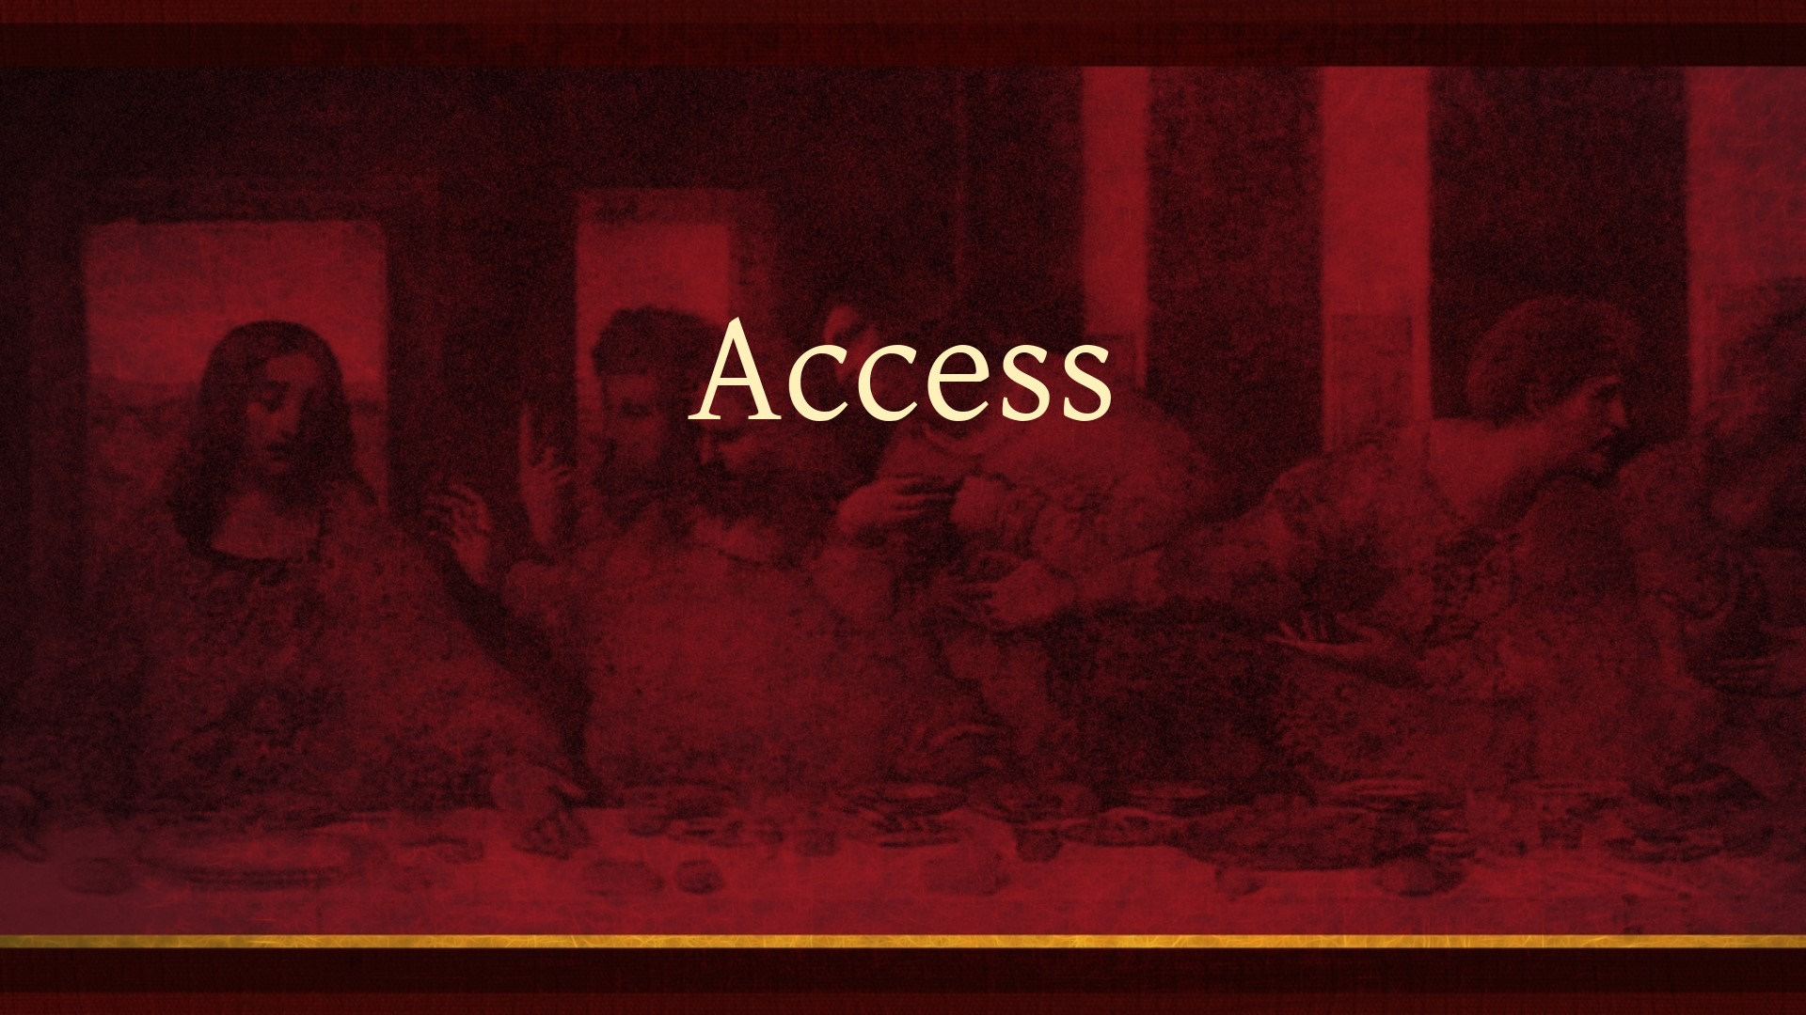

Salem Lutheran Church
1-715-537-3011
http://www.salembarron.com
rev.mike.nielsen@gmail.com

Theme of the Day: All too often we don’t have the right connections with the right person at the right time to accomplish all the right things. If we could just obtain access. The good news is that through the blood of Jesus we have unlimited access!

“Access!”

Confession and Absolution

Hymn of Invocation: When You Woke That Thursday Morning LSB 445
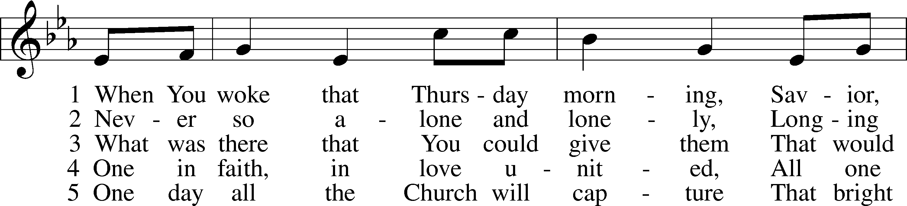
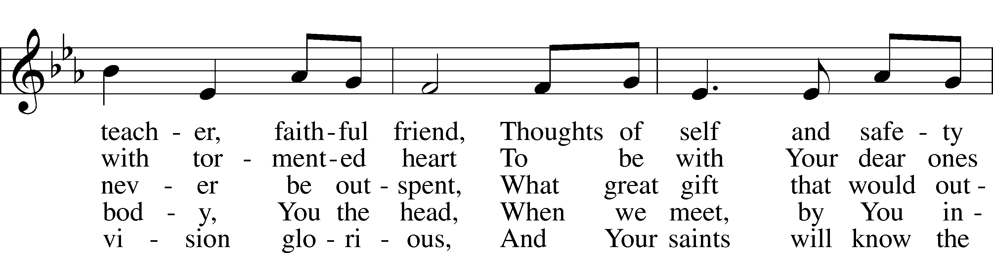
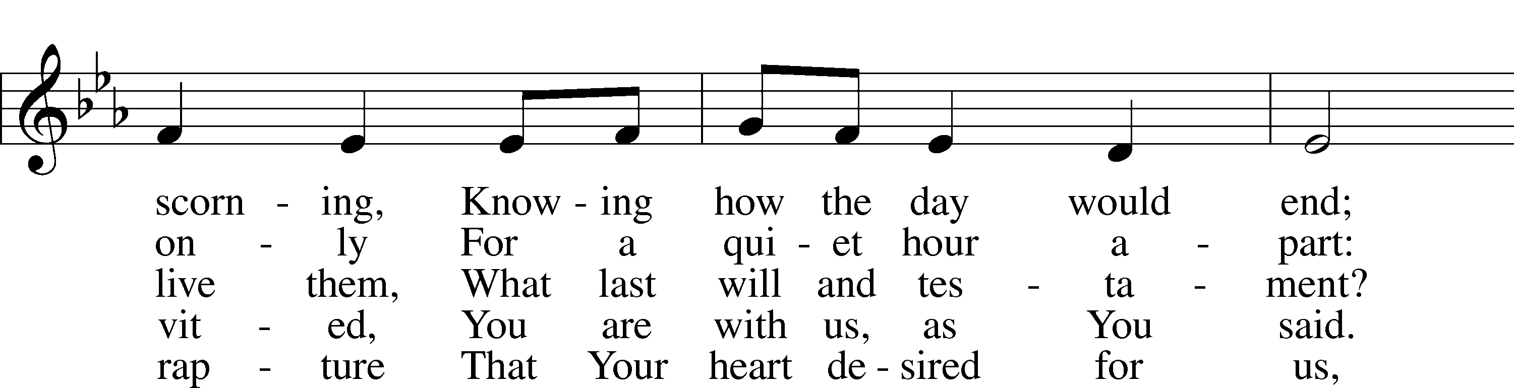
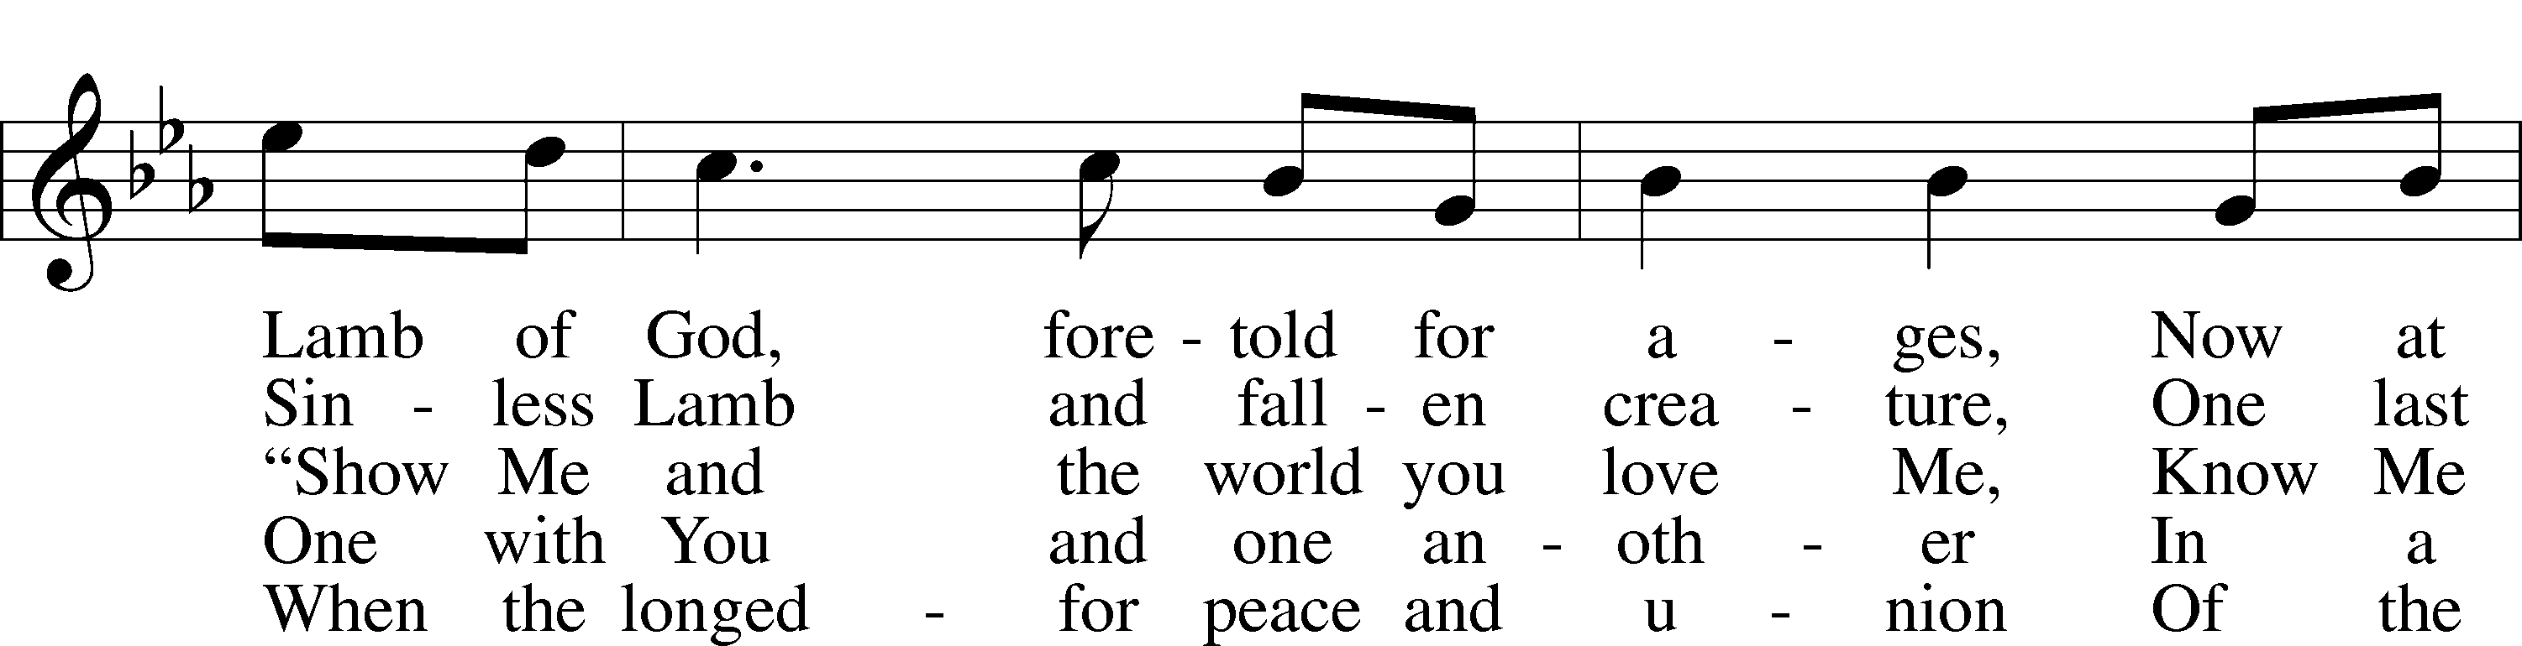
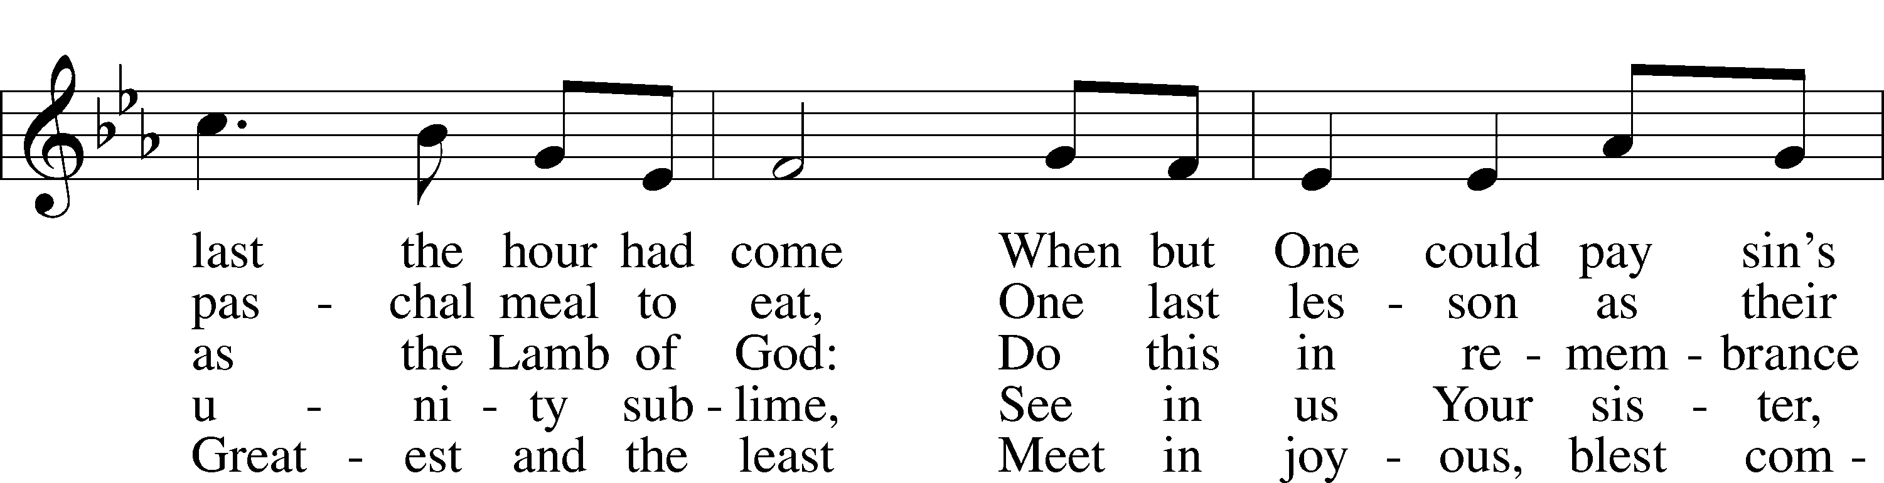
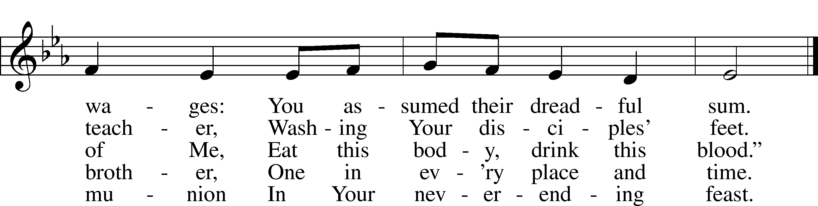
Text: Jaroslav J. Vajda, 1919–2008
Tune: Marty Haugen, 1950
Text: © 1991 Concordia Publishing House. Used by permission: LSB Hymn License no. 110005504
Tune: © 1987 GIA Publications, Inc. Used by permission: LSB Hymn License no. 110005504
Stand

The sign of the cross may be made by all in remembrance of their Baptism.

Opening Sentences
P In the name of the Father and of the T Son and of the Holy Spirit.
C Amen.

P I will go to the altar of God,
C to God my exceeding joy.
P Our help is in the name of the Lord,
C who made heaven and earth.

Confessional Address
P During this Lenten season we have heard our Lord’s call to intensify our struggle against sin, death, and the devil—all that prevents us from trusting in God and loving each other. Since it is our intention to receive the Holy Supper of our Lord Jesus Christ on this night when He instituted this blessed meal for our salvation, it is proper that we complete our Lenten discipline by diligently examining ourselves, as St. Paul urges us to do. This holy Sacrament has been instituted for the special comfort of those who are troubled because of their sin and who humbly confess their sins, fear God’s wrath, and hunger and thirst for righteousness.
But when we examine our hearts and consciences, we find nothing in us but sin and death, from which we are incapable of delivering ourselves. Therefore, our Lord Jesus Christ has had mercy on us. For our benefit He became man so that He might fulfill for us the whole will and law of God and, to deliver us, took upon Himself our sin and the punishment we deserve.
So that we may more confidently believe this and be strengthened in the faith and in holy living, our Lord Jesus Christ took bread, broke it, and gave it to His disciples and said: “Take, eat; this is My body, which is given for you.” It is as if He said, “I became man, and all that I do and suffer is for your good. As a pledge of this, I give you My body to eat.”
In the same way also He took the cup, gave thanks, and gave it to them, saying: “Drink of it, all of you; this cup is the new testament in My blood, which is shed for you for the forgiveness of sins.” Again, it is as if He said, “I have had mercy on you by taking into Myself all your iniquities. I give Myself into death, shedding My blood to obtain grace and forgiveness of sins, and to comfort and establish the new testament, which gives forgiveness and everlasting salvation. As a pledge of this, I give you My blood to drink.”
Therefore, whoever eats this bread and drinks this cup, confidently believing this Word and promise of Christ, dwells in Christ and Christ in him and has eternal life.
We should also do this in remembrance of Him, showing His death—that He was delivered for our offenses and raised for our justification. Giving Him our most heartfelt thanks, we take up our cross and follow Him and, according to His commandment, love one another as He has loved us. As our Lord on this night exemplified this love by washing His disciples’ feet, so we by our words and actions serve one another in love. For we are all one bread and one Body, even as we are all partakers of this one bread and drink from the one cup. For just as the one cup is filled with wine of many grapes and one bread made from countless grains, so also we, being many, are one Body in Christ. Because of Him, we love one another, not only in word, but in deed and in truth.
May the almighty and merciful God and Father of our Lord Jesus Christ, by His Holy Spirit, accomplish this in us.
C Amen.

P Having heard the Word of God, let us confess our sins, imploring God our Father for the sake of His Son, Jesus Christ, to grant us forgiveness.

Silence for reflection on God’s Word and for self-examination.

P O almighty God, merciful Father,
C I, a poor, miserable sinner, confess unto You all my sins and iniquities with which I have ever offended You and justly deserved Your temporal and eternal punishment. But I am heartily sorry for them and sincerely repent of them, and I pray You of Your boundless mercy and for the sake of the holy, innocent, bitter sufferings and death of Your beloved Son, Jesus Christ, to be gracious and merciful to me, a poor, sinful being.

P God be merciful to you and strengthen your faith.
C Amen.

P Do you believe that the forgiveness I speak is not my forgiveness but God’s?
C Yes.

P Let it be done for you as you believe.

P In the stead and by the command of my Lord Jesus Christ I forgive you all your sins in the name of the Father and of the T Son and of the Holy Spirit.
C Amen.

P Now may the God of peace Himself sanctify you completely, and may your whole spirit, soul, and body be kept blameless at the coming of our Lord Jesus Christ. He who calls you is faithful; He will surely do it. Go in T peace.
C Amen.
Service of the Word

Introit Psalm 116:1–4; antiphon: v. 5
Gracious is the Lord, and righteous;
our God is merciful.
I love the Lord, because he has heard
my voice and my pleas for mercy.
Because he inclined his ear to me,
therefore I will call on him as long as I live.
The snares of death encompassed me; the pangs of Sheol laid hold on me;
I suffered distress and anguish.
Then I called on the name of the Lord:
“O Lord, I pray, deliver my soul!”
Gracious is the Lord, and righteous;
our God is merciful.

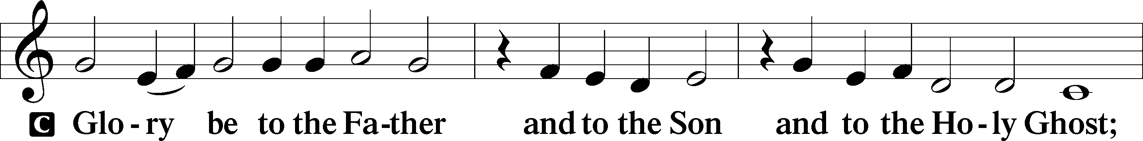
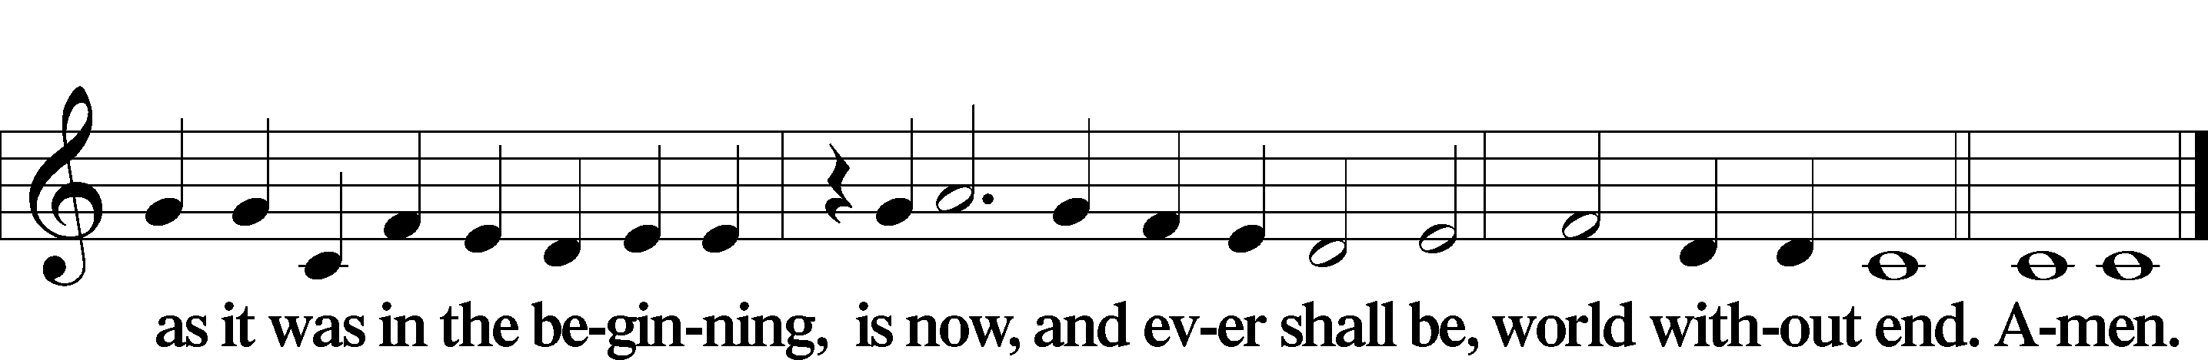

Kyrie LSB 186
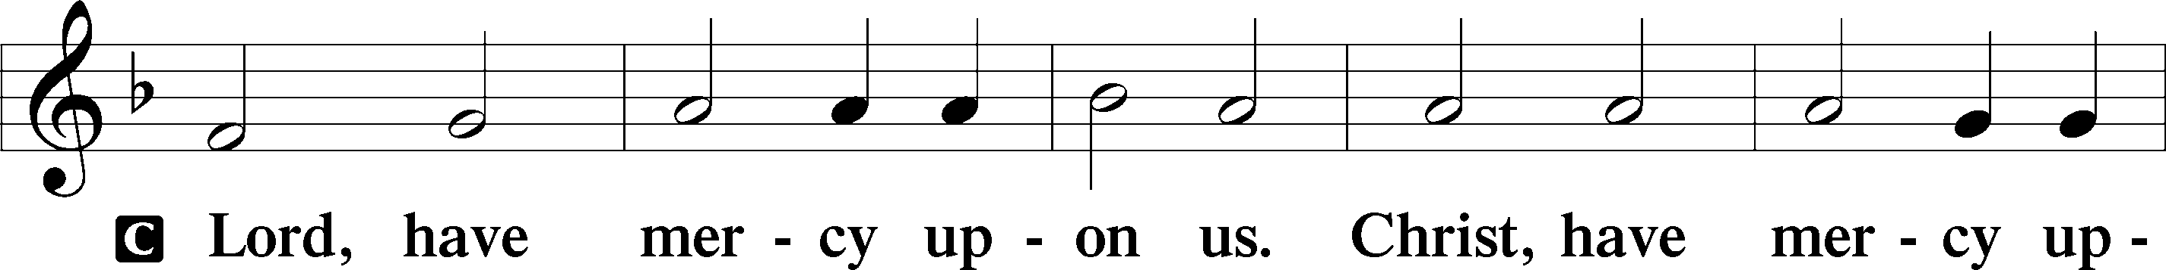
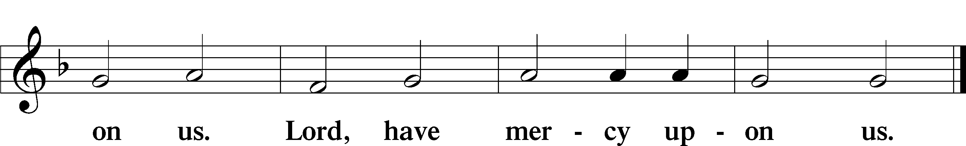

Salutation and Collect of the Day
P The Lord be with you.
C And with thy spirit.

P Let us pray.
O Lord, in this wondrous Sacrament You have left us a remembrance of Your passion. Grant that we may so receive the sacred mystery of Your body and blood that the fruits of Your redemption may continually be manifest in us; for You live and reign with the Father and the Holy Spirit, one God, now and forever.

C Amen.

Sit

Old Testament Reading Exodus 24:1–11
1Then he said to Moses, “Come up to the Lord, you and Aaron, Nadab, and Abihu, and seventy of the elders of Israel, and worship from afar. 2Moses alone shall come near to the Lord, but the others shall not come near, and the people shall not come up with him.”
3Moses came and told the people all the words of the Lord and all the just decrees. And all the people answered with one voice and said, “All the words that the Lord has spoken we will do.” 4And Moses wrote down all the words of the Lord. He rose early in the morning and built an altar at the foot of the mountain, and twelve pillars, according to the twelve tribes of Israel. 5And he sent young men of the people of Israel, who offered burnt offerings and sacrificed peace offerings of oxen to the Lord. 6And Moses took half of the blood and put it in basins, and half of the blood he threw against the altar. 7Then he took the Book of the Covenant and read it in the hearing of the people. And they said, “All that the Lord has spoken we will do, and we will be obedient.” 8And Moses took the blood and threw it on the people and said, “Behold the blood of the covenant that the Lord has made with you in accordance with all these words.”
9Then Moses and Aaron, Nadab, and Abihu, and seventy of the elders of Israel went up, 10and they saw the God of Israel. There was under his feet as it were a pavement of sapphire stone, like the very heaven for clearness. 11And he did not lay his hand on the chief men of the people of Israel; they beheld God, and ate and drank.

A This is the Word of the Lord.
C Thanks be to God.

Psalm
[During the sermon series on Exodus we are using psalms that celebrate Israel’s
Deliverance from Egypt. Today we use selected verses from Psalm 78.]

P: When Israel went out from Egypt, the house of Jacob from a people of strange language.
C: Judah became his sanctuary, Israel his dominion.
P: The sea looked and fled,
C: The mountains skipped like rams, the hills like lambs.
P: Tremble at the presence of the Lord,
C: At the presence of the God of Jacob!
P: Who turns the rock into a pool of water,
All: The flint into a spring of water.

Epistle Romans 5:1–10
1Therefore, since we have been justified by faith, we have peace with God through our Lord Jesus Christ. 2Through him we have also obtained access by faith into this grace in which we stand, and we rejoice in hope of the glory of God. 3More than that, we rejoice in our sufferings, knowing that suffering produces endurance, 4and endurance produces character, and character produces hope, 5and hope does not put us to shame, because God’s love has been poured into our hearts through the Holy Spirit who has been given to us.
6For while we were still weak, at the right time Christ died for the ungodly. 7For one will scarcely die for a righteous person—though perhaps for a good person one would dare even to die— 8but God shows his love for us in that while we were still sinners, Christ died for us. 9Since, therefore, we have now been justified by his blood, much more shall we be saved by him from the wrath of God. 10For if while we were enemies we were reconciled to God by the death of his Son, much more, now that we are reconciled, shall we be saved by his life.

A This is the Word of the Lord.
C Thanks be to God.

Stand

Verse of the Day John 13:1b
Having loved his own who were in the world, he loved them to the end.

Holy Gospel Matthew 26:26–30
P The Holy Gospel according to St. Matthew, the twenty-sixth chapter.
C Glory be to Thee, O Lord.

26Now as they were eating, Jesus took bread, and after blessing it broke it and gave it to the disciples, and said, “Take, eat; this is my body.” 27And he took a cup, and when he had given thanks he gave it to them, saying, “Drink of it, all of you, 28for this is my blood of the covenant, which is poured out for many for the forgiveness of sins. 29I tell you I will not drink again of this fruit of the vine until that day when I drink it new with you in my Father’s kingdom.”
30And when they had sung a hymn, they went out to the Mount of Olives.

P This is the Gospel of the Lord.
C Praise be to Thee, O Christ.

Nicene Creed
C I believe in one God,
the Father Almighty,
maker of heaven and earth
and of all things visible and invisible.

And in one Lord Jesus Christ,
the only-begotten Son of God,
begotten of His Father before all worlds,
God of God, Light of Light,
very God of very God,
begotten, not made,
being of one substance with the Father,
by whom all things were made;
who for us men and for our salvation came down from heaven
and was incarnate by the Holy Spirit of the virgin Mary
and was made man;
and was crucified also for us under Pontius Pilate.
He suffered and was buried.
And the third day He rose again according to the Scriptures
and ascended into heaven
and sits at the right hand of the Father.
And He will come again with glory to judge both the living and the dead,
whose kingdom will have no end.

And I believe in the Holy Spirit,
the Lord and giver of life,
who proceeds from the Father and the Son,
who with the Father and the Son together is worshiped and glorified,
who spoke by the prophets.
And I believe in one holy Christian and apostolic Church,
I acknowledge one Baptism for the remission of sins,
and I look for the resurrection of the dead
and the life T of the world to come. Amen.

Sit

Hymn of the Day: Not All the Blood of Beasts LSB 431
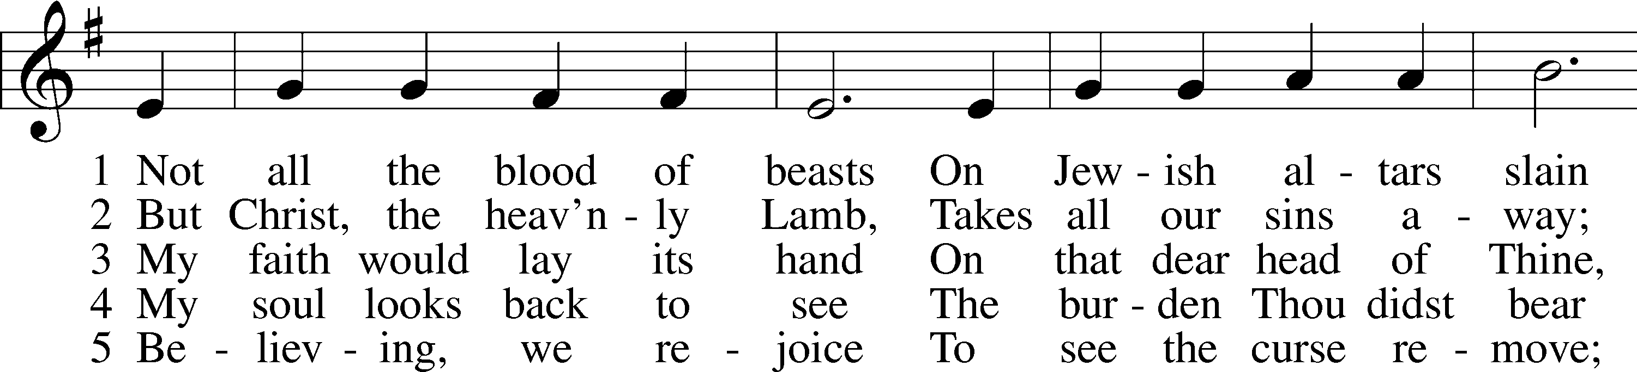
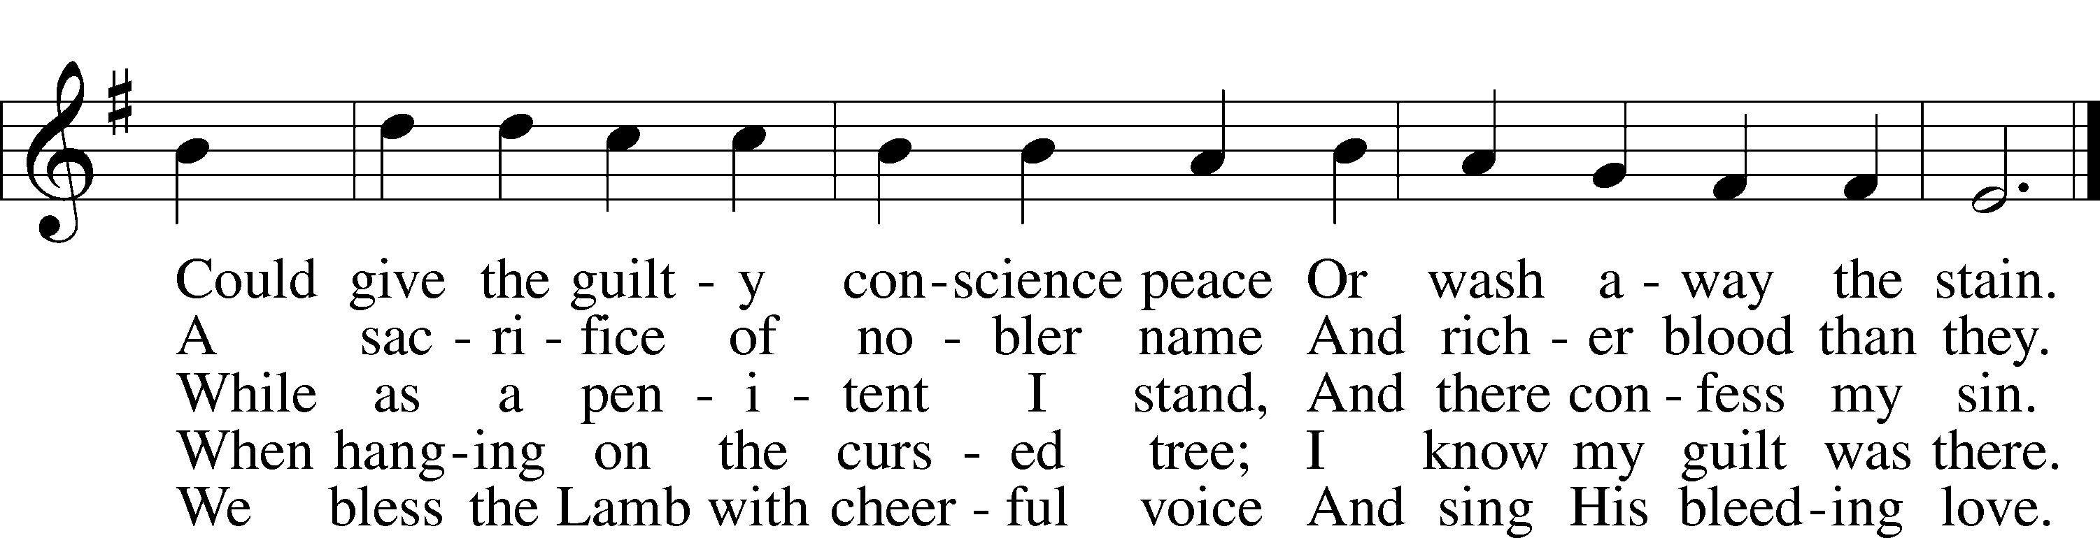
Text: Isaac Watts, 1674–1748, alt.
Tune: William Daman, c. 1540–1591
Text and tune: Public domain

Sermon

Stand

Offertory LSB 192
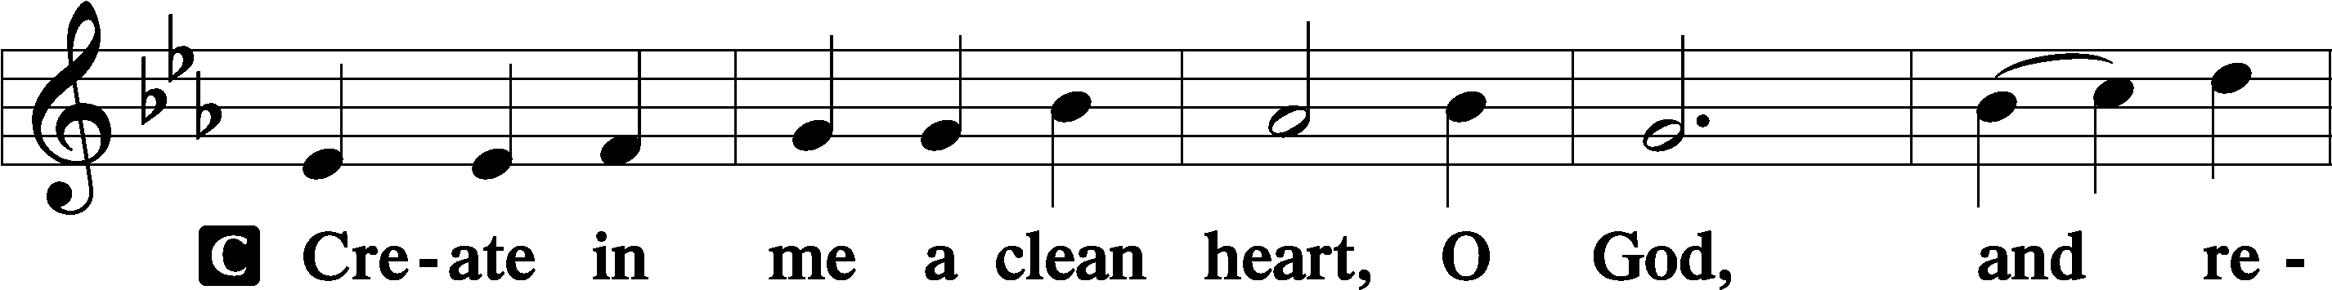
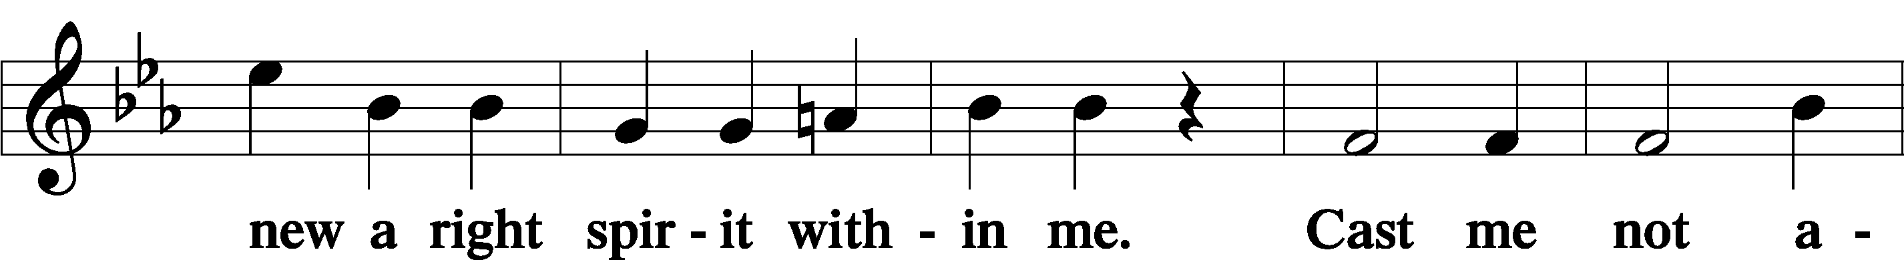
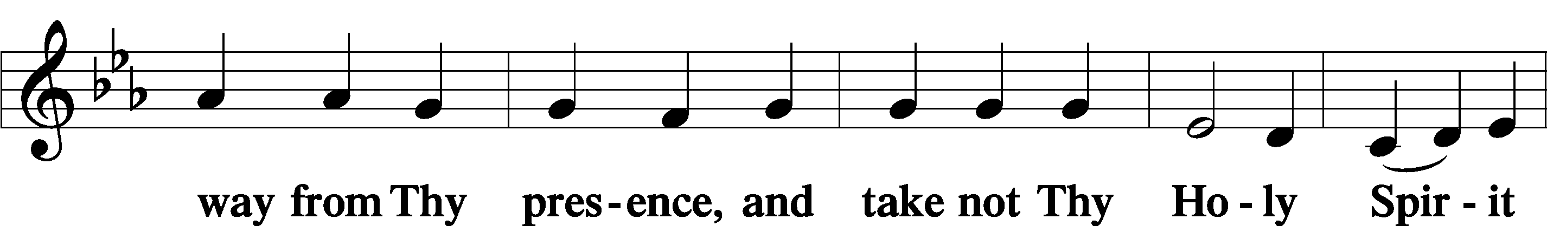
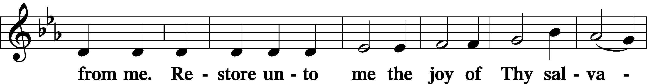
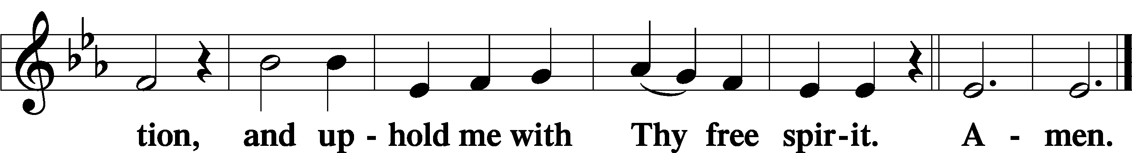

Sit

Offering

Stand

Prayer of the Church

Service of the Sacrament
Please complete a communion card for our records; they are in the pew in front of you, or request one from an usher. Salem’s communion practice is that of close communion. We invite to our rail those who are members in good standing of sister Missouri Synod parishes. Visitors, please contact the pastor prior to communing. For those who prefer to use the Common Cup, we ask your assistance by holding the cup’s base as you commune.

Preface LSB 194
P The Lord be with you.
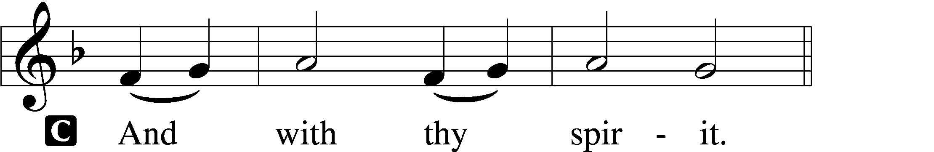

P Lift up your hearts.
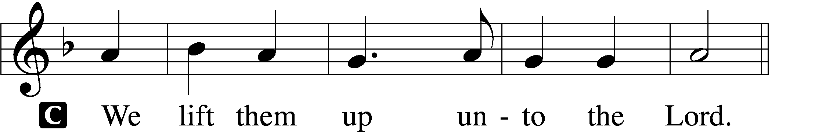

P Let us give thanks unto the Lord, our God.
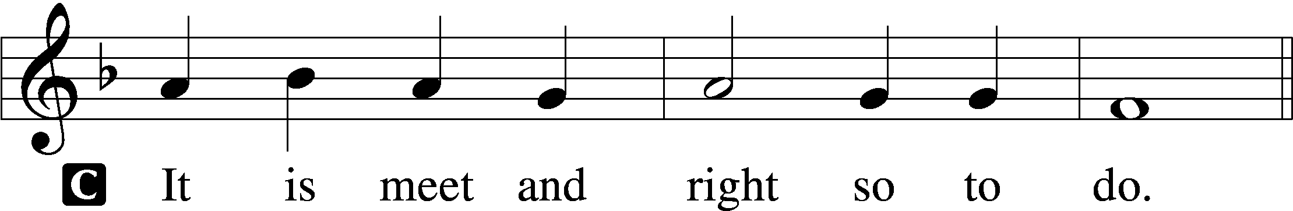

P It is truly meet, right, and salutary that we should at all times and in all places give thanks to You, holy Lord, almighty Father, everlasting God, through Jesus Christ, our Lord, who accomplished the salvation of mankind by the tree of the cross that, where death arose, there life also might rise again and that the serpent who overcame by the tree of the garden might likewise by the tree of the cross be overcome. Therefore with angels and archangels and with all the company of heaven we laud and magnify Your glorious name, evermore praising You and saying:

Sanctus LSB 195
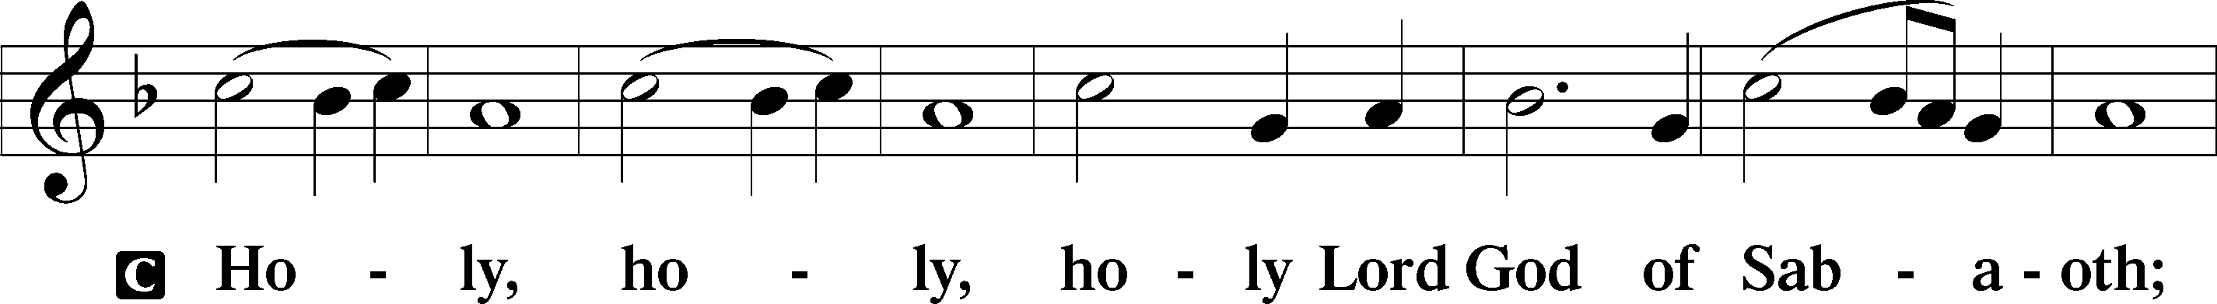
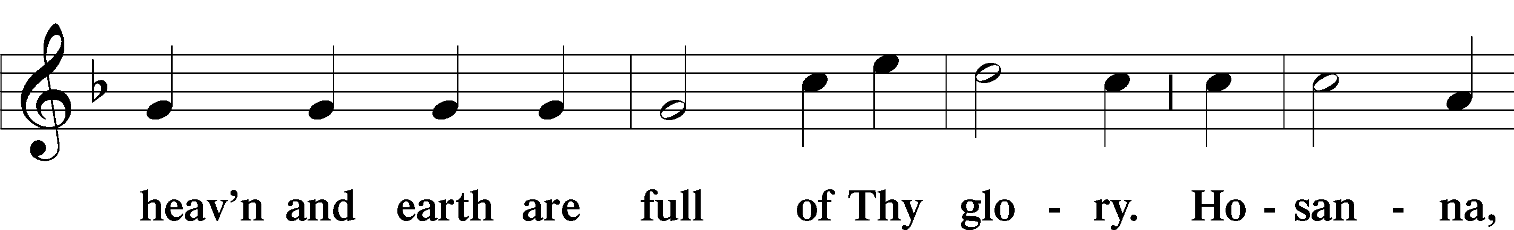
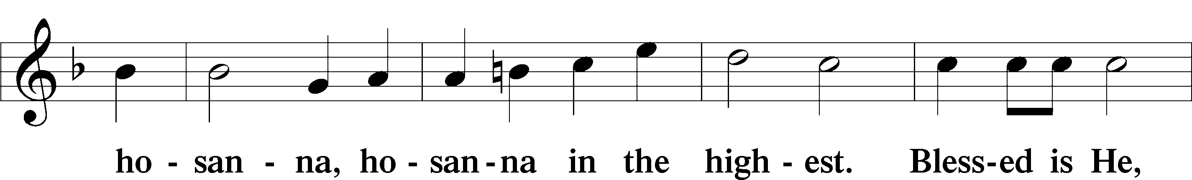
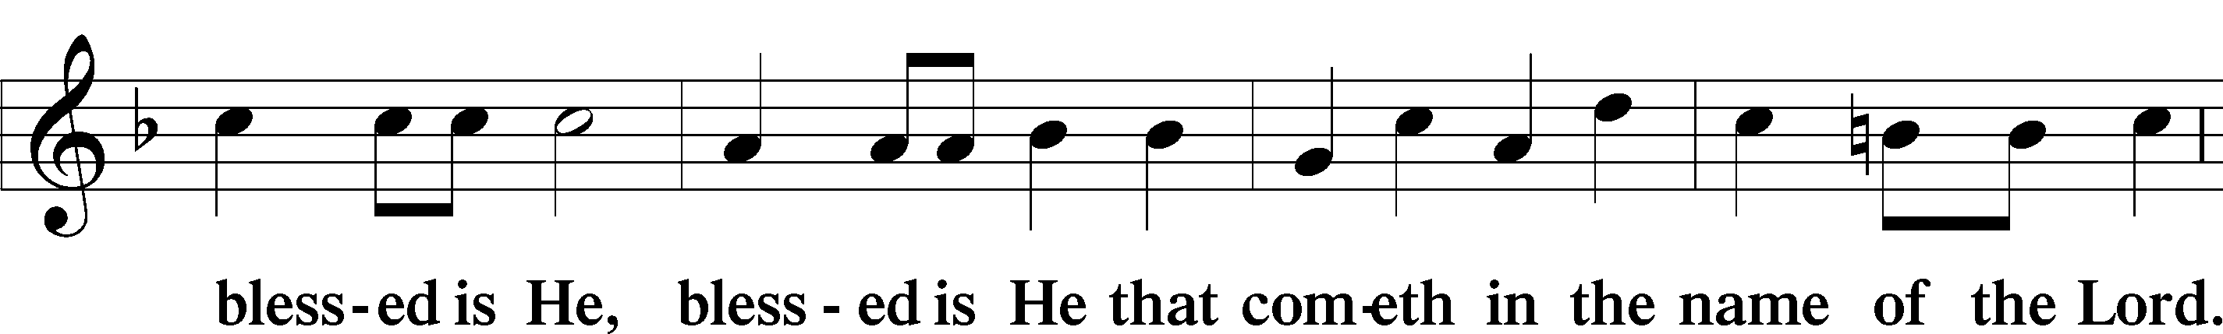
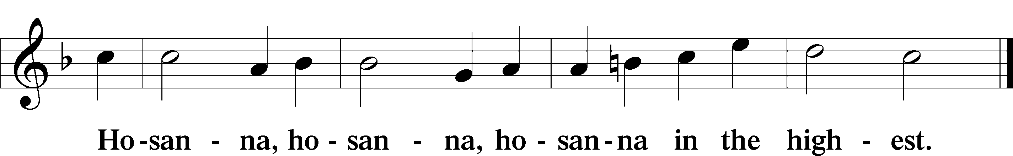

Lord’s Prayer LSB 162
P Lord, remember us in Your kingdom and teach us to pray:
C Our Father who art in heaven, hallowed be Thy name, Thy kingdom come, Thy will be done on earth as it is in heaven; give us this day our daily bread; and forgive us our trespasses as we forgive those who trespass against us; and lead us not into temptation, but deliver us from evil. For Thine is the kingdom and the power and the glory forever and ever. Amen.

The Words of Our Lord LSB 197
P Our Lord Jesus Christ, on the night when He was betrayed, took bread, and when He had given thanks, He broke it and gave it to the disciples and said: “Take, eat; this is My T body, which is given for you. This do in remembrance of Me.”

In the same way also He took the cup after supper, and when He had given thanks, He gave it to them, saying: “Drink of it, all of you; this cup is the new testament in My T blood, which is shed for you for the forgiveness of sins. This do, as often as you drink it, in remembrance of Me.”

Pax Domini LSB 197
P The peace of the Lord be with you always.

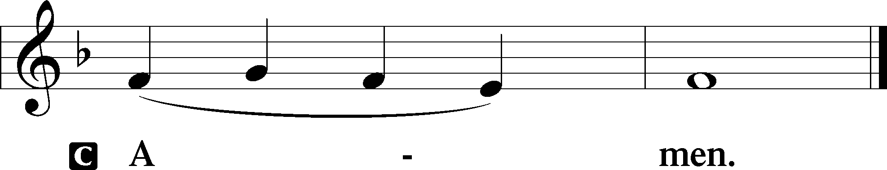

Agnus Dei LSB 198
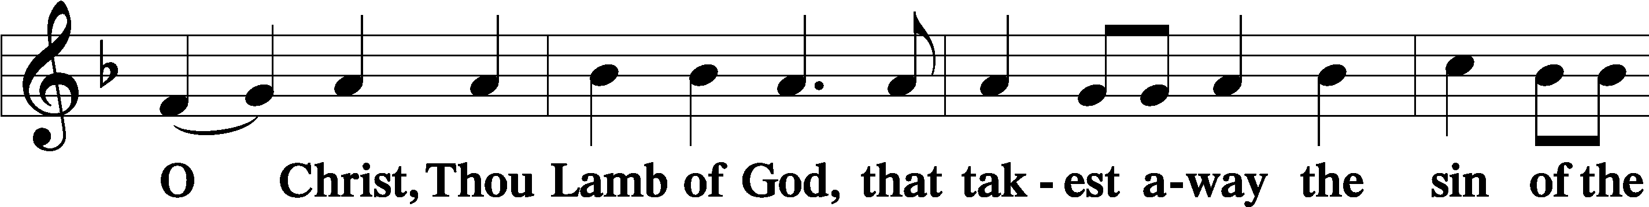
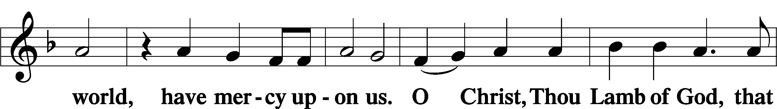
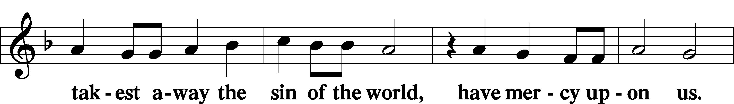
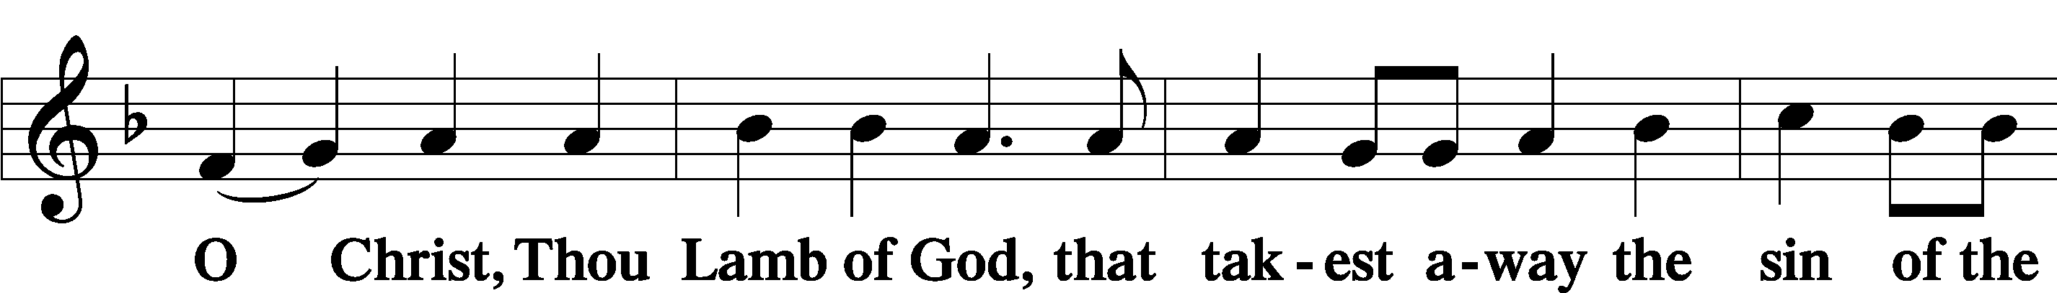
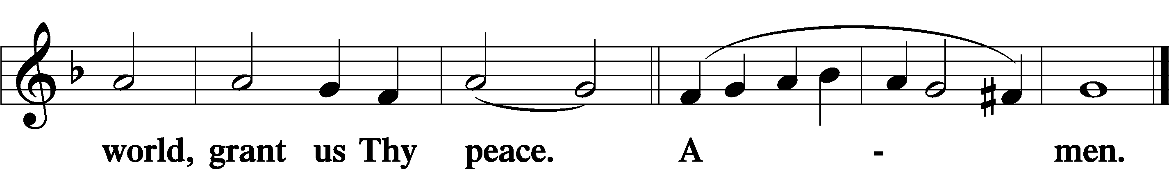

Sit

Distribution

Distribution Hymn: O Lord, We Praise Thee LSB 617
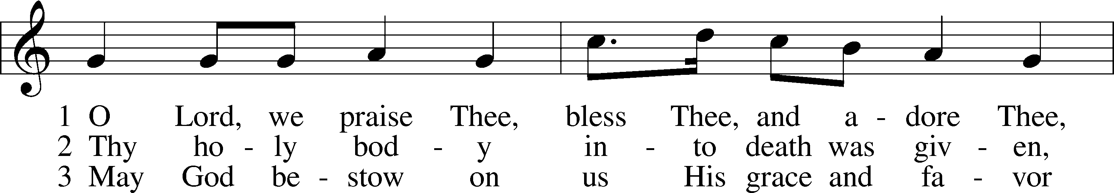
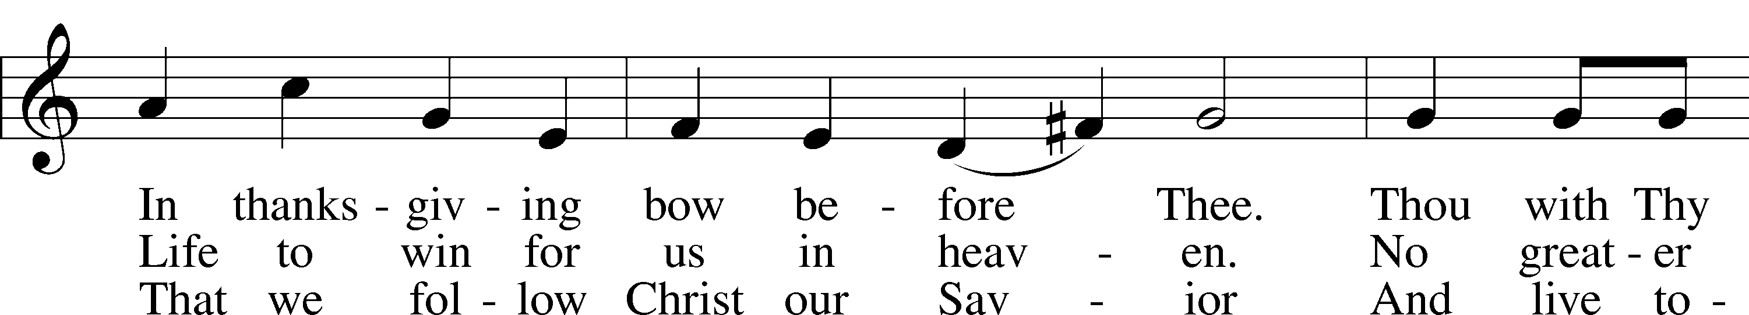
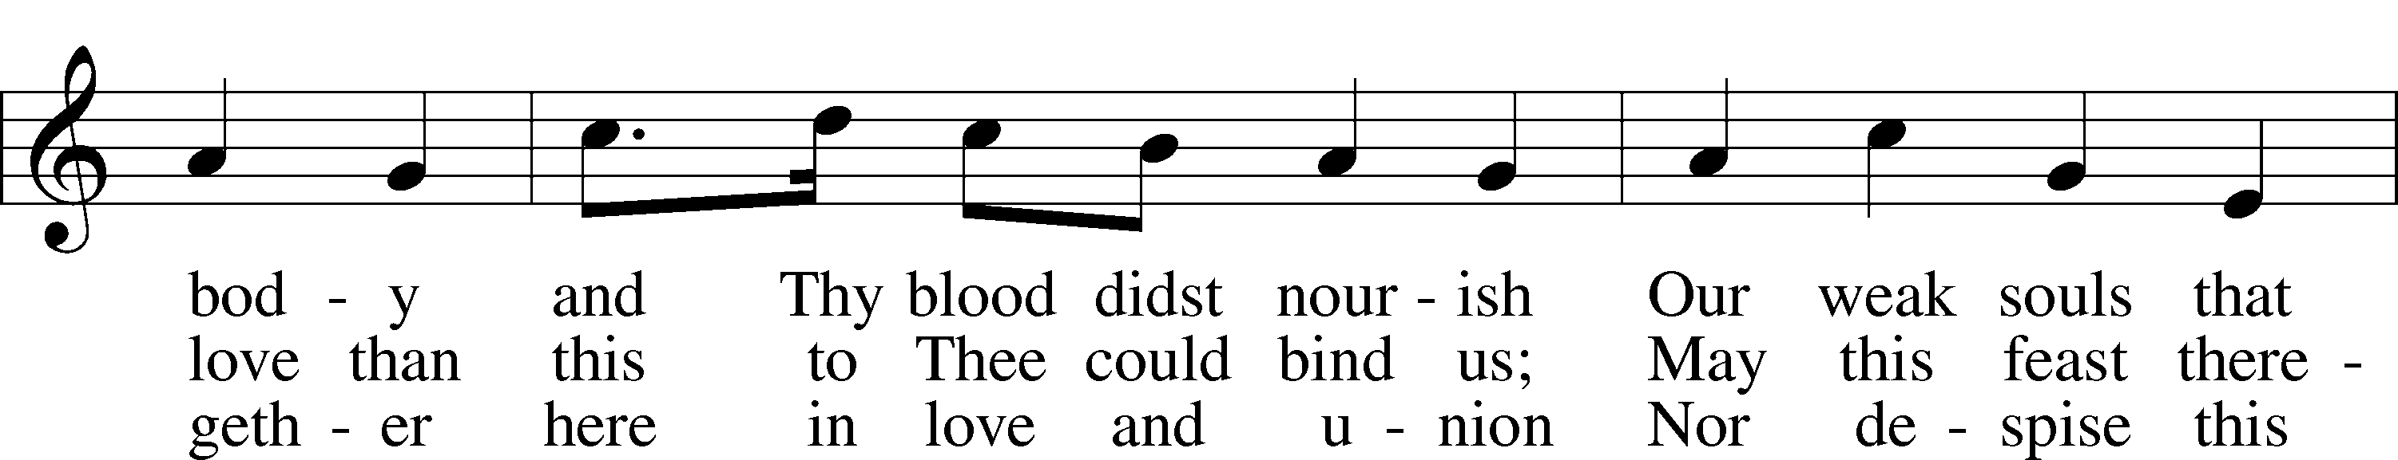
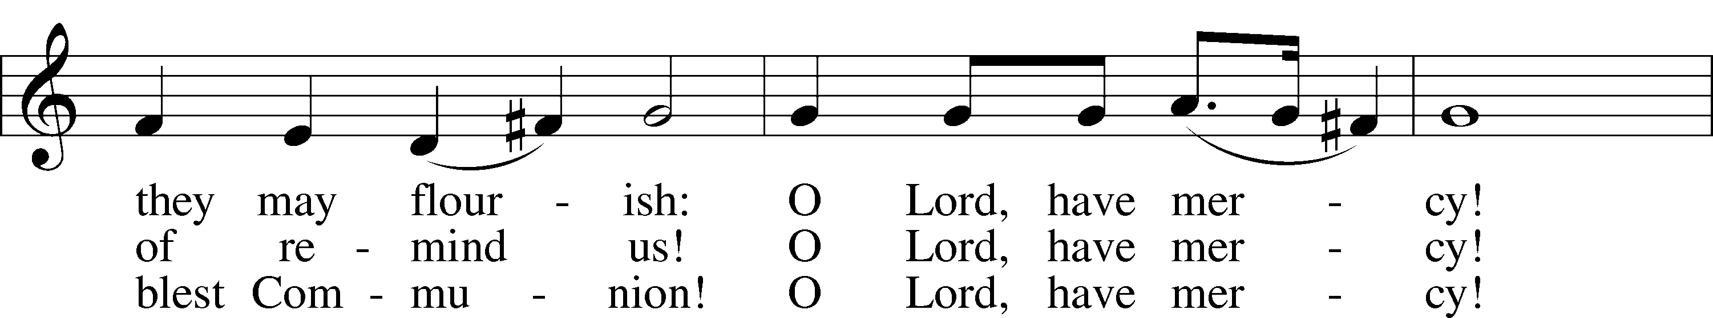
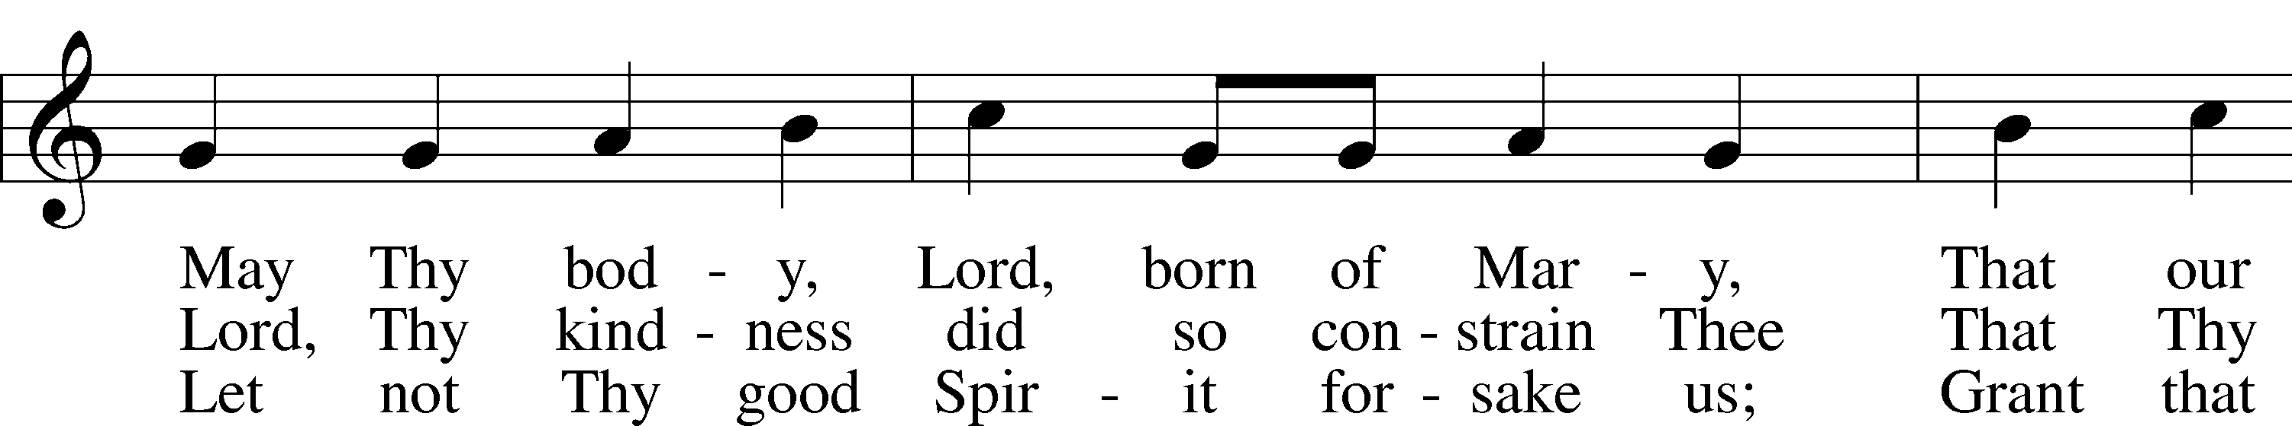
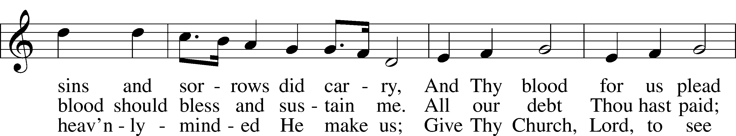
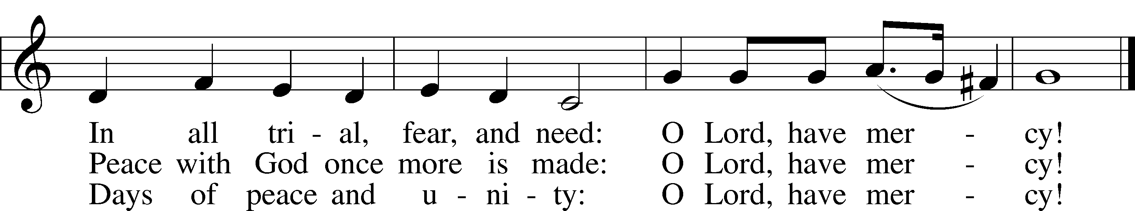
Text: tr. The Lutheran Hymnal, 1941, alt.; (st. 1): German, 14th cent.; (sts. 2–3): Martin Luther, 1483–1546
Tune: Geystliche gesangk Buchleyn, 1524, Wittenberg, ed. Johann Walter
Text: © 1941 Concordia Publishing House. Used by permission: LSB Hymn License no. 110005504
Tune: Public domain

Distribution Hymn: Jesus Comes Today with Balm and Healing LSB 620
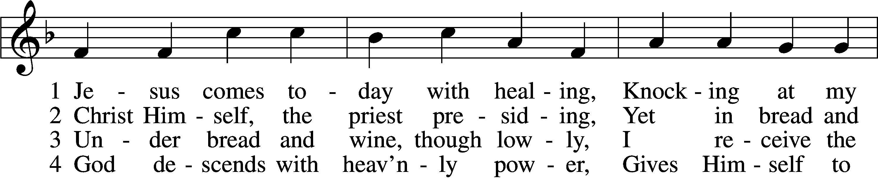
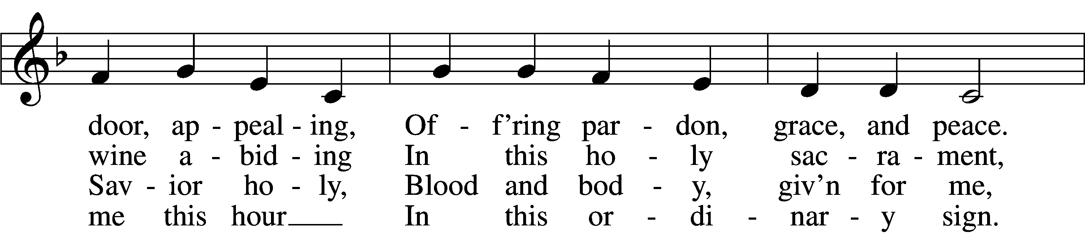
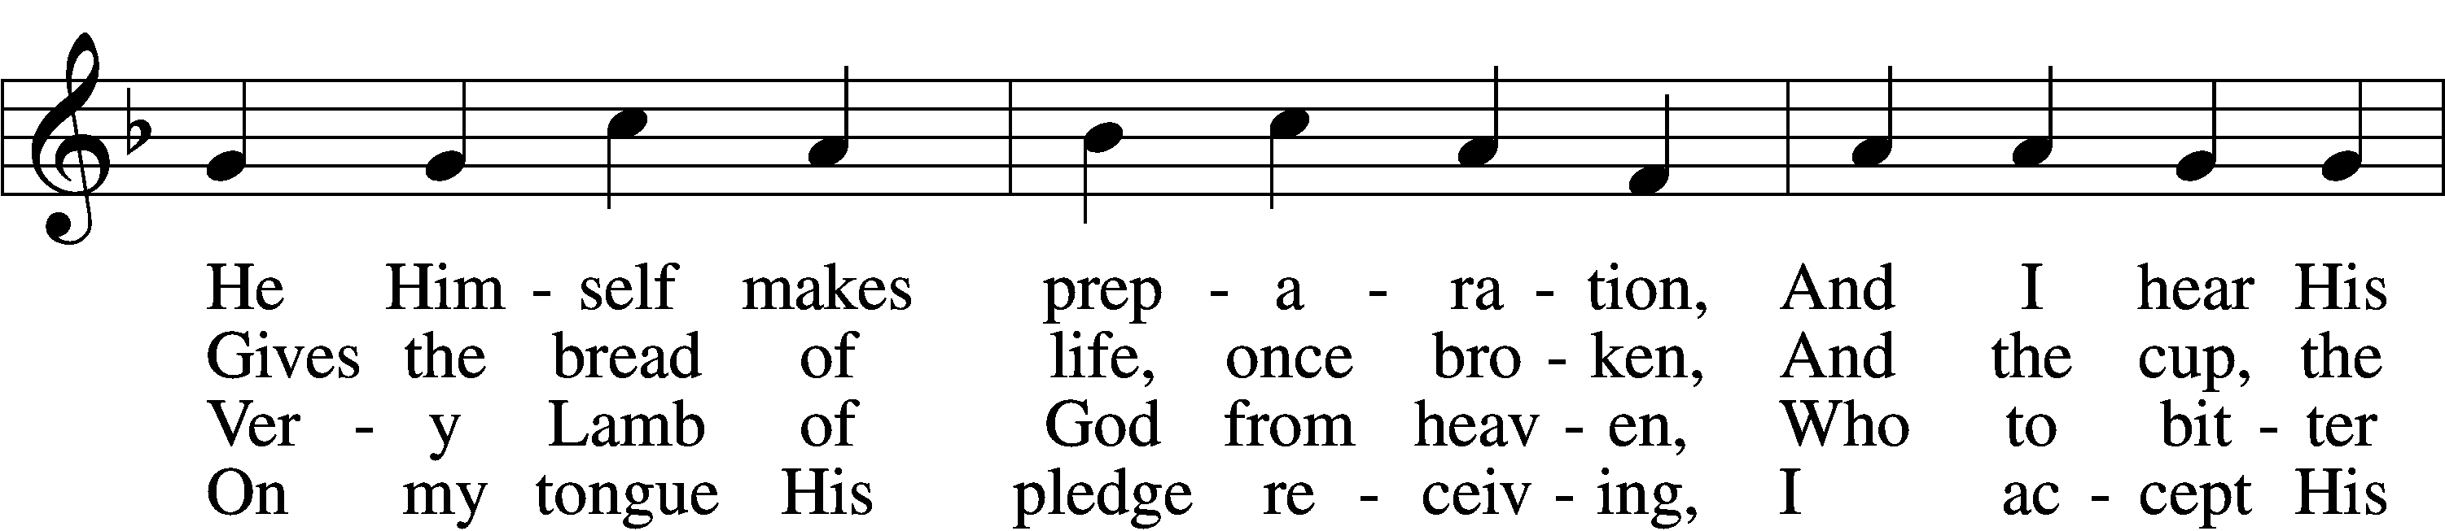
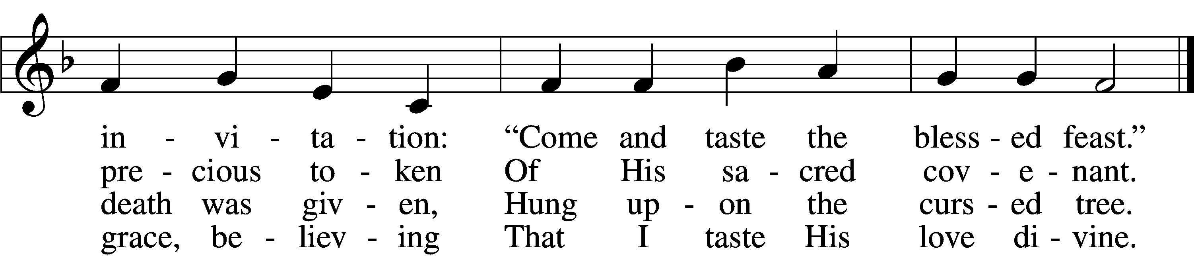

5 Let me praise God’s boundless favor,
Whose own feast of love I savor,
Bidden by His gracious call.
Wedding garments He provides me,
With a robe of white He hides me,
Fits me for the royal hall.

6 Now have I found consolation,
Comfort in my tribulation,
Balm to heal the troubled soul.
God, my shield from ev’ry terror,
Cleanses me from sin and error,
Makes my wounded spirit whole.
Text: Heinrich Puchta, 1808–58; tr. David W. Rogner, 1960
Tune: Johann Löhner, 1645–1705; adapt. Johann Balthasar König, 1691–1758
Text: © David W. Rogner. Used by permission: LSB Hymn License no. 110005504
Tune: Public domain

Stand

Nunc Dimittis LSB 199
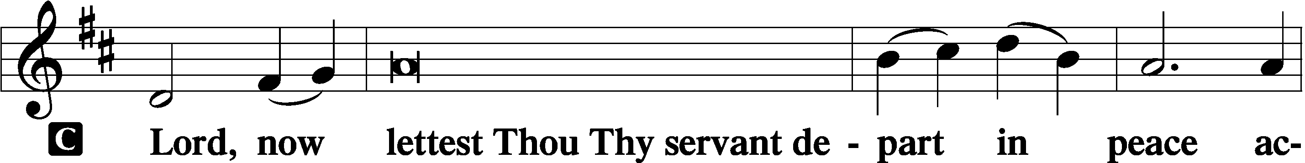

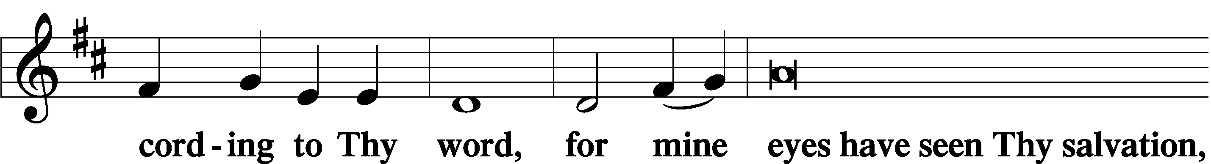

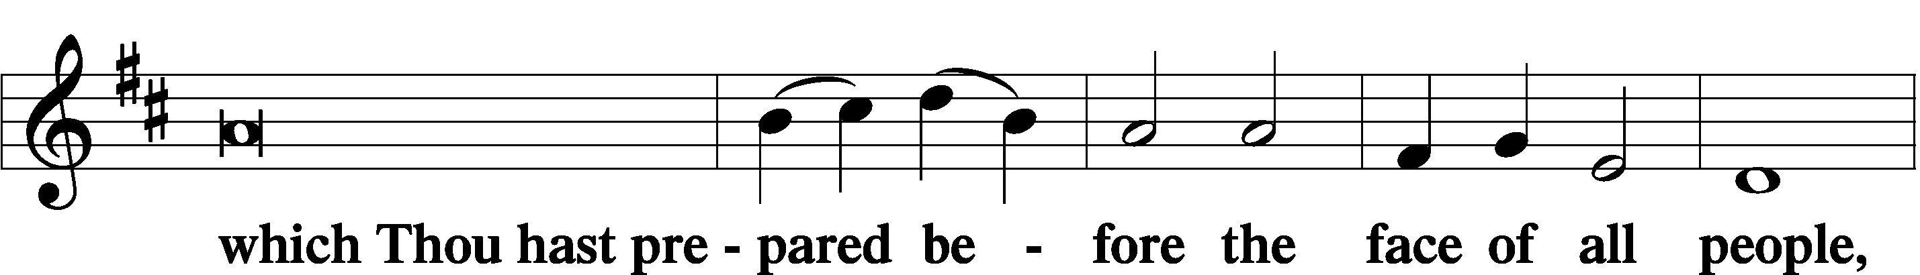

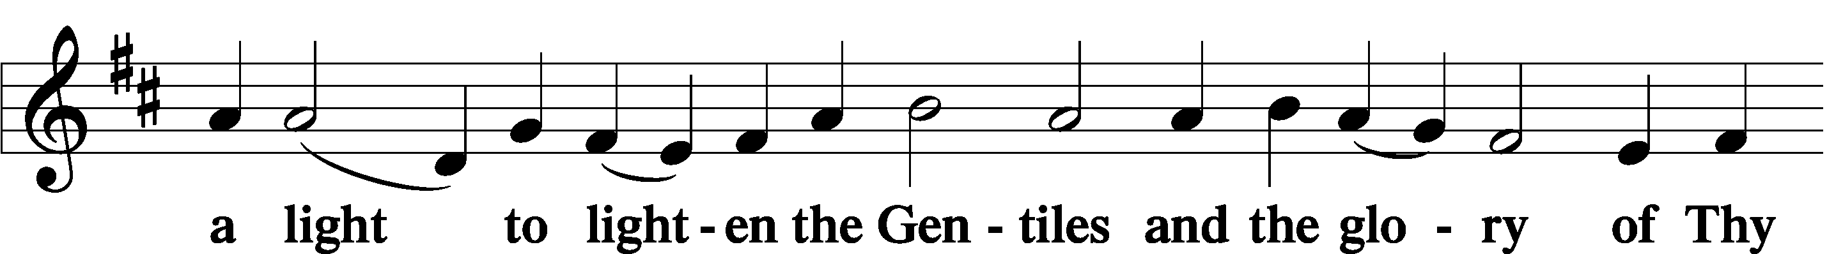

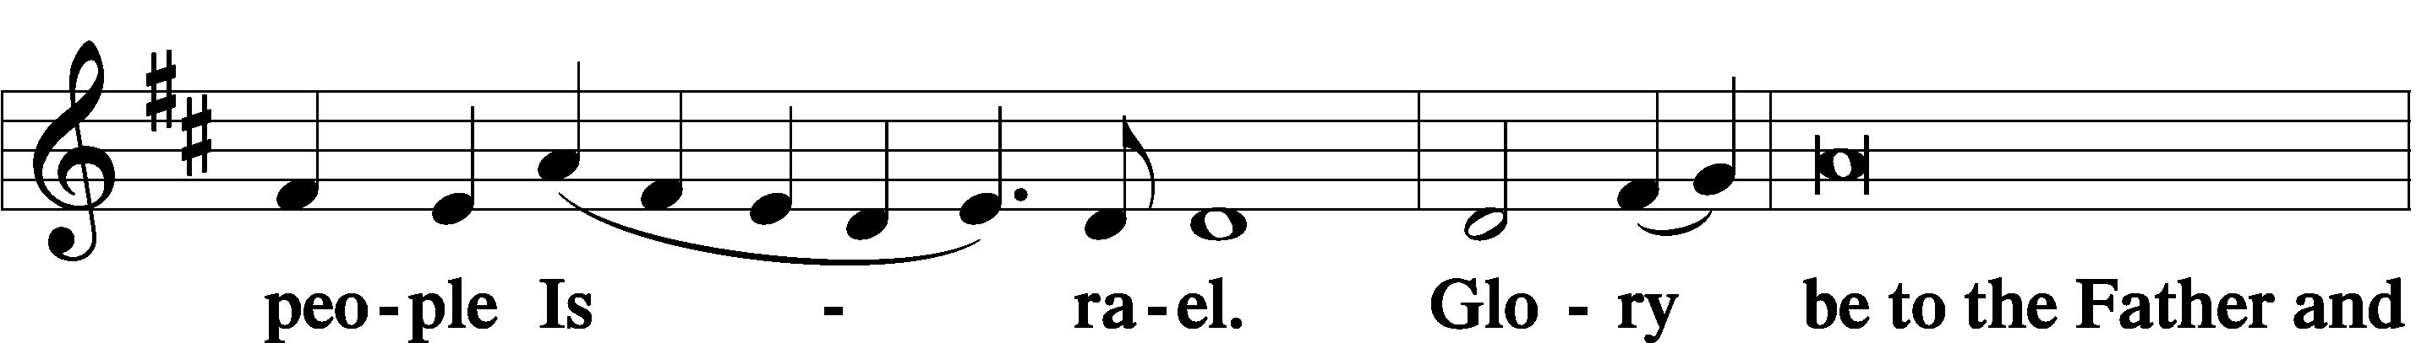

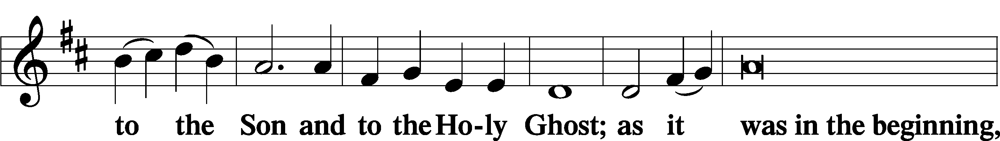

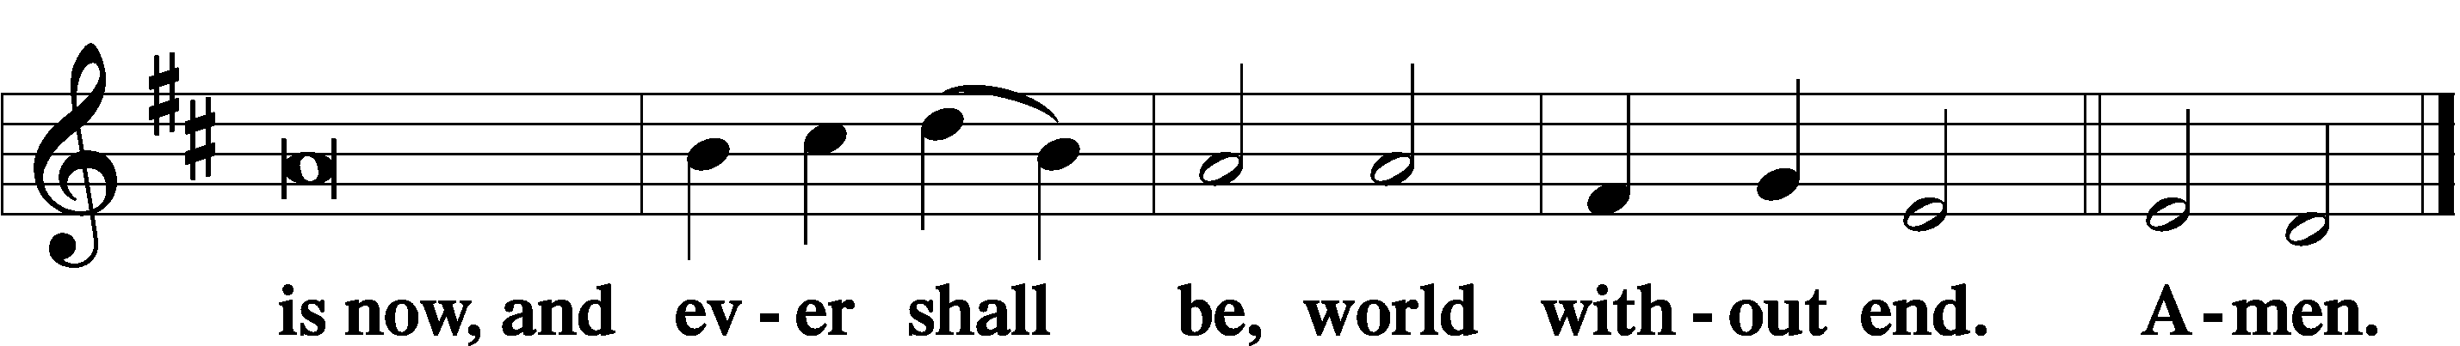

Thanksgiving LSB 200
A O give thanks unto the Lord, for He is good,

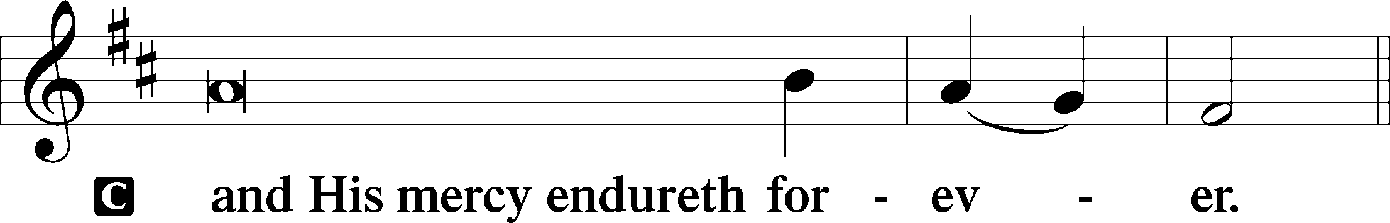

A Let us pray.
We give thanks to You, almighty God, that You have refreshed us through this salutary gift, and we implore You that of Your mercy You would strengthen us through the same in faith toward You and in fervent love toward one another; through Jesus Christ, Your Son, our Lord, who lives and reigns with You and the Holy Spirit, one God, now and forever.

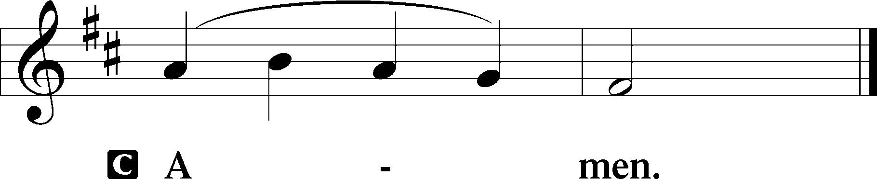

Hymn to Depart: Go To Dark Gethsemane sts. 1–3
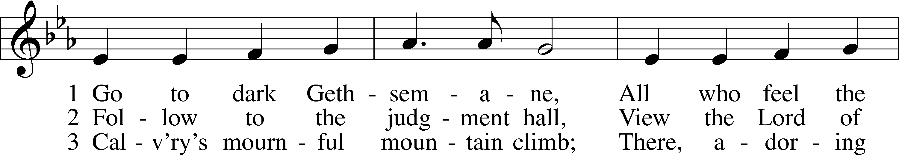
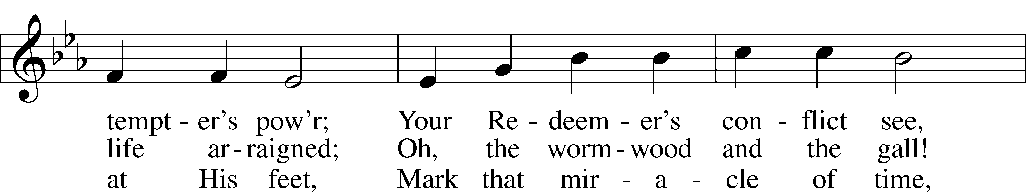
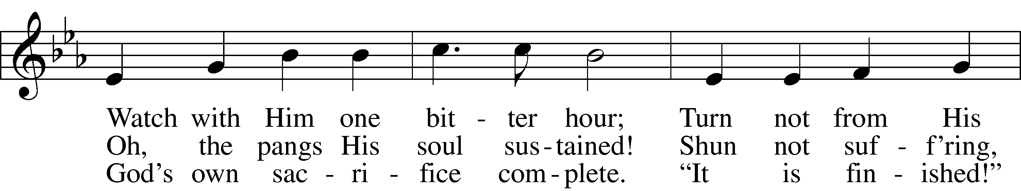
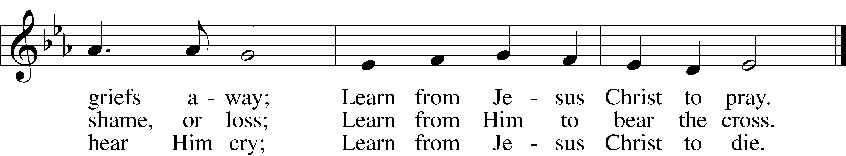
Text: James Montgomery, 1771–1854
Tune: Richard Redhead, 1820–1901
Text and tune: Public domain

STRIPPING OF THE ALTAR (6:30pm only)

The Communion vessels are reverently removed from the altar, the altar is stripped, and the chancel is cleared in preparation for the solemn services of Good Friday.

Reading Psalm 22
Why Have You Forsaken Me?
1My God, my God, why have you forsaken me?
Why are you so far from saving me, from the words of my groaning?
2O my God, I cry by day, but you do not answer,
and by night, but I find no rest.
3Yet you are holy,
enthroned on the praises of Israel.
4In you our fathers trusted;
they trusted, and you delivered them.
5To you they cried and were rescued;
in you they trusted and were not put to shame.
6But I am a worm and not a man,
scorned by mankind and despised by the people.
7All who see me mock me;
they make mouths at me; they wag their heads;
8“He trusts in the Lord; let him deliver him;
let him rescue him, for he delights in him!”
9Yet you are he who took me from the womb;
you made me trust you at my mother’s breasts.
10On you was I cast from my birth,
and from my mother’s womb you have been my God.
11Be not far from me,
for trouble is near,
and there is none to help.
12Many bulls encompass me;
strong bulls of Bashan surround me;
13they open wide their mouths at me,
like a ravening and roaring lion.
14I am poured out like water,
and all my bones are out of joint;
my heart is like wax;
it is melted within my breast;
15my strength is dried up like a potsherd,
and my tongue sticks to my jaws;
you lay me in the dust of death.
16For dogs encompass me;
a company of evildoers encircles me;
they have pierced my hands and feet—
17I can count all my bones—
they stare and gloat over me;
18they divide my garments among them,
and for my clothing they cast lots.
19But you, O Lord, do not be far off!
O you my help, come quickly to my aid!
20Deliver my soul from the sword,
my precious life from the power of the dog!
21Save me from the mouth of the lion!
You have rescued me from the horns of the wild oxen!
22I will tell of your name to my brothers;
in the midst of the congregation I will praise you:
23You who fear the Lord, praise him!
All you offspring of Jacob, glorify him,
and stand in awe of him, all you offspring of Israel!
24For he has not despised or abhorred
the affliction of the afflicted,
and he has not hidden his face from him,
but has heard, when he cried to him.
25From you comes my praise in the great congregation;
my vows I will perform before those who fear him.
26The afflicted shall eat and be satisfied;
those who seek him shall praise the Lord!
May your hearts live forever!
27All the ends of the earth shall remember
and turn to the Lord,
and all the families of the nations
shall worship before you.
28For kingship belongs to the Lord,
and he rules over the nations.
29All the prosperous of the earth eat and worship;
before him shall bow all who go down to the dust,
even the one who could not keep himself alive.
30Posterity shall serve him;
it shall be told of the Lord to the coming generation;
31they shall come and proclaim his righteousness to a people yet unborn,
that he has done it.

Acknowledgments
Divine Service, Setting Three from Lutheran Service Book
Unless otherwise indicated, Scripture quotations are from the ESV® Bible (The Holy Bible, English Standard Version®), copyright © 2001 by Crossway, a publishing ministry of Good News Publishers. Used by permission. All rights reserved.
Created by Lutheran Service Builder © 2024 Concordia Publishing House.

